How to exchange stories of local flood resilience from flood rich areas to the flooded areas of the future

Flood risk communication requires strong attention to message, messenger and timing within the adaptive cycle. This paper evaluates research that used a co-production of knowledge model to create digital stories from an archive of flood memories, garnered from residents affected by the severe UK summer 2007 floods. We explored whether a knowledge exchange process could: deliver on community members’ desires to share lay flood knowledge for local resilience; inject experience of new digital media to support local/national flood risk management agencies, and meet aspirations of academic researchers to explore how flood memories might contribute to building local capital for resilience. We found more fluid versions of co-production were needed, reflecting how roles of researcher, participant and organisation continually shifted throughout the process, with a ‘knowledge brokering/ technology capital’ role for the researcher. Digital storytelling did ultimately allow personal stories to travel beyond flood-affected areas, and be shared within communities and flood risk management organisations, allowing peer-to-peer communication of flood resilience knowledge beyond the local.

**Keywords:** digital storytelling, sustainable flood memory, local knowledge, flood risk, resilience

This work was supported by the UK Economic and Social Research Council (ESRC) under Grant RES-062-23-2783 and ES/I003576/2.

# Introduction:

When you live by a river like the Severn, it's such a volatile river. It's got that many elements working together, that when all the elements come together you got trouble...When you've got a river that’s in flood, and tide on top of that, and wind driven tide on top of that, it just compounds the situation. If the planners had only listened…So when a flood comes, I just get on with it. Now, I'm afraid, all these people that run the city, and anything to do with flooding and spending money, they don't want to know.

Ray, digital storyteller

In recognising uncertainty and complexity, lay flood knowledge can be seen to be adaptive and resilient in a way that is critical to the responses of the State. Following the severe UK summer 2007 floods, the *Pitt Review: Lessons learned from the 2007 floods* (UK Cabinet Office, 2008) stated, “experts involved in emergency response should not ignore the skills, energy and ingenuity that are latent in most communities; in preparing for an emergency, communities have important shared local knowledge and can harness local resources and expertise.” (p350). This report challenged earlier understandings of Flood Risk Management (FRM) and so for experts in FRM agencies, post-Pitt Review, there was a new, “duty to share” their knowledge (Haughton et al., 2015, p380) and embark upon partnership working across disciplines and professions. Although Haughton et al. outlined the case for hybrid knowledge formation and co-production of flood risk knowledge, it can be argued that the high potential value of integrating different lay knowledges (observational, cultural, experiential, inter-generational, and archival) has only been partially explored (see, for example, Whatmore, 2009).

Our research (McEwen et al., 2016; Garde-Hansen et al, 2017) daylighted the discourses and narratives that played out during and after the 2007 floods, addressing the Pitt Review’s concerns. In this, we proposed the concept of SFM conceived as:

“an approach to memory work that is both individual and community-focused, taking account of materialised memories, e.g. in landscape, technology, social media, formal and informal archives. It integrates individual (personal) and collective (community) experiences across different media and materialities. Such memory is ‘sustainable’ and persistent in creating and supporting conditions for its furtherance, with strong attention to inter- and intra-generational exchanges and social learning.” (p17)

We aimed to develop this concept as a process and practice that could bring new insights to local FRM delivery, exploring how knowledges, emotions, practices and materialities interact around remembering floods for individual and community resilience. Local resources accessed within SFM include personal testimonies – as stories and anecdotes, autobiographical accounts and materialised memories (photographs, physical markers etc.) of past events that capture experiences of living through severe floods. Importantly SFM supports generation of strategies for storing and sharing of “actionable adaptive knowledges” that help build local capital for living with future flood risk (McEwen and Holmes 2017, p143). Hence, research with emplaced communities on collective and communicative flood memories should afford a protocol connecting knowledge, community, memory and resilience. This paper reflects on how the latter stories might be captured, and exchanged/ shared.

Processes and practices of ‘Sustainable Flood Memory’: our methods The SFM Project had two phases. In Phase 1, the ‘interviewing’ phase, in-depth, semi-structured interviews (1-4 hours duration) were conducted with 95 people[1] who had experienced flooding in four floodplain settings, with different histories, forms, levels of flood experience and kinds of “communities” (see McEwen et al., 2016 for detail about Phase 1’s framing and methodology). The resulting audio-archive contained insights from residents who had been living and adapting to life in flood-prone areas. These stories could be harrowing and dramatic, such as those from residents who had seen their homes inundated and had spent months living in mobile homes. Other stories detailed ingenious sustained efforts made to protect cherished homes from successive floods of varying length and intensity. The archive contained examples of unique local knowledge: how to recognise signs of an imminent flood, how to prepare for a flood, how to deal with effects of inundation and how to adapt for future flooding. As well as providing examples of good practice in partnership working between residents and flood risk agencies, the interviewees - in some settings - also shared episodes of disharmony. Some interviewees expressed their frustration that their local knowledge had been, and was being, ignored by experts. As we had built up the archive, some interviewees had emerged as the primary source of trusted flood information for their neighbours. Although locally respected, these ‘flood gurus’- also felt that they were apart from the decisions being taken on local FRM by agencies.

Although the archive was rich and varied, it was the potential, generative power of its stories – stories of resilience being re-told to promote resilience – that appealed in particular to both us and our project’s FRM stakeholders (comprising environmental regulator, local government, third sector NGOs, county archives and a community flood action group).

In Phase 2, we co-developed a process which aimed to explore the transfer and exchange of stories beyond the areas where they were generated. This occurred in direct collaboration with regional stakeholders, developing new co-working practices between the interdisciplinary academic team and the environmental regulator. A key methodological principle was simultaneously to engage community participation throughout the resulting process. The trust and deep relationships inherent in producing the Phase 1 of the SFM project, coupled with the ethos of democratisation post-Pitt Review meant that the first aim of Phase 2 was to co-produce new, digital stories with the original interviewees. Digital stories offered the potential to combine audio stories with the visual, personal, flood archives (photographs, scrapbooks, etc.) of the project’s participants. The second aim was to explore whether digital storytelling could have a function for knowledge exchange within and outside of the case-study areas. For example, could digital stories about flooding be transferred, have resonance and impact in other settings that might be hit by future floods? Could past events become “authentic guides for future events” (Baake and Kaempf, 2011, p. 431) when communicated across generations? A research plan emerged whereby the project would co-produce a new archive of digital stories (audio with images, narratives) framed around memories of extreme flooding and local knowledge.

# Digital storytelling: background context

Beyond just ‘being stories’, digital storytelling is, “the process of illustrating personal narratives and stories with photographs, artwork, music, voice-overlay, video clips, and text – creating a first-person mini-movie of sorts” (Willox, 2012, p. 132). More specifically, Burgess (2006) defined digital storytelling as “a workshop-based process by which ordinary people create their own short, autobiographical films that can be streamed on the web or broadcast on television” (p. 207). The method originated in California, designed by Lambert (co-founder/Director, Center for Digital Storytelling (CDS), Berkeley), as an alternative media form with an ethos of democratisation (Kidd, 2005). Taught in community workshops, individuals are brought together to create personal multimedia ‘stories’, generally involving 2-3 minutes of recorded narration as audio accompanied by participants’ own photographs and/or short video clips in a form which allows complete control of representation to remain in the storyteller’s hands (Kidd, 2005). The Centre for Digital Storytelling’s core methodology for making digital stories includes six steps: an introduction to digital storytelling concepts; an oral story circle; script writing and editing; preparation of media to be included in the story; producing the story using software editing tools; and screening of final stories with group reflection (Guse, 2013).

# Digital Storytelling for resilience

Resilience is a contested term used in diverse ways: “as a scientific concept, as a guiding principle, as inspirational ‘buzzword’, or as a means to become more sustainable” (de Bruijn, 2017, p 21). Most definitions of resilience as “capacity” highlight processes of adaptive success (individual; collective) in facing significant threats, disturbance, stress or adversity (Norris *et al*. 2008; McEwen et al., 2016’s framing of ‘flood resilience’ p15). When asked to define “resilience” one contributor to the *100 Resilience cities* website responded by saying, “resilience is not just about infrastructure, it’s about how things gel and how people are engaged in a city.” (100 Resilient Cities, 2016). In the SFM project, we saw digital storytelling as a method which could function as a means to “gel and engage people,” whilst promoting learning for resilience. The research aims were across three levels, or scales of influence: giving control to the storytellers we had met who felt they lacked control; providing accessible flood knowledge, in understandable language, to the story listener; and to wider, flood-affected UK communities, unique knowledge about “surviving floods”. Each project stakeholder would, inevitably, have different levels of interest in each aim. For example, at an early team-meeting[2], the environmental regulator highlighted potential of the stories to “educate”. As such, we as researchers would be constantly - to quote Willox (2012) – “engaged in a quest to negotiate the tricky, complex and ever changing space between research methodology, methods, participants and researchers…” (p131). At the outset, the digital storytelling method offered potential to reflect, preserve, and promote histories and narratives of the community whilst complementing and informing the resilience and preparedness policy strategies of the project’s stakeholders. For the first aim, examples of similar projects are numerous (for example, “The Online Museu da Pessoa project”, as noted in Clarke, 2009). However, our second aim required sharing of stories far beyond the catchment where they were made, and here there are fewer examples of such wide-reaching (and potentially resilience-building) projects. As Dunford (2017) states:

Digital storytelling can be justifiably criticized for its relatively modest aspirations, characterised by a focus on small-scale production that is rarely shared beyond the specific communities that participated in the Digital Storytelling workshops. (p320)

# Adapting digital storytelling methods

In what can be referred to as ‘traditional digital storytelling’, the approach to participation is firmly grounded in facilitation of the ‘story circle’ where individual stories are found, developed and crafted using a series of different storytelling techniques to enable a group of participants to tell a story (Dunford, 2017). As part of processes of exporting the stories from the archive, we needed to expand our roles from facilitators in story creation processes to mediators in the distribution of stories. In the SFM project, our experience was that a ‘story circle’ was often just the first of many types of participation and, as a stand-alone method, was often unable to deliver completed digital stories. Of the three methods we eventually used, Method 1 served as a precursor, beginning with a trawl of the SFM interview transcripts, which had previously been coded using Nvivo software, looking for short narratives or vignettes.

Figure 1: Nvivo-generated thematic code, and child-nodes for Emotion and Affect

Existing thematic codes included “Emotion and Affect” and “Infrastructure and Services” (see Figure 1 for an example). These thematic codes were then adapted to capture aspects of flood preparedness such as “Emotional resilience” and “Infrastructural resilience” (Figure 2). Interviewees were then asked to reflect on their content again, in context of Phase 2. By co-working to find appropriate images, a personal story could be illustrated. Once rendered, these nascent ‘stories’ described and reflected different aspects of ‘preparedness for flood risk’ viewed through different resilience frames (Figure 2).

Figure 2: Digital Stories creation – Methods 1 and 2: vignettes initially coded to resilience frames; new story developed under the same resilience frame

Method 2 emerged when one participant, whilst listening to a playback of her original audio interview/vignette, did not like the sound of her own voice and felt that her story could be told better, and so instead of forming the story, the selected vignette became a stimulus for development of a new story. In using a vignette of emotional resilience as a ‘resilience foundation’, we created a new story, so that the teller had engaged with the resilience frame, and independently created a better example of it. This was then captured as audio with images selected by the storyteller. The story circle method - arguably the closest approach to the original digital storytelling ethos – was the basis of Method 3, and the model of the Community (group) Digital Storytelling workshop. These workshops were held in three of the original case-study locations within community settings and venues – and acted as stimuli for generation of new stories. On fliers and posters, participants were asked to “come and share their flood memories, local knowledge and photographs that capture[d] individual or community resilience… [so that they could be] shared within [their] community and with other communities nationally”. The posters specified that “no technical expertise [was] required”. Throughout the day, participants who had lived with and through floods, worked alongside project team facilitators to script short stories which were then recorded in quieter parts of the venue.

Figure 3: A flood mark inside the house of a storyteller

Achieving real outcomes with real people requires flexibility; it involves accommodating chaos and messiness (Pain et al., 2007), and this need for flexibility necessitated our first drift from traditional digital storytelling. As described above, the SFM project adopted the workshop method as a means to create digital stories, but several factors led to us adapting the method. Firstly, the success of the traditional model often led to storytellers building up stories in the accommodating atmosphere of the workshops to the extent that, in order to complete some stories, further images were needed that were not available on the day. To some extent, the ‘moment of creation’ was lost and some stories not completed. This issue was further complicated by some workshop participants often being on what Burgess (2006) referred to as “the wrong side of the digital divide…less culturally and technologically privileged citizens” (p211). During Phase 1 of the project, recording interviews did not involve any technological interaction and although completion of a new, digital story might require further home visits from SFM team members - for example, to scan hard copy photographs of previous flood events, or take new photographs altogether – the tellers did not use the editing software[3] (Figure 3).

By the end of the story creation process, we had produced 21 digital stories: four from Methods 1 and 2 and thirteen from Method 3. All stories were signed off by participants for use for educational purposes, in accordance with the project’s ethics clearance. As authorship was a key element of digital storytelling processes, names were not anonymised.

Figure 4: Example of initial phases of digital story creation in a workshop

# Results and discussion

## Introduction: the shifting roles of the tellers, the listeners and communities

The results below are set out to provide insights on three levels - the teller, the listener, and the community – illustrating the shifting roles within the SFM project. As we assembled, published and shared the digital stories, we were able to see the different motivations of storytellers, listeners and the communities who created and received the stories and how these could change. For example, a teller might tell their story with a view to the impact that they wanted to have on a specific listeners (e.g. policy makers), whilst other listeners (e.g. project stakeholders), seeing in the story examples of local resilience, wanted to project the story onto other flood risk communities around the country. The scope of digital storytelling here went beyond just the opportunity to be listened to, and to share knowledge.

## Creating resilience from anger: the storytellers changing stories as a result of engagement

As a result of longitudinal engagement[4] and digital storytelling, we were able to observe how emotion could be channelled, turning anger into stories of resilience. One flood story (which would eventually become a digital story) was told by a participant called Richard and recorded three times: once during an initial interview, once during a flood conference where he was in attendance, and finally during a digital storytelling workshop[5]. In the first interview with Richard , he described his intense dissatisfaction at flood risk measures taken by his local authority and how he had “complained to the Minister [for the environment], but they [were] intent on looking after water quality and ecology, fish and wildlife, rather than people.” When he attended the SFM flood conference four months later , Richard told his story of flood resilience but also used the microphone to directly address the policymaker delegates, illustrating what Puccia Parham (2014), argued was the storyteller’s aim of not so much to preserving a permanent record as informing and influencing their immediate audience (p209). Within the local storytelling workshop which Richard attended seven months later, we were able show some early digital stories, allowing him and other tellers to see their power. At this workshop, Richard re-recorded a vignette (Method 2) which we had selected based on adaptive resilience and community capital. It was the story which he had told at the SFM flood conference, but without the targeting of policymakers (Figure 5).

Figure 5: A still frame with added text from Richard’s digital story

A similar voyage across the digital storytelling process was taken by a teller called Ray. Below is a section from an interview (one of four) conducted with Ray in which he described his local flood knowledge and his frustration at not being listened to:

What will happen is the flood will come so deep that it will overtop the road, it will strip the tarmac. And once it has stripped the tarmac, it will rip it all away and release all the penned up water behind it. I have spent the best part of ten years of letter writing. I even went to Parliament, and the [Environmental regulator]. And I said, “I'm sure you've heard of me. I've sent an awful lot of letters to all you lot, and nobody is listening”.

Despite Ray’s experience and enrichment that he brought to the research process, his sometimes forthright responses meant that brokering was required by project researchers in effect, adding a ‘scaffolding around the relationship’ (McEwen et al, 2016). One example of this scaffolding process was the way that SFM researchers began by listening to and recording the tellers’ broader concerns of loss of community, detachment and loneliness (McEwen et al, 2016, p.336) as we embarked upon a co-productive journey. This ‘journey’ echoed Tuckman and Jensen’s (1977) model of four stage group development, often referred to as ‘forming’, ‘storming’, ‘norming’ and ‘performing’ (Tuckman and Jensen 1977; Luke et al., 2014, p.45). Our initial, ‘storming stage’, as well as embracing broader issues, was also where potential for conflict was higher, as clarification of values and goals was sought. However, by the final, ‘performing’ stage, high performing citizens emerge - able to work at collective goals, issues and difficulties with increased loyalty, support, cohesion, synergy and high morale (Luke et al., p45). As a result, other project stakeholders were not immediately turned off by what had been – initially - provocative language. As such, the journey, from audio interview clip to a rendered digital story resulted in a quite different story emerging. As a result of brokering and mediation, Ray’s initial determination to tell a tale of anger and frustration at the circumstances in which his home flooded could be changed to a story of how to overcome flooding. The aim here was, as described by Luke, et al (2014), “to turn festering social and environmental issues into a citizen demand for change…more appropriate for society as a whole.” (p45). At the same time, conversely, because Ray was asked to focus on parts of his story which included “different types of individual or community resilience[6],” no post-editing was required after the final story was recorded.

*Figure 6: A still from the "Knowing the River" digital story*

At the same time, and because of relationships that he had built up over time with project researchers, Ray also trusted that he would not be misrepresented or edited in a way he would find objectionable. Thumim (2009), recognising that a certain amount of pragmatism is often required in digital storytelling projects, observes

…to participate in a project that is devised by the professionals; [participants] must fit their story into a shape that has ultimately been decided by the professionals. At the same time, however, those involved…use their own position and status to open a space for people who do not have such status, and do not therefore have access to equipment, skills or a platform for display that delivers the legitimacy that comes with these institutions. (p627)

As Dunford (2017) states, “digital storytelling is often driven by a complex iterative process characterised by the interplay of different tensions between the participant, facilitator and the commissioner” (p324). When we eventually – mutually - chose which of Ray’s stories to create and publish, we did so knowing that it was just one of his (countless) that could have been told. Dunford (2017) recognising possible ethical unease of such curtailing, enhancing or embellishing, similarly recognised that it is probably unrealistic to ever completely represent a storyteller within one project’s scope as, “there may be stories that are just too complex to tell within a two-to-three minute piece” (p318). Despite the co-production method, it is unlikely that a collaborative approach can ever result in a perfectly symmetrical power relationship (Sandercock and Attali, 2010). Instead we found that our methods needed to continually adapt and evolve. An example is that although all tellers were given the final editorial say on their completed story, many did not have internet access to view the files, and so DVD copies were given to them to view before the stories were finally approved and released online.

## The teller becomes the community of tellers

By the time the digital stories were shown in public, some eight years had passed since the 2007 floods but particular emotional responses to it became active again. In disaster phases, it is well established that frequently emotional highs and emotional lows occur in collective reactions (Klaebe, 2013;UK Health Protection Agency, 2011);this was particularly evident when trialling early versions of digital stories at community events held in locations where the stories had been made. At one screening, one visibly upset attendee (who had also made a separate digital story) remarked to the storyteller, “I had forgotten how bad it was for you”. These stories were capable of opening wounds and memories that had lain dormant for some years (Puccia Parham, 2014). The extent of this particular reaction prompted a change in the project’s approach to digital story screenings in the communities that they had been generated, to the extent that we subsequently shared broad content of the story with audiences prior to screenings. The power of stories to evoke potent memories and emotions, however, remained. This was demonstrated at another, later, community event when a person, who was asked to describe what makes a digital story memorable replied: “Remembering my neighbours’ suffering”.

During both the community-based story telling process and subsequent screening events, where storytellers could interact and view each other’s stories, valuable opportunities arose to converse with others who had experienced flooding and had stories to tell. In this sense a community, an “us”, was advanced. This camaraderie, as described below by story teller Chris, also offered balance to the inevitable editing that occurs in digital storytelling.

An individual story is lengthy which means editing thus some important bits may get deleted. During the process of capturing each story we were allowed to speak how we liked and for as long as we wanted. It is important to share these experiences with other victims as there may be a better understanding of 'why did this happen to us.

Chris

Even with a co-working relationship in place, participants felt that caution needed to be exercised around people who had experienced or would experience flooding. Richard, for example, felt that “those whose lives were emotionally more scarred need to be handled with serious consideration to avoid further damage.” William felt that sensitivity should be applied, not just to people who had been flooded previously but to those who might be considering moving into flood risk , adding that digital stories were “…good, as long as they don’t make people too cautious about moving into flooded areas.”

When tellers reflected on storytelling processes two years after completing their stories, they were aware of the distance their stories had travelled (see list of events for examples[7]); this seemed to vindicate their emotions at having not previously being heard or listened to. Richard summarised the project’s benefits as being, “twofold: to the interviewee, the opportunity to offload, to the interviewer the opportunity to use another’s experience to benefit the wider Community.”

It allows local communities to feel that their voices are being heard. It shows the realities of the impacts that flooding has on people that can’t always be shown through statistics. It allows local knowledge to be shared and learnt from (including by the experts).

Alison and Mark

It felt as if our experiences of being flooded had some value, and could be of interest to other people.

Jonathan and Maureen

Those who weren't affected by these disasters soon forget. By capturing our stories, it can be used several times in the future to remind all of what the floods of 2007 meant.

Chris

Some tellers reiterated that the project’s results could not be replicated in other disaster areas without an existing relationship in place between researchers and at least some residents or would-be storytellers. This would likely involve engagement with another core of enthusiasts, similar to those described in McEwen et al (2018): the locals who would, “proactively, manually unblock local drains in times of flooding in order ‘to get things done’” (2018 p22). Like other tellers, Fernando spoke of project participants as a community, reflecting that “[the SFM project was] very dependent on the good fortune of having access to a truly dedicated group of individuals who are able and willing to actually coordinate, organise and share all the information gained…”

Between creating his story and reflecting on the process two years later, Fernando had moved to another area in North America, one that similarly flooded. He felt that sharing his experiences in another flood risk area had “helped enormously! I am living proof!”

As I slowly join their community, they know that not only do I understand perfectly how they really feel, anguish and despair etc. I have lived it myself!

Fernando

The tellers also used the non-tellers to illustrate the cathartic power of a story. Richard, for example, described the ‘active forgetting’[8] of some residents as a valid coping mechanism used in a similar way to his own active remembering via digital storytelling:

The memories of an emotional nature which include fear, resignation to a stronger force, distress and the consequential result of material loss are handled in different ways. Some find the “head in the sand system” best by putting it all out of mind and some, like myself, will always remember those times.

Richard

## Storytellers feel less isolated by listening to the stories of others

The merits of sharing the experience include hearing other people's stories and feeling less isolated about it all. It can make being flooded feel like a more positive experience, and less traumatic.

Jonathan and Maureen

It can be argued that some of the “isolation” that was described by residents in the case-study areas and their often poor relationship with FRM agencies meant that any kind of interaction – provided here by brokering of the SFM project team – meant that digital storytelling became the first way to amplify their voice and enter into a dialogue. Similar findings had been described by Klaebe (2012) when she asked her digital storytelling group to reflect on the process:

They all had similar responses- "we just couldn't believe that you would come and help us... you don’t know how much it means to us that you would just drop everything and come to be with us."

Klaebe, 2012, p5.

Fernando expressed similar reflections when he echoed Jonathan’s positive experience of ‘not being alone,’ with regard to fellow flood victims:

I'd like to say that I found the experience of trying to reflect and "capture" "my" experience not just very positive, but actually very helpful in many levels! Firstly I really appreciated the fact that there were people prepared to listen and help, that was invaluable in the healing process, also enabling me to participate in an ever expanding circle of people…

Fernando

The “ever expanding circle of people” that Fernando referred to were not necessarily tellers who he had encountered at events but instead, people who he had been linked to electronically, via the project’s online digital story archive, where he could see his story as part of an accessible collection. Sharing of the flood stories among physically absent yet electronically co-present tellers gave Fernando comfort, and subsequent sharing allowed him to see moments - emotional gestures in a particular time and space - move between tellers in other co-present spaces (Hjorth, et al, 2014) While Fernando did not physically tour his story, he inhabited online localities whereby physically absent friends were simultaneously absent presences (Hjorth et al, 2014).

Being “listened to” was aligned with the teller’s freedom of “getting it out”. Chris and Richard both expressed this:

People who suffer from natural disasters like flooding need to share their stories to help get it out of their system and it seemed that seeing the story as a finished piece – an edited, rendered and published video – also allowed participants to put their trauma “in order”.

Richard

Remembering the story provided an opportunity to put in order those events which happened on a rolling basis totally out of one’s own control. Capturing the story helped in putting things into an order and a detached perspective.

Chris

## The listeners and the ‘uncomfortable’ stories

Telling these kinds of stories is an inherently multidisciplinary task, one that draws us into conversation with a host of different ways of making sense of others’ worlds.

Van Dooren, 2016, p85.

The first people to watch the completed digital stories had been the storytellers themselves. However, the SFM stakeholders, including members of the environmental regulator, watched draft versions of the stories and commented on them throughout production processes, as part of the co-production model. In unpacking the idea of co-production in digital storytelling projects, Thumim (2009) distinguished between importance of process and outcome, referencing the Capture Wales project – funded by the BBC - and therefore subject to the standards and “expectations of that institution” (p630). There was therefore emphasis on the “quality of outcome” (p630). However, as a digital storytelling project, attention similarly had to be paid to the ‘quality of process’- creating space where, for example, ‘individuals assert their identity’ (Meadows, 2003, p93). In the SFM project, these tensions between outcomes and processes manifested themselves in slightly different ways. As discussed previously, for some storytellers, the notion of simply ‘amplifying an ordinary voice’ (Burgess 2006, p207) was complicated by political motivations. For some, participation in the digital storytelling process represented the latest in a series of steps taken to get across their point that the flood measures undertaken by the environmental regulator were inadequate or erroneous. Similarly, if we look at one stakeholder involved in the SFM project - the environmental regulator - the co-production process was affected by pressures of working within (organisational) structures in order to achieve (organisational) outcomes. For example, in an interdisciplinary project the initial process – the productive beginning - is characterised by swapping of ideas and materials (Holt and Webb, 2007). However, this was often problematic as the environmental regulator stakeholders were unable – as a result of protocols - to view certain online video channels in the office, rendering some early drafts of stories unseen. Tensions between project outcomes and processes also occurred when the environmental regulator questioned digital story content which was at odds with official flood advice. For example, when a photograph depicting a man wading, waist high through a flooded road (Figure 7) was used by one storyteller in their story, the environmental regulator asked whether this could ever be hosted (or linked to) the environmental regulator website.

Figure 7: A man wading in floodwater: still from a digital story

I know we are trying really hard not to push the messages from the [environmental regulator] because [the digital stories] are people’s accounts, but when I saw the picture of the man in the floodwater standing almost up to his waist, I think the whole element of personal safety – don’t walk in floodwater, don’t drive in floodwater – is really critical and I would be uncomfortable showing that [digital story] to anybody. I wonder how much editorial control we could have?

Environmental regulator, SFM project correspondence.

For Burgess (2006), the “distribution channels for digital storytelling remain limited and frequently under the control of institutions that provide the workshops...” (p209). As digital stories are also essentially ‘personal stories’ (Bromley, 2010, p19), another brokering exercise by the researchers was to continually balance the project outcomes and processes with the personal and cultural, practice of digital storytelling. The digital stories could be shown with disclaimers regarding health and safety, but they could not be edited and to work in this way was, as one SFM environmental regulator stakeholder put it during a meeting, ‘very new’ for them. However, by illustrating that a digital story’s emotional content (and lack of safety) could be part of its power to resonate, and that a digital story could never be a completely authoritative lesson in flood resilience, the stories began to be trusted by the environmental regulator.

In describing the Capture Wales Project, Burgess (2006) noted “the primacy of the recorded voice places digital storytelling at some distance from the textual and visual emphasis of new media…recapturing the warmth of human intimacy…” (p210) and at early viewings, there was a recognition of the ‘personal’ and ‘the emotional’ elements of SFM project stories. It was suggested that such voices – in other words, the ‘not too corporate’ – could potentially pass well between ‘at risk’ communities because emotions were not specific to geography and place. It was felt that a digital story might show what meaning the particular teller gave to that flood experience.

This kind of example of emotional resilience is something that could transfer well between communities (not geography specific).

Our corporate messages tend to be about practical steps to take. The whole emotional element way of coping with flooding doesn’t really come across, so it’s really good that that side is shown.

Environmental regulator, SFM project correspondence.

## The power of emotional stories

The SFM digital stories were then shown at public events, ushering in the project’s third aim: to explore the impact of the stories on communities who were deemed (by the environmental regulator[9]) to be at risk of flooding but had yet to experience the catastrophic floods of our project’s case-study area. A typical example was a group of around 20 people in South-West England who had gathered to work on their local emergency/flood plan with an Engagement Officer from the environmental regulator. The group watched 4-5 stories followed by discussion on their reflections, after which they completed a short reflective evaluation. An SFM researcher observed three of these meetings.

For a format that releases the ‘ordinary’ (Burgess, 2006), often after showing our digital stories, adjectives describing the extraordinary/unordinary emotion of the content appeared in written evaluations[10]. For example, ‘moving,’ ‘traumatic,’ ‘frightening’ and ‘suffering’ all appeared when viewers were asked to provide five words that come to mind having watched the digital stories[11]. Sandercock and Attali (2010) described the verdict from their first audience screening of their digital stories as “…very emotionally powerful” (p35); this was similarly attributed to “personal stories”. Thumim (2009) spoke of “the extraordinary emotional power” of the stories produced by the Capture Wales project, attributing this to the “more authentic reality than that delivered by professionals precisely because people represent themselves” (p623). Baake and Kaempf (2011) stated that “narratives are valuable to those who are responsible in environmental management; a wealth of oral stories, folk songs, poetry, novels, newspaper articles, and story lines…a nation’s archived treasure” (p431). For the environmental regulator, however, the emotional power of the SFM digital stories - though not in doubt - was still troublesome:

[The digital story is] a very powerful way to engage people about the impacts of flooding if they have no prior experience of flooding. [However] I think we would have to be very sensitive and consider the community we were working in if we were to use them with people who have been affected by flooding as the films may be too emotive.

Environmental regulator: Engagement officer, SFM project correspondence

It was the experience of our project team that emotion was something that had to be carefully managed, lest it swing from one extreme (anger and frustration from a story teller, for example) to the other, whereby a story was edited to the point that it was no longer the teller’s story. In contrast, there were some stories produced[12], where the composed nature of the storytelling in the face of personal adversity - such as living in a house which is under water - generated equally positive responses from viewers. However, people, such as the environmental regulator, showing the stories at events, warned viewers prior to playing the videos. Attendees (and listeners) were also given details of support groups such as the UK National Flood Forum, a self-help charity for flood victims. This was another example of the brokering role played by the project researchers, between the teller, the listener and the community and reflects other projects (McEwen et al, 2016) where learning to deal with emotion effectively played an important part of the formative stages in establishment of local flood groups. Here, emotion was an important factor that jeopardised group cohesion, effecting development throughout all process stages.

When the SFM project discussed the idea of creating stories with participants in the case-study areas, some tellers saw this as an opportunity to communicate their local knowledge, and for the project’s stakeholders to show how some people had coped with disaster by drawing upon several different types of resilience ( Figure 2). When the stories were shown more widely, a further quality emerged, namely the value of shared language. If the tellers told of extraordinary events, it was the ordinariness of their circumstance and, by extension, their language, which became an important factor in the sharing of these stories. “Excellent way to communicate with the community. Peer-to-peer, not preaching,” was how one viewer responded in their evaluation form (Figure 8).

Figure 8: A section of an evaluation form from a digital story event

As Burgess had put it, even “clichés become shared lexical elements [in digital storytelling] through which individual creativity can work in the service of peer to peer communication, enabling access at either end of the creative process” (2006, p211).

While experimenting with film as a means of encouraging dialogue around planning and policy issues, Sandercock and Attili (2010) described their intent to “evoke and provoke” (p41) and similarly, the most consistent outcome at community events where SFM digital stories were shown was the power of the format to stimulate and provoke discussion. For the community members who watched the digital stories, this was often a new opportunity to engage with the environmental regulator, perhaps emboldened having heard voices of people much like themselves. At events in flood risk areas flood risk, or which had not been flooded in living memory, these story-provoked discussions acted as an effective means of encouraging people to engage with flood impacts and to prepare, representing a lower level form of truth and reconciliation between community and agencies. As one facilitator said in their own evaluation of the event, “The group found the stories to be powerful and they sparked a lively conversation.” Another facilitator at another event highlighted the “good discussion…seemed to encourage conversation.”

# Concluding thoughts and implications for practice

By embedding local knowledge into digital stories, the Sustainable Flood Memories Project explored whether digital storytelling could elicit social change. Although we set out to create digital stories using traditional digital storytelling methods, we quickly found that it led to unfinished stories[13]. Reflecting criticism from other authors on the ‘lack of ambition in digital storytelling’ (Dunford, 2017, p320), we wanted to expand the focus beyond the production phase, and into the journey that a story makes once it has left the computer screen. This involved exploring effects that stories have on the teller, the listener and the communities into which they are taken.

Some stories which had previously only been told locally in the flooded streets of a small estate in the Severn catchment could transfer to other parts of the country, and simultaneously communicate environmental policy in more accessible, peer-to-peer ways. In this on-going process, digital storytellers themselves became listeners to new stories - from other tellers in the project - becoming a new community in the process. When brokered by project researchers, the stories of some tellers were re-ordered from cathartic rants at perceived inaction by agencies to enlightening stories of resilience. We found that empathetic power of the digital story - as described in the literature – could stretch beyond the confines of the initial workshop.

For the storytellers, producing stories of resilience included a series of stages – of building trust. These must include a phase where people who have experienced flooding can ‘let off steam’ and this means that researchers must actively broker knowledge. As a potentially difficult part of storytelling processes, this requires adaptation of participatory models. The team should anticipate scaffolding needs, reinforcing success and providing longer-timespans for support and development so that later in the process, better relationships can be achieved with FRM stakeholders.

As part of our journey, we, the project researchers acted as the brokers of local and specialist knowledges (both ‘expert’– nurturing the tear-shaped intersection (called “resilience stories”) of a Venn diagram where interests of flood survivors and environmental regulator meet. In many ways, this emergent brokering role, with its technical education/interference, its management of story creation and its refining of the publishing process contradicted the traditional digital storytelling ethos.

When stories are being made, let tellers see examples of digital stories so they can ‘feel’ the impact for themselves. Equally, however, when showing stories of resilience, it is important to remember that raw emotion can upset as well as inspire.

Our experience of working with the environmental regulator is that they too were in a process of opening up to what they considered to be “evidence”. The environmental regulator initially described discomfort with story content at the project’s start, ill at ease with the freedom afforded to storytellers and the high levels of ‘emotion’ inherent in certain stories. However, health and safety does not need to be edited into a film at expense of somebody’s personal photographs; it can, for example, be highlighted in introductory text. Similarly, prior to engagement with the process, some project partners arguably saw digital storytelling as an opportunity to embark on “just another community engagement exercise”. However, seeing reactions from members of the public to the same emotional power that had initially caused unease, led to stories being used as a new way to communicate flood risk, despite the practicalities of implementation within their organisations. The emotion inherent in the digital stories that were produced led to varied responses from the at-risk communities where the stories were shown. The stories’ power was described as both ‘universal’ and yet ‘site specific’. The message taken from a viewing of the same story could be that the voice sounded like that of a peer, but delivered in a format that was unusual in its unfussy, non-corporate way.

We found that as the roles of the researcher, participants and organisations continually shift over the course of this type of research then a co-production of knowledge method cannot always have a perfectly level power relationship at all times. As a result of shifting scenarios, methods must adapt and evolve to meet the changing landscape of both storytellers and listeners.

References:

100 Resilient Cities. (2016). *Bristol's Resilience Challenge*. The Rockefeller Foundation. Accessed 12th September 2019. Available at <https://www.100resilientcities.org/cities/bristol/>

Baake, K. and Kaempf., C (2011). No Longer ‘‘Bullying the Rhine:’’ Giving Narrative a Place in Flood Management. *Environmental Communication* 5(4), 428-446

Bromley, R. (2010) Storying community: Re-imagining regional identities through public cultural activity. *European Journal of Cultural Studies*. 13(1), 9–25.

Burgess, J. (2006) Hearing Ordinary Voices: Cultural Studies, Vernacular Creativity and Digital Storytelling. *Journal of Media & Cultural Studies.* 20(2), 201-214.

Cabinet Office (2008) The Pitt review: lessons learned from the 2007 floods. Report, <http://www.cabinetoffice.gov.uk/thepittreview.aspx>. Accessed 1 May 2013

Clarke, M.A. (2009) The Online Brazilian Museu da Pessoa. In: Garde-Hansen J, Hoskins, A. and Reading, A. (eds.) *Save As... Digital Memories*. New York: Palgrave Macmillan, 51-166.

de Bruijn, K., Buurman, J., Mens, M, Dahm, R. and Klijn, K. (2017)

Resilience in practice: Five principles to enable societies to cope with extreme weather events, *Environmental Science & Policy*, 70, 21-30,

Dunford, M. (2017). Understanding voice, distribution and listening in Digital Storytelling. *Participations Journal of Audience and Reception Studies*. 14(1), 313-328.

Garde-Hansen, J., McEwen, L. J., Holmes, A. and Jones, O. (2017) Sustainable Flood Memory: Remembering as Resilience. Memory Studies 10(4), 384–405.

Gregory, J. and Miller, S. (2001). Caught in the crossfire? The public’s role in the science wars. In: Labinger, J. and Collins, H. (eds) *The one culture?* University of Chicago Press, 61-84.

Guse, K., Spagat, A., Hill. A., Lira, A., Heathcock, S. and Gilliam, M. (2013). Digital Storytelling: A Novel Methodology for Sexual Health Promotion. *American Journal of Sexuality Education*, 8(4), 213-227.

Haughton, G., Bankoff, G., and Coulthard, T.J. (2015). In search of ‘lost’ knowledge and outsourced expertise in flood risk management. *Transactions of The Institute of British Geographers*, 40(3), 375-386.

Hjorth, L. and Pink, S. (2014), 'New visualities and the digital wayfarer: Reconceptualizing camera phone photography and locative media', *Mobile Media & Communication*, 2(1), 40-57.

Holt, A. and Webb, T. (2007). Interdisciplinary Research: Leading Ecologists Down the Route to Sustainability? *Bulletin of the British Ecological Society*, 38(3), 2-13.

Kesby, M. Pain, R., Kindon, S. and Kesby, M. (2007) Participation as a form of power: retheorising empowerment and spacialising Participation Action Research. In: Kindon, S., Pain, R. and Kesby, M. (eds) *Participatory Action Research Approaches and Methods: Connecting People, Participation and Place* (Routledge Studies in Human Geography) London and New York, Routledge, 19-25.

Kidd, J. (2005). Digital Storytelling at the BBC: the reality of innovative audience participation. In: *Re-Visionary Interpretations of the Public Enterprise (RIPE*). Available at: http://ripeat.org/library/Kidd.pdf (accessed 10 July 2017).

Klaebe, H.G. (2013). Facilitating local stories in post-disaster regional communities: evaluation in narrative-driven oral history projects. *Oral History Journal of South Africa* 1, 125-142.

Luke, H., Lloyd, D., Boyd, W. and den Exter, K. (2014). Improving conservation community group effectiveness using mind mapping and action research. *Conservation and Society* 12(1), 43-53

McEwen, L., Holmes, A., Quinn, N., & Cobbing, P. (2018). ‘Learning for resilience': Developing community capital through flood action groups in urban flood risk settings with lower social capital. *International Journal of Disaster Risk Reduction, 27, 329-342.*

McEwen L., Garde Hansen J., Jones O., Holmes, A., and Krause, F. (2016). Sustainable flood memories, lay knowledges and the development of community resilience to future flood risk. *Transactions of the Institute for British Geographers*, 42(1), 14-28.

McEwen, L., & Holmes, A. (2017). "Sustainable Flood Memories": Developing the concept, process and practice in flood risk management. In F. Vinet (Ed.), Floods 2, 141-153. ISTE Press Ltd and Elsevier Ltd

Meadows, D. (2003). Digital Storytelling: Research-Based Practice in New Media. *Visual Communication*, 2(2), 189-193.

Meadows, D. and Kidd, J. (2009). 'Capture Wales': The BBC Digital Storytelling Project. In: Hartley J and McWilliam K (eds) *Story Circle: Digital Storytelling Around the World*: Chichester, Wiley-Blackwell, 91-117.

Pain, R., Kindon, S. and Kesby, M. (2007). Participatory Action Research: making a difference to theory, practice and action. In: Kindon S, Pain R and Kesby M (eds) *Participatory Action Research Approaches and Methods: Connecting People, Participation and Place* (Routledge Studies in Human Geography) London and New York, Routledge, 9-18.

Ponzoni, E. (2015). Windows of understanding: broadening access to knowledge production through participatory action research. *Qualitative Research*, 16(5), 557-574.

Puccia Parham, C. (2014). Beyond the Interview: A Historian’s Journey into Community *Storytelling. Storytelling, Self, Society*, 10(2), 194–219

Sandercock, L. and Attili, G. (2010). Digital Ethnography as Planning Praxis: An Experiment with Film as Social Research, Community Engagement and Policy Dialogue. *Planning Theory & Practice* 11(1), 23-45.

Thumim. N. (2009). ‘Everyone has a story to tell’ Mediation and self-representation in two UK institutions. *International Journal of Cultural Studies,* 12(6), 617-638.

Tuckman, B.W. and Jensen, M.A.C. (1977) Stages of small-group development revisited. *Group and Organization Management* 2(4):419-427.

UK Health Protection Agency (2011) The effects of flooding on mental health. Available at: www.alnap.org/pool/files/master-mental-health-2-dec-'11-with-logo.pdf (Accessed 10 August 2017)

van Dooren, T. and Rose D.B. (2016). “Lively Ethnography: Storying Animist Worlds,” Environmental Humanities, 8(1), 77-94.

Whatmore S.J. (2009). Mapping knowledge controversies: science, democracy and the redistribution of expertise. *Progress in Human Geography* 33, 587–598.

Willox A.C., Harper S.L., Edge V.L. (2012). Storytelling in a digital age: digital storytelling as an emerging narrative method for preserving and promoting indigenous oral wisdom. *Qualitative Research* 13(2), 127-147.

1. 65 residents and 30 institutional actors were interviewed (94 recorded hours). Overall gender balance was 55 males and 40 females, age distribution of 32 respondents over 65; 50 aged 41-65 years; nine aged 25-40 years; and four under 25 years.
2. Meetings between project stakeholders (including the environmental regulator) took place quarterly at the University
3. [Sony] Vegas Pro 14 editing software
4. The SFM project built on a series of ‘engaged’ research projects (2004- ) that had involved partnership working between researchers and members of the public in the River Severn catchment. Three participants in the SFM project had not only contributed to this project but had also taken part in other community-based research projects between 2004-6 and 2010/11.
5. Available at <https://www.youtube.com/watch?v=afd1r9056BQ>
6. Taken from the SFM Project flier for a community digital storytelling workshop
7. Events included: 2014: Tewkesbury Flood risk and resilience, UK; 2015: Exeter St Thomas Emergency Group Meeting, UK; Manor Park Flood Action group in Slough, UK
8. ‘Active forgetting’ also known as repression of memories (McEwen et al, 2018).
9. By hydrological modelling
10. Thumim (2009, p626) discusses the “ordinary/extraordinary” dichotomy in digital storytelling.
11. Reflective evaluation sheets (10 questions) were handed out after events.
12. See, for example, ‘Abbey Terrace: A village on its own’ <https://www.youtube.com/watch?v=2hhJG3VsAPY>
13. Of the 13 stories drafted during the workshop, none were completed on the day. Some were later completed in the homes of the teller, or via phone and email contact. Two stories remained incomplete after the tellers could not be subsequently contacted.

    FIGURES

    Figure 1: Nvivo-generated thematic code, and child-nodes for Emotion and Affect

    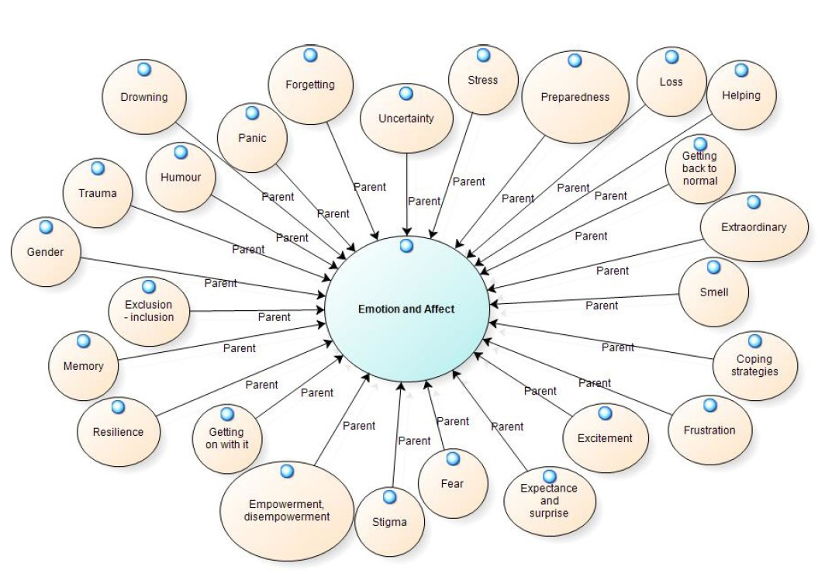

    Figure 2: Digital Stories creation – Methods 1 and 2: vignettes initially coded to resilience frames; new story developed under the same resilience frame

    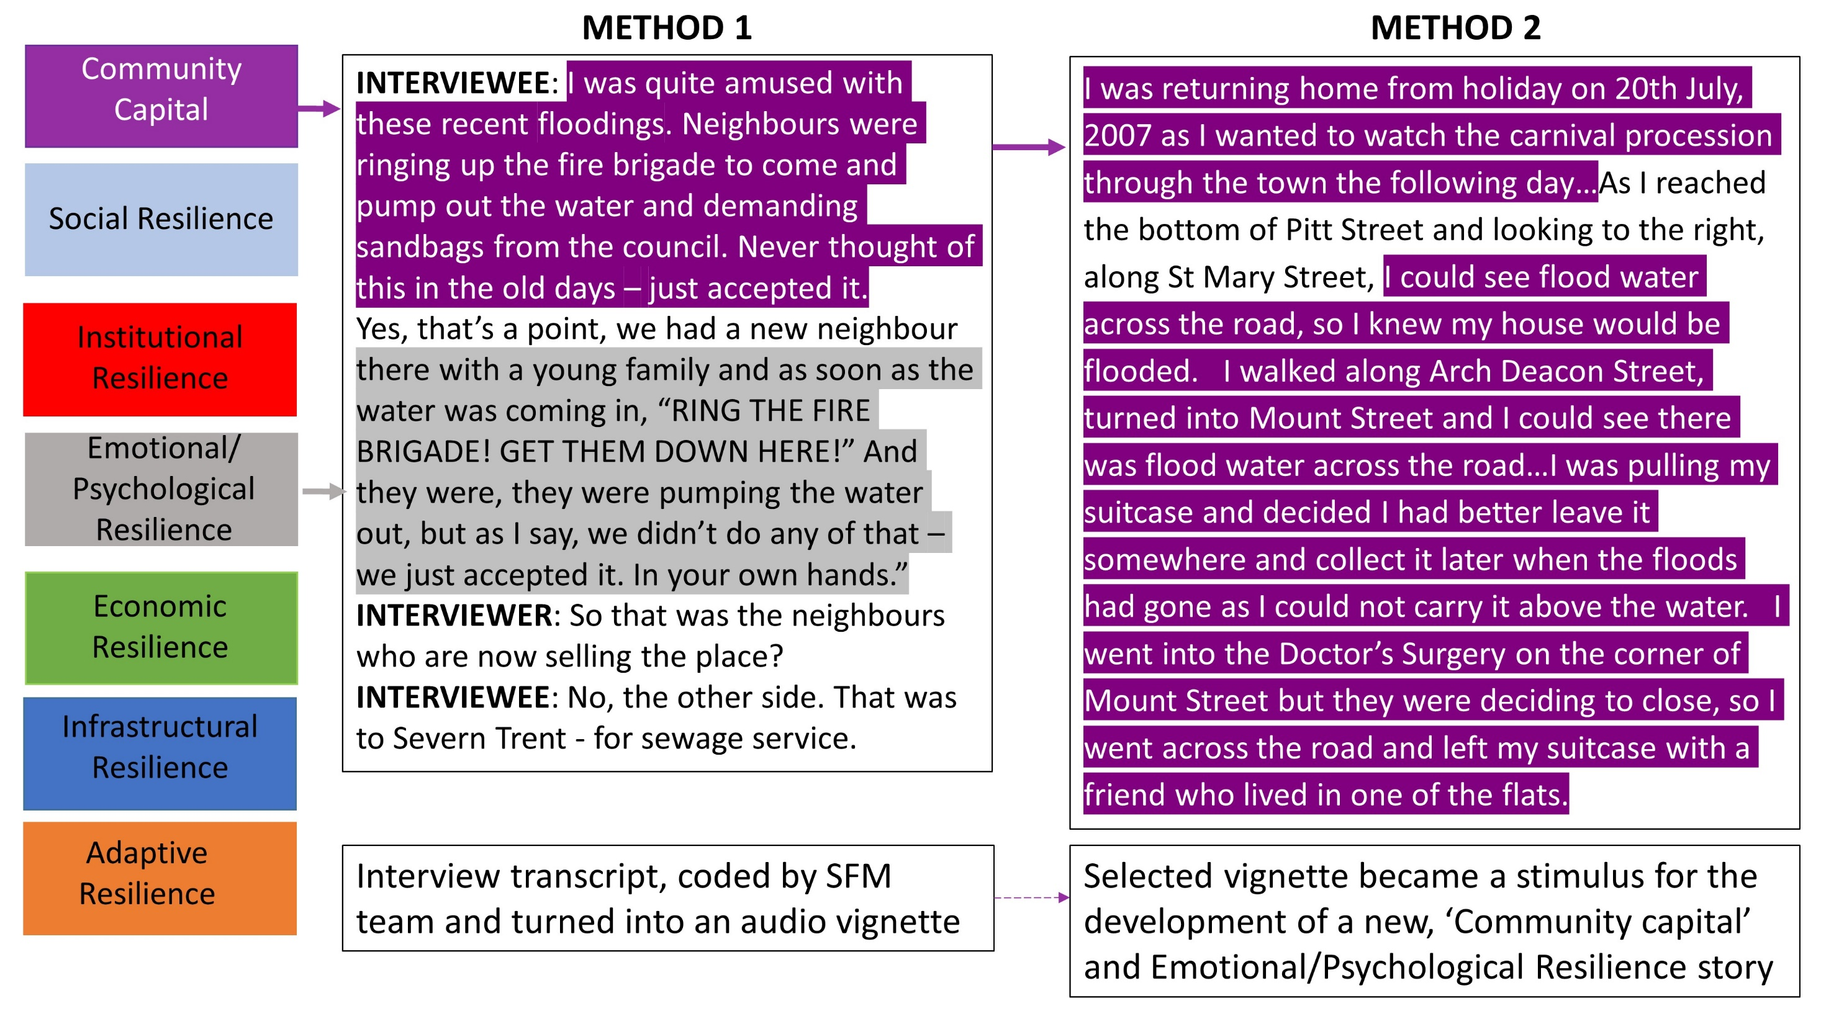

    Figure 3: A flood mark inside the house of a storyteller

    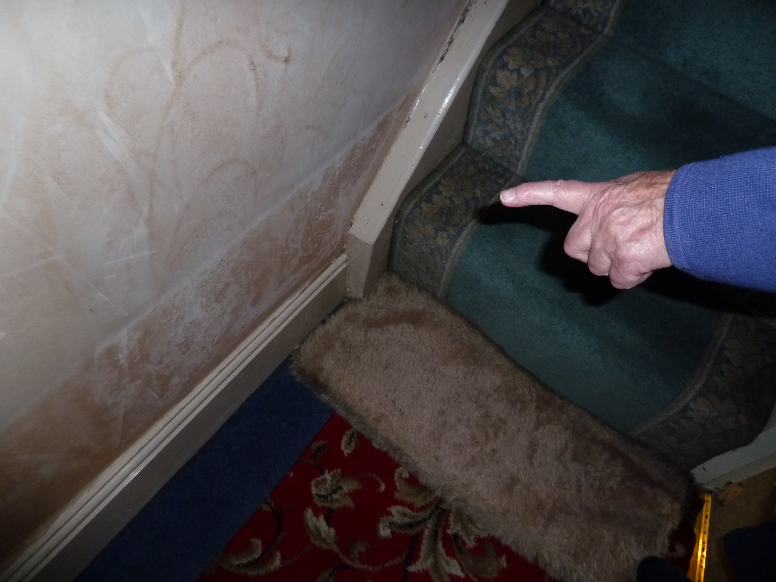

    Figure 4: Example of initial phases of digital story creation in a workshop

    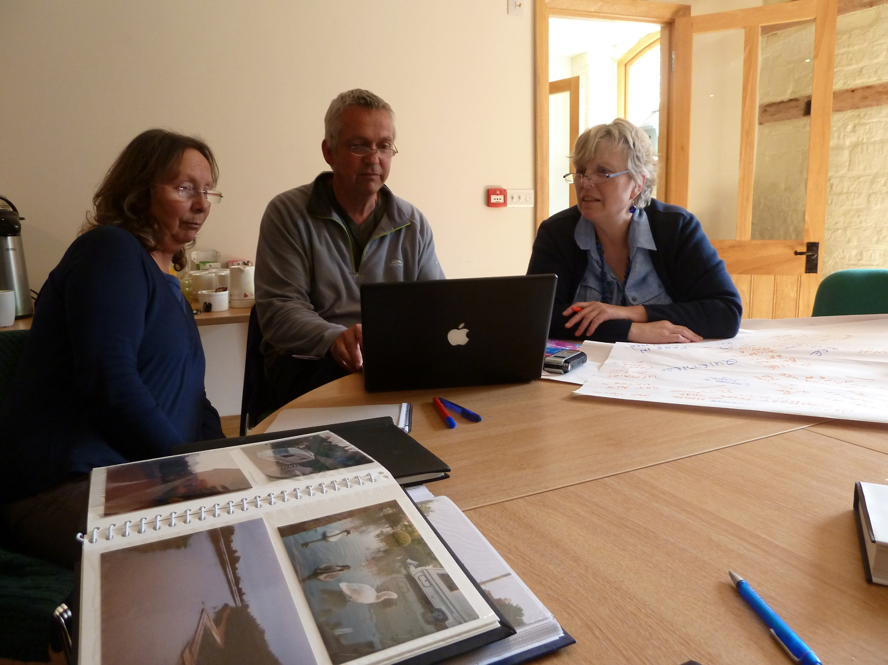

    Figure 5: A still frame with added text from Richard’s digital story

    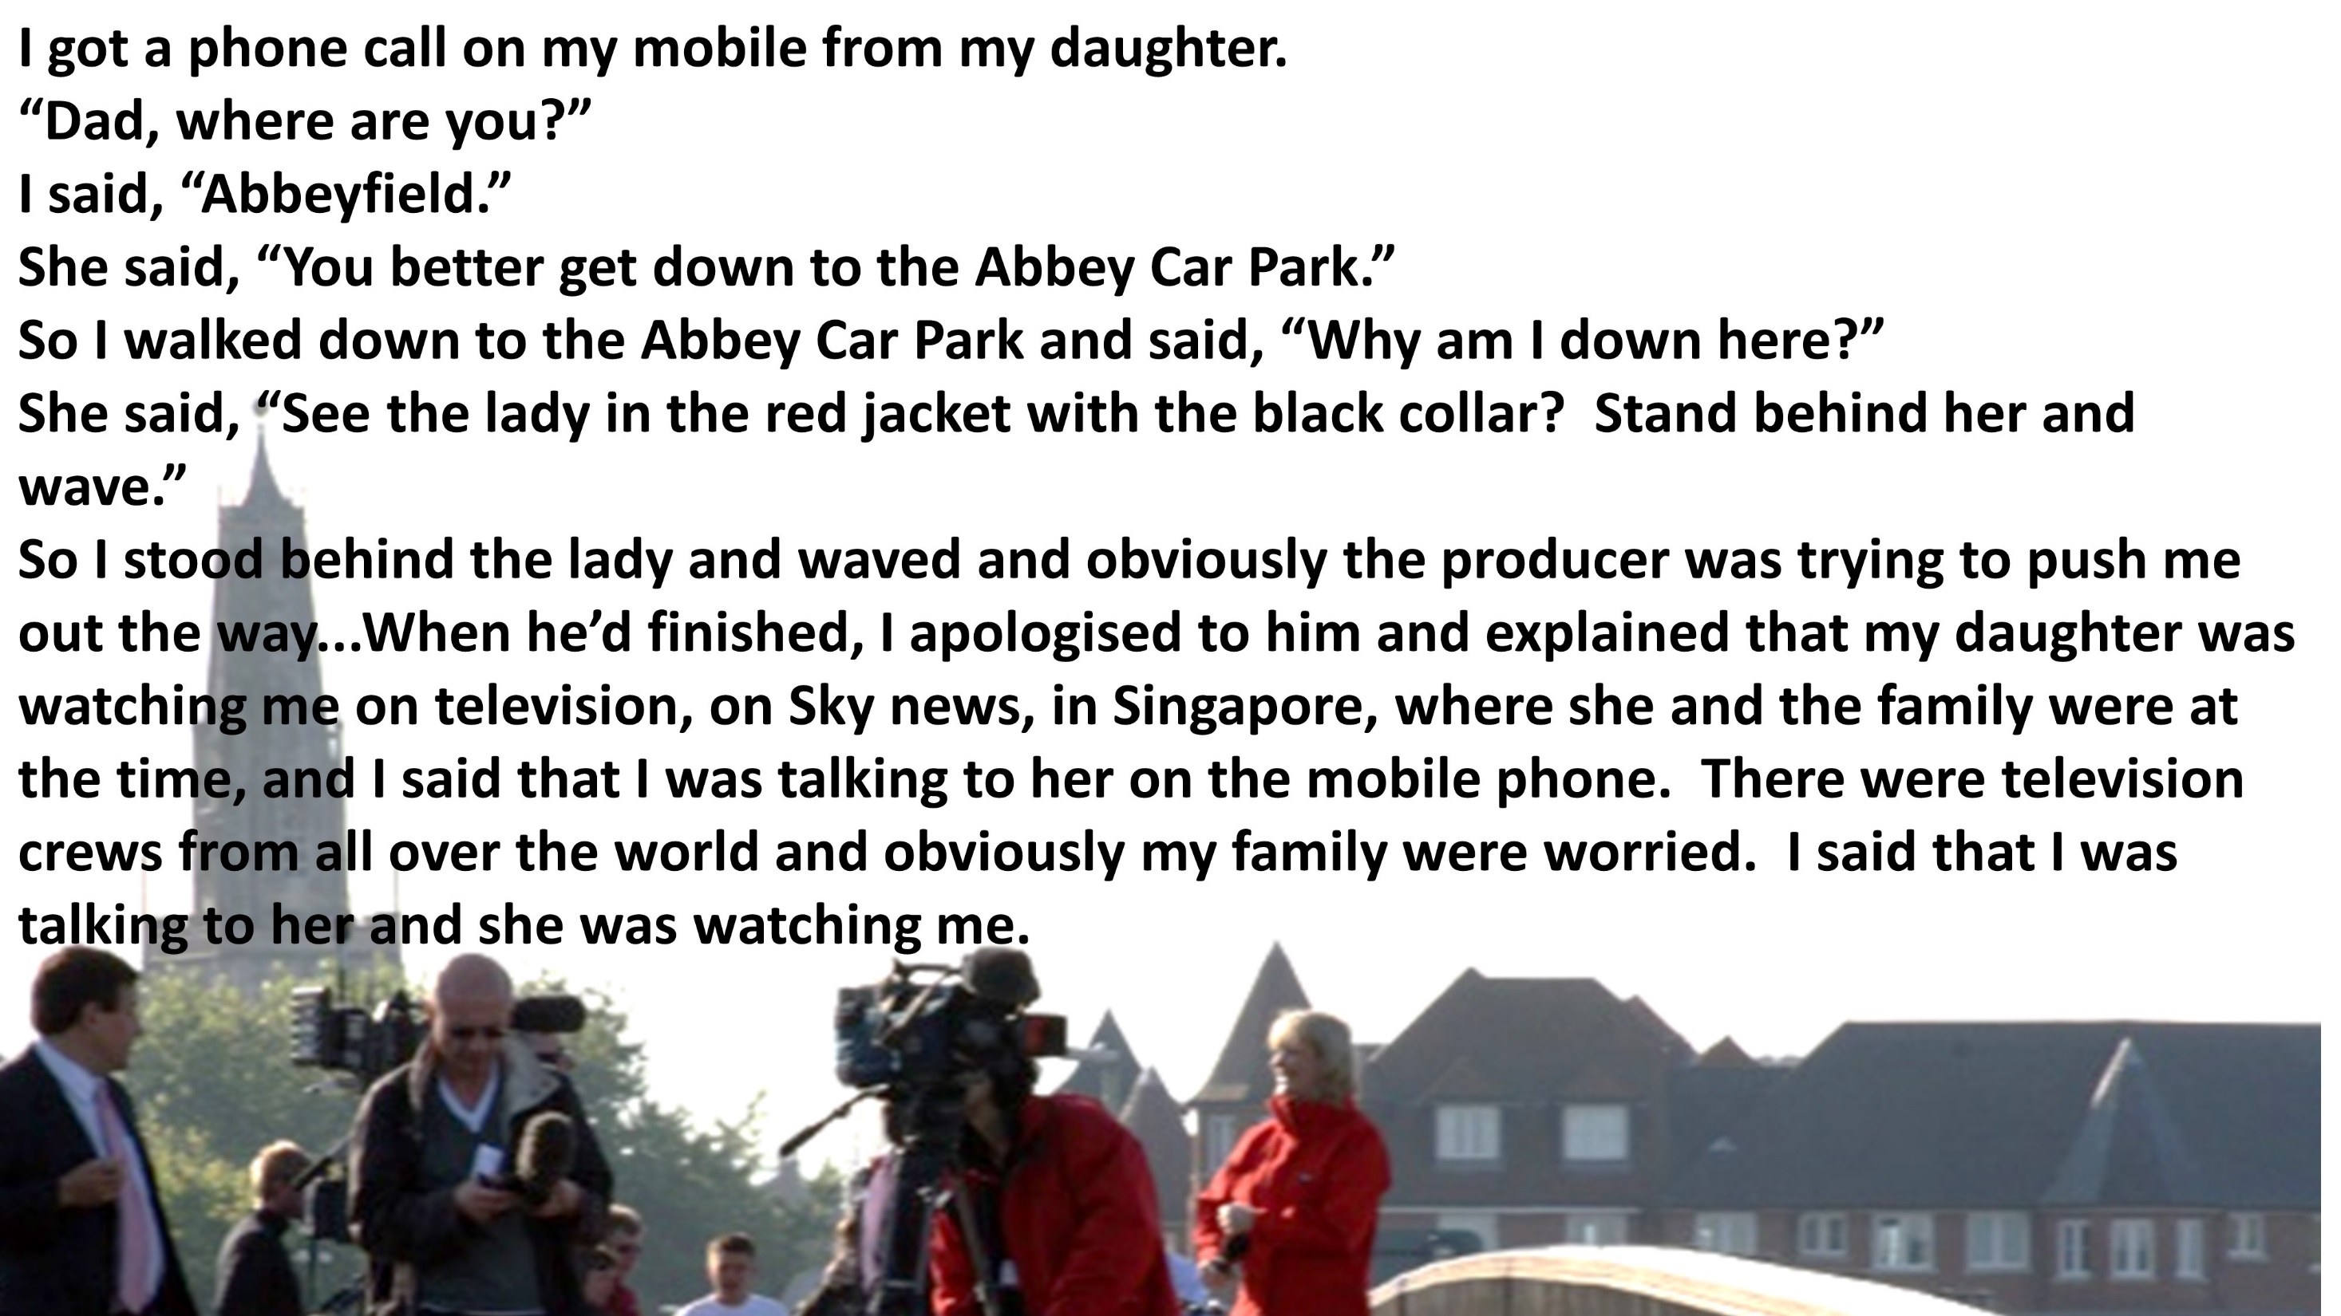

    Figure 6: A still from the "Knowing the River" digital story

    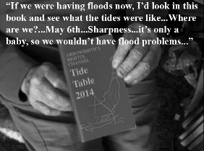

    Figure 7: A man wading in floodwater: still from a digital story

    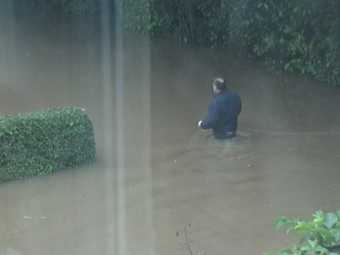

    Figure 8:

    