Title Page
Title: Gait biomechanics in Joint Hypermobility Syndrome: a spatiotemporal, kinematic and kinetic analysis.
Original Research.
Authors: Najla Alsiri, PhD.^{a, b}, Mary Cramp, PhD ª, Sue Barnett, PhDª, and Shea Palmer PhDª.
ª Department of Allied Health Professions, University of the West of England, Bristol, United Kingdom
^{b} Al-razi Orthopedic and Rehabilitation Hospital, Kuwait City, Kuwait.
The research was conducted with the approval of the East Midlands, Leicester Research Ethics Committee (14/EM/1008).
Corresponding author: Dr. Najla Alsiri. Address: Al-razi Orthopedic and Rehabilitation Hospital, Kuwait City, Kuwait. Email: dr.alsiri@outlook.com
Postal address: Sulibekhat – Jamal abdulnaser Str. P.O.Box: 5 – postal Code: 13001. Cable: Health _ Kuwait.
Acknowledgment:
The study was funded by the Kuwait government as a part of PhD project and sponsored by the University of the West of England, Bristol, United Kingdom. The authors acknowledge Donna Wicks from the Hypermobility Syndrome Association, United Kingdom, Rachel Lewis from North Bristol NHS Trust, United Kingdom, and Sin-ti Towlson from the Royal National Hospital of Rheumatic Diseases, United Kingdom, for their support during patient recruitment. The authors are grateful to the participants who took part in the research.
Source of funding: The study was funded as a PhD projects by the Kuwait Government.
Conflict of interest statement: The authors declare no conflict of interest.

Gait in Joint Hypermobility Syndrome
Title: Gait biomechanics in Joint Hypermobility Syndrome: a spatiotemporal, kinematic and kinetic analysis.
ABSTRACT
Background: Joint Hypermobility Syndrome (JHS) symptoms of widespread joint hypermobility and pain, muscle weakness and reduced muscle-tendon stiffness suggest that there may be an impact on gait parameters. Identification of gait abnormalities may inform assessment and management.
Objective: To explore the impact of JHS on gait parameters.
Study design: Cross-sectional design.
Methods: A JHS group of 29 participants (mean age 37.57 (S.D. 13.77) years) was compared to a healthy control group of 30 participants (mean 39.27 (S.D. 12.59) years). Spatiotemporal parameters, joint kinematics and joint kinetics were captured using the Qualisys motion capture system synchronized with a Kistler force platform.
Results: Statistically significant reductions in walking speed, stride length and step length were found in the JHS group, whilst stance and double support durations were significantly increased (p < 0.01). During the swing phase, the JHS group showed significantly less knee flexion (p < 0.01). Reductions hip extensor moment, and knee power generation and absorption were identified in the JHS group (p < 0.01). No other gait parameters were significantly altered.
Conclusion: The JHS group walked more slowly with a kinematic ‘stiffening’ pattern. Hypermobility was not evident during gait. The observed stiffening pattern could be a strategy to avoid pain and improve balance. Impairments in moment and power generation could be related to several symptomatic and aetiological factors in JHS. Clinicians should carefully consider gait in the assessment and management of people with JHS targeting the impairments identified by the current study.
Key words: Joint Hypermobility Syndrome, kinematic, kinetic, gait, three-dimensional.
Word count: 4548

- INTRODUCTION
Joint hypermobility syndrome (JHS) is an inherited connective tissue disorder in which multiple synovial joints demonstrate symptomatic and excessive motion in the absence of systemic inflammation (Hakim et al., 2004; Hakim and Grahame, 2003; Simmonds and Keer, 2007). JHS is multi-systemic, adversely affecting the musculoskeletal, cardiovascular, digestive and autonomic nervous systems due to abnormalities in the connective tissues of these systems, which changes their physiology (Hakim and Grahame, 2003). JHS is a severe and disabling condition found in 30% of those referred to a musculoskeletal triage service in the United Kingdom (Connelly et al., 2014). The hypermobility type of Ehlers-Danlos Syndrome (EDS-HT) has been accepted as an identical condition to JHS, where the two are indistinguishable (Ainsworth and Aulicino, 1993; Fatoye et al., 2012; Hakim et al., 2004; Hakim and Grahame, 2003; Simmonds and Keer, 2007; Tinkle et al., 2009). Although both JHS and EDS-HT were included in the present investigation, the term JHS will be used in most instances to encompass both diagnostic terms. Although new diagnostic criteria were recently introduced for hypermobility-related disorders (Castori et al., 2017; Malfait et al., 2017), the current research was conducted before those criteria were available.
Gait is an important indicator of functional capacity and general health, and reflects the integrity of visual, vestibular, proprioceptive, neuromusculoskeletal, cognitive and psychological systems (Allum and Adkin, 2003; Buchner et al., 1996; Foroughi et al., 2008; Lelas et al., 2003; Lemke et al., 2000; Patla, 1998; Rigoldi et al., 2012; Riskowski et al., 2005). Gait analysis can identify the functional impact of health conditions (Lelas et al., 2003; Flansbjer et al., 2006). The gait of people with JHS could theoretically be altered due to laxity in the connective tissues of their joints’ supportive structures (Hakim and Grahame, 2003; Simmonds and Keer, 2007). Laxity is caused by mutation in the genes encoding collagen and abnormalities in the enzymes responsible for collagen modification essential for maintaining the mechanical rigidity and stability of joints (Grahame, 2009; Malfait et al., 2006). JHS may also be associated with mutation in tenascin-X, which is prevalent in musculoskeletal tissues and bridges between collagen fibers (Malfait et al., 2006). Tenascin-X is essential for collagen formation and regulation (Malfait et al., 2006). It is therefore hypothesized that collagen deficiency in ligamentous and musculotendonous tissues is responsible for joint hypermobility and instability in JHS and will impact on lower limb joint biomechanics and spatiotemporal parameters during walking.
Symptoms such as joint pain and instability, fatigue, muscle weakness, proprioceptive deficits, and physical and psychological decline (such as depression and anxiety) might also have an impact on the gait of people with JHS (Fatoye et al., 2012; Hakim and Grahame, 2003; Rombaut et al., 2010; Toker et al., 2010). For example, chronic widespread pain in JHS could inhibit the motor system and cause muscular weakness (Le Pera et al., 2001). Knowledge of the relationship between joint pain, insability and gait parameters has previously helped to inform the management of patients with Anterior Cruciate Ligament (ACL) injuries and knee osteoarthritis. For example, people with ACL injuries were found to avoid quadriceps contraction to control tibial forward translation (Berchuck et al., 1990; Hart et al., 2009; Jensen et al., 2013) and people with osteoarthritis reduced their joint moment as a strategy to cope with pain (Hurwitz et al., 1997). Such symptoms of joint instability and pain are also features of JHS and could alter gait in people with the condition. Investigating gait parameters could therefore provide greater understanding of functional deficits in JHS and help to direct rehabilitation interventions toward specific gait impairments that might be identified.
Few studies have previously explored gait in adults with JHS/EDS-HT (Celletti et al., 2012; Galli et al., 2011; Rigoldi et al., 2012). All previous studies used three-dimensional motion analysis, which is the gold standard for assessment of movement with excellent clinimetric properties through standardized, well described and evidence-based methods (Celletti et al., 2012; Connell, et al., 2004; Ingemarsoon et al., 2003; Jensen et al., 2013). Previous studies explored specific gait components (Celletti et al., 2012; Galli et al., 2011; Rigoldi et al., 2012). Galli et al., (2011) examined 12 men and women with JHS/EDS-HT and found significant reductions in step length and ankle dorsiflexion in the JHS/EDS-HT group when compared to the control group. Rigoldi et al., (2012) compared 12 patients with EDS-HT with 20 healthy controls and demonstrated significant reductions in step length, ankle plantarflexion and hip power. Celletti et al., (2012) examined 21 women with JHS/EDS-HT and used the Gait Profile Score to represent gait kinematic differences, identifying lower physiological gait for the hip, knee and ankle overall kinematics in the JHS group.
The current study advances these reports; it provides a comprehensive three-dimensional gait analysis, including spatiotemporal, kinematic and kinetic parameters of the lower limb joints, uses clinically confirmed diagnostic criteria and has a justified sample size. Such comprehensive analysis of the entire lower limb joints is important because JHS affects the entire musculoskeletal system, rather than isolated individual joints. The findings of the current study could identify specific gait impairments in JHS to direct the rehabilitation programs, therefore optimizing the provided management and improving patient activity level. Consequently, the primary objective of the current study was therefore to explore the impact of JHS on spatiotemporal parameters and lower limb joint biomechanics (kinematics and kinetics) in adults, through a comparison with a control group. A secondary objective was to investigate the correlation between joint pain, as the predominant impairment in JHS, and spatiotemporal and biomechanical parameters.
- METHODS
2.1 Participants
The research was approved by the East Midlands, Leicester Research Ethics Committee (14/EM/1008) in accordance with The Code of Ethics of the World Medical Association (Declaration of Helsinki). Informed written consent was obtained from participants and their privacy rights was observed. Ambulatory men and women aged ≥ 18 years were included. The exclusion criteria were: lower back or lower limb injuries during the last three months as so to not interrupt the healing process (Connell et al., 2004), fracture in the lower limbs during the last 12 months as this could affect walking speed and balance (Ingemarsson et al., 2003); pregnancy; and giving birth during the last year due to postpartum ligament laxity (Romabut et al., 2011). Participants were excluded from the control group if they had generalized joint laxity (≥ 4/9 in the Beighton score); pain (within the last three months) in the lower back or lower limb joints (Connelly et al., 2014); or had a connective tissue disorder or other conditions which cause weakness in the lower limbs.
People with JHS were recruited from the Hypermobility Syndromes Association (HMSA) (a UK patient organization), and two secondary care hospitals in South West England, UK. Participants in the control group were recruited via an email advert to staff and students of the University of the West of England, Bristol, UK (UWE), and their relatives and friends. Recruitment packs were sent to potential participants, and those who were willing to take part in the study returned a reply slip to the research team. The diagnosis of JHS was initially self-declared by patients then confirmed clinically by the chief investigator (NA) using the Brighton criteria for JHS and the Revised Nosology of Villefranche for EDS-HT (Brighton et al., 1998; Hakim et al., 2004; Hakim and Grahame, 2003; Simmonds and Keer, 2007). A matching pair design for control participants with a frequency distribution control method was followed to ensure between-group homogeneity in terms of age and sex.
Prospective sample size calculations were informed by available published data, from which representative effect sizes could be calculated to investigate the study hypothesis of an impact of JHS on gait spatiotemporal parameters and biomechanics when compared to a control group. For spatiotemporal parameters, Galli et al., (2011) found a significant reduction in step length in JHS, with an observed effect size of 0.84. For kinematic parameters, Rigoldi et al., (2012) reported a significant difference for ankle dorsiflexion, with an effect size of 0.74. Finally, for kinetic parameters, Galli et al., (2011) found a reduction in plantar flexor moment during the terminal stance phase, with an effect size of 0.70. The smallest effect size of 0.70 was thus used as a realistic basis for the sample size calculation (corresponding to a moderate to large SMD). Sample size was estimated to be a minimum of 26 participants per group at α = 0.05 and 80% power. A target sample of 30 per group was set to allow for up to 20% attrition.
2.2 Instrumentation
A QualisysTM motion capture system (Qualisys, Gothenburg, Sweden) was used to capture movement kinematics through ten infrared cameras (Oqus 3+) and Qualisys Track Manager software (QTM). Instrument settings were checked and calibration was performed before each session according to the manufacturer guidelines. A Kistler force platform (Multicomponent force plate type 9281E, Kistler Group, Eulachstrasse, Swizerland) was synchronised with the Qualisys system to identity gait events and kinetics along with the trajectory analysis. The QualisysTM system captures data with high validity, reliability, and precision (Everaert et al., 1999; Yavuzer et al., 2008; Kejonen and Kauranen, 2002; Sinclair et al., 2012). Good to excellent intra-rater reliability (ICC ranged from 0.625-0.996) of the kinematics of lower limb joints was demonstrated in the current study for repeated marker placement and repeating the walk test in ten participants from the control group (Alsiri, 2017). Average pain intensity experienced over the last week was assessed using Visual Analogue Scales (VAS) for the hip, knee and ankle joints. VAS is a simple tool with high validity and reliability (Lara-Munoz et al., 2004; Williamson and Hoggard, 2005).
2.3 Data collection and analysis
Data collection was conducted at the Human Analysis Laboratory, University of the West of England (UWE), Bristol. The same researcher (NA) conducted the examination to eliminate inter-rater variability. Infrared retro-reflective markers, and four marker clusters were attached to the lower limb joints to define their segmental coordinate systems and track segmental motion following the Calibrated Anatomical System Technique (CAST) (Cappozzo et al., 1995). Joint angles were determined using the joint co-ordinate system. A static trial was recorded, prior to the collection of dynamic trials for calculation of relevant segmental co-ordinate systems. Each participant was then asked to walk along a 10 m walkway at self-selected walking speed starting with three trials for familiarization. Self-selected walking speed was examined to allow the observation of natural walking patterns of people with JHS. Five trials of each limb were recorded with clear contacts with the force plate, which is sufficient to obtain good reliability; ICC > 0.7 (Laroche et al., 2011). Twenty seconds rest was provided between trials to minimise fatigue (Orendurff et al., 2008).
Data were processed using the QTM software to display and identify the markers’ trajectories and their six degrees of freedom using the Automatic Identification Model. Each gait event was labelled, and foot contact and foot off gait events were labelled to identify stance and swing phases. A low-pass filter was used to remove the noise without affecting the true signals. The output was transmitted to a computer through analogue-digital converter, then to QTM and sampled at a frequency of 100 Hz. After events processing the data were converted to C3D files and transferred and processed in Visual 3D software to produce kinematic and kinetic curve graphs. Data normalized to gait cycle within Visual 3D, were exported in ASCii format to Microsoft Excel.
Statistical Package for the Social Science (SPSS version 22, IBM corp.) was used for statistical analysis. Histograms and Shapiro-Wilk tests were used to assess data normal distribution (Field, 2009). Independent t-tests were used for the normally distributed data to analyse differences between groups, and Mann-Whitney U tests were used for non-normally distributed data (Field, 2009). Inferential statistics were used to compare the JHS group against the control group in terms of gait spatiotemporal parameters including walking speed, stride and step length, stance time duration, double support time, initial double support time, and terminal double support time. The two groups were compared in terms of gait kinematics of the pelvic, hip, knee and ankle joints in the frontal, sagittal and transverse planes. Gait kinetics, namely moments and powers, were also compared at the hip, knee and ankle joints in the three planes of movement. To reduce the risk of type I error due to multiple comparisons, the alpha was reduced to 0.01 (Pallant, 2010). Therefore, statistically significant differences were identified when p ≤ 0.01.
Standardised mean differences (SMDs) was reported with 95% confidence interval (CI) to quantify the size of the differences (Cohen, 1988; Samsa et al., 1999; Walker, 2007). A SMD of 0.2 suggests a small difference, 0.5 suggests a moderate difference, and 0.8 suggests a large difference (Cohen, 1988). SMDs of 0.5 and higher are highlighted in bold in the tables (tables 2-5). To make the data more accessible, only analyses for the right leg are presented in this manuscript, as there were no statistically significant differences between right and left limbs. Pearson Product Correlation Coefficients were used to correlate joint pain with gait parameters. A confounded analysis was performed with multiple regressions to examine the potential influence of age, body weight, and joint pain (back, hip, knee and ankle pain), with gait parameters found to be significantly different in the JHS group.
- RESULTS
3.1 Demographic and pain data
Participant demographic characteristics, reported in table 1, indicate that the groups were largely similar. Significant differences were found between the two groups in the Beighton score, as would be expected. The JHS group showed statistically significant increase in the pain intensity experienced at the hip, knee and ankle joints during both rest and movement when compared to the control group; p = 0.001 (Table 1).
Table one will be inserted here ---------------------------------------------------
3.2 Spatiotemporal parameters
Statistically significant differences were found for the JHS group in walking speed, initial double support duration and terminal double support duration (table 2). The SMDs were moderate to large for the majority of those differences (table 2).
Table two will be inserted here ------------------------------------------------------
3.3 Kinematic gait analysis
No statistically significant differences were identified between the two groups for pelvic and hip kinematics (table 3). The SMDs suggested a moderate reduction in pelvis upward obliquity and hip abduction in the JHS group during the swing phase (table 3). A statistically significant reduction was found in knee flexion during the swing phase in the JHS group and the SMD suggested a moderate difference (table 4), this change was illustrated graphically (figure 1). No graphical observations nor statistical differences were highlighted for ankle kinematics (table 4).
Table three will be inserted here ---------------------------------------
Table four will be inserted here ----------------------------------------
Figure 1 will be inserted here -----------------------------------------------
3.4 Kinetic gait analysis
The statistical analysis identified significant reductions in the JHS group when compared to the control group in hip extensor moment, knee power generation in the sagittal plane, and knee power absorption in the transverse plane (table 5). These changes are illustrated graphically in figure 2. The SMDs suggested moderate differences between the two groups in hip extensor and internal rotator moments (table 5). Moderate to large differences were identified between the groups as suggested by the SMDs in knee extensor, internal rotator, and external rotator moments, and knee power generation in the sagittal plane and knee power absorption in the transverse plane (table 5).
Table 5 will be inserted here ------------------------------------------
Figure 2 will be inserted here -------------------------------------
3.5 Joint pain
The most common painful joint in the JHS group was the knee joint (90.32% of participants), followed by the hip joint (83.87%) and the ankle joint (77.41%). Relationships proved to be statistically significant were only reported, where joint pain was significantly correlated (p<0.05) to walking speed, stride length and stance duration percentage. Moderate correlations were found between stance duration percentage and hip and ankle joint pain (r = 0.436 and 0.446 respectively). Very weak to weak correlations were found between joint pain and gait kinematics (r-values ranged 0.005 to 0.281).
3.6 Confounded analysis:
The results of multiple regression (Table 6) showed that the established model of the influence of age, body weight and joint pain explains 16.2% of the variance in gait speed, 13.6% of the variance in maximum knee flexion during the swing phase, 12.3% of the variance in hip maximum moment at the sagittal plane, 16.8% of the variance in knee maximum power generation in the sagittal plane, and 30.4% of the variance in knee minimum power absorption in the transverse plane (Table 6). However, none of the models reached statistical significance except for the knee power absorption model (p = 0.003). Beta Standardized Coefficients were the highest for joint pain but only knee pain in knee minimum power absorption model reached statistical significance (p = 0.007).
Table 6 will be inserted here --------------------------------------------------------
- DISCUSSION
A range of spatiotemporal parameters were significantly different with large effect sizes in the JHS group compared to the control group, including walking speed, stride length, step length, initial double support time and terminal double support time. A statistically significant reduction with medium effect size was identified in the JHS group’s kinematics in knee flexion during the swing phase. Simultaneously, statistically significant reductions with medium to large effect sizes were shown in the JHS group in hip extensor moment, knee power generation in the sagittal plane, and knee power absorption in the transverse plane. Multiple regression analyses of the current study indicated that joint pain could be the main influence on joint biomechanics.
Spatiotemporal parameters for adults with JHS were explored in one previous study. Galli et al., (2011) reported a significant reduction in the EDS-HT group’s step length with no significant difference in stance phase duration and velocity. The current investigation contradicts Galli et al., (2011), as a significant reduction in walking speed, and a significant increase in double support time and terminal double support time were identified. Galli et al., (2011) used a small sample size of 12 participants with EDS-HT versus 20 controls exposing their results to possible type II error. Galli et al., (2011) also did not clarify their patient diagnostic criteria which may have created differences in sample characteristics between the two studies.
The significant changes in the JHS group’s spatiotemporal parameters could be explained by joint pain and reduced power as these factors have previously been identified as being significantly correlated with walking speed (Chen et al., 1997; Lusa, et al., 2015; Purser et al., 2012). Adopting a pattern of increasing the double support duration in JHS could be a strategy to avoid joint pain, stress and load (Debi et al., 2009), where correlations were found in the current study between stance duration percentage and hip and ankle joint pain. Significant reductions in hip moments and knee power generation and absorption, identified in the current study, could explain the alterations in spatiotemporal parameters. We have previously reported (Alsiri, 2017) the predicted effect of differences in walking speed on kinetic parameters using the regression equations of Lelas et al., (2003). All predicted differences were less than the actual observed differences. Therefore, although speed may have been a factor, it is insufficient to explain the differences between groups. It should be noted, however, that regression equations were not available for all kinetic parameters investigated in our study.
A ‘stiffening’ pattern was evident in people with JHS, identified as the stiffening of hypermobile joints to act as normally mobile joints during the stance phase of walking. Most of the descriptive statistics, graphical observations, and the SMDs suggested that the JHS group’s kinematics were either comparable or reduced when compared with the control group and provides some support for this pattern. Stiffening was also evident as a reduction in gait kinematics during the swing phase. There was a statistically significant reduction in knee flexion, and the SMDs suggested moderate reductions in pelvic upward obliquity and hip abduction. The similarities found in the graphs between the control group and the JHS group (despite joint hypermobility) further support this stiffening pattern.
The concurrent statistical reductions in joint moments and powers, along with kinematic stiffening, could suggest a relationship between the kinematic and kinetic observations in JHS. Kinetic reductions in the JHS group could be related to collagen and protein genetic abnormalities, muscle weakness, reduction in musculoskeletal stiffness and/or pain-motor inhibition (Hakim and Grahame, 2003; O’Connell et al., 2010; Rombaut et al., 2012; Sahin et al., 2008; Scheper et al., 2013; Syx et al., 2015; Voermans et al., 2009; Alsiri et al., 2019). The kinetic reductions identified in the JHS group could be an avoiding behavior employed intentionally to avoid joint hypermobility and pain, which might also explain the stiffening observed in the kinematic analysis. The avoiding behavior theory was first described by Berchuck et al., (1990) as “quadriceps avoidance” theory and was further supported by a study in people with ACL injuries (Berchuck et al., 1990; Hart et al., 2009; Jensen et al., 2013). This pattern is adopted by people with ACL injury by reducing the contraction of the quadriceps to control tibial forward translation (Hart et al., 2009). Such a theory could be applied to people with JHS as they may share some instability features with the ACL population. Such behavior is also noticed in people with osteoarthritis, where moments are reduced during walking and this has been referred to as a pain coping strategy (Hurwitz et al., 1997). The stiffening pattern we have observed could be further explored through electromyographic studies to understand the contribution of the lower limb musculature.
The current study analysed the gait kinematics of people with JHS in three planes of movement. Therefore, there are several parameters that could not be compared with the existing literature. Gait kinematics in adults with JHS were explored in two studies previously, where mostly sagittal plane kinematics were reported. The results of the first study of Galli et al (2011) support the stiffening pattern we observed, as functional joint hypermobility was not demonstrated in the EDS-HT group. Specifically, no significant differences between EDS-HT and the control group were found for the pelvis, hip and knee kinematics during the stance phase, except for ankle dorsiflexion which was significantly reduced. The second available study of Celletti et (2012) further supports the stiffening pattern, as the kinematic parameters were physiologically reduced when compared to the control group. However, comparing the current results with those of Celletti et al (2012) might be inappropriate due to differences in data reporting; they used the Gait Profile Score, a single index for gait alterations.
There has been no previous report exploring hip and knee moments and powers during the gait cycle in people with JHS. Galli et al., (2011) reported significant reductions in the ankle plantar flexors’ moment and power generation in the EDS-HT group. The reductions observed in the current study failed to reach statistical significance. The contrast in findings might be related to the heterogeneous age of the groups investigated by Galli et al. (2011) (mean ± SD age of the EDS-HT group was 43.08 ± 6.78 and in the control group was 37.23 ± 8.91 years) (Galli et al., 2011), with the reduced moment and power generation in the JHS group being related to their older age. However, our study also observed reduced ankle plantar flexors moment and ankle power generation in the JHS group that did not reach statistical significance. The associated SMDs suggested small to medium differences which may indicate type II error in our results.
Previous biomechanical explorations in JHS were limited, therefore, the findings of reduced kinetic values have been compared against other musculoskeletal conditions. Analysis has previously revealed moment reductions in people with osteoarthritis, with the exception of a significant increase in knee adductor moment, and ACL injuries like JHS (Hurwitz et al., 1997; Hart et al., 2009; Toker et al., 2010). ACL injuries may be more comparable with JHS due to sharing the instability feature. People with JHS might adopt stiffening as a pain-avoiding behavior to avoid over-stressing the joints and inducing pain. Joint laxity and hypermobility are major contributors to the pathogenesis of pain (Acasuso-Diaz and Collantes-Esteez, 1998). Overstretching the joint structures could induce micro-trauma, inflammation and pain, which can be complicated with repetitive over-stretching causing overuse injuries and a vicious cycle of pain (McMaster, 1996; Smith, 2005). Stiffening could be adopted to control the hypermobility-pain cycle. People with JHS might adopt stiffening during walking due to their fear of falling, as controlling their walking kinematics could improve their balance, where 95% of the participants in the EDS-HT group in Rombaut et al.’s (2011) study had fallen during the previous year. Kinematic reduction in the swing limb could be adopted as a load reduction strategy employed to reduce joint stress and pain and improve equilibrium (Mundermann et al., 2005; Simic et al., 2011). Balance is a critical problem in people with JHS, and it is associated with increased falling frequency (Rombaut et al., 2011). Such a strategy of reducing the leg opening by reducing pelvic upward obliquity and hip abduction maintains the center of mass within the base of support, could maintain equilibrium (Cappozzo et al., 1995; Lee and Farley, 1998). Moreover, medio-lateral trajectory of the center of mass is influenced by hip abduction/adduction to control medio-lateral equilibrium (Winter, 1995).
The current study has comprehensively explored gait parameters in people with JHS, including spatiotemporal, kinematic and kinetic parameters for the entire lower limbs. The study used a gold standard three-dimensional motion analysis, valid diagnostic criteria and a standardized protocol. In addition, a conservative alpha level of 0.01 was employed for statistical significance to reduce the risk of type I error due to multiple comparisons. However, the study is limited by several factors. The cross-sectional design employed in the current study can be used to examine relationships and associations, however, this design is unable to determine cause and effect relationships (Hennekens and Buring, 1987). It was not practical to blind the lead researcher, which might risk exposing the results to expectation bias (Bailey, 1997; Bowling, 2009), and gait kinematics were not normalised to speed (Lelas et al., 2003; Kwon et al., 2015). The sample was based on a priori sample size calculations, however the medium to large effect size of 0.70 used in the calculation, in conjunction with the use of a conservative alpha level, may have exposed the study to type II errors. A study with a larger sample size would be needed to explore any observations that failed to reach statistical significance. The reduced kinetics observed in the JHS group might be related to the fact that the JHS group walked more slowly than the control group (Ardestani et al., 2016). This factor has not been corrected for and this should be considered when interpreting the kinetics findings.
Clinicians should carefully consider gait in the assessment and management of people with JHS, particularly understanding and improving the relationships between joint pain and the stiffening gait pattern. Rehabilitation programs could be directed towards improving joint control through specific and functional strength training for dynamic stabilizer muscles and gradually increasing walking speed. The success of gait training should be assessed via effects on pain and reducing the dependency on the stiffening pattern. Future studies are needed to understand the long-term effects of the stiffening pattern on potential muscle weakness, instability and pain and to evaluate the effectiveness of gait training.
- CONCLUSION
Multiple gait impairments were revealed in people with JHS, including reduced walking speed, altered spatiotemporal parameters, stiffened kinematics and reduced moments and powers. Future research is needed to determine the effects of the observed stiffening pattern on the long-term symptoms and progression of the condition. The identified impairments could be targeted during gait rehabilitation to improve activity and participation.

- CONFLICT OF INTEREST
The authors declare no conflict of interest.

- REFERENCES
- Acasuso-Diaz M, Collantes-Esteez E. Joint hypermobility in patients with fibromyalgia syndrome. Arthritis Care Res. 1998;11(1):39-42.
- Ainsworth S, Aulicino, P. A survey of patients with Ehlers-Danlos syndrome. Clin Orthop Relat Res. 1993;286:250-256.
- Allum J, Adkin A. Improvements in trunk sway observed for stance and gait tasks during recovery from an acute unilateral peripheral vestibular deficit. Audiol Neurotol. 2003;8(5):286-302.
- Alsiri N. The impact of joint hypermobility syndrome in adults: a quantitative exploration of neuromuscular impairments, activity limitations and participation restrictions. 2017. University of the West of England, Bristol. http://eprints.uwe.ac.uk/30112/18/Thesis_Najla_4RegistoryV2.pdf
- Alsiri N, Al-Obaidi S, Asbeutah A, Almandeel M, Palmer S. The impact of hypermobility spectrum disorders on musculoskeletal tissue stiffness: an exploration using strain elastography. Clin Rheumatol. 2019;38(1):85-95.
- Ardestani M, Ferrigno C, Moazen M, Wimmer M. From normal to fast walking: impact of cadence and stride length on lower extremity joint moments. Gait and Posture. 2016;46:118-125.
- Bailey D. 1997. Research for health professional: a practical guide. 2nd ed. Philadelphia: F.A. Davis Company.
- Berchuck M, Andriacchi T, Bach B, Reider B. Gait adaptation by patients who have a deficient anterior cruciate ligament. Journal of Bone and Joint Surgery. 1990;72(6):871-877.
- Bowling A. 2009. Research methods in health: investigating health and health services. 3rd ed. England: The McGraw-Hill Companies.
- Brighton P, Paepe A, Steinmann B, Tsipouras P, Wenstrup R. Ehlers-Danlos syndrome: Revised Nosology, Villefranche, 1997. Am J Med Genet. 1998;77:31-37.
- Buchner D, Larson E, Wagner E, Koepsell T, Lateur B. Evidence for a non-liner relationship between leg strength and gait speed. Age Aging. 1996;25(5):386-391.
- Cappozzo A, Catani F, Croce U, Leardini A. Position and orientation in space of bones during movement: anatomical frame definition and determination. Clin Biomech. 1995;10(4):171-178.
- Castori M, Tinkle B, Levy H, Grahame R, Malfait F, Hakim A. A framework for the classification of joint hypermobility and related conditions. Am J Med Genet C Semin Med Genet. 2017;175(1):148-157.
- Celletti C, Galli M, Cimolin V, Castori M, Albertini G, Camerota F. Relationship between fatigue and gait abnormality in joint hypermobility syndrome/Ehlers-Danlos syndrome hypermobility type. Res Dev Disabil. 2012;33(6):1914-1918.
- Chen I, Kuo K, Andriacchi T. The influence of walking speed on mechanical joint power during gait. Gait Posture. 1997;6:171-176.
- Cohen J. 1988. Statistical power analysis for behavioural sciences. 2nd edition. USA: Lawrence Erlbaum Associates.
- Connell D. Schneider-Kolsky M. Hoving J, Malara F, Buchbinder R, Koulouris G, Burke F, Bass C. Longitudinal study comparing sonographic and MRI assessments of acute and healing hamstring injuries. AJR Am J Roentgenol. 2004;183(4):975-984.
- Connelly E, Hakim E, Davenport S, Simmonds J. A study exploring the prevalence of Joint Hypermobility Syndrome in patients attending a Musculoskeletal Triage Clinic. Physiotherapy Practice and Research. 2014;36(1):43-53.
- Debi R, Mor A, Segal O, Segal G, Debbi E, Agar G, Halperin N, Haim A, Elbaz, A. Differences in gait pattern, pain, function and quality of life between males and females with knee osteoarthritis: a clinical trial. Musculoskeletal Disorders. 2009;10(127).
- Everaert D, Spaepen A, Wouters M, Stappaerts K, Oostendrop R. Measuring small linear displacements with a three-dimensional video motion analysis system: determining its accuracy and precision. Arch Phys Med Rehabil. 1999;80(9):1082-1089.
- Fatoye F, Palmer S, Macmillan F, Rowe P, Van der Linsen M. Pain intensity and quality of life perception in children with hypermobility syndrome. Rheumatol Int. 2012;32:1277-1284.
- Ferrell W, Tennant N, Sturrock R, Ashton L, Greed G, Brydson G, Rafferty D. Amelioration of symptoms by enhancement of proprioception in patients with joint hypermobility syndrome. Arthritis Rheum. 2004;50(10):3323-3328.
- Field A. 2009. Discovering statistics using SPSS. 3rd ed. London: SAGE publication.
- Flansbjer U, Downham D, Lexell J. Knee muscle strength, gait performance, and perceived participation after stroke. Physical Medicine and Rehabilitation. 2006;87(7):974-980.
- Foroughi N, Smith R, Vanwanseele B. The association of external knee adduction moment with biomechanical variables in osteoarthritis: A systematic review. The Knee. 2008;16(5):303-309.
- Fritz S. Lusardi M. White paper: “walking speed: the sixth vital sign”. J Geriatr Phys Ther. 2009;32(2):2-5.
- Galli M, Cimolin V, Rigoldi C, Castori M, Celletti C, Albertini G, Camerota F. Gait strategy in patients with Ehlers-Danlos syndrome hypermobility type: a kinematic and kinetic evaluation using 3D gait analysis. Res Dev Disabil. 2011;32:1663-1668.
- Grahame R. Joint hypermobility syndrome pain. Current Pain and Headache Reports. 2009;13:427-433.
- Hakim A, Cherkas L, Grahame R, Spector T, MacGregor A. The genetic epidemiology of joint hypermobility: a population study of females twins. Arthritis & Rheum. 2004;50 (8):2640-2644.
- Hakim A, Grahame R. 2003. Joint hypermobility. Best Pract Res Clin Rheumatol. 2003;17(6):989-1004.
- Hall, S. (1999) Basic biomechanics. 3rd ed. United States: McGraw Hill.
- Hart J, Ko J, Konold T, Pietrosimione B. Sagittal plane knee joint moments following anterior cruiciate ligament injury and reconstruction: A systematic review. Clinical Biomechanics. 2009;25:277-283.
- Hennekens CH, Buring JE. Epidemiology in Medicine, Lippincott Williams & Wilkins, 1987.
- Hurwitz D, Hulet C, Andriacchi T, Rosenberg A, Galante J. Gait compensations in patients with osteoarthritis of the hip and their relationship to pain and passive hip motion. Journal of Orthopaedic Research. 1997;15:629-635.
- Ingemarsson A, Frandin K, Mellstrom D, Moller M. Walking ability and activity level after hip fracture in elderly- a follow-up. J Rehabil Med. 2003;35 (2):76-83.
- Jensen B, Olesen A, Pedersen M, Kristensen J, Remvig L, Simonsen E, Juul-Kristensen B. Effect of generalised joint hypermobility on knee function and muscle activation in children and adults. Muscle Nerve. 2013;48(5):762-769.
- Judge J, Ounpuu S, Davis R. Effects of age on the biomechanics and physiology of gait. Clinics in Geriatrics Medicine. 1996;12(4):659-678.
- Kejonen P, Kauranen K. Reliability and validity of standing balance measurements with a motion analysis system. Physiotherapy. 2002;88(1):25-32.
- Kwon J, Son S, Lee N. Changes of kinematic parameters of lower extremities with gait speed: a 3D motion analysis study. J Phys Ther Sci. 2015;27(2):477-479.
- Lara-Munoz, C., Leon, S., Feinstein, A., Puente, A. and Wells, C. (2004) Comparison of three rating scales for measuring subjective phenomena in clinical research. Archives of Medical Research. 35 (1), pp. 43-48.
- Laroche D, Duval A, Morisset C, Beis J, d’Athis P, Maillefert J, Ornetti P. Test-retest reliability of 3D kinematic gait variables in hip osteoarthritis patients. Osteoarthritis Cartilage. 2011;19:194-199.
- Le Pera, D., Graven-Nielsen, T., Valeriani, M., Oliviero, A., Lazzaro, V., Tonali, P. and Arendt-Nielsen, L. (2001) Inhibition of motor system excitability at the cortical and spinal level by tonic muscle pain. Clinical Neurophysiology. 112 (9), pp. 1633-1641.
- Lee, C. R., Farley, C. T., 1998. Determinants of the center of mass trajectory in human walking and running. J Exp Biol. 201, pp. 2935-2944.
- Lelas J, Merriman G, Riley P, Kerrigan D. Predicting peak kinematic and kinetic parameters from gait speed. Gait Posture. 2003;17(2):106-112.
- Lemke M, Wendorff T, Mieth B, Buhl K, Linnemann M. Spatiotemporal gait pattern during over ground locomotion in major depression compared with healthy control. Journal of Psychiatric Research. 2000;34(4-5):277-283.
- Lusa A, Amigues I, Kramer H, Dam T, Giles J. Indicators of walking speed in rheumatoid arthritis: relative influence of articular, psychological, and body composition characteristics. Arthritis Care Res (Hoboken). 2015;67(1):21-31.
- Malfait F, Francomano C, Byers P, Belmont J, et al. (2017) The 2017 international classification of the Ehlers-Danlos syndrome. Am J Med Genet C Semin Med Genet. 2017; 175(1):8-26.
- Malfait, F., Hakim, A., Paepe, A. and Grahame, R. (2006) The genetic basis of the joint hypermobility syndromes. Rheumatology (Oxford). 45 (5), pp. 502-507.
- McMaster W. Swimming injuries. Sports Med. 1996;22(5):332-336.
- Mickelborough J, Van der Linden M, Richards J, Ennos A. Validity and reliability of a kinematic protocol for determining foot contact events. Gait Posture. 2000;11:32-37.
- Mundermann A, Dyrby C, Andriacchi T. Secondary gait changes in patients with medial compartment knee osteoarthritis: increased load at the ankle, knee and hip during walking. Arthritis Rheum. 2005;52(9):2835-2844.
- O’Connell M, Burrows N, Van Vlijmen-Willems M, Clark S, Schalkwijk J. Tenascin-X deficiency and Ehlers-Danlos syndrome: a case report and review of the literature. Br J Dermatol.2010;16(6):1340-1345.
- Orendurff M, Schoen J, Bernatz G, Segal A, Klute G. How humans walk: bout duration, steps per bout, and rest duration. J Rehabil Res Dev. 2008;45(7):1077-1089.
- Pallant, J. (2010). SPSS survival manual. 4th ed. London: McGraw.
- Patla A. How is human gait controlled by vision. Ecological Psychology. 1998;10(3-4):287-302.
- Purser J, Golightly Y, Fenf Q, Helmick C, Renner J, Jordan J. Slower walking speed is associated with incident knee osteoarthritis-related outcomes. Arthritis Care Res (Hoboken). 2012;64(7):1028-1035.
- Richards J. The measurement of human motion: a comparison of commercially available systems. Hum Mov Sci. 1999;18:589-602.
- Rigoldi C, Galli M, Cimolin V, Camerota F, Celletti C, Tenore N, Albertini G. Gait strategy in patients with Ehlers-Danlos syndrome hypermobility type and Down syndrome. Res Dev Disabil. 2012;33(5):1437-1442.
- Ringsberg K, Cerdhem P, Johansson J, Obrant K. Is there a relationship between balance, gait performance and muscular strength in 75-year-old women? Age Aging. 1999;28(3):289-293.
- Riskowski J, Mikesky A, Bahamonde R, Alvey T, Burr D. Proprioception, gait kinematics, and rates of loading during walking: are they related? Journal of Musculoskeletal and Neurological Interaction. 2005;5(4):379-387.
- Rombaut L, Malfait F, Cools, A, De Paepe A, Calders P. 2010. Musculoskeletal complaints, physical activity and health-related quality of life among patients with the Ehlers-Danlos syndrome hypermobility type. Disabil Rehabil. 2010;32(16):1339-1345.
- Rombaut L, Malfait F, De Wandele I, Mahieu N, Thijs Y, Segers P, Paepe A, Claders P. Muscle- tendon tissue properties in the hypermobility type Ehlers-Danlos syndrome. Arthritis Care Res (Hoboken). 2012;64(5):766-772.
- Rombaut L, Malfait F, De Wandele I, Thijs Y, Palmans T, De Paepe A, Calders P. Balance, gait, falls, and fear of falling in women with the hypermobility type of Ehlers-Danlos syndrome. Arthritis Care Res (Hoboken). 2011;63(10):1342-1439.
- Rothman K. No adjustments are needed for multiple comparisons. Epidemiology. 1990;1(1):43-46.
- Sahin, N, Baskent A, Ugurlu H, Berker E. Isokinetic evaluation of knee extensor/flexor muscle strength in patients with hypermobility syndrome. Rheumatology International. 2008:28;643-648.
- Samsa G, Edelman D, Rothman M, Willimans R, Lipscomb J, Matchar D. Determining clinically important differences in health status measures. A general approach with illustration to the health utilities index mark II. Pharmacoecomomics. 1999;15(2):141 – 155.
- Scheper M, Engelbert R, Rameckers E, Verbunt J, Remvig L, Juul-Kristensen B. Children with generalised joint hypermobility and musculoskeletal complaints: state of the art diagnostics, clinical characteristics, and treatment. Biomd Res Int. 2013. doi: 10.1155/2013/121054.
- Simic M, Hinman R, Wrigley T, Bennell K, Hunt M. Gait modification strategies for altering knee joint load: A systematic review. Arthritis Care Res (Hoboken). 2011;63(3):405-426.
- Simmonds J, Keer R. Hypermobility and the hypermobility syndrome. Man Ther. 2007;12:298-309.
- Sinclair J, Taylor P, Greenhalgh A, Ddmundson C, Brooks D, Hobbs S. The test-retest reliability of anatomical co-ordinate axes definition for the quantification of lower extremity kinematics during running. J Hum Kinet. 2012;35:15-25.
- Smith M. (2005) A review of the initial management of soft tissue sports injuries. Journal of Orthopaedic Nursing. 2005;9:103-107.
- Syx D, Symoens S, Steyaert W, De Paepe A, Coucke P, Malfait F. Ehlers-Danlos syndrome, hypermobility type, is linked to chromosome 8p22-8p21.1 in an extended Belgian family. Dis Markers. 2015. doi: 10.1155/2015/828970.
- Tinkle B, Bird H, Grahame R, Lavallee M, Levy H. The lack of clinical distinction between the hypermobility type of Ehlers-Danlos syndrome and the joint hypermobility syndrome. Am J Med Genet A. 2009;149A:2368-2370.
- Toker S, Soyucen E, Gulcan E, Kabay S, Ozbek O, Ozveren O, Aksakalli E, Cimbiz A. Presentation of two cases with hypermobility syndrome and review of the literature. Eur J Phys Rehabil Med. 2010;46(1):89-94.
- Voermans N, Alfen N, Pillen S, Lammens M, Schalkwijk J, Zwarts M, Rooij I, Hamel B, Engelen, B. Neuromuscular involvement in various types of Ehelers-Danlos syndrome. Annals of Neurology. 2009;65(6):687-697.
- Walker I. Statistics for psychology. Making sense of our world through analysis. 2007 [http://staff.bath.ac.uk/pssiw/stats2/page2/page14/page14.html].
- Williamson, A. and Hoggart, B. (2005) Pain: a review of three commonly used pain rating scales. Journal of Clinical Nursing. 14 (7), pp. 798-804.
- Winter D. Human balance and posture control during standing and walking. Gait Posture. 1995;3(4):193-214.
- Yavuzer G, Oken O, Elhan A, Stam H. Repeatability of lower limb three-dimensional kinematics in patients with stroke. Gait Posture. 2008;27(1):31-35.

- TABLES
Table 1: The demographic characteristics of the JHS and the control group and pain intensity experienced during the last week at the lower limb joints.
Demographic characteristics | JHS group  n = 29 |  | Control group  n = 30 |  | p-value
Sex | 27 women | 2 men | 28 women | 2 men | 0.94
 | Mean | SD | Mean | SD | p- value
Age (years) | 37.57 | 13.77 | 39.27 | 12.59 | 0.62
BMI | 27.27 | 6.12 | 25.45 | 3.08 | 0.15
Height (cm) | 164.45 | 7.89 | 162.73 | 8.07 | 0.41
Weight (kg) | 73.84 | 17.44 | 67.44 | 10.36 | 0.29
Beighton score | 6.24 | 1.57 | 1.10 | 0.75 | <0.001*
Hip pain during rest | 3.54 | 2.85 | 0.06 | 0.32 | 0.001*
Hip pain during movement | 3.97 | 2.97 | 0.05 | 0.20 | 0.001*
Knee pain during rest | 2.62 | 2.51 | 0.09 | 0.38 | 0.001*
Knee pain during movement | 3.27 | 2.73 | 0.05 | 0.22 | 0.001*
Ankle pain during rest | 2.07 | 2.38 | 0.00 | 0.00 | 0.001*
Ankle pain during movement | 2.89 | 2.61 | 0.00 | 0.00 | 0.001*
Key: BMI = body mass index; SD = standard deviation; * = statistically significant difference.

Table 2: The descriptive statistics and comparisons of gait spatiotemporal parameters of the JHS and the control group.
Spatiotemporal  Parameters | JHS group  n = 29 | Control group  n = 30 | p-value | SMD (95% CI)
Speed (m/s) | 1.14 (0.23) | 1.33 (0.16) | 0.001* | -0.96 (-1.49, -0.41)
Spatial parameters
Stride length (m) | 1.18 (0.25) | 1.34 (0.12) | 0.004* | -0.82 (-1.34, -0.28)
Step length (m) | 0.61 (0.07) | 0.67 (0.06) | 0.004* | -0.92 (-1.45, -0.37)
Temporal parameters
Stance duration % | 60.30 (2.88) | 58.71 (2.03) | 0.018 | 0.64 (0.11, 1.15)
Double support duration % | 20.49 (3.26) | 18.09 (4.97) | 0.034 | 0.57 (0.04, 1.08)
Initial double support duration % | 10.44 (1.78) | 8.57 (1.06) | 0.001* | 1.28 (0.71, 1.82)
Terminal double limb support duration % | 10.26 (1.77) | 8.75(1.26) | 0.001* | 0.99 (0.43, 1.51)
Key: Values are reported in mean (standard deviation). * Indicates statistically significant difference. SMD: standardised mean difference, CI: confidence interval. SMD of 0.5 and higher are highlighted in bold suggesting at least moderate differences [Cohen, 1988].

Table 3: Gait kinematics for the pelvis and hip joint during the stance, swing and initial contact (IC) phases for the JHS and control group.
Kinematic parameters  (degrees) | JHS group  n= 29 | Control group  n = 30 | p-value | SMD (95% CI)
Maximum kinematics (Stance phase) (Degrees)
Anterior pelvic tilt | 8.46 (5.45) | 6.97 (5.53) | 0.30 | 0.27 (-0.24, 0.78)
Upward pelvic obliquity | 2.92 (2.04) | 3.52 (2.02) | 0.26 | -0.30 (-0.80, 0.22)
Internal pelvic rotation | 6.46 (4.12) | 7.25 (3.09) | 0.40 | -0.22 (-0.73, 0.30)
Hip flexion | 26.41 (6.83) | 28.46 (6.45) | 0.24 | -0.31 (-0.82, 0.21)
Hip adduction | 9.81 (3.88) | 10.15 (3.67) | 0.73 | -0.09 (-0.60, 0.42)
Hip internal rotation | 6.19 (6.67) | 6.74 (9.54) | 0.80 | -0.07 (-0.58, 0.44)
Maximum kinematics (Swing phase) (Degrees)
Anterior pelvic tilt | 8.14 (4.98) | 6.97 (5.39) | 0.39 | 0.23 (-0.29, 0.73)
Upward pelvic obliquity | 3.62 (2.28) | 4.88 (2.13) | 0.03 | -0.57 (-1.08, -0.04)
Internal pelvic rotation | 6.25 (4.21) | 7.03 (2.65) | 0.39 | -0.22 (-0.73, 0.29)
Hip flexion | 27.42 (6.59) | 28.77 (6.58) | 0.43 | -0.21 (-0.71, 0.31)
Hip adduction | 5.51 (3.27) | 4.77 (2.93) | 0.36 | 0.24 (-0.28, 0.75)
Hip internal rotation | 1.20 (6.81) | 2.78 (5.25) | 0.32 | -0.26 (-0.77, 0.26)
Minimum Kinematics (Stance phase) (Degrees)
Posterior pelvic tilt | 4.88 (5.16) | 4.15 (5.12) | 0.59 | 0.14 (-0.37, 0.65)
Downward pelvic obliquity | -3.96 (2.27) | -4.99 (2.01) | 0.07 | 0.48 (-0.04, 0.99)
External pelvic rotation | -6.48 (2.68) | -6.78 (3.23) | 0.70 | 0.10 (-0.41, 0.61)
Hip extension | -8.54 (7.91) | -11.89 (7.81) | 0.10 | 0.43 (-0.10, 0.94)
Hip abduction | -0.58 (3.81) | -2.09 (3.42) | 0.11 | 0.42 (-0.10, 0.93)
Hip external rotation | -7.04 (7.34) | -7.89 (8.00) | 0.67 | 0.11 (-0.40, 0.62)
Minimum kinematics (swing phase) (Degrees)
Posterior pelvic tilt | 5.20 (4.93) | 4.26 (5.10) | 0.47 | 0.19 (-0.33, 0.70)
Downward pelvic obliquity | -1.98 (1.60) | -1.77 (1.95) | 0.65 | -0.12 (-0.63, 0.39)
External pelvic rotation | -4.59 (2.79) | -4.61 (3.02) | 0.98 | 0.01 (-0.50, 0.52)
Hip extension | -1.71 (8.12) | -4.61 (7.03) | 0.14 | 0.38 (-0.14, 0.89)
Hip abduction | -2.91 (3.49) | -4.73 (2.71) | 0.02 | 0.58 (0.06, 1.10)
Hip external rotation | -8.38 (7.09) | -8.25 (5.66) | 0.93 | -0.02 (-0.53, 0.49)
Kinematics (initial contact) (Degrees)
Pelvic tilt | 6.72 (5.21) | 5.86 (5.44) | 0.53 | 0.16 (-0.35, 0.67)
Pelvic obliquity | -0.69 (1.71) | -0.04 (1.85) | 0.17 | -0.36 (-0.87, 0.15)
Pelvic rotation | 5.76 (4.51) | 6.79 (3.42) | 0.32 | -0.26 (-0.77, 0.26)
Hip flexion/extension | 25.64 (6.84) | 27.03 (7.12) | 0.44 | -0.20 (-0.71, 0.32)
Hip abduction/adduction | 2.81 (4.08) | 1.45 (3.70) | 0.18 | 0.35 (-0.17, 0.86)
Hip internal/external rotation | -4.60 (8.47) | -5.53 (7.92) | 0.66 | 0.11 (-0.40, 0.62)
Key: Values are reported in mean (standard deviation). SMD: standardised mean difference, CI: confidence interval. SMD of 0.5 and higher are highlighted in bold suggesting at least differences [Cohen, 1988]. When values are positive, the knee in flexion/valgus position.

Table 4: Gait kinematics for the knee and ankle joints during the stance, swing and initial contact phases for the JHS and control group.
Knee kinematic parameters  (degrees) | JHS group  n = 29 | Control group  n = 30 | p-value | SMD (95% CI)
Maximum kinematics (stance phase) (Degrees)
Knee flexion | 34.27 (7.76) | 34.73 (7.04) | 0.81 | -0.06 (-0.57, 0.45)
Knee valgus | 6.77 (3.73) | 5.59 (3.17) | 0.19 | 0.34 (-0.18, 0.85)
Ankle dorsiflexion | 8.24 (4.49) | 8.26 (2.73) | 0.98 | -0.01 (-0.52, 0.51)
Foot internal progression | 8.23 (6.34) | 7.58 (5.02) | 0.66 | 0.11 (-0.40, 0.62)
Ankle internal rotation | 9.00 (6.45) | 9.52 (4.63) | 0.72 | -0.09 (-0.60, 0.42)
Maximum kinematics (swing phase) (Degrees)
Knee flexion | 55.04 (7.68) | 59.19 (5.15) | 0.01* | -0.64 (-1.15, -0.11)
Knee valgus | 8.51 (3.23) | 8.08 (3.30) | 0.62 | 0.13 (-0.38, 0.64)
Ankle dorsiflexion | 2.14 (4.71) | 0.83 (4.60) | 0.28 | 0.28 (-0.42, 0.79)
Foot internal progression | 0.77 (6.68) | 0.27 (5.38) | 0.51 | 0.08 (-0.43, 0.59)
Ankle internal rotation | 3.21 (5.23) | 3.31 (4.69) | 0.94 | -0.02 (-0.53, 0.49)
Minimum kinematics (stance phase) (Degrees)
Knee extension | 1.32 (4.34) | 0.49 (3.62) | 0.42 | 0.21 (-0.31, 0.72)
Knee varus | 0.71 (3.70) | 0.25 (3.05) | 0.60 | 0.14 (-0.38, 0.65)
Ankle plantar flexion | -17.09 (8.40) | -16.98 (4.92) | 0.61 | -0.02 (-0.53, 0.49)
Foot external progression | -6.77 (5.54) | -5.90 (3.24) | 0.46 | -0.19 (-0.70, 0.32)
Ankle external rotation | -6.56 (6.27) | -5.92 (3.68) | 0.63 | -0.13 (-0.63, 0.39)
Minimum kinematics (swing phase) (Degrees)
Knee extension | -1.94 (5.10) | -2.62 (5.04) | 0.60 | 0.13 (-0.38, 0.64)
Knee varus | -0.36 (3.71) | -0.52 (2.77) | 0.85 | 0.05 (-0.46, 0.56)
Ankle plantar flexion | -21.66 (8.20) | -21.44 (6.26) | 0.90 | -0.03 (-0.54, 0.48)
Foot external progression | -8.25 (5.95) | -8.66 (5.24) | 0.78 | 0.07 (-0.44, 0.58)
Ankle external rotation | -9.02 (5.63) | -10.51 (6.28) | 0.34 | 0.25 (-0.27, 0.76)
Kinematics (initial contact) (Degrees)
Knee flexion/extension | 2.73 (4.02) | 3.25 (3.39) | 0.59 | -0.14 (-0.65, 0.37)
Knee valgus/varus | 5.16 (4.17) | 3.96 (3.21) | 0.22 | 0.32 (-0.19, 0.83)
Ankle dorsi/plantar flexion | -5.03 (8.07) | -3.31 (2.75) | 0.27 | -0.29 (-0.80, 0.23)
Foot progression | -4.31 (5.46) | -4.28 (5.21) | 0.98 | -0.01 (-0.52, 0.50)
Ankle internal/external rotation | -0.12 (4.68) | 0.25 (3.58) | 0.72 | -0.09 (-0.60, 0.42)
Key: Values are reported in mean (standard deviation). * Indicates statistically significant difference. SMD: standardised mean difference, CI: confidence interval. SMD of 0.5 and higher are highlighted in bold suggesting at least moderate differences [Cohen, 1988].

Table 5: Gait moment and power generated and absorbed at the hip, knee and ankle joints in the sagittal, frontal and transverse planes for the JHS and control group.
Moment (Nm/kg) and power (Watts/kg) parameters | JHS group  n = 29 |  | Control group  n = 30 |  |  | p- value |  | SMD (95% CI)
Maximum moment (Nm/kg)
Hip flexion/extension | 0.50 (0.20) |  | 0.65 (0.22) |  |  | 0.01* |  | -0.71 (-1.23, -0.18)
Hip abduction/adduction | 0.92 (0.25) |  | 0.95 (0.14) |  |  | 0.42 |  | -0.15 (-0.66, 0.36)
Hip internal/external rotation | 0.07 (0.03) |  | 0.09 (0.04) |  |  | 0.07 |  | -0.56 (-1.08, -0.04)
Maximum power generation (Watts/kg)
Hip flexion/extension | 0.70 (0.30) |  | 0.84 (0.28) |  |  | 0.08 |  | -0.48 (-0.99, 0.04)
Hip abduction/adduction | 0.59 (0.24) |  | 0.65 (0.17) |  |  | 0.06 |  | -0.29 (-0.80, -0.23)
Hip internal/external rotation | 0.14 (0.14) |  | 0.12 (0.16) |  |  | 0.66 |  | 0.13 (-0.38, 0.64)
Minimum moment (Nm/kg)
Hip flexion/extension | -0.57 (0.23) |  | -0.66 (0.16) |  |  | 0.09 |  | 0.46 (-0.07, 0.97)
Hip abduction/adduction | -0.13 (0.08) |  | -0.13 (0.06) |  |  | 0.66 |  | 0.00 (-0.51, 0.51)
Hip internal to external rotation | -0.19 (0.08) |  | -0.20 (0.09) |  |  | 0.80 |  | 0.12 (-0.40, 0.63)
Minimum power absorption (Watts/kg)
Hip flexion/extension | -0.61 (0.69) |  | -0.56 (0.26) |  |  | 0.23 |  | -0.10 (-0.61, 0.42)
Hip abduction/adduction | -0.53 (0.30) |  | -0.54 (0.29) |  |  | 0.66 |  | 0.03 (-0.48, 0.54)
Hip internal/external rotation | -0.26 (0.17) |  | -0.33 (0.18) |  |  | 0.12 |  | 0.40 (-0.12, 0.91)
Maximum moment (Nm/kg)
Knee flexion/extension | 0.41 (0.15) |  |  | 0.51 (0.22) |  |  | 0.04 | -0.53 (-1.04, 0.00)
Knee valgus/varus | 0.12 (0.05) |  |  | 0.11 (0.06) |  |  | 0.07 | 0.18 (-0.33, 0.69)
Knee internal/external rotation | 0.09 (0.05) |  |  | 0.12 (0.04) |  |  | 0.02 | -0.66 (-1.18, -0.13)
Maximum power generation (Watts/kg)
Knee flexion/extension | 0.54 (0.29) |  |  | 0.71 (0.31) |  |  | 0.01* | -0.57 (-1.08, 0.04)
Knee valgus/varus | 0.08 (0.04) |  |  | 0.10 (0.06) |  |  | 0.32 | -0.39 (-0.90, 0.13)
Knee internal/external rotation | 0.11 (0.12) |  |  | 0.27 (0.89) |  |  | 0.45 | -0.25 (-0.76, 0.27)
Minimum moment (Nm/kg)
Knee flexion/extension | -0.32 (0.15) |  |  | -0.38 (0.13) |  |  | 0.06 | 0.43 (-0.09, 0.94)
Knee valgus/varus | -0.27 (0.14) |  |  | -0.31 (0.11) |  |  | 0.56 | 0.32 (-0.20, 0.83)
Knee internal/external rotation | -0.10 (0.04) |  |  | -0.12 (0.04) |  |  | 0.04 | 0.50 (-0.02, 1.01)
Minimum power absorption (Watts/kg)
Knee flexion/extension | -0.77 (0.39) |  |  | -0.95 (0.48) |  |  | 0.11 | 0.41 (-0.11, 0.92)
Knee valgus/varus | -0.14 (0.09) |  |  | -0.15 (0.10) |  |  | 0.62 | 0.11 (-0.41, 0.61)
Knee internal/external rotation | -0.10 (0.04) |  |  | -0.14 (0.05) |  |  | 0.001* | 0.88 (0.34, 1.40)
Maximum moment (Nm/kg)
Ankle dorsi/plantar flexion | 1.24 (0.18) | 1.33 (0.12) |  |  | 0.05 |  |  | -0.59 (-1.10, -0.06)
Foot progression | 0.28 (0.11) | 0.26 (0.10) |  |  | 0.36 |  |  | 0.19 (-0.32, 0.70)
Ankle internal/external rotation | 0.02 (0.01) | 0.02 (0.03) |  |  | 0.51 |  |  | 0.00 (-0.51, 0.51)
Maximum power generation (Watts/kg)
Ankle dorsi/plantar flexion | 2.68 (0.86) | 3.08 (0.82) |  |  | 0.08 |  |  | -0.48 (-0.99, 0.05)
Foot progression | 0.38 (0.29) | 0.28 (0.23) |  |  | 0.13 |  |  | 0.38 (-0.14, 0.89)
Ankle internal/external rotation | 0.09 (0.21) | 0.02 (0.02) |  |  | 0.27 |  |  | 0.47 (-0.05, 0.98)
Minimum moment (Nm/kg)
Ankle dorsi/plantar flexion | -0.11 (0.05) | -0.13 (0.03) |  |  | 0.17 |  |  | 0.49 (-0.04, 1.00)
Foot progression | -0.05 (0.06) | -0.05 (0.03) |  |  | 0.39 |  |  | 0.00 (-0.51, 0.51)
Ankle internal/external rotation | -0.10 (0.04) | -0.13 (0.05) |  |  | 0.10 |  |  | 0.66 (0.13, 1.18)
Minimum power absorption (Watts/kg)
Ankle dorsi/plantar flexion | -0.81 (0.67) | -0.67 (0.25) |  |  | 0.64 |  |  | -0.28 (-0.79, 0.24)
Foot progression | -0.17 (0.10) | -0.15 (0.08) |  |  | 0.58 |  |  | -0.22 (-0.73, 0.29)
Ankle internal/external rotation | -0.36 (1.01) | -0.12 (0.06) |  |  | 0.06 |  |  | -0.34 (-0.85, 0.18)
Keys: Values are reported in mean (standard deviation). * Indicates statistically significant difference. SMD: standardised mean difference, CI: confidence interval. SMD of 0.5 and higher are highlighted in bold suggesting at least moderate differences [Cohen, 1988].

Table 6: Multiple regression between gait parameters found to be significantly reduced in the JHS group with age, body weight, back pain, hip pain, knee pain and ankle pain.
 | R Square | Percentage | ANOVA  P value | Beta standardized coefficient | Coefficient P value
Speed | 0.162 | 16.2% | 0.155 | Knee pain =  -0.241 | 0.230
Maximum knee flexion during the swing phase | 0.136 | 13.6% | 0.245 | Ankle pain =  -0.326 | 0.187
Hip maximum moment in the sagittal plane | 0.123 | 12.3% | 0.315 | Back pain =  -0.236 | 0.110
Knee maximum power generation in the sagittal plane | 0.168 | 16.8% | 0.127 | Knee pain =  -0.397 | 0.047
Knee minimum power absorption in the transverse plane | 0.304 | 30.4% | 0.003* | Knee pain = 0.661 | 0.007*
Keys: *Indicates statistically significant difference at p < 0.01.

- FIGURES LEGENDS
Figure 1: Curve graphs showing the kinematics of the lower limb joints during the gait cycle at sagittal, frontal, and transverse planes for the JHS group; n = 29, the control group; n = 30. The solid line displays the mean and the semi-transparent line displays the standard deviation. The vertical line separate between the stance and swing phase in gait graphs. JHS group graphs were compared against the control group graph. ↓ indicates statistically significant reduction in kinetics in the JHS group when compared to the control group.
Figure 2: Curve graphs showing the kinetics acting at the lower limb joints during the gait cycle for the JHS; n = 29, and control group; n = 30. The solid line illustrates the mean and the semi-transparent line illustrates the standard deviation. The vertical line separate between the stance and swing phase in gait graphs. JHS group graphs were compared against the control group graph. ↓ indicates statistically significant reduction in kinetics in the JHS group when compared to the control group.
FIGURES
Gait kinematics
Figure 1: Curve graphs showing the kinematics of the lower limb joints during the gait cycle at sagittal, frontal, and transverse planes for the JHS group; n = 29, the control group; n = 30. The solid line displays the mean and the semi-transparent line displays the standard deviation. The vertical line separate between the stance and swing phase in gait graphs. JHS group graphs were compared against the control group graph. Indicates statistically significant reduction in kinetics in the JHS group when compared to the control group.
Joint | Plane of movement | Sagittal plane | Frontal plane | Transverse plane
Pelvis | JHS group | 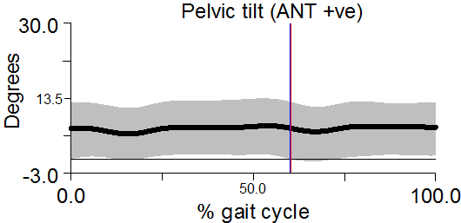 | 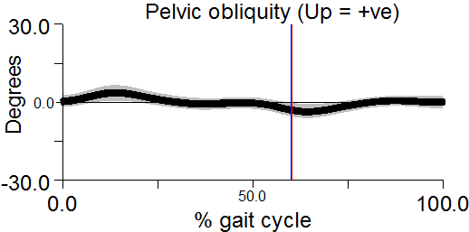 | 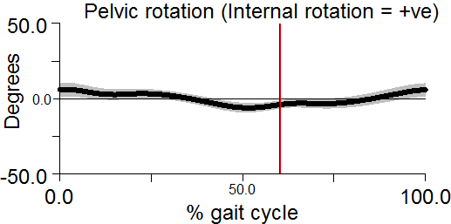
 | Control  Group | 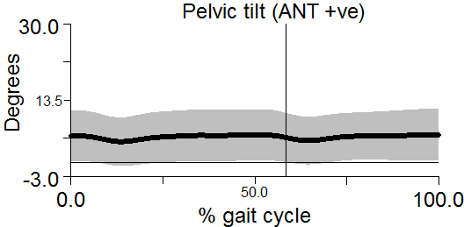 | 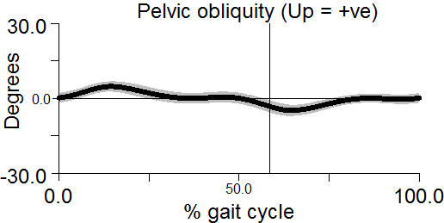 | 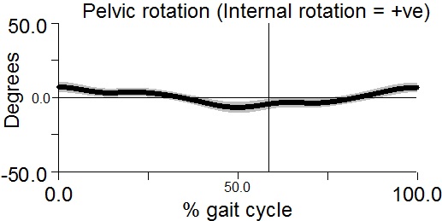
Hip | JHS group | 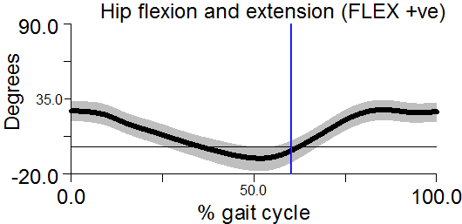 | 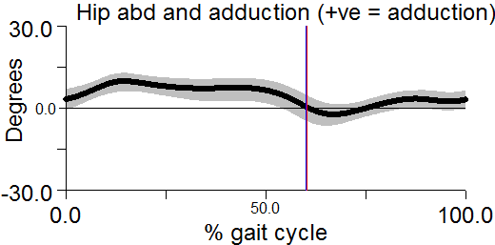 | 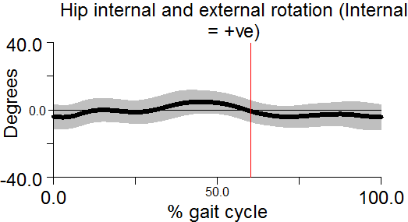
 | Control group | 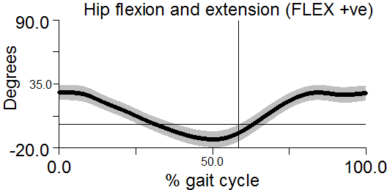 | 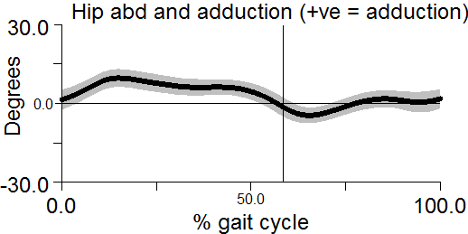 | 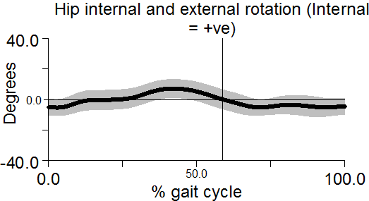
Knee | JHS group | 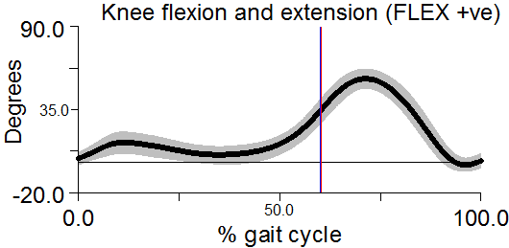 | 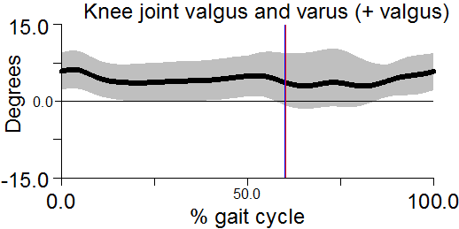 | N/A
 | Control group | 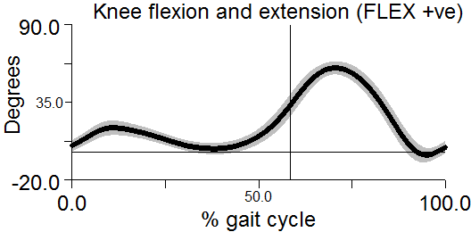 | 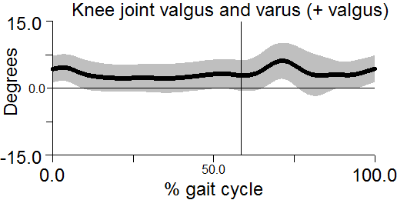 | N/A
Ankle | JHS group | 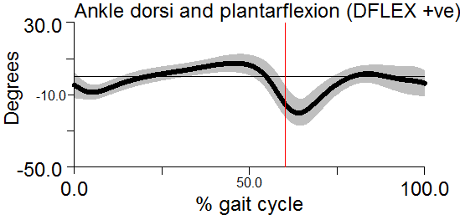 | N/A | 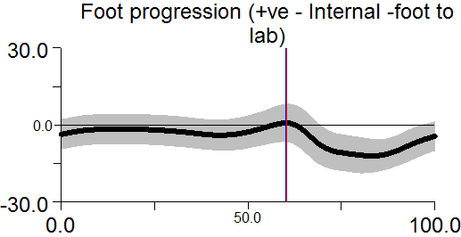
 | Control group | 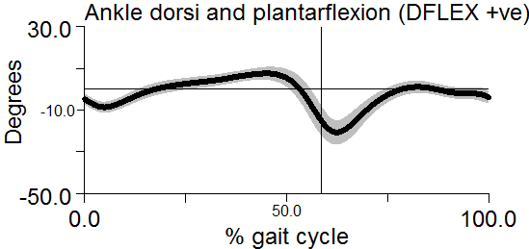 | N/A | 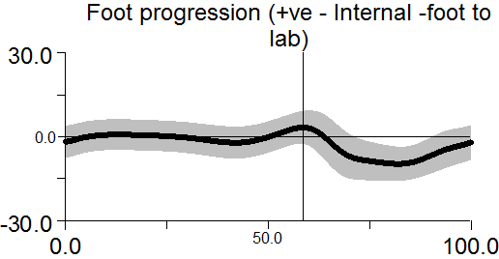

Gait kinetics
Figure 2: Curve graphs showing the kinetics acting at the lower limb joints during the gait cycle for the JHS; n = 29, and control group; n = 30. The solid line illustrates the mean and the semi-transparent line illustrates the standard deviation. The vertical line separate between the stance and swing phase in gait graphs. JHS group graphs were compared against the control group graph. indicates statistically significant reduction in kinetics in the JHS group when compared to the control group.

Joint | Movement plane | Sagittal plane  (moment) | Frontal plane  (moment) | Sagittal plane  (power)
Hip | JHS group | 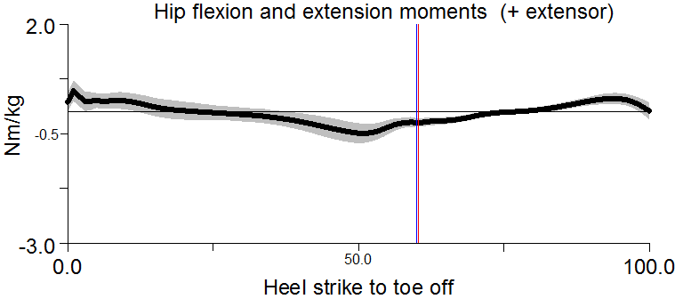 | 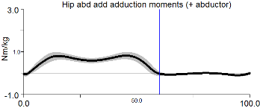 | 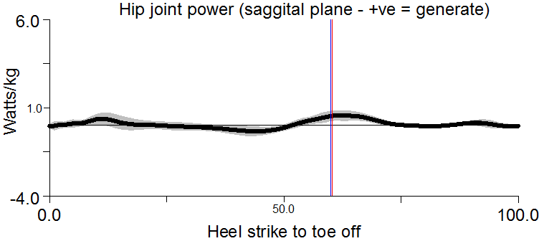
 | Control  Group | 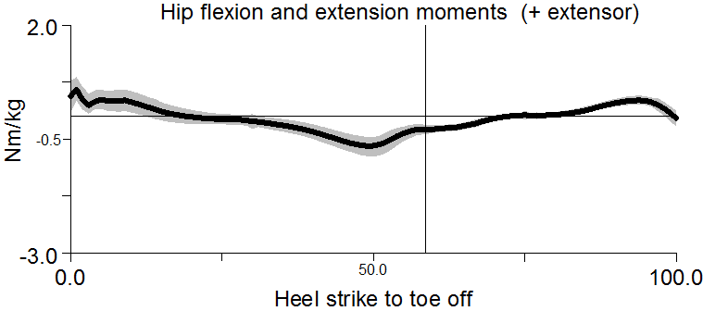 | 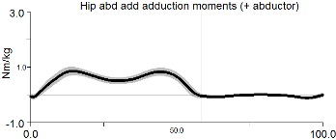 | 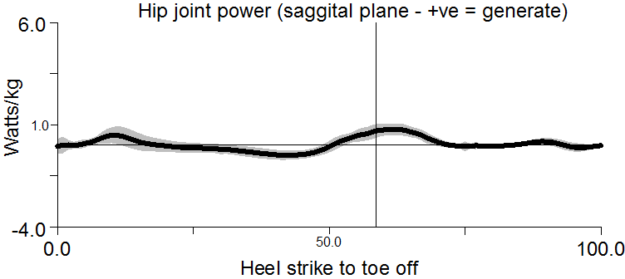
Knee | JHS group | 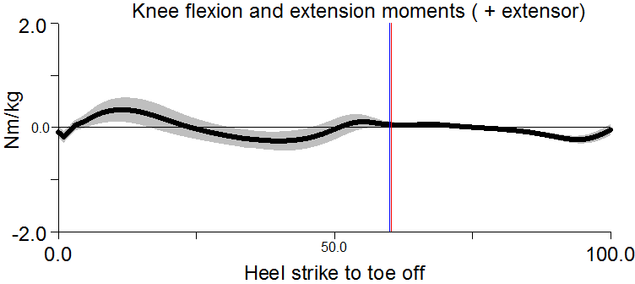 | 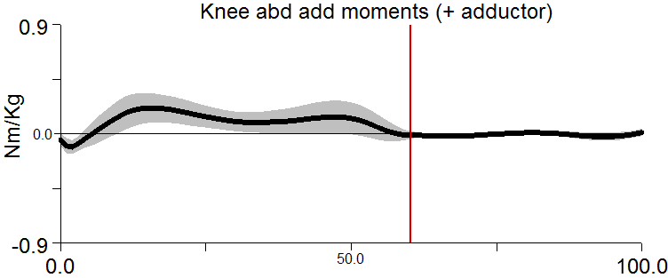 | 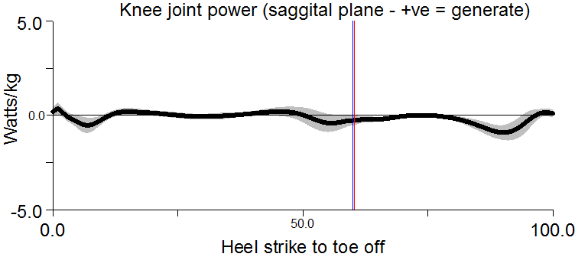
 | Control group | 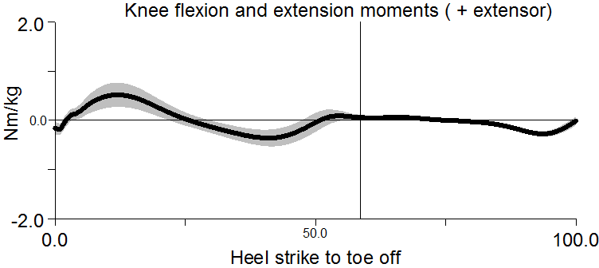 | 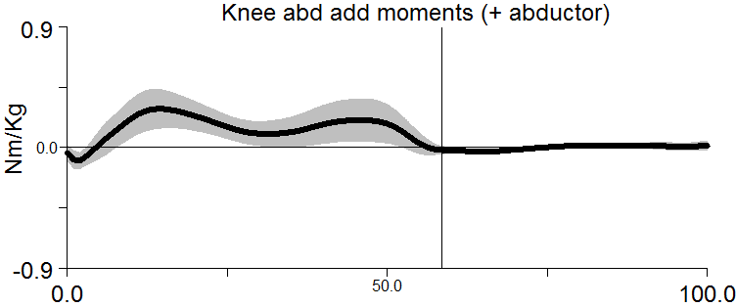 | 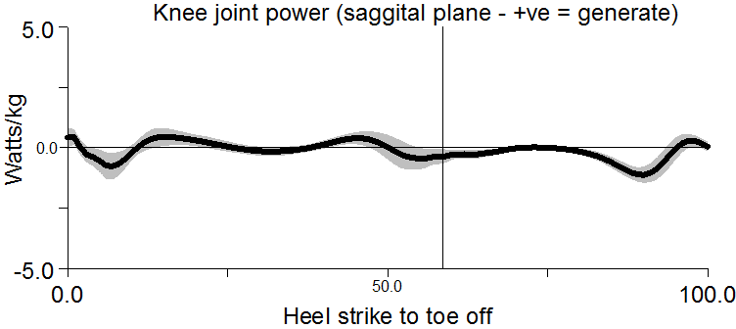
Ankle | JHS group | 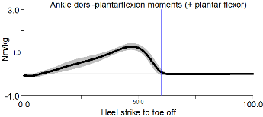 |  | 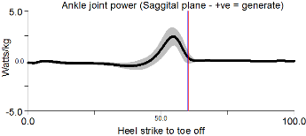
 | Control group | 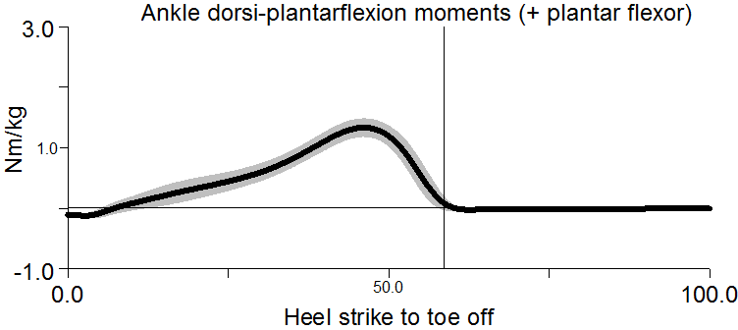 |  | 