RIFAXIMIN IN NON-ALCOHOLIC STEATOHEPATITIS: AN OPEN-LABEL PILOT STUDY
Running title: Rifaximin in Non-Alcoholic Steatohepatitis
Jeremy FL Cobbold^{1,2}*, Stephen Atkinson¹, Julian R Marchesi^{3,4}, Ann Smith³, Sann N Wai¹, Julie Stove¹, Fariba Shojaee-Moradie⁵, Nicola Jackson⁵, A Margot Umpleby⁵, Julie Fitzpatrick⁶, E Louise Thomas⁶, Jimmy D Bell⁶, Elaine Holmes³, Simon D Taylor-Robinson¹, Robert D Goldin¹, Michael S Yee⁷, Quentin M Anstee⁸, Mark R Thursz¹
¹ Department of Medicine, Imperial College London, London, UK
² Translational Gastroenterology Unit, Oxford University Hospitals NHS Foundation Trust, Oxford, UK
³ Department of Surgery and Cancer, Imperial College London, UK
⁴ School of Biosciences, Cardiff University, Cardiff, UK
⁵ Diabetes and Metabolic Medicine, Faculty of Health and Medical Sciences, University of Surrey, Guildford, UK
⁶ Currently: Department of Life Science, Faculty of Science and Technology, University of Westminster, London, UK. Previously: Institute of Clinical Science, Imperial College London, London, UK
⁷ Department of Endocrinology and Diabetic Medicine, Imperial College Healthcare NHS Trust, London, UK
⁸ Institute of Cellular Medicine, Newcastle University, Newcastle-Upon-Tyne, UK

*Current address and address for correspondence:
Dr Jeremy Cobbold
Translational Gastroenterology Unit, Oxford University Hospitals NHS Foundation Trust, John Radcliffe Hospital
Headington, Oxford, OX3 9DU, UK
Email: Jeremy.cobbold@ndm.ox.ac.uk
Tel: +44 (0)1865 228746
Fax: +44 (0)1865 228763

List of abbreviations: NAFLD, non-alcoholic fatty liver disease; NASH, non-alcoholic steatohepatitis; LPS, lipopolysaccharide; ALT, alanine aminotransferase; HGP, hepatic glucose production; ¹H NMR, proton nuclear magnetic resonance; IHCL, intrahepatocellular lipids; PCA, principal components analysis; OPLS-DA, orthogonal partial least squares discriminant analysis; HOMA-IR, homeostasis model assessment-estimated insulin resistance index; HDL, high density lipoprotein.

ABSTRACT
Aim: Gut microbial dysbiosis is implicated in the pathogenesis of non-alcoholic steatohepatitis (NASH). We investigated downstream effects of gut microbiota modulation on markers of hepatic inflammation, steatosis, and hepatic and peripheral insulin sensitivity in patients with NASH using Rifaximin therapy.
Methods: Patients with biopsy-proven NASH and elevated aminotransferase values were included in this open-label pilot study, all receiving 6 weeks Rifaximin 400mg twice daily, followed by a 6 week observation period. The primary endpoint was change in ALT after 6 weeks of Rifaximin. Secondary endpoints were change in hepatic lipid content and insulin sensitivity measured with a hyperinsulinaemic euglycaemic clamp.
Results: Fifteen patients, 13 male, 2 female, with median (range) age 46(32-63) years were included. Seven had diabetes on oral hypoglycaemic medications and 8 had no diabetes. After 6 weeks of therapy, no differences were seen in ALT (55 [33-191] versus 63 [41-218]IU/L, p=0.41), peripheral glucose uptake (28.9 [19.4-48.3] to 25.5 [17.7-47.9] µmol/kg/min, p=0.30), hepatic insulin sensitivity (35.2 [15.3-51.7]% versus 30.0 [10.8-50.5]%, p=0.47), or hepatic lipid content (21.6[2.2-46.2]% before and 24.8[1.7-59.3]% after Rifaximin, p=0.59) before and after Rifaximin treatment. After 12 weeks from baseline, serum ALT increased to 83(30-217)IU/L, p=0.02. There was a significant increase in HOMA-IR (p=0.05). The urinary metabolic profile indicated a significant reduction in urinary hippurate with treatment, which reverted to baseline after cessation of Rifaximin, although there was no consistent difference in relative abundance of faecal microbiota with treatment.
Conclusion: These data do not indicate a beneficial effect of Rifaximin in patients with NASH.
Abstract 248 words (max 250)

Key words:
Antibiotic; Hippurate; Insulin resistance; Microbiota; NAFLD; Non-alcoholic steatohepatitis

INTRODUCTION
Non-alcoholic fatty liver disease (NAFLD) is the most common cause of liver dysfunction and an increasing cause of liver-related morbidity and mortality globally(1, 2). NAFLD, and its inflammatory and potentially progressive subtype, non-alcoholic steatohepatitis (NASH), represents a complex disease trait, with genetic and environmental influences on incidence and disease progression(2, 3). While lifestyle measures in order to achieve sustained weight loss, including dietary changes and regular exercise are the mainstay of current management(4), many patients do not respond to such measures and specific therapies are lacking(5, 6).

The gut microbiota is increasingly recognised as a key metabolic influence in the body and a potentially modifiable environmental target in disorders of energy metabolism and fat storage(7). Mechanisms include increase of calorific yield of meals by co-digestion, production of short chain fatty acids and bacterial endotoxin (7, 8)(9).

Microbial interventions, such as transfer of caecal contents from conventionally-raised mice to germ free mice have been shown to alter the host phenotype(7), while a study in patients with the metabolic syndrome demonstrated improved insulin sensitivity in patients receiving a faecal allogenic enteric infusion from a lean donor than from an autologous infusion(10). Besides direct microbial transfer, other methods for alteration of the gut microbiota include use of prebiotics, probiotics and antibiotics(11). Antibiotic therapy in obese mice reduced LPS and improved the metabolic phenotype(12), while Rifaximin was found to reduce endotoxinaemia in patients with decompensated cirrhosis, associated with improvements in hepatic synthetic function, but not aminotransferase values(13).

Rifaximin is a minimally-absorbed, broad spectrum antibiotic, which has been found to have clinical utility in a number of gastrointestinal settings with few side effects(14-16). With standard oral dosing, intraluminal drug levels exceed the minimum inhibitory concentrations for most bacterial species by up to 250-fold, while systemic absorption is <0.4% of the dose(17).

We hypothesised that modulation of the gut microbiota, using Rifaximin, in humans with NASH would lead to improvement in hepatic inflammation, hepatic lipid content and insulin sensitivity. Thus, we conducted a pilot prospective clinical trial to evaluate the efficacy and safety of such an approach. We examined the faecal microbiota, urinary metabolome and inflammatory cytokine profile as secondary analyses to assess whether any changes observed were linked to detectable differences in bacterial populations, to microbial co-metabolism and whether this could be mediated by inflammatory signalling.

METHODS
Ethical approval (REC 10/H0711/58) was obtained and the study was registered on the European Clinical Trials Database (EudraCT 2010-021515-17). Patients were recruited from Hepatology clinics at a single UK centre (Imperial College Healthcare NHS Trust) between May 2011 and June 2012. Informed consent was obtained from all patients included in the study and the study protocol conforms to the ethical guidelines of the 1975 Declaration of Helsinki as reflected in a priori approval by the institution's human research and ethics committee (West London REC 2). Male and female patients were eligible for inclusion if aged between 18 and 70 years with non-alcoholic steatohepatitis histologically-proven, as evidenced by the presence of all of: steatosis, hepatocyte ballooning and lobular inflammation, and scored according to Kleiner(18) by a single experienced histopathologist (RDG) within the previous year, with or without mild to moderate fibrosis (stage 0-3/4) and with persistently elevated alanine aminotransferase (ALT) values on at least two occasions in the three months prior to recruitment. Patients were excluded if there was histological evidence of cirrhosis; hepatic decompensation; regular alcohol consumption exceeding 14 units/week (16g ethanol/day) for a woman or 21 units/week (24g ethanol/day) for a man; evidence of viral, autoimmune or other metabolic liver disease on a chronic liver disease screen; a history of malignancy or systemic inflammatory conditions; myocardial infarction or cerebrovascular events in the preceding 6 months; a history of bariatric surgery, blind loop or short bowel; use of any treatment known or suspected to change bowel flora within 3 months of enrolment; initiation or major dose change of metformin, thiazolinediones, biguanides, statins, fibrates, anti-obesity medications or insulin within 3 months of enrolment.

Study design
This was an open-label study of Rifaximin (Normix, Alfa Wasserman S.p.A, Bologna, Italy) 400mg twice daily for six weeks followed by a further six weeks observation period during which patients received standard care. Compliance with treatment was checked by collection of empty blister packs. Subjects were asked to provide a structured dietary and lifestyle history as previously described(19). The primary endpoint was change in ALT after 6 weeks’ Rifaximin therapy. Secondary endpoints were change in hepatic and whole-body insulin sensitivity assessed by the two-stage hyperinsulinaemic euglycaemic clamp and change in hepatic triglyceride content assessed by proton nuclear magnetic resonance spectroscopy at 6 weeks from baseline. Serum ALT, biochemistry and anthropometrics were also measured at 12 weeks to look for longer-term effects. Stool microbiota, urinary metabolic profile and serum cytokine profile were measured before and after intervention.
Laboratory measurement
Routine biochemistry was undertaken by the hospital biochemistry laboratory on the Aeroset (ALT, AST, HDL, triglyceride) or Architect (insulin) clinical chemistry analyser platforms (Abbott Diagnostics, Illinois, USA). Insulin concentrations were determined using a one-step chemiluminescent immunoassay. Cytokine analysis was performed by Aushon Multiplex Immunoassay Analysis (Aushon Biosystems, Billerica, USA).
Hyperinsulinaemic euglycaemic clamp
The two-step hyperinsulinaemic euglycaemic clamp combined with a [6,6-²H₂]glucose infusion to measure insulin sensitivity was performed as previously described and detailed in the supplementary information (20). Patients consumed nothing but water orally after eating a low-fat pre-prepared meal (identical before and after intervention) 10 hours prior to the clamp study.
Plasma glucose concentration and enrichment time-courses were smoothed using optimal segments analysis(21) and non-steady-state equations(22)

Proton nuclear magnetic resonance spectroscopy
Patients fasted for at least 10 hours prior to scanning. Rapid T₁-weighted magnetic resonance images were acquired using a 1.5T Phillips AchievaTM scanner (Philips Medical Systems, Best, Netherlands), as previously described(23). Proton nuclear magnetic resonance (¹H NMR) spectra were acquired at 1.5T, using a surface coil. Transverse images of the liver were used to ensure accurate positioning of the (20x20x20 mm) voxel in the liver, avoiding blood vessels, the gall bladder and fatty tissue. Spectra were obtained from the right lobe of the liver using a PRESS sequence (TR 1500ms, TE 135 ms) without water saturation and with 128 signal averages. Intrahepatocellular lipids (IHCL) were measured relative to liver water content, as previously described(24).
Faecal microbiota
Faeces were collected in a sterile container at each assessment visit and frozen at -70⁰C within 10 minutes. DNA was extracted using a Qiagen DNA stool extraction kit (Qiagen, Manchester, UK), with an additional bead beating step added before the ASL buffer was added to the stool sample. The extracted DNA was quantified using a Qubit platform and all DNA samples were normalised to 10 ng/µL. The 16S rRNA gene was amplified using primers for the V1 to V3 regions and sequenced using paired end 250bp chemistry on an Illumina MiSeq platform (Illumina Inc, San Diego, California). The data were analysed using bioinformatics statistical packages (Mothur, STAMP) and R (R Foundation, Vienna, Austria) to determine whether any statistically significant changes in the profiles of the faecal microbiota had occurred(25-27).

Urinary metabolomics
Urine was collected, processed and buffered as detailed in the supplementary information. All NMR spectra were referenced, phased and baselined corrected as detailed in the supplementary information. Data were initially modelled using unsupervised principle components analysis (PCA) and subsequently combined with clinical data and modelled using orthogonal partial least squares discriminant analysis (OPLS-DA). For univariate analyses Topspin (Bruker, Billerica, USA) was used to integrate under spectral resonances for metabolites of interest and the quantitative data was analysed in the statistics package SPSS (IBM, Armonk, USA).
Statistical analysis
Statistical analyses were performed using SPSS 20.0 (SPSS Inc., Chicago, USA). Based on historical data from 20 patients with paired ALT data in response to lifestyle and standard of care intervention from the NAFLD clinic at our institution, a sample size of 16 would provide 80% power and α of 0.05 to detect a change in ALT of 25IU/L with an expected standard deviation of the difference of 33IU/L. Data were non-parametrically distributed, so are displayed as median (range). Significance of differences in endpoints before and after intervention was tested by the Wilcoxon Signed Rank test.

RESULTS
Of the 77 patients with biopsy-proven NAFLD evaluated in clinic over the recruitment period, 41 met inclusion criteria and were invited to take part in the study. On receipt of the patient information, 18 patients declined to participate and 23 were screened. Of these, a further two declined to participate further at the screening visit and three were excluded by the screening questionnaire. Of the 15 patients who initiated the study protocol, one participant was unable to tolerate MR scanning owing to claustrophobia and another participant declined the hyperinsulinaemic euglycaemic clamp having already started the study. Baseline patient characteristics are displayed in Table 1. 100% compliance with Rifaximin therapy was reported by all participants. One subject noted loose stools for 36 hours during therapy, which resolved spontaneously and therapy was not discontinued. No other adverse events were recorded. Recruitment was halted after enrolment of 15 subjects because of difficulty in recruitment to the full study protocol over the defined study time period.
Hepatocellular inflammation
Alanine aminotransferase (ALT) values, the primary endpoint in this study, were 55IU/L (33-191) before Rifaximin, 63IU/L (41-218) after 6 weeks’ Rifaximin (p=0.41 compared to baseline) and 83IU/L (30-217) after a further 6 weeks follow-up (p=0.017 compared to baseline), Figure 1A. Anthropometrics, HOMA-IR and lipid profile before and after Rifaximin are shown in Table 2. There was a significant increase in HDL and HOMA-IR at 12 weeks.
Hepatic Lipid content
Hepatic lipid content (IHCL) was 21.6% (2.2-46.2) before and 24.8% (1.7-59.3) after Rifaximin, p=0.59. Figure 1B.
Insulin sensitivity
Hepatic insulin sensitivity as assessed by suppression of hepatic glucose production was 35.2% (15.3-51.7) before Rifaximin and 30.0% (10.8-50.5) after Rifaximin, p=0.47, Figure 1C. Peripheral insulin sensitivity as assessed by glucose Rd was 28.9 μmol/kg/min (19.4-48.3) before Rifaximin and 25.5 μmol/kg/min (17.7-47.9) after Rifaximin, p=0.30, Figure 1D.
Cytokine analysis
There were no differences in serum cytokine values, including TNFα and IL-1β, before and after treatment with Rifaximin, and over the observation periods (Supplementary Table 1).

Urinary metabonomics
Urinary metabolites were identified as seen in the representative urinary metabolic profile, Figure 2A. Principal components analysis of urinary metabolic profiles demonstrated close clustering of quality control samples and case samples clustered by patient, Figure 2B. Supervised partial least squares discriminant analysis (OPLS-DA) failed to produce robust, predictive models based upon the effect of treatment upon urinary metabolic profiles. Examination of the loadings plots for the OPLS-DA models identified three metabolites, alanine, creatinine and hippurate, with modest correlation with treatment status, Figure 2C. These metabolites were examined further in univariate analyses, Figure 2D. A significant decrease in hippurate levels was observed following treatment with rifaximin (p=0.048). A significant increase in hippurate levels was seen from immediately after treatment to 6 weeks after its discontinuation (p=0.035); no difference was seen between 6 weeks post-treatment and pre-treatment hippurate levels (p=0.721). There were no statistically significant changes in alanine or creatinine levels with treatment.

Stool Microbiota
No consistent differences were observed in the relative abundance of gut microbiota at the phylum level in faeces with Rifaximin treatment (Figure 3). However significant differences in the microbiota were seen at the genus level in individual patients with Rifaximin treatment (Supplementary Figure 1, published online), although these differences were not common to all subjects.

DISCUSSION
In this study, we performed an open-label clinical trial of Rifaximin in patients with NASH to test effect and safety. Although there was no evidence of change in markers of hepatic inflammation, hepatic lipid content or insulin sensitivity after 6 weeks of therapy, serum ALT values increased significantly from baseline to 12 weeks, in association with increased insulin resistance as assessed by the HOMA-IR score. An increase in serum HDL values was also observed. Univariate analysis of urinary hippurate levels suggests that treatment transiently suppressed the production of this metabolite. However, robust changes were not demonstrated in the faecal microbiota, or a panel of pro- and anti-inflammatory serum cytokines. No adverse events were recorded. These results contrast with another recent open label study of Rifaximin in NAFLD/NASH which reported an improvement in liver biochemistry, body mass index and IL-10 after 28 days of Rifaximin 1200mg per day in 27 patients with NASH, although insulin sensitivity, liver fat and gut microbiota were not assessed specifically in that study(28).

Ours was a prospective clinical study in which subjects were intensively investigated to look for signals of biological effect of Rifaximin on NASH in human subjects that might form the basis of larger studies of longer duration. The sample size is relatively small, but the study was powered to detect a difference in ALT of 25IU/L with treatment, which was not seen. This study included more patients than studies using the hyperinsulinaemic euglycaemic clamp to assess the effects of antibiotic administration and faecal transfer on insulin sensitivity(10, 29), so might be expected to show a difference in insulin sensitivity if Rifaximin were to cause an effect of similar magnitude to those interventions. The study was of similar size to studies assessing the microbial and metabolic effects of Rifaximin in cirrhosis(30, 31) and the effect of Rifaximin on liver biochemistry in patients with PSC(32). Nevertheless, the study was not powered to detect differences in subgroups, such as those with and without type 2 diabetes mellitus. The six-week course of therapy may be considered short, but metabolic effects of antibiotics are seen at 1 week(29) and changes in hepatocellular inflammation are detectable rapidly in serum. The dose of Rifaximin used in this study is lower than in other recent clinical trials which have used 550mg twice daily, a dose licenced for use in the secondary prophylaxis of hepatic encephalopathy(14). This difference reflects the Rifaximin preparations and dosing information available, and the clinical usage for gastrointestinal infections at the time of study initiation. Assessment of changes to the intestinal microbiota using sequencing of faecal bacterial DNA is limited as the faecal microbiota may not reflect the metabolically active microbiota at the small bowel mucosa, which are implicated in the effects of Rifaximin and more readily sampled in animal studies(33).

Although the primary and secondary outcome measures were not altered by Rifaximin in this study, some additional markers changed post-treatment. These differences were not specified in the a priori analysis so should be interpreted tentatively at this stage. However, this, and other studies, suggest that some broad spectrum oral antibiotics, including Rifaximin, may be associated with adverse metabolic and hepatic responses. For example, oral administration of a short course of vancomycin reduced peripheral insulin sensitivity in patients with the metabolic syndrome, in association with reduced gut microbial diversity(29). In another study of patients with cirrhosis before and after Rifaximin administration, there was a reduction in the ratio of secondary to primary bile acids(31), suggesting a possible mechanism for any Rifaximin-induced insulin resistance. As in the present study, previous work using a systems biology approach to evaluate metabolic and microbial effects of Rifaximin in patients with cirrhosis and minimal hepatic encephalopathy demonstrated no significant difference in the overall microbiome composition of stool(30). So, in contrast with in vitro studies, which demonstrate activity against a broad-spectrum of bacteria(34), the effects of Rifaximin in vivo may be on bacterial function and virulence, rather than simply a reduction in numbers(35, 36). The observation in the present study that urinary hippurate levels decreased with Rifaximin therapy is relevant as urinary hippurate is influenced by the intestinal microbiota (as well as age, sex and dietary intake, which were controlled for in the present study)(37). Hippurate is a glycine conjugate of benzoic acid and a normal constituent of the human urinary metabolite profile. Germ-free mice have significantly lower levels of urinary hippurate than conventially raised mice(38) and administration of vancomycin to mice leads to changes in the faecal microbiome and associated suppression of urinary hippurate levels(39). Metabolism of high-molecular weight polyphenolic compounds by colonic microbiota leads to production of benzoic acid which may be excreted as hippurate(37). Differential capacities of microbiota species to metabolise polyphenolic compounds(40) means that antibiotic-mediated changes in bacterial numbers or population composition may alter the bioavailability of upstream metabolites of benozoic acid and this lead to changes in urinary hippurate levels. Benzoic acid is converted to hippurate predominantly in hepatic mitochondria and impaired hepatic function is associated with a decreased capacity to produce hippurate from orally or intravenously administered precursors(41, 42). Thus there is some evidence that the transient depression in urinary hippurate levels with Rifaximin in this study is mediated by suppression of such activity by colonic microbiota.
This work indicates that the use of a minimally-absorbed, broad spectrum antibiotic is not associated with consistent changes in the stool microbiota at the phylum or genus level, but suggests a metabolic effect, illustrated by the urinary hippurate levels. Nevertheless, such an intervention has not led to detectable changes in ALT, insulin sensitivity and hepatic steatosis, nor is it associated with a robust pattern of inflammatory cytokines. This study does not support the use of antibiotics as a therapeutic intervention in NASH, but suggests a possible adverse metabolic effect which needs further evaluation. The variable effect of this intervention at a genus level between patients indicates that future studies should focus on functional niches rather than the abundance of the microbiota to direct therapy. Future therapies targeting the gut microbiota will need to be more nuanced to result in beneficial metabolic and inflammatory modulation.
Administration of Rifaximin for 6 weeks to subjects with non-alcoholic steatohepatitis was not associated with changes in markers of hepatocellular damage, hepatic triglyceride content, insulin sensitivity or systemic inflammation at 6 weeks, although an increase in serum ALT levels was noted at 12 weeks, associated with increased HOMA-IR and HDL. On the basis of the evidence presented in this study, Rifaximin cannot be recommended as a potential therapy in NAFLD/NASH, but further studies are warranted to investigate the hepatic and metabolic consequences of enteric antibiotic therapies.

Acknowledgements: This work was funded in full by a grant from the UK National Institutes for Health Research (NIHR) Biomedical Research Facility at Imperial College London, awarded by the Imperial College London Academic Health Sciences Centre Research Committee. JFLC held an NIHR Clinical Lectureship from 2009 to 2012 and is currently supported by the NIHR Biomedical Research Centre at Oxford University Hospitals NHS Foundation Trust. QMA is the recipient of a Clinical Senior Lectureship Award from the Higher Education Funding Council for England (HEFCE). The authors declare no conflicts of interest.

References
1. Chalasani N, Younossi Z, Lavine JE, Diehl AM, Brunt EM, Cusi K, Charlton M, et al. The diagnosis and management of non-alcoholic fatty liver disease: practice guideline by the American Gastroenterological Association, American Association for the Study of Liver Diseases, and American College of Gastroenterology. Gastroenterology 2012;142:1592-1609.
2. Anstee QM, Targher G, Day CP. Progression of NAFLD to diabetes mellitus, cardiovascular disease or cirrhosis. Nat Rev Gastroenterol Hepatol 2013;10:330-344.
3. Tilg H, Moschen AR. Evolution of inflammation in nonalcoholic fatty liver disease: the multiple parallel hits hypothesis. Hepatology 2010;52:1836-1846.
4. Ratziu V, Bellentani S, Cortez-Pinto H, Day C, Marchesini G. A position statement on NAFLD/NASH based on the EASL 2009 special conference. J Hepatol 2010;53:372-384.
5. Look ARG, Wing RR, Bolin P, Brancati FL, Bray GA, Clark JM, Coday M, et al. Cardiovascular effects of intensive lifestyle intervention in type 2 diabetes. N Engl J Med 2013;369:145-154.
6. Thoma C, Day CP, Trenell MI. Lifestyle interventions for the treatment of non-alcoholic fatty liver disease in adults: a systematic review. J Hepatol 2012;56:255-266.
7. Backhed F, Ding H, Wang T, Hooper LV, Koh GY, Nagy A, Semenkovich CF, et al. The gut microbiota as an environmental factor that regulates fat storage. Proc Natl Acad Sci U S A 2004;101:15718-15723.
8. Samuel BS, Shaito A, Motoike T, Rey FE, Backhed F, Manchester JK, Hammer RE, et al. Effects of the gut microbiota on host adiposity are modulated by the short-chain fatty-acid binding G protein-coupled receptor, Gpr41. Proc Natl Acad Sci U S A 2008;105:16767-16772.
9. Volynets V, Kuper MA, Strahl S, Maier IB, Spruss A, Wagnerberger S, Konigsrainer A, et al. Nutrition, intestinal permeability, and blood ethanol levels are altered in patients with nonalcoholic fatty liver disease (NAFLD). Dig Dis Sci 2012;57:1932-1941.
10. Vrieze A, Van Nood E, Holleman F, Salojarvi J, Kootte RS, Bartelsman JF, Dallinga-Thie GM, et al. Transfer of intestinal microbiota from lean donors increases insulin sensitivity in individuals with metabolic syndrome. Gastroenterology 2012;143:913-916 e917.
11. Abu-Shanab A, Quigley EM. The role of the gut microbiota in nonalcoholic fatty liver disease. Nat Rev Gastroenterol Hepatol 2010;7:691-701.
12. Cani PD, Bibiloni R, Knauf C, Waget A, Neyrinck AM, Delzenne NM, Burcelin R. Changes in gut microbiota control metabolic endotoxemia-induced inflammation in high-fat diet-induced obesity and diabetes in mice. Diabetes 2008;57:1470-1481.
13. Kalambokis GN, Tsianos EV. Rifaximin reduces endotoxemia and improves liver function and disease severity in patients with decompensated cirrhosis. Hepatology 2012;55:655-656.
14. Bass NM, Mullen KD, Sanyal A, Poordad F, Neff G, Leevy CB, Sigal S, et al. Rifaximin treatment in hepatic encephalopathy. N Engl J Med 2010;362:1071-1081.
15. Prantera C, Lochs H, Grimaldi M, Danese S, Scribano ML, Gionchetti P, Retic Study G. Rifaximin-extended intestinal release induces remission in patients with moderately active Crohn's disease. Gastroenterology 2012;142:473-481 e474.
16. Meyrat P, Safroneeva E, Schoepfer AM. Rifaximin treatment for the irritable bowel syndrome with a positive lactulose hydrogen breath test improves symptoms for at least 3 months. Aliment Pharmacol Ther 2012;36:1084-1093.
17. Ojetti V, Lauritano EC, Barbaro F, Migneco A, Ainora ME, Fontana L, Gabrielli M, et al. Rifaximin pharmacology and clinical implications. Expert Opin Drug Metab Toxicol 2009;5:675-682.
18. Kleiner DE, Brunt EM, Van Natta M, Behling C, Contos MJ, Cummings OW, Ferrell LD, et al. Design and validation of a histological scoring system for nonalcoholic fatty liver disease. Hepatology 2005;41:1313-1321.
19. Williams HR, Cox IJ, Walker DG, North BV, Patel VM, Marshall SE, Jewell DP, et al. Characterization of inflammatory bowel disease with urinary metabolic profiling. Am J Gastroenterol 2009;104:1435-1444.
20. Robertson MD, Wright JW, Loizon E, Debard C, Vidal H, Shojaee-Moradie F, Russell-Jones D, et al. Insulin-sensitizing effects on muscle and adipose tissue after dietary fiber intake in men and women with metabolic syndrome. J Clin Endocrinol Metab 2012;97:3326-3332.
21. Finegood DT, Bergman RN. Optimal segments: a method for smoothing tracer data to calculate metabolic fluxes. Am J Physiol 1983;244:E472-479.
22. Steele R, Bishop JS, Dunn A, Altszuler N, Rathbeb I, Debodo RC. Inhibition by Insulin of Hepatic Glucose Production in the Normal Dog. Am J Physiol 1965;208:301-306.
23. Thomas EL, Saeed N, Hajnal JV, Brynes A, Goldstone AP, Frost G, Bell JD. Magnetic resonance imaging of total body fat. J Appl Physiol (1985) 1998;85:1778-1785.
24. Thomas EL, Hamilton G, Patel N, O'Dwyer R, Dore CJ, Goldin RD, Bell JD, et al. Hepatic triglyceride content and its relation to body adiposity: a magnetic resonance imaging and proton magnetic resonance spectroscopy study. Gut 2005;54:122-127.
25. Parks DH, Tyson GW, Hugenholtz P, Beiko RG. STAMP: statistical analysis of taxonomic and functional profiles. Bioinformatics 2014;30:3123-3124.
26. Schloss PD, Westcott SL, Ryabin T, Hall JR, Hartmann M, Hollister EB, Lesniewski RA, et al. Introducing mothur: open-source, platform-independent, community-supported software for describing and comparing microbial communities. Appl Environ Microbiol 2009;75:7537-7541.
27. MacIntyre DA, Chandiramani M, Lee YS, Kindinger L, Smith A, Angelopoulos N, Lehne B, et al. The vaginal microbiome during pregnancy and the postpartum period in a European population. Sci Rep 2015;5:8988.
28. Gangarapu V, Ince AT, Baysal B, Kayar Y, Kilic U, Gok O, Uysal O, et al. Efficacy of rifaximin on circulating endotoxins and cytokines in patients with nonalcoholic fatty liver disease. Eur J Gastroenterol Hepatol 2015;27:840-845.
29. Vrieze A, Out C, Fuentes S, Jonker L, Reuling I, Kootte RS, van Nood E, et al. Impact of oral vancomycin on gut microbiota, bile acid metabolism, and insulin sensitivity. J Hepatol 2014;60:824-831.
30. Bajaj JS, Heuman DM, Sanyal AJ, Hylemon PB, Sterling RK, Stravitz RT, Fuchs M, et al. Modulation of the metabiome by rifaximin in patients with cirrhosis and minimal hepatic encephalopathy. PLoS One 2013;8:e60042.
31. Kakiyama G, Pandak WM, Gillevet PM, Hylemon PB, Heuman DM, Daita K, Takei H, et al. Modulation of the fecal bile acid profile by gut microbiota in cirrhosis. J Hepatol 2013;58:949-955.
32. Tabibian JH, Gossard A, El-Youssef M, Eaton JE, Petz J, Jorgensen R, Enders FB, et al. Prospective Clinical Trial of Rifaximin Therapy for Patients With Primary Sclerosing Cholangitis. Am J Ther 2014.
33. Xu D, Gao J, Gillilland M, 3rd, Wu X, Song I, Kao JY, Owyang C. Rifaximin alters intestinal bacteria and prevents stress-induced gut inflammation and visceral hyperalgesia in rats. Gastroenterology 2014;146:484-496 e484.
34. Jiang ZD, DuPont HL. Rifaximin: in vitro and in vivo antibacterial activity--a review. Chemotherapy 2005;51 Suppl 1:67-72.
35. Jiang ZD, Ke S, Dupont HL. Rifaximin-induced alteration of virulence of diarrhoea-producing Escherichia coli and Shigella sonnei. Int J Antimicrob Agents 2010;35:278-281.
36. Brown EL, Xue Q, Jiang ZD, Xu Y, Dupont HL. Pretreatment of epithelial cells with rifaximin alters bacterial attachment and internalization profiles. Antimicrob Agents Chemother 2010;54:388-396.
37. Lees HJ, Swann JR, Wilson ID, Nicholson JK, Holmes E. Hippurate: the natural history of a mammalian-microbial cometabolite. J Proteome Res 2013;12:1527-1546.
38. Claus SP, Tsang TM, Wang Y, Cloarec O, Skordi E, Martin FP, Rezzi S, et al. Systemic multicompartmental effects of the gut microbiome on mouse metabolic phenotypes. Mol Syst Biol 2008;4:219.
39. Yap IK, Li JV, Saric J, Martin FP, Davies H, Wang Y, Wilson ID, et al. Metabonomic and microbiological analysis of the dynamic effect of vancomycin-induced gut microbiota modification in the mouse. J Proteome Res 2008;7:3718-3728.
40. Peppercorn MA, Goldman P. Caffeic acid metabolism by bacteria of the human gastrointestinal tract. J Bacteriol 1971;108:996-1000.
41. Hemming AW, Gallinger S, Greig PD, Cattral MS, Langer B, Taylor BR, Verjee Z, et al. The hippurate ratio as an indicator of functional hepatic reserve for resection of hepatocellular carcinoma in cirrhotic patients. J Gastrointest Surg 2001;5:316-321.
42. Aoyama H, Kamiyama Y, Ukikusa M, Ozawa K. Clinical significance of hippurate-synthesizing capacity in surgical patients with liver disease: a metabolic tolerance test. J Lab Clin Med 1986;108:456-460.

Table 1. Baseline Characteristics.
Characteristic | Total cohort
Number | 15
Gender, M/F | 13/2
Age, yrs | 46 (32-63)
Weight, kg | 83.8 (66.3-116.0)
BMI, kg/m² | 27.2 (22.9-35.3)
Waist, cm | 101.9 (86.9-127.3)
Diabetes, Y/N | 7/8
Abdominal Obesity†, Y/N | 14/1
Dyslipidaemia† , Y/N | 11/4
Hypertension†, Y/N | 9/6
Metabolic syndrome†, Y/N | 9/6
ALT, IU/L | 55 (33-191)
AST, IU/L | 35 (20-100)
Triglyceride, mmol/L | 1.69 (0.94-2.94)
HDL, mmol/L | 1.07 (0.73-1.45)
HOMA -IR | 3.65 (1.52- 8.18)
Histology‡
Steatosis, 0/1/2/3 | 0/4/8/3
Ballooning, 0/1/2/3 | 0/12/3/0
Lobular inflammation, 0/1/2 | 0/12/3
Fibrosis, 0/1/2/3/4 | 1/6/4/4/0
Data expressed as numbers or median (range) as appropriate. †IDF criteria 2005. ‡ Kleiner et al. 2005

Table 2. Anthropometrics and metabolic clinical chemistry
 | Pre-Rifaximin (0 weeks) | Post-Rifaximin (6 weeks) | †P= | Post-Rifaximin (12 weeks) | †P=
BMI, kg/m2 | 27.15 (22.86-35.27) | 27.84 (22.92-35.59) | 0.14 | 28.08 (22.73-35.59) | 0.47
Waist, cm | 101.9 (86.9- 127.3) | 100.6 (87.7-125.5) | 0.58 | 101.5 (87.0-126.0) | 0.27
HOMA-IR | 3.65 (1.52-8.18) | 4.31 (1.25-8.54) | 0.08 | 4.29 (2.04-15.71) | 0.05
Total Cholesterol, mmol/L | 4.68 (2.52-5.98) | 4.65 (2.58-7.37) | 0.14 | 4.44 (2.75-7.10) | 0.33
HDL, mmol/L | 1.07 (0.73-1.45) | 1.11 (0.80-1.45) | 0.18 | 1.19 (0.77-1.62) | 0.004
Triglycerides, mmol/L | 1.69 (0.94-2.94) | 1.47 (0.81-3.17) | 0.73 | 1.47 (0.76-5.23) | 0.89
†compared to baseline

FIGURE LEGENDS
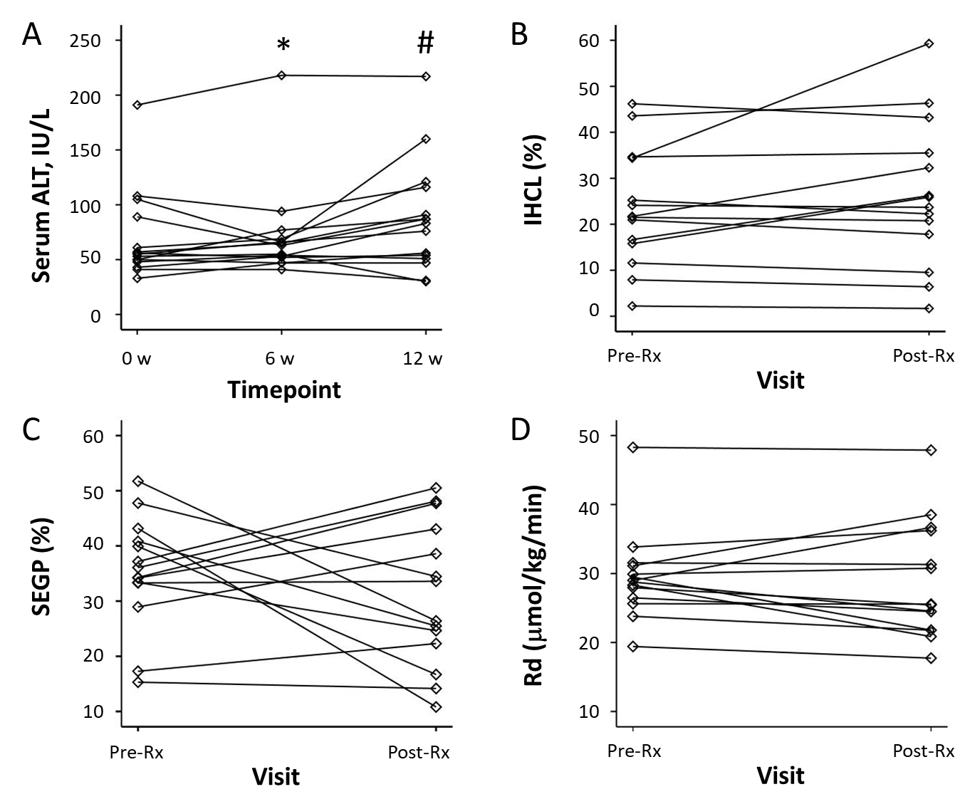
Fig. 1. Primary and secondary study endpoints before and after Rifaximin therapy. (A) Serum ALT values at baseline, 6 weeks (end of treatment) and 12 weeks (6 weeks after end of treatment). Individual patient data (n=15). * P=0.41 vs baseline, # P=0.02 vs baseline, P=0.04 vs 6 wks. (B) Intrahepatocellular lipid content (IHCL), expressed as a percentage, before and after Rifaximin therapy. Individual patient data (N=14). (C) Hepatic insulin sensitivity (% suppression of endogenous glucose production, SEGP) before and after Rifaximin therapy. Individual patient data, (N=14). (D) Peripheral insulin sensitivity (Rd) before and after Rifaximin therapy. Individual patient data (N=14).
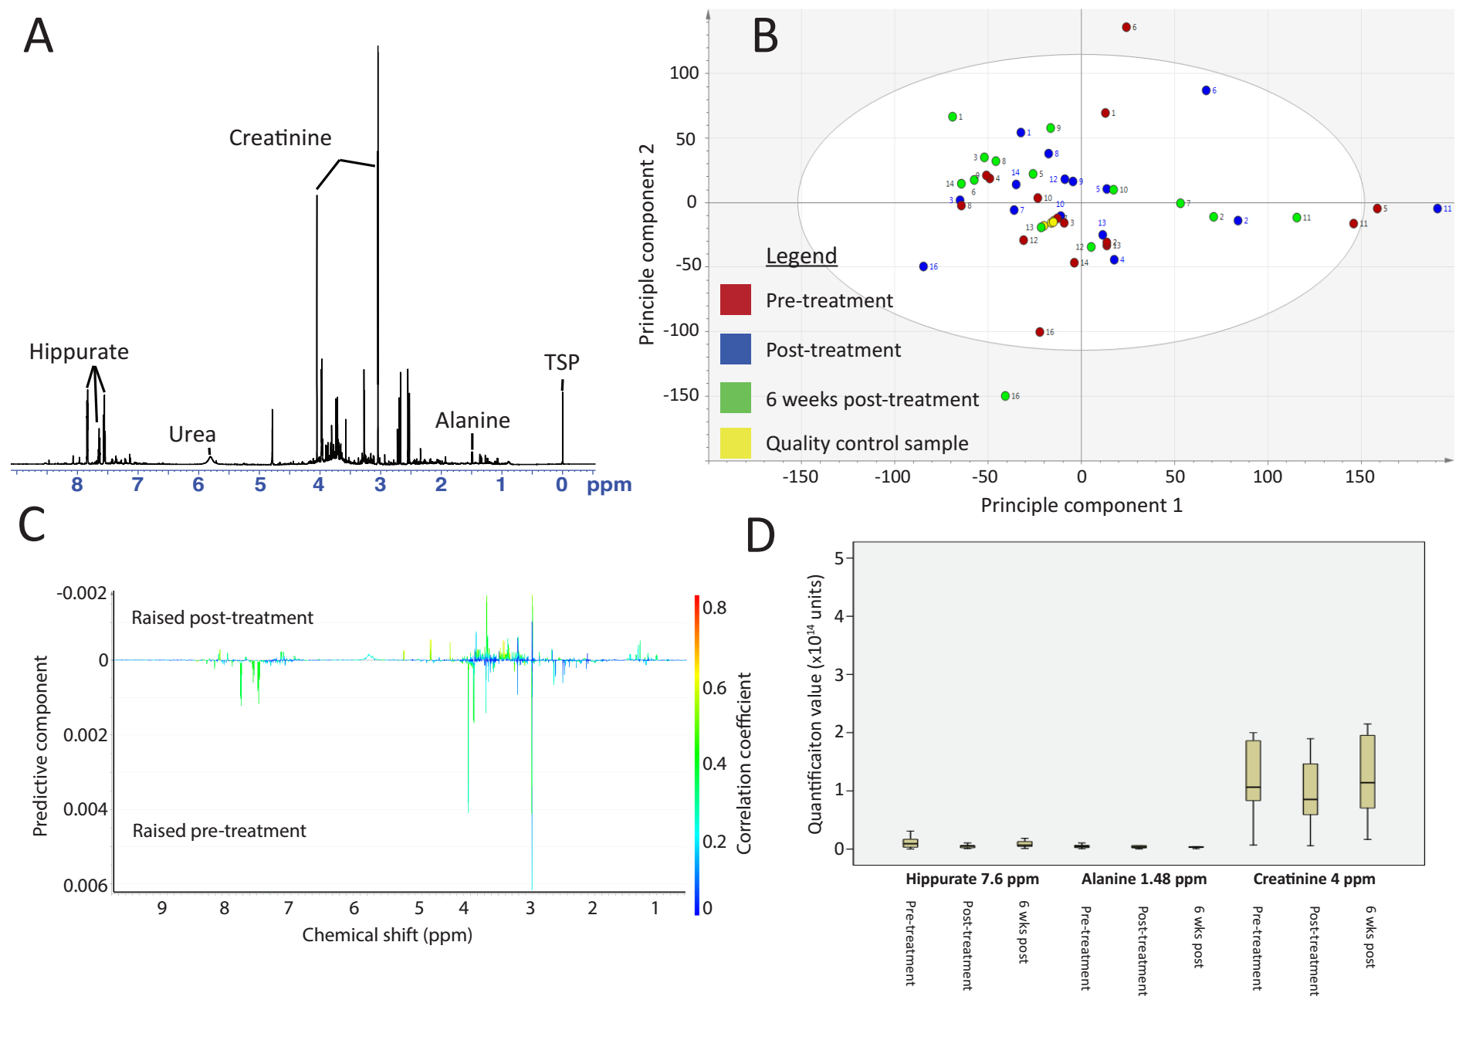
Fig. 2. Urinary metabonomic analysis. (A) Typical 1D-NOSEY NMR spectrum of urine. (B) Scores plot from unsupervised principal components analysis, coloured by timepoint and labelled by patient identification number. (C) S-line loadings plot from OPLS-DA for pre- and post- treatment timepoints. (D) Boxplots of quantified metabolites of interest at each study timepoint.
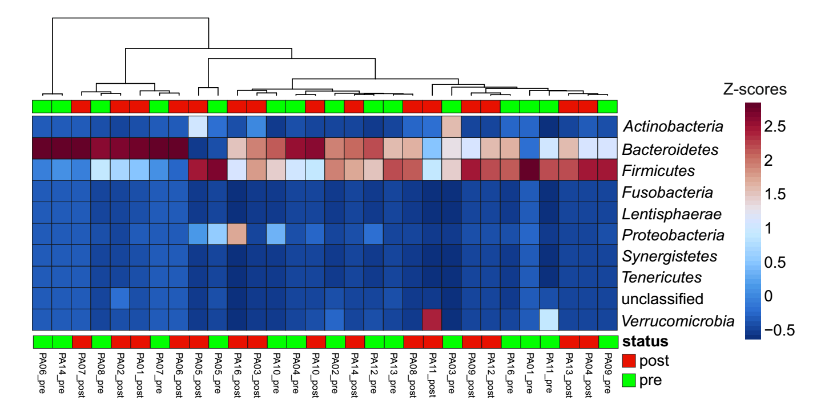
Fig. 3. Effect of Rifaximin on the phylum level composition of faeces. The heatmap shows the abundance of the phylum-level 16S rRNA gene sequences for each patient pre and post Rifaximin. Relative abundances of the sequence reads plotted are colour coded from less (blue) to more abundant (red). The colour value shows log10 fold changes.

Cobbold et al. RiFL Supplementary Material

RIFAXIMIN IN NON-ALCOHOLIC STEATOHEPATITIS: AN OPEN-LABEL PILOT STUDY
Jeremy FL Cobbold^{1,2}*, Steven Atkinson¹, Julian R Marchesi^{3,4}, Ann Smith³, Sann N Wai¹, Julie Stove¹, Fariba Shojaee-Moradie⁵, Nicola Jackson⁵, A Margot Umpleby⁵, Julie Fitzpatrick⁶, E Louise Thomas⁶, Jimmy D Bell⁶, Elaine Holmes³, Simon D Taylor-Robinson¹, Robert D Goldin¹, Michael S Yee⁷, Quentin M Anstee⁸, Mark R Thursz¹

Table of contents
Supplementary material | Page no.
Methods: hyperinsulinaemic euglycaemic clamp | 2
Methods: urinary metabolomics | 3
Supplementary Table 1 | 4
Figure Legend for Supplementary Figure 1 | 5

METHODS
Hyperinsulinaemic euglycaemic clamp
Patients consumed nothing but water orally after eating a low-fat pre-prepared meal (identical before and after intervention) 10 hours prior to the clamp study. Upon arrival intravenous cannulae were inserted into both antecubital fossae for blood sampling and infusion of the glucose isotope, insulin and glucose. A primed infusion of [6,6-²H₂] glucose (170 mg; 1.7 mg.min⁻¹) was administered for 7 hours. Samples were taken from 100-120 min to measure baseline hepatic glucose production (HGP). A 2-step hyperinsulinaemic–euglycaemic clamp was commenced at 120 min: insulin infusion at 0.3 mU.kg⁻¹.min⁻¹ (low-dose) for 120 min to measure the insulin sensitivity of HGP, then at 1.5 mU.kg⁻¹.min⁻¹ (high-dose) for 180 min to measure insulin sensitivity of peripheral glucose uptake (Rd). Euglycaemia was maintained by adjusting a 20% glucose infusion, spiked with [6,6-²H₂] glucose (7 mg.g⁻¹ glucose for low-dose, 10 mg.g⁻¹ high dose) according to 5 minute plasma glucose measurements to keep the patient’s blood glucose level at a target concentration of 5 ± 0.5 mmol/L.
Plasma glucose concentration and enrichment time-courses were smoothed using optimal segments analysis(1). HGP and Rd (µmol.kg⁻¹.min⁻¹) were calculated using non-steady-state equations(2), assuming a volume of distribution of 22% body weight. Hepatic insulin sensitivity was calculated as (basal HGP (90-120 min) – HGP during low-dose insulin (210-240 min)/basal HGP) x 100. Glucose Rd was calculated at steady-state following high-dose insulin (390-420 min)

Urinary metabolomics
Urine was collected in a sterile container at each assessment visit, centrifuged to remove sediment and frozen at -70⁰C within 30 minutes. For analysis, 540μl of urine was centrifuged at 14,000 rpm for 15 minutes and buffered with 60μl NMR buffer (containing TSP), then plated into 96-rack NMR plate. Control samples comprising an equal mixture of all case samples were generated and prepared in the same manner. An NPC NMR machine (Bruker, Billerica, USA) with a refrigerated robotic sample-handling unit was used. Two NMR experiments (NOSEY and J-resolved) were conducted on each sample. All spectra were referenced to trimethylsilyl propionic acid (TSP) and a sharp and appropriately sited water peak. A Bruker automated script was used to perform Fourier transforming, phasing and baselining. Resulting spectra were aligned and subsequently trimmed and the water peak removed prior to normalisation using in-house Matlab scripts (Mathworks, Natick, USA). Resulting spectral data were imported into Simca (Umetrics, San Jose, USA).

Supplementary Table 1. Serum Cytokine and Adipokine values before and after Rifaximin
Cytokine | Pre-Rifaximin | Post-Rifaximin | P
IL1beta*, pg/mL | 0.55 (0.01-3.41) | 0.57 (0.12-3.07) | 1.00
IL6, pg/mL | 4.52 (1.65-43.32) | 3.09 (1.50-56.23) | 0.39
IL10, pg/mL | 0.76 (0.18-5.64) | 0.95 (0.12-6.31) | 0.96
IL18, pg/mL | 318.4 (140.1-504.7) | 336.6 (193.7-650.7) | 0.65
CD14, ug/mL | 2.22 (1.12-6.50) | 2.34 (0.89- 10.95) | 1.00
TNFalpha#, pg/mL | 1.20 (0.35-15.18) | 1.06 (0.17-22.67) | 0.59
Leptin, ng/mL | 14.81 (4.63-956.00) | 14.79 (5.06-1094.26) | 0.10
Resistin, ng/mL | 19.61 (9.76-80.00) | 21.08 (9.07-107.69) | 0.73
Adiponectin, ug/mL | 2.26 (0.90-8.33) | 2.34 (0.62- 15.47) | 0.57
(n=15, *n=7, #n=9)

Supplementary Fig. S1. Effect of Rifaximin on the genus level composition of faeces in individual patients. Significant changes, >5%, at the genus level were plotted for each patient pre (blue bars) and post (orange bars) antibiotic administration. Significance of genus change was estimated in STAMP using Fisher’s exact test and multiple testing was controlled for using a Benjamini-Hochberg FDR test. Sample PA07 was not included as changes were <5%.

1. Finegood DT, Bergman RN. Optimal segments: a method for smoothing tracer data to calculate metabolic fluxes. Am J Physiol 1983;244:E472-479.
2. Steele R, Bishop JS, Dunn A, Altszuler N, Rathbeb I, Debodo RC. Inhibition by Insulin of Hepatic Glucose Production in the Normal Dog. Am J Physiol 1965;208:301-306.

