# An Investigation of the Performance of Nascent Manufacturing Firms

**Abstracts**

To understand the context for firms being created in the manufacturing space we explore the factors affecting performance by applying Gartners’ (2004) overarching theoretical framework. We investigate the phenomenon of nascent entrepreneurship from a multi-stage perspective answering calls to provide studies that are more explicit about the timing of the performance in particular contexts. Our research shows that a college degree is helpful in receiving funding, and start-up experience has a slightly negative impact on defining the market, which highlights the interactions between individuals and process and casts new insights into the context of nascent entrepreneurship in the manufacturing industry.

Keywords: Manufacturing New Ventures, PSED, New Venture Performance, New Venture Creation in Manufacturing, Nascent Entrepreneurship

## 

## 1 Introduction

Early stage versus later stage start-ups in the manufacturing industry is key to study yet little is known about the differences faced when developing the new venture, start-up in this context. Elert, *et al.* (2017) show that the successful launch and commercialisation of the first product is crucial to the survival of a new firm. This research focuses on this area by addressing a burgeoning question focused on what key factors affect new ventures from a theoretical framework. The objective of this research is therefore to study the impacts that interactions between individuals, process, and environment have on new venture performance in the manufacturing industry for start-ups. We aim to explain the factors that are important for performance in manufacturing firms. Currently, little has been written about the process of starting manufacturing businesses (Al-Zoubi, 2016; Bruton, Su & Filatotchev 2018; Cai, Peng & Wang, 2018), using frameworks to explain the phenomenon of new venture creation (Tuazon, Bellavits & Filatotchev, 2018). Although there are several perspectives and potential explanations why some nascent entrepreneurs start early versus later explained in research by for example Hindle & Klyver (2011) the process of explaining the differences in performance is still sparse (for firms in the manufacturing industry. This research thus uses Gartner’s (2004) model on new venture creation to assess the perspective of individuals, process and the environment to explain performance differences between early versus later stage manufacturing start-ups. We contribute to an advanced understanding of the factors important to new venture creation in the manufacturing industry to explain the context. We provide evidence of the role of individuals, process, and environment in explaining the context within the manufacturing industry to explain factors for technology transfer. At the individual level our research investigates prior research that having education, positively influences the activity of receiving funding, which means higher education will help entrepreneurs attract investment (West, Page & Noel, 2008; Dimov, 2010). Specifically, a rich start-up experience can help entrepreneurs to define the market and thus formulate a customer base, ultimately aiding them in transitioning their new business to a formal firm (Kim, Aldrich & Keister, 2006) or for example, sharing of selected pieces of understanding of the refined opportunity (Davidsson, 2015) enables entrepreneurs to attract data scientists to join technology firms, recruit top managers to leave established roles elsewhere to join the management team, convince suppliers that it makes sense to collaborate, or attract financial investments from providers of capital. We expand on the relationship between start-up experience and defining the market which is considered to be positively associated.

McKelvie and Wood (2015) suggest that prior work experience is a poor predictor to measure performance as decisions based on individuals’ experiences are typically subjective. For example, individuals with more work experience may be so familiar with the working process that they become mechanical in their approach and not able to adapt to change. We expand on the understanding of interactions between the individual, process and environment using Gartner’s (2004) framework to explain the outcomes.

This article is organised as follows; firstly, we define new venture creation. Then, we present a discussion about new venture creation and an illustration of the benefits of Gartner’s (2004) model. Thirdly, we present a theoretical discussion regarding each of the factors of the model in the context of the manufacturing industry. The methods section is presented outlining the sample of nascent entrepreneurs; the conceptual model to be tested is presented, followed by the results of the analyses and the discussion with implications, the contribution to theory, limitations and future research to understand the formation of new ventures in the context of manufacturing industry.

## 2 Theory and Hypotheses Development

## 2.1 New venture creation

New venture creation is the process of having an innovative idea, setting up an organisation, and carrying out start-up activities (Tuazon, Bellavits & Filatotchev, 2018). For example, when an entrepreneur wants to position themselves in the technology industry, they need to form an organisation, and then start activities like hiring staff, asking for funding, and promote their business to the customer base. New venture creation connects to entrepreneurship by associating to an individual’s ability or want to create opportunities, act on transferring the technological and entrepreneurial ideas in an uncertain environment, and develop their new business (Elert, *et al.*, 2017, Reynolds, 2011). Thus, new venture creation and by association entrepreneurship, is the long-term process involving initial identification of an opportunity, establishment of an organisation, and start-up development during the early period. It is important to investigate the start-up process in manufacturing to understand how venture creation can be explained for early versus later starting nascent entrepreneurs in order to explain the attributes important for starting early versus later. New venture research has flourished over the last two decades, yet there is still a lack of integrative frameworks and theory explaining the phenomenon (Davidsson, 2006; Reynolds & Curtin, 2011; Tuazon, Bellavits & Filatotchev, 2018). The nascent venture studies are useful because from them we have a more informed understanding of the key factors affecting performance. A number of studies advocate the need for more research showing the interactions of factors to explain performance (Gartner & Shaver, 2012; Markova, Perry & Farmer, 2011). Tuazon, et al. (2018) propose that the use of multi-stage studies would strengthen the understanding of nascent entrepreneurship and usefully provide grand theory to explain nascent entrepreneurship.

**2.2 Modelling new venture creation**

As an initial attempt to explain the phenomenon of nascent entrepreneurship Gartner’s (1985) model for new venture creation originally stated that four major aspects; individuals, process, environment, and organisation should be assessed. In 2004, however; modifications were made, thus omitting the organisational aspect.

The *individuals* section relates to the characteristics of entrepreneurs, which are divided into demographic characteristics and cognitive characteristics (Gartner, 2004). Demographic characteristics contain objective variables like age, gender, personal background, and work experience (Gartner, 2004, Alsos and Ljunggren, 2016; West & Noel, 2008; Williams & Shepherd, 2016). The *process* contains all the activities for creating a new venture, like hiring, asking for funding, and defining the market (Gartner, 2004; Brinckmann & Kim, 2015). The *environment* aspect considers both the internal and external conditions needed to create a new business; for example, the openness of customers and the readiness of start-up capital (Gartner, 2004, Reynolds, 2011). *Organisation* identifies the types of business and competition strategies (Gartner, 1985). However, various types of businesses and competition strategy have since been allocated to the process and the environment respectively in the differentiated model (Gartner, 2004; Renko et al., 2012).

The organisation is considered as a self-contained entity, with various sectors relating to different aspects; for example, with competition strategies, marginal cost treated as a competitive price in a static market could not be used as a competitive price in the IT market because it might be limited. However, types of businesses should belong to the opportunity recognition process (Edelman & Yli-Renko, 2010). Entrepreneurs develop prototypes for products when they recognize opportunities (Uygur, 2019). Therefore, when finding opportunities, they already have an idea about the type of new business to be started (Brändle et al.,2018). In addition, for competitive strategy, it may be reasonable to comprise the environment, as competition strategies imitate difficulties or opportunities prevalent in the business environment (Knight, 2000). Therefore, the modified model in 2004 provides a better explanation of new venture performance than the 1985 model.

Gartner’s model (2004) analyses new venture performance comprehensively from the perspectives of individuals, process, and environment, which may be the most convincing model for further analyses. In addition, the majority of existing studies on the performance of new ventures rarely use a multidimensional analysis (Tuazon, Bellavits & Filatotchev, 2018), and typically only focus on one part of Gartner’s model to analyse new venture creation. There needs to be more explanation of the performance of new ventures by using a multidimensional analysis, thus indicating the benefits of Gartner’s model.

Many studies show the interactions between individuals and process; for example, differences in gender and the level of risk-taking could lead to different funding (Palalic, *et al.*, 2017), and work experience could help opportunity reorganisation (Hanohov & Baldacchino, 2018). However, the interaction analysis is needed to analyse the impact of interaction among *individuals, process*, and *environment* in one specific area with the same data on new venture performance. Contingent analyses are considered between two factors effects on performance. For an empirical analysis of such interactions, the related literature on the three perspectives shall therefore be studied.

## 2.3 Individual factors in Manufacturing

It is important to study the characteristics of entrepreneurs, since these can lead new ventures to different outcomes (Lee and Lee, 2015). A considerable number of variables are used to measure the characteristics of individuals. Firstly, the age of entrepreneurs is widely considered due to its significant impact on new ventures. Although younger entrepreneurs might have a higher educational level, those who are older have advantages in work experience, their social network, and finance (Weber and Schaper, 2004). In addition, gender could influence the performance of new businesses. For example, some evidence shows that women are granted less funding due to risk avoidance (Alsos and Ljunggren, 2016). In the manufacturing industry, there are more male entrepreneurs (Greene, *et al.,* 2001) and therefore a direct comparison about gender is not as useful.

In addition, Nambisan and Baron (2013) indicate that well-educated entrepreneurs achieve in a wide range of activities due to persistence and concentration. However, Rideout and Gray (2013) suggest universities are failing to teach students the necessary skills and ideas needed for entrepreneurship; this is evidenced by the appearance of entrepreneurial education. Furthermore, professional experience is a necessary variable to distinguish entrepreneurs from other occupations (Gartner, 2004). There is support for the view that work experience may be helpful for entrepreneurs to successfully create a business (Box, *et al.*, 1993; Dimov, 2010). Uddin and Khan (2015) also posit that high levels of experience are required for entrepreneurs in manufacturing to thrive. This is consistent with research by Dimov, (2010) who have supported these views. However, entrepreneurs with work experience could be subjective, which may negatively impact the performance of a new business (Dimov, 2010). A number of studies have focused on the interactions between individuals and other factors in manufacturing (Di & Bruning, 2011; Nambisan & Baron, 2013).However, gaps exist in research on the specific stage where new businesses transition to new forms about the interactions between individuals and the other two parts, process and environment, in the manufacturing industry.

## 2.4 Process factors

Process involves a number of sub-processes, such as recognising opportunities, making a business plan, finding more financial support, purchasing material, formulating the customer base, hiring, and providing the product or service (Al-Zoubi, 2016.). Shane and Venkataraman (2000) suggest that researchers should focus on opportunity recognition, as this process marks the beginning of creating a new business. Recent evidence suggests that more experienced entrepreneurs in an industry, discover the opportunity more easily, which shows the relative important interaction between individuals and process (Cai, Peng & Wang, 2018; Singh, 2000).

New manufacturing businesses are generally small. Furthermore, competitors to the new manufacturing business are other small manufacturing businesses. To compete, a new manufacturing firm needs to have a certain amount of capital to create an efficiently sized plant at a minimum (Orr, 1974). However, a new manufacturing business generally faces the issue of lacking venture capital (Barney, 1991; Orrr, 1974). Gatewood, *et al.* (2009), found support that new businesses in the manufacturing industry are more likely to get funding. Martínez (2009) illustrates which poor approaches to obtaining funds could force new businesses to ultimately quit. Gartner (2004) states that financial sophistication, relevant to the knowledge and skills of financial management, has a positive relationship with the successful creation of new businesses. Numerous new businesses lack resources, especially financial resources (Barney, 1991; Markman and Baron, 2003; Manolova, Edelman, Brush, & Rotefoss, 2012). However, there may be financial constraints for entrepreneurs, which would only benefit entrepreneurs with better knowledge (Martinez, 2009). Mcmahon (2001) posits that in the manufacturing industry, the strategy of getting advice from external professional accountants positively impacts business growth, consequently indicating the interaction between environment and process. Thus,

**Hypothesis 1a:** Having a college degree has a significantly positive impact on the activity of receiving funding in the manufacturing industry.

Additionally, in the manufacturing industry, businesses tend to define the market as a way to develop a customer base. An empirical analysis shows that market orientation could help innovation in manufacturing firms (Wu, *et al.*, 2008; Agarwal et al. 2014; Bolumole, et al. 2015). Thus, defining the market with different methods seems to positively affect new venture performance. Concerning employment, new manufacturing firms have the potential to create numerous jobs (Fairlie & Miranda, 2017). In 2009, the manufacturing industry and related services created almost 500 million jobs (UNIDO, 2013). Such a significant number of jobs seem to indicate that more employees are needed in the manufacturing industry. Furthermore, Dimov, (2010) asserted that start-up experience helps the process of creating new businesses. Therefore, based on their viewpoint, the influence of start-up experience on defining the market will be tested. However, very few studies have investigated the interaction between defining the market or receiving funding with some individuals’ characteristics such as work experience and other environmental factors in the manufacturing industry. Thus,

**Hypothesis 1b:** Start-up experience has a significantly positive influence on the activity of defining the market.

## 2.5 Environmental factors

The dimension of environment is typically divided into stable environment and the dynamic environment (Hmieleski, *et al.*, 2015). The former provides entrepreneurs with the necessary information for making decisions. The latter, dynamic environment concerns the relevant information entrepreneurs require to have flexible assessments to predict the outcome of developing new businesses (Hmieleski, *et al*, 2015). The environment of this research is situated in the economically turbulent period of the Global Financial Crisis (GFC). During this time, entrepreneurs needed more knowledge and skills to survive (Davidsson & Gordon, 2012; Fairlie and Miranda, 2017). However, Rideout and Gray (2013) claim that universities were not teaching students ways to obtain the skills and abilities needed for entrepreneurship. Based on this view, the effect that having a college degree has on sales will be investigated.

**Hypothesis 2a:** Having a college degree has a significantly negative influence on sales.

A widely researched factor in the environment relates to competitive strategies. Initially, this was included in a separate part, organisation, in Gartner’s model, but is now contained in the environment in the modified model (Gartner, 2004). Due to limited resources, especially financial ones, a suitable strategy to enhance new venture performance could be the efficient allocation of valuable resources during the start-up stage (Edelman & Yli-Renko, 2010; Manolova et al., 2012). This approach ultimately specifies the interface between environmental factors and process factors.

**Hypothesis 2b:** Start-up experience has a slightly negative effect on sales.

Funding plays a vital role in new business creation in the manufacturing industry (Gatewood, *et al.,* 2009). Additionally, *defining the market* positively influences the performance of new firms in this sector (Agarwal et al. 2014; Bolumole, et al. 2015). Figueroa-Armijos (2019) found that public start-up and expansion capital, as government loans and guaranteed loans, decrease firm survival in the manufacturing and KIBS sectors and firm receipts in both sectors, when compared with private sources of capital. In the US, the competition strategy based on cost might be necessary for small new manufacturing firms. The importance of technological advantages and distinctive products for the establishment of manufacturing businesses are understood. Because of environmental uncertainty, new businesses should respond quickly to changes to attract customers and thus reduce operational uncertainty (Baron, 2006; Krajňáková, *et al.*, 2015). Competitive uncertainty particularly requires a new business to attract customers (Gartner, 2004), where sales play a part. Receiving funding and defining the market are two activities that positively impact on the environment during the GFC and will be tested.

**Hypothesis 3a:** Receiving funding has a slightly positive effect on the increase of sales in the manufacturing new ventures.

**Hypothesis 3b:** Defining the market has a slightly positive influence on the increase of sales in the manufacturing new ventures.

# 3. Methods

This research investigates the interactions between multiple factors that affect performance when a new business transitions from a start-up business to a formal firm in the manufacturing industry. To address this, thorough literature review was conducted to identify the model that would help to explain the interaction between the factors. Literature identified Gartner’s (2004) model that was meant to provide a robust format for analysis and understanding of the variables of venture creation and their inter-relationships. Researchers have since applied the framework to explore several contemporary research themes like corporate, social, academic and international entrepreneurship (Brahma, Tripathi, & Bijlani, 2018). Owing to its popularity and relevance, Gartner’s (2004) model was selected to research the influencing factors in creating new ventures, for its conceptual portrayal of key factors for new venture creation. Van Gelderen, Thurik & Bosma, (2005) have used this model to investigate the success and risk factors for new ventures in a sample of Dutch nascent entrepreneurs. The influencing factors in the model were divided into *individuals, process*, and *environment*. After establishing the basic model, each case was used in the model for treatment as individual independent ventures. The logistic regression method was used for this research analysis because the characteristic of the dependent variable is binary (0, 1) (Podsakoff et al. [1990](https://onlinelibrary.wiley.com/doi/full/10.1111/jsbm.12086#jsbm12086-bib-0076)). The binary, dependent variable, suggests that logistic regression is suitable to assess the relationships between the variables and interactions between the constructs to investigate the hypotheses (Stock & Watson, 2003). Previous research used logistic regression such as Townsend, *et al.*, (2010). (Rerup, 2005; Mcmahon, 2001; Van Gelderen, *et al.,* 2011), which also enhanced the reliability. Therefore, the use of the empirical analysis with a deductive approach was deemed appropriate.

## 3.1 Data Source and Sampling

The samples were obtained from the PSED Ⅱ; a project designed in six waves of follow-up interviews with nascent entrepreneurs from 2006 to 2011 (Reynolds, *et al.*  2016). The PSED Ⅱ[1] dataset was used with an empirical analysis based on manufacturing businesses. In PSED Ⅱ, there are 95 cases in manufacturing industry, which accounts for 6.5% of the total 1,214 cases (Reynolds and Curtin, 2008). Out of the 95 cases, 67 cases qualified as being useable and were thus chosen for the purpose of this research (Reynolds and Curtin, 2008). Most research defines a new venture as a firm that has been in business for under six years; a definition that this research then adopted (Manolova, *et al.*, 2010). Table 1 shows the 67 useable cases had different outcomes during the six years as a result of not responding to the follow-up survey, quitting the venture, becoming a formal firm, or still being in the start-up process (Reynolds and Curtin, 2008). In year six, only 29 new businesses were useful for analysis, and one of the cases had lost all records of sales and job data thus making it unusable.

**[Insert figure 1 about here]**

The first year’s data (wave 1, 2006) and the data in the sixth year (wave 6, 2011) was used following the suggestions from Reynolds (1997, 2011) that it takes 7 years to start a new venture. This research investigated the influencing interactions when a new business transitions from a start-up business to a formal firm in the manufacturing industry, which is the time taken to start a successful new venture (Manolova, *et al*., 2010). Therefore, only the first-years data and the sixth-years data were used.

## 3.2 Conceptual Model

The model was based on Gartner’s (2004) framework, i.e. variables that affect new venture performance are split into three parts: individuals, process, and environment (Gartner, 2004). Thus, the relationship between the performance of new ventures and these three parts is as follows:

**Y (performance of new ventures) = f (A. individuals -** education, start-up experience**\*, B. Process-** asking for funding, defining the market, and receiving funds **\*, C. Environment-** the ability to attract customers (sales)**)**.

The model was set to estimate the interactions between the three parts. Therefore, the formula was advanced to become:

**Y (a new firm/ in process) = f (individuals, process, environment, individuals*process, individuals*environment, process*environment)**

This relationship is also shown in Figure 2. Overall, it was necessary to prove three interactions, which are as follows:

**A. Individuals*process.**

**B. Individuals*environment**

**C. Process*environment**

**[Insert figure 2 about here]**

## 3.3 Dependent variable

The *new firm* is the dependent variable (and thus a binary variable). If a new business successfully became a new firm, it equals 1. If a new firm was still in the start-up process, it equals 0. In a binary logistic regression, the variable, new firm, appears in the format of log odds. The reason is shown by the relevant theory below (Tranmer and Elliot, 2008):

At first, Pi is set as:

Pi =Pr(Y=1| X=xi)

This indicates the probability of new ventures successfully becoming new firms, under certain conditions. Then, the log odds are:

Log odds = logit = Log ($\frac{ Pi}{1- Pi}$)

This logit link function transforms probabilities (0 $≤$ P i 1) to log format ($-∞<$ Log ($\frac{ Pi}{1- Pi}$) $<+∞$) (Tranmer and Elliot, 2008).

The selected 28 cases show an increasing number of new businesses becoming new firms by the end of the sixth-wave interview (Year 6, 2011) (see Table 1). This trend indicates that the interaction between variables associated with the transition is meaningful.

**[Insert table 1 about here]**

## 3.4 Independent variables

Ten variables were included in the model: *individual factors* include age, gender, education, and start-up experience; *environmental factors* include; the ability to attract customers (sales) and the abilities to attract employees (job); and *process factors* include the activities of hiring, asking for funding, defining the market, and receiving funds.

### **3.4.1 Individuals factors**

In terms of individual factors, four variables were used in the logistic model*: age, gender, start-up experience and education*. *Age* is a widely researched factor when investigating individuals’ characteristics (Gartner, 2004). Reynolds, *et al.* (2016) posits that the majority of entrepreneurs endeavouring to create a new venture are under 45 years old. Therefore, if the age range is less than 45 years old, it is 1. Otherwise, it is 0. For this study, the number of entrepreneurs who were older than 45 years old is more than those who were younger than 45 years old (see Table 2).Gender is used to ascertain the proportion of gender differences (Gartner, 2004; Dawson & Henley, 2015). In the model if an entrepreneur is male, it is 1. Otherwise, it is 0. In the sample, there are more female entrepreneurs than male cases and they constitute more than 50% of the total entrepreneurs in the manufacturing industry (see Table 2).*Start-up experience* includes both past and current start-up experiences. Box, *et al. (*1993) indicates that start-up experience has a positive relationship with the successful performance of new ventures in the manufacturing industry (Hanohov & Baldacchino, 2018). The average start-up experience of the sample in the first year is one year, which is set as the bounded year. Table 2 shows that, in the first wave, there are more entrepreneurs with one year or less start-up experience than those with more than one year.

*Education* positively influences the performance of new ventures (McCann & Vroom, 2015; Nambisan & Baron, 2013). If the highest education degree of an entrepreneur is college level, it equals 1. Otherwise, it is 0. Table 2 reveals that there are more entrepreneurs whose highest education is not a college degree than those with a college degree.

**[Insert table 2 about here]**

### **3.4.2 Environmental factors**

Regarding environment, the *sales* and the *number of employees* represent the ability to attract customers and the ability to attract employees (jobs), respectively, in turn reflecting competitive uncertainty and operational uncertainty (Gartner, 2004; Krajňáková, *et al.*, 2015).Competitive uncertainty involves the ability of a new business to attract customers (Gartner, 2004), of which sales play a part. One of the reasons is that sales reveal customer satisfaction (Gomez, *et al.*, 2004). Therefore, sales can be used as a variable to reflect the ability to attract customers. If sales are less than $196,470 (the average sales in the first year), it equals 0. Otherwise, it equals 1. Table 3 reveals that from 2006 to 2011 the majority of new businesses had sales in excess of $197,470. As part of environmental uncertainty, operational uncertainty includes the firm’s ability to attract employees (Gartner, 2004; Krajňáková, *et al.*, 2015). The number of employees (jobs) is a good indicator because, in manufacturing, employers prefer skilled workers. However, new small businesses are prone to providing low wages and poor working conditions, meaning very few skilled employees find it attractive (Neumark, *et al.*, 2011). Therefore, the number of employees that a new business has could reflect the firm’s ability to attract employees. If a new business has more than two employees, it is 1. Otherwise, it is 0. Table 3 shows that the majority of new businesses had more than two employees in 2011.

**[Insert table 3 about here]**

### **3.4.3 Process factors**

The process factors included in the model include the activities *of hiring, asking for funding, defining the market, and raising funds*. New businesses often face the problem of a lack of resources (Markman and Baron, 2003). Therefore, employees and funding play an important role in developing new ventures. Defining the market is related to formulating the customer base (Reynolds, *et al.*, 2016; Kim, Aldrich & Keister, 2006), which influences the success of a business. If a new business does these activities, it is 1 see table 4. Otherwise, it equals 0. From the results, it is clear that an increasing number of businesses are carrying out such activities.

**[Insert table 4 about here]**

# 4. Findings and Analyses

When using logistic regression, if the sample size is small and variables are binomial, there could be issues of Type I error (Chernick, *et al.*, 2011). For example, a true null hypothesis could be incorrectly rejected. Such an event occurs because logistic regression is only suitable for analyses with large sample sizes. Therefore, due to the small number of observations in this study, resampling by bootstrapping was needed to provide more accurate results, since it is capable of increasing the number of cases by resampling from the original observations.

The results of the standard errors for the 28 cases show that the majority of coefficients before bootstrapping presented in Appendix A were much smaller, than when compared to after bootstrapping, as shown in Appendix B. This situation led to better, more divergent confidence intervals. The coefficient of start-up experience with larger standard errors is statistically significant at the 5% level, indicating that differences in impact between the start-up experience variables for new venture performance was not an accidental phenomenon. Therefore, the bootstrap method was deemed suitable for the research to boost the sample and enable better analyses.

The results show the interactions between individuals and process, the interactions between individuals and environment, and the interactions between process and environment, successively. Table 5 presents the descriptive statistics for the key variables.

## 4.1 Descriptive statistics and correlation coefficients of the variables

In Table 5, the correlation of education and receiving funding, the correlation of education and sales, and the correlation of start-up experience and sales are not statistically significant at 95% level as the p-values are more than 5% (Stock and Watson, 2003). As education and start-up experience are emphasised in creating new business, the interactions between these variables were examined. Start-up experience and defining the market are correlated, receiving funding and sales, and the correlation of defining the market and sales are statistically significant at 95% level, indicating interactions between these variables. Therefore, their interactions were tested.

**[Insert table 5 about here]**

## 4.2 Interactions between individuals and process

In Model 1 (refer to Table 6), the regression coefficient of determination, R2, is .847, meaning this model accounts for 84.7% of the data and is good for predicting the outcome. The coefficient of the interaction between education and the activity of receiving funding is positive and statistically significant at 95% level (p = .01 <.05). This result supports *Hypothesis 1a*, which posits that having a college degree has a significantly positive influence on receiving funding in the manufacturing industry. Additionally, the coefficients of the number of employees (jobs), hiring, and receiving funding are statistically significant at 95% level. The coefficients of jobs and hiring are both positive. The negative coefficient of receiving funds indicates that investment may not be helpful for new businesses in the start-up stage transitioning to a formal firm.

Model 2 (see Table 6), the regression accounts for 71.5% of the data (R2= 0.715). The coefficient of the interaction between start-up experience and defining the market is negative and statistically insignificant (p= .28 >.05). This result refutes the *Hypothesis 1b* suggesting a strongly positive relationship between these variables. Additionally, the coefficients of the number of jobs and hiring are positive and statistically significant at 95% level, producing a significantly positive effect to transition to new businesses. Sales and receiving funding are negative and statistically significant at 95% level, demonstrating increases in sales and funds does not help the transition process. These results show there is limited impact from customers and funds on a new firm. The reasons behind these conflicts will be discussed later.

**[Insert table 6 about here]**

## 4.3 Interactions between individuals and environment

Model 3 (Table 7), the coefficient of determination, R2, equals 0.74, thus describing 74% of the data. The coefficient of education and sales is negative and statistically significant (p =.04<.05). *Hypothesis 2a* is supported, having a college degree leads to an increase of sales. Start-up experience, hiring, and defining the market are positive, statistically significant and have a strongly positive impact on the success of new ventures. However, the coefficients of age, gender, sales, and jobs are statistically insignificant. Therefore, the analyses cannot confirm that these factors have a strong impact on the transition process.

In Model 4 (see Table 7), the coefficient of determination shows that R2 = 0.72, meaning it is suitable for predicting effects (Stock and Watson, 2003). *Hypothesis 2b,* i.e. start-up experience has a slightly negative influence on sales is supported due to the negative and statistically insignificant coefficient between the variables at 95% level (p =.26>.05). Also, the coefficients of education, the number of employees (jobs), hiring, and defining the market are positive and statistically significant at 95% level. Receiving funding is negative and statistically significant at 95% level, which is opposite to investment being important for new businesses to succeed in the manufacturing industry. The coefficients of age, gender, start-up experience, sales, and asking for funding are insignificant. Therefore, confirmation of these variables impact on the outcome is not as clear.

**[Insert table 7 about here]**

## 4.4 Interactions between environment and process

In Model 5 (Table 8), the regression coefficient accounts for 76.6% of the data (R2=0.766). The coefficient of the interaction between receiving funding and sales is negative and statistically significant (p-value = .03<.05) which refutes the *Hypothesis 3a* that receiving funding has a slightly positive impact on the increase of sales. The negative relationship does not support the view that funding is important to entrepreneurs in the manufacturing industry.

In Model 6 (Table 8), the regression explains 72.7% of the data, R2= 0.727. The interaction between defining the market and sales is negative and statistically insignificant (p= .06>.05). *Hypothesis 3b,* defining the market in manufacturing has a slightly positively influence on increasing sales is refuted, defining the market does not lead to an increase in sales. However, Wu, *et al.,* (2008) believes that defining the market can positively affect a firm’s performance.

**[Insert table 8 about here]**

# 5. Discussion

The discussion focuses on the interactions between individuals and process. It also then provides a discussion about the interaction between individuals and environment, as well as the interactions between process and environment. Thereafter, the discussion on the other variables in the model is presented.

## 5.1 Interactions between individuals and process

*Hypothesis 1a* predicts a significantly positive relationship for the interaction between education and received funding. Having a college degree is expected to help entrepreneurs find investment and, as such, this interaction could contribute in helping new businesses become formal firms. The result of empirical analysis confirms the *Hypothesis 1a* (Table 6, Model 1) by showing there is a positive relationship between the two variables. According to Markman and Baron (2003), the majority of new businesses face the problem of a lack of resources. Thus, gaining financial resources might be useful in helping entrepreneurs develop their business. However, the evidence suggests that it is easier for well-educated entrepreneurs to receive funding (Hanohov & Baldacchino, 2018). There are several reasons for this. At the beginning, in terms of the entrepreneurs themselves, Nambisan and Baron (2013) believe that entrepreneurs with a higher education are more successful in the kinds of activities they undertake due to their persistence and concentration. Since the process of investing in a new business has the potential to be long-winded and complicated for venture capitalists (Fried and Hisrich, 1994), entrepreneurs need to take risks if they are to receive any investment (Greene, *et al*., 2001). Thus, entrepreneurs need to be patient and find a suitable way to ask for funding if they are to be successful. Martínez, *et al.* (2007) indicate that entrepreneurs with higher levels of education are better at negotiating, critical thinking, making decisions, working independently, embracing challenges, taking responsibility, and taking risks. Therefore, with these abilities, well-educated entrepreneurs tend to find it easier to gain funding from the bank or other investors than other entrepreneurs. For new venture capitalists, when investors are interested in a new kind of business, they may be more attracted to entrepreneurs with more knowledge, and thus provide funding after working out a business plan together (Fried and Hisrich, 1994). As such, the notion that a positive relationship between education and receiving funding exists is supported by the literature.

*Hypothesis 1b* predicts that there is a significantly positive relationship between start-up experience and defining the market for establishing a manufacturing new firm. Interestingly, a rich start-up experience can help entrepreneurs to define the market and thus formulate a customer base, ultimately aiding them in transitioning their new business into a formal firm (Kim, Aldrich & Keister, 2006). Our findings are in contrast from the hypothesis and indicate that there is a slightly negative impact between start-up experience and defining the market. However, our findings are consistent with the study of Klyver and Schenkel (2013), who also observed a negative interaction effect of individuals’ founding experiences. Other empirical analyses have shown that start-up experience has a positive relationship with successful new firm creation in the manufacturing industry (Box, *et al.,* 1993), while some claim that previous work experience can function as a barrier (Gasse, 1982). This is because entrepreneurs could form habits that are not easy to change (Gasse, 1982). Dew, *et al.* (2009) provides evidence that work experience is a poor predictor of performance as decisions made by individuals’ experiences are typically subjective. For example, individuals with rich work experience may be so familiar with the working process that they become mechanical in their approach, resulting in them missing information and making mistakes. Therefore, when highly experienced entrepreneurs define the market (Kim, Aldrich & Keister, 2006), it might be possible that they make a decision based on limited information, and that they are overconfident with their judgements due to their previous professional experience (Dew, *et al*., 2009; McKelvie & Wood, 2015). Consequently, they make mistakes. In terms of the market, for example, market orientation could be a method through which it is defined. The key to market orientation is the ability of a new business to meet the demand of customers and relevant shareholders (Naidoo, 2010). Therefore, whether an entrepreneur has more experience and can make the correct decisions is irrelevant; if they lack the resources, such as employee and financial resources, a new firm could deliver limited requirements in a particular market and the market for the new firm might shift. This could thus lead to a negative relationship between start-up experience and defining the market. The result of a slightly negative relationship between start-up experience and defining the market might be reasonable, despite being disputed by much of the extant literature. The difference of the current finding suggests that the context might influence the outcome, and the current study gives credence to Drew *et al*.’s findings that work experience may be unsuitable to predict new venture performance.

## 5.2 Interactions between individuals and environment

In *Hypothesis 2a*, the relationship between having a college degree and sales is predicted to be significantly negative. Higher education is not helpful in increasing sales. The results confirm the hypothesis, showing that higher education does not lead to an increase in sales. In terms of the interaction between individuals and process, Nambisan and Baron (2013) indicate that individuals with a higher education degree achieve more due to persistence and concentration. However, entrepreneurial education does have a positive relationship with increasing sales (Dimov, 2010; Wood & Mckelvie, 2015) because entrepreneurs need academic entrepreneurial education to gain the relevant skills for financial performance and the formulation of repeat customers. Therefore, it seems reasonable that there is a significantly negative relationship between education and sales. Without specific skills, it could be hard for entrepreneurs to attract customers, and encourage them to accept their new product or service (Figueroa-Armijos, 2019). New businesses examined were all active during the financial crisis, when there were lower demands for these small- and medium-sized entrepreneurial firms (Papaoikonomou, *et al*., 2012). During this period, the requirement of skills from entrepreneurs to increase sales was much higher than usual. Therefore, the strongly negative interaction between education and increasing sales might be reasonable.

*Hypothesis 2b* predicts that start-up experience has a slightly negative impact on the increase of sales. Our results show that there is a negative relationship (though not statistically significant) between start-up experience and sales. Studies on start-up experience and sales have shown that start-up experience can potentially have a negative effect on some aspects of new venture performance (Rerup, 2005). Firstly, it is possible that the start-up experience is not associated with the current new business (Rerup, 2005; Figueroa-Armijos, 2019). If this is the situation, entrepreneurs could make inaccurate decisions or attempt the wrong strategies regarding sales, resulting ultimately failing to attract new customers. More start-up experience may not help entrepreneurs to increase sales and improve the ability to attract customers. Ultimately, whether the new firm is successful depends on how they apply their knowledge (Rerup, 2005; Dimov, 2010). It might also be possible that the type of start-up experience was not suitable for the financial crisis, leading to unpredicted problems unresolved because of previous start-up experience. For example, companies had lower demand for products for a long time, and were in competition in a particularly volatile marketplace (Haluk and Özgül, 2007). Customers in this period preferred lower priced products, and most of them could not accept (or afford) a new-brand product (Gruber *et al.,* 2012; Zurawicki and Braidot, 2005). These problems required more specific/ niche knowledge and skills to be used, to which previous start-up experience was not applicable. Therefore, certain types of start-up experience do not necessarily help sales, and may in fact have a negative impact on sales during the transition process of a new business in turbulent times.

## 5.3 Interactions between process and environment

*Hypothesis 3a* predicts that the process of receiving funding has a slightly positive effect on the increase of sales. Gatewood, *et al.* (2009) highlight the importance of a new business having funds in the manufacturing industry. The majority of new businesses face the problem of a lack of resources (Markman and Baron, 2003). Thus, it was predicted that receiving funding would lead to new businesses developing smoothly and increasing sales. However, the result of the empirical analysis found that the relationship between receiving funding and sales is negative, and this impact is statistically significant. Interestingly, receiving funding does not always mean increasing sales. There are a number of potential reasons for this situation. From the perspective of entrepreneurs, there are two potential reasons. Firstly, different funding strategies can have different impacts on the growth of sales. Furthermore, based on the investment form, equity-based funding can be divided into staged funding or lump-sum funding; i.e. entrepreneurs receive all the funding in several stages or at once, respectively (Zhang, *et al.,* 2017). In addition, Gartner (2004) emphasises that not only acquiring financial capital resources, but also managing the resources, is critical when creating a new business. Therefore, when entrepreneurs allocate resources inefficiently, it might lead to a reduction in sales. In terms of customers, there might have been insufficient demand during the financial crisis, which would have also decreased sales (Haluk and Özgül, 2007). Thus, there might be a negative relationship between receiving funding and sales in manufacturing.

In terms of *Hypothesis 3b*, defining the market is predicted to have a slightly positive influence on sales. This view is based on the reason that new venture performance is shown to be positively impacted, too (Wu, *et al.,* 2008). However, the result shows that defining the market has a slightly negative impact on sales. There are some potential reasons for this phenomenon. Firstly, there may be cognitive bias when entrepreneurs make decisions about marketing (Adomdza, *et al.*, 2016). For example, entrepreneurs may be overconfident with their judgements (Simon, *et al*., 2000), and be subsequently less inclined to carry out comprehensive research or give an accurate interpretation regarding the information (Adomdza, *et al.*, 2016). Entrepreneurs may ignore the negative impact of the potential outcomes (Simon, *et al*., 2000). In this case, it is therefore possible that entrepreneurs did not make informed decisions, and made errors when defining the market, resulting in decreased sales (Krajňáková, *et al.*, 2015). Additionally, there might be some problems with the quality or the price of the products. During the financial crisis, customers became more rational and paid much more attention to the quality-to-price ratio. Customers preferred good-quality products at a lower price (Zurawicki and Braidot, 2005). As such, if a new manufacturing firm set an unsuitable price or produced a poor-quality product, it is quite possible that their sales dropped. Thus, it is reasonable to accept the negative relationship between defining the market and sales.

Other variables in the model (age, gender, hiring, and the number of employees) show varying impacts on the process of a new business transitioning from a start-up to a formal firm. Regarding age, the logistic regressions reveal that older people performed better in the specified period. This may be because older entrepreneurs in the manufacturing industry have more advantages in terms of their social networks and finance than the young, despite younger entrepreneurs perhaps having a higher level of education (Weber and Schaper, 2004; McCann & Vroom, 2015). Regarding gender, the majority of results show that females perform better than males (Powell and Eddleston, 2013). This may be because women are more likely to use family background (and the supporting networks) as a starting point for starting a business (Gartner, 2004; Krajňáková, *et al.*, 2015). Concerning hiring, all the results indicate that the activity of hiring has a positive impact on a new firm. This is most likely because hiring employees is a critical task when developing a new business (Fairlie and Miranda, 2017). All the results indicate that the ability to attract employees to a new business (jobs) has a positive influence on the establishment of a formal firm, since this demonstrates the competitiveness of a new business (Gartner, 2004).

## 5.5 Contribution to Theory

There are three key considerations that are required for creating new manufacturing firms. This study builds on the work and requests to use theoretical frameworks by Davidsson (2006); Reynolds & Curtin, (2011); Tuazon, Bellavits & Filatotchev, (2018). By using the theoretical framing of the new venture creation process of Gartner, (2004), it was found that entrepreneurs should not only depend on previous start-up experience to make decisions. This is because such experience might not correspond or be relevant to the current new business and/or the current circumstances of the economic environment (Cai, Peng & Wang, 2018; Markman & Baron, 2003; Rerup, 2005). To avoid the negative impact that previous start-up experience could bring to entrepreneurs, it is necessary to sufficiently analyse the current information, such as new venture policies in the context of starting the new manufacturing venture and comply with regulations. Secondly, entrepreneurs should consider their strategies they deploy to receive funding more carefully. Different kinds of funding strategies could have different impacts on performance of new ventures (Bolumole, Calantone, Di Benedetto, & Melnyk, 2015; Smolarski and Kut, 2011, Markman and Baron, 2003). Entrepreneurs should use the strategy of staged funding and the strategy of funding from one investor separately as confirmed in work by Zhang, Xiang, Ding, & Chen, (2017). Otherwise, if they use them together, it could lead to a negative influence on sales (Smolarski and Kut, 2011). Thirdly, entrepreneurs should try to avoid cognitive bias when defining their marketing, such as being overconfident. If entrepreneurs are overconfident with their judgements, they could miss the potentially damaging information that could negatively influence the development of their new venture (Simon, *et al*., 2000; Adomdza, *et al.*, 2016). To avoid cognitive bias, entrepreneurs should focus on researching current information more thoroughly and have a comprehensive and accurate understanding of the relevant information pertinent to their business context. Entrepreneurs need to be adaptable to the types of sales and marketing which depends on reading the market correctly (Papaoikonomou, *et al*., 2012).

**5.6** **Practical Implications**

Apart from the theoretical contributions, our study also has strong practical implications. Our findings demonstrate that lenders and also policy advisors should not place as much emphasis on the previous experience of the entrepreneurs, especially where the new venture is in a different area to skills and previous experiences of entrepreneurs. Policies and regulations for new ventures should consider the experiences of the entrepreneur but should be more aligned to the current new venture being developed and take account of the environment and the potential success of this venture being a success. Another key implication is the focus on lending and finance for new ventures in the manufacturing industry. Overall performance can be negatively by access to funds. Our research suggests that staged funding from lenders and government might be better to ensure that the new venture is able to grow the business and influence sales and organically develop a viable venture over time. The overconfidence of entrepreneurs needs to be considered by institutions, bodies and advisors when working with nascent entrepreneurs. Access to information for creating new ventures need to be available not just for new nascent entrepreneurs but also for those entrepreneurs interesting in establishing new ventures in other industries to their own.

**6. Conclusion**

Entrepreneurship plays an important role in economic development (Elert, *et al.*, 2017), and is a vital source of job opportunities (Acs, *et al.*, 2008). The objective of this research was to study the impacts that interactions between *individuals, process, and environment* have on new venture performance in the manufacturing industry for start-ups to explain the factors that are important for performance in manufacturing firms. The research contributes to the literature on new venture creation by showing the interactions between individuals, process, and environment exist during such a transition stage. This contributes to the calls for multi-stage studies. More specifically, our research shows that a college degree is helpful in receiving funding, and start-up experience has a slightly negative impact on defining the market, which highlights the interactions between individuals and process. In addition, both a college degree and start-up experience have negative impacts on sales, thus demonstrating the interactions between individuals and environment. In addition, receiving funding has a negative effect on sales, and defining the market has a slightly negative impact on sales, which shows the interactions between process and environment. However, due to the limitations of this study, further research should aim to investigate similar interactions using Gartner’s (2004) framework using samples taken from emerging market contexts.

Although this research uses a suitable model and an authoritative database, there are some limitations. Firstly, the data focused on a particular period, the global financial crisis, which created an unstable environment for the development of entrepreneurship. Therefore, the results might not be able to explain the transition of a new business from a start-up to a formal firm in a more indicative, steady economic environment. In addition, the results of the empirical analysis and the potential reasons behind these are only suitable for new businesses in the manufacturing industry. Thus, the results and the potential reasons would not be suitable to explain the performance of new ventures in other industries.

Three principle suggestions emerge from these findings. *Firstly*, the impact of interactions on new venture performance during periods of economic stability should be investigated, such as the period before and after the economic crisis, as the results could be different from the results in this article. *Secondly,* countries such as developing countries, for example, Brazil, India and China need to be investigated. In these countries, there are different economic environments and cultures, which could lead to different contextual findings. *Thirdly,* the abilities of new ventures to attract customers and employees should be studied. Currently, the existing research has focused on these abilities from the perspective of a new firm. In this study, sales and the number of employees were used to measure the abilities of new ventures to attract customers and employees, respectively. More combinations of variables could be studied when measuring these abilities in future studies.

# 

# References

Acs, Z.J., Desai, S. and Hessels, J., (2008). Entrepreneurship, economic development and institutions. *Small Business Economics*, 31(3), pp.219-234.

Adomdza, G.K., Åstebro, T. and Yong, K., (2016). Decision biases and entrepreneurial finance. *Small Business Economics,* 47(4), pp.819-834.

Agarwal, R., Brown, P. J., Green, R., Randhawa, K., & Tan, H. (2014). Management practices of Australian manufacturing firms: why are some firms more innovative?. International *Journal of Production Research*, 52(21), pp. 6496-6517.

Alsos, G.A. and Ljunggren, E., (2016). The role of gender in entrepreneur–investor relationships: A signaling theory approach. *Entrepreneurship Theory and Practice*, 41(4), pp. 567-590.

Al-Zoubi, M.O., (2016). The entrepreneurial process networks as a new theoretical framework for understanding and analyzing the practice of creating a new business venture*. Journal of Management Research*, 8(3), pp.60-75.

Box, T.M., White, M.A. and Barr, S.H., (1993). A contingency model of new manufacturing firm performance. *Entrepreneurship: Theory and Practice,* 18(2), pp.31-46.

Brahma M., Tripathi S.S., Bijlani S. (2018). New Venture Creation: From Gartner to the Present. In: Javadian G., Gupta V., Dutta D., Guo G., Osorio A., Ozkazanc-Pan B. (eds) *Foundational Research in Entrepreneurship Studies*, Palgrave Macmillan, Cham. pp. 77-102

Brändle, L., Berger, E. S. C., Golla, S., & Kuckertz, A. (2018). I am what I am - How nascent entrepreneurs’ social identity affects their entrepreneurial self-efficacy. *Journal of Business Venturing Insights*, 9, pp. 17–23.

Bruton, G.D., Su, Z. and Filatotchev, I. (2018), New venture performance in transition economies from different institutional perspectives, *Journal of Small Business Management*, 56(3), pp. 374-391.

Bolumole, Y. A., Calantone, R. J., Di Benedetto, C. A., & Melnyk, S. A. (2015). New product development in new ventures: the quest for resources. *International Journal of Production Research*, 53(8), pp. 2506-2523

Brinckmann, J., Kim, S. M., (2015). Why we plan: The impact of nascent entrepreneurs’ cognitive characteristics and human capital on business planning. *Strategic Entrepreneurship Journal,* 9 (2), pp. 153–166.

Chernick, M.R., González-Manteiga, W., Crujeiras, R.M. and Barrios, E.B., (2011). Bootstrap methods. In *International Encyclopedia of Statistical* Science, Springer Berlin Heidelberg, pp. 169-174.

Cai,L., Peng,X, Wang, L., (2018) The characteristics and influencing factors of entrepreneurial behaviour: The case of new state-owned firms in the new energy automobile industry in an emerging economy, *Technological Forecasting and Social Change,*135, pp. 112-120

Davidsson, P., (2015). Entrepreneurial opportunities and the entrepreneurship nexus: A reconceptualization. *Journal of Business Venturing*, 30 (5), 674–695.

Elert, N., Henrekson, M. and Stenkula, M., (2017). Innovation, Entrepreneurship and the Complementary Skill Structure. *In Institutional Reform for Innovation and Entrepreneurship*, Springer International Publishing, pp. 9-23

Fairlie, R.W. and Miranda, J., (2017). Taking the leap: The determinants of entrepreneurs hiring their first employee. *Journal of Economics & Management Strategy*, *26*(1), pp.3-34.

Figueroa-Armijos, M. (2019). Does public entrepreneurial ﬁnancing contribute to territorial servitization in manufacturing and KIBS in the United States? *Regional Studies*, 53(3), pp. 341-355.

Fried, V.H. and Hisrich, R.D., (1994). Toward a model of venture capital investment decision making*. Financial Management*, pp.28-37.

Gartner, W.B., (1985). A conceptual framework for describing the phenomenon of new venture creation. Academy of Management Review, 10(4), pp.696-706.

Gartner, W.B., Shaver, K.G., Carter, N.M., and Reynolds, P.D., (2004). Handbook of entrepreneurial dynamics: The process of business creation. Sage, London, pp. 1-567

Gartner, W., & Shaver, K. (2012). Nascent entrepreneurship panel studies: progress and challenges. *Small Business Economics*, 39(3), pp. 659–665.

Gasse, Y., (1982). Elaborations on the psychology of the entrepreneur. In C. A. Kent, D. L. Sexton, & K. H. Vesper (Eds.), *Encyclopedia of Entrepreneurship*, Englewood Cliffs, NJ: Prentice Hall, pp. 209-223.

Greene, P.G., Brush, C.G., Hart, M.M. and Saparito, P., (2001). Patterns of venture capital funding: is gender a factor? Venture Capital: An *International Journal of Entrepreneurial Finance,* 3(1), pp.63-83.

Gatewood, E.J., Brush, C.G., Carter, N.M., Greene, P.G. and Hart, M.M.,(2009). Diana: a symbol of women entrepreneurs’ hunt for knowledge, money, and the rewards of entrepreneurship. *Small Business Economics*, 32(2), pp.129-144.

Gomez, M.I., McLaughlin, E.W. and Wittink, D.R., (2004). Customer satisfaction and retail sales performance: an empirical investigation. *Journal of Retailing*, 80(4), pp.265-278.

Gruber, M., MacMillan, I. C., Thompson, J. D., (2012). From minds to markets. *Journal of Management*, 38 (5), pp. 1421–1449.

HalukKöksal, M. and Özgül, E., (2007). The relationship between marketing strategies and performance in an economic crisis. *Marketing Intelligence & Planning,* 25(4), pp.326-342.

Hallowell, R., (1996). The relationships of customer satisfaction, customer loyalty, and profitability: an empirical study. *International Journal of Service Industry Management*, 7(4), pp.27-42.

[Hanohov](https://www.emeraldinsight.com/author/Hanohov%2C+Ruven), R., [Baldacchino](https://www.emeraldinsight.com/author/Baldacchino%2C+Leonie), L., (2018). Opportunity recognition in sustainable entrepreneurship: an exploratory study, *International Journal of Entrepreneurial Behavior & Research,* 24 (2), pp.333-358.

Hmieleski, K.M., Carr, J.C. and Baron, R.A., (2015). Integrating discovery and creation perspectives of entrepreneurial action: The relative roles of founding CEO human capital, social capital, and psychological capital in contexts of risk versus uncertainty. *Strategic Entrepreneurship Journal*, 9(4), pp.289-312.

Hindle, K., and Klyver, K., (2011). Handbook of research on new venture creation. Edward Elgar Publishing Ltd, Cheltenham, UK, pp. 1-371.

Kim, P. H., Aldrich, H. E., & Keister, L. A. (2006). The impact of financial, human, and cultural capital on entrepreneurial entry in the US. *Small Business Economics*, 27, pp. 5–22.

Klyver, K., & Schenkel, M. T. (2013). From resource access to use: Exploring the impact of resource combinations on nascent entrepreneurship. *Journal of Small Business Management*, 51(4), pp. 539–556

Krajňáková, E., Navikaite, A. and Navickas, V., (2015). Paradigm shift of small and medium-sized enterprises competitive advantage to management of customer satisfaction*. Engineering Economics*, 26(3), pp.327-332.

Knight, G., (2000). Entrepreneurship and marketing strategy: The SME under globalization. *Journal of International Marketing*, *8*(2), pp.12-32.

Lee, S.M. and Lee, B., (2015). Entrepreneur characteristics and the success of venture exit: an analysis of single-founder start-ups in the US. *International Entrepreneurship and Management Journal,* 11(4), pp.891-905.

Luke, B., Verreynne, M.L. and Kearins, K., (2007). Measuring the benefits of entrepreneurship at different levels of analysis. *Journal of Management & Organization*, 13(4), pp.312-330.

Markman, G.D. and Baron, R.A., (2003). Person–entrepreneurship fit: why some people are more successful as entrepreneurs than others. *Human Resource Management Review*, 13(2), pp.281-301.

Markova, G., Perry, J., & Farmer, S. M. (2011). It’s all about the data:: challenges and solutions in the study of nascent entrepreneurs. *Journal of Developmental Entrepreneurship*, 16(2), 169–198.

Martínez, D., Mora, J.G. and Vila, L.E., (2007). Entrepreneurs, the Self‐employed and Employees amongst young European higher education Graduates*. European Journal of Education*, 42(1), pp.99-117.

Martínez, J.A.B., (2009). Entrepreneurship policies and new business performance and growth: an empirical analysis based on manufacturing industries. *Environment and Planning C: Government and Policy*, 27(2), pp.195-215.

Mcmahon, R.G., (2001). Growth and performance of manufacturing SMEs: The influence of financial management characteristics*. International Small Business Journal,* 19(3), pp.10-28.

Manolova, T.S., Manev, I.M. and Gyoshev, B.S., (2010). In good company: The role of personal and inter-firm networks for new-venture internationalization in a transition economy. *Journal of World Business*, 45(3), pp.257-265.

Naidoo, V., (2010). Firm survival through a crisis: The influence of market orientation, marketing innovation and business strategy. *Industrial Marketing Management,* 39(8), pp.1311-1320.

Nambisan, S. and Baron, R.A., (2013). Entrepreneurship in Innovation Ecosystems: Entrepreneurs' Self‐Regulatory Processes and Their Implications for New Venture Success. *Entrepreneurship Theory and Practice,* 37(5), pp.1071-1097.

Neumark, D., Wall, B. and Zhang, J., (2011). Do small businesses create more jobs? New evidence for the United States from the National Establishment Time Series. *The Review of Economics and Statistics,* 93(1), pp.16-29.

Narver, J.C. and Slater, S.F., (1990). The effect of a market orientation on business profitability*. The Journal of Marketing*, pp.20-35.

Orr, D., (1974). The determinants of entry: A study of the Canadian manufacturing industries. *The Review of Economics and Statistics*, pp.58-66.

Powell, G.N. and Eddleston, K.A., (2013). Linking family-to-business enrichment and support to entrepreneurial success: do female and male entrepreneurs experience different outcomes? Journal of Business Venturing, 28(2), pp.261-280.

Papaoikonomou, E., Segarra, P. and Li, X., (2012). Entrepreneurship in the context of crisis: Identifying barriers and proposing strategies*. International Advances in Economic Research*, 18(1), pp.111-119.

Palalic, R., Ramadani, V. and Dana, L.P., (2017). Entrepreneurship in Bosnia and Herzegovina: Focus on Gender. *European Business Review,* 29(4), pp. 476-496.

Rowley, J., (2005). The four Cs of customer loyalty. *Marketing intelligence & Planning,* 23(6), pp.574-581.

Rerup, C., (2005). Learning from past experience: Footnotes on mindfulness and habitual entrepreneurship. *Scandinavian Journal of Management*, 21(4), pp.451-472.

Reynolds, P.D., Hechavarria, D., Tian, L.R., Samuelsson, M. and Davidsson, P., (2016). Panel Study of Entrepreneurial Dynamics: A Five Cohort Outcomes Harmonized Data Set, Research Gate (doi: 1.13140/RG.2.1.2561.7682).

Reynolds, P.D. and Curtin, R.T., (2008). Business creation in the United States: Panel study of entrepreneurial dynamics II initial assessment. Foundations and Trends in Entrepreneurship, 4(3), pp.155-307.

Reynolds, P., Hart, M. and Mickiewicz, T., (2014). The UK Business Creation Process. The 2013 Panel Study of Entrepreneurial Dynamics Pretest; Technical report: Aston Business School, UK

Renko, M., Kroeck, K.G. and Bullough, A., (2012). Expectancy theory and nascent entrepreneurship. *Small Business Economics*, *39*(3), pp.667-684.

Rideout, E.C. and Gray, D.O., (2013). Does entrepreneurship education really work? A review and methodological critique of the empirical literature on the effects of universitybased entrepreneurship education*. Journal of Small Business Management,* 51(3), pp.329-351.

Simon, M., Houghton, S.M. and Aquino, K., (2000). Cognitive biases, risk perception, and venture formation: How individuals decide to start companies. *Journal of Business Venturing*, 15(2), pp.113-134.

Stokes, D., (2000). Putting entrepreneurship into marketing: the processes of entrepreneurial marketing. *Journal of Research in Marketing and Entrepreneurship,* 2(1), pp.1-16.

Smolarski, J. and Kut, C., (2011). The impact of venture capital financing method on SME performance and internationalization. *International Entrepreneurship and Management Journal,* 7(1), pp.39-55.

Stock, J.H. and Watson, M.W., (2003). *Introduction to econometrics* (Vol. 104). Boston: Addison Wesley.

Singh, R.P., (2001). A comment on developing the field of entrepreneurship through the study of opportunity recognition and exploitation. *Academy of Management Review,* 26(1), pp.10-12.

Shane, S. and Venkataraman, S., (2000) The promise of entrepreneurship as a field of research. *Academy of Management Review*, 25(1), pp.217-226.

Söderblom, A., Samuelsson, M., Wiklund, J. and Sandberg, R., (2015). Inside the black box of outcome additionality: Effects of early-stage government subsidies on resource accumulation and new venture performance. *Research Policy*, 44(8), pp.1501-1512.

Townsend, D.M., Busenitz, L.W. and Arthurs, J.D., (2010). To start or not to start: Outcome and ability expectations in the decision to start a new venture*. Journal of Business Venturing,* 25(2), pp.192-202.

Tranmer, M. and Elliot, M., (2008). Binary logistic regression. Cathie Marsh for census and survey research, pp. 1-43

Uygur, U., (2019). An Analogy Explanation for the Evaluation of Entrepreneurial Opportunities. *Journal of Small Business Management*, 57(3), pp. 757-779.

Ulvenblad, P., Berggren, E. and Winborg, J., (2013). The role of entrepreneurship education and start-up experience for handling communication and liability of newness. *International Journal of Entrepreneurial Behavior & Research,* 19(2), pp.187-209.

UNIDO.(2013). Industrial Development Report 2013. Available at:<https://www.unido.org/fileadmin/user_media/Research_and_Statistics/UNIDO_IDR_2013_main_report.pdf> (Accessed 02 May 2019)

Uddin, M.A. and Khan, K., (2015). A study of the entrepreneurial constrains in the Indian manufacturing sector. *International Journal of Economics and Financial Issues,* 5(4), 1055-1059.

van Gelderen, M., Thurik, R., & Bosma, N. (2005). Success and risk factors in the pre-startup phase. *Small Business Economics*, 24(4), pp. 365-380.

Weber, P. and Schaper, M., (2004). Understanding the grey entrepreneur. *Journal of Enterprising Culture*, *12*(02), pp.147-164.

West III., Page, G. and Noel, T. W., (2008). The Impact of Knowledge Resources on New Venture Performance *Journal of Small Business Management,* 47(1), pp. 1-22

Williams, T., Shepherd, D., (2016). Building resilience or providing sustenance: Different paths of emergent ventures in the aftermath of the Haiti earthquake. *Academy of Management Journal,* 59(6), pp. 2069-2102

Wood, M.S. and McKelvie, A. (2015). Opportunity evaluation as future focused cognition: identifying conceptual themes and empirical trends. *International Journal of Management Reviews*, 17 (2), pp. 256-277.

Wooldridge, J.M., (2015). Introductory econometrics: A modern approach. South-Western Cengage Learning, Mason, USA, pp. 1-849

Wu, W.Y., Chang, M.L. and Chen, C.W., (2008). Promoting innovation through the accumulation of intellectual capital, social capital, and entrepreneurial orientation. *R&D Management*, 38(3), pp.265-277.

Zhang, Y., Xiang, K., Ding, C. and Chen, T., (2017). Staged Venture Capital Investment considering Unexpected Major Events. *Discrete Dynamics in Nature and Society*, Article ID 9427285, pp. 1-8.

Zurawicki, L. and Braidot, N., (2005). Consumers during crisis: responses from the middle class in Argentina. *Journal of Business Research*, 58(8), pp.1100-1109.

**Appendix A- The Logistic Regression Before bootstrapping**

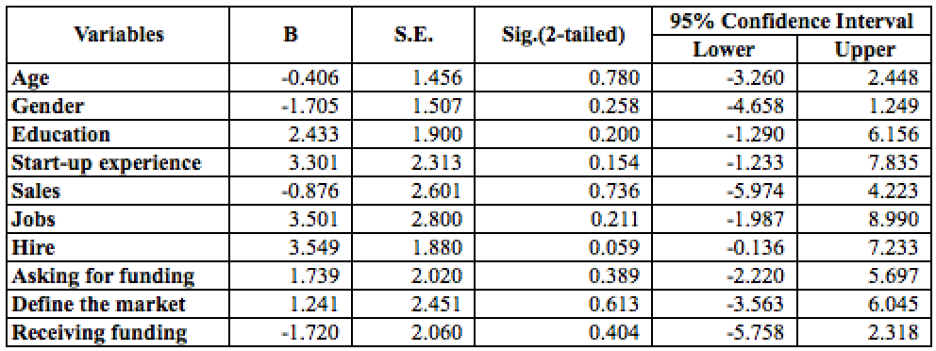

**Appendix B- The Logistic Regression after bootstrapping (B=1000)**

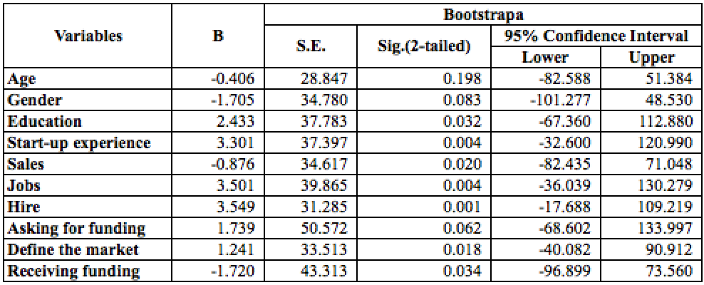

Figure 1: Development of new ventures over time

**A. Individuals**

Education

Start-up experience

**B Process**

Receiving Funding

Defining the market

New firm

Or

Still in the process

**C. Environment**

Sales

Sales

**A. Individuals**

Education

Start-up experience

**B. Process**

Receiving Funding

Defining the market

**C. Environment**

Sales

Sales

Figure 2: The model of new venture performance

Table 1: The number of entrepreneurs with different outcomes

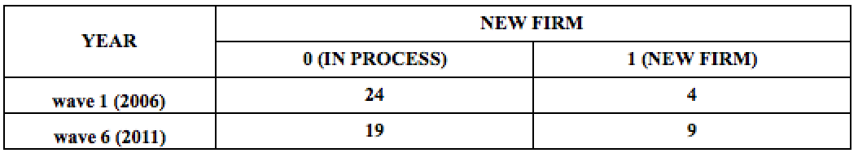

Table 2: Individual factors

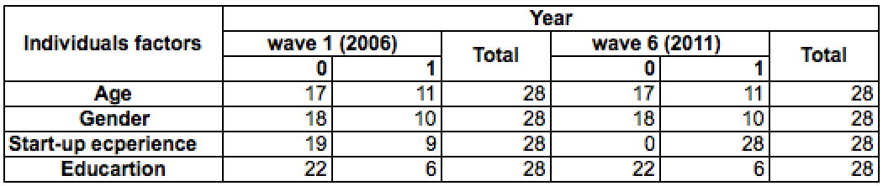

**Note:** For age, 0 represents the entrepreneur who is above 45 years old, and 1 represents the entrepreneur who is 45 years and/or younger. For Gender, 0 represents the entrepreneurs who are male, and 1, represents the entrepreneurs who are female. For Start-up experience, 0 represents the entrepreneurs who have one year and/or less start-up experience and 1 represents the entrepreneurs who have more than one year, start-up experience. For education, 0 represents the entrepreneurs without a college degree and 1 represents the entrepreneurs with a college degree.

Table 3: Environmental factors

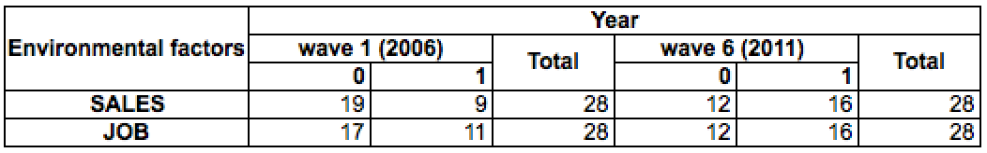

Table 4: The number of activities in new ventures

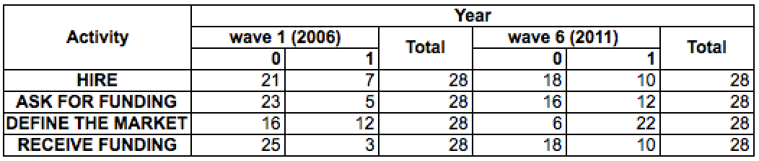

Table 5: Correlations of variable

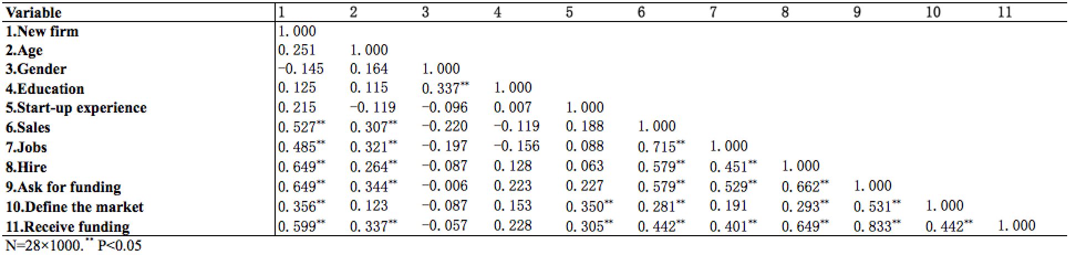

Table 6: Interactions between Individuals and process

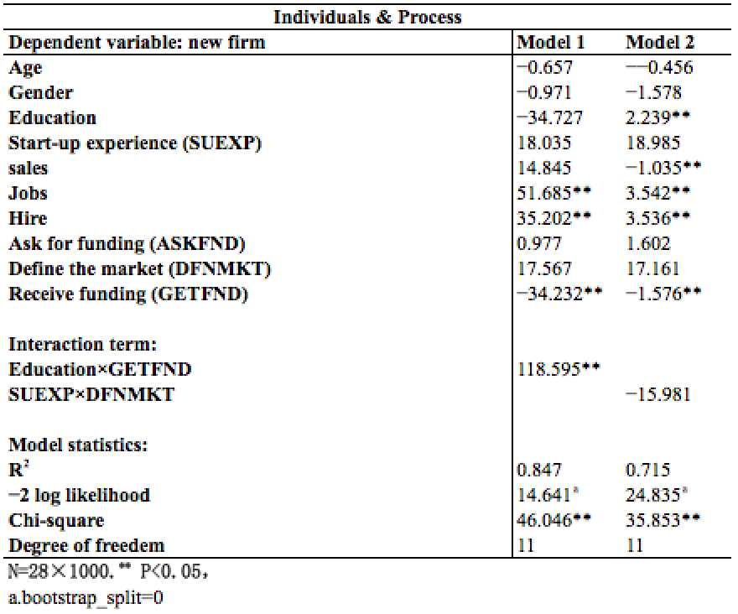

Table 7: Interactions of between individuals and environment

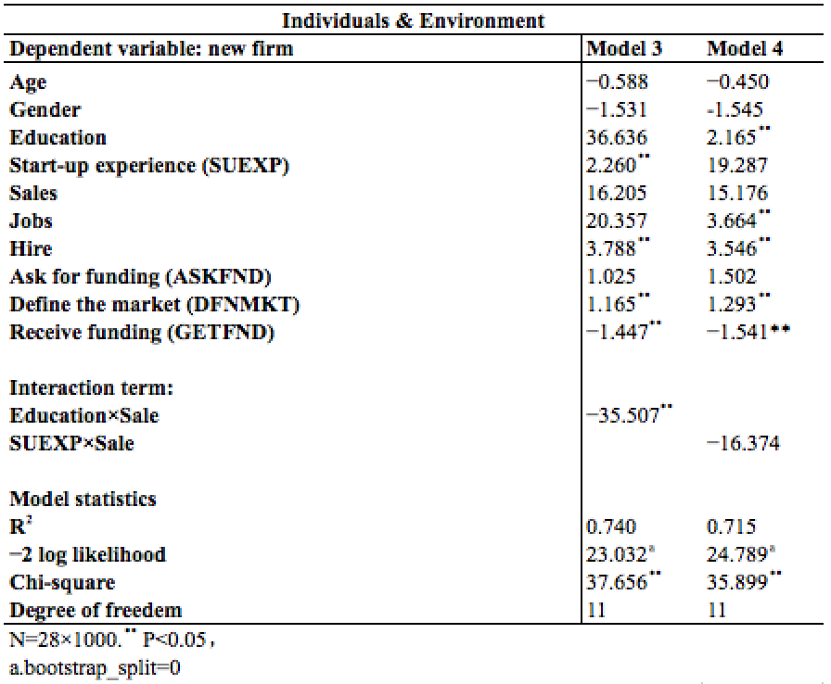

Table 8: Interactions between environment and process

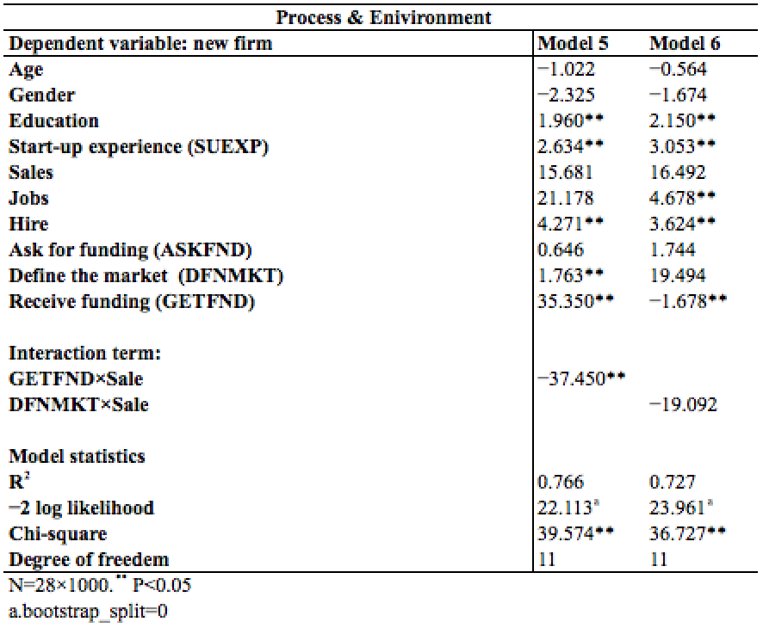

1. The panel study of entrepreneurial Dynamics Ⅱ (PSEDⅡ) investigates new venture performance in the United State with six waves of interviews (Reynolds, *et al.*, 2016). The investigation is not easy as most new businesses are not registered at the beginning (Reynolds, *et al*., 2016). These businesses are still transitioning to fully registered businesses. Therefore, the project is complicated and expensive to track (Reynolds, Hart and Mickiewicz, 2014). The PSED data can be accessed here www.psed.isr.umich.edu