Figure 4. Referral destinations following persistent symptomsª

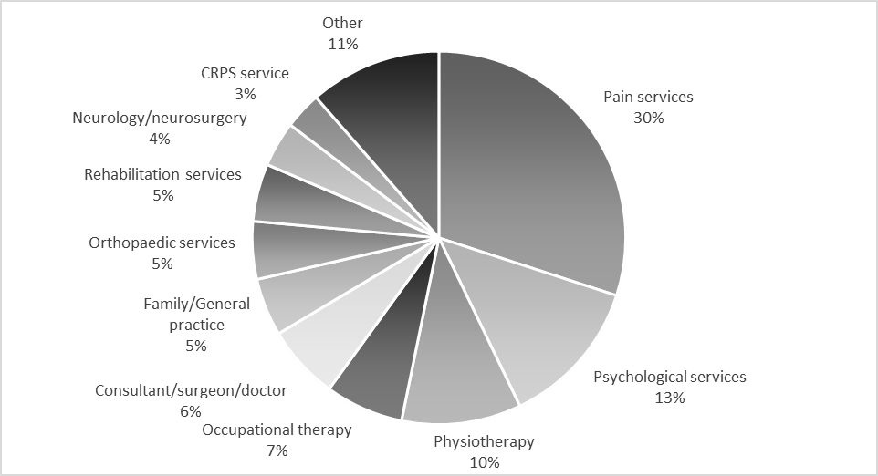
ª % of the 280 referral destinations listed by the clinicians and clinical academics providing patient care who responded to this question (n=181)

