Figure 3. Referral destinations after first clinical consultationª
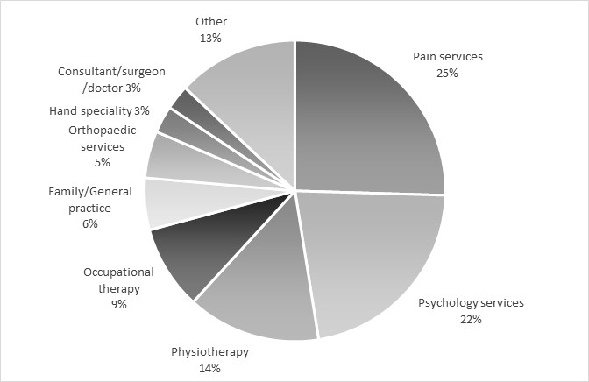
ª % of the 380 referral destinations listed by the clinicians and clinical academics providing patient care who responded to this question (n=184)

