Figure 2. Clinical specialism (n=251)ª
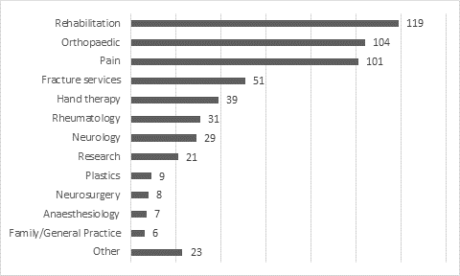
ª 548 specialities were selected by 251 respondents as they were able to select more than one specialism, e.g. working in orthopaedic and pain specialisms.

