Fig 1: Number of respondents per continent
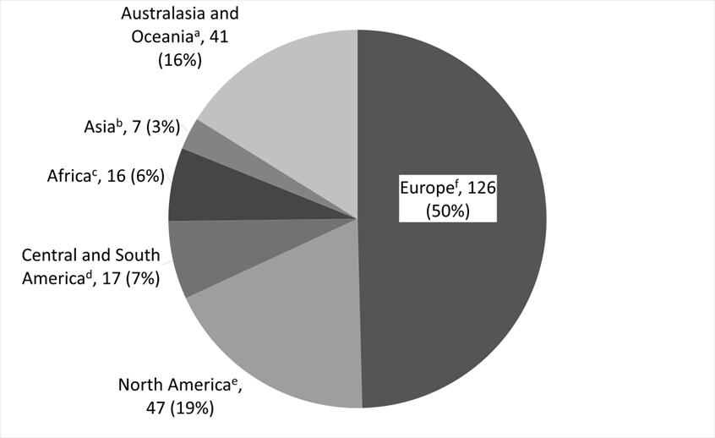
ª Australia, New Zealand
^{b} China, India, Japan, South Korea, Taiwan, Thailand
^{c} Kenya, Nigeria, Senegal, South Africa
^{d} Argentina, Bolivia, Brazil, Chile, Colombia, Guatemala, Mexico, Uruguay, Venezuela
^{e} Canada, United States
^{f} Belgium, Denmark, France, Germany, Ireland, Israel, Italy, Netherlands, Norway, Sweden,
Switzerland, United Kingdom

