Top of Form

**Small Ceramic Microbial Fuel Cell As a Trigenerative System for Electricity, Organics Degradation and Urine Filtration**

I. Gajda, J. Greenman (University of the West of England), C. Santoro, A. Serov, P. Atanassov (University of New Mexico), and I. Ieropoulos (University of the West of England)

**Abstract Text:**

Bioelectrochemical systems are employing microbes as biocatalysts to convert waste into valuable resources. For example, a Microbial Fuel Cell (MFC) utilises chemical energy locked in human urine into direct electrical current and can be scaled-up to power practical applications [1]. It is therefore paramount to improve power output and study catalytic reactions in which wastes are converted to useful products. In this work, an iron based electrocatalyst incorporated into an air-breathing cathode was tested in order to verify the functionality of the MFC as a simple, trigenerative system for (i) improved electricity levels (ii) to efficiently treat waste (neat human urine) in the anode and (iii) to obtain electrochemically treated (cleaned) catholyte as a function of system performance. The novelty of this process is in the simplicity of the operation, chemical-free and self-sustaining recovery.

* **Materials and Methods**
* Small scale (50 mm height) terracotta cylinders were constructed as MFCs with an internal cathode chamber and an external anode [2]. Cathodes were based on activated carbon (control) and iron catalyst blended into activated carbon (catalyst). Anodes were made from carbon veil wrapped around the ceramic cylinder. Each reactor was placed in the plastic beaker and seeded with a concentrated mixed inoculum derived from activated sludge and fresh human urine. The following feeding cycles, neat human urine was used as substrate for the MFCs.
* **Results and Discussion**
* The power output data are consistent with the polarisation experiments and indicate that the catalyst is performing 37 % better than the control. The catalyst based MFCs were also most efficient in utilising organic content (COD removal) in the anode which can be linked to their electrical performance.Due to MFC operation, a continuous formation of clear liquid was observed on the cathode electrode which was initially empty. It was recovered as a catholyte liquid from the inner chamber of the MFC (Fig 1) as an electrochemically cleaned (bleached) catholyte.

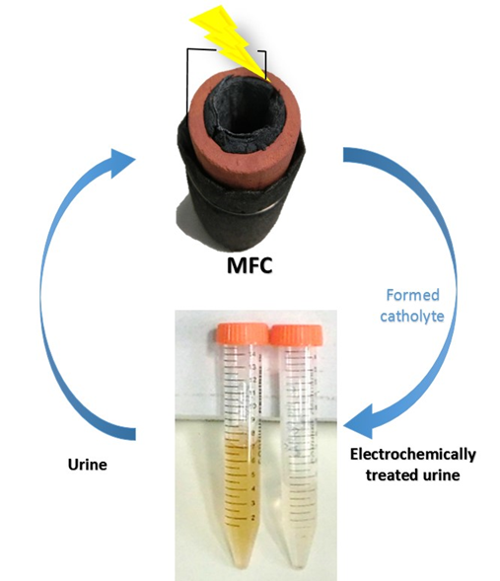

Fig. 1. Urine filtration through electrochemically formed catholyte.

Due to the electric field generated by the microbial anode, the substrate (urine) is separated into two solutions: the anolyte and the catholyte showing pH and ion splitting. Ion concentration, pH and rate of catholyte production relationships showed a linear dependence with power generation which underlined the ability of ceramic MFC system to generate electric power and simultaneously clean human urine.

* **Conclusions**
* The study confirmed that current generation was a key factor to drive the water extraction, pH and ion splitting functioning similar to electrodialysis system bleaching urine.
* **Acknowledgements**
* This work has been supported by the Bill & Melinda Gates Foundation, grant no. OPP1094890 and OPP 1139954.
* **References**

1. Ieropoulos, I. *et al*., (2016). Pee power urinal – microbial fuel cell technology field trials in the context of sanitation. Environ. Sci.: Water Res. Technol., 2, 336-343.
2. Gajda, I., *et al*., (2015). Simultaneous electricity generation and microbially-assisted electrosynthesis in ceramic MFCs. Bioelectrochemistry 104, 58–64.