Does nature finance pose macroeconomic risks?

Analysis using a stock-flow consistent model with land

Tom Youngman, Associate Lecturer, University of the West of England

[tom.youngman@uwe.ac.uk](mailto:tom.youngman@uwe.ac.uk)

Presented at the European Society for Ecological Economics conference in Pontevedra, Galicia, Spain at 9:00am on Thursday 20th June 2024. This work was carried out for my dissertation on the MSc Economics programme at SOAS University of London. My supervisor Yannis Dafermos carefully and expertly supervised the project and I am deeply grateful for his support.

*Extended abstract*

States, international organisations, financial institutions and businesses are increasingly seeking to mobilise large financial flows to fund ecosystem restoration. (UNEP, 2022) This paper asks what these new financial flows mean for the macroeconomy, and how macroeconomic feedback effects should be taken into account when contemplating nature finance programmes.

I augment DEFINE-GOV (Dafermos and Nikolaidi, 2023), a simplified version of ecological stock-flow-consistent model DEFINE (Dafermos et al., 2016), with a simple land module. Land is classified as either a *source* of greenhouse gas emissions or a *sink* for greenhouse gases. Agricultural, urban and industrial land is assumed to be a source of greenhouse gas emissions and trees and other natural vegetation are assumed to be a sink of greenhouse gas emissions. Growth in GDP leads land to be converted from sink to source. Spending on nature projects leads lands to be converted from source to sink.

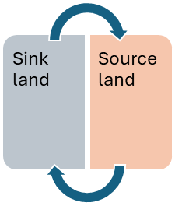

*Growth in GDP*

*Nature spending*

Figure : graphical depiction of the land module in my model

As DEFINE-GOV is a demand-driven model with post-Keynesian growth assumptions (Lavoie and Godley, 2001), expansion of nature spending leads to an increase in GDP as a second order effect. This in turn leads to some land being converted from sink to source. Nature spending thus has a feedback effect, with some proportion leading to second order harm to nature. The size and scale of this feedback effect is one of my principal objects of study.

I model three implementation channels through which nature spending can be carried out: public employment, public-private partnership and private enterprise. Nature spending through public employment is funded from government spending, and results in wages being paid to households without any aspect of profit or return. Nature spending through public-private partnership is still funded from government investment, but this time firms take a share of profits as well as paying workers to carry out nature restoration. Private nature spending is funded by firms in the same way as other private investments, through a mixture of bank credit and use of own profits. Firms make profits on these projects and pay a share both to workers as wages and to banks as interest. These three channels augment the DEFINE-GOV transactions matrix as shown in figure 2.

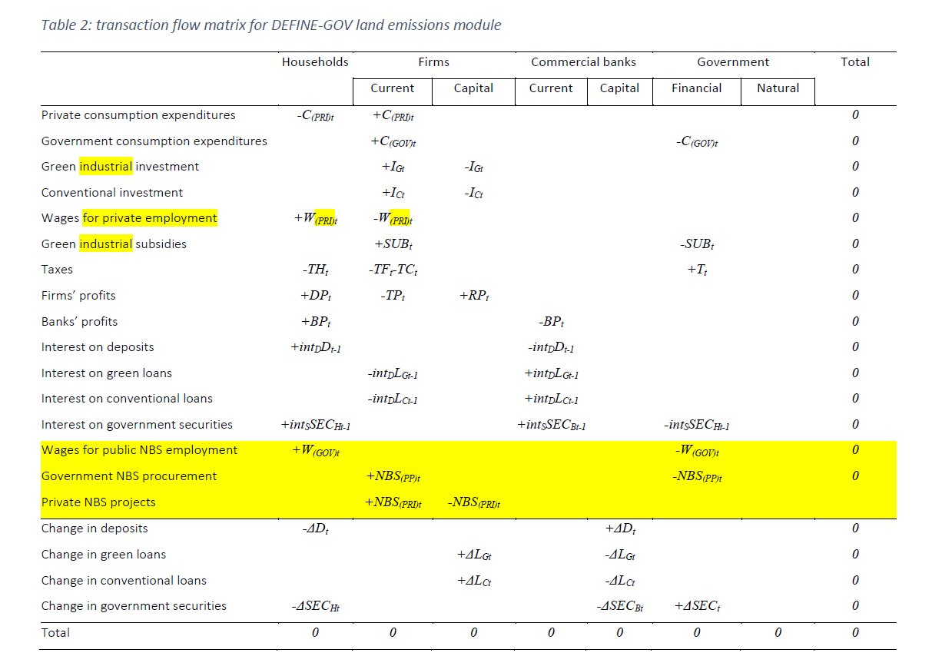

Figure : the new transactions matrix in my land-augmented version of DEFINE-GOV

The balance of two new parameters becomes central to modelling results. *Land intensity of output* is the quantity of land converted from sink to source by an expansion in output. *Restoration return* is the quantity of land converted from source to sink per pound spent on nature restoration. I carry out sensitivity analysis on these parameters as well as the responsiveness of investment levels to profits and on the marginal propensity to consume.

**Modelling results**

I model three types of nature spending policies: a spending target as a proportion of GDP, a fixed hectare target for the area of sink land and a policy of ‘offsetting’ damage done in the previous period. The second order damage to nature caused by the economic stimulus of nature spending leads to the latter two policies failing to meet their targets: lagged expectations mean the spending programmes are never quite enough to meet their goal. This problem can be mitigated by setting a small contingency factor, by which nature spending also aims to do more than last period’s results would suggest.

I find any spending on nature restoration significantly boosting output, particularly when land restoration costs are high. The extra economic activity from this feedback risks further primary habitat loss but is very unlikely to prevent nature spending making net improvements to ‘sink’ land area. Better greenhouse gas emissions specification is required to assess whether benefits of the net gains in sink land outweigh the harm from further appropriation of undisturbed habitats.

Figure 4: change in growth rate of output when nature spending is 0.22% of global GDP

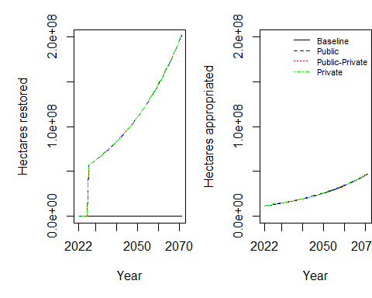

Figure 3: changes in source and sink land under when nature spending is set at 0.22% of global GDP

Publicly funded increases to nature spending increase the public debt to GDP ratio. The stimulus from privately funded increases to nature spending causes a small decrease in the public debt to GDP ratio. Firm leverage declines however nature spending is funded. Nature spending causes the wage share to decline slightly, but less so when nature restoration is delivered through public employment.

Figure 5: public debt-to-output and leverage ratio when nature spending is 0.22% of global GDP

Sensitivity analysis on the investment and consumption parameters demonstrates the impact that macroeconomic characteristics can have on the successful delivery of environmental policies. Increasing the marginal propensity to consume and the sensitivity of investment to profits makes the economy more responsive, with small changes in demand having big impacts in GDP. This amplifies the economic stimulus feedback effect from nature spending. Combining these extreme macroeconomic scenarios with the least favourable land parameters can lead to a scenario where no land restoration targets can be met because of the scale of the feedback effects. Contexts where nature spending is likely to crowd in other investments, and where households have a high marginal propensity to consume, are thus contexts where these feedback effects need to be more carefully considered.

**Selected bibliography**

Dafermos, Y., Nikolaidi, M., 2023. Developing, calibrating and simulating stock-flow consistent models. UK Partnership for Accelerated Climate Transitions.

Dafermos, Y., Nikolaidi, M., Galanis, G., 2016. A stock-flow-fund ecological macroeconomic model. Greenwich Papers in Political Economy, Greenwich Papers in Political Economy.

Lavoie, M., Godley, W., 2001. Kaleckian Models of Growth in a Coherent Stock-Flow Monetary Framework: A Kaldorian View. Journal of Post Keynesian Economics 24, 277–311. https://doi.org/10.1080/01603477.2001.11490327

UNEP, 2022. State of Finance for Nature 2022. Available at: https://www.unep.org/resources/report/state-finance-nature