**Why assessment transformation needs a thriving** **ecosystem**

Antony Hill

University of the West of England

Dean of Learning and Teaching (College of Health, Science & Society)

[Antony.Hill@uwe.ac.uk](mailto:Antony.Hill@uwe.ac.uk) / 0117 3283653

Cathy Minett-Smith

University of the West of England

Dean of Learning and Teaching (College of Business & Law)

[Cathy.Minett-Smith@uwe.ac.uk](mailto:Cathy.Minett-Smith@uwe.ac.uk) / 0117 3281303

**[Introduction]** Transforming assessment practice is something the entire Higher Education Sector strives for, increasingly so with a focus on inclusive assessment and the opportunity to change the culture from assessment **of** learning to assessment **as** learning (Elkington 2020). This transformation is often positioned as being relatively straightforward if it is considered to be linked with the isolated activity of changing the assessment task. However, the direct assessment task or activity that a student completes sits in an ecosystem of complex connections. If these are not acknowledged, understood and interrogated, they can create genuine dampers to innovation and potentially weaken the experience for both staff and students.

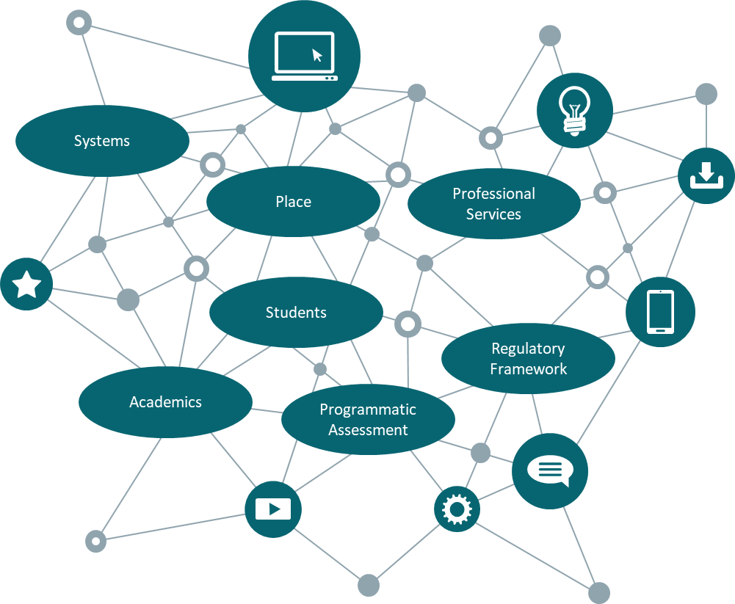

**[Academics]** For staff, the culture around assessment is absolutely key in facilitating transformation (Mellati and Khademi, 2018). This isn’t about strategy or plans, but the (often unspoken) “norms” that propagate through an assessment ecosystem. Without surfacing and discussing, they continue to propagate. A classic cultural example is delivering a mirrored version of one’s own experience of assessment practice as opposed to learning from it. Even the most passionate innovator often starts with an essay and exam as the “norm” for a module assessment with the feeling that they will need to make an argument to do anything different.

A related concept, beyond the scope of this article, is potential gaps in staff assessment literacy arising from lack of training or time pressures. The potential to be held accountable for drops in student performance, and/or student satisfaction can drive a tendency for risk aversion for many staff (McVitty, 2022). Conversely, those who do innovate can sometimes be positioned as a maverick, or worse, as fuelling dissatisfaction amongst students who compare experiences across modules. The culture needs to be one of empowerment, where we are transparent about flipping norms, and explicit in the need for risk taking.

**[Programmatic Assessment]** Increased emphasis on programmatic assessment demands a team, as opposed to an individualistic, approach to assessment design (Khanna and Velan, 2024).

Each individual assessment may be soundly designed, but without considering the balance and contribution of all of the assessments, something key is lost in the student experience. I’m sure we can all think of examples where staff have wanted to do something different, more interesting, and richer and what happens is, for example, a student ends up doing 5 poster presentations across their 5 modules rather than 5 written exams. Assessment doesn't occur in a vacuum. Combine a culture of empowerment with team collaboration and the right conditions for transformation within the ecosystem start forming.

**[Students]** The most important area of the ecosystem that we haven’t elaborated on yet, are the students themselves. It's certainly possible to design assessments to be as inclusive as possible and programmatic (especially through universal design for learning), but without exploring and incorporating our students’ motivations and expectations they still may not thrive in this space. Whilst some students may thrive in a context of varied, innovative assessments, others rely on familiarity to build confidence (O'Neill and Padden, 2021). Managing student expectations in the assessment process requires transparency and focussed effort to present an authentic and credible rationale for what students are being asked to do when, why and how they need to plan to engage (Winstone et al., 2017). Failing to do so results in repeated conversations on topics such as groupwork and assessment bunching resulting in frustration for everyone. Confidence in the assessment design is a necessary pre-requisite for students to grapple with the intellectual challenge and struggle inherent in the process.

Admittedly, this is very easy to say but hard to do meaningfully. With all of the best design intentions, we still do need to honest and open about the struggle. Expectation setting can often be forgotten (especially when there have been huge efforts in assessment design) but it will still always be needed and is healthy to be pragmatic.

So, we’ve carefully designed assessments and we’ve reflected with our students, adapted, and then linked this to expectations. What are the other features of the ecosystem that need to be considered though? Wider university support through the various professional services are vital aspects that contribute to the health of the ecosystem along with non-human elements such as university systems, estates infrastructure and facilities, digital spaces and regulatory frameworks. All of these elements need to be working in harmony to enable transformation to thrive.

**[Professional Services]** The team around assessment needs to feel seamless. Beyond the more immediate teaching staff there needs to be an integration of professional services at the point of need in a clear and consistent way.  The range and quality of the support available is extensive with students typically providing overwhelmingly positive feedback when they have accessed it. The challenge that many institutions face is getting students to access the support. Often this is linked with students needing to self-diagnose their support needs and then knowing how to find the help in an extensive but possibly bewildering offer. The move towards dialogic approaches to assessment and the new paradigm of feedback are positive steps in connecting learning support more purposefully with the assessment journey by focussing on which specific skills are needed in particular tasks (Carless, 2022). Furthermore, there are increasing examples of professional service colleagues being embedded in curriculum delivery to bring the support closer to the learning. However, this needs to be done in a strategic way to make the most effective use of a precious and limited resource. Crucially, attention needs to be paid to how we join the dots for students, making meaningful connections between the various parts of the ecosystem which can be achieved through a clear articulation of the members of a student’s learning team and the role that they play.

**[Systems]** Similarly, systems need to be consistently integrated. Connected to assessment there are so many different elements – the virtual learning environment, student records, student tracking to name but a few.  Interestingly without these being considered as part of the ecosystem, they can often be perceived as blockers or barriers. How many innovations have floundered at the hurdle of trying to deliver it in the virtual learning environment or trying to get a grading system to accommodate a slightly different approach to marking. There are usually ways of making it work but it often requires dogged determination to achieve that, often involving clumsy work arounds. With the best will in the world, we can’t always have a seamless experience within our systems, so we do need to come back to the ethos that these systems are there for the student, not merely vehicles to record student achievement.

**[Place]** Innovation can often be achieved when there is freedom to use physical space and facilities in different ways to develop more authentic forms of assessment. For example, simulating recruitment assessment workshops, or utilising a campus estate to simulate a major healthcare incident. Where subjects have dedicated specialist space, such as Law Moot Courts, this can be relatively easy to achieve but for subjects that don’t have access to dedicated space it can be much more problematic often requiring changes to timetables and managing associated communications with students. Where learning and assessment are blended more seamlessly together, such as in block teaching approaches, this is arguably easier to achieve. However, even these approaches may still limit innovation if the available learning space does not adapt easily to different types of use and flexible availability in what is usually a fairly rigid academic year assessment calendar. There are also the physical and digital spaces that facilitate experimentation around assessment (beyond the systems). Physically this could be timetabling approaches to support alternative assessments for example; which can be either an enabler or barrier depending on its connection to the wider ecosystem.

Place is not only physical; it also encompasses digital spaces. One of the inherent challenges in conducting assessment in digital spaces is less control over managing the space and equitable provision of quality digital environments. Whilst the provision from the university might be high quality, the student will experience differing levels of quality due to factors beyond the university’s control such as hardware and internet speeds. Digital poverty is a genuine challenge in the learning experience and harder to mitigate in context of assessment where the consequential risks are high. From a digital perspective the most current high-profile area is the use of artificial intelligence in assessment. Interestingly this has the potential to be a significant disrupter to the assessment ecosystem, impacting in several ways. We can continuously try to embrace this rapidly changing dynamic (through encouraging its correct use, bringing into design etc.). Pace of change becomes the challenge here as this can potentially destabilise the entire system if either the adaptions are too fast or too slow. Of course, for an ecosystem, it is almost possible to remove destabilising factors when there is, realistically, no mechanism to stop them constantly being brought in. Considering this more holistically is key.

**[Regularity framework]** In any natural ecosystem there are obviously always rules that need to be followed, e.g. water flows downhill, which affects everything inside in, and this is no different for an assessment ecosystem. One of the primary areas (not yet discussed) relating to the rules are our regulatory frameworks, which can significantly influence student behaviour and engagement.  There needs to be acknowledgement that there are no regulations that suit all but we do need to have honest conversations with students to mitigate unintended consequences. This is an ecosystem though where we can, to an extent, change the rules or at least help all the actors to interact appropriately within them.

The wider regulatory context to be taken into consideration in the ecosystem are the quality descriptors that govern higher education provision. We are all accustomed to the level descriptors and have written our programme and module learning outcomes with due diligence ensuring progression of academic skill throughout the levels. Whilst subject benchmarks are regularly updated, level descriptors have remained relatively static over time. Put simply, whilst the expectations of the body of knowledge to be covered are changing, the expectations of what students need to do to show us that they have acquired and can use this knowledge have not. Juxtapose this with changes in digital aspect of the ecosystem and it throws up interesting tensions that either challenge or support innovation. For example, what does it mean to critique or create in an AI enabled world? What is uniquely human about some of the tasks we ask students to do, is that adequately captured in level descriptors and what is the best way to then measure this. Furthermore, the need to ‘know’ and/or recall key knowledge to enable you to evidence higher level skill is more important than ever. Some more traditional forms of assessment, such as exams, are odd ways of assessing knowledge recall. And we have come full circle back to earlier comments relating to safeguarding innovation overload.

**[Conclusion]** It’simportant to accept that, however well balanced an ecosystem is, it can never be perfect and will always be open to disruption. However, by understanding the complex connections between the multiple components, how they interact, and striving for that balance we can generate an assessment ecosystem in which our students can thrive.

**[References]**

Elkington, S. (2020) Essential Frameworks for Enhancing Student Success: Transforming Assessment in Higher Education, A Guide to the Advance HE Framework, York: Advance HE.

Mellati, M. and Khademi, M. (2018) Exploring Teachers’ Assessment Literacy: Impact on Learners’ Writing Achievements and Implications for Teacher Development, Australian Journal of Teacher Education, 43(6): 1.

McVitty, D (2022) Building back learning and teaching means changing assessment. WonkHE [blog], 24 January. Available from: https://tinyurl.com/2zbfk9h3

Khanna, P. and Velan, G. (2024) Programmatic Assessment: Are we there yet? UNSW Sydney [blog], 7 May. Available from: https://tinyurl.com/5dynxhae

O'Neill, G. and Padden, L. (2021) Diversifying assessment methods: Barriers, benefits and enablers,

Innovations in Education and Teaching International, 59(4): 398-409.

Winstone, N.E., Nash, R.A., Parker, M., and Rowntree, J. (2017). Supporting learners' agentic engagement with feedback: A systematic review and a taxonomy of recipience processes, Educational Psychologist,52(1): 17-37.

Carless, D. (2022) Feedback for student learning in higher education. In: 4th International Encyclopaedia of Education, Oxford: Elsevier.