# Circularity in the built environment – a call for a paradigm shift

Tove Malmqvist, KTH Royal Institute of Technology, Sweden

Alice Moncaster, Open University, UK

Freja Rasmussen, Danish Building Institute, Denmark

Harpa Birgisdottir, Danish Building Institute, Denmark

## Introduction

The built environment provides our basic human needs, of warmth, shelter and community. However buildings and their associated infrastructure are also responsible for more than 40% of global energy use and 35% of raw material consumption, and account for as much as one third of global greenhouse gas emissions and the same proportion of global waste. It is clear that the ways in which we design, construct, maintain, redevelop and use our built environment are of fundamental importance for staying within the planetary limits.

The concept of a circular economy has been applied for some while to the manufactured components that form our buildings and infrastructure; however it has only recently been applied to individual buildings and urban neighbourhoods. New terms such as ’circular buildings’ are now entering our language, and demonstration projects labelled as such are increasingly being marketed as solutions to the challenges of global warming and resource scarcity. Nevertheless clear details of resource flows and environmental impacts are still for the most part unknown, as is an understanding of how circular design and construction strategies might reduce those flows and impacts.

This chapter considers how circularity might be approached and achieved within the messy complexity of the built environment. Through three case studies we discuss both the technical and the social aspects of circularity. The final section then uses insights from the literature and the case studies to develop a new framework for the dynamics of a successful circular built environment.

## Existing approaches to circular buildings

A low-carbon and resource-efficient agenda for the built environment has been discussed and enacted for many years, through a focus on ’sustainable’ and ’green’ buildings (Ness and Xing 2017). This has meant that, while not the primary topic of interest, the core circular principles of closing material loops, reducing material use, and keeping products in use (Stahel 1981; Bocken et al. 2016) are already present within a range of initiatives and building assessment methods. Table 1 summarises the key design strategies for sustainable buildings and construction works which have been recommended by both academics and professional bodies, and classifies them in relation to the underlying principles of circularity.

|  |  |
| --- | --- |
| Principles of circularity | Sustainable design strategies |
| Closing loops | * Using bio-based materials * Using recycled and reused materials/ components * Designing for disassembly, designing in layers * Ensuring purity of materials and components * Documenting materials and components |
| Slowing loops | * Designing for service life extension of construction and components * Designing for low maintenance of construction and components * Designing for adaptability of construction and components * Designing for beauty and attachment |
| Narrowing flows | * Designing light weight constructions * Optimizing construction form * Optimizing usable area * Optimizing energy use * Sharing spaces * Virtualizing design process * 3D printing of constructions (OR industrializing construction process) |

Table 1. Design strategies for buildings and construction works in relation to the circular economy principles. Design strategies from (Malmqvist et al. 2018; Cheshire 2016; Bocken et al. 2016; Ellen MacArthur Foundation 2015; McDonough, W.; Braungart 2002)

A number of calculation tools are used for assessing sustainability, and now circularity, in the built environment, including Life Cycle Assessment (LCA), Life Cycle Costing, Material Flow Analysis and System Dynamics Assessment. Ghisellini et al (2018) suggest that LCA is most frequently used for circularity - although Eberhardt et al (Eberhardt, Birkved, and Birgisdóttir 2019) find that in practice examplar ‘circular’ projects are seldom critically assessed for the actual achievement of their claims. While the current European and International standards describe a linear process approach to LCA, our Figure 1 therefore adapts this to show a circular process, with consecutive cycles of material flows and the building as the initial object. Subsequent processes which use the waste materials from the initial building could themselves be new buildings, or they could be individual products used in the built environment or elsewhere. As with all processes there will be losses at each stage from wasted materials and energy. However these will be more complex for a building than for individual manufactured products, since the long building lifespan means that many individual components will be replaced, often repeatedly, over the building’s lifetime.

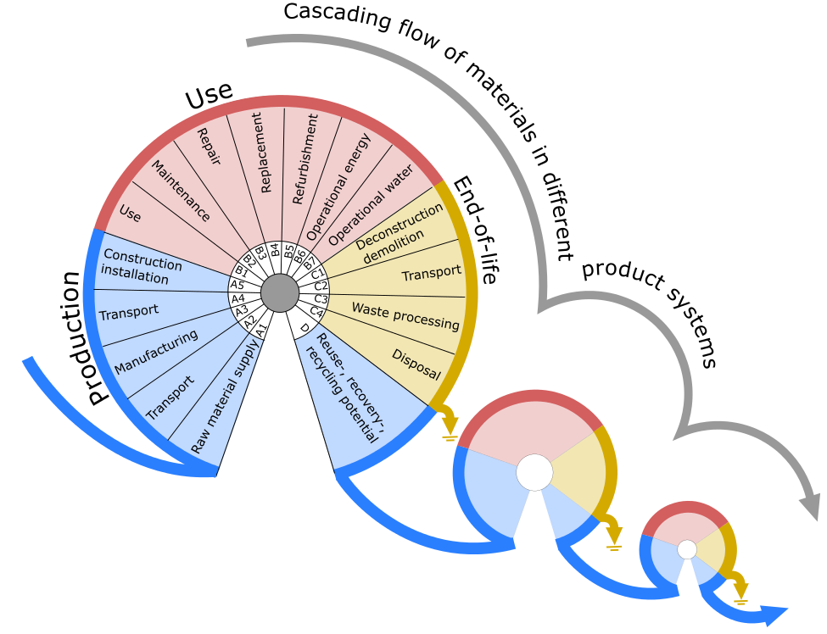

Figure 1. Circular material flows of the built environment in the terminology and modularity of LCA for building and constructions, as specified in the EN 15978 standard (CEN 2012) (Figure original to the authors)

Technical assessments of circular strategies therefore focus on material resources and related material flows. Through this perspective, buildings are essentially considered as temporary ‘material banks’.

But we know really that buildings are not just collections of materials. The built environment fulfils the lowest levels of Maslow’s hierarchy of needs – physiological (warmth, somewhere to prepare food, access to safe drinking water) and safety (protection from both the physical and human environment). As Tweed and Sutherland (2007) note, the higher levels, of ’love’, 'esteem’, and ’self-actualization’ are also provided within and by the built environment. Buildings, they say, ’are never purely functional. The most mundane buildings can acquire higher level meanings, often unintentionally, and these meanings may be quite different, even diametrically opposed, for different groups of people.’ (Tweed and Sutherland 2007 p64) Jonsson (2005) further relates society’s needs for cleanliness, social interaction, and education, to a wider and complex network of physical built infrastructure including treated water provision, transportation networks, and electricity. Both buildings and the wider built environment then are the means for providing society’s multiple and diverse needs. Reframed thus, it is clear that any thorough assessment of the circularity of the built environment must also consider its social purpose.

It follows that concepts of circularity require a highly interdisciplinary approach. The large number of actors who are involved (Lützkendorf, Balouktsi, and Frischknecht 2016; Birgisdóttir 2016) grows with each spatial level. Pomponi and Moncaster (2017) suggest that the need for an interdisciplinary approach grows accordingly, and that the multiple layers in a building, all with different service lives, as well as the different life stages of the building, will each have their own actors and stakeholders. These extend further through long supply chains (Leising, Quist, and Bocken 2018). Laurenti et al (2018) therefore argue for the need to find circular solutions based on systems integration, in which it is acknowledged that the institutional and material systems are interrelated.

In summary, it is clear that the built environment plays a critical role for society, that circularity must consider more than just the technical issues, complex as those already are, and that there are numerous actors involved in each step of the way. A truly circular built environment therefore will not be achievable through a simple focus on individual circular products, or even on zero/low-carbon buildings; while these are important aspects, it also requires a deeper understanding and exploration of how the built environment can best provide the needs of society.

## Illustrating perspectives of circularity in the built environment

This section discusses our approach to circularity through three case studies. The first focuses on society’s need for shelter, looking at the domestic building as a circular product, and considering what LCA can offer as an assessment tool for circularity. The second case looks at educational needs through a study of four UK schools, and considers how the multiple professional experts and tools used during the design process can determine the circularity of the outcomes. Finally in the third case, the needs and role of users and owners are considered in the management of existing commercial buildings. Each case study summarises a detailed case study published elsewhere.

### Case 1: Perspectives on a quantitative evaluation tool

Within the built environment, circular economy initiatives generally focus on resource loops while life cycle assessment (LCA) focuses on life cycles. LCA thus assesses individual products over their lifetime. Figure 1 relates this linear approach to a circular one through depicting resources as moving through a series of individual loops which cascade through different systems. However, even focusing on one loop at a time, the LCA method provides the option of assessing products and services from a cradle-to-cradle perspective.. In practice this means calculating the environmental benefits of previously recycled materials used at the start of the system (production - module A1-A3 in Figure 1) and the benefits of future recycling and reuse (module D of Figure 1) that are expected in the subsequent loop, or next system. Allocation principles are needed to distribute the emissions between the end of the first or start of the second system, and there are several methods for doing this, each with their own implications. The European Standards approach (CEN 2012) prescribes a 100:0 allocation between systems, which generates advantageous results when using recycled materials as input to a system. However, the delivery of recyclable materials to the next product system, for instance through the strategy of ‘designing for disassembly’ (DfD), does not advantage the primary system under study, merely requiring a report of the potential future benefits for the next system.

A case study of two residential buildings applying recycling and DfD strategies respectively demonstrates this more in detail. The case builds on Rasmussen et al. (2019) in which calculation details can be found. Table 2 shows the details of the case buildings.

Table 2. Details of case buildings. Adapted from Rasmussen et al. (2019)

|  |  |  |
| --- | --- | --- |
|  | Recycle building | DfD building |
| **Type** | Residential, single-family | Residential, multi-family |
| **Heated floor area, m2** | 129 | 77 |
| **Description of building** | 1-storey house with structural system of steel (shipping containers), light shell and built-up roof | 2-storey apartment block concept of pre-cast concrete structure with a tile cladding shell and built-up roof |
| **Details of design strategies** | Direct reuse of shipping containers as constructive elements. Direct reuse of concrete strip foundations, EPS, construction wood, windows and facing tiles. Material recycling of gypsum boards and aluminium | Elements designed for 2 service lives: constructive elements (concrete) designed for disassembly; façade system, gypsum and wood wool boards installed with rails and brackets; carpet tiles with take-back cleaning service and resale |
| **Illustration of case building** |  |  |

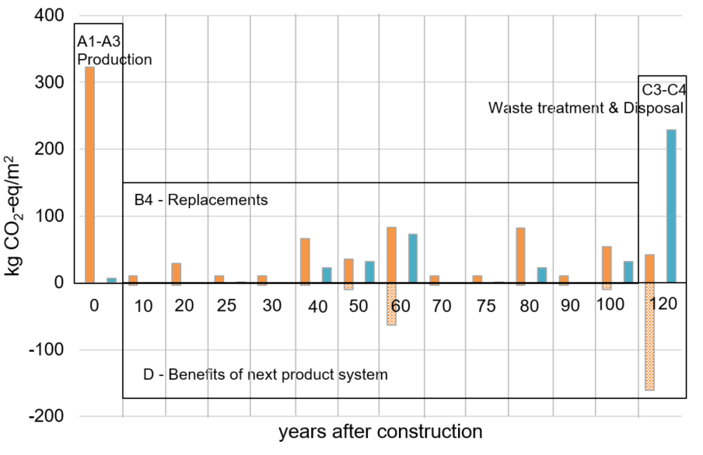

Figure 2. Details of the Recycle building (blue) and the DfD building (orange) buildings’ life cycle stages (refer Figure 1) and the ‘pulses’ of greenhouse gas emissions related to materials, at certain points in time after the construction

Figure 2 illustrates the potential impacts to global warming from life cycle stages of the Recycle building (blue) and the DfD building (orange). The low impacts of the recycled construction in the production stage is caused by the low-impact, or even burden-free, recycled materials as well as the use of construction wood that stores carbon. However, during and at the end of the building lifetime, the waste treatment (incineration) of wooden products causes the stored carbon to be released, resulting in notable potential impacts from these life cycle stages of the Recycle building. Due to the use of virgin materials, the DfD building causes high emissions in the production and replacement stages compared with the Recycle building, but the DfD building entails potential savings in the next product system because the directly re-usable elements are assumed to have a 2nd life in a different building. However, according to the CEN standardised method, these savings do not benefit the environmental footprint of the DfD building because the savings are only (potentially) attained in the next product system. In this way, the 100:0 allocation approach specifically promotes a system’s use of recycling/reuse rather than a system providing recyclable/reusable materials by including the merits of the first strategy, but not the second strategy, to the system under study. This focus on the immediate impacts rather than the (potential) benefits at the end of the building’s life thus encourages current low-emission design. Nevertheless designers and policy makers should recognise that the potential savings in module D are important and should not be disregarded.

In the DfD building 34% of the potential savings for the subsequent system (module D) are related to the reuse of 800 kg aluminium profiles. In comparison, the reusable concrete walls, slabs and pillars together constitute only 25% of the potential savings in module D. This highlights the importance of ‘looping’ of specific emission-intensive materials rather than just focusing the design on DfD of components of high volumes. A viable focus for circular building design and policy strategies could thus be found in combining 1) designs that use recycled materials for the initial construction and 2) designs that ensure the potential reuse of high benefit materials, not only at the end of life of the building but also at various stages of replacement throughout the life cycle.

This case study therefore shows how decision-making regarding circular strategies can be evaluated and informed by applying a specific tool, in this case LCA. However, the case study also highlights how calculation rules, such as those regarding allocation, have the potential to implicitly endorse some solutions over others. It is therefore of special importance to apply a variety of evaluation tools and system perspectives to circular projects in an iterative process in which the network of actors learn from the feedback from evaluations. Furthermore, circular projects may challenge the evaluation frameworks that are developed for linear product chains and point to areas in which further method development is needed.

### Case 2: Complexities of the design decision process for sustainable and circular schools

The move towards a circular built environment will necessarily involve many actors, each of whom play a role in the design decisions that are taken. These decisions are in turn further influenced by the tools that are used, including assessment tools such as LCA as discussed above, but also a number of common or proprietary decision tools. This section considers the diverse impact of these multiple actors and tools through a qualitative study of the design and construction of four school buildings in the UK (see Figure 3). Further details are provided in Moncaster (2012).

Backhouse and Eastwick Field Schools, both built by the same contractor, originally had very different stated design aspirations. For Eastwick Field sustainability was a strong focus for the school and governing body from the start, and was supported by the considerable expertise and interest of the design team. This was widely interpreted to include environmental aspects such as reducing energy, carbon and waste, and also social aspects such as improving disabled accessibility and ensuring widespread consultation with the school community. In contrast for the Backhouse project there was very little stated aspiration for anything more than a low cost building that met the minimum regulatory requirements. The tools and processes which were used to develop the aspirations for the new buildings played a major role in what then happened, and failed to happen.

At both schools the stakeholders who used and managed the schools – governing bodies, school leadership and teachers, and pupils and parents - were invited to input to the design. At Backhouse this was through the initial planning consultation process. However the Local Authority client for the school clearly saw it as a tick-box exercise, a need to ‘be seen to have consulted’ as one governor put it; the room data sheets and technical drawings used to present the design were not designed for lay understanding, and not surprisingly evoked little comment. At Eastwick Field instead a specific tool called the Design Quality Indicator (DQI) was used for this purpose, in theory to make the process more accessible and allow more of an equal input to the design concepts. However the DQI was shown to have constrained discussion to topics predefined again by the Local Authority client, and the participants were therefore extremely critical about the process. Both the planning consultation and the DQI were therefore seen as ‘an exercise in demonstrating support’ and neither encouraged higher aspirations at Backhouse nor supported those at Eastwick Field. Only the (mandatory) use of the certification tool BREEAM for Eastwick Field was shown to have had a positive effect, leading to some reduction of materials and operational energy use.

Once the Backhouse project was on site there was a noted difference in approach. The contractor used an in-house tool called ’Playing cards for the future’ to encourage each of their construction sites to compete in collecting credits (’cards’) for various sustainability aspects. The site team worked hard to win the competition, resulting in considerable reduction in site waste as well as excellent consultation with the end user throughout the building programme. This was shown to have been a direct impact of the use of this particular tool, as well as strong leadership from the contractor.

The next two buildings at St Augustine and Lane Academy were constructed by a second contractor. The St Augustine building was originally designed to be steel frame, but part-way through design the structural engineer proposed using cross-laminated timber (CLT) instead. This was innovative in the UK at the time, and there was no experience of the material within the design team, so the proposal provoked considerable objection. However the structural engineer successfully persuaded his colleagues, using a simplified in-house LCA Excel tool which convinced them of the embodied carbon savings which could be achieved. The St Augustine project was also the contractor’s first experience of using CLT, but it proved a positive experience for them, producing considerable business benefits in terms of speed of erection, minimisation of waste and improved safety on site. They therefore decided to use the same material for their next project, Lane Academy. The use of CLT therefore made excellent business sense for both the structural engineer (who now had a niche design expertise) and the contractor, as well as having benefits towards circularity in terms of reducing waste and greenhouse gas emissions, and towards improved working conditions on site. Its introduction was the result again of strong leadership, initially from the structural engineer and then from the contractor, as well as the demonstration provided by the LCA tool.



*Figure 3. St Augustine School under construction; there were frequent visitors to the site to see the innovative CLT system being installed (photo credit: Alice Moncaster)*

Finally Eastwick Field and Lane Academy also both used the Government’s Excel-based ‘schools carbon calculator’ to demonstrate reduction of greenhouse gas emissions. However a particular calculation hidden within the ’black box’ of this particular tool led to a biomass boiler being the default option by which the required carbon reduction could be demonstrated. As a result 90% of the schools which used the tool, including Eastwick Field and Lane Academy, had installed biomass boilers. The contractors who had worked on a number of schools knew that this was a glitch in the tool, and also knew that many of the installed biomass boilers were never switched on, since a conventional gas system (which was easier to run) was always installed alongside as a backup. The Government continued to promote biomass, however, since the carbon calculator tool was feeding back the (mis)information that the schools installing biomass achieved the targeted reductions in greenhouse gas emissions. This argument was based on assumptions within the tool which were never challenged, and demonstrates that rules embedded within specific methods and tools can push designers towards a solution that is in some cases irrational.

In each of these projects a number of tools were used explicitly to inform decisions. While several were useful in supporting design and construction judgements, the impact was much more complex than understood at the surface with, in many cases, the tools restricting rather than enabling choices. The case study has therefore shown how the tools, combined with conflicting claims of expertise and unequal distributions of power, have both shaped and often limited what has been considered during the design of the schools, and what has then been built.

It is critical that we understand the hidden power and wider consequences of the assessment and decision tools we use to support our design, and include all actors and stakeholders in the process, rather than trusting the tools to define the ‘correct’ solutions for circularity. As with the previous case study focused on LCA, this has important implications for how we should approach the design and assessment of circular buildings.

### Case 3: Incorporating the built environment users

The long life of a building structure means that its constituent materials are subjected to recurrent processes of maintenance, replacement and adaptation, each of which have an impact on material flows and losses. When considering circularity this becomes an important concern. The cycles of these activities vary considerably and can also be extended for various reasons, such as through careful use and maintenance, or due to limited financial resources, or because of not wanting to lose valued cultural heritage factors; on the other hand components may be replaced much sooner due to changed user preferences or demands, fire and water damage, and other user impacts.

The following case study of a major refurbishment project of an office building in Stockholm (Liljenström and Malmqvist 2016) is used to discuss this aspect further in relation to achieving circularity in the built environment.

The project was carried out in 2014 in an office building built in 1940 in central Stockholm, Sweden. It was primarily driven by a new tenant moving in and involved the demolition and reconstruction of the interior walls, construction of an internal stair case, replacement of floor and ceiling finishes, doors and glass walls, sanitary porcelain, kitchen equipment, ventilation and electrical installations. The study focused on assessing the greenhouse gas emissions associated with the refurbishment project, partly driven by the property owner who wanted to better understand the quantities of resource flows and emissions. The study was based on detailed on-site inventories of waste streams and purchased materials.

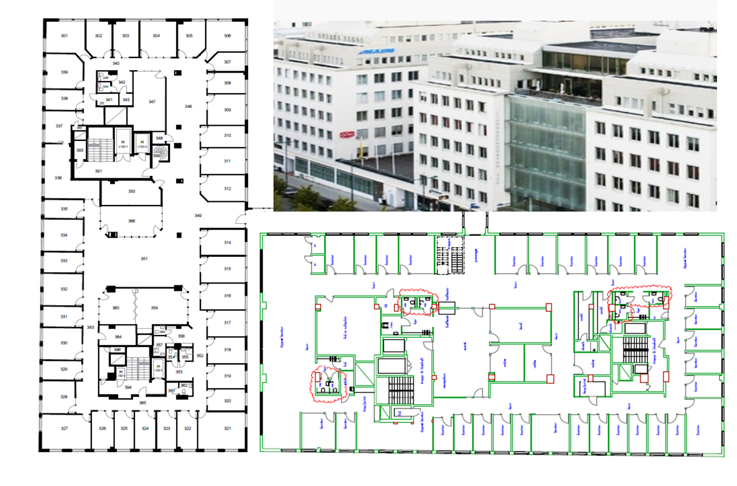

Figure 4. Case building and interior design after (left) and before (bottom) refurbishment. (photo and documents: Vasakronan and gwsk arkitekter.

Leases for this property owner are typically 3-5 years and fit-outs of varying size are carried out in between leases. While extensive refurbishment projects such as the one in this case study are common they are less frequent, at around 15-year intervals or when interior fittings start to look old and out-dated. For example in this case study the doors and kitchenettes dated back to the 1980s. The primary reason for reconstructing the internal walls was improved acoustic requirements compared to the original construction.

The embodied greenhouse gas emissions of this project amounted to just over 60 kg CO2-eq per m2 gross floor area. This figure covers production of new materials and products, transport to and from site of new material and waste produced, as well as treatment of wasted materials and products. 96% of this impact relates to the production of new material and products, divided by different components and items according to Figure 5. The emissions related to the fit-out can be contrasted to the cradle-to-gate (A1-A3 in Figure 1) impact of new buildings of around 200-300 kg CO2-eq/m2 (Rasmussen et al. 2018) Therefore just one fit-out project can represent between one fifth and one third of the impact of producing an entirely new building. If similar refurbishments take place in this building three times within 50 years, the environmental cost for material flows of refurbishments only will be equal to the cradle-to-gate impact of producing the building. Furthermore, around 30% of the emissions from this project originated from new furniture, commonly directly purchased by the tenant, and so the total impact associated with refurbishments and fit-outs over the life cycle will increase even further for offices with short leases and fast tenant turn-over.

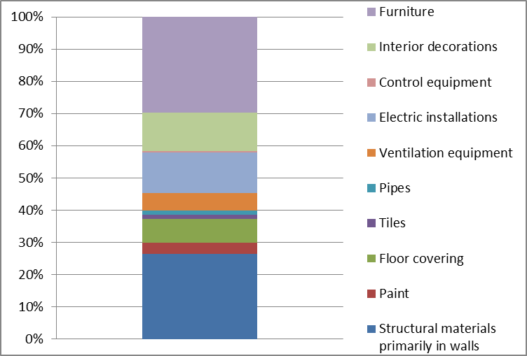

Figure 5. Proportional contributions to greenhouse gas emissions associated with production of new components and items installed in the refurbishment project.

The case study clearly demonstrates that the user-specific flows of materials in buildings are substantial when calculating the related emissions. For example, Andersson et al (2018) estimated that if re-used products instead of new were used in such office fit-outs, potentially 30% of the emissions could be saved. Nevertheless, this case study also illustrates the need for broadening relations, discussions and contracts to ensure circular strategies are realised. Many actors are involved in office fit-out projects, such as the tenant, the property owner, the project leader, the architect, and the contractors who handle the demolition and new construction. Different actors have the potential to influence different parts of the project; however to really promote circularity, solutions need to be sought through cooperation and potentially through the involvement of new actors or new actor collaborations. In discussions with the property owner of the case study building, the tenants’ desire for a modern, light, and fresh office space appeared as one of the largest obstacles to more resource efficient fit-outs. It thus reveals the importance of understanding and considering social preferences and behaviours when trying to implement circular strategies. For slowing of loops to become reality in this case, negotiations between the property owner and tenants need to take place, as well as a shift in tenant preferences and values. In addition, other obstacles to more circular approaches revealed in this case study included the limited markets for re-using components, that Dfd had not been employed when the building was designed, and also that the wall material contained hazardous substances. Finally, the property owner reported that they had preferred to construct an open office solution, but due to the character of the new tenants’ work, a cell structure was created with less possibility for closing loops in the future.

To tackle the obstacle of a limited market for reused components this particular property owner, together with other stakeholders, recently initiated the creation of a digital market place for reused furniture, interior materials, etc., offering an example of new business model innovation for circularity which is happening in many places in the world. It thus depicts an example of how crossing sectoral borders and establishing new actor collaborations can be of importance when searching for more circular solutions.

## Development of a holistic framework for dynamics in the circular built environment

The case studies discussed in the previous section have offered a number of important perspectives on circularity in the built environment. All three cases address aspects of the technical assessment of circularity through narrowing flows, closing or slowing loops. However they also demonstrate that calculation and assessment methods are dependent on the social constructions of the problem, on the relative power of the actors making the decisions, and on values and decisions obscured within the assessment and decision tools themselves. Both the first and second case studies show how the design of the tool or the method will support different strategies and approaches to circularity. The first study demonstrates how the current European LCA methodology steers designers towards the use of recycled and reused materials, rather than towards design for disassembly which would facilitate future reuse of building components. The second shows that calculation and process tools often limit decisions to perspectives embedded within the tool; instead they need to be assessed critically in order to ensure that they are supporting meaningful input to design decisions by the non-technical users and occupiers of buildings. Without incorporating these perspectives at the design stage it will be difficult, and potentially impossible, to ensure that buildings are designed appropriately and efficiently for their intended social purpose, and thus that they achieve the longest life and highest level of circularity. The third case also stresses the importance of the social context of the building, and pinpoints the great extent to which user behaviour and values – and in this case the design of tenancy agreements - affects material impacts. It shows finally that new ways of engagement and interaction between multiple actors in the value chain can support the more circular use of material resources.

Therefore while the literature has shown that the core principles of the circular economy are already enacted to an extent through the realisation of some generic design strategies, our case studies illustrate that the impacts are limited, that critical evaluation is not always carried out, and further still that the social context and needs intended to be met by the building project are seldom adequately considered by the design process. Without this understanding, the building will be reduced (as implied by the LCA approach) to a mere collection of materials, which is unlikely to have the best performance or longest usable life. The interpretation of the built environment instead as a provider of our social needs makes meaningful inclusion of as many actors and stakeholders as possible within the process an important first step; however, the case studies also illustrate that the dynamics between these actors and stakeholders and the tools – both the design decision tools which enable such inclusion, and the assessment tools which evaluate and inform the material selection - are crucial.

We therefore propose a new framework for the dynamics and interactions of a circular built environment, in which the practical initiatives and the evaluation of their effects take into account the users’ needs and the social context (Figure 6). When setting up a project for improving the circularity in the built environment, whether it concerns individual building projects or projects to promote circular principles of the existing built environment, the widest selection of actors should be invited to input to the design and implementation strategies in order to apply the core principles. This can be supported through the careful and critical use of appropriate decision process tools, and then evaluated and informed through the critical use of technical tools such as LCA, while understanding the wider implications of the methods used. The initiatives and the tool-based decision-support and evaluation should follow an iterative process in which performance is continually evaluated against the circular principles. The extensive interaction between multiple actors will also thus generate new understanding and knowledge, which in turn can be applied to following projects. The proposed framework thereby demonstrates the importance of understanding the built environment as the outcome itself of an iterative process to provide for our human needs using the fewest resources.

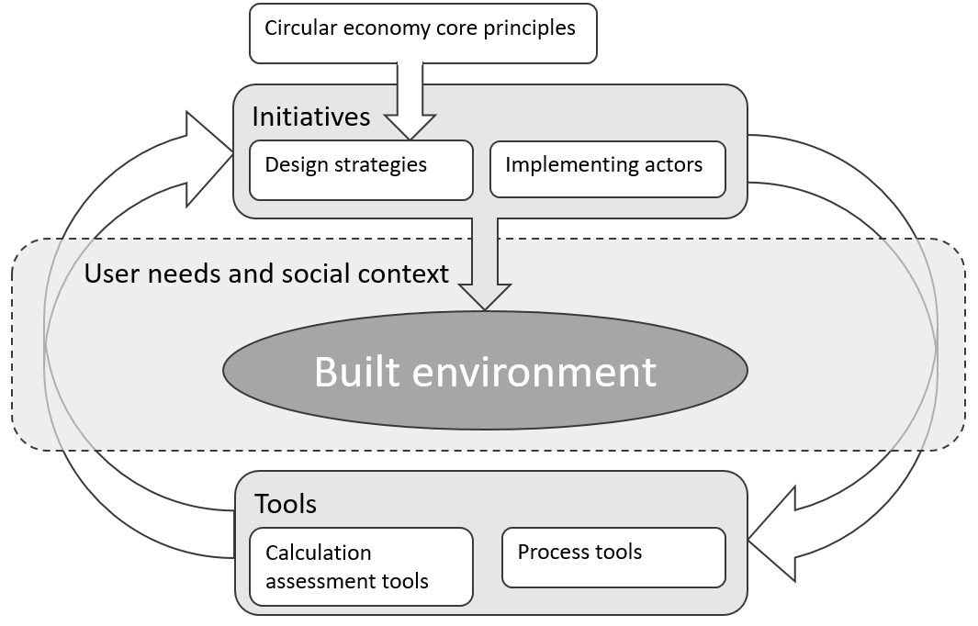

Figure 6. A holistic framework of the dynamics and interactions of a circular built environment

## Concluding remarks

Current initiatives that are framed as ‘circular economy’ approaches are mostly focused on narrowing material flows, as did the sustainability initiatives before them. This is a natural reflection of the difficulties of radical change within a complex and conservative industry such as construction. There is similarly a strong tendency in capitalist societies to focus on promoting more and newer technologies in response to challenges such as climate change, rather than considering radical change in practices. But the built environment is not merely a collection of products constructed of individual materials, and circularity cannot be achieved through simply reducing material use or increasing technologies, or through any focus which considers buildings as independent and stand alone products, however circular. Of equal or greater importance is an understanding of the built environment as the infinite arena for and enabler of the multiple and essential social needs of individuals, communities and nations. We argue that for circularity of the built environment to be accomplished, there is a need to focus on interdisciplinary knowledge sharing and co-production, and the holistic assessments of solutions against social needs, as well as the technical material outcomes.

With increasing alarm about both the climate and finite material resources, extreme societal and economic system transition is needed. For this to happen true innovation needs to happen, and fast. The strength of new concepts such as the circular economy can be through changing our ways of thinking and knowing, creating new mind-sets which can direct us towards such innovation. Only when we start considering the physical structures of the built environment first as the context for our needs, and second as a collection of materials, will we be able to work together to achieve the best solutions that we are capable of.

## References

Andersson, J, H Gerhardsson, Å Stenmarck, and J Holm. 2018. “Potential Och Lösningar För Återbruk På Svenska Kontor.” Stockholm.

Birgisdóttir, Harpa. 2016. “IEA-EBC Annex 57 Subtask4 Case Study Report - Case Studies Demonstrating Embodied Energy and Embodied Greenhouse Gas Emissions in Buildings.”

Bocken, Nancy M.P., Ingrid de Pauw, Conny Bakker, and Bram van der Grinten. 2016. “Product Design and Business Model Strategies for a Circular Economy.” *Journal of Industrial and Production Engineering* 33 (5): 308–20. https://doi.org/10.1080/21681015.2016.1172124.

CEN. 2012. “EN 15978: Sustainability of Construction Works - Assessment of Environmental Performance of Buildings - Calculation Method.” Brussels: CEN – European Committee for Standardization.

Cheshire, David. 2016. *Building Revolutions: Applying the Circular Economy to the Built Environment*. Newcastle Upon Tyne: RIBA Publishing.

Eberhardt, Leonora Charlotte Malabi, Morten Birkved, and Harpa Birgisdóttir. 2019. “Building Life-Cycle Design and Engineering Strategies for a Circular Economy – a Systematic Literature Review.” *Submitted to Journal of Cleaner Production*.

Ellen MacArthur Foundation. 2015. “POTENTIAL FOR DENMARK AS A CIRCULAR ECONOMY A CASE STUDY FROM: DELIVERING THE CIRCULAR ECONOMY – A TOOLKIT FOR POLICY MAKERS.” Cowes, Isle of Wight.

Ghisellini, Patrizia, Maddalena Ripa, and Sergio Ulgiati. 2018. “Exploring Environmental and Economic Costs and Benefits of a Circular Economy Approach to the Construction and Demolition Sector. A Literature Review.” *Journal of Cleaner Production* 178 (March): 618–43. https://doi.org/10.1016/J.JCLEPRO.2017.11.207.

Jonsson, Daniel K. 2005. “The Nature of Infrasystem Services.” *Journal of Infrastructure Systems*. https://doi.org/10.1061/(asce)1076-0342(2005)11:1(2).

Laurenti, Rafael, Jagdeep Singh, Björn Frostell, Rajib Sinha, and Claudia R. Binder. 2018. “The Socio-Economic Embeddedness of the Circular Economy: An Integrative Framework.” *Sustainability (Switzerland)* 10 (7): 1–10. https://doi.org/10.3390/su10072129.

Leising, Eline, Jaco Quist, and Nancy Bocken. 2018. “Circular Economy in the Building Sector: Three Cases and a Collaboration Tool.” *Journal of Cleaner Production* 176 (March): 976–89. https://doi.org/10.1016/J.JCLEPRO.2017.12.010.

Liljenström, Carolina, and Tove Malmqvist. 2016. “Resource Use and Greenhouse Gas Emissions of Office Fit-Outs - A Case Study.” *Central Europe Towards Sustainable Building 2016: Innovations for Sustainable Future, CESB 2016, 22 June 2016 through 24 June 2016*. Environmental Strategies Research (fms), Sustainable development, Environmental science and Engineering, School of Architecture and the Built Environment (ABE), KTH: Grada Publishing. http://urn.kb.se/resolve?urn=urn:nbn:se:kth:diva-195453.

Lützkendorf, Thomas, Maria Balouktsi, and Rolf Frischknecht. 2016. “IEA-EBC Annex 57 Subtask1 Report - Basics, Actors and Concepts.”

Malmqvist, Tove, Marie Nehasilova, Alice Moncaster, Harpa Birgisdottir, and Freja Rasmussen. 2018. “Design and Construction Strategies for Reducing Embodied Impacts from Buildings – Case Study Analysis.” *Energy and Buildings* 166: 35–47.

McDonough, W.; Braungart, M. 2002. *Cradle to Cradle: Remaking the Way We Make Things*. New York: North Point Press.

Moncaster, Alice. 2012. “Constructing Sustainability: Connecting the Social and the Technical in a Case Study of School Building Projects.” University of East Anglia. https://doi.org/10.13140/2.1.1531.1042.

Ness, David A., and Ke Xing. 2017. “Toward a Resource-Efficient Built Environment: A Literature Review and Conceptual Model.” *Journal of Industrial Ecology* 21 (3): 572–92. https://doi.org/10.1111/jiec.12586.

Pomponi, Francesco, and Alice Moncaster. 2017. “Circular Economy for the Built Environment: A Research Framework.” *Journal of Cleaner Production* 143: 710–18. https://doi.org/10.1016/j.jclepro.2016.12.055.

Rasmussen, F N, M Birkved, and H Birgisdóttir. 2019. “Upcycling and Design for Disassembly – LCA of Buildings Employing Circular Design Strategies.” *IOP Conference Series: Earth and Environmental Science* 225: 12040. https://doi.org/10.1088/1755-1315/225/1/012040.

Rasmussen, Freja N., Tove Malmqvist, Alice Moncaster, Aoife Houlihan Wiberg, and Harpa Birgisdottir. 2018. “Analysing Methodological Choices in Calculation of Embodied Energy and GHG Emissions from Buildings.” *Energy and Buildings* 158: 1487–98. https://doi.org/https://doi.org/10.1016/j.enbuild.2017.11.013.

Stahel, W. 1981. “The Product-Life Factor.” In *An Inquiry into the Nature of Sustainable Societies: The Role of the Private Sector*, edited by S. Grinton Orr, 72– 96. Houston.

Tweed, Christopher, and Margaret Sutherland. 2007. “Built Cultural Heritage and Sustainable Urban Development.” *Landscape and Urban Planning* 83 (1): 62–69. https://doi.org/10.1016/j.landurbplan.2007.05.008.