Post Occupancy Evaluation in Educational Spaces:
The Impact of Seasonal Discrepancies

ÖZLEM DURAN¹ JILL ZHAO² WILLIAM PETTIFER³

¹University of Salford, Salford, UK
² University of West of England, Bristol, UK
³University of Bath, Bath, UK

ABSTRACT: This paper presents findings from a Post Occupancy Evaluation research of a BREEAM Excellence-rated university building, to understand the experience of the students using university study spaces. This research focuses on winter conditions and the outcome is compared with the outcome of previous research which focused on summer conditions. The research combined qualitative and quantitative methods and focused on occupancy patterns, thermal comfort, air quality, and noise level of the study spaces within the building, as well as the students’ preferences and experiences of the study spaces. The research collected over 350 questionnaire surveys in total (over 200 in summer and over 150 in winter), as well as monitored environmental data and observation data over two weeks. (by on-site data recorders and momentary data recordings by manual devices) The findings showed winter and summer behavioural differences and occupants’ comfort perceptions, suggesting that the building management decisions have to consider seasonal discrepancies to improve building performance but more importantly, avoid having a negative impact on students’ environmental comfort and subsequent learning experience.
KEYWORDS: University buildings, Post-occupancy evaluation, thermal comfort, occupant behaviour, educational spaces

1. INTRODUCTION
Sustainable buildings are crucial for providing quality education [1]. Considering students spend more time in educational buildings than in any other public building [2], it is worth highlighting the importance of adequate performance with the consideration of student’s wellbeing and productivity. The built environment is the largest energy consumer and greenhouse gas emitter, and the public sector in particular is associated with poor design and mismanagement [3]. High energy consumption in campus buildings is one of the biggest expenses in the educational sector [4]. Additionally, there is a lack of understanding of energy consumption and its influence on user comfort during building operations [5].
University buildings’ occupancy patterns are very different than in other building typologies and are difficult to predict because they are occupied predominantly by a group of students with different daily timetables, study patterns, course requirements, and a wide range of personal preferences [6]. Therefore, to overcome the environmental comfort performance gap (difference between energy and comfort predictions vs and actual performance of a building), understanding the students’ behaviour is significant [8]. Additionally, students’ intellectual performances are proven to be impacted by environmental factors, thermal comfort in particular [8]. Thermal discomfort causes distraction and reduction in the student’s academic performance and mental tasks [8,9, 10]. Therefore, measuring the in-use occupant behaviour and understanding students’ environmental evaluation of the study spaces, are critical in predicting and optimising the environmental comfort and performance of university buildings

2. POST OCCUPANCY EVALUATION
Post Occupancy Evaluation (POE) is defined as a structured evaluation of a building’s performance post-initial use and provides an understanding of the user’s and building’s needs, alongside recommending ideas for meeting the needs [11]. Benefits of utilising POE include cost and time savings, and better space utilisation [12]. These benefits would help to improve the daily life of the occupants. However, there are barriers to using POE which has resulted in POEs being underused in educational spaces and thus resulting in potential health implications such as underperformance of users [13].
POE exposes the strengths and weaknesses of projects and design, from which development teams can learn in order to further improve their projects. However, POE is often bypassed to reduce the cost of a project. The barriers include; the absence of compensation for conducting a POE, fear of revealing shortcomings and risking property value [14], lack of time, awareness and specialists and variations in performance indicators, methodology and objectives.
Although secondary school buildings are widely studied, focusing on factors that influence student performance, such as indoor pollutants and thermal conditions such as ventilation rate [15], air quality [16] and thermal comfort [17], there are limited POE studies on university buildings [11, 14, 18]. The lack of consensus on the performance indicators, variations of the aim of the project and the collected data type reduce the comparability of these projects. Moreover, there is only a very limited number of studies which investigated the impact of seasonal discrepancies in particular in POE studies of university buildings. Serghides et al [19] highlighted the impact of equipment used in summer (negatively) and winter (positively) on thermal comfort due to the internal heat gain from the equipment. On the other hand, Isaac [20] did not report any seasonal discrepancies, suggesting this to be the result of design and construction adaptability to different weather patterns. However, adaptability to seasonal changes requires the identification of weather patterns that have an impact on the occupant's perception and behaviour. The occupancy pattern and energy consumption level of university buildings fluctuate greatly across the year based on seasons that are associated with term times, exam periods and holidays. Therefore, more studies are needed to determine seasonal discrepancies in the post-occupancy use of university buildings.
This paper presents findings from post-occupancy evaluation research of a BREEAM Excellence-rated [21] university building, to understand the experience of the students using university study spaces. The research focuses on winter conditions and the outcome is compared with the preliminary research [22] which focused on summer conditions. This comparison informs on the seasonal discrepancies in study spaces in terms of environmental conditions such as thermal comfort, air quality, noise and variations in occupant behaviours.

3. METHODOLOGY
The studied building is a five-storey, purpose-built university building that has achieved a BREEAM Excellence rating for its design scheme and the design of the building adopted a principle to maximise sustainability through informed decisions . It is located in the East Midlands in the U.K and the construction was completed in March 2021.
The research combined qualitative and quantitative methods and focused on occupancy patterns, thermal comfort, air quality, and noise level of the study spaces within the building, as well as the students’ preferences and experiences of the study spaces. The winter and summer data are compared to investigate the seasonal discrepancies. The winter data collection included data from over 150 questionnaire surveys as well as monitored environmental data (by on-site data recorders and momentarily data recording by manual devices) and observation data over two weeks; between 28 February 2023 and 13 March 2023 at 9 am, 12 pm and 3 pm. The external temperature during observation hours varied between 0 ̊C-7 ̊C allowing the observation period to be representative weeks for winter. Summer data was collected from 11 May 2022 to 17 May 2022 on 5 weekdays from 9 am to 5 pm. in one-hour intervals and resulted in 206 questionnaire surveys returned by the students. This period was chosen to maximise the respondent rate, as it was just before the exam period. The external temperature fluctuated between 10 ̊C and 23 ̊C during the studied period.
Figure 1: First-floor (top) and second-floor (bottom) study spaces and surveyed zones

The surveys comprise two sections; Demographics (age, gender, how much time was spent studying per day and week, students’ preferred study area, thermal sensitivity, clothing level and metabolism level prior to entering the study space), as well as environmental comfort (thermal comfort, ventilation, humidity, lighting and acoustics). Each category of the environmental comfort questions adopted a similar structure. It asked the occupants to rate their sensations using a seven-point Likert scale [23] and their adaptive behaviour, followed by any further comments they wanted to express. The observation data includes the number of occupants per zone, how many windows were open, as well as temperatures, CO2, and noise levels.
The common study areas are on the first and second floors of the building and can be accessed directly via the main staircase. For the purpose of this research, the study spaces were divided into five different zones that have distinctive characteristics (Figure 1). Zones 1, 2, and 3 are part of the library on the first floor. Zone 1 is dedicated to studying using university computers, with some group work areas. Zone 2 is a quiet study area and Zone 3 is a silent area. Zone 4 is on the second floor and is dedicated to group work comprising eight rooms, among which only two have windows. Zone 5 is a tutorial space, furnished to allow group seating. It also has direct access to the terrace located on the second floor. The majority of the openable windows face southeast and southwest.
Due to the acoustic constraints of the local environment and to achieve compliance with Building Bulletin 93 [24], the use of natural ventilation throughout the year is not possible. Therefore, the study spaces adopt a hybrid ventilation system. The units are provided with a wall-mounted controller with integral temperature and CO2 sensors, accessible by the occupants. The control allows the ventilation system to be boosted temporarily (for an hour) or turned off. There is no separate mode for winter or summer ventilation. All the studied zones are equipped with no active cooling. Learning spaces are heated 24 hours during term times based on a setpoint of 21°C between 7:00-18:00 and 19°C throughout the rest of the day and night.

4. DATA ANALYSIS
The following section compares the winter and summer data to highlight the discrepancies.
4.1 Occupancy
The majority of the respondents were aged between 18 and 25. Both studies showed a larger percentage of female occupants who responded to the questionnaires than their male counterparts. Proportionally, more female participants (45%) were sensitive to cold than males (27%).
Most of the respondents reported a low metabolic rate in all five zones in both studies. This aligns with Bleicher and Maclean [25] where occupants seated at desks typically have a lower metabolic rate. The level of clothing (Figure 2) shows seasonal differences in the comparison, with the majority of respondents wearing ‘moderate to light’ clothing in summer and ‘moderate to heavy’ clothing in winter.
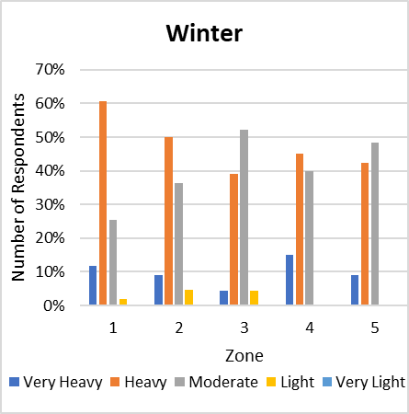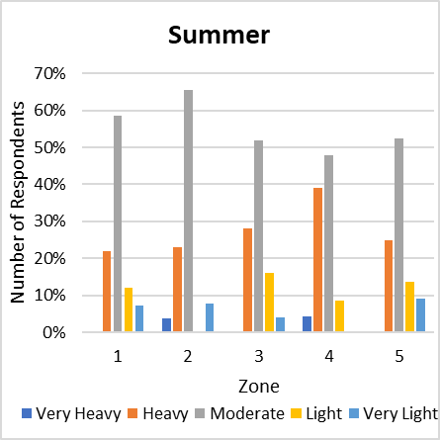
Figure 2: Seasonal difference of clothing level per zone
The occupancy level across zones fluctuates between the two seasons (Figure 3). The group study space (Zone 4) was less popular during exam season (summer) but had a higher level of occupancy during winter. The maximum occupancy in Zone 4 in winter had at times exceeded that of Zone 1, even though Zone 1 is designed to accommodate nearly twice the size of Zone 4 occupants. Winter study also showed the occupancy levels in Zone 5 fluctuating greatly throughout the day, with lunchtime having the highest footfall, due to this zone containing a kitchenette where hot food can be consumed.
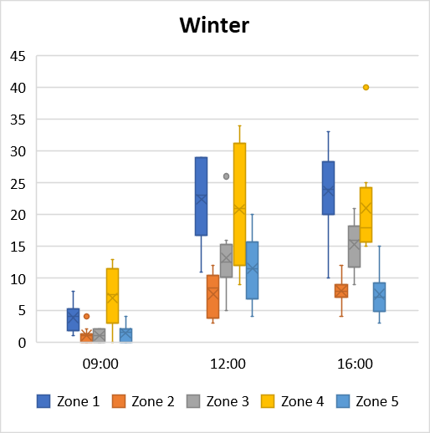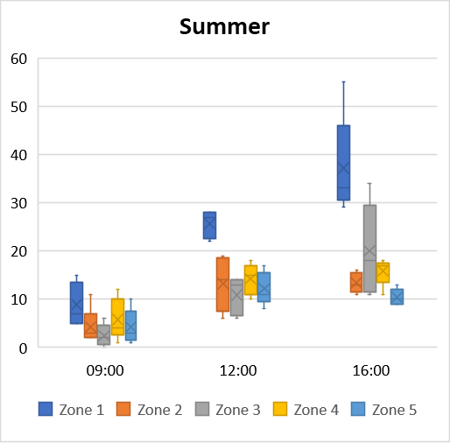
Figure 3: Seasonal occupancy level per zone in three timestamps

4.2 Thermal environment
Similar to the summer study, a bigger proportion of participants found the temperature to be neutral. In the summer study, 23% of the respondents stated it was warm and 10% stated very warm (Figure 4).
The measured temperatures were relatively stable in all zones (Figure 5), despite seasonal changes and occupancy levels. Temperature fluctuation throughout the observed period is more apparent across zones in winter than in summer. Zone 5 had a lower minimum temperature in winter than other zones, corresponding to a higher vote of ‘slightly cold’ in the thermal satisfaction survey.
Zone 1 is by far the warmest zone in both studies with the highest mean and max temperature. It has the highest occupancy levels on average of the five zones, as well as the provision of computers, both of which had an impact on the zone’s temperature [22]. This has been moderately reflected in the thermal satisfaction vote in the summer study. Winter study resulted in a smaller proportion of respondents reporting the environment being warmer than their preferences across zones except for Zone 4, where 55% of the users reported it to be ‘slightly warm’ or ‘warm’. This might be due to the higher occupancy in Zone 4.

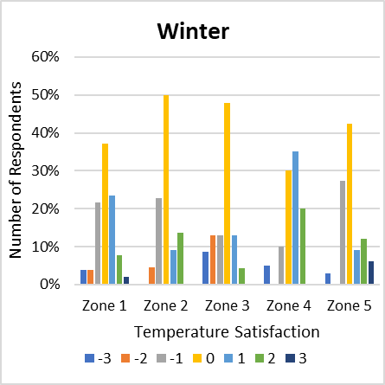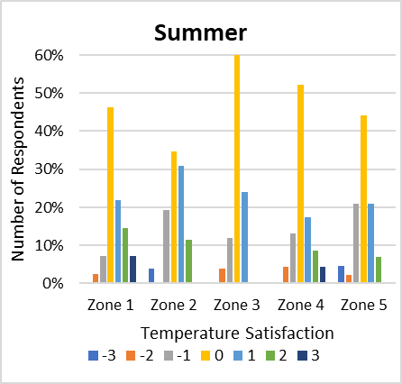
Figure 4: Seasonal temperature satisfaction per zone

In both studies, most students responded to the temperature by changing clothing with 69% doing so in the winter study and 58.2% in the summer study. In the summer study, there was a larger percentage of students opening or closing windows (17%) to adjust indoor temperature than in winter, where only 6.3% of the students opened or closed windows in winter. This suggests that there were less adaptable opportunities in window openings to regulate temperature and ventilation during winter.
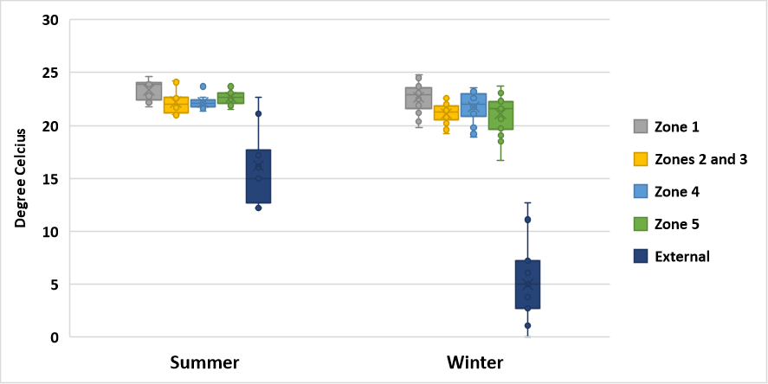
Figure 5: Temperature range by zone by season

4.3 Ventilation and CO2
Corresponding to the window opening behaviour observed, 94% of the time, all windows were closed in the winter study, a much higher proportion in comparison to the summer (66%), contributing to an overall higher CO2 levels measured in doors. (Figure 6). There was a wider gap between the highest and lowest CO2 levels in the winter study with levels ranging between 400 and 1400ppm than in the summer study (between 400 and 900ppm). CO2 levels generally increased throughout the day in both studies, with 9am on average having the lowest CO2 levels and 4 pm generally having the highest. Similar to the summer study, Zones 4 and 5 show higher mean and maximum CO2 level, the peak CO2 level exceeded 1500 ppm on one occasion, indicating risks of inadequate ventilation [26].
Despite the low window opening behaviour, the main method for the occupants to regulate ventilation is still to open or close a window in both studied seasons (62%), followed by ‘do nothing’ (14%). In the summer study, 17% of the respondents indicated they were unable to adjust the indoor temperature. They found the control to be ‘confusing’ and were only able to adjust the fan speed rather than temperature.
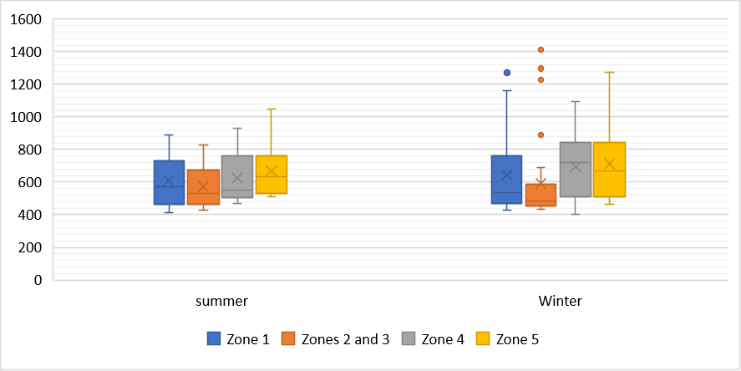
Figure 6: CO2 level by zone by season

A low percentage of respondents encountered odour. However, the proportion of people who reported encountering odour in winter was higher (12%) than in summer (5%). Most of the respondents who encountered odour were in Zones 4 and 5 where the consumption of hot food was permitted, unlike the other zones. This was supported by most of the comments being related to food. In winter seasons, more hot food was consumed, creating higher occupancy in the kitchenette area and a higher proportion of complaints against food odour, suggesting the seasonal usage of the kitchenette and inadequate ventilation during mealtimes.

4.4 Acoustic
45% of the respondents were satisfied with the noise levels. 9 am was generally the quietest time of day in all five zones. Correlating with the occupancy level, Zones 1 and 4, which had higher occupancy levels on average across the observed time period, were also noisier than Zones 2 and 3, which generally had lower occupancy levels. The noise levels in Zone 5 fluctuated and often peaked at noon due to it being popular at lunchtime.
The summer study had a larger percentage of respondents who found that roads/traffic was the dominant source of disruption (20%) than that of the winter study 13%. This could be due to a larger number of windows being open in summer, making the traffic noise more prominent to building users. The most dominant action in response to noise levels was putting on headphones (75%). The percentages of the other actions between the two studies were also similar to each other, with changing location being the second most dominant action in response to noise levels (18%).

5. DISCUSSION
The previous study reported that during the summer data collection period, which was also predicted to have one of the highest volumes of occupancy, the occupancy level on average across all 5 zones remained far below the design maximum occupancy level. The CO2 level across five zones stayed under 1000 ppm most of the time. Therefore, the hybrid ventilation system, which was set to be triggered by CO2 levels, was activated only once throughout the observation period. However, the questionnaire survey revealed that approximately a third of the surveyed occupants found the spaces warm or very warm, despite the majority of the occupants self-identified as sensitive to cold [22]. Yet the initial simulation model did not predict overheating risk based on CIBSE TM52 [27]. As a result, no cooling was set despite the system having the capability. The occupants mostly used adaptive behaviours, such as opening windows, to regulate the temperature. During the summer observation period, over 50% of the windows were open on the fifth day when the internal temperature across all zones reached 24°C. However, during the time period when the recorded CO2 level in any zone reached over 900ppm (Zones 4 and 5 on day 1 and Zones 5 on day 4), no window was open, suggesting that the occupants were more likely to open windows based on thermal comfort rather than air quality.
This has also been reflected in the winter study. Unlike in the summer, the winter ventilation strategy relied heavily on the mechanical ventilation system to lower the indoor CO2 level. The options of opening windows were much less popular due to a lower external temperature. 94% of the time, all windows were closed despite a higher CO2 level being recorded. On occasions the CO2 measure was bordering 1500 ppm, indicating risks of inadequate ventilation.
This seasonal difference has been accentuated by the report of odour and noise. In summer study, ventilation relied on behavioural adaptations such as window opening to achieve thermal comfort. As a result, the occupants who preferred quiet or silent study zones reported a higher level of traffic noise being carried through the opened windows from the adjacent roads. Whereas in winter study, noise from traffic was less of an issue with the majority of the windows being closed. However, during the winter, the increased consumption of hot food in the kitchenette area and a lack of adaptive behaviours for opening windows to expel foul air, or having sufficient mechanical ventilation resulted in more reports of odour. In both case scenarios, the hybrid ventilation strategy fell short due to different reasons. Therefore, we recommend that the ventilation systems to be reconfigured to consider the seasonal discrepancies in how the study spaces are used. For instance, in the summer, considering the acoustic need and overheating risks, the mechanical ventilation should be programmed to also be able to be activated by temperature, instead of solely taking CO2 into levels account, thus mitigating overheating whilst preserving a good acoustic level for exam preparation. In winter, given the limited adaptation behaviour for window opening, mechanical ventilation settings should consider an extra boost during mealtimes in study areas where hot food is being prepared and consumed to remove extra odour.
Noticeably, in both studies, when asked what actions to take when temperature was not to their preferences, a variety of adaptive behaviours were reported, including ‘change clothing’, ‘having a hot/cold drink’, ‘change location’, ‘turn on heating/cooling’, and ‘opening/closing windows’. No respondent has chosen the ‘do nothing’ option. Whereas when asked what actions to take when ventilation was not satisfactory, ‘opening/closing windows’ was the most popular action, followed by ‘do nothing’ (17%), suggesting that behaviour adaptations responding to ventilation and air quality needs are limited. The occupants either do not know or are not supported with ways to adapt their behaviour to achieve satisfactory ventilation and air quality.

6. CONCLUSION
The result suggests that seasonal differences in how university study areas are used, and the availability of behavioural adaptation options could mean that hybrid ventilation strategies need to be re-evaluated to provide optimum thermal comfort.
The POE study detected seasonal discrepancies in study spaces in terms of environmental conditions and variations in occupant behaviours which impact the students' wellbeing. The building management decisions have to consider these discrepancies and alter strategies based on occupants' seasonal needs (in this case temperature-based triggers in summer and CO2-based triggers in winter) to improve building performance.
We recognise a series of limitations in this study. Firstly, the sample size could benefit from a larger and more diverse range of participants. Due to the majority of the respondents being females in this study, thermal satisfaction is likely to be affected by the result of their thermal sensations. Secondly, the summer observation period has not captured the highest temperatures, e.g. in July, because students were on term holiday.

ACKNOWLEDGEMENTS
This research is based on previous research which was made possible by the UROS funding provided by the University of Lincoln, UK. This funding allowed four student researchers to participate in summer term data collection. The student researcher William Pettifer then carried out the data collection for the winter term as part of his dissertation “A Study of the Usage and Effectiveness of Post Occupancy Evaluation in Educational Spaces” at the University of Lincoln, UK.

REFERENCES
- Aghimien, D.O., Adegbembo, T.F., Aghimien, E.I. and Awodele, O.A., 2018. Challenges of Sustainable Construction: A Study of Educational Buildings in Nigeria. International Journal of Built Environment and Sustainability, 5(1). Available from https://ijbes.utm.my/index.php/ijbes/article/view/244
- Zomorodian, Z.S., Tahsildoost, M. and Hafezi, M., 2016. Thermal comfort in educational buildings: A review article. Renewable and Sustainable Energy Reviews, 59 895–906.
- Macmillan, S.(Ed.), 2004. Designing Better Buildings: Quality and Value in the Built Environment. Taylor & Francis.
- Dias Pereira, L., Raimondo, D., Corgnati, S.P. and Gameiro da Silva, M., 2014. Energy consumption in schools – A review paper. Renewable and Sust. Energy Reviews, 40 911–922.
- Lawrence, R. and Keime, C., 2016. Bridging the gap between energy and comfort: Post-occupancy evaluation of two higher-education buildings in Sheffield. Energy and Buildings, 130 651–666.
- Franceschini, P.B, Neves, L.O., 2022. A critical review on occupant behaviour modelling for building performance simulation of naturally ventilated school buildings and potential changes due to the COVID-19 pandemic, Energy and Buildings, 258.
- Shi, X., Si, B., Zhao, J., Tian, Z., Wang, C., Jin, X., Zhou, X., 2019. Magnitude, Causes, and Solutions of the Performance Gap of Buildings: A Review. Sustainability 11. https://doi.org/10.3390/su11030937
- Ricciardi, P., Buratti, C., 2018. Environmental quality of university classrooms: Subjective and objective evaluation of the thermal, acoustic, and lighting comfort conditions. Building and Environment. 127, 23–36. https://doi.org/10.1016/j.buildenv.2017.10.030
- Jowkar, M., Rijal, H.B., Brusey, J., Montazami, A., Carlucci, S., Lansdown, T.C., 2020. Comfort temperature and preferred adaptive behaviour in various classroom types in the UK higher learning environments. Energy and Buildings. 211, 109814. https://doi.org/10.1016/j.enbuild.2020.109814
- Barbhuiya, Saadia, Barbhuiya, Salim, 2013. Thermal comfort and energy consumption in a UK educational building. Building and Environment 68, 1–11. https://doi.org/10.1016/j.buildenv.2013.06.002
- Mustafa, F.A. (2017) Performance assessment of buildings via post-occupancy evaluation: A case study of the building of the architecture and software engineering departments in Salahaddin University-Erbil, Iraq. Frontiers of Architectural Research, 6(3) 412–429.
- Preiser, W.F.E., 2001. Feedback, feedforward and control: post-occupancy evaluation to the rescue. Building Research & Information, 29(6) 456– 459.
- Ahmed, H., Edwards, D.J., Lai, J.H.K., Roberts, C., Debrah, C., Owusu-Manu, D.-G. and Thwala, W.D. 2021 Post Occupancy Evaluation of School Refurbishment Projects: Multiple Case Study in the UK. Buildings, 11(4) 169.
- Ahmadi, R. T., Saiki, D., Ellis, C., 2016. Post Occupancy Evaluation an Academic Building: Lessons to Learn, Journal of Applied Sciences and Arts: Vol. 1 : Iss. 2, Article 4. Available at: http://opensiuc.lib.siu.edu/jasa/vol1/iss2/4
- Batterman, S., 2017. Review and extension of CO₂-based methods to determine ventilation rates with application to school classrooms, International Journal of Environmental Research. Public Health 14 (2) 145.
- Wargocki, P., Porras-Salazar, J.A., Contreras-Espinoza, S.,Bahnfleth, W.. 2020. The relationships between classroom air quality and children’s performance in school, Building and Environment. 173
- Kükrer, E., Eskin, N., 2021. Effect of design and operational strategies on thermal comfort and productivity in a multipurpose school building, J. of Building Engineering. 44
- Tookalooa, A., Smithb, R., 2015. Post Occupancy Evaluation in Higher Education. Procedia Engineering 118 515
- Serghides, D.K. , Chatzinikola, C.K., Katafygiotou, M.C., 2015. Comparative studies of the occupants’ behaviour in a university building during winter and summer time, Intern. Journal of Sustainable Energy, 34:8, 528-551, DOI:10.1080/14786451.2014.905578
- Isaac, S., Meir, I., Pignatta, G. (Eds.). 2023. Net-Zero and Positive Energy Communities: Best Practice Guidance Based on the ZERO-PLUS Project Experience (1st ed.). Chapter 1: Post-occupancy evaluation: the missing link. Routledge. https://doi.org/10.1201/9781003267171
- BREEAM, 2023. [Online] Available at: https://bregroup.com/products/breeam/how-breeam-works/
- Duran, O., Zhao, J., 2022. Post-Pandemic Study Spaces: Post Occupancy Evaluation of BREEAM Excellence Rated University Building. ASA (Architectural Science Association) Conference, Perth, Australia
- ANSI/ASHRAE 55, 2020. Environmental Conditions for Human Occupancy, Atlanta, GA, USA: ASHRAE American Society of Heat., Refrigeration and Air Conditioning Engineers.
- BB93, 2015. Building bulletin 93, Acoustic design of schools: performance standards, Department of Education.
- Bleicher and Maclean (2023) Thermal Comfort (TG 22/2023). BSRIA.
- HSE, 2023. Using CO₂ monitors - Ventilation in the workplace. [accessed 13 May 2023]. Available at: https://www.hse.gov.uk/ventilation/using-co2-monitors.htm
- CIBSE TM52. 2013. The limits of thermal comfort: avoiding overheating in European buildings. London: CIBSE

