Corporate Branding and Brand-building Behavior: Leadership as the Stepping Stone

Kaufmann, H.R.
Vrontis, D.
Czinkota, M.
Hadiono, A.

Purpose: The study aims to clarify the theoretical relationship between corporate branding, brand-building behavior, identity congruence and leadership as the key-integrating factor. Putting Hatch and Schultz (2008)’s VCI Alignment as the role model, it tries to interlink the model with recent and relevant research findings in the field of identity and leadership.

Design / Methodology / Approach: Based on a wide ranging literature review, the paper conceptually synthesizes current mainstream models on the importance of leadership in integrating organization’s Vision-Culture-Image, preventing misalignment, as well as ensuring the identity congruence between organization, corporate brand and stakeholders. It also highlights detailed factors resulting from such brand-oriented leadership to enact brand-building behavior and form identity congruence.

Research Limitations / Implications: The so far conceptual study suggests further empirical findings to validate the synthesized model by testing the relationship between VCI Alignment, brand-oriented leadership model and identity congruence.

Practical Implications: The generation of an integrated model will support leaders in holistically managing corporate branding efforts, starting from setting the brand vision to the employees’ brand-building behavior.

Originality / Value: The study delineates innovative conceptual frameworks leading to a synthesis of current mainstream models not integrated so far. The study clearly shows the theoretical relationship between VCI Alignment and brand-oriented leadership model to endorse brand-building behavior and identity congruence.

Key Words: Corporate Branding, Behavioral Branding, Leadership, Identity Congruence, and Brand-building Behavior.

Paper Type: Conceptual Paper

Introduction: Striving for Higher Levels of Competitive Advantage
Conventionally, branding definitions concentrated more on an external perspective and focused on communicative elements of a brand designed to identification, top of mind recall and competitive differentiation by the customer (i.e. Kotler, 2007). However, due to globalization and increasingly challenging developments in the business environment calling for higher levels of competitive advantage and brand loyalty, corporate branding has significantly gained in prominence. A corporate brand itself is more intended to identify and differentiate the organization based on the entire product offering in the minds of all the organization's constituencies (i.e. Ormeno, 2007) embracing also an internal and more integrated perspective. Recognized as an important strategic asset by now, it differs from product branding along various dimensions including the object of attention, origins of brand identity, locus of responsibility, target audience and time horizon as presented in Table 1.
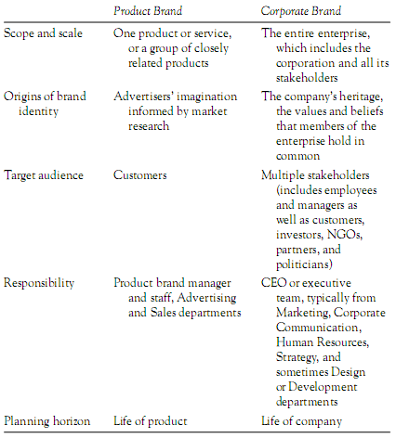
Table 1. How Corporate and Product Brand Differ (Hatch and Schultz, 2001, 2008)
The totality of stakeholders is one of the central elements of corporate branding differentiating it from product branding. Product brands typically dedicate all their attention on customers and consumers, whereas corporate brands intend to associate with all the organization’s stakeholders — customers and consumers, but also investors, suppliers, distributors, partners, governments, local, national, and international community groups, as well as employees (Hatch and Schultz, 2008). Yet, we should also be aware that companies who brand all of their products under one family name like BMW, Coca Cola, or Microsoft are not necessarily engaging in corporate branding. This is because of the unity of the logo, name, or color scheme being only one necessary but not sufficient aspect of a corporate brand. In fact, corporate branding entails a great deal more (Hatch and Schultz, 2008). According to Davis (2007, pp. 120), “corporate branding is a composite of all the experiences, encounters and perceptions a customer has with an organization. It implies that all internal and external communications are aimed at presenting a single, unified message. The underlying motivator: to build trust in the organization – not in a particular product or service.” Its source for originality, uniqueness and inimitability is the organization’s heritage and the values and beliefs that, going beyond Davis’ (opcit) definition, the corporation and all its stakeholders hold in common.
The shared values and beliefs in the corporate brand enable it to perform the strategic function of positioning that is generating points of perceptual differentiations as to competitive products. Furthermore, corporate branding intends to attract and remind stakeholders of why they belong to or should join the community of values and vested interests that swirl around the brand. Thus, in an ideal case, a corporate brand gives interpreters symbols, which reflect their own ideas, feelings, or experiences when associating with the organization the brand represents (Hatch and Schultz, 2008). This synthesis of differentiations and sense of belonging becomes increasingly significant due to its proven ability to positively and effectively affect customers’ purchase decision (Siano et al., 2009).
According to Kitchen (2003), the importance of corporate branding becomes apparent due to a variety of factors. Firstly, the customers’ purchase decision is often primarily influenced by the emotional relationship between the organization and customers (i.e. shared values, trust, loyalty, etc), a fact, epitomized in the term of ‘added value’. Nowadays, people buy products not only for what they can do (functional values) but also for what they mean (symbolic or emotional/experiential values). For example, people choose Volvo because they perceive congruence with their values related to ‘safety’ and ‘trust’. Secondly, an increasing number of costumers demand companies to behave in a socially responsible way, and to provide transparency about their operations. Obviously, it is easier for an organization to comply with these requirements by focusing on corporate brands rather than communicating the benefits of individual products. Thirdly, the costs for developing and maintaining individual product brands have increased exorbitantly. On the other hand, using leverage effects of corporate brand extensions done by companies such as Nestle (Nescafe, Nesquik, etc) promote cost and economies of scale efficiencies in terms of reduced marketing and advertising spending.
To summarize, corporate branding enables an organization to more effectively differentiate their products, increase communication effectiveness, and create higher levels of reassurance for stakeholders who are brand advocates and friends (Ormeno, 2007; Wilson and Gilligan, 1997). Most importantly, the company sustainably becomes a proprietor of its own resources (Collins and Montgomery, 1995) as it is much easier for the competitor to copy a product rather than to duplicate an organization with unique values, people and behavior (Aaker, 1996).

Various Level of Identities: Organization – Corporate Brand – Stakeholders
As identities exist in various level (e.g. individual, society, national and ethnic level), there is a great need for identity theory in studying corporate branding, as it is tightly linked with the identities of organization, stakeholders, corporate brand itself, as well as the congruency within them. As reflected in framework below, several authors (e.g. McCracken, 1995, Urde, 1997, 2003, Balmer and Greyser, 2002 in Urde, 2009) highlighted the importance and the interplay between identities in the various level. Hence, corporate branding is an ongoing interaction and negotiation of values among the internally held identity, the identity defining corporate brand, and the identity as perceived by the stakeholders (Urde, 2009). The core values and promises then bridge the internal and external sides of the corporate brand, thus ensure identity congruency.
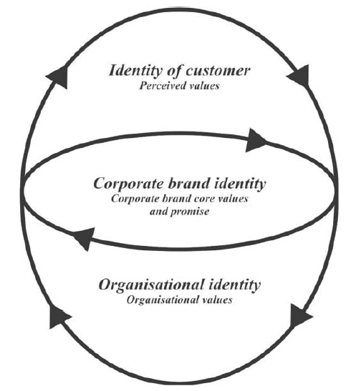
Figure 1. Brand Orientation Framework (Urde, 2009, pp. 622)
Similarly, Hatch and Schultz (2008) proposed that the first important step in successfully managing a corporate brand is creating its identity which means knowing “who we are as an organization (culture)” and “how our, internal and external, stakeholders see us (image).” The desired image of the organization can be communicated conventionally through an integrated communication mix. Whilst organizations can utilize some marketing tools such as market research, customer relation programs or surveys in responding to the latter question. Thus, identity focused communication between organization and stakeholder is the main key as shown on below model.
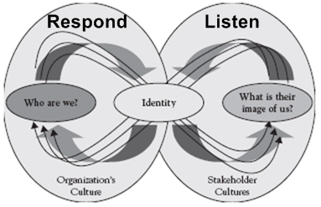
Figure 2. Organizational Identity Dynamics Model (Hatch and Schultz, 2008, p. 55)
Authentically communicating and living the corporate brand’s identity can be described as a move from inside-out. This is continuously complemented by an outside-in perspective, which can be equated as listening to and perceiving stakeholders’ opinions on the corporate brand. Ideally, the organization’s culture and identity should match those of the stakeholders. Thus, a core task of marketing control is to continuously checking for this authenticity and identity congruence.
The importance of identity and authenticity in corporate branding are also confirmed by Kaufmann et al. (2007), through their research in Hilti, a world leader in construction industry. They suggested that there are at least two fundamental and mutually intertwined concepts in corporate branding, which are identity and value. Here, the concept of identity particularly referred to the identity of the organization as a whole and the personal identity of employees, where proper integration between the two is very crucial. The latter concept of value was involved in the scope of organizational values. Along with the identity integration, these values should also be strong enough to create an all-encompassing organization culture representing the basis for authentic brand behavior. As Plato once put it as “care for the soul,” Kaufmann et al. (2007) finally pointed out the heightened responsibility of the company to ensure a “healthy” identity of the employees.

Corporate Branding Through Vision-Culture-Image (VCI) Alignment Model
Brain research points to the necessity of the existence of a vision for target orientated human behavior (BCG Breakthrough Leadership). According to this research, the prefrontal cortex utilizes a vision to move humans accordingly into action. Hence, the second step involves recognizing how identity, culture and image need to influence vision and vice versa. In this case, Hatch and Schultz (2008) add the third question, “who do we want to be and how will we be known.” Again, answering this question is strongly determined by the identity desired by the stakeholders as a corporate vision should reflect the desires of the stakeholders (Antonakis, 2008). Therefore, Hatch and Schultz’ model is suggested to add the question: “what their identity is.” Figure 3 below aligns the strategic vision with the organizational and stakeholders’ identity.
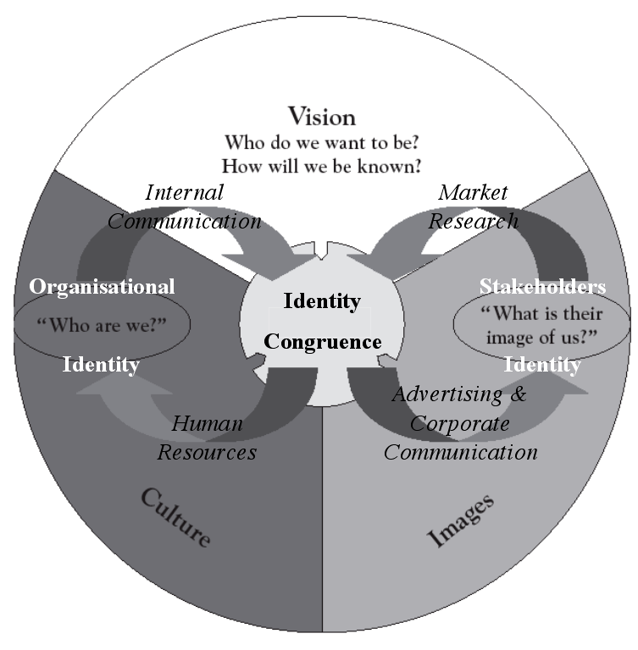
Figure 3. Adapted VCI Alignment Model (based on Hatch and Schultz, 2008)
The core message of the model is that the greater the level of coherence of what the organization’s top managers want to accomplish in the future (strategic vision), what has always been known or believed by the organization’s employees (culture), and what its external stakeholders expect or desire from the organization (images, stakeholders’ identity), the stronger the corporate brand equity will be (Hatch and Schultz, 2008). While the previous theory claims that it is the identity conversations (e.g. culture and images) that develop the identity and grow the brand, the VCI Alignment Model suggests that the ‘identity’ (i.e. everything the organization is, says, and does) is represented by a combination of vision, culture and images related to the stakeholders’ identity that underpins the corporate brand. Thus, corporate branding is a process built on the interplay between the organizational and stakeholders’ identity.
A well-communicated vision is a starting point to build the identity congruence. Just as listening and responding to external stakeholders aligns vision with images, listening and responding to employees aligns culture with vision. When vision aligns with images, customers and other external stakeholders will be attracted by the organization and its products. When culture aligns with vision, employees’ aspirations might conform to top management’s aspiration, which is seen to be the most effective motivational technique. Furthermore, the level of commitment towards achieving the strategic vision increases. Finally, if, culture aligns with images, employees will receive positive feedback from customers and other stakeholders, which, in turn, increases their motivation. All of these alignments would eventually strengthen its corporate brand (Hatch and Schultz, 2008).
In corporate branding, an organization's mission statement should be translated into the culture of the organization, which in turn influences the image of the organization (Chatterjee, 2009). In order to achieve this, all corporate functions need to be integrated to perform the translation correctly. Otherwise, different groups doing different things pull the brand in different directions and fail to form synergies (Gotsi and Wilson, 2001; Vallaster and de Chernatony, 2005; Kaufmann et al., 2007; Hatch and Schultz, 2008). This might involve a business development core team to work on improving an organization’s vision; an internal communication department to communicate the underlying organization values, culture, and expected behaviors; the human resources department to conduct employee trainings and find the right people into the talent and brand ambassador pool; and finally, a marketing department to carry out market research and an integrated and identity based corporate communication mix.
VCI misalignment causes gaps that can damage an organization’s corporate brand: A Vision-Culture gap opens when the organization does not deliver on its promises; a Vision-Image gap opens when stakeholders’ perceptions conflict with management’s strategic vision; while an Image-Culture gap opens when employees do not understand and support strategic visions (Percy, 2007) and when no identity congruence exists. There is also the need to manage all three gaps simultaneously since one gap, in the long run, will often lead to another gap (Hatch and Schultz, 2008). As the model, as well as the previous one, is not regarded to sufficiently relate to identity congruence, it is slightly adapted accordingly.
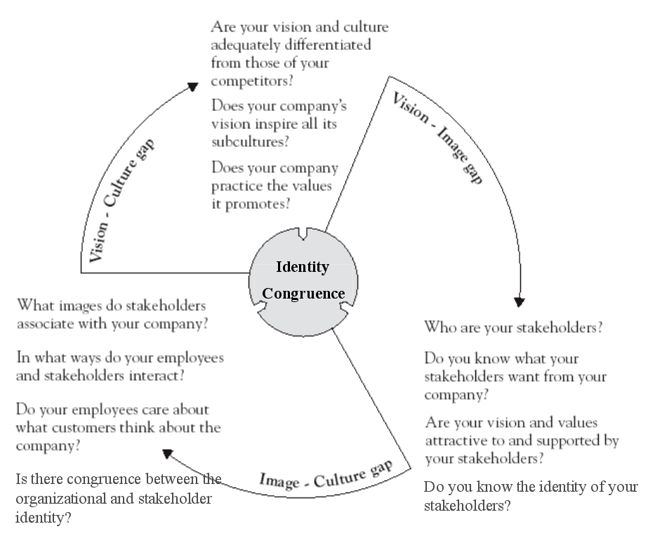
Figure 4. Gaps Created by VCI Misalignment (adapted from Hatch and Schultz, 2008)
Eventually, when the vision, culture and images are aligned, based on a continuous check of authenticity, the corporate brand will guide the way to more pro-actively anticipating and innovating, rather than simply reacting to the ever-changing demands of the organization’s environment (Hatch and Schultz, 2008).

Brand-building Behavior: Advertising and Corporate Communication are Not Enough!
The increasing importance of corporate branding entails new challenges that cannot be sufficiently addressed within a traditional marketing framework. It becomes apparent from the discussion so far, a need to ensure the employee behaviors are consistently aligned with corporate brand promise (Kaufmann et al., 2007; Hulberg, 2006 and Balmer and Gray, 2003 in Maxwell and Knox, 2009) has to come to the fore. Since employees constitute the interface between a corporate brand’s internal and external environment, they communicate and live the brand values towards the market through their interactions with its costumers and consumers. In consequence, the behavior of employees is seen as another dominant element together with other corporate marketing mix elements. Employees provide external stakeholders with information about the identity of the organization (de Chernatony, 2001; Kaufmann et al., 2007; Hulberg, 2006 in Maxwell and Knox, 2009). Moreover, if this information is not consistent with the advertised values of the corporate brand and the identity of the stakeholders, the credibility of the brand itself may be undermined (de Chernatony, 2001; Hulberg, 2006 in Maxwell and Knox, 2009). A study conducted by Henkel, Tomczak, and Wentzel (2006, in Specht, 2007) on marketing managers of Swiss and German Companies in several industries re-confirmed that brand performance is now no longer only determined by the message conveyed by mass media (63.5%), but by behavioral branding as well (31.5%).
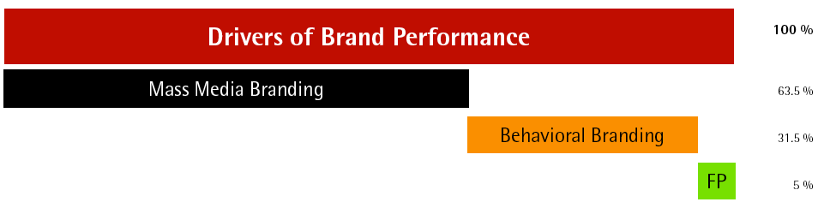
Figure 5. Drivers of Brand Performance (Henkel, Tomczak, and Wentzel, 2006 in Specht, 2007, pp. 20)
In this sense, employees themselves must be motivated to personify and deliver the brand promise and to act as ambassadors for the brand (Kaufmann et al., 2007; Hemsley, 1998 in Jenewein and Muhlmeier, 2007; Schultz and de Chernatony, 2002 and Hulberg, 2006 in Maxwell and Knox, 2009). Hence, they have a powerful impact on costumers’ perception of the brand and the organization itself (Balmer and Wilkinson, 1991; Harris and de Chernatony, 2001, in Jenewein and Muhlmeier, 2007). Apart from quality and pricing, employees’ behavior has empirically been proven to be the third most important factor for customers in deciding whether to choose an organization and buy its product or not (MORI, 1999 in Jenewein and Muhlmeier, 2007). In line with De Cernatony (2001) and Hulberg (2006, in Maxwell and Knox, 2009), Harris and de Chernatony (2001, in Jenewein and Muhlmeier, 2007) emphasize that employees are even becoming the central component of brand building process as their behavior can either reinforce a brand’s values or, if inconsistent with these values, undermine the credibility of communicated values.
This development calls for new approaches, and most importantly, a new mindset about branding (ProBRAND, 2001). As we can see from the illustration below, in the ‘old economy,’ branding is a part of a marketing strategy that descends from business strategy. It is communicated through advertising using graphics and images to external audiences (i.e. costumers). Contrastingly, in the ‘next economy,’ branding is positioned more prominently within the business strategy. With the micro-sociological concept of identity as the ‘glue,’ branding is now designed through brand “touch-points” that interact and shape experiences of the internal (employees) and external audiences (customers) around the brand itself. Kaufmann et al. (2007) concluded, especially for organizations that dispose a heavy service component or with active sales function, these brand shaping “moments of truth” are indeed essential as customer image is influenced enormously by direct interaction between them. Due to the cross-functional nature of the “touch-points,” the HR and IT functions will also play an important role in this branding strategy.
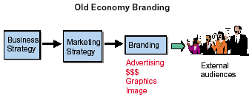
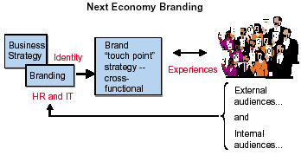
Figure 6. Illustrations of “Old Economy” and “Next Economy” Branding Process (ProBRAND, 2001, pp. 3-4)
Several researchers have used different terminologies to address such behaviors although they are similar in meaning (e.g. behavioral branding; brand-oriented, brand-adequate, brand-related, brand-supportive, brand-loyal behaviors, etc.). “Behavioral branding” itself can be defined as any type of verbal or non-verbal behavior that directly or indirectly determines brand experience and brand equity (Tomczak et al., 2005 in Specht, 2007). On their most recent research, Morhart et al. (2009) specifically defined “employee brand-building behaviors” as employees’ contributions (both on and off the job) to an organization’s customer-oriented branding efforts. These behaviors can be detailed into three main categories: retention, in-role brand-building behaviors, and extra-role brand-building behaviors (latter are further divided into positive word of mouth and participation).
“Retention” refers to employees upholding their professional relationship with the corporate brand. In Morhart’s et al. (2009) research on the service industry, this variable was considered important, as the continuous employment of brand representatives is crucial for service firms. When customers are confronted with ever-changing contact-personnel, it will be difficult for them to develop a trust and commitment based long-term relationship with the service brand. “In-role brand-building behaviors” refer to employees’ meeting the standards prescribed by their organizational roles as brand representatives (either written in behavioral codices, manuals, display rules, and so forth, or unwritten). In a corporate branding context, customers’ brand experiences are also influenced by employees’ brand-building behaviors (Hatch and Schultz, 2008). Thus, it is crucial that employees behave in a way that is consistent with the corporate brand promise the organization conveys through its public messages (Morhart et al., 2009).
”Extra-role brand-building behaviors” refer to employee actions that go beyond the prescribed roles for the good of the corporate brand and are discretionary (Morhart et al., 2009). In this category, the most important branding efforts are participation (on the job) and positive word of mouth (off the job). Firstly, employees who actively participate in brand development (e.g. by internally passing on branding-relevant customer feedbacks from customer touch points) will provide high-quality inputs for the organization’s brand management. Secondly, employees’ personal advocacy on the organization’s corporate and product brands outside the job context are credible forms of advertising for actual and potential customers.

Brand-oriented Leadership: A Bridge to Brand-building Behavior
In order to communicate a corporate brand coherently and consistently to the market, all employees have to share the same understanding of the brand itself and act in line with the brand values (Jenewein and Muhlmeier, 2007). In this context, Vallaster and de Chernatony (2005) proposed that employees’ brand-related behaviors could be effectively influenced by the leadership culture of the organization. The aim of such leadership is that all employees believe in the brand values and are ready to live and communicate them consistently across all relevant contact points within the organization and towards its important stakeholders. As we can see from figure 7, the model is characterized by two notable factors, which are developing and communicating a coherent and clear brand vision; and creating a brand consistent social interaction between the leader and the employees through example. In this sense, a successful leader could be typically characterized as a transformational leader who is visionary and inspirational (Vallaster and de Chernatony, 2005; 2006; Jenewein and Muhlmeier, 2007; Antonakis, 2008). As shown by Vallaster and de Chernatony, 2006), mere internal brand building process with concept and translation script of new corporate identity elements are no longer enough. The leader him/herself must serve as a mediator in encouraging new schema to enact the expected brand-adequate behavior.

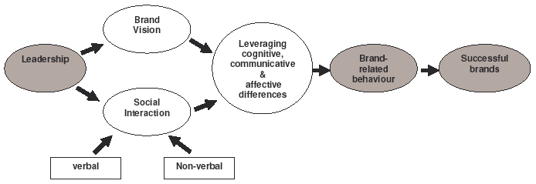
Figure 7. Leadership Brand-building Model (Vallaster and de Chernatony, 2005, pp.188).
Based on the work of Vallaster and de Chernatony (2005), Jenewein and Muhlmeier (2007) expanded the leadership brand-building model by conceptualizing relevant aspects (see Figure 8). Apart from defining and communicating brand vision and promise, the leader has to also live and act the brand values accordingly. In the other hand, employees should also be empowered to live brand values themselves (de Chernatony and Cottam, 2006). Such leadership leads to an increase in brand commitment by strengthening employees’ identification with the organization, thus initiate the feeling of personal duty and loyalty to enact brand behavior. This occurs by supporting the internalization or integration of brand values into the employees' self-concept due to value congruency, and by avoiding negative effects of employees’ compliance. As a form of ‘punishment avoidance,’ compliance is therefore considered to be the minimum condition an organization can expect from its employees. Thus, employees who only show compliance do not authentically live brand values up to prescribed standards (Zeplin, 2006 in Jenewein and Muhlmeier, 2007; Kaufmann et al., 2007; Morhart et al., 2009). Finally, by enhancing brand commitment, employees will be more likely to communicate and act in accordance with the brand values (Vallaster and de Chernatony, 2005; de Chernatony and Cottam, 2006; Jenewein and Muhlmeier, 2007).
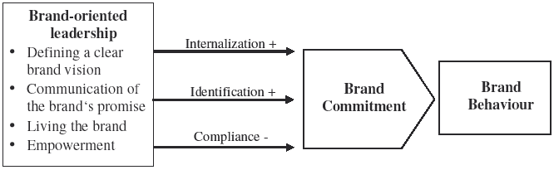
Figure 8. Brand-oriented Leadership Model (Jenewein and Muhlmeier, 2007, pp. 12)
In their latest research, Morhart et al. (2009) proposed an even more detailed model on the relationship between leadership style and brand-building behaviors, however, accentuating and integrating above concepts as well. As shown by figure 9, the causal chain of their model takes the form of “leadership style → basic need satisfaction → source of motivation → employees’ brand-building behaviors.” The crucial concept that lies in the “source of motivation” is customer-contact employee’s internalization of a brand-based role identity (as brand representative) into his or her self-concept. Specifically, this ‘internalization’ is also comprised of role identity, organizational identification, and value congruence concepts. It will occur when (1) employees have accepted the corporate brand values as their own and thus perceive value congruence between their own and those values, and (2) the brand-based role identity is positioned prominently in the salience hierarchy among the various role identities within their self-concepts (as explained in Kaufmann et al., 2007). In the end, this internalization is expected to entail aforementioned identity-congruent behaviors, such as retention, in-role, and extra-role brand-building behaviors.
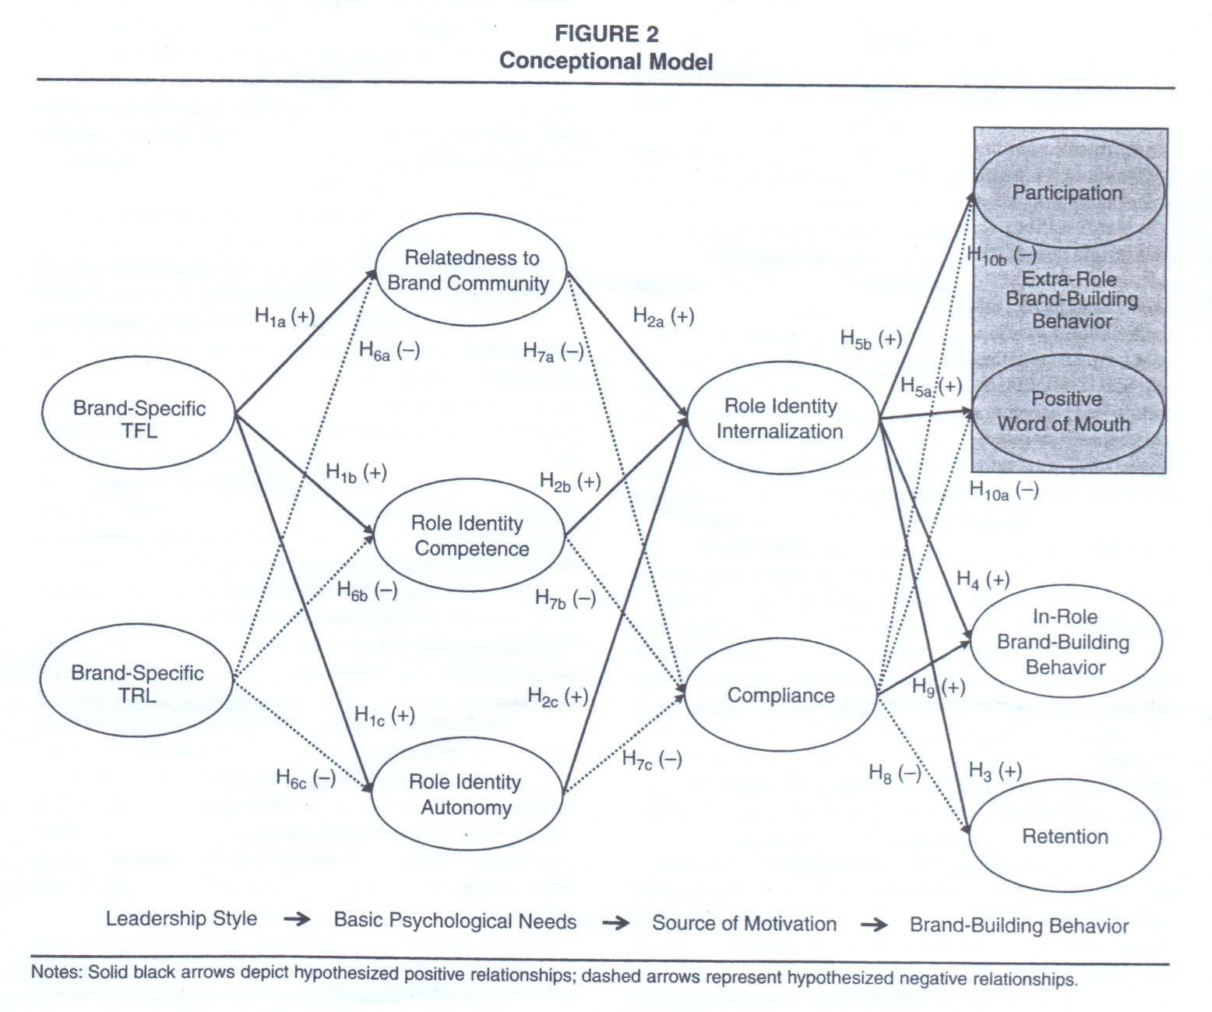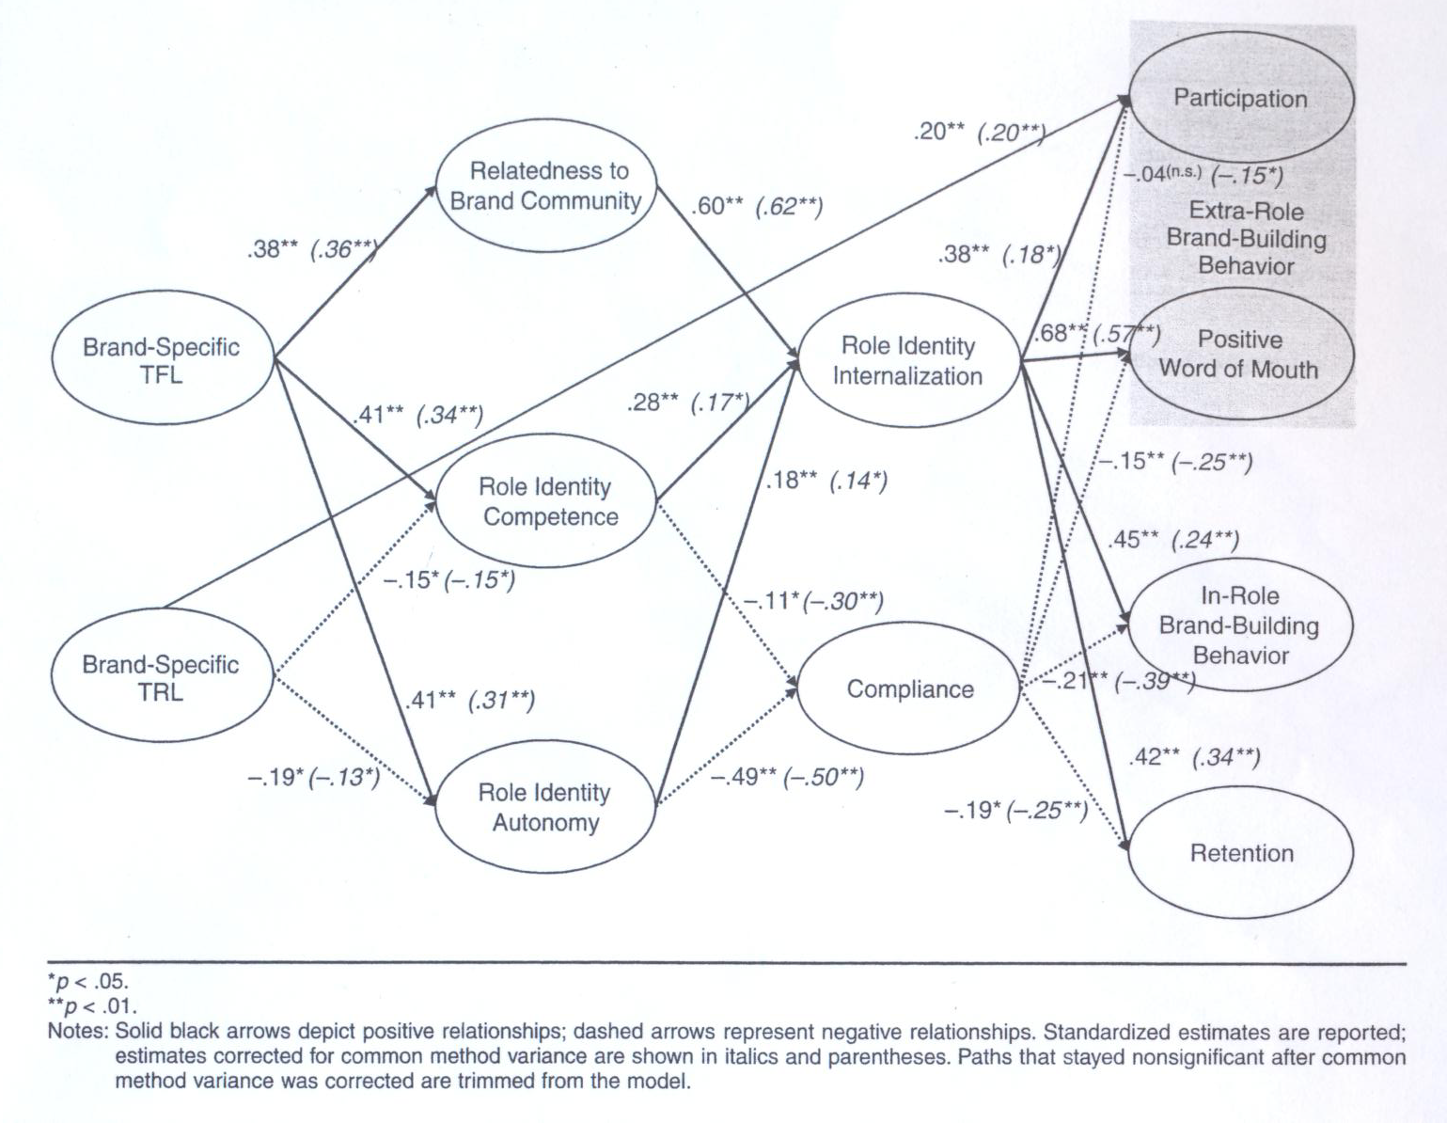
Figure 9. Brand-Specific Leadership Model (Morhart et al., 2009, pp. 125 & 131)
Morhart et al. (2009) argued that employee’s brand-building behavior is identity-congruent behavior that follows from a person’s self-concept in terms of the corporate brand. Employees will likely to internalize such brand-based role identity when they experience satisfaction of their needs for relatedness, competence, and autonomy in their roles as brand representatives. In the same vein as Vallaster and de Chernatony (2005), Brand-specific transformational leader (TFL) helps them to ‘internalize’ the brand values by providing a work environment in which they experience satisfaction of the three needs, and thus support their adoption of the brand-based role identity. While transactional leader (TRL) thwarts employees’ needs satisfaction and, thus, hinder their integration of brand-based role identity into their self-concepts. In this sense, TFL can be defined as a leader’s approach to motivate his or her employees’ behavior to act on behalf of the corporate brand by appealing to their values and personal convictions, while TRL is done by appealing to a contingency rationale in employees’ minds (Morhart et al., 2009).

A Synthesis Model of Corporate Branding and Brand-building Behavior
As shown in the previous discussion on the interrelationship between identity, corporate branding, leadership, behavioral branding, and brand-building behavior topics, there is a heightened necessity to incorporate the existing so far quite scattered models into a single integrated one. The generations of such a model will allow wider perspectives to emerge. Furthermore, corporate branding management, from setting the brand vision until the occurrence on employees’ brand-building behavior is more thoroughly explained. For example, we see that Hatch and Schultz’s (2008) model doesn’t emphasize brand-building behavior, as well as identity congruence and brand-oriented leadership concepts. However, these concepts are deemed important, both to authentically communicate the corporate brand identity and to achieve identity congruence, both internally (with organizational identity) and externally (with stakeholders’ identity).
Hence, a new conceptualization (see Figure 10) is provided that synthesizes between the VCI Alignment model (Hatch and Schultz, 2008), identity congruence (Kaufmann et al., 2007), and the brand-based leadership models that relate to brand-building behavior (i.e., Vallaster and de Chernatony, 2005; 2006; de Chernatony and Cottam, 2006; Jenewein and Muhlmeier, 2007; and Morhart et al., 2009). In this model, we suggest that leadership serves as the key integrating concept that incorporates and aligns all corporate branding elements (vision, culture, and image), as well as ensuring the identity congruence between organization, corporate brand and stakeholders through employees’ brand-building behavior.

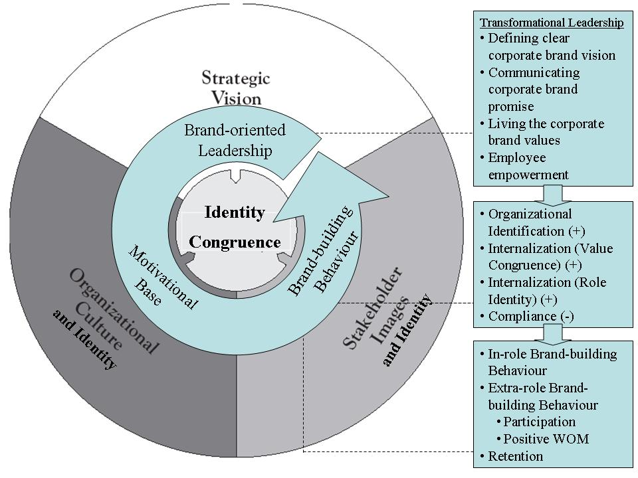
Figure 10. Synthesis Model of Corporate Branding and Brand-building Behavior

In order to internalize organization’s strategic vision of who we want to be and who we will be known, a brand-oriented leader must firstly define a clear corporate brand vision, communicate the promise, and live the values. These must be done in order to ensure every employee clearly understand about the direction of organization, its promise to the stakeholders, and what values and behaviors are expected. Empowerment must also be used as a core aspect of transformational leadership to engage the employees in actually living the values.
Through transformational leadership style, the leader will help the employees to have a positive identification with the organization, and internalize the corporate brand values and role identity as corporate brand ambassadors within their self-concept to achieve identity congruency. While avoiding the negative effect of compliance, these concepts will serve as the motivational base for the employees to enact identity congruence behavior, namely brand-building behavior. In this sense, the brand-oriented leadership will shape or re-confirm the organization’s culture of who we are, thus ensuring the alignment of vision and culture.
A strong motivational base will enable the employees to become brand ambassadors by showing brand-building behavior towards the stakeholders, hence, ensuring the alignment of culture and image. The in-role behavior will be specifically shown in their role as customer representatives, while the extra-role behavior will strengthen the corporate brand, both internally and externally to the society. Here, retention will also contribute a great value in shaping long-term relationships with the stakeholders. Complementing mass branding efforts, these brand-building behaviors will eventually shape or re-confirm stakeholders’ images and achieve congruency with their identity. As a logical consequence, brand-oriented leaders and employees will also be more likely to hear and fully understand stakeholders’ needs. Finally, the alignment of image and vision will also take place, as the stakeholders’ trust upon the organization increases, thus makes its vision and values attractive to and supported by them.

References
Antonakis, J. (2008), “Leadership: What Is It and How It Is Implicated In Strategic Change,” International Journal of Management Cases, Vol. 8, Issue 4, pp. 4-20.
Aaker, D. A. (1996), Building Strong Brands, New York: The Free Press.
Chatterjee, S. (2009), Corporate Branding: an Integrated Development Approach [Internet]. Available from: http://www.indianmba.com/Faculty_Column/FC982/fc982.html [Accessed 5 June 2010].
Collins, D. J. and Montgomery, C. A. (1995), “Competing on Resources: Strategies in the 1990s,” Harvard Business Review, Vol. 73, No. 4, pp. 118-128.
Davis, S. (2007), Corporate Branding: Making the Brand the Strategic ‘Driver’ for the Entire Organization [Internet]. Available from: http://www.scribd.com/doc/127439/ Corporate-branding?autodown=pdf [Accessed 28 May 2010].
de Chernatony, L. (2001), From Brand Vision to Brand Evaluation: Strategically Building and Sustaining Brands, Oxford: Butterworth-Heinemann.
de Chernatony, L. and Cottam, S. (2006), “Internal Brand Factors Driving Successful Financial Services Brands,” European Journal of Marketing, Vol. 40, No. 5/6, pp. 611-633.
Gotsi, M. and Wilson, A. (2001), “Corporate Reputation Management: Living the Brand,” Management Decision, Vol. 39/2, pp. 99-104.
Hatch, M. J. and Schultz, M. (2001), “Bringing the Corporation Into Corporate Branding,” European Journal of Marketing, Vol. 37, No. 7/8, pp. 1041-1064.
Hatch, M. J. and Schultz, M. (2008), Taking Brand Initiative: How Companies Can Align Strategy, Culture, and Identity Through Corporate Branding, San Francisco: Jossey-Bass.
Jenewein, W. and Muhlmeier, S. (2007), Brand-oriented Leadership, Switzerland: University of St. Gallen.
Kaufman, H. R., Cajthaml, M., and Meier, M. M. (2007), “Behavioral Branding: The Interdisciplinary Hilti Case,” International Journal of Management Cases, Special Issue CIRCLE Conference, Vol. 9, Iss. 3 / 4, pp. 329-334.
Kitchen. P. J. (2003), The Future of Marketing: Critical 21st – Century Perspectives, New York: Palgrave Macmillan.
Kotler, P. (1997), Marketing Management: Analysis, Planning, Implementation and Control, New Jersey: Prentice Hall International.
Maxwell, R. and Knox, S. (2009), “Motivating Employees to “Live the Brand”: A Comparative Case Study of Employer Brand Attractiveness within the Firm,” Journal of Marketing Management, Vol. 25, No. 9-10, pp. 893-907.
Morhart, F. M., Herzog, W., and Tomczak, T. (2009), “Brand-Specific Leadership: Turning Employees into Brand Champions,” Journal of Marketing, Vol. 73, September 2009, pp. 122-142.
Ormeño, M. (2007), Managing Corporate Brands: A New Approach to Corporate Communication, Germany: Springer e-Book Collection.
Percy, L. and Elliot, R. (2007), Strategic Brand Management, New York: Oxford University Press Inc.
ProBRAND. (2001), “Behave Yourself! Aligning Organizational Culture and Value in Support of Your Brand Building Efforts,” Online/Offline Branding Conference, New York: ProBRAND.
Siano, A., Kaufmann, H. R., and Basile, G. (2009), “The Evolution of New Consumer Roles in Branding,” Managerial and Entrepreneurial Developments in the Mediterranean Area, Cyprus: EuroMed Press.
Specht, N. (2007), “People Branding: Employees as Brand Ambassadors,” Vortrag im Rahmen des Best Brands College, Munchen: ServiceLust GmbH.
Urde, M. (2009), “Uncovering the Corporate Brand’s Core Values,” Management Decision, Vol. 47, No. 4, pp. 616-638.
Vallaster, C. and de Chernatony, L. (2005), “Internalization of Service Brands: The Role of Leadership during the Internal Brand Building Process,” Journal of Marketing Management, Vol. 21 (1/2), pp. 181-203.
Vallaster, C. and de Chernatony, L. (2006), “Internal Brand Building and Structuration: The Role of Leadership,” European Journal of Marketing, Vol. 40, No. 7/8, pp. 761-784.
Wilson, R. M. S. and Gilligan, C. (1997), Strategic Marketing Management: Planning, Implementation, and Control, 2nd ed., UK: Butterworth-Heinemann.

