TITLE
Effects of Partnered Dance in People with Parkinson’s (PWP) - A scoping review

Lead author: Ms. Ting Ka Cheng
Co-author: Ms. Sarah Sessa
Work Address: N.A.
Email: Leannecheng264@gmail.com
Phone details: +852 6712 6644
Social media: LinkedIn: Leanne Cheng

Professional and academic qualifications of all authors:
Ms. Ting Ka Cheng, BSc (Hons) Physiotherapy (2023), School of Health and Social Wellbeing, University of the West of England, Bristol, U.K.
Current Position: Qualified Physiotherapist
Ms Sarah Sessa, MSc, PGCert TLHE, BSc (Hons), MCSP, FHEA
Senior Lecturer in Neurorehabilitation, School of Health and Social Wellbeing, University of the West of England, Bristol, U.K.

ABSTRACT
Background: Partnered dance has been evidenced as beneficial for people with Parkinson’s (Osborne et al., 2022, Radder et al., 2020, Keus et al., 2014). However, the details are still ambiguous with regard to how partnered dance and its components impact PWP.

Objectives: This Scoping Review (ScR) aims to summarize the effects of partnered dance on PWP physically, psychologically, and cognitively, and the effects exerted by cueing, types of partners, and leading professionals. This review hopes to outline current related research findings and to identify research gaps for future research.

Data sources: Major electronic databases including PubMed, CINAHL, COCHRANE Web of Science, EMBASE, MEDLINE, and Grey literature including Google Scholar and Open Grey, were searched from November 2022 until March 2023.

Study selection: Of the primary studies included in the search, 12 were selected; seven randomized control trials (RCT), one non-RCT, one pilot study, one proposal, one interview, and one single-group pre-post design.

Methodology: PCC (Population, Concept, Context) was used to generate the search strategy. Researchers were divided into groups of two and three to initially screen titles and abstracts, followed by a comparison of the full-text against the inclusion and exclusion criteria. The studies selection process was recorded in the Preferred Reporting Items for Systematic reviews and Meta-Analyses extension for Scoping Reviews (PRISM-ScR).
Results: Four main themes were identified:1) effects of partnered dance on PWP were identified by all 12 studies 2) types of cueing were identified by nine studies, 3) types of partners were identified by 10 studies, and 4) types of leading professionals were also identified by 10 studies.

Conclusion: PWP benefit from partnered dance physically (through improved initiation of movement, balance, and gait), and psychologically by providing reassurance, promoting socialization, and enhancing participation. Additionally, cueing provided by partners can alleviate freezing of gait and partners positively affect the PWP’s dance classes experience. Although most studies mentioned the leading professionals, none discussed how different leading professionals affect PWP. None of the included articles discussed whether or how different leading professionals would affect PWP, highlighting the need for further investigations.

KEYWORDS
Partnered dance, Dance, Parkinson’s, Rehabilitation, Cueing

INTRODUCTION
Parkinson’s is a progressive neurodegenerative disorder, the main movement symptoms being caused by the loss of dopaminergic neurons in the substantia nigra (SN) disrupting basal ganglia (BG) functions (Surmeier, 2018). Dopamine deficiency causes motor dysfunction: primarily bradykinesia, resting tremors, and rigidity, and non-motor symptoms including sensory difficulties, cognitive impairment, and psychosocial changes (Kalia and Lang, 2015). As the Parkinson’s pathology progresses, activities of daily livings (ADLs) are reported as becoming increasingly difficult, PWP are recorded as experiencing diminishing motivation to engage in social activities, increasing reliance on others (Shulman et al., 2008), and reducing physical function (Zafar, Bozzorg, and Hackney, 2017). Moreover, Foster and Hershey (2011) suggested that restricted participation in ADLs results in reduced QoL (Duncan and Earhart, 2011) and life satisfaction (Edwards et al., 2006). Therefore, Parkinson’s is also associated with a lower quality of life (QoL) and high socioeconomic cost (Gumber, Ramaswamy, and Oranuch, 2019). This relationship highlights the importance of pursuing interventions that improve symptoms and enhance participation in ADLs.

Current treatment for Parkinson’s includes a combination of pharmacological and non-pharmacological options (National Institute for Health and Care Excellence, 2017), for example, dopaminergic therapy and deep brain stimulation (Lindenbach and Bishop, 2013), or antiparkinsonian medication and physical interventions (Keus et al, 2014). With regards the pharmacological approach, Dopaminergic therapy neither prevents progressive disability (Chaudhuri, Healy and Schapira, 2006), nor does it adequately address the low participation factors reported by PWP including depression (Rascol et al., 2003). Medication effectiveness also decreases as Parkinson’s progresses and may lead to side effects such as severe on-off fluctuations and drug-induced dyskinesia (Lindenbach and Bishop, 2013).

Exercise, however, has been proven to positively impact the Parkinson’s motor symptoms, particularly gait, balance and ability to perform ADLs (Osborne et al, 2022, Radder et al, 2020). If performed at sufficient intensity and regularity, exercise may improve functional circuitry by increasing synaptic strength and influencing neurotransmission, therefore slowing the disease progression, demonstrating a neuroprotective role of exercise (Ellis and Rochester, 2018). As personal preference to different types of exercise affects consistent participation, especially if a traditional exercise style is not enjoyed (Jancey et al., 2007; Qutubuddin et al., 2007), broadening the availability of styles to remain physically active, such as Tai Chi, dance, and yoga might increase adherence to exercise (Kabra et al., 2018; Houston and McGill, 2011).

Dance therapy has positive effects on motor impairment, endurance, balance, gait, and QoL (Sharp and Hewitt, 2014). It encourages social interaction, promotes adherence, and fosters motivation to participate (Federici, Bellagamba, and Rocchi, 2005). One author currently runs dance classes locally for PWP but only single person routines are taught. The authors wanted to explore whether dancing with a partner would provide increased benefit in terms of outcomes.

In terms of the neuroanatomical effect, a positron emission tomography (PET) study suggested that the BG might be sensitive to the interactions among entrainment (co-ordination or synchronisation of rhythms), meter (counting), and spatial patterning (relating to the relationship of the dancer to objects or people in their environment), specifically seen in dance (Brown, Martinez and Parsons, 2006), with potentially interesting implications for PWP where BG function is disrupted. Navigating movements, maintaining attention, and making decisions simultaneously provide the opportunity for multitasking (Earhart, 2009). Music also acts as an auditory cue and boosts the reward system, releasing more dopamine via the ventral tegmental area to improve mood, motivation, and cognition (Rios Romenets et al., 2015; Hackney and Earhart, 2009). Keus et al (2014) suggest that partnered dance shows benefits for improving gait and reducing the risk of falls in PWP.

When considering different styles of dance, Tango movements have been shown to enhance motor abilities by targeting Parkinson-related impairments, including initiation, spontaneous directional changes, and speed changes, thus alleviating difficulties with movement initiation, turning, and bradykinesia (Lötzke, Ostermann and Bussing, 2015). In comparison, ballroom dance does not include backward and cross-stepping, allowing less able participants to be involved in the class (Kunkel et al., 2017). Dancing with a partner promotes social and personal relationships while also improving physical limitations like axial impairments and dynamic balance (McNamara, Durso, and Harris, 2006). A study by De Dreu, Kwakkel, and Van Wegan (2015) stated the benefits of different types of partnered dance and cueing, however, the respective changing effects caused by different types of dance are not mentioned.

There are several established dance organizations for PWP, including Dance for PD (New York), Dance for Parkinson’s (London), and Queensland Ballet. Neither the research nor information from dance organizations make clear the critical aspects for understanding the effects of partnered dance on PWP. Moreover, studies focusing on the partner’s importance and influence remain ambiguous as demonstrated in a single group pre-post design study by Koch et al., (2016). Identifying themes across studies is critical for understanding the effects of partnered dance on PWP. A ScR is an approach for synthesizing research evidence (Pham et al., 2014) and aims to map and appraise current evidence and gaps to stimulate future change in practice, policies, and studies (Aromataris and Riitano, 2014). This ScR encompasses different study designs, so a wide range of effects on PWP can be extracted, with mapping and engagement of the diverse research landscape (Arksey & O’Malley, 2007).
Aims
This Scoping review (ScR) aims to summarize the effects of partnered dance on PWP physically, psychologically, and cognitively, and explores the effects exerted by cueing, partners, and leading professionals on PWP. In addition, current findings and gaps for future research will be summarized.
METHOD
This ScR uses a combination of the Arksey and O’Malley framework (2007), the Joanna Briggs Institute (JBI) approach (Peters et al., 2020) and guidance from the Preferred Reporing Items for Systematic and Meta-Analyses Extension for Scoping reviews (PRISMA-ScR) (Tricco et al., 2018) to establish an understanding of relevant terminology, concepts, and key items to report (Sarkis-Onofre, 2021).

Eligibility Criteria
The Population, Concept, Context (PCC) framework (Table 1) is recommended by JBI to identify the main concepts in the review questions to develop a full search strategy.

Element | Description
Population | - PWP
Concept | - Interventions: Partnered dance  - Outcomes:  - Effects-Physically, Psychologically and Cognitive
Context | - Primary health setting  - Community  - Dance room/ dance class
Table 1: Details of the Population, Concept, Context (PCC) being investigated
The inclusion and exclusion criteria are shown in Table 2 and reference the PCC elements, which was standardized for title and abstract screening and full-text screening.
Inclusion | Exclusion
English Language | - Non-English language
Parkinson's, stage 1-4, Hoehn and Yahr | - Non Parkinson's
PWP with co-morbidities
Partnered dance | - Non-partnered dance
 | - Secondary studies
 | - Did not mention effects of partner
Table 2: Inclusion and exclusion criteria of terms searched for the review
To be included in the review, papers needed to focus on Parkinson’s (with participants included who have Parkinson’s), partnered dance, and the effects of the partner in partnered dance. Participant criteria were kept broad in line with a ScR, thus, all Hoehn and Yahr stages of Parkinson’s (Hoehn and Yahr, 1967) (a commonly used scale for describing symptoms of Parkinson’s progressed) were included, as were co-morbidities. Primary studies e.g. quantitative, qualitative, and mixed methods of studies were included. Secondary studies were excluded to avoid drawing secondary research data that had been included as primary papers. Only English language studies were included. No time constraint or geographical filter was added as over-refining may filter out any related studies. Papers were excluded if they did not fit into the PCC framework, e.g. only focusing on non-partnered dance, without mentioning any effects of partnered dance.

Information sources
An initial limited search of PubMed and CINAHL was undertaken on 16 November 2022 to identify articles on the topic (JBI, 2020). Titles, abstracts, and index terms were used to develop a comprehensive search strategy. The full search went on to include PubMed, CINAHL, COCHRANE Web of Science, EMBASE, and MEDLINE, Google Scholar, and Open Grey. Justification of the published database is listed in Appendix 1. Snowballing was performed, which is the process of screening the reference list of the included studies in case of missing preliminary studies (Kohli, 2020), and can have an additional yield of relevant studies up to 42.7% (Horsley, Dingwall and Sampson, 2011).

Search
The Boolean search strategy was applied (Aromataris and Rittano, 2014). Truncations (*) and the “OR” operation were used to maximize the sensitivity (Leach et al., 2022). The “AND” strategy was used to combine search terms to specify the search. Search terms were developed and executed by all the researchers and summarized in Appendix 2. A comprehensive search was carried out of the seven databases mentioned above with the search terms from inception to March 2023. A picture of the entire search strategy from MEDLINE is shown in Appendix 3. After completing the database search, Mendeley software was used to remove duplications.

Selection of sources of evidence
Group members were divided into two groups to screen the titles and abstracts of 355 articles using the inclusion and exclusion criteria as shown in Table 2. Journals that were not relevant were excluded. Where the relevance of a study was unclear, the full text was obtained and reserved for retrieval.
Then the list of 59 studies for full-text screening was divided and distributed between the two groups to check their eligibility. Disagreements were resolved through whole-group discussion. Studies that did not meet the inclusion criteria were excluded. Included and excluded studies, with justifications, were presented in a PRISMA-ScR flow diagram (Figure 1).

Data Charting process
All five researchers determined which variables to extract and developed the tables. All the members charted the data, discussed the results, and continuously updated the tables in an iterative process. Article characteristics e.g. origins, aims, sample size, intervention type, intervention comparator, and effects of partner were extracted to the Data extraction table (Appendix 4).

Data Items
Data extracted included Parkinson’s stage and medication, details of the intervention including setting, duration of the class, effects, cueing, type of partner, leading professionals, and outcome measures for the effects. Key themes and patterns that were identified were recorded in the Key Themes and Patterning charts (Appendices 5 and 6).

Finally, the Patterns, Advances, Gaps, Evidence for Practice and Research Recommendations (PAGER) framework was used (Appendix 7) to synthesise the results. Designed by Bradbury-Jones et al., 2021, this tool provides an enhanced consistent approach to the analysing and reporting of review findings.

Critical appraisal
Critical appraisal of studies was not undertaken: unlike a systematic literature review (SLR), a ScR aims to scope the literature to summarize the current knowledge and gaps but not primarily focus on the quality of the studies.

RESULTS
Selection of sources of evidence
The PRISMA-ScR flow diagram (Figure 1) presents the article selection process. 763 articles were identified as potentially relevant to the research question. Titles and abstracts of 355 papers were screened against inclusion and exclusion criteria in Table 2. 59 articles were eligible for full-text review. The main reasons for exclusion were not referring to the effects of partners and having no access to full articles due to time constraints to contact authors for full-text screening. Twelve articles were left for final synthesis.
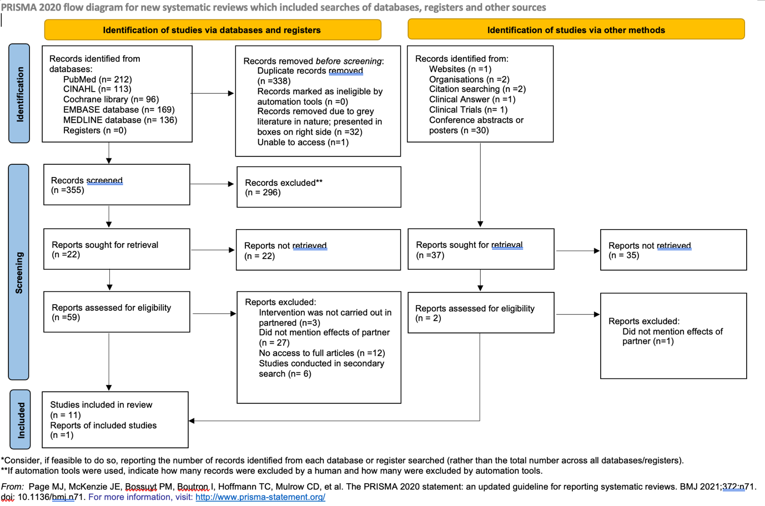
Figure 1: PRISMA-ScR flow diagram

Characteristics of sources of evidence
The articles’ characteristics are described in Appendix 4, together with a description of the aim, origin, study design, sample size, intervention type, intervention comparator, and the effects of partners in partnered dance. The origins include the U.S.A., U.K., and Germany. The sample size varies from 11-102 participants.
The duration of the class, effects of partnered dance, cueing, type of partner, leading professionals, medications, and outcome measures are listed in the Key themes charting (Appendix 5). The Parkinson’s stage of participants in the papers ranges from stage one to four. The setting includes living communities, a local dance centre, a dance school, etc.

Results of individual sources of evidence
Four main themes from partnered dance were identified: (1) The partners’ effects; (2) Types of partners; (3) Cueing (4) Leading professionals.

Effects of partner:
Physical
Nine out of twelve studies (Beerenbrock et al., 2020; Giménez-Llort and Castillo-Mariqueo, 2020; Hackney et al., 2020; Koch et al., 2016; Duncan and Earhart 2012; Hackney and Earhart 2010; Marchant, Sylvester, and Earhart 2010; Hackney and Earhart, 2009; Hackney, Kantorovich and Earhart, 2007) mentioned the positive physical impacts. Two studies (Giménez-Llort and Castillo-Mariqueo, 2020; Hackney et al., 2020) mentioned the effect of facilitating movement. Partners provide spatial external cues and timeframes to facilitate movements, coordination, and execution. The partner’s weight-shifting and direction of movement help initiate movement, increase or maintain stride length and cadence, and improve weight-shifting techniques, strengthening the PWP’s unity of movements. Five studies (Giménez-Llort and Castillo-Mariqueo, 2020; Marchant, Sylvester and Earhart, 2010; Hackney and Earhart, 2010; Hackney and Earhart, 2009; Hackney, Kantorovich and Earhart, 2007) stated improvements in balance and gait by external cues from partner e.g., physical contact at the hands, allows PWP to challenge their movement boundaries and use their partner’s limbs to counterweight for self-balance. One study (Marchant, Sylvester, and Earhart, 2010) discusses the idea that the partner's help to develop weight-shifting provides an element of resistance that potentially enhances muscle strength.

Psychological
Six studies (Beerenbrock, et al., 2020; Giménez-Llort and Castillo-Mariqueo, 2020; Kunkel et al., 2018; Zafar, Bozzorg, and Hackney, 2017; Koch et al., 2016; Kunkel et al.,2017) mentioned psychological impacts. Dance partnerships impact the degree of the PWP’s enjoyment and well-being. PWP found it more reassuring and pleasurable when dancing with a partner. The delightful atmosphere enhanced participation in dance class and extended social life. In the study by Koch et al. (2016), they used the outcome measure ‘Therapeutic factors of art therapies in PD’ and found that unison with the partner increased happiness after the intervention. Dancing with a partner radiates a sense of harmony among the family, as reported in a semi-standardized interview from the study by Beerenbrock et al (2020). Negative psychological effects arose when opinions clashed and were unresolved, and the stress of perhaps “letting down partners”.

Cueing
Nine studies (Giménez-Llort and Castillo-Mariqueo, 2020; Hackney et al., 2020; Koch et al., 2016; Kunkel et al., 2017; Duncan and Earhart, 2012; Marchant, Sylvester and Earhart, 2010; Hackney and Earhart, 2010; Hackney and Earhart, 2009; Hackney, Kantorovich and Earhart, 2007) mentioned the cueing strategy. This includes auditory cueing e.g. music, verbal cueing, rhythmic and metronome, visual, tactile, cognitive, and cueing from partners which combines a mixture of the above types.

Types of partner
All the studies mentioned the types of partners, identifying six types: general volunteers, spouses, relatives, friends, caregivers and other participants in the intervention.

Leading professionals
Except for the studies by Giménez-Llort and Castillo-Mariqueo (2020) and Duncan and Earhart (2012), all included studies indicated different leading professionals: dance instructors, exercise trainers, therapists, and assistants.

Synthesis of results
Information of the effects, cueing, type of partner, leading professionals, medication and outcome measures for partnered dance were synthesized and patterned in the Patterning chart (Appendix 6).

DISCUSSION
This ScR identified twelve studies exploring the effects of partnered dance on PWP. Four key themes including the physical and psychological effects, the accompanying cues, the types of dance partners, and leading professionals will be discussed.

Many PWP experience freezing which impairs their ADLs (Tambasco et al., 2016), and the inability to accomplish daily tasks leads to unsafe conditions and poor QoL (Edemekong et al., 2022). Partners exert positive physical effects such as weight-shifting techniques and cueing direction of movement, to help initiate movement which may alleviate freezing partner supports the PWP to develop weight-shifting techniques through turning. Different movements have various levels of weight transfer, for example: a step involves full weight-bearing, and a rock or check, only partial (Crewe, 2020). It is proven that multimodal biofeedback such as visual and vibrotactile together, delivered by the partner, facilitates movement initiation more effectively than just one model (Lee et al., 2015). However, one RCT (Hackney et al., 2007) found that both the partnered Tango group and the exercise group showed trends toward reduction in freezing, with no difference between the two groups. Moreover, weight-shifting encourages greater use of the affected limb, enhancing muscle strength (Reyna, 2013). To overcome the offered resistance, the PWP utilizes isometric muscle control instead of “flopping” onto the partner (Binda, Culham, and Brouwer, 2010), possibly strengthening their muscles for daily use. Ideally, the improvement in initiating movements and muscle strength may prove to the PWP that they have the strength and promote participation.

Balance problems are related to fall risks, preventing PWP from being active due to fear of falling (Abendroth, Lutz and Young, 2012; Wielinski et al., 2005). Partnered dancing intervention consistently improves balance performance (Shanahan et al., 2015; Sharp and Hewitt, 2014; Earhart, 2010) and multiple types of sensory information have been indicated in two RCTs as critical elements of balance control for PWP (Lefaivre and Almeida, 2015; Conradsson et al., 2012). The results support the use of cueing from partners for improving balance, which correlates with the studies found in this review and the mechanisms will be explained under the theme “cueing”. Physical touch also allows the PWP to challenge their balance boundaries safely as they are confident that their partners will assist them by controlling dynamic balance and external disturbances, as well as providing readjustment of movement if needed. The stops, starts, and turns with the partner can also be seen as a form of functional balance training (de Dreu et al., 2012). Improvement in balance enhances motor learning, ADL performance, QoL, and well-being (Tan et al., 2012; Ellis et al., 2011).

Interestingly, partners were found to have positive and negative psychological impacts. Depression is prevalent in 8.1% of PWP (Changas et al., 2013) and depressive symptoms correlate with decreased dopamine transporter in the anterior putamen (Weintraub et al., 2005). Rhythmic tango steps have been shown to selectively activate the putamen by the PET scanner (Brown, Martinez and Parsons, 2006). It could be postulated that Tango improves depressive symptoms through activation of the putamen. Mood has been demonstrated to impact health, and the expression of emotion has certain health benefits (Goodill, 2005). It was found that dance partnership impacts the degree of enjoyment for PWP. They feel more reassured, and with the release of dopamine, the “happy hormone”, mood is improved and symptoms of anxiety and depression are alleviated (Douka et al., 2019). As non-motor symptoms and motor symptoms are alleviated with dopamine release, participation in social activities increases, reinforcing the feeling of well-being. However, one interviewee who was the dance partner and spouse of the PWP from Kunkel et al. study (2018) stated that he felt stressed about leading due to the lack of confidence and difficulties and was afraid to let down his partner. Negative impact also happens when PWP and their partners have clashed opinions. Therefore, the choice of partner will be discussed.

Among the twelve studies, none of them discussed the cognitive effects of dancing with a partner yet 80% of PWP have one or more cognitive domains impaired after five years from diagnosis. Neuroimaging in PWP showed early affectation of monoamine and cortical systems beyond the nigrostriatal dopaminergic pathway that cause cognitive impairments with executive dysfunction, trouble concentrating, and memory issues (Speelman et al.,2011). Available literature (Pereira et al., 2019; Dhami, Moreno and DeSouza, 2015; Bläsing et al., 2012) suggests that partnered dance contributes to a PWP’s cognition improvement, including spatial memory, perception, and emotions, however, the benefits observed were not measured in a way that could directly attribute them to the presence of a partner. In other words, the benefits could be derived from other factors such as the steps or music. Research that attempts to explore this would allow a more holistic view of how partnered dance specifically affects cognitive function.

Cueing is defined as “an external temporal or spatial stimulant to facilitate movement initiation and continuation” (Lim, 2009). The caudate and putamen (collectively known as the striatum), are the input nuclei for the BG. The output nuclei SN and Globus pallidus (GB) inhibit the thalamus. External cues activate the cerebral cortex to send information to the striatum via the cortico-striatal pathway (Haber, 2016). The glutamate neurons in this pathway excite neurons in the striatum, releasing Gamma-aminobutyric acid (GABA) in the GB internal and substantial nigra par reticulata (SNpr). The GABA inhibits activity in the GB and SNpr and stops inhibiting the thalamus that is involved in movements (Galvan et al., 2010), thus opening the gate for movement to occur (Muthukrishnan et al., 2019). The different types of cueing observed in the included studies were auditory, visual, tactile, cognitive, or combined cues from the partner. With the aid of external cues, a PWP can achieve movements of nearly normal speed and amplitude through focused attention to critical aspects of movement (Baker, Rochester and Nieuwboer, 2007). Auditory cues improve the temporal parameters, including cadence and gait speed, which can bypass the internal rhythm deficit associated with Parkinson’s (Lee, Lee and Song, 2015).
Music is the most mentioned type of cueing and by affording a variety of mind-body responses from self-regulation to sensorimotor coupling, it is effective for mobility, psychological, social, and well-being (Bieńkiewicz and Craig, 2016). Nombela et al., (2013) suggest that music also facilitates the activation of motor networks that bypass the Parkinson’s-affected networks via cerebellum-thalamic-cortical circuitry. One study participant stated the music allowed her to forget her imbalance, lifted her the mood and found initiation of movement to be easier (Hackney, Kantorovich and Earhart, 2007). In contrast, some participants in the control group of the same study found it distracting which is corroborated by several Parkinson’s studies that found music offered additional cognitive demands (Rose et al., 2019). Previous studies have cited the importance of considering cultural aspects: PWP may find the class more enjoyable if they know the songs and become emotionally involved with specific memories of their culture (Jensen and Bonde, 2018; Hannon, Soley and Ullal, 2012).

Visual cues, such as stepping over and tapping a partner’s foot, can relieve freezing of gait (Jiang and Norman, 2006) and enable the visual-cerebellar motor circuit that influences the spatial aspects of gait (Morris et al., 1994). Tactile cues are presented in “contact improvisation” where the point of contact facilitates interaction through a shared site of stabilization or movement (Marchant, Sylvester and Earhart, 2010). Contact improvisation techniques include “rolling and pulling” and also utilizing the negative space around the partner which may provide cognitive cues for creating movement (Marchant, Sylvester and Earhart, 2010). In the stroke population, a small sample size (n=22) study (Waller and Whitall, 2005) looking at bilateral arm training with rhythmic auditory cues (BATRAC), saw benefits in upper-extremity function and strength for people with left hemisphere lesions. Interestingly, and in opposition to these findings, a study by (Richards et al., 2007) found no effects, explained by the participants having a higher motor function, and being less sensitive to the treatment: this explanation is also supported by another study (Lum et al.,2006), highlighting the importance of considering the individual’s severity level of condition when providing treatment. Controversially, cueing exerts negative effects on people with Huntington’s (PWH). One study found using musical and metronome cueing to be distracting for PWH while walking (Schaefer, 2014), contraindicating results for PWP where cueing assisted and improved PWP’s gait. This can be explained by a higher prevalence of attentional deficit and difficulties with sensori-motor synchronization in PWH as compared to PWP (Aldaaz et al.,2019 This result implies some executive function and cognitive capacity is necessary for auditory cues to support gait (Schaefer, 2014), highlighting the importance to consider an individual’s cognitive level when using cues.

In the included studies a wide range of partners were recruited as shown in the Patterning chart (Appendix 5). However, only one interview study (Beerenbrock et al., 2020) explored the impact of different partners on PWP. They suggest that when choosing volunteers, the experience should be considered, they should enjoy dancing, be sensible, and have good social skills, which is corroborated by a recommendations paper by Hackney and Earhart (2010). Beerenbrock et al. (2020) suggest the PWP’s experience of the dance class may be influenced by their relationship and compatibility with their partner: partners who were able to develop a good rapport gained greater enjoyment and a sense of achievement. Dancing with a spouse provides morale and emotional support to PWP, improving adherence and positive reinforcement. Participants who partnered with friends or relatives reported feeling motivated and more enjoyment as it was someone they knew. Participants who partnered with volunteers had ambiguous feelings, for example, if the PWP and the volunteer partner had a clash of personality or opinions, experience was less positive. One of the volunteers stated the dilemma of wanting to help without being seen to take over, which highlights the importance of the volunteer to encourage PWP to take the lead after safety considerations.

EVIDENCE GAP AND RECOMMENDATIONS FOR FUTURE STUDIES
PAGER (Appendix 7) was applied to analyze and report the inherent gaps, and how the review findings can resonate with and inform the future direction for both practice and research (Bradbury-Jones et al., 2021).

This ScR has identified the physical and psychological effects of partnered dance on PWP in most of the included studies, however, none explored the cognitive effects. Researchers should investigate the effects of partnered dance on PWP cognitive function to consider whether partnered dance can be another adjunct treatment targeting cognitive symptoms in this population. Despite the use of outcome measures throughout the studies the direct physical and psychological effects of partnering on PWP were mainly self-reported by the participants or interpreted by the authors. However, one study (Koch et al., 2016) used The therapeutic factors of art therapies in PD outcome measure which directly measures the happiness with the company of the partner, and consists of eight items that reflect central hypothesized active factors in arts therapies related to the aesthetic experience particularly geared toward PWP. This highlights the need for designing unified outcome measures to ensure the validity of the findings and that they are specifically due to the presence of a partner rather than other factors. Evidence with regards to how the PWP’s experience is affected by different types of partners is limited with the need for further exploration to validate the recommendations about the choice of the partner type.

Lastly, although the types of leading professionals recruited in the included studies were mentioned, none provide any evidence on how leading professionals impact on PWP in partnered dance, studies are required to address the significant gap in the field as a precursor for researchers to explore whether different types of leading professions exert different effects on PWP.

STRENGTHS AND LIMITATIONS
Recommended guidelines and standard methods were followed to conduct this ScR with a comprehensive literature search including grey literature. However, the following limitations should be considered when interpreting the review results. Firstly, to broaden the number of studies included, the stages of PWP in the Hoehn and Yahr scale, co-morbidity, and medications did not limit whether studies were included. This could affect sensitivity to interventions leading to variating results. Secondly, due to the scoping nature of this review, critical appraisal was not conducted to rate the quality of evidence, therefore implications for practice cannot be graded. Lastly, due to time constraints, authors for studies that have no access to could not be contacted.

CONCLUSION
This ScR summarizes a collection of studies exploring different elements of partnered dance. It is important to consider symptom severity and cognitive levels when providing partnered dance treatment. With this in mind, two key benefits of partnered dance for PWP that are highlighted in this SR were found:
- Physical: Mainly through initiation of movement and improving balance and gait
- Psychologically: By providing reassurance, promoting socialization and enhancing participation and improving QoL.

A variety of cueing and the pathophysiology of cueing were discussed. Benefits of cueing are improved gait and initiation of movement, although some people may find cueing to be a distraction. This research also found that PWP’s experience of dance classes may be influenced by their relationship and compatibility with their dance partners, so thoughtful recruitment of types of partners is needed. The paucity of articles discussing the effects of different leading professionals highlights the need for further investigations, e.g. systematic review for clinical implications when setting up partnered dance groups. Overall, this ScR provides a precursor for further investigations on different elements of partnered dance targeting different Parkinsonism symptoms.
(Word Count: 4721 words)
ACKNOWLEDGEMENTS
I would like to take my deepest gratitude to Ms. Sarah Sessa, my supervisor for this publication, for her unlimited guidance, trust, and most warming encouragement throughout the research, for providing useful resources to enhance my knowledge of research, and for always allowing me to ask questions and to solve problems together. I thank Mr. Rob Grieve and Ms. Rachel Thomas for providing expert guidance and feedback. I thank Ms. Lois Stevens for providing comments on the article. I thank the librarians of UWE Glenside Campus for helpful discussions about Grey literature. I thank the members of the research group Chun Cheung, Tin Chan, Tsz Chow, and Tsz Yue for their trust and support throughout.

DECLARATION OF INTEREST STATEMENT
The authors declared no potential conflicts of interest with respect to the research, authorship, and publication of this article.

FUNDING
This is a student-led project and there were no sources of funding for this scoping review.

REFERENCES

Abbruzzese, G. et al. (2016) ‘Rehabilitation for parkinson’s disease: Current outlook and future challenges’, Parkinsonism Related Disorders, 22. doi:10.1016/j.parkreldis.2015.09.005.

Abendroth, M., Lutz, B.J. and Young, M.E. (2012) ‘Family caregivers’ decision process to institutionalize persons with parkinson’s disease: A grounded theory study’, International Journal of Nursing Studies, 49(4), pp. 445–454. doi:10.1016/j.ijnurstu.2011.10.003.
Aldaz, T. et al. (2019) ‘Non-motor symptoms in Huntington’s disease: A comparative study with parkinson’s disease’, Journal of Neurology, 266(6), pp. 1340–1350. doi:10.1007/s00415-019-09263-7.
Arksey, H. and O’Malley, L. (2007) ‘Scoping studies: Towards a methodological framework’, International Journal of Social Research Methodology, 8(1), pp. 19–32. doi:10.1080/1364557032000119616.

Aromataris, E. and Riitano, D. (2014) ‘Systematic reviews’, AJN, American Journal of Nursing, 114(5), pp. 49–56. doi:10.1097/01.naj.0000446779.99522.f6.

Baker, K., Rochester, L. and Nieuwboer, A. (2007) ‘The immediate effect of attentional, auditory, and a combined cue strategy on gait during single and dual tasks in parkinson’s disease’, Archives of Physical Medicine and Rehabilitation, 88(12), pp. 1593–1600. doi:10.1016/j.apmr.2007.07.026.

Beerenbrock, Y. et al. (2020) ‘Perceived effects of tango argentino on body experience in persons with parkinson’s disease (pd)—a qualitative study with affected persons and their partners’, Complementary Therapies in Medicine, 48, p. 102221. doi:10.1016/j.ctim.2019.102221.

Bieńkiewicz, M.M. and Craig, C. (2016) ‘Editorial: Sound, music, and movement in parkinson’s disease’, Frontiers in Neurology, 7. doi:10.3389/fneur.2016.00216.

Binda, S.M., Culham, E.G. and Brouwer, B. (2010) ‘Balance, muscle strength, and fear of falling in older adults’, Experimental Aging Research, 29(2), pp. 205–219. doi:10.1080/03610730303711.
Bläsing, B. et al. (2012) ‘Neurocognitive control in dance perception and performance’, Acta Psychologica, 139(2), pp. 300–308. doi:10.1016/j.actpsy.2011.12.005.
Bradbury-Jones, C. et al. (2021) ‘Scoping reviews: The PAGER framework for improving the quality of reporting’, International Journal of Social Research Methodology, 25(4), pp. 457–470. doi:10.1080/13645579.2021.1899596.

Brown, S.B., Martinez, M.J. and Parsons, L.M. (2006) ‘The neural basis of human dance’, Cerebral Cortex, 16(8), pp. 1157–1167. doi:10.1093/cercor/bhj057.

Chagas, M.H. et al. (2013) ‘Neuroimaging of depression in parkinson’s disease: A Review’, International Psychogeriatrics, 25(12), pp. 1953–1961. doi:10.1017/s1041610213001427.

Chaudhuri, K.R., Healy, D.G. and Schapira, A.H. (2006) ‘Non-motor symptoms of parkinson’s disease: Diagnosis and management’, The Lancet Neurology, 5(3), pp. 235–245. doi:10.1016/s1474-4422(06)70373-8.

Conradsson, D. et al. (2012) ‘A novel conceptual framework for balance training in parkinson’s disease-study protocol for a randomised controlled trial’, BMC Neurology, 12(1). doi:10.1186/1471-2377-12-111.
Crewe, I. (2020) Fundamentals, part one: Weight transfer, Joy of Dance. Available at: https://www.joyofdance.ca/blog-posts/fundamentals-part-one-weight-transfer/ (Accessed: 13 July 2023).
de Dreu, M.J. et al. (2012) ‘Rehabilitation, exercise therapy and music in patients with parkinson’s disease: A meta-analysis of the effects of music-based movement therapy on walking ability, balance and quality of life’, Parkinsonism &amp; Related Disorders, 18. doi:10.1016/s1353-8020(11)70036-0.

de Dreu, M.J., Kwakkel, G. and van Wegen, E.E. (2015) ‘Partnered dancing to improve mobility for people with parkinson’s disease’, Frontiers in Neuroscience, 9. doi:10.3389/fnins.2015.00444.

Dhami, P., Moreno, S. and DeSouza, J.F. (2015) ‘New Framework for rehabilitation- fusion of cognitive and physical rehabilitation: The hope for dancing’, Frontiers in Psychology, 5. doi:10.3389/fpsyg.2014.01478.

Douka, S. et al. (2019) ‘Traditional dance improves the physical fitness and well-being of the elderly’, Frontiers in Aging Neuroscience, 11. doi:10.3389/fnagi.2019.00075.

Duncan, R.P. and Earhart, G.M. (2012) ‘Randomized controlled trial of community-based dancing to modify disease progression in parkinson disease’, Neurorehabilitation and Neural Repair, 26(2), pp. 132–143. doi:10.1177/1545968311421614.

Duncan, R.P. and Earhart, G.M. (2011) ‘Measuring participation in individuals with parkinson disease: Relationships with disease severity, quality of life, and Mobility’, Disability and Rehabilitation, 33(15–16), pp. 1440–1446. doi:10.3109/09638288.2010.533245.

Earhart, G.M. (2009) Dance as therapy for individuals with parkinson disease, European journal of physical and rehabilitation medicine. Available at: https://www.ncbi.nlm.nih.gov/pmc/articles/PMC2780534/herapy for Individuals with Parkinson Disease (Accessed: 13 July 2023).

Edemekong, P.F. et al. (2022) Activities of daily living - statpearls - NCBI bookshelf, StatPearls [Internet]. Available at: https://www.ncbi.nlm.nih.gov/books/NBK470404/ (Accessed: 13 July 2023).

Edwards, D.F. et al. (2006) ‘The impact of mild stroke on meaningful activity and life satisfaction’, Journal of Stroke and Cerebrovascular Diseases, 15(4), pp. 151–157. doi:10.1016/j.jstrokecerebrovasdis.2006.04.001.

Ellis, T. et al. (2011) ‘Which measures of physical function and motor impairment best predict quality of life in parkinson’s disease?’, Parkinsonism &amp; Related Disorders, 17(9), pp. 693–697. doi:10.1016/j.parkreldis.2011.07.004.

Federici, A., Bellagamba, S. and Rocchi, M.B. (2005) ‘Does dance-based training improve balance in adult and young old subjects? A pilot randomized controlled trial’, Aging Clinical and Experimental Research, 17(5), pp. 385–389. doi:10.1007/bf03324627.

Foster, E.R. and Hershey, T. (2011) ‘Everyday executive function is associated with activity participation in parkinson disease without dementia’, OTJR: Occupation, Participation and Health, 31(1_suppl). doi:10.3928/15394492-20101108-04.

Giménez-Llort, L. and Castillo-Mariqueo, L. (2020) ‘Pasodoble, a proposed dance/music for people with parkinson’s disease and their caregivers’, Frontiers in Neurology, 11. doi:10.3389/fneur.2020.567891.

Galvan, A. et al. (2010) ‘Localization and function of GABA transporters in the globus pallidus of Parkinsonian Monkeys’, Experimental Neurology, 223(2), pp. 505–515. doi:10.1016/j.expneurol.2010.01.018.

Goodill, S.W. (2005) ‘An introduction to medical dance/movement therapy: Health care in motion’, Jessica Kingsley Publishers, 2(2), pp. 171–174. doi:10.1080/17533015.2010.502385.

Gumber, A., Ramaswamy, B. and Thongchundee, O. (2019) Effects of parkinson’s on employment, cost of care, and quality of life of people with condition and family caregivers in the UK: A systematic literature review, Patient Related Outcome Measures, Volume 10, pp. 321–333. doi:10.2147/prom.s160843.
Haber, S.N. (2016) ‘Corticostriatal circuitry’, Dialogues in Clinical Neuroscience, 18(1), pp. 7–21. doi:10.31887/dcns.2016.18.1/shaber.
Hackney, M.E. et al. (2020) ‘Rationale and design of the paired trial: Partnered dance aerobic exercise as a neuroprotective, motor, and cognitive intervention in parkinson’s disease’, Frontiers in Neurology, 11. doi:10.3389/fneur.2020.00943.

Hackney, M. and Earhart, G. (2009) ‘Effects of dance on movement control in parkinson’s disease: A comparison of Argentine Tango and american ballroom’, Journal of Rehabilitation Medicine, 41(6), pp. 475–481. doi:10.2340/16501977-0362.

Hackney, M.E. and Earhart, G.M. (2010) ‘Effects of dance on gait and balance in parkinson’s disease: A comparison of partnered and nonpartnered Dance Movement’, Neurorehabilitation and Neural Repair, 24(4), pp. 384–392. doi:10.1177/1545968309353329.

Hackney, M.E. and Earhart, G.M. (2010) ‘Recommendations for implementing tango classes for persons with parkinson disease’, American Journal of Dance Therapy, 32(1), pp. 41–52. doi:10.1007/s10465-010-9086-y.

Hackney, M.E. et al. (2007) ‘Effects of tango on functional mobility in parkinson’s disease: A preliminary study’, Journal of Neurologic Physical Therapy, 31(4), pp. 173–179. doi:10.1097/npt.0b013e31815ce78b.
Hackney, M.E., Kantorovich, S. and Earhart, G.M. (2007) ‘A study on the effects of Argentine tango as a form of partnered dance for those with parkinson disease and the healthy elderly’, American Journal of Dance Therapy, 29(2), pp. 109–127. doi:10.1007/s10465-007-9039-2.
Hannon, E.E., Soley, G. and Ullal, S. (2012) ‘Familiarity overrides complexity in rhythm perception: A cross-cultural comparison of American and Turkish listeners.’, Journal of Experimental Psychology: Human Perception and Performance, 38(3), pp. 543–548. doi:10.1037/a0027225.
Hoehn, M.M. and Yahr, M.D. (1967) ‘Parkinsonism: Onset, progression, and mortality’, Neurology, 17(5), pp. 427–427. doi:10.1212/wnl.17.5.427.
Horsley, T., Dingwall, O. and Sampson, M. (2011) ‘Checking reference lists to find additional studies for Systematic Reviews’, Cochrane Database of Systematic Reviews, 2011(8). doi:10.1002/14651858.mr000026.pub2.
Houston, S. and McGill, A. (2011) English national ballet dance for parkinson’s, dance for parkinsons report 2011. Available at: https://hafraah.files.wordpress.com/2015/02/dance-for-parkinsons-report-2011.pdf (Accessed: 13 July 2023).

Huse, D.M. et al. (2005) ‘Burden of illness in parkinson’s disease’, Movement Disorders, 20(11), pp. 1449–1454. doi:10.1002/mds.20609.

Jancey, J. et al. (2007) ‘Reducing attrition in physical activity programs for older adults’, Journal of Aging and Physical Activity, 15(2), pp. 152–165. doi:10.1123/japa.15.2.152.

Jensen, A. and Bonde, L. (2018) ‘The use of arts interventions for mental health and wellbeing in Health Settings’, Perspectives in Public Health, 138(4), pp. 209–214. doi:10.1177/1757913918772602.

Jiang, Y. and Norman, K.E. (2006) ‘Effects of visual and auditory cues on gait initiation in people with parkinson’s disease’, Clinical Rehabilitation, 20(1), pp. 36–45. doi:10.1191/0269215506cr925oa.

Kabra, A. et al. (2018) ‘Emerging and alternative therapies for parkinson disease: An updated review’, Current Pharmaceutical Design, 24(22), pp. 2573–2582. doi:10.2174/1381612824666180820150150.

Kalia, L.V. and Lang, A.E. (2015) ‘Parkinson’s disease’, The Lancet, 386(9996), pp. 896–912. doi:10.1016/s0140-6736(14)61393-3.

Keus SHJ, Munneke M, Graziano M et al (2014). European Guideline for Parkinson’s disease. KNGF/ParkinsonNet, the Netherlands

Koch, S.C. et al. (2016) ‘The embodied self in parkinson’s disease: Feasibility of a single tango intervention for assessing changes in psychological health outcomes and aesthetic experience’, Frontiers in Neuroscience, 10. doi:10.3389/fnins.2016.00287.

Kohli, A. (2020) ‘snowballing’ in Systematic Literature Review, LinkedIn. Available at: https://www.linkedin.com/pulse/snowballing-systematic-literature-review-amanpreet-kohli (Accessed: 13 July 2023).

Kunkel, D. et al. (2017) ‘A randomized controlled feasibility trial exploring partnered ballroom dancing for people with parkinson’s disease’, Clinical Rehabilitation, 31(10), pp. 1340–1350. doi:10.1177/0269215517694930.
Kunkel, D. et al. (2018) ‘It takes Two: The influence of dance partners on the perceived enjoyment and benefits during participation in partnered ballroom dance classes for people with parkinson’s’, Disability and Rehabilitation, 40(16), pp. 1933–1942. doi:10.1080/09638288.2017.1323029.
Leach, E. et al. (2022) ‘Access to chronic pain services for adults from minority ethnic groups in the United Kingdom: A scoping review protocol’, Musculoskeletal Care, 20(4), pp. 731–741. doi:10.1002/msc.1629.
Lee, B.C. et al. (2015) ‘The effects of different sensory augmentation on weight-shifting balance exercises in parkinson’s disease and healthy elderly people: A proof-of-concept study’, Journal of NeuroEngineering and Rehabilitation, 12(1). doi:10.1186/s12984-015-0064-y.
Lee, N.-Y., Lee, D.-K. and Song, H.-S. (2015) ‘Effect of virtual reality dance exercise on the balance, activities of daily living, and depressive disorder status of parkinson’s disease patients’, Journal of Physical Therapy Science, 27(1), pp. 145–147. doi:10.1589/jpts.27.145.
Lefaivre, S.C. and Almeida, Q.J. (2015) ‘Can sensory attention focused exercise facilitate the utilization of proprioception for improved balance control in pd?’, Gait &amp; Posture, 41(2), pp. 630–633. doi:10.1016/j.gaitpost.2015.01.013.
Lim, K. (2009) Rehabilitation in parkinson’s disease: Strategies for cueing - core. Available at: https://core.ac.uk/download/pdf/15457078.pdf (Accessed: 13 July 2023).

Lindenbach, D. and Bishop, C. (2013) ‘Critical involvement of the motor cortex in the pathophysiology and treatment of parkinson’s disease’, Neuroscience &amp; Biobehavioral Reviews, 37(10), pp. 2737–2750. doi:10.1016/j.neubiorev.2013.09.008.

Lötzke, D., Ostermann, T. and Büssing, A. (2015) ‘Argentine tango in parkinson disease – a systematic review and meta-analysis’, BMC Neurology, 15(1). doi:10.1186/s12883-015-0484-0.
Lum, P.S. et al. (2006) ‘Mime robotic device for upper-limb neurorehabilitation in subacute stroke subjects: A follow-up study’, The Journal of Rehabilitation Research and Development, 43(5), p. 631. doi:10.1682/jrrd.2005.02.0044.
Marchant, D., Sylvester, J.L. and Earhart, G.M. (2010) ‘Effects of a short duration, high dose contact improvisation dance workshop on parkinson disease: A pilot study’, Complementary Therapies in Medicine, 18(5), pp. 184–190. doi:10.1016/j.ctim.2010.07.004.

McNamara, P., Durso, R. and Harris, E. (2006) ‘Life goals of patients with Parkinson’s disease: A pilot study on correlations with mood and cognitive functions’, Clinical Rehabilitation, 20(9), pp. 818–826. doi:10.1177/0269215506070811.
Morris, M.E. et al. (1994) ‘The pathogenesis of gait hypokinesia in parkinson’s disease’, Brain, 117(5), pp. 1169–1181. doi:10.1093/brain/117.5.1169.
Muthukrishnan, N. et al. (2019) ‘Cueing paradigms to improve gait and posture in parkinson’s disease: A narrative review’, Sensors, 19(24), p. 5468. doi:10.3390/s19245468.
NICE (2017) Parkinson’s disease in adults - nice, Parkinson’s disease in adults . Available at: https://www.nice.org.uk/guidance/ng71/resources/parkinsons-disease-in-adults-pdf-1837629189061 (Accessed: 13 July 2023).

Nombela, C. et al. (2013) ‘Into the groove: Can rhythm influence Parkinson’s disease?’, Neuroscience &amp; Biobehavioral Reviews, 37(10), pp. 2564–2570. doi:10.1016/j.neubiorev.2013.08.003.

Osborne, J.A. et al. (2022) ‘Physical therapist management of parkinson disease: A clinical practice guideline from the American Physical Therapy Association’, Physical Therapy, 102(4). doi:10.1093/ptj/pzab302.

Pereira, A.P. et al. (2019) ‘Music therapy and dance as gait rehabilitation in patients with parkinson disease: A review of evidence’, Journal of Geriatric Psychiatry and Neurology, 32(1), pp. 49–56. doi:10.1177/0891988718819858.

Peters, M. et al. (2020) ‘Chapter 11: Scoping reviews’, JBI Manual for Evidence Synthesis [Preprint]. doi:10.46658/jbimes-20-12.

Pham, M.T. et al. (2014) ‘A scoping review of scoping reviews: Advancing the approach and enhancing the consistency’, Research Synthesis Methods, 5(4), pp. 371–385. doi:10.1002/jrsm.1123.

Qutubuddin, A.A. et al. (2007) ‘A comparison of computerized dynamic posturography therapy to standard balance physical therapy in individuals with parkinson’s disease: A pilot study1’, NeuroRehabilitation, 22(4), pp. 261–265. doi:10.3233/nre-2007-22402.

Radder, D.L. et al. (2020) ‘Physiotherapy in parkinson’s disease: A meta-analysis of present treatment modalities’, Neurorehabilitation and Neural Repair, 34(10), pp. 871–880. doi:10.1177/1545968320952799.

Rascol, O. et al. (2003) ‘Limitations of current parkinson’s disease therapy’, Annals of Neurology, 53(S3). doi:10.1002/ana.10513.

Reyna, R. (2013) How to improve balance with weight shifting exercises, How to Improve Balance with Weight Shifting Exercises. Available at: https://wellness.nifs.org/blog/bid/82243/How-to-Improve-Balance-with-Weight-Shifting-Exercises (Accessed: 13 July 2023).

Richards, L.G. et al. (2007) ‘Bilateral arm training with rhythmic auditory cueing in chronic stroke: Not always efficacious’, Neurorehabilitation and Neural Repair, 22(2), pp. 180–184. doi:10.1177/1545968307305355.

Rios Romenets, S. et al. (2015) ‘Tango for treatment of motor and non-motor manifestations in parkinson’s disease: A Randomized Control Study’, Complementary Therapies in Medicine, 23(2), pp. 175–184. doi:10.1016/j.ctim.2015.01.015.

Rose, D. et al. (2019) ‘Music and metronomes differentially impact motor timing in people with and without parkinson’s disease: Effects of slow, medium, and fast tempi on entrainment and synchronization performances in finger tapping, toe tapping, and stepping on the spot tasks’, Parkinson’s Disease, 2019, pp. 1–18. doi:10.1155/2019/6530838.

Sarkis-Onofre, R. et al. (2021) ‘How to properly use the Prisma statement’, Systematic Reviews, 10(1). doi:10.1186/s13643-021-01671-z.
Schaefer, R.S. (2014) ‘Auditory rhythmic cueing in movement rehabilitation: Findings and possible mechanisms’, Philosophical Transactions of the Royal Society B: Biological Sciences, 369(1658), p. 20130402. doi:10.1098/rstb.2013.0402.
Shanahan, J. et al. (2015) ‘Is Irish set dancing feasible for people with Parkinson’s disease in Ireland?’, Complementary Therapies in Clinical Practice, 21(1), pp. 47–51. doi:10.1016/j.ctcp.2014.12.002.

Sharp, K. and Hewitt, J. (2014) ‘Dance as an intervention for people with Parkinson’s disease: A systematic review and meta-analysis’, Neuroscience; Biobehavioral Reviews, 47, pp. 445–456. doi:10.1016/j.neubiorev.2014.09.009.

Shulman, L.M. et al. (2008) ‘The evolution of disability in Parkinson disease’, Movement Disorders, 23(6), pp. 790–796. doi:10.1002/mds.21879.

Speelman, A.D. et al. (2011) ‘How might physical activity benefit patients with parkinson disease?’, Nature Reviews Neurology, 7(9), pp. 528–534. doi:10.1038/nrneurol.2011.107.

Surmeier, D.J. (2018) ‘Determinants of dopaminergic neuron loss in parkinson’s disease’, The FEBS Journal, 285(19), pp. 3657–3668. doi:10.1111/febs.14607.

Tambasco, N. et al. (2016) ‘Morning akinesia in parkinson’s disease: Challenges and solutions’, Journal of Parkinsonism and Restless Legs Syndrome, p. 57. doi:10.2147/jprls.s83276.

Tan, D. et al. (2012) ‘Relationships between motor aspects of gait impairments and activity limitations in people with parkinson’s disease: A systematic review’, Parkinsonism &amp; Related Disorders, 18(2), pp. 117–124. doi:10.1016/j.parkreldis.2011.07.014.

Tricco, A.C. et al. (2018) ‘Prisma extension for scoping reviews (PRISMA-SCR): Checklist and explanation’, Annals of Internal Medicine, 169(7), pp. 467–473. doi:10.7326/m18-0850.

Waller, S.M. and Whitall, J. (2005) ‘Hand dominance and side of stroke affect rehabilitation in chronic stroke’, Clinical Rehabilitation, 19(5), pp. 544–551. doi:10.1191/0269215505cr829oa.

Weintraub, D. et al. (2005) Striatal dopamine transporter imaging correlates with anxiety and depression symptoms in Parkinson’s disease, Journal of Nuclear Medicine. Available at: https://jnm.snmjournals.org/content/46/2/227.long (Accessed: 13 July 2023).

Wielinski, C.L. et al. (2005) ‘Falls and injuries resulting from falls among patients with Parkinson’s disease and other Parkinsonian syndromes’, Movement Disorders, 20(4), pp. 410–415. doi:10.1002/mds.20347.

Zafar, M., Bozzorg, A. and Hackney, M.E. (2017) ‘Adapted Tango improves aspects of participation in older adults versus individuals with Parkinson’s disease’, Disability and Rehabilitation, 39(22), pp. 2294–2301. doi:10.1080/09638288.2016.1226405.

APPENDICES

Database | Justification | Limitation
PUBMED  (cite: National Library of medicine, PubMed user guide.) https://pubmed.ncbi.nlm.nih.gov/help/#how-do-i-search-pubmed | - Free resource  - More than 34 million citations and abstracts of biomedical literature  - Available to public online since 1996  - Maintained by the national center for biotechnology information (NCBI), at the U.S. National library of medicine (NLM)
CINAHL | - Covers more than 4500 journals from fields of nursing and allied health  - Coverage dating as far back as 1937  - Offering complete coverage of English language nursing journals and publications from the national league for nursing and the American nurses' association, CINAHL covers nursing, biomedicine, health sciences librarianship, alternative/ complementary medicine, consumer health and 17 allied health disciplines  (UWE, 2022) | Majority of the journals covered are in English language
AMED (Allied and complementary medicine) | - Bibliographic database produced by the health care information service of the British library  Cover 3 main subject areas:  - Complementary medicine  - Palliative care  - Professions allied to medicine (physiotherapy, occupational therapy, rehabilitation, and speech& language therapy)  (UWE, 2022)
COCHRANE LIBRARY | - Considered to be the best only source of reliable evidence on the effects of health care  - Includes the Cochrane database of systematic reviews (CDSR) which is leading resource for systematic reviews in health care  (UWE, 2022)
EMBASE | - Includes 24 million indexed recorded in the field of biomedicine  - Covers more than7500 current, mostly peer reviewed, journals, of which 2000 are not included in Medline.  - Specialist areas include psychiatry and pharmacology  - Includes conference abstracts from more than 7000 biomedical, drug and medical device conferences dating back to 2009  (UWE, 2022)
MEDLINE | - Contains journal citations and abstracts for biomedical literature from around the worked  - US national library of medicine (NLM) premier bibliographic database and contains more than 26 million references to journal articles in life science with a concentration on biomedicine (UWE 2022)  - Currently, citations from approximately 5200 worldwide journals in 40 languages; 60 languages for older journals.  (UWE, 2022)
Appendix 1: Justifications and limitations of databases

Search number | Search terms
Search 1 | - ‘Parkins*’ or ‘Parkinson’s disease’
Search 2 | - ‘Partner danc*’ or ‘partnered dance*’ or ‘double danc*’ or’ danc* with two people’ or ‘couple danc*’ or ‘Dance therapy’ or ‘Dance movement’ or ‘Dance movement therapy’
Search 3 | ‘Tango’ or ‘Waltz’ or ‘Foxtrot’ or ‘Rumba’ or 'Mexican danc*' or 'Latin danc*’ or ‘Cha Cha’ or ‘Swing’ or ‘Bolero’ or ‘Mamboo’ or ‘Salsa’ or ‘Merengue’ or ‘Bachata’ or ‘Kizomba’ or ‘Lindy hop’ or ‘Balboa’ or ‘Charleston’ or ‘Shag’ or ‘Boogie woogie’ or ‘jitterbug’
Search 4 | - Search 2 OR search 3
Search 5 | - Search 1 AND search 2 AND search 4
Appendix 2: Search terms

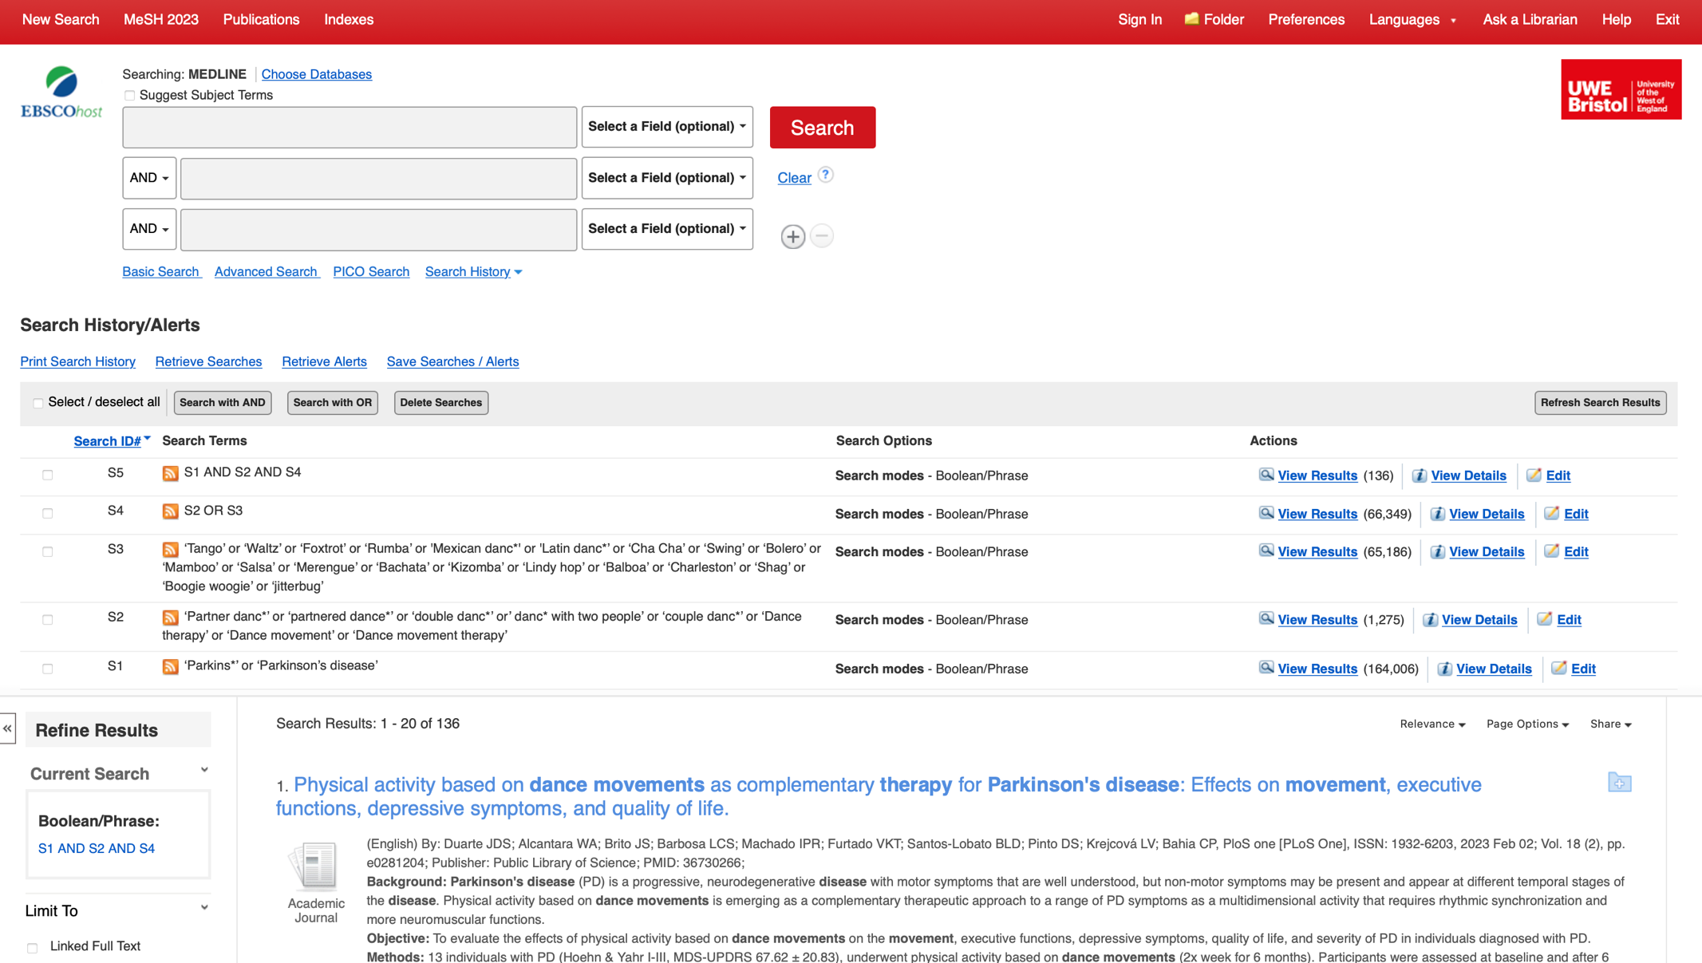

Appendix 3: Figure of the entire search strategy from MEDLINE
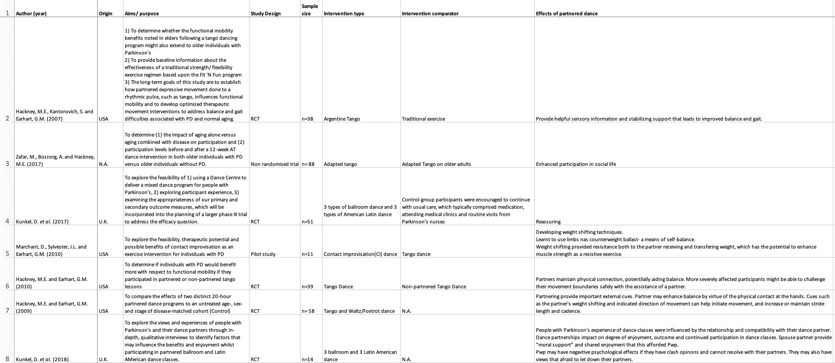

Appendix 4: Data extraction table (1)

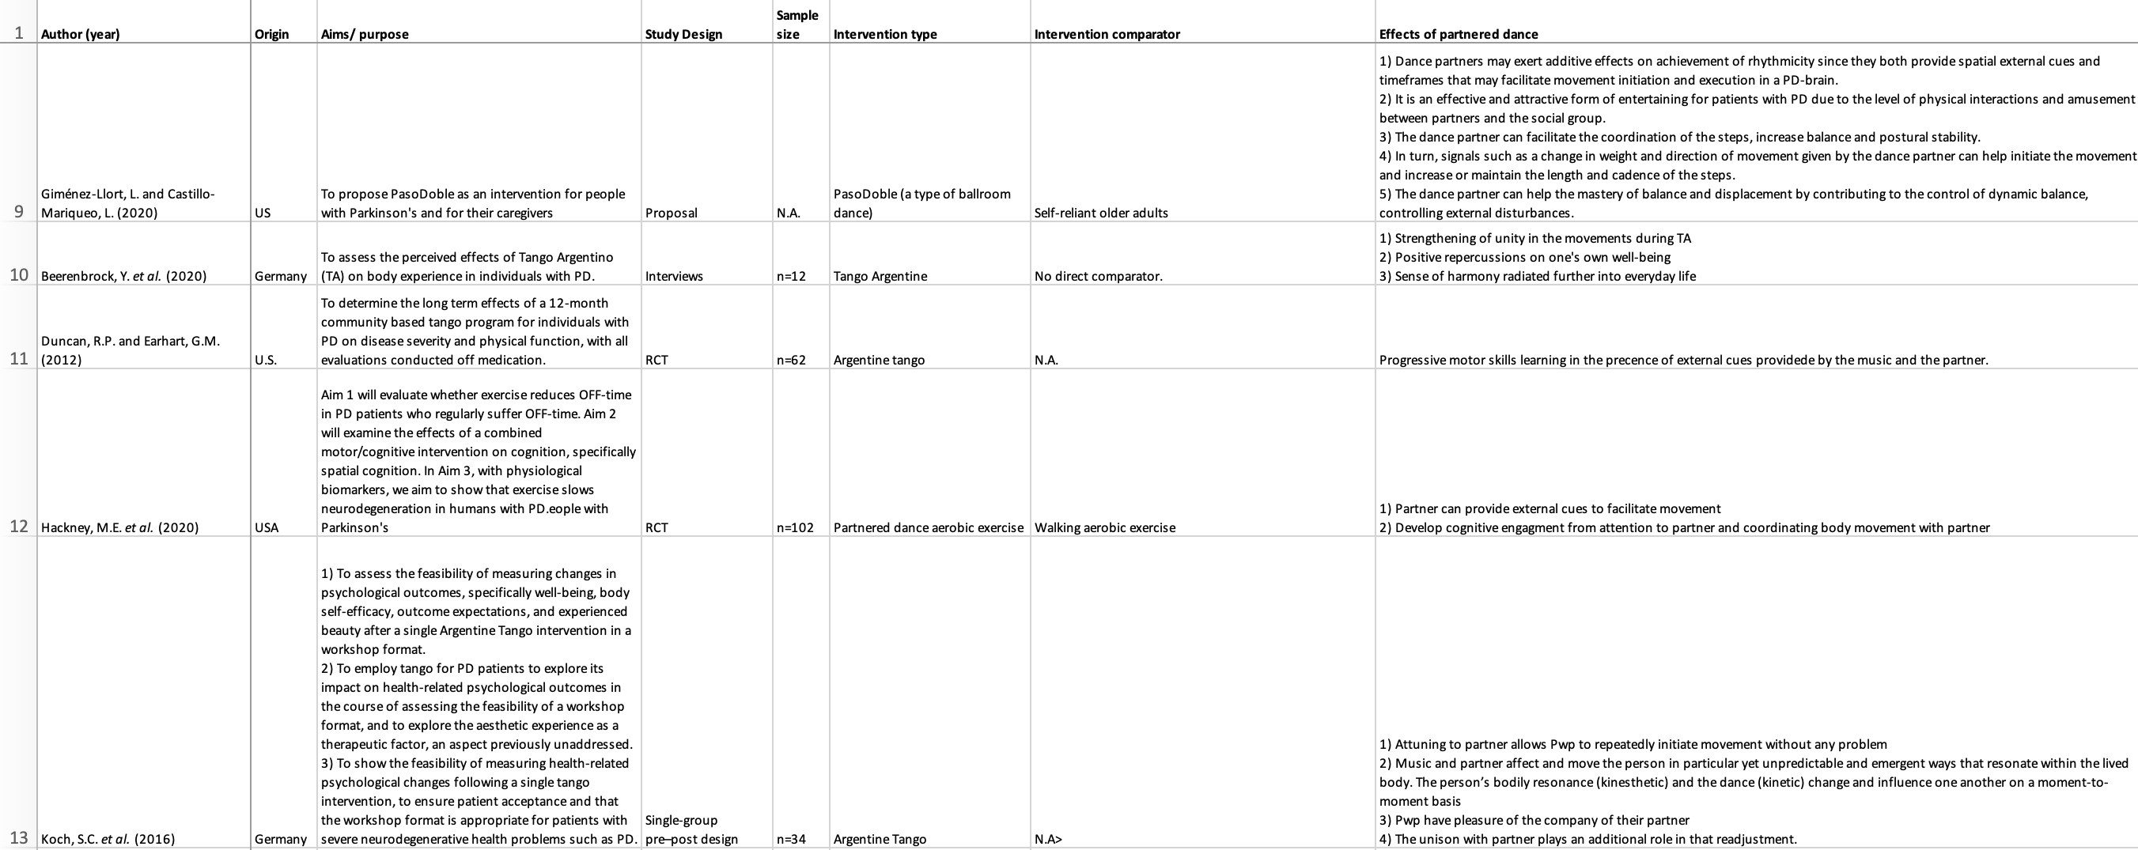

Appendix 4: Data extraction table (2)

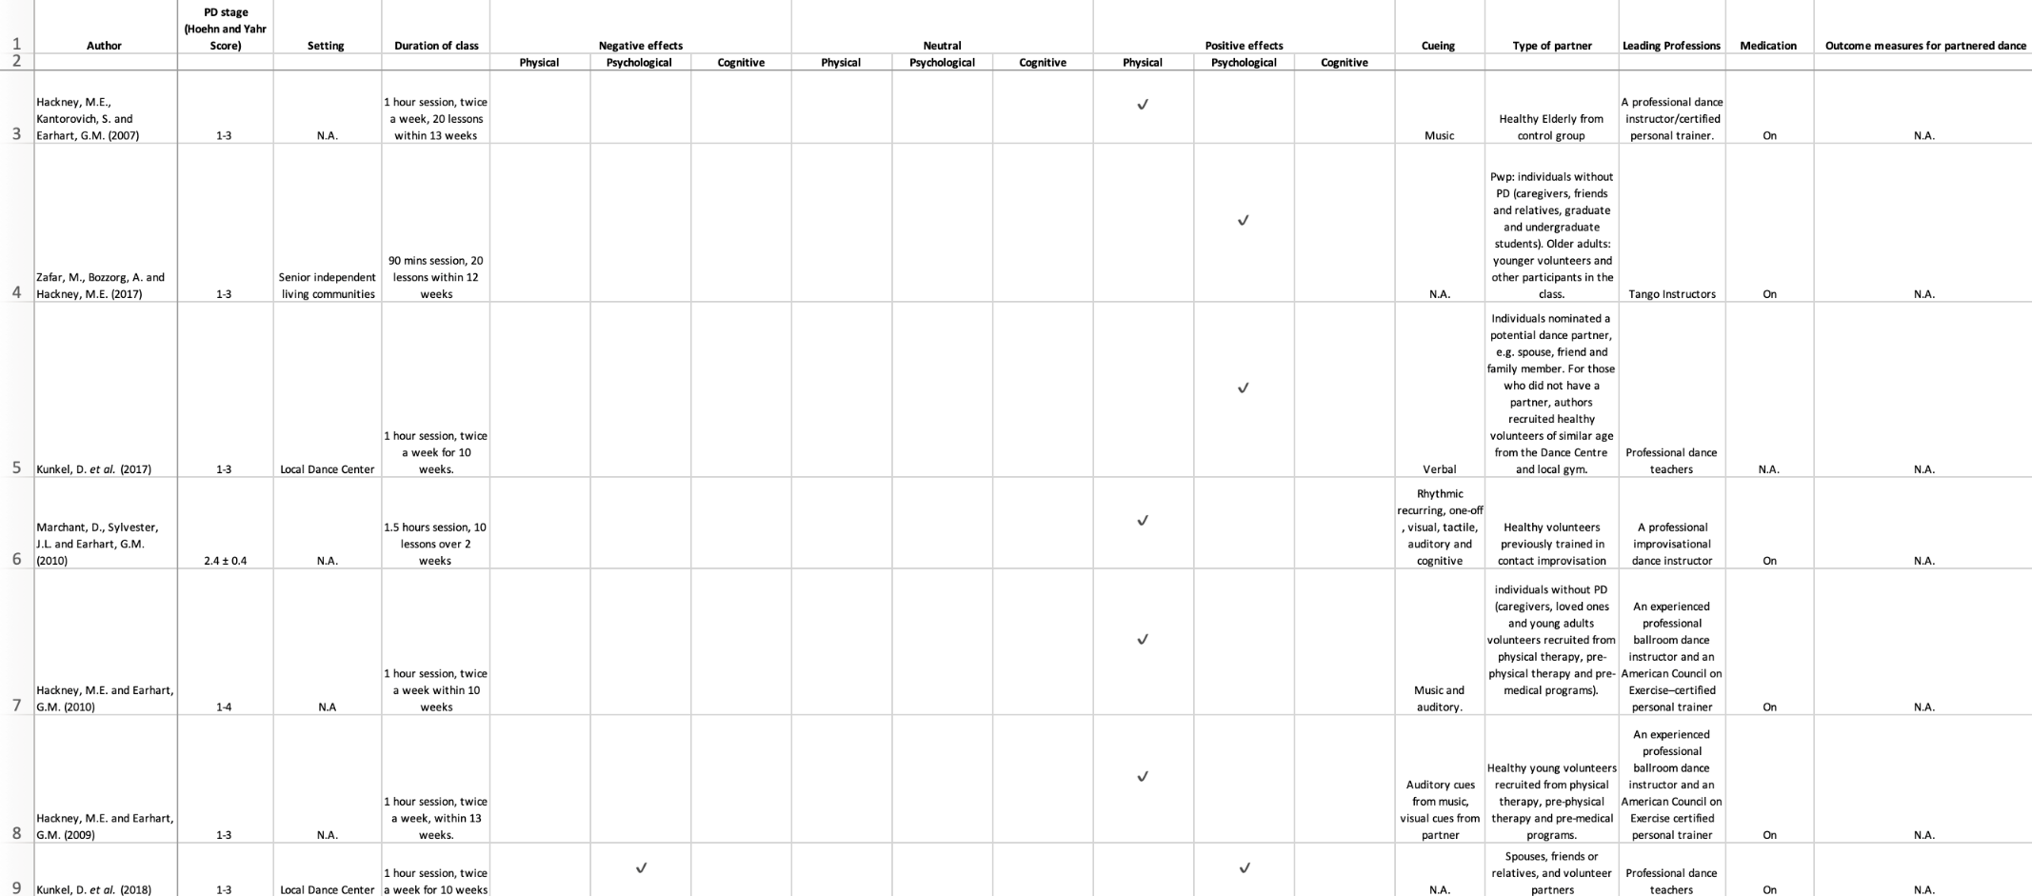
Appendix 5: Key themes charting (1)

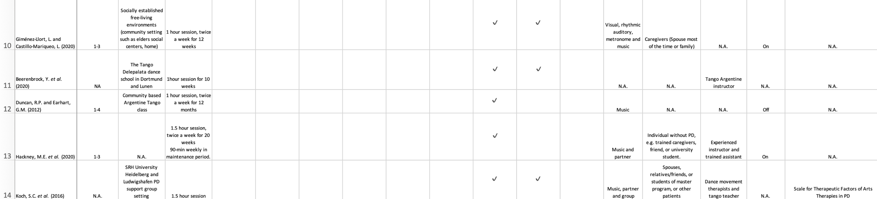
Appendix 5: Key themes charting (2)

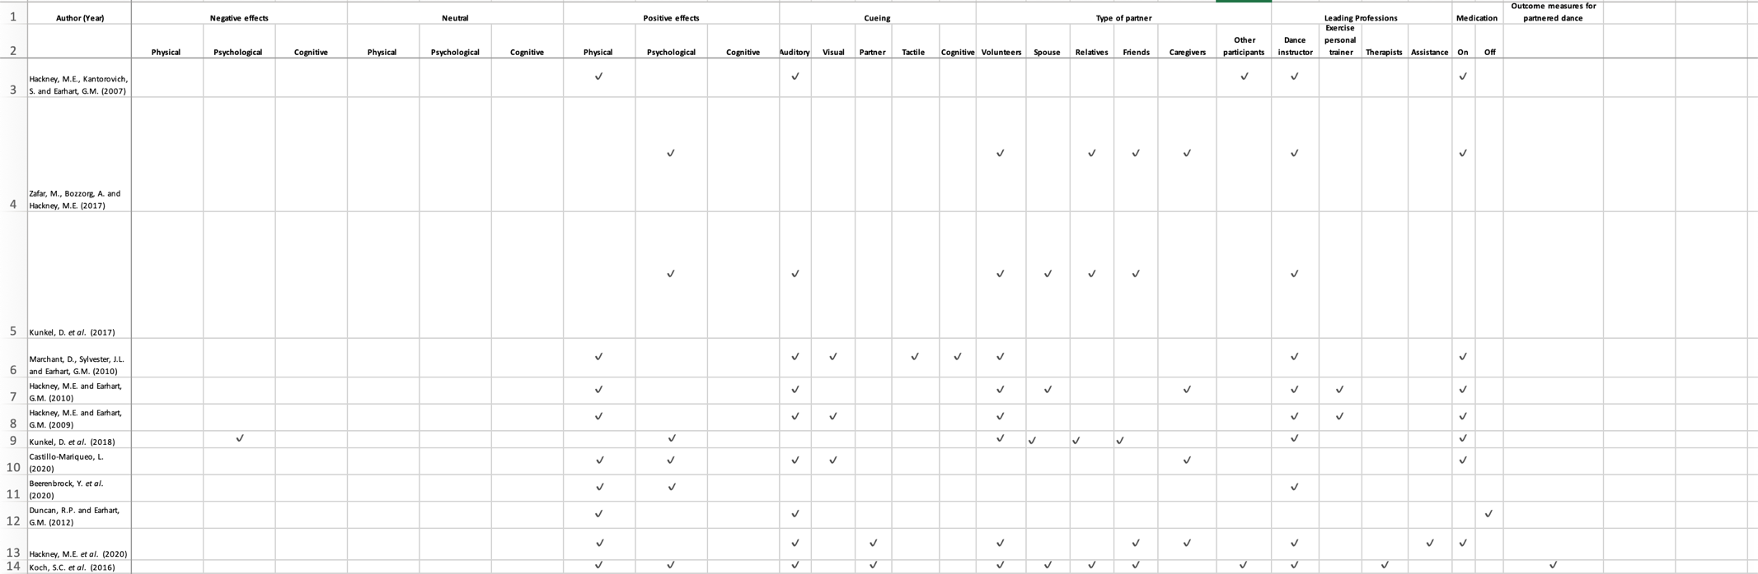
Appendix 6: Patterning chart

Pattern | Advances | Gaps | Evidence for practice | Research recommendation
The partners' effect on PWP | There is evidence of positive effects from the partner to PWP physically and psychologically | 1) There is a need for exploring unified outcome measures for measuring the effects of partners on PWP physically and psychologically.  2) There is limited evidence on the negative effects from the partner to PWP physically and psychologically.  3) There is lack of evidence on the effects from the partner to PWP cognitively. | 1) When targeting to treat PWP physical symptoms, one may consider applying partnered dance.  2) Leading professionals should notice any psychological changes of PWP that may arise from their partners. | 1) To develop an unified outcome measures to ensure the validity of the findings.  2) To carry out more research exploring any negative effects from the partner to PWP psychologically in partnered dance.  3) To carry out more research investigating any cognitive effects derived from partners.
Types of partner | There is an evidence that PWP’s experience of the dance class appeared to be influenced by their relationship with their dance partners and their compatibility with them. | 1) There is a need for ongoing empirical work exploring how different types of partners affect PWP.  2) There is inadequate of research about any different physical effects derived from different partners on PWP. | 1) It is important that professionals or research conductors consider the recruitment or selection of the types of partners when conducting partnered dance class for PWP and to consider any training need to be given to PWP’s partners. | 1) To continue exploring the relationship between different types of partners and the effects on PWP to validate recommendations on the choice of the type of partners.  2) To carry out more research exploring any possible/ different physical effects derived from various types of partners.
Cueing | There is evidence of a positive relationship between different types of cueing and the effects on PWP. | 1) There is a lack of studies unifying the use of types of cueing targeting various symptoms for PWP.  2) There is a paucity of research on the direct effect of cueing on PWP in partnered dance. | 1) It is important that professionals or research conductors consider what and how different types of cueing can be applied to assist and benefits PWP. | 1) Research is needed to specifically investigate how different types of cueing can affect PWP differently, particularly in partnered dance.
Leading professionals |  | 1) There is a paucity of evidence of how different leading professionals may affect PWP’s participation to class, physically, psychologically and cognitively. | 1) Evidence to emerge from future research | 1) Studies are required to address the significant gap in the field regarding leading professionals’ impact on PWP.
Appendix 7: Patterns, Advances, Gaps, Evidence for Practice and Research Recommendations (PAGER) framework

