**Negotiating Creativity**

Abstract

This paper explores an aspect of Creative Writing’s pedagogy which can be overlooked by students and teachers, who primarily want to focus on how to write better scripts, fiction and poetry. It addresses a problem many creative writing teachers face – how can we develop the way students and writers think about and reflect upon their writing? It is suggested that analysis of the context of creative writing in the marketplace (through interrogation of our understanding of what ‘creativity’ means, and how markets for fiction have developed) enables us to re-assess literary output from the specific point of view of students and teachers in the field of Creative Writing.

The interface between writing and markets has been explored before. William Morris, Walter Benjamin, Virginia Woolf, Gertrude Stein, Marshall McLuhan, Slavoj Žižek, Amitav Ghosh and Tim Morton are part of a literary/philosophical tradition in which the product of creative writing - fiction - may be interpreted as exemplary of developmental cultural processes. I suggest that the idea of the author as autonomous decision maker, ‘feeling’ their way through text creation, workshopping, and discussion - central to the teaching of creative writing - can be complimented with an understanding that ‘creativity’ is socially contingent.

Notwithstanding economic and literary theories that see creativity and creative output as a kind of mood board representing the zeitgeist of a place and time, I suggest that individual writers negotiate the cultural circumstances of their eras through recognisable and consistent approaches to creative production in changing marketplaces. This process, called ‘negotiating creativity’, bridges the gap between writers’ inner imaginings and the demands of the world around them. It can be understood, explored and learned. It has been a means of framing the relationship between writers and their markets since the Early Modern period. In this article, Miguel de Cervantes is considered in conjunction with two twentieth-century, French theoreticians, Roland Barthes and Michel Foucault, as an illustration of the practice and analysis of negotiating creativity, and its longevity.

**Negotiating Creativity**

*How re-examining familiar texts enables us to reconsider artistic creative processes.*

Students of creative writing will appreciate this problem: because nobody knows what creativity is, it is difficult to explain the ‘creative’ part of our subject, and the term ‘writing’ can mean at least two very different things.

Many creative writing students are inspired by the stories they read or watch at home, not the ones they were introduced to at school. In our subject, the term ‘writing’ encompasses both pulp fiction and canonical literature. We’re happy to improve the confidence and quality of work of students who want to make soap operas, and ones who want to follow in the footsteps of the Modernists. Indeed, when we analyse the distinction between ‘pulp’ and ‘literature’, we can see the ways they in which their significance is mediated through preconceptions. Literature is created by elites so that they can become distinguished. Everything else is pulped.

What if we look at texts in a different way? What if we consider it as evidence of a creative negotiation common to all writers, one which, if you’re lucky (like Shakespeare), could make your name for time immemorial or, if you’re unlucky (like Christopher Marlowe), could get you killed? Can we think of writing as a process that binds creative work to the practical circumstances surrounding creative production of any particular era? Could analysis of writers’ entrepreneurial negotiations with creativity offer creative writing students a way of participating in productive literary analysis and reflection without getting lost in the labyrinth of abstraction?

By way of illustration, let’s take someone who we might consider the first and most important modern author and also maybe the biggest best seller of all time, and consider how he negotiated creativity or, perhaps even, how he discovered the idea.

**How Cervantes negotiated creativity**

At the same time as the English were transforming the business of stagecraft into an entrepreneurial creative industry which conjoined playwriting with theatre construction, in Spain, the book, the nature of authorship and copyright law were spun together in web of invention so flimsy and malleable that, more than 400 years later, the work in question foreshadows modernism and the Anthropocene in its appreciation of the two-faced nature of post Gutenberg life. Cervantes’ *Don Quixote* appears to be about the past; it’s a spoof on the old traditions of medieval romances. But the joke is on us. As well as its world, its characters and what they do, it’s about the way we understand fiction, it's about the present and the future, it’s simultaneously nostalgic and futuristic, it wriggled away from its time and place by hiding in plain sight, smuggling itself out of the seventeenth century disguised as the ancient texts that appear consistently within its covers. It established comedy, or maybe more accurately, non-sequitur and paradox as both a form of entertainment and a mode of thought, influencing writers from Borges to Eco to Joyce, and it places authors in a metatextual negotiation between the text they want to write, the text readers want to read, the text publishers wish to produce and the whereabouts of a mysterious ingredient - newness.

At the end of Book 1, Sancho Panza returns to his wife Juana/Teresa with Don Quixote, ‘thin and pale, and lying on top of a pile of hay in an ox-cart’. His housekeeper and his niece put him to bed and the fading Don has to listen to them lampooning the very stories he sought to emulate during his journey:

And then the two women again raised the roof with their outcry; again they renewed their cursing of the books of chivalry, again they implored heaven to cast the authors of all those lies and absurdities into the depths of the bottomless pit. All this left them bewildered and fearful so that as soon as their master and uncle felt a little better they’d lose him again, and that was what happened (463).

In the last clause of this paragraph, the reader feels the intensity and colour draining, almost visibly from the imagination as it empties from the text.

Within a paragraph, all we are left with is the news that Don Quixote did indeed run away again, and that he is rumoured to have gone to Zaragoza. There are some documents featuring poems about Quixote, which the author of the account was given by an ‘aged doctor’ who found them in a lead casket in a now rebuilt church.

Soon there’s nothing left. Just this little note:

These [the documents in the lead casket from the rebuilt church provided by the old doctor] verses that were legible; since the others were worm-eaten, were handed to an academician for him to decipher, It is reported that he has done so, after long vigils and much toil, and that he intends to publish them, as we await Don Quixote’s third sally (468).

And after that, there’s one more line, a quotation:

Forsi latro cantera con miglioor plectio (468).

Following his recent translation of the novel, Tom Lathrop explains the quote in more detail saying: ‘Cervantes himself fuelled the flames about a sequel in the very last line of the Quixote, which is a subtle dare, a challenge to another author to continue don Quixote’s adventures. It is a slightly modified verse from Canto 30 of Ariosto‘s *Orlando Furioso*, which reads ‘Forsi altri cantera con miglior plettro’. [perhaps someone else will sing with a better plectrum (or pen, as Cervantes later interprets this line)] (16).’

In *Jousting at windmills: Cervantes and the quixotic fight for authorial control,* Biggs makes the case that Cervantes’ apparent invitation for another to take up their pen and to tell us what happens during Don Quixote’s next adventure wasn’t meant to be taken literally. Superficially, the fact that another writer, working under the pseudonym Alonso Fernández de Avellaneda, released the second part of the story of Don Quixote in 1614, nine years after Cervantes had published the first part shows that his ‘dare’ was taken seriously. On the other hand, the new story can be regarded as one of the first examples of what we would now consider copyright infringement and it seems to have galvanised Cervantes. In fact, Biggs details how the situation was a good deal more complex than that. Cervantes had sold the rights to his novel the publisher Francisco de Roble for 1,500 reals in 1604. Although formal copyright laws didn’t exist at the time, the idea of copyright did and De Roble had a royal charter giving him a 10 year monopoly in the text stating: ‘If any unauthorised person prints or sells this work or causes this work to be printed or sold, the printed materials will be seized, as well as the printing apparatuses used, and a fine of 500,000 maravadises will be imposed.’

The appearance of Avellaneda’s version of the second part of this story, at the point in time when the original copyright monopoly was due to expire, suggests two things – the ability of authorities to enforce copyright was real and meaningful and that concepts of authorship and ownership were well understood. Today, we might call Avellaneda’s *Quixote* ‘fan fiction’. Indeed, we might be able to describe it more accurately if we knew who Alonso Fernández de Avellaneda really was. He or she could have been a rival, a group of rivals or even an associate, after all, the references to the fake story in the authorised version of Part II form an important part of its paradoxical ‘in the world’ and ‘out of it’ effectiveness.

Biggs notes that one (perhaps) unforeseen consequence of Avellaneda’s intervention was to hurry Cervantes into the production of his own sequel. Here we have creative negotiation as part of a writers’ practice in the story and in the day-to-day business of writing and publishing. One of Cervantes’ themes was to expose the paradoxes inherent in creative production. The story is predicated on Quixote’s delusional predilection for medieval romances. As he experiments with the new format, the novel, Cervantes sets his tale in the context of a battle to free the imagination from canonical texts.

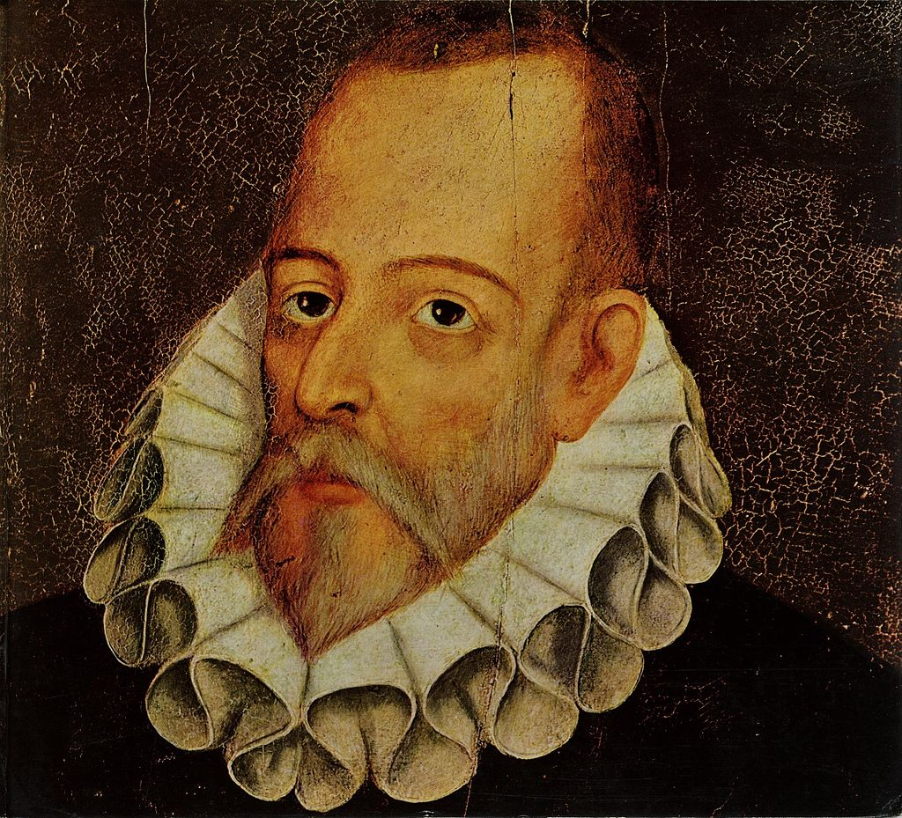

This man is not necessarily Cervantes. Unsigned portrait of an unidentified gentleman, attributed to Juan de Jáuregui y Aguilar, (c1547-1615), private collection. The painting was once assumed to be Jáuregui’s lost portrait of Cervantes. The name of Cervantes (1547-1616) at the top and that of Jáuregui at the bottom were added centuries after it was painted.

For creative writers today, as they approach the literary canons of the cultures we happen to live in, Cervantes’ dismissal of risible old conventions rings true. The analysis of conventional texts, and the assumptions made by the people who put them in front of us, draws us into a labyrinth of literary criticism from which creative writers wanting to make new stories may never emerge.

**How to be an author**

By focussing on the creative process of authors like Cervantes, it is possible to reframe discussions concerning authorship. In our workshops, many of our creative writing students find the question of authorship far easier to answer than literature students – obviously, they are the authors. To some extent, attempts to challenge creative writers by asking them to reconsider ideas of authorship may not help the development of their work, even though such ideas can be meaningful and productive.

By framing our enquiry in practical terms, so that authors’ creative processes are seen as a negotiation with creativity, students can engage in literary analysis, historical and philosophical research and remain at the centre of their own creative process – linked through the idea that we all negotiate creativity.

Writing in 1969, in response to Roland Barthes’ declaration that the author was ‘dead’, this is how Michael Foucault answered his question ‘What is an author?’

The coming into being of the notion of "author" constitutes the privileged moment of individualization in the history of ideas, knowledge, literature, philosophy, and the sciences. Even today, when we reconstruct the history of a concept, literary genre, or school of philosophy, such categories seem relatively weak, secondary, and superimposed scansions in comparison with the solid and fundamental unit of the author and the work (141).

Cervantes, who danced around the head of a pin in order to claim authorial credit and to mystify authorial signification, would have understood both Foucault’s and Barthes’ late twentieth century take on the layers of meaning implicit in the term ‘author’.

When Foucault wrote:

The author's name manifests the appearance of a certain discursive set and indicates the status of this discourse within a society and a culture. It has no legal status, nor is it located in the fiction of the work; rather, it is located in the break that founds a certain discursive construct and its very particular mode of being. As a result, we could say that in a civilization like our own there are a certain number of discourses endowed with the "author function" while others are deprived of it (148).

he could also have been describing Cervantes’ condition in 1614. Today, Foucault’s assertion that an author’s name had no legal status isn’t correct. Now authors names are regularly registered as trade marks, as are their fictional characters and titles. The curator function Foucault ascribed to authors has become one of brand identification based on copyright and trade mark Intellectual Property (IP) portfolios. This is just one example of way in which an author’s negotiation with creativity changes with the mores of a time. The process remains the same, the context changes. Authors today negotiate with a capitalised, brand-aware, technologically driven market, one in which even the idea that creativity is a naturally occurring and distinctly human phenomenon is challenged through technology (like generative artificial intelligence) and markets (through the transformation of creativity into an asset, or property). By exploring processes of negotiating creativity, students and teachers of creative writing may reflect on their work, its relationship with the modern marketplace and a continuum of creative development that links us all to Don Quixote.

Inspired by Björk’s *Hyperballad*, Timothy Morton described massively distributed ‘Hyperobjects’, like oil, or Styrofoam; in *Hyposubjects, on becoming human*, he demonstrates how they are enacted by ‘Hypersubjects’. Creativity today has characteristics of a Mortonian Hyperobject and, informed by our awareness of Morton’s mode of thinking and expression, we can reframe our understanding of creative negotiations and, to a useful extent, objectify today’s newness in a form that suits our discipline:

We live in a time of hyperobjects, of objects too massive and multi-phasic in their distribution in time and space for humans to fully com-prehend or experience them in a unitary way. A black hole is a kind of hyperobject, a biosphere is another. But many of the hyperobjects that concern us have human origins. For example, global warming. Or antibiotics. Or plastic bags. Or capitalism. These hyperobjects exceed and envelop us like a viscous fog, they make awkward and unexpected appearances, they inspire hypocrisy and lameness and dread.

A certain kind of human has helped usher the world into the hyper-objective era. Let’s call them hypersubjects. You will recognize them as the type of subjects you are invited to vote for in elections, the experts who tell you how things are, the people shooting in your schools, the mansplainers from your Twitter feed. (15)

The transformation of hitherto intangible ideas like creativity into philosophical or even commercial enclosures - and ensuing discussions concerning their curation by ‘hypersubjects’ - is not a new phenomenon. Cervantes and his relationship with intellectual property shows us how the process of negotiating creativity has existed for longer than the concepts we currently use to define it. He exemplifies a fiction writer’s interest in theory and ideas, and the story teller’s desire not to become trapped by them. By understanding how writers negotiated with creativity in the past and do so today, we and our students can develop our own creative process so that we don’t know too much, and we don’t know to little.

**Prompt**

Cervantes, seemingly always joking, shows us that creative negotiations with literary significations, intellectual property regulations and brands have been part of literary creative process since commercial publication began. Each negotiation is unique and specific to its own context. It represents the work and character of the author in dialogue with the zeitgeist of their time.

A formula for creative writers negotiating creativity:

P + C x IP = N

Publisher plus Creativity multiplied by Intellectual Property = Negotiation

An interesting activity for readers to try, after reminding their students that Cervantes was serious and not serious at the same time, might be to ask their classes to develop their own formulas for Negotiating Creativity.

**Works cited and bibliography.**

Barthes, Roland: The Death of the Author, *The Magazine in a Box 5+6.* Aspen, 1967. Web. 20/11/2023.

Biggs, Henry: Jousting at windmills: Cervantes and the quixotic fight for authorial control. *Marquette Intellectual Property Law Review, 22(2),* 2013, pg 218. Web.

Björk: “Hyperballad”, *Post*, London, One Little Indian, (1995). CD.

Cervantes, Miguel de: *Don Quixote, Part One*, translated from the Spanish by John Rutherford, London: Penguin, 2000, pg. 463, 468. Print.

Eco, Umberto: *On Literature*, London: Vintage, 2006. Print.

Foucault, Michel:What Is an Author?  *In Textual Strategies, perspectives in post structuralist criticism,* edited by .Josue V. Harari,New York: Cornell University Press, 1979, pg 141, 148. Web.

Jáuregui y Aguilar, Juan de: Portrait of Miguel de Cervantes attributed to Juan de Jáuregui y Aguilar, Private Collection, 1547-1615.

Lathrop, Tom: Don Quixote and its errant author, *New England Review, Volume 31, No 4,* Middlebury, 2010, pg 16. Web.

Logie, John: 1967: The Birth of “The Death of the Author.” *College English*, 75(5), Annapolis Junction 2013, pgs. 493–512. Web.

Morton, Timothy: Boyer, Domenic: *H**yposubjects, on becoming human*, London: Open Humanities Press2021, pg 14.

Wallace, Jeff: *Abstraction in Modernism and Modernity: Human and Inhuman* Edinburgh, Edinburgh University Press, 2023. Print.

**Biography**

Dr Dan Anthony is a senior lecturer in Creative and Professional Writing at the University of the West of England. He writes for children and adults and his quirky style is almost universally and incorrectly described as comic. His most recent novel is *The Pumpkin Season* (2021), set in what used to known as Eastern Europe during the 1990s, it explores a world moving thoughtlessly forward, like this one. He is a specialist in intellectual property administrations and has edited the UK Government’s annual report on IP crime for several years. His academic research focuses on the intellectual property and the question of whether our approach to it stifles or encourages innovation.