The importance of fun in the EAP classroom

**Amy Coryat** *University of the West of England, Bristol, UK*

Introduction

Research in neuroscience and psychology suggests that when a student enjoys learning, there is greater affective engagement and more learning because ‘joy and comfort aid effective information processing and long-term memory’ (Willis, 2007). The idea of using fun learning activities in any classroom, therefore, seems logical. So why should EAP be different?

This talk aimed to inspire delegates to think about *how* EAP is taught and consider bringing more fun into the EAP classroom.

Fun in EAP (or the lack of it!)

Before my talk I had asked several EAP practitioners the following question: *What do you think of when you think of EAP?* At the beginning of my talk, attendees were asked to guess the responses. Answers prior to the conference focused on *what* is taught, e.g. types of academic writing, referencing and presentations, whereas during my talk responses were more related to people’s perceptions of EAP, e.g. dry, dense, serious, difficult and boring.

There is a lack of literature related to fun in EAP. However, my experience suggests that it is an important factor. My definition of fun – feeling positive emotions, e.g. enjoyment, excitement and interest – was shared with the audience, before a second question was posed: *Why isn’t fun a hot topic in EAP?* The materials, time pressures, students’ expectations that EAP should be serious, and teachers’ fears of trivialising the input were all given as possible reasons.

As well as research in neuroscience and psychology, second language acquisition literature supports the notion that fun aids learning (e.g. Tomlinson, 2013). During the talk, quotes and paraphrases from the aforementioned fields were used in a game of Guess the Missing Word, where attendees had to guess the words that were missing. The missing words were *enjoys, happy, affective, pleasurable* and *joy*, highlighting the importance of positive emotions in learning, even in EAP.

Examples adapted from General English

The perception of EAP can be that it is serious and that there is no time for games (Turner, 2012). However, it was argued that fun activities like learning games have a place in EAP, and I shared several examples of game-like activities used in general English, which could be adapted to an EAP context: Noughts and Crosses, Dominoes, Matching Game, Crossword, Half a Crossword, Call my Bluff, Hotseat, Lucky Box, Mystery Box, Correct or Incorrect Auction, Bamboozle, Escape Room.

Two of the activities were outlined in more detail to provide examples of how games could be implemented in EAP. The Noughts and Crosses activity (Figure 1) demonstrated that it is possible to create fun activities that require little preparation and minimal class time.

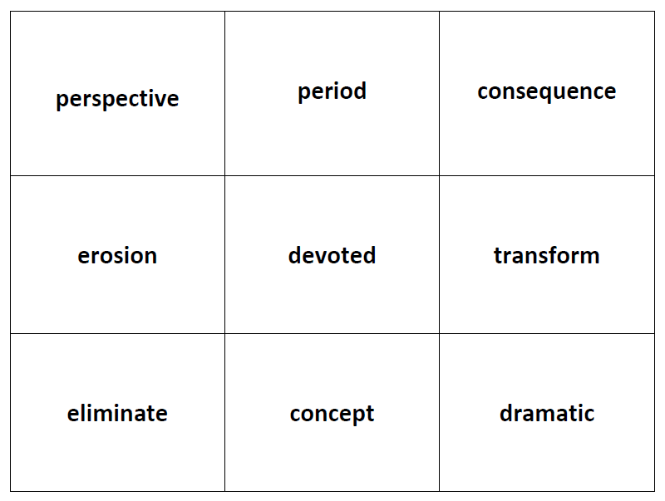

Figure 1: *Noughts and Crosses*

This activity was designed to create interest at the beginning of a lesson and practise academic vocabulary that learners had previously studied. To gain a nought or cross, learners had to give the correct pronunciation, the meaning and an example sentence.

I also shared information about an EAP escape room I created. The theme of the escape room is climate change and it begins with a short, dramatic video setting the scene and outlining the aim to escape the room in 60 minutes. The video can be watched here: <https://youtu.be/os03w34H3SQ>. The activities encourage critical thinking and practise other academic skills, too, such as supporting claims with evidence, and evaluating sources. Material included locks, boxes, UV torches and a UV pen. For further information on my escape room, please email me.

The students’ views

Research supports the use of fun activities in EAP, but it is also important to consider how they work in practice, in particular how our learners receive them. During my talk, I shared quotes from several pre-sessional students, as well as a video where two students give their views on fun in EAP. Students highlighted that the fun of game-like activities helped them remember vocabulary better than traditional methods. Two students also mentioned that these activities helped them forget about any worries, demonstrating how fun can break down the affective filter. The students were clear advocates of fun in the EAP classroom and recognised the positive impact it had on their learning.

Conclusion

Fun activities like games should be seen as a learning tool in EAP. They are ways of engaging students, building positive relationships and increasing affective engagement. Our students’ emotional wellbeing is connected to their ability to learn. Providing them with fun activities which distract them from any worries in their life, and encourage them to learn, is a good thing.

Link to presentation recording: http://youtu.be/WLPNLKjy-kk

amy.coryat@uwe.ac.uk

References

Tomlinson, B. (2013). *Developing Materials for Language Teaching*. Bloomsbury.

Turner, R. (2012). *The Gamification of EAP*. 12th BUSEL International Conference in Language Teaching Issues: EAP in University Settings. Ankara.

Willis, J. (2007). The Neuroscience of Joyful Education. *Educational Leadership Journal*, 64. <http://www.ascd.org/publications/educational-leadership/summer07/vol64/num09/The-Neuroscience-of-Joyful-Education.aspx>