**Introduction**

We do not know how many people in the world live with a learning disability or autism or both (PWLDA) (Olusanya et al., 2023). In England, it is estimated that more than 1.3 million people have a learning disability, including 950,000 adults over the age of 18 (UK Government, 2023). Over 2.16% of adults and 2.5% children in the UK are believed to have a learning disability (Mencap, 2024). The UK department of Health & Social Care defines a learning disability as “a significantly reduced ability to understand new or complex information, to learn new skills (impaired intelligence), with a reduced ability to cope independently (impaired social functioning), which started before adulthood” (UK Government, 2023). A learning disability is a lifelong condition, but its severity varies considerably, and is usually assigned a mild, moderate, or severe classification (UK Government, 2023). Autism and learning disabilities often co-occur, but data on co-occurrence is scarce. Recent NHS Digital data suggests that PWLD who have been diagnosed with autism had increased from 19.8% in 2016-17 to 28.6% in 2020-21 (NHS Digital, 2021b).

People with learning or other disabilities face significant health inequalities and poorer outcomes. They are twice as likely to develop long term physical and mental health conditions, and often die up to 20 years earlier than people without disabilities (World Health Organisation, 2023). In the UK the life expectancy for a person with a learning disability is 27 years shorter for women and girls and 23 years shorter for men and boys (Learning Disabilities Mortality Review, 2019). The UK National Institute for Health and Care Excellence (NICE) suggests that people with a learning disability are 3 to 4 times as likely to die from avoidable medical causes. Most deaths in this population can be avoided if timely and effective treatments are provided (NICE, 2021).

Prescribing is the most common intervention patients receive in primary, hospital and community NHS settings (NHS Digital, 2024). In the year 2021/22, the costs of prescribing in England alone were a staggering £17.2 billion. Around 55% of the costs were for medicines prescribed in primary care, and 44.3% of the costs were for medicines dispended in hospitals (NHS Business Services Authority, 2022). People with a learning disability are often prescribed multiple medicines because they may present with multiple morbidities or are reported to have challenging behaviours (Learning Disabilities Mortality Review, 2019). Antipsychotics, antiepileptics and benzodiazepines tend to be the most commonly prescribed medicines, often in the absence of a mental health diagnosis (NHS Digital, 2021b).

Prescription medicines can be prescribed, in the UK, by a range of healthcare professionals including: General Practitioners (GPs), hospital doctors, dentists, nurses, pharmacists, optometrists, physiotherapists, podiatrists, paramedics or therapeutic radiographers (NHS, 2018). The increased demand for healthcare services, and the decline in the number of general practitioners (GPs) continue to create an expanding space for the non-medical prescribers (NMPs) workforce to develop new ways of working and new models of care in primary, secondary and tertiary care settings (Armstrong, 2023). The NHS Long Term Plan aims for an additional 20,000 NMPs and social prescribers to support care delivery in primary care settings (NHS England, 2019). Recent data suggests that there are 59,326 nurses (NMC, 2023); 18,042 pharmacists (GPhC, 2023); 2543 paramedics (HCPC, 2022); 2000 physiotherapists (Frontline, 2023); and more than 166 therapeutic radiographers (HCPC, 2019) with supplementary or independent prescribing annotations. The number of non-medical prescribers is likely to exceed 90,000, as the number of prescribers annotated on the Health and Care Professions Council (HCPC), the regulator of 15 health and care professions, is not routinely published.

Given that non-medical prescribers work across various healthcare settings, the likelihood of interactions and providing care to PWLDA is significant. Yet, overwhelming evidence point at clinicians’ lack of training, knowledge and confidence when providing care to this population (Maddox et al., 2019; Doherty et al. 2020). As a result, they often struggle to make reasonable adjustments for PWLDA within their clinical practice (Doherty et al., 2020). This barrier to providing safe and high-quality care to PWLDA, is highlighted throughout the tragic events that led to Oliver McGowan's death, and has promoted the development of the Oliver McGowan's mandatory training on learning disability and autism for all registered health and social care providers) from July 2022 (Care Quality Commission, 2023). Many clinicians rely on specialist input from learning disability nurses, whose numbers have been steadily declining over the years. Since 2009, there has been a 42% decline in registered learning disability nurses in England, from 5,553 to 3,214 in 2021 (Plymouth Marjon University, 2023). This does not only paint a bleak picture for specialist learning disability nursing provision, but also underscores the importance of upskilling the health and social care workforce to reduce and prevent catastrophic outcomes for PWLD, or autism or both.

The updated Core Capabilities Framework for Supporting People with a Learning Disability (2019) details the skills, knowledge and behaviours, referred to as capabilities, for health and social care staff providing care and support for PWLD. It is also a useful guide to universities and other training providers to standardise training, enhance its relevance to practice and improve its quality and focus (Skills for Health, 2019). Not surprisingly, knowledge, understanding and behaviours relating to medicines’ use have been highlighted as key capabilities especially when providing care for physical health, mental health, managing challenging behaviours, epilepsy, nutrition, hydration and dysphagia, reducing inequalities and avoiding over-medicating PWLD (Skills for Health, 2019).

As the largest training provider of non-medical prescribing training in the UK, currently training over 800 every year, The University of the West of England (UWE) recognises the potential for this training to be far reaching, and potentially impacting the quality of care delivered to PWLD in the UK and beyond. The University reached out the Brandon Trust, a charity supporting 1,600 children, young people and adults with a learning disability, autism or both in an effort to co-design the UWE prescribing training to meet the needs of PWLDA (Brandon Trust, 2024).

We worked with the Brandon Trust’s panel of experts by experience, called the Adventurers, formed in December 2020 (Brandon Trust, 2024). They are a group of 14 PWLDA, aged between 25-50 years, based in the Southwest of England who meet regularly online to discuss and inform the design and delivery of the organisation’s initiatives.

In this article, we describe the process and outcomes of our co-production collaboration, and provide recommendations to prescribing training providers on how to enhance their learning disability training.

**The Adventurers’ review of the prescribing curriculum**

We held a number of workshops, online, with ten Adventurers to discuss the Royal Pharmaceutical Society’s Prescribing Competency Framework (RPS, 2021). This is a guiding framework for prescribers and prescribing training providers detailing the skills and competencies needed to provide safe and effective prescribing (RPS, 2021). We attempted to understand the Adventurers' perspectives on what good looks like in relation to the skills and competencies listed in the framework. Table 1 summarises the Adventurers’ key success indicators for each of the ten competencies of the Prescribing Competency Framework. Appendix 1 includes an extract of the RPS framework, with annotations from the Adventurers.

**Table 1. Indicators for success, as identified by the Adventurers, against the ten competencies of the RPS Prescribing Competency Framework**

|  |  |
| --- | --- |
| **RPS prescribing competencies** | **The Adventurers’ indicators for success** |
| **Competency 1: Assess the Patient**  This competency refers to communication skills, appropriate consultation skills and settings, checking the patient’s records and documents and seeking guidance and advice from specialist teams. | * Understanding that it is a legal duty for prescribers to make reasonable adjustments within their consultations and settings for PWLDA (Public Health England, 2018). E.g. going to a quiet room. * Understanding of the Mental Capacity Act (2005), Deprivation of Liberty Safeguards (DoLS), and Best Interest decisions and how they impact the lives of PWLDA. * Using a range of communication tools such as Easy Read materials and pictures during consultations. * Speaking to the PWLDA, not just their support worker; “nothing about me without me”. * Ensuring that the PWLDA is consenting to plans and interventions if able. * Being patient and considerate during consultations. * During physical assessments e.g. measuring blood pressure or taking a blood sample, explaining the procedure and its purpose is useful. * Speaking slowly and clearly and building a rapport with the PWLDA e.g. asking about their day and their plans. * Checking online and paper records e.g. the Hospital Passport and charts, and gathering feedback from family/teams if the person lacks capacity. * Being aware that a learning disability is a significant risk factor for constipation, dehydration, and weight issues. * Actively stopping over medication of people with a learning disability, autism, or both (STOMP) (NHS England, 2023) * Seeking input from Learning Disabilities Teams/ specialists to improve care. * Being consistent e.g. preferably the same clinician is seen every time. |
| **Competency 2: Identify evidence-based treatment options available for clinical decision making**  This competency refers to the practices of making evidence-informed prescribing decisions taking into account the patient’s parameters. | * Managing constipation, and addressing nutrition and hydration needs of PWLDA at every opportunity. * Actively stopping over medication of people with a learning disability, autism, or both (STOMP) (NHS England, 2023) * Understanding the parameters of the MCA and BI decisions when assessing the risks and benefits of PWLDA taking vs. not taking their medicines. * Being aware that PWLDA are severely impacted by health inequalities and as a result, they will likely present with various co-morbidities and complications. This is relevant when making decisions about treatments and their impact on quality of life. * Being aware that PWLDA may exhibit behaviours that may challenge e.g. a risk of pulling tubes/cannula’s/PEG out and devising management plans accordingly, while avoiding over prescribing medicines, especially antipsychotics and benzodiazepines. * Acknowledging that information from family/ carers is a reliable source of information. * Being mindful of the communication behaviours of the PWLDA and using appropriate methods to gain information from them to inform prescribing decisions. |
| **Competency 3: Present options and reach a shared decision**  This competency relates to the skills required to contextualise prescribing and clinical consultations to suit the needs of diverse patients and enable their active involvement in prescribing decisions. | * Being able to assess the capacity of the PWLDA and tailor communication to suit their needs and preferences. * Using a variety of sources of information such as family/ carers and the patient’s hand-held documents such as the Hospital Passport. * Ensuring the provision of reasonable adjustments to facilitate effective interactions with PWLDA. * Using Easy Reads and other communication tools to relay information and checking that the PWLDA understands it. “Sometimes people say yes even if they don’t understand fully.” |
| **Competency 4: Prescribe**  This competency relates to the knowledge and behaviours related to prescribing, such as awareness of guidelines and relevant medicines information. | * Explaining the potential side effects of medication, especially gastro-intestinal and central nervous system related effects as these tend to have a significant impact on PWLDA * Communicating relevant information about dosing and duration of administration with PWLDA, their family/ carers and the healthcare teams that will take over their care after discharge. * Understanding what will happen after the patient is discharged and how discharge information is communicated to other teams/ departments. This is an important responsibility for any prescriber. * Checking that PWLDA can be supported to take medication and understand what they need to do if self-managing their health conditions. |
| **Competency 5: Provide information**  This competency relates to communication skills when assessing patients’ health literacy and understanding, and signposting them to appropriate resources to support their self-management practices and address their concerns. | * In addition to effective communication of medicines information and aspects of clinical consultations as highlighted above, communicating the reasonable adjustments that are made/ could be made, outcomes of mental capacity assessments and discussions with family/ carers is also important to demonstrate. * Understanding how different services/ teams collaborate or could be joined together and being able to effectively communicate information across services to enhance the quality of care for PWLDA. This is particularly relevant to practitioners working in hospital settings and those working at interfaces when communicating discharge information. |
| **Competency 6: Monitor and Review**  This competency relates to the skills required to monitor outcomes of prescribing and adjust treatment plans accordingly. Also, the ability to recognise the risks of/ occurrence of adverse drug reactions and managing them. | * Awareness of and being able to actively stop over medication of PWLDA. * Active monitoring of medical charts and clinical observations and remembering that learning disability is often a significant risk factor for rapid deterioration as signs and symptoms are often missed due to communication and competency issues. * Working in partnership with families and carers to enable active monitoring and facilitate their input into the patient’s care. |
| **Competency 7: Prescribe Safely**  This competency relates to clinicians prescribing within a defined scope of competence, and under appropriate clinical governance processes. This also includes keeping abreast with safety information and actively reporting near misses and adverse drug reactions. | * Actively reporting adverse drug reactions, errors and near misses involving care for PWLDA. * Being able to identify and report safeguarding concerns related to medicines and other aspects of care to improve the lives of PWLDA. |
| **Competency 8: Prescribe Professionally**  This competency relates to being responsible and accountable for prescribing decisions and prescribing in accordance with the needs of patients, frameworks governing prescribing in the NHS and other organisations’ procedures and processes. | * Understanding the needs of PWLDA and communicating prescribing decisions clearly and compassionately. |
| **Competency 9: Improve Prescribing Practice**  This competence relates to reflections on prescribing practices and using objective auditing and monitoring tools to identify patterns of prescribing behaviours and highlight areas requiring improvement. | * Having ideas about potential ways of collecting feedback from PWLDA. * Ensuring continuous professional education on the issues PWLDA face. * Working with charities and organisations supporting PWLDA to make use of networks for learning as both parties (prescribers and organisations) strive to achieve the goal of improving care for PWLDA. These organisations can also be “a critical friend” to discuss prescribing policies and practices that affect PWLDA. |
| **Competency 10: Prescribe as Part of a Team**  This competency highlights the skills needed to work within/ in collaboration with multi-disciplinary teams, seeking expert input and support from other clinicians and working in partnership with others to improve patients’ care. | * Working in partnership with charities and other organisations (not just healthcare) for support around mental capacity assessment, and advocacy for PWLDA. * Communicating clearly and effectively across teams, departments, and organisations especially in relation to hospital discharge. * Ensuring full discharge information /instructions are provided to PWLDA, their family/ carers and the range of clinicians who will be supporting them, including community pharmacy staff. |

**Co-developing learning and teaching activities**

After annotating the RPS Competency Framework with potential training areas and indicators of successfully achieving competency, the Adventurers and the academic team decided to focus on improving communication skills with PWLDA. Communication is identified by PWLDA as the main reason inhibiting them from accessing and receiving good quality care (Badcock and Sakellariou, 2022). Risks to patient safety and harm have frequently been attributed to poor communication (Mencap, 2018; Ramsey et al., 2022). Clinicians also highlight that communication, and failure or inability to engage with alternative ways of communication in accordance with PWLDA needs, as the most challenging aspect of providing care for PWLDA (Badcock and Sakellariou, 2022).

To help prescribing students improve their communication skills with PWLDA, we co-produced a 15-minute video (Youtube, 2023) with the Adventurers. In the video, the adventurers discuss what makes clinical consultations inclusive and respecting of their needs, and the information they would like prescribers to communicate to them about their medicines. Eight top tips for future prescribers are provided at the end of the video, including:

* Introduce yourself and smile (even under a mask!). We like Happy Smiley People.
* Speak slowly and use simple language when explaining things. Give us time to process information.
* Talk to us instead of our carers. Give us time and space to explain things and answer your questions.
* There are many people involved in the prescribing of our medicines. We prefer consistency as much as possible.
* Appointment time is very important to us. Please keep us informed if you are running late.
* We want to be part of ALL decisions about our health and medicines.
* We like to know the names of the medicines we are taking, what they do, their side effects and how to take them.
* Be patient, kind, caring, understanding and a good listener!

The prescribing students were then asked to reflect on the content of the video and the Adventurers’ indicators for success, and consider how they can improve the experiences for PWLDA within their own clinical practice. Their reflections and ideas were then assessed as part of their prescribing log assessment (a portfolio of evidence of learning in practice). Figure 1 illustrates the components of the co-developed learning and teaching activity.

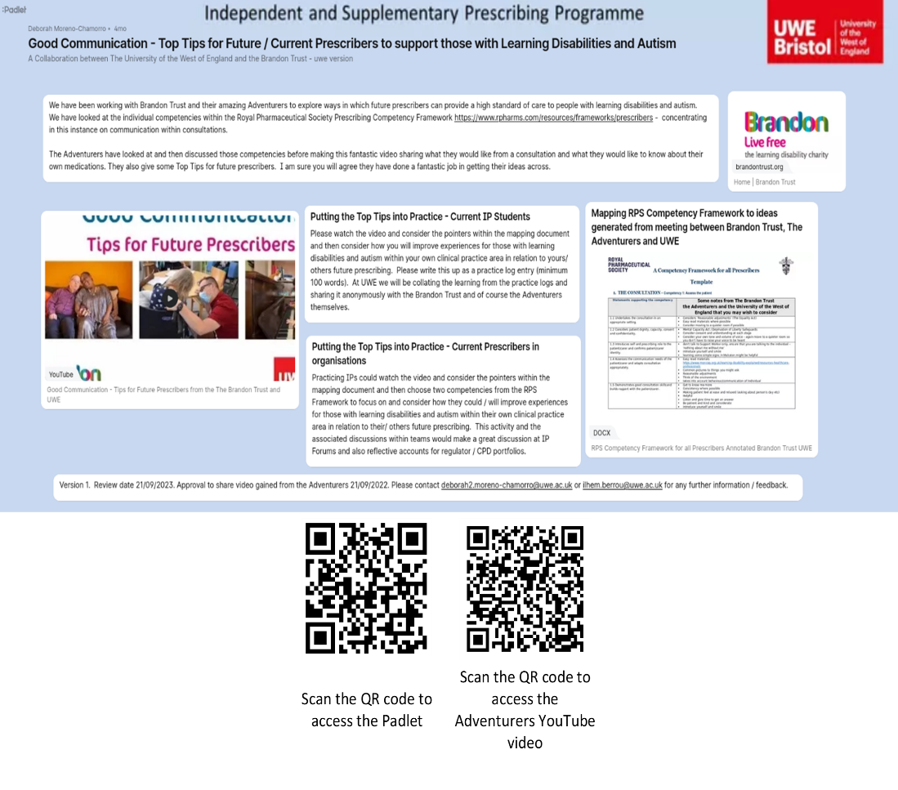

**Figure 1.** Padlet presentation illustrating the components of the learning & teaching activity co-developed with the Brandon Trust Adventurers.

**“Hands-on” communication training by the Adventurers**

Since 2023, the Adventurers started delivering live communication training sessions with clinicians undertaking the UWE Prescribing training. The sessions are delivered online (through Microsoft Teams), as part of the UWE Prescribing Training programme. To date, 8 live training sessions have been delivered, training over 800 prescribing clinicians. Figure 2 shows some of the feedback provided by the prescribing students.

The students discuss with the Adventurers their preferences during a clinical consultation and ask questions about appropriate and less appropriate prescribing behaviours. Through this approach, the clinicians are provided with a safe learning environment to communicate with PWLDA and ask questions they may not be comfortable, or feel safe to ask within their organisations/ teams. These training sessions helped our clinicians gain a deep understanding of the challenges PWLDA face, and their needs. Equally, the Adventurers are exposed, for the first time, to the insecurities and uncertainties of clinicians when dealing with PWLDA, and as a result of their discussions with our clinicians, improved their understanding of the healthcare system, and the roles different clinicians play within it.

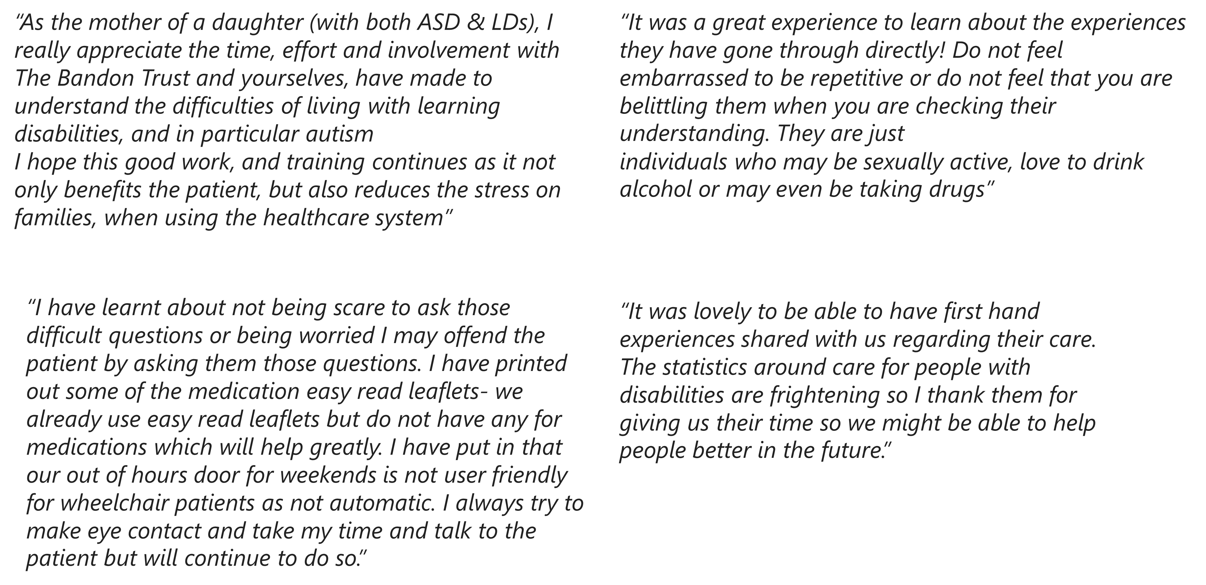

**Figure 2. Students’ feedback on the Adventurers’ communication training**

**Impact**

Changing clinical practice is difficult as it requires learning a new practice and unlearning previous practices (Gupta et al., 2017). Here we only report the initial impact of the co-production collaboration. Further evidence of long-term impact, if any, will be assessed in the future.

**Competence in communicating with PWLDA**

The prescribing trainees’ knowledge and competence were assessed formally, through a written portfolio of evidence, and informally, through engagement with the Adventurer’ communication training sessions. Miller’s Framework is a useful tool to assess our clinicians’ competence in communicating with PWLDA. The framework includes 4 levels of competence, starting with knowledge (knows) at the lowest level, followed by competence (knows how), then performance (shows how) then action (does) (Miller, 1990). Appendix 2 includes extracts of evidence submitted by students in relation to this learning. All students achieved the knowledge and competence levels of Miller’s Framework, but many also achieved the performance and action levels of the framework. The different achievements are mainly due to the wide variety of clinical settings where our prescribing trainees work, and the availability of supervisory support and specialist learning disabilities input in their setting.

**Widening the reach and accessibility of training**

The co-produced materials were made freely accessible, and were shared with the UWE Prescribing team’s wider network of non-medical prescribing (NMP) leads with regional NHS Trusts and other organisations to increase their reach. The NMP leads then shared the materials with prescribers within their Trusts, through their NMP forums. Many acknowledged that this resource was also shared with junior doctors and other physicians. The following quotes are some of the responses received through our regional network.

*“We will be sharing this with our NMPs through the prescribing forum - but wondered if it would be ok to share with the wider Learning Disabilities team as well. For instance - there may be junior doctors new to (the Trust) who may benefit from this video”*

*“Thank you for this superb video. It's valuable for all prescribers, not just learners”*

*“Just to let you know in Somerset, we will be sending this out via our weekly primary care update as a scatter gun approach. But we will also be contacting those directly who are future prescribers”*

*“Thank you for forwarding this. I watched it out of due diligence to be honest, but actually, once I started to write a reflection on it, I really began thinking about the issues mentioned. It got me thinking how wonderful it would be to have a more autism/sensory/disability friendly clinic in the children's outpatient department. Just like how in supermarkets and soft plays the lights get lowered, phone ringers are turned down, TV off, spaces less crowded, time keeping prioritised etc. I think I may take this conversation to my matron as she's matron for ambulatory care and talk about it some more... Thanks for the inspiration!”*

In addition to widening the reach, and potentially the impact, of the training materials, this sharing activity changed the relationship between the higher education institution (education provider) and the healthcare organisations (Employers of our students). It created a partnership to harness the resources and networks of both parties to create change on the ground and improve the quality of care for PWLDA.

**Further impact**

Further changes occurred as a result of this co-production collaboration with the Adventurers. The Adventurers reported:

* Enhanced computer skills and confidence throughout the delivery of the online communication training sessions.
* Improved knowledge and understanding of potential non-pharmacological treatment options. The Adventurers learnt from our students about social prescribing and the various non-pharmacological approaches that exist for the management of health conditions. They were encouraged to discuss those with their healthcare teams.
* Increased understanding of the healthcare system, which consequently improved the communication training. The Adventurers report that this collaboration is helping them and Brandon Trust build better relationships between primary care and social care. For example, they realised that community pharmacies that usually provide dosette boxes for PWLDA are not paid to do so, but despite this, many pharmacists continue to offer this service, albeit at their own expense. The Adventurers appreciated the input of community pharmacists and had a greater understanding of the challenges that may stop them from providing this vital service.
* Increased co-production activities with other universities and organisations. The Adventurers won the regional Co-production Award at the Southwest regional finals of the Great British Care Awards and are shortlisted to win a national co-production award (Carr, 2023).
* Awareness of the power of their voice in shaping healthcare training, and service design and delivery, which increased their confidence in their skills and expertise, and enabled them to be advocates for PWLDA.

The UWE Independent Prescribing Team equally benefitted from this co-production collaboration. In addition to being supported by the Adventurers to train our prescribers, the team has the blueprint of a co-production model with charities and other organisations to enhance the prescribing training. This model is being adopted to co-design other university programmes. The team was awarded a Community Impact Award, by the University of the West of England, for strengthened connections with communities in the West of England to shape and drive future prosperity, health and wellbeing, equality and diversity, sustainability, and cultural and community development across all parts of the region and to create opportunities for all.

Furthermore, co-author FMB, a prescribing student at the time, was Awarded the Sarah McMullen Disability Studies Prize for distinct and innovative work in an area of Disability, in 2023 for her reflections on the co-produced learning materials and ensuing actions.

**Conclusions**

People with learning disabilities, autism or both are significantly affected by health inequalities and suboptimal care. Communication is one of the main reasons standing in the way of PWLDA accessing healthcare, and healthcare professionals providing high quality care. Prescribing medicines and other interventions occurs at almost every healthcare setting, and at most encounters with healthcare professionals. There is, therefore, scope for delivering training and education interventions, to improve prescribers' communication skills when encountering PWLDA. Co-producing communication training with PWLDA provides authenticity and contextualises the training to the people’s lived experience. In addition to gaining competence in communicating with PWLDA and understanding their needs, the training enables prescribers to identify issues within their clinical settings that may impact the quality of care for PWLDA and change processes within their organisations to address them. The Adventurers highlighted other areas within the prescribing curriculum warranting attention such as increasing clinicians’ confidence when assessing mental capacity and stopping over medication of people with a learning disability. More research and reporting on interventions to address these areas are needed.

**References**

Armstrong A. 2023. Non-medical prescribing in primary care in the UK: an overview of the current literature. Journal of Prescribing Practice. 5(1):18–25. doi:https://doi.org/10.12968/jprp.2023.5.1.18.

Badcock E, Sakellariou D. 2022. “Treating him…like a piece of meat”: Poor communication as a barrier to care for people with learning disabilities. Disability Studies Quarterly. 42(1). doi:https://doi.org/10.18061/dsq.v42i1.7408

Brandon Adventurers. Brandon Trust. [accessed 2024 Feb 17]. <https://www.brandontrust.org/about-us/brandon-adventurers/> [Accessed 17.02.2024]

Brandon Trust. <https://www.brandontrust.org/about-us/> [Accessed 15.09.2023]

‌Care Quality Commission (CQC). 2023 Apr 19. Training staff to support autistic people and people with a learning disability. <https://www.cqc.org.uk/guidance-providers/training-staff-support-autistic-people-and-people-learning-disability> [Accessed 15.09.2023]

Plymouth Marjon University. 2023. University addresses shortage of learning disability nurses in England with revolutionary new programme. <https://www.marjon.ac.uk/about-marjon/news-and-events/marjon-news/university-addresses-shortage-of-learning-disability-nurses-in-england-with-revolutionary-new-programme.html#:~:text=Since%202009%2C%20England%20has%20experienced> [Accessed 14.09.2023]

Carr L. 2023 Nov 26. Winners of the Great British Care Awards 2023, South West announced. The Great British Care Awards. <https://www.care-awards.co.uk/winners-of-the-great-british-care-awards-2023-south-west-announced/> [Accessed 17.01.2024]

The Chartered Society of Physiotherapy. Frontline. 2023 Dec 1. Independent prescribing rights - 10 years on. <https://www.csp.org.uk/frontline/article/independent-prescribing-rights-10-years#:~:text=More%20than%202%2C000%20HCPC%20registered> [Accessed 02.01.2024]

Doherty AJ, Atherton H, Boland P, Hastings RP, Hives L, Hood K, James-Jenkinson L, LEAVEY R, Randell L, Reed J, et al. 2020. Barriers and facilitators to primary health care for people with intellectual disabilities and/or autism: An integrative review. BJGP Open. 4(3). doi:https://doi.org/10.3399/bjgpopen20X101030.

General Pharmaceutical Council (GPhC). 2023. GPhC register trend data January 2023 <https://www.pharmacyregulation.org/search/site/The%20GPhC%20register%20as%20of%2031%20January%202023%20-%20Trend%20data> [Accessed 02.01.2024]

Gupta DM, Boland RJ, Aron DC. 2017. The physician’s experience of changing clinical practice: a struggle to unlearn. Implementation Science. 12(1). doi:https://doi.org/10.1186/s13012-017-0555-2. <https://implementationscience.biomedcentral.com/articles/10.1186/s13012-017-0555-2>.

Health and Care of People with Learning Disabilities Experimental Statistics 2020 to 2021. NHS Digital. <https://digital.nhs.uk/data-and-information/publications/statistical/health-and-care-of-people-with-learning-disabilities/experimental-statistics-2020-to-2021> [Accessed 14.09.2023]

Health and Care Professions Council (HCPC). 2019. Number of therapeutic radiographers annotated as independent prescribers. <https://www.hcpc-uk.org/globalassets/resources/2020/2019/01.-january/number-of-therapeutic-radiographers-annotated-as-independent-prescribers---january-2019.pdf?v=636977447780000000> [Accessed 15.09.2023]

Health and Care Professions Council (HCPC). 2022. Number of Paramedics with SP/IP. <https://www.whatdotheyknow.com/request/number_of_paramedics_with_spip> [Accessed 02.01.2024]

Maddox BB, Gaus VL. 2019. Community Mental Health Services for Autistic Adults: Good News and Bad News. Autism in Adulthood. 1(1):15–19. doi:https://doi.org/10.1089/aut.2018.0006.

Mencap. 2018. Treat me well Simple adjustments make a big difference A campaign to transform how the NHS treats people with a learning disability. <https://www.mencap.org.uk/sites/default/files/2018-07/2017.005.01%20Campaign%20report%20digital.pdf> [Accessed 15.09.2023]

Mencap. 2020. How common is learning disability? Mencap. <https://www.mencap.org.uk/learning-disability-explained/research-and-statistics/how-common-learning-disability> [Accessed 15.09.2023]

Miller GE. 1990. The assessment of clinical skills/competence/performance. Academic Medicine. 65(9):S63-7. doi:https://doi.org/10.1097/00001888-199009000-00045. <https://winbev.pbworks.com/f/Assessment.pdf>.

‌NHS Business Services Authority. 2022. Prescribing Costs in Hospitals and the Community - England 2021/22. <https://www.nhsbsa.nhs.uk/statistical-collections/prescribing-costs-hospitals-and-community-england/prescribing-costs-hospitals-and-community-england-202122#:~:text=In%202021%2F22%2C%20the%20cost> [Accessed 15.09.2023]

NHS England. 2016. Stopping over medication of people with a learning disability, autism or both (STOMP). <https://www.england.nhs.uk/learning-disabilities/improving-health/stomp/> [Accessed 17.09.2023]

NHS. 2018 Jan 9. Medicines information. <https://www.nhs.uk/conditions/medicines-information/#:~:text=Prescription%2Donly%20medicines%2C%20such%20as> [Accessed 15.09.2023]

NHS England. 2019. Learning Disability Mortality Review (LeDeR) Programme: Action from Learning NHS England and NHS Improvement. <https://www.england.nhs.uk/wp-content/uploads/2019/05/action-from-learning.pdf> [Accessed 14.09.2023]

NHS England. 2019. New ways of working to free up doctors as part of the NHS Long Term Plan. <https://www.england.nhs.uk/2019/07/new-ways-of-working-to-free-up-doctors-as-part-of-the-nhs-long-term-plan/> [Accessed 15.09.2023]

NHS Digital. 2021b. Prescribing. <https://digital.nhs.uk/data-and-information/publications/statistical/health-and-care-of-people-with-learning-disabilities/experimental-statistics-2020-to-2021/prescribing> [Accessed 15.09.2023]

NHS Digital. 2024. Prescribing data. <https://digital.nhs.uk/data-and-information/areas-of-interest/prescribing#:~:text=Prescribing%20is%20the%20most%20common> [Accessed 15.09.2023]

NICE impact people with a learning disability | Reviewing the impact of our guidance | Measuring the use of NICE guidance | Into practice | What we do | About. NICE. <https://www.nice.org.uk/about/what-we-do/into-practice/measuring-the-use-of-nice-guidance/impact-of-our-guidance/nice-impact-people-with-a-learning-disability#:~:text=People%20with%20a%20learning%20disability%20are%20under%20served%20in%20access> [Accessed 15.09.2023]

Nursing & Midwifery Council (NMC). 2023. The NMC register 1 April 2022– 31 March 2023<https://www.nmc.org.uk/globalassets/sitedocuments/data-reports/may-2023/0110a-annual-data-report-full-uk-web.pdf> [Accessed 15.09.2023]

Olusanya BO, Smythe T, Ogbo FA, Nair MKC, Scher M, Davis AC. 2023. Global prevalence of developmental disabilities in children and adolescents: A systematic umbrella review. Frontiers in Public Health. 11. doi: https://doi.org/10.3389/fpubh.2023.1122009.

Public Health England. 2018. Reasonable adjustments for people with a learning disability. <https://www.gov.uk/government/collections/reasonable-adjustments-for-people-with-a-learning-disability>.

Public Health England. 2023 Mar 22. Learning disabilities: applying All Our Health. GOVUK. <https://www.gov.uk/government/publications/learning-disability-applying-all-our-health/learning-disabilities-applying-all-our-health> [Accessed 15.09.2023]

Ramsey L, Albutt A, Perfetto K, Quinton N, Baker J, Louch G, O’Hara J. 2022. Systemic safety inequities for people with learning disabilities: a qualitative integrative analysis of the experiences of English health and social care for people with learning disabilities, their families and carers. International Journal for Equity in Health. 21(1). doi:https://doi.org/10.1186/s12939-021-01612-1. <https://equityhealthj.biomedcentral.com/articles/10.1186/s12939-021-01612-1>

Royal Pharmaceutical Society. 2021. Prescribing Competency Framework. <https://www.rpharms.com/resources/frameworks/prescribers-competency-framework> [Accessed 14.09.2023]

Skills for Health. 2019. Core Capabilities Framework for Supporting People with a Learning Disability. <https://www.skillsforhealth.org.uk/wp-content/uploads/2020/11/Learning-Disability-Framework-Oct-2019.pdf> [Accessed 15.09.2023]

World Health Organization. 2023 Mar 7. Disability and Health. WHO. <https://www.who.int/news-room/fact-sheets/detail/disability-and-health> [Accessed 15.09.2023]

‌YouTube. 2023. Good Communication - Tips for Future Prescribers from the The Brandon Trust and UWE. <https://youtu.be/2VmGirwt49k?si=T-jbKJdSzWHvmzMN> [Accessed 17.09.2023]

‌