What Should Be Automated Next in Developing Construction Smart Contracts? Five Principles for Guiding Incremental Change

Dr Jim Mason, School of Architecture and Environment, University of the West of England, Coldharbour Road, Bristol, BS16 IQY, United Kingdom. Jim.mason@uwe.ac.uk

Abstract

Existing research on smart contracts in construction primarily concentrates on their operational stage and the mechanics of their potential operation. Having established “can we do it?” the next question to answer is “how do we do it?” The answer involves a consideration around smart contract adoption and its synthesis with the entire construction process from procurement to in-use. Particular attention is needed for integration into complimentary and receptive working practices resulting in the optimum conditions for adoption. The current risk is that smart contract adoption may suffer from a lack of clear guidance and happens on a piecemeal and ad-hoc basis. This study proposes a principled approach to counter this risk. This approach has been seen before in construction law in the form of the Abrahamson Principles, which remain a seminal reference point in any discussion of construction law. The use of a framework is therefore proposed based on five key principles to guide the automation of contract terms, discussing the importance of control, codability, consideration, efficiency, and data access. This approach uses an interdisciplinary methodology with an applied professional constituency to promote law reform-based research. The inductive/deductive approach is aimed at sharing insights into the question with the hope that the consequent principles aid the incremental implementation of smart contracts in the industry.
Introduction

The recent completion of the five-year mission of the Centre for Digital Built Britain (Daye, 2022) evidence that the pathway to digital twins in the Built Environment is mapped out and includes the implementation of smart contracts. Smart contracts are set to take their place alongside Integrated Project Delivery, Modern Methods of Construction and Design for Manufacture movements (Sonmez et al., 2022). The standardisation and repeatable environments of factory construction and regular demand provide ideal test beds for smart contract staples such as automating payments and real time involvement of delivering goods and transit arrangements (Di Giuda et al., 2020). The advances made in applying similar technologies in other industries is starting to gather significant purchase in construction. For example, Tata were reported to be tracking their steel girders via individual barcodes from foundry to installation as long ago as 2018 (Penzes, 2018). The benefit for construction of being a late adopter of technology is that, in most cases, it is the appliance of science that is required rather than its conception.
Interest in smart contracts could demonstrably be said to have followed the Gartner hype-cycle (Fenn and Blosch, 2018). Where new ideas are “hyped” as interest sours before trailing off into a trough of disillusion. The hype cycle has its critics (Steinert and Leifer, 2010) about its claims to be scientific. Nevertheless, it is a useful notion and one that many innovation triggers tend to follow. The good news, for those fearing the sidelining of whichever technologies one is interested in, is that the disillusion is followed by a slope of enlightenment and a plateau of productivity. As one commentator put it “we tend to overestimate the effect of a technology in the short run and underestimate the effect in the long run.”( Amara, 2006).
Collaboration (formerly partnering) is another construction related phenomenon that has definitely suffered a Gartner cycle. The plateau of productivity stage has seemed a way off for its main proponents. The collaboration movement is said to be experiencing a Groundhog Day (Mosey, 2021) where the resistance and inertia around partnering languishes in a Bermuda Triangle of idealistic debate, cynical criticism, and unrealised good intentions. Similar frustrations have long since been visible in the technology camp, Mark Farmer’s (Farmer, 2016) exasperated refrain is “modernise of die.”
It may have been true that what partnering needed to succeed was Building Information Modelling (BIM) (Saxon, 2013). Ten years on it may well be the case that what they both need to succeed are smart contracts. A compelling case can be built when like-minded individuals working as a team can see the benefits of their collaboration in such things as instantaneous payments and reduced overheads as facilitated by smart contract adoption. Technology supports collaboration and vice versa. However, both require a statement of principles approach to ensure consensus ad idem. The primary purpose of this paper is to give guidance on how to identify where technology and collaboration come closest together. In these instances, the principles proposed will help to select those opportunities where the pre-conditions for automation are present and are therefore where the smart contract automation process might reasonably start. In adopting this approach the smart contract principles aim to ensure that smart contracts remain a tool for the sort of positive and progressive change the industry is crying out for.

Literature Review

Smart contracts have great potential for fixing the causes of poor construction contract administration and through that can seek to eliminate some of the claims and disputes that plague the industry. A smart contract is the name given to any attempt to automate contract administration considering events encountered. A smart contract is a recording of a legal agreement between parties written in a language that is both human-intelligible and machine-readable, whose text incorporates an algorithm which automates some or all the performance of the agreement (McNamara and Sepasgozar, 2021). For example, an event occurs – an expiration date is reached, and the contract executes the protocols that have been coded. One advantage is there is little need for intermediaries.
Two separate phenomena appear realisable in the context of smart contracts. It may be a case of either/or in their development or a hybrid that may eventually proliferate. There is the simple transaction type of smart contract which was the original notion developed by the founder of smart contracts (Szabo, 1997). The transactional swap of goods for money represents a completed contract. The project bank account is another, more sophisticated version of this where the supply side agree their relevant shares from the currency deposited by the client in the bank account and agree to unlock the box and make the money flow to each other. The smart contract is the same idea without the box and without the currency and permissions – they can all be automated to an extent (Al Khalil et al., 2017). For the foreseeable future, the authorisation for releasing substantial sums of money is likely to remain a human action. This is consistent with the idea that the future of the professions (Susskind and Susskind, 2022) is for human’s to retain those elements of their role where they continue to add value – in the case of construction smart contracts this may amount to auditing the data and performing the oracle role. Put another way, we are still going to want humans to sign the big cheques.
The second possibility for smart contracts is the contract which is smart in the true sense. Settling for the simple transaction-based solution or the focus on readable language might be to hold back the machine learning aspects and the ability to innovate beyond the limited terms of references mentioned above. This other definition of a smart contract involves the facility to detect and resolve competing contract clauses. The example in the case of MT Hojgaard A/S v E.ON where the Judge deemed the contract one of “multiple authorship” where each set of lawyers were adjudged to have been more interested in incorporating their one-sided terms rather than producing a contract to capture the bargain. The resulting mess, and judicial exasperation, might may have been avoided had a smart contract writing programme been used to highlight and remove the uncertainties. On the other hand, the resulting uncertainties might have been an acceptable trade-off against the value of arguing down one side or other of the drafting argument.
In part this “smart” approach would be to recognise the importance of the BIM clash detection approach and apply the logic more widely (Sonmez et al., 2022). Clash detection has hitherto been restricted to solely design information but could equally apply to clash detection of information or contract clauses or terms. Although there is no specific example of this to relate, it is straightforward to imagine how that it could apply if, say, a construction material becomes outlawed in the United Kingdom and joins the list of deleterious materials. A smart contract would be able to detect the “clash” and identify and resolve all mentions of the material in contract documents and replace with a substitute without the harmful properties.
This alternative yet potentially complimentary version of what a smart contract can do – interrogate data and apply its machine learning, in similar projects and extrapolating the answers - is a more forward-looking version of a smart contract which has emerged in the intervening years since my original paper on Szabo-like transactions in 2016 (Mason, 2017). Thus, although the heralded changes have been slow to emerge the signs of their uptake and preconditions needed for their development are evident, particularly involving blockchain solutions (Msawil et al., 2022) and its potential in preventing or reducing construction related problems, including those related to contract administration.
The present and near future of smart contracts appears to be the stack approach – the automation of those terms will centre firstly on those which involve algorithms which are easily codable and manageable. The first of these “low hanging fruit” are weather delay events as demonstrated by the EHAB weather ledger (Lamb, 2018). The ledger ascertains automatically whether the rain or wind (or both) experienced on a project is better or worse than a 1 in 10-year event. It does this by checking itself against data from the Meteorological Office. If the weather event is worse than a 1 in 10-year event, then the compensation event procedure of the New Engineering Contract is triggered. This is an interesting development but at one level nothing more than primary school children collecting rainfall in an empty yoghurt pot and measuring it. The real issue – the ramifications and forecasted consequences of the compensation event and the measure of its accompanying loss and/or expense dependent on it were wrangled with in the usual manner and not addressed by the ledger. The progress made was that at least there would have been a verifiable record of what happened. The argument goes that the greater the granularity and reliability of the data, the fewer places there are for disputes to reside as there is less margin for disputes and different interpretations of the data to lie.
Research Gap

The risk for any siloed industry is that work is carried out without the wider terms of reference being appreciated or considered. Smart contract academics have been too focused on intricate workings and platform discussions and not cognisant of the prevailing conditions or environment required to see smart contracts flourish. One reason for the false estimations resulting in hype is not having a clear enough purpose in applying the technology once it is available. Smart contracts are no different. Insufficient work has been done to date on cementing the contribution of smart contracts within the wider procurement initiatives (Ozkan et al., 2021). The focus for smart contracts has centred on its operational contribution, notably the means of delivery via the blockchain. The movement has largely stalled in the proof of concept phase where the main question is “can we do it?” The answer, from the research community at least, has been a resounding yes (McNamara and Sepasgozar, 2021). The “how do we do it?” question is the one which has yet to be answered and where the research gap exists. Legal risk management theory was at a similar crossroads in its early development when Max Abrahamson set out his seminal principles in 1983. It is the author’s hope that the principles set out herein can be useful in developing the application of smart contracts to the construction industry. The question that arises is why have the valuable initiatives either stalled, in the case of collaboration, or are at risk of stalling, in the case of technology? The answer may be that insufficient attention has been given to the principles of how progress might be achieved and where efforts are best marshalled. This paper seeks to address this deficit and proposes guidance in the form of the principles set out herein.
Research Method

Legal research styles were split into four approaches representing law reform, fundamental, expository and legal theory research (Arthurs, 1983) The interdisciplinary methodology, in which this work is positioned, relies on the professional constituency of the researcher. One of the priorities for the “new academic community” of legal scholars (Chynoweth, 2007) is to communicate its purpose, norms, values and methodologies to the wider built environment research community in which it resides. The socio-legal approach seeks to investigate law from the perspective of the social sciences (Tebbit, 2005). This tradition analyses the inter-relation of law with its stakeholders.
The selected researcher role in this investigative study is that of empathetic observer (Blaikie, 2000). The risk of bias within this approach is real and present and is duly acknowledged. This was addressed in the Abrahamson paper with the statement “I realise the danger of preaching…Nevertheless we must have a starting point (Abrahamson, 1983).” Through this starting point it is hoped that the principles will allow progress towards market adoption and saturation. The diffusion of innovations theory (Rogers, 1962) informs that communication of new ideas over time can lead to mass adoption provided a sound footing is provided for the take-up.
The author has relied on deductive and inductive approaches (Azungah, 2018) in deciding on the principles featured here. The inductive research approach involves formulating a theory based on specific observations and aims to draw general conclusions about the investigated phenomenon. The deductive research approach starts with an existing theory or generalisation and aims to test its applicability to a specific scenario, in this case the construction industry (Azungah, 2018). This study examines the influence of knowledge-infused human behaviour and introduces five guiding principles to facilitate gradual progress in smart contracts. These principles, inspired by the existing framework of the Abrahamson principles, are adapted to the context of smart contracts in the construction industry.
The methodological socio-legal assumption on which this paper is based is that recognition should be made that before laws or legal vehicles come principles. The classic example in construction law is the afore-mentioned Abrahamson’s principles (Abrahamson, 1983) from which the risk profile of standard form contracts was based. Another is the Latham report (Latham, 1994) whose principles (recommendations) lead to the Housing Grants Construction and Regeneration Act of 1996. The Hackitt review (Hackitt, 2018) and its golden thread of data principle as hopefully to be enacted further in the Building Safety Act 2022 is the latest in the line of examples of the best place to start – with the “why”.
The starting point for this discussion is therefore that if we already have available the collaboration imperative and the technological infrastructure which are required for smart contracts. What is required are the principles around the guidance of what terms to automate, on the premise that smart contract adoption will be incremental. The basic question is “what should guide our hand in deciding which clauses should be automated next?” The requirement of validation of the principles will be required following their dissemination and is an eagerly anticipated piece of research in itself.

Findings - The Old and New Principles
Abrahamson’s five principles (see Figure 1) can be summarised as follows: a party should take the risk if that party is:
- In one party’s control
- able to insure it
- the most efficient party to take the risk.
- accrues the economic benefit if the priced risk does not eventuate.
- is more effected if the risk eventuates.
The application of both sets of principles is based on a majority outcome. Most risks give a clear outcome, for example, design risk sitting with the client on a traditionally procured project. Other risks are more nuanced, such as ground conditions where a careful weighing up on the risk principles are required. The author maintains that this risk should rest with the client as it is in their control for longer (i), insurance products are available (ii) and it results in efficiencies (iii). This is more persuasive that the contractor running the risk of gaining an economic benefit (iv) and being most impacted (v). In either case, the risk can be mitigated by proper site investigations. Abrahamson was self-effacing in terms of the cogency of the risks and the potential for them to give conflicting outcomes. Nevertheless, he recognised that it was “better to start from a position of principle than of unspoken bias” (Abrahamson, 1983).
Taking the Abrahamson approach, this paper proposes five new principles to guide the construction sector towards automation (see Figure 2). The recommendation to automate is again based on a majority outcome whether in favour or cautioning against the selection of the term. Automate a contractual term, where:
i) it is in the parties’ control and/or insurable.
ii) the contract logic is codable and substantiates what preceded.
iii) Efficiencies for project management accrue for the benefit of the supply community and there is a time/cost/quality benefit for the client
iv) Extraneous events are reasonably predictable and manageable.
v) The data/records of all that has transpired are permanently available to both parties and interested third parties.
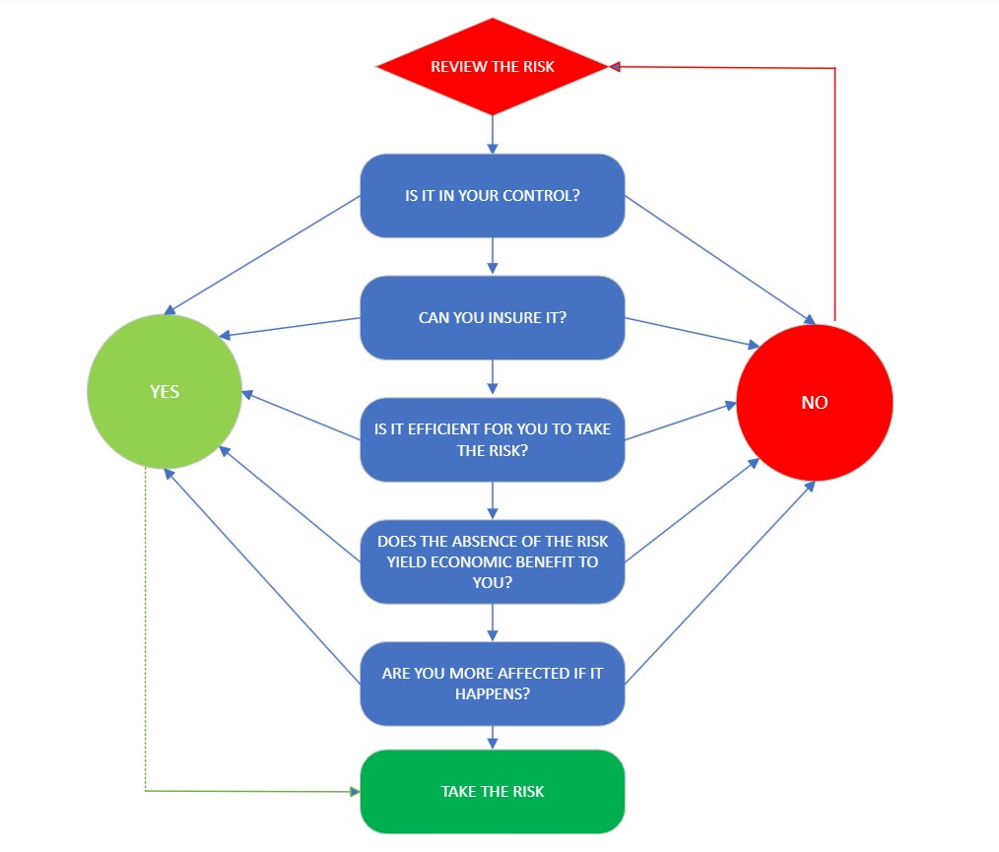
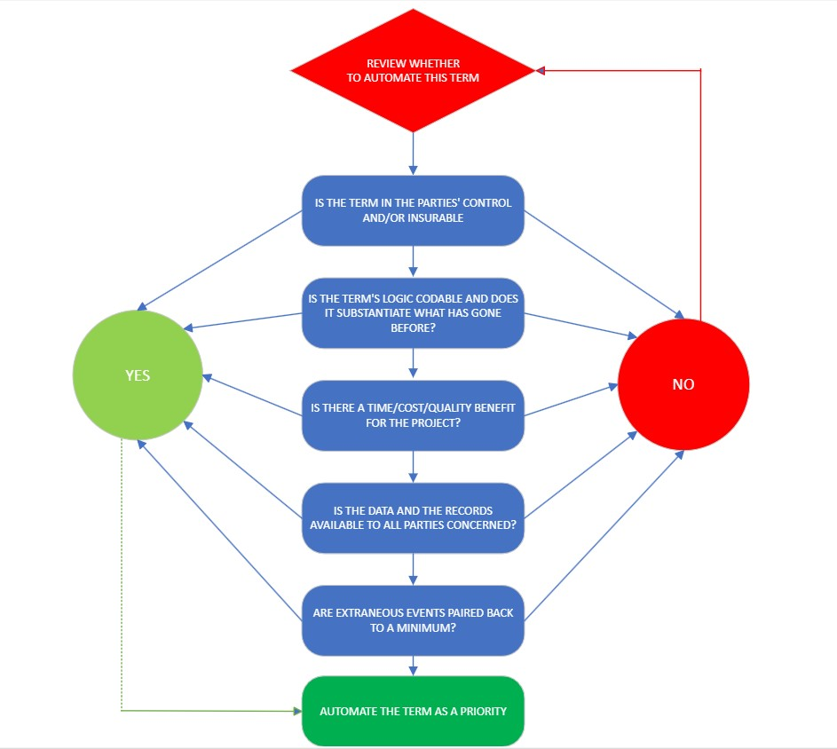
Figure 1: Abrahamson's Principles on when a party to a construction contract should be allocated a risk
Figure 2: Principles for selecting terms for automation via smart contracts

Taking these in turn:

It is in the parties’ control and is insurable.

The Weather Ledger referred to earlier also took important steps relating to insurance. Exponents of risk theory (as set out in Abrahamson’s principles) know that insuring a risk is one way to manage it. Clyde and Co, a leading firm in insurance and construction law, worked with the other partners on the Weather Ledger project and see the potential for parametric insurance type arrangements where the worst-case scenarios based on experience inform the pay out in the anticipation or actuality of an event occurring (Brook, 2018). This approach could well be the key to bottoming out risk considerations around smart contracts and is worth exploring further in another paper.
Having control is key to managing risk. In the absence of control, we have insurance, possibly of the parametric type mentioned above. The more standardised, reliable, and repeatable the processes then the greater the control of the risk. Modern methods of construction and factory-built settings provide these in some measure and reach out towards the tipping point where everyone is comfortable with the simple transactional version of the smart contract .

The contract logic is codable and substantiates what preceded.

The ability to turn contractual obligations into computer code via the use of algorithms appears increasingly straightforward. “If this, then this” is the simple transactional formula mentioned earlier. Contract logic ought to be codable allowing for either machine approval of completed tasks or human or by a combination of the two. Of course, it is rarely as simple as a single test for completion of a stage. However, whereas human users may baulk at too many pre-conditions attached or links in the chain/network of a processes being fulfilled, computers are adept at handling complication. The processing power and memory of computers to have the pre-conditions in place for the completion of a multi-faceted task is a key strength of the brute force of computer programming. Another key strength is the substantiation of what has preceded in an incremental approach to completion. Essentially, the ratification and visibility of previous compliant actions overlays planned obligations with tangible fulfilled obligations.
- Extraneous events are kept to a minimum
Smart contract design using the stack approach (Mason, 2022) sets a course for partial automation retaining the need for oracles to deal with unforeseen or unpredictable situations as well as giving value judgments or reckoning. This has been the role of the Contract Adminstrator throughout the history of standard form construction contract development. The benefits of automation can be simplified to the statement that all things should run smoothly and there should be as little departure as possible from the as-planned to the as-built. One of the areas holding back smart contract development is the unique nature and environment of each building site. From its site conditions to its constraints on the use of resources and the lack of data capture infrastructure all combine to make the site very different from the controlled conditions of a factory, for example. This is a challenge which is being overcome through the use of technology such as drones and even robot dogs (Takaya et al, 2016). The technology will incrementally provide acceptable solutions and pair back the requirement for human checks and input. The terms of the contract to be automated as a priority will be those ones which are light on extraneous events and on those sites where a higher degree of predictability of outcomes is possible.
iv) Are Time/Cost/Quality benefits delivered for the whole Project?
Obviously, businesses require incentives to pursue new innovations– there needs to be consideration and an answer to the question – “what is in it for me?” The party/teams who took the steps to use the smart contract term should see the financial benefit of making the investment. Happily, for the contract parties this should benefit both. This principle should allow the supply chain to push back on the imposition of automation for the sake of it and facilitate discussion against excessive computation. The start-up investment in the technology can be prohibitively expensive and the client has to be comfortable with some of these costs coming back to its own long term improvement plan. Unfortunately, the construction sector is not known for its clarity of long-term vision.
v) Are the data and are the records available to all parties concerned?
Blockchain is one solution allowing the means to achieve availability of data and records. The blockchain takes the access to the data and its security out of the hands of the private ledger (and therefore the client’s sole grasp) and provides transparent and verifiable evidence of what transpired to interested third parties, such as funders. Blockchain remains as a credible solution, despite having endured its own hypecyle.
Increasing the sharing, granularity, accuracy and auditing of recording and predicting data should result in fewer issues with disputed facts. Sadly, to date, disputes endure notwithstanding the improvements in records. Disputes around such new issues as access to data are just as likely to feature in the courts of the future. The case of Trant v Mott MacDonald demonstrated that progress towards a technologically enhanced reduction in disputes may yet be a way-off.

Conclusion

It would be as well to issue an Abrahamson-type proviso to these principles for automation to state that there may be some tensions or inconsistencies in-built into the five broad suggestions made. However, the advantage the author has is that unlike with risk management between two parties whose interests can never fully overlap – who are, after all beholden to their shareholders and to return profits – is that here, they can. Technological advancement, done strategically, can benefit the whole industry. In the case of smart contracts, the strategy involves the careful selection of the terms which should be automated as a priority. It is hoped that these principles are useful in guiding the debates towards those areas most receptive to the advancement of technology.

Data Availability Statement

No data, models, or code were generated or used during the study.

References

List of Cases

MT Hojgaard A/S v E.ON [2017] UKSC 59 BLR 477

Trant v Mott MacDonald [2017] EWHC 2061 (TCC)

Works Cited

Ozkan, E., Azizi, N. and Haass, O. (2021), “Leveraging Smart Contract in Project Procurement through DLT to Gain Sustainable Competitive Advantages”, Sustainability, MDPI AG, Vol. 13 No. 23, p. 13380, doi: 10.3390/su132313380.
Abrahamson, M.W. (n.d.). “Risk Management’(1983)”, International Construction Law Review, Vol. 1, pp. 241–244.
Al Khalil, F., Butler, T., O’Brien, L. and Ceci, M. (2017), “Trust in Smart Contracts is a Process, As Well”, Financial Cryptography and Data Security, Springer International Publishing, pp. 510–519, doi: 10.1007/978-3-319-70278-0_32.
Amara, R. (2006) The Age, 31 October 2006
Arthurs, H. (1983) Law and Learning Report Consultative Group on Research and Education in Law, Ottawa.
Azungah, T. (2018), “Qualitative research: deductive and inductive approaches to data analysis”, Qualitative Research Journal, Emerald Publishing Limited, Vol. 18 No. 4, pp. 383–400.
Brook, N. (2018) The Advantages of Parametric Insurance Market Insight, Clyde & Co, 23 April 2018
Chynoweth, P. (2007) Changing Times for Built Environment Legal Scholarship, Structural Survey 25(3/4)
Daye, J. (2022), “Our Artefacts Our Stories”, Text, , 16 March, available at: https://www.cdbb.cam.ac.uk/news/our-artefacts-our-stories (accessed 1 August 2023).
Di Giuda, G.M., Giana, P.E. and Pattini, G. (2020), “The shortening and the automation of payments: the potentiality of smart contract in the AECO sector”, Proceedings of International Structural Engineering and Construction, Vol. 7, ISEC Press, pp. 1–6.
Farmer, M. (2016), “The farmer review of the UK construction labour market: Modernise or die”, Construction Leadership Council.
Hackitt, J. (2018), “Independent review of building regulations and fire safety”, Parliament by the Secretary of State for Housing, Communities and Local Government by Command of Her Majesty.
Lamb, K. (2018), “Blockchain and Smart Contracts: What the AEC sector needs to know”, CDBB.
Latham, S.M. (1994), “Constructing the team”, HM Stationery Office London.
Mason, J. (2017), “Intelligent Contracts and the Construction Industry”, Journal of Legal Affairs and Dispute Resolution in Engineering and Construction, American Society of Civil Engineers, Vol. 9 No. 3, p. 04517012, d
Mason, J. (2022) Innovating Construction Law: Towards the Digital Age Routledge
McNamara, A.J. and Sepasgozar, S.M. (2021), “Intelligent contract adoption in the construction industry: Concept development”, Automation in Construction, Elsevier, Vol. 122, p. 103452.
Mosey, D. (2021), “Constructing the Gold Standard: An Independent Review of Public Sector Construction Frameworks”, UK Cabinet Office Mudi, A (2016)‘Quantity Surveyor’s Role in Public-Private Partnership Highway Concession’, International Journal of Engineering Research & Technology, Vol. 5 No. 2, pp. 407–417.
Msawil, M., Greenwood, D. and Kassem, M. (2022), “A Systematic evaluation of blockchain-enabled contract administration in construction projects”, Automation in Construction, Vol. 143, doi: 10.1016/j.autcon.2022.104553.
Penzes, B. (2018), Blockchain Technology in Construction Institution of Civil Engineers.
Rogers, E. (1962) Diffusion of Innovations New York: First Edition, Free Press of Glencoe
Sonmez, R., Ahmadisheykhsarmast, S. and Güngör, A.A. (2022), “BIM integrated smart contract for construction project progress payment administration”, Automation in Construction, Vol. 139, p. 104294, doi: 10.1016/j.autcon.2022.104294.
Steinert, M. and Leifer, L. (2010), Scrutinizing Gartner’s Hype Cycle Approach, p. 13.
Susskind,R. & Susskind, D. (2022), the Future of the Professions, Second Edition, Oxford University Press.
Szabo, N. (1997), “Formalizing and Securing Relationships on Public Networks”, First Monday, doi: 10.5210/FM.V2I9.548.
Takaya, K., Asai, T., Kroumov, V. and Smarandache, F. (2016) Simulation Environment for Mobile Robots Testing Using ROS and Gazebo, 20th International Conference on System Theory Control and Computing (ICSTCC)
Tebbit, M. (2005) Philosophy of Law, an Introduction Taylor & Francis Group

Figure Captions List

Figure 1: Abrahamson's Principles on when a party to a construction contract should be allocated a risk (line 237)
Figure 2: Principles for selecting terms for automation via smart contracts (line 240)

[2017] UKSC 59 BLR 477
[2017] EWHC 2061 (TCC)

