**A Review of the Performance of CHIRPS and Future Research Directions in Hydro-Climatic Studies**

Hongrong Du1, Mou Leong Tan1,2*, Fei Zhang 3,4, Kwok Pan Chun5, Longhui Li2,

Muhammad Humayun Kabir6

1GeoInformatic Unit, Geography Section, School of Humanities, UniversitiSains Malaysia, 11800 Penang, Malaysia; [ej81hongrong@student.usm.my](mailto:ej81hongrong@student.usm.my)

2School of Geography, Nanjing Normal University, Nanjing, 210023, China; [longhui.li@njnu.edu.cn](mailto:longhui.li@njnu.edu.cn)

3College of Geography and Environmental Sciences, Zhejiang Normal University, Jinhua 321004, China

4College of Geography and Remote Sensing Sciences, Xinjiang University, Urumqi 830017, China; [zhangfei3s@xju.edu.cn](mailto:zhangfei3s@xju.edu.cn)

5Department of Geography and Environmental Management, University of the West of England, Bristol BS16 1QY, UK; [kwok.chun@uwe.ac.uk](mailto:kwok.chun@uwe.ac.uk)

6Department of Agricultural Extension and Information System, Sher-e-Bangla Agricultural University, Dhaka, Bangladesh; [mhumayunsau@gmail.com](mailto:mhumayunsau@gmail.com)

*Corresponding author: [mouleong@usm.my](mailto:mouleong@usm.my) / [mouleong@gmail.com](mailto:mouleong@gmail.com)

# Abstract

Long-term gridded precipitation products (GPPs) are crucial for climatology and hydrological research to overcome the limitations of gauge observations. Climate Hazards Group InfraRed Precipitation with Station data (CHIRPS) provides long-term daily precipitation data over the globe from 1981 to near-present, but its reliability varies across regions. This review aims to summarize the performance of CHIRPS from 123 research articles that published between 2015 and 2021.The findings show that the number of CHIRPS validation studies has been increased dramatically in the past two to three years. The studies were primarily conducted in China, Ethiopia, Kenya, Uganda, and India, while a relatively few studies in North America, Central Asia, and Europe. The performance of CHIRPS varied depending on geographical location and climate condition, with better performance in Africa. In contrast to other GPPs, CHIRPS is always not the best product, but it is considerablely well in capturing monthly precipitation and is suitable for assessing drought. There are also shortcomings such as inaccurate estimation of sparse sites in complex terrain areas and inaccurate capture of extreme precipitation events. Future research directions on this topic should focus on: (1) enhancing CHIPRS through the integration of gauges, satellite and reanalysis data; (2) validating CHIRPS for extreme indices calculations and relate to large-scale atmospheric circulations like ENSO; (3) evaluating the capability of CHIRPS in hydrological modelling; and (4) further validating CHIRPS under various topographical and climate conditions. This review can act as a reference to scientists who wish to applyCHIRPS in their climatology analysis and hydro-climatic modelling as well as the CHIRPS developers to further improve the product.

Keywords: CHIRPS; Climate Change; Validation; Precipitation; Rainfall; Hydrology; Extreme.

# 1. Introduction

Precipitation is one of the most important variables related to atmospheric circulation in weather and climate researches (Huffman et al. 2010, Sun et al. 2018). It is a key component of water cycle, driving the climate, meteorology, agricultural land and hydrology sectors (López López et al. 2018). Accurate precipitation data is essential for understanding the temporal and spatial variation characteristics of precipitation in different parts of the world (Bohnenstengel et al. 2011, ZHENG Jie 2016), not only for climate trends and variability research, but also for water management and hydrological modelling (Atiah et al. 2020a, Popovych and Dunaieva 2021, Sharannya et al. 2020).The most common ways to get precipitationdata are throughgauge observations, ground-based radar,satellite data and reanalysis estimate(Sun et al. 2018).

Gauge observations are considered as the most accurate precipitation data (Solakian et al. 2020), however, lack of station dispersion in remote or difficult-to-reach places and the short measurement times are among common limitations(Essou et al. 2016). Ground-based weather radar has been progressively employed for rainfall forecast, monitoring, and analysis since the 1970s. The key benefits of ground-based radar arethe ability to estimate large-scale precipitation, but it can only be used in more rich and densely populated areas due to the high installation and operating costs(Kidd 2001). With the advances of satellite technologies, geosynchronous satellites (GEO) and low earth orbit (LEO) satellites are then widely used to detect precipitation at a global scale(Maggioni and Massari 2018).

Open-source gridded precipitation products (GPPs), with the advantages of wide spatial extent and temporal continuity, are potentially to compensate the shortcomings of gauge observations, especially in un-gauged or little gauges areas including the oceans, complex mountain ranges and deserts(Jiang et al. 2016). Comparing CHIRPS (Climate Reanalysis product, <https://data.chc.ucsb.edu/products/CHIRPS-2.0/>), MSWEP (Climate Reanalysis product, <https://www.gloh2o.org/mswep/>), IMERG (Satellite product, <https://giovanni.gsfc.nasa.gov/giovanni/>), and GPCP (Gridded Gauge, http://gpcp.umd.edu/) data for 2022 year(Figure 1). GPCP (Gridded Gauge) data has the lowest spatial resolution; CHIRPS, MSWEP, and IMERG are more suitable for regional scale studies than GPCP. In northern South America, and Southeast Asia, CHIRPS and IMGERG and GPCP are more similar than MSWEP datasets with the precipitation is almost 3000mm/year to 4000 mm/year, MSWEP is lower than other three. The performance of the four types of data is consistent in Australia and west Africa. Overall, data on precipitation originates from various sources and behaves differently. However, infra-red (IR)satellite sensors frequently miss low precipitation events and underestimate orographic rains, whereas passive microwave(PMW)satellite retrievals have difficulty in detecting orographic precipitation, particularly in the winter season(Yilmaz and Derin 2014). Furthermore, the number and spatial coverage of gauge observations, satellite techniques, and data assimilation models all limit the dependability of GPPs(Sun et al. 2018).Hence, the capability of GPPs is highly uncertain in hilly regions with complex topography and the regions close to the coast. Due to the discrepancy between GPPs and actual precipitation, their use in hydrological modeling and flood monitoring is likely to be limited(Maggioni and Massari 2018, Maggioni et al. 2016, Solakian et al. 2020).

Climate Hazards Group InfraRed Precipitation with Station data (CHIRPS) developed by Geological Survey (USGS) and University of California, Santa Barbara (UCSB)provides near global precipitation at the spatial resolutions of 0.05° and 0.25°from 1981 to near-present. It was developed to serve the gauge-limited Africa for drought monitoring by the USAID Famine Early Warning Systems Network (FEWS-NET). For instance, CHIRPS was used to calculate standardized precipitation index (SPI)for detecting and analyzing historical drought events in Africa. Satellite data, monthly gauge observations, and precipitation forecast factors were combined to create the Climate Hazards Precipitation Climatology (CHPClim) (Chris C. Funk 2013).TRMM Multi-satellite Precipitation Analysis (TMPA) 3B42 version 7 was used to calibrate the global cold cloud duration (CCD) rainfall estimates and to integrate precipitation observations from various sources, including national and regional weather services, to generate CHIRPS data.

CHIRPS outperformed PERSIANN-CDR, CMORPH-BLD, and TRMM-3B43 in assessing droughts in Europe, Oceania, and Africa(Zhao and Ma 2019). In regions with extensive gauge distribution, such as the southeastern United States, the southeastern Chinese province of Jiangsu province, South Africa, and the southeastern United States, CHIRPS was able to capture more than 75% of the drought events. As a result, CHIRPS can be employed as in drought monitoring that operates in real time (Zhao and Ma 2019), and it is suitable for tropical forests (Burton et al. 2018). CHIRPS is more consistent with station precipitation data than CFSR in different climatic zones (Dhanesh et al. 2020). Xiang et al. (2021) evaluated eight GPPs, including CHIRPS, for 1382 catchments in China, Europe, and North America, with CHIRPS V2.0 performedthe third best after the GPCC and MSWEP V2.0.On a daily basis, however, the performance of CHIRPS is not satisfactory. These studies show thatCHIRPS performs varies underdifferentgeographical and climate conditions.

Meteorological research requires accurate meteorological data, and CHIRPS is an open source database with extensive coverage, lengthy time series (so far more than 40 years), and a range of time resolutions that is suitable for meteorological research. Many studies have been conducted to test the performance of CHIRPS, however, to the best of our knowledge, are view to summarize these work, particularly under the hydrological perspective, is not available in the literature. Hence, this review aims to provide an overview of the performance of CHIRPS in precipitation estimations at the global and regional scales as well as thehydrologic aspect. There is no literature review on the research progress of CHIRPS at present. This paper summarizes the benefits, drawbacks, and applicability of CHIRPS, enabling novices to rapidly comprehend CHIRPS data and select the most applicable data set. In addition, this review can act as a reference to the CHIRPS developers to understand better the advantages and limitations of the product across the globe, which is important for the improvement of the coming versions.



Fig 1. The Spatial distribution map of different precipitation products in the year 2022 (a)CHIRPS; (b)IMERG; (c)MSWEP; (d)GPCP products.

# 2. Methodology

In order to summarize the effectiveness of CHIRPS in a global context, we have conducted a literature search using the SCOPUS database with the terms “CHIRPS”and“precipitation” from January 2018 to December 31, 2021. The initial search has resulted more than 300 articles from the Scopus database. As this review only considered the studies related to the validation of CHIRPS in climate and hydrological aspects, the total number of papers is 112, and the previous few important papers on CHIRP/S (11 published before 2018) are added. Finally, bringing the total number of papers to 123. Conference proceedings and books were excluded from this review. The region of publication, type of data, time of study, validation method, statistical indicators, and conclusions of thestudies were extracted and compiled in an excel for further analysis and preparation of figures and tables.

During the initial process, an ID code was assigned to each article based on the naming method adopted by(Pradhan et al. 2022).First, we identified the continent and country to which the studies belong to. Since most of the studies focused on the comparison analysis with other GPPs, in the second step, we extracted the values of the most used statistical indicators such as root-mean-square error (RMSE), correlation coefficient (CC) and bias. RMSE measures the absolute mean difference between GPPs and the corresponding gauge observations. RMSE close to 0 indicates a better performance. Meanwhile, CC measures the linear correlation between GPPs and gauge observation, with the values ranging from -1 to 1, indicating a high degree of negative/positive correlation, respectively (Gebrechorkos et al. 2018).The bias indicates how closely the mean of satellite rainfall correlates to the mean of observed rainfall(Bayissa et al. 2017).

Besides that, we also extracted information of the most used categorical metrics such as probability of detection (POD), false alarm ratio (FAR)and critical success index (CSI). POD calculates the occurrence of precipitation detected by GPPs, but ignoring false alarms. On the other hand, FAR reflects the sensitivity of GPPs to precipitation events, which does not appear in station data but detected by GPPs. While, CSI shows the ability of GPPs to detect actual precipitation(Wang et al. 2020). The values of POD, FAR and CSI range from 0 to 1. A score of 1 for POD means that precipitation occurs in perfect agreement between GPPs and gauge observations, while a score of 0 means that there is no agreement at all. FAR measures the false alarm rate where a score of 0 indicates that no false alarms occurred. Meanwhile, the CSI index provides a measure of the critical success rate of mixing POD and FAR, a perfect score of 1 means zero occurrences in both false alarms and misses categories(Ayoub et al. 2020). Finally, the performance of CHIRPS in hydrological modelling is also presented.3. Overview of CHIRPS assessment.

## 3.1 General Overview

Among the selected 123 articles, most of the studies were conducted in Asia (55 articles), followed by Africa (48 articles), South America (12 articles), Europe (3 articles), and 1 article for each North America, Oceania, and Southwest Pacific(There are four studies atthe global scale; however, it should be noted there is a study involved only Asia, North America, and Europe.--I want delete it) Figure 2 shows the distribution of CHIRPS performance assessment is uneven throughout the globe. Most studies were conducted in China (22 articles) and Ethiopia (20 articles), accounting about 34% of the selected literature. The number of articles on the Kenya, Uganda, and India areas exceeds or is equivalent to ten. Literature exists on the majority of African countries (particularly in North and East Africa), with anything from 5 to 9 articles per country.

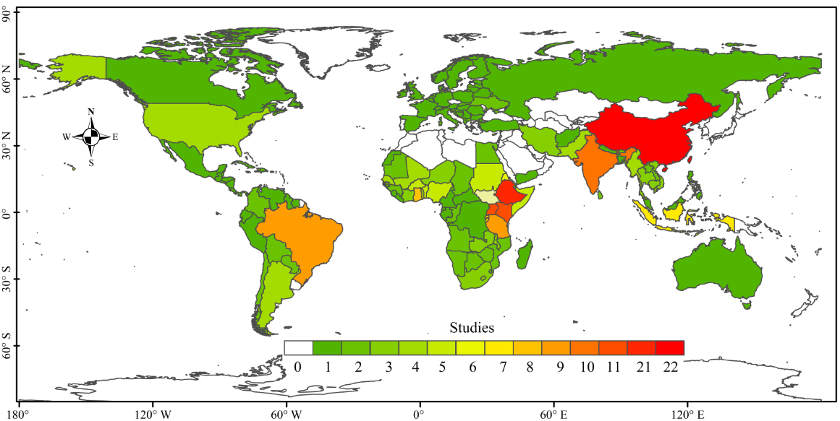

Figure 2. Geographical distribution of the CHIRPS validation studies.

The number of publications has been increase significantly since 2017, where the highest number of 37 articles was found in 2021, and the second in 2020, with 36 articles. The total articles that published in 2018 and 2019 were 36, while the least number of papers in 2015 and 2016, with 1 and 2, respectively. As can be seen from Figure 3, Asia has the most significant upward trend in publications, from only 1 publication in 2016 to 20 in 2021. The number of articles published in Africa is balanced, with 12 articles in all years except 2017 and 2019, where 5 and 7 articles were published respectively. South America also shows an increasing trend in the last five years, with 4 articles were published in both 2020 and 2021. Oceania and South West have one article each, published in 2016 and 2021, respectively. Overall, the validation of CHIRPS was conducted mostly in Asian and Africa. Some studies on CHIRPS are shown in Table 1.

Table 1. The list of CHIRPS research

|  |  |  |  |  |  |  |  |  |  |  |  |  |
| --- | --- | --- | --- | --- | --- | --- | --- | --- | --- | --- | --- | --- |
| Region | Nation | lon | lat | Coverage | record_start | record_end | Gridded/Satellite/ other data | CHIRP/S products | observational data | temporal_scale | spatio_scale | First-author |
| Global | Global | 180°W–180°E | 20°S–20°N | tropical forests | 2015 | 2016 | TRMM 3b42 v7,PERSIANN-CDR,CMAP | CHIRP v2.0 | Rain gauge data | Monthly | 0.25° | C. Burton, |
| Africa | Burundi, Eritrea, Ethiopia, Kenya, Rwanda, and Uganda; | 28°–52°E | 5°S–20°N | regional | 1983 | 2015 | TAMSA,ARC 2.0 | CHIRPS | \ | Seasonal,Annually | 0.25° | Elsa Cattani |
| South America | Argentina | 71◦~67◦W | 30°S - 40°S | Semiarid Central-Western | 1987 | 2016 | \ | CHIRPS | 49 rainfall stations | Monthly，Annually | 0.05◦ | Juan A. Rivera |
| Europe | Italy | 15.4°-18°E | 36°-41°N | Calabria | 1981 | 2010 | GCM-RCM, E-OBS | CHIRPS | \ | Monthly | 0.05° | Giulio Nils Caroletti |
| Africa | Guinea | 18°W–20°E | 0°−12.5°N | The Gulf of Guinea | 1981 | 2014 | \ | CHIRPS | 18 rain gauge data | Season | 0.05° | Adeline Bichet |
| Africa | Ethiopia, Kenya, Somalia, Uganda, Rwanda and Tanzania | 29°–47°E | 10°S–15°N | Eastern Africa | 2006 | 2010 | TAMSAT,ARC 2.0 | CHIRP/S | 1,200 rain gauge data | Daily, Dekadal and Monthly | 0.05° | Tufa Dinku |
| Asia | China | 112°–120°E | 35°–43°N | The east of China. | 1981 | 2015 | \ | CHIRPS | 29rain gauge data | Monthly, Seasonally, Annually | 0.05° | Feng Gao |
| South America | Brazil | 58°-53°W | 10°30′-14°30′S | The Cerrado–Amazon transition region | 1985 | 2017 | GPM-3IMERGMv6, and GPM-3IMERGDLv6,PERSIANN-CDR, PERSIANN-CCS,PERSIANN | CHIRPS-2.0, | 32 stations | Monthly | 0.05° | Mairon Ânderson Cordeiro Correa de Carvalho |
| Africa | South Sudan | 24°–36°E | 3°–12°N | The Nile Basin | 1983 | 2010 | GPCC 7.0,PERSIANN-CDR,TAMSAT-2,ARC2,MSWEP 2.0 | CHIRPS v2.0 | 5 stations | Monthly, Annually | 0.05° | Mohammed Basheer |
| Asia | India | 74°00′–76°30′ E | 13°00′–15°30′ N | Tungabhadra river basin. | 2000 | 2012 | GPCP-CDR v1.3,PERSIANN-CDR,TRMM 3B42 v7;SM2RAIN-CCI ; GPCC v.7,GPCC v.2018,GSMAP Gauge RNL v6 ,NCEP-CFSR,PGF v2,PGF v2,MSWEP v1.2 | CHIRP v2.0 ,CHIRPS v2.0 （0.05）,CHIRPS v2.0 （0.25） | IMD,APHRODITE, | Monthly,Annually | 0.25°,0.05° | Kolluru Venkatesh |
| Asia | Malaysia | 1°N–8°N | 99°E –120°E | regional | 2008 | 2012 | TMPA 3B42v7;PGFv3,GSMaP_RNL | CHIRPS 0.05 CHIRPS 0.25 | 41 rain gauge stations | Monthly | 0.25°,0.05° | Afiqah Bahirah Ayoub |
| Africa | Burundi | 28°58′–30°53′E | 2°15′–4°30′S | regional | 1983 | 2016 | PERSIANN‐CDR,CRU | CHIRPS v2.0 | 14 meteorological stations | Daily, Monthly,Annually | 0.25◦,0.05◦ | Athanase Nkunzimana |
| Asia | Indonesia | 107°22′ E–107°57′ E, | 6°43′–6°56′ S | Upper Citarum basin | 2005 | 2018 | TRMM ,SACA&D | CHIRPS | Rain gauge | Daily,Annually | 0.05°,0.25° | S.R. Rusli |

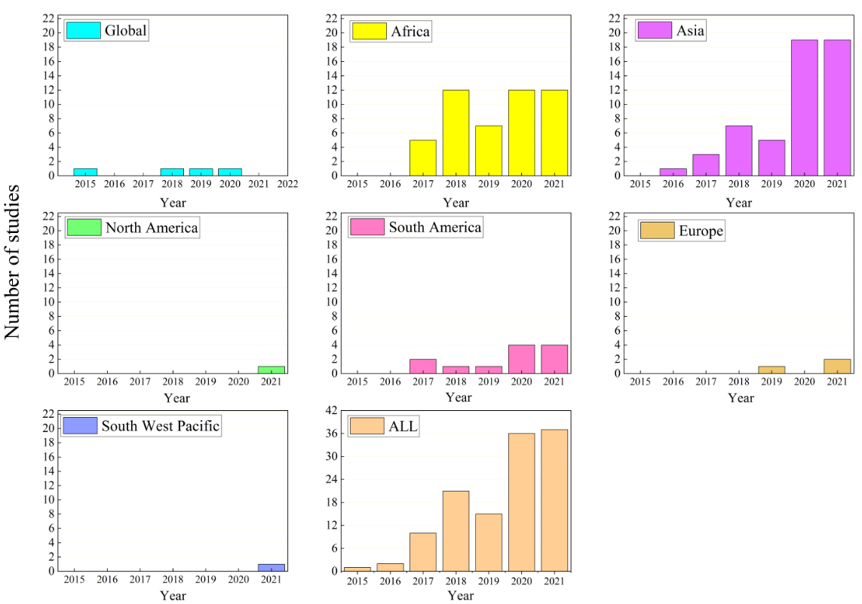

Figure 2. The number of articles on CHIRPS in different region from 2015 to 2021.

Figure 4 illustrates the distribution of journals that published the CHIRPS validation studies, where Remote Sensing had the highest number of 28 articles, accounting for 22.22% of the literature. Atmospheric Research published the second highest number, with 13 articles. Theoretical and Applied Climatology, Water, Climate and Journal of Hydrology were published between three to ten articles. While, Theoretical and Applied Climatology, Hydrology and Earth System Sciences, Quarterly journal of the Royal Meteorological Society have published at least three papers. Consideration of the journal category, we found that the atmospheric field received the largest number of articles of CHIRPS, followed by remote sensing and hydrology. Fields of geography, natural science, earth science and environment have published less than ten articles.

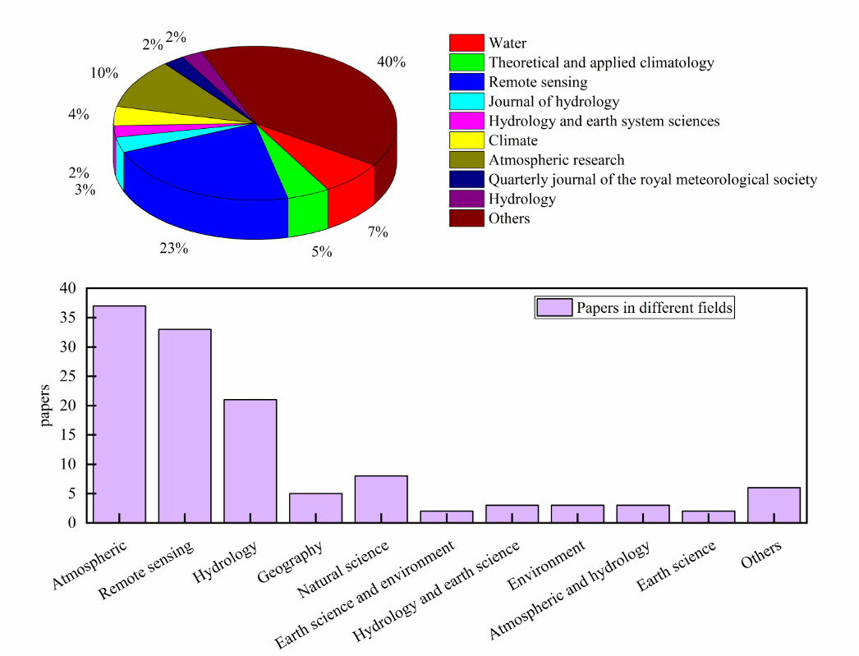

Figure 4. Journals commonly publish the CHIRPS validation studies.

Figure 5 depicts the number of CHIRPS studies in six different evaluation time series of 0-5 years, 6-10 years, 11-15 years, 16-20 years, 21-25 years, 26-30 years, 31-35 years, and 35-39 years. Majority of the CHIRPS validation studies were conducted on a monthly basis, with the daily and annual scales following closely behind. Compared to other scales, only a few studies looked at the 5-day and 10-day scales. Among 123 articles, 100 of which are focused on the CHIRPS 0.05oresolution, 15 of which were the CHIRPS 0.25° resolution, seven studies focused both the 0.05°and 0.25°spatial scale, and one of which is about the CHIRP project. Table 2 lists the number of articles that applied the five commonly used statistical indicators.

G:\修改文件CHIRPS\tu\20230914095720.tif

Figure 5. The number of CHIRPS assessment studies for different evaluation time scales.

Table 2. Number of articles usingsix statistical indicators in the CHIRPS validation research.

|  |  |  |
| --- | --- | --- |
| Statistical Metric | | Nmber of Article |
| Continuous Statistical Metric | RMSE | 66 |
| CC  BIAS | 30  32 |
| Categorical Statistical Metric | POD | 37 |
| FAR | 38 |
| CSI | 17 |

## 3.2 Continuous Statistical Metrics

There are only a few studies focused solely on CHIRPS, where most the studies have compared CHIRPS with other GPPs such as TMPA3B43V7, PERSIANN-CDR, CMORPH, ARC 2.0,MSWEP, Integrated Multi-Satellite Retrievals for Global Precipitation Measurement(IMERG), GPCC and APHRODITE. Figure 6 shows the monthly CC values in different regions, where 45 % of the studies applied CC in comparing CHIRPS with other GPPs. For the monthly scale, studies in Ghana (0.97 – 0.99) and Ethiopia (0.84 – 0.96) have reported the best CC values (Dinku et al. 2018, Gebrechorkos et al. 2018). The range of the reported CC values is the largest in China and Iran, varying from 0.15 to 0.97 and 0.15 to 0.9, respectively. On the continent level, as shown in Figure 6(b), Africa had the best CC value of 0.89, followed by North America (0.88), Oceania (0.875), South America (0.85), Europe (0.845), Asia (0.79), South West Pacific (0.695) and East Africa (0.4). The CC values of CHIRPS in Yemen, Malaysia, Brazilian, Nigeria, United States, Tanzania, Kenya, Italy and Crimea are mostly above 0.6, showing a relatively good correlation of CHIRPS with gauge observations in this region.

CHIRPS was similar to other GPPswhere the CC values of daily scale are not asgood as the monthly scale.Forexample,in China, the CC values ranged from0.27 to 0.7 on daily scale (An et al. 2020, Liu et al. 2019, Wu et al. 2018), while the CC values up to between0.9 and 0.97 on monthly scale (Hsu et al. 2021, Pang et al. 2020, Xia et al. 2021). Similarly, in Iran, daily CC values range from 0.18 to 0.53, while monthly values range from 0.38 to 0.83(Ghozat et al. 2020, Mokhtari et al. 2021).In Indonesia, the daily CC value is 0.28 and the monthly CC value of 0.79(Wiwoho et al. 2021).

G:\修改文件CHIRPS\tu\cc.tif

Figure 6. The CC values in monthly precipitation evaluation at the (a) national and (b) continental scales as well as (c) studies reported only a single CC value.

Similarly, about 45 % of the studies have used RMSE in assessing the performance of CHIRPS. Figure 7 shows the RMSE values in monthly precipitation in different regions. Precipitation in different regions is different. In order to make RSEM comparable, precipitation regions are divided. According to the global average annual precipitation distribution, regions with an average annual precipitation of 500ml or less are classified as Figure 7(a), regions with an average annual precipitation of 1000ml or more are classified as Figure 7(c), and regions in between are grouped together Figure 7(b).

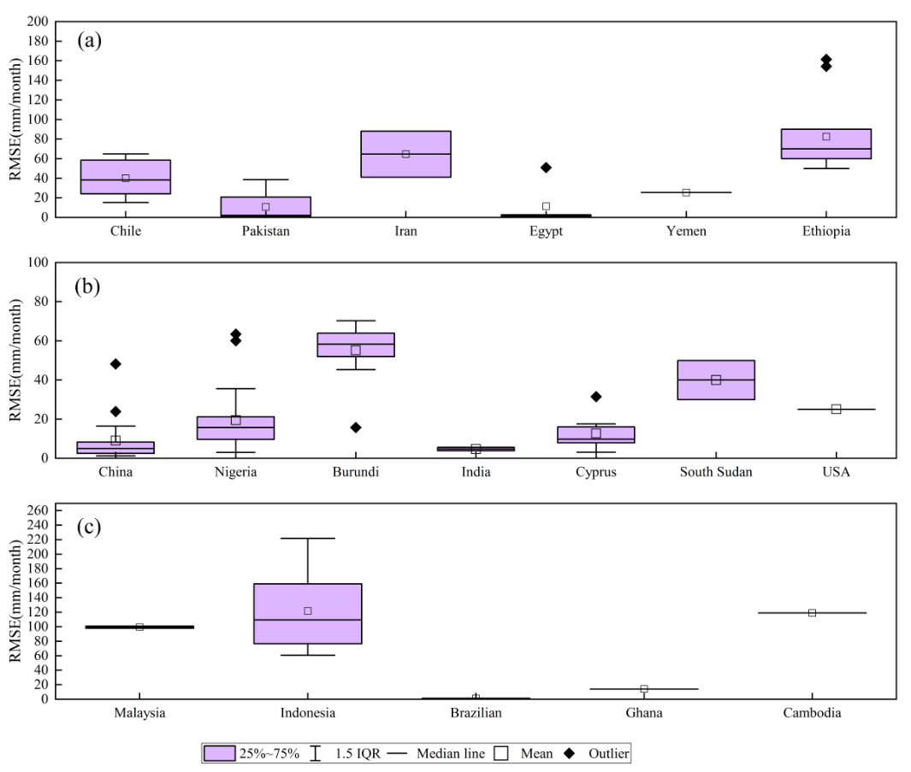

Figure 7. The RMSE values of CHIRPS performance in monthly precipitation at the (a)average annual precipitation of 500ml or less precipitation region (b) average annual precipitation of 500ml to 1000ml, (c) average annual precipitation of 1000ml or more precipitation region

In Figure 7(a), it can be seen that Pakistan(2.075), Egypt(2.0) have lower RMSE values than Chile(38.25), Iran(64.6), and Ethiopia(70.02). Brasilia(1.21) and Ghana(14) have lower RMSE values than Malaysia(99.36), Indonesia(109.26), and Cambodia(119) in regions with significant precipitation(Figure 7(c)). Burundi(58.35) and South Sudan(40), as well as regions with moderate precipitation(Figure 7(b)), have higher RMSE values than other nations. This is related to geographical location, precipitation distribution, density of rain stations, and differences in test accuracy.

## 3.3 CategoricalStatistical Metrics

About 30% of the studies reported the POD and FAR values, and 14% on the CSI values. In most articles, the threshold for rainfall used to distinguish between rainy and dry days is 0 mm(Li et al. 2021, Liu et al. 2020), 0.1 mm(Xia et al. 2021), or 1 mm(Ayehu et al. 2018, Ayoub et al. 2020), and some studies used the threshold of 5mm (Paredes-Trejo et al. 2017, Rivera et al. 2018).The median values of POD, FAR and CSI on a daily scale for the CHIRPS evaluation in different regions are illustrated in Figure 8.The median values of POD for Burundi, India, Indonesia, Yemen andEgypt are among the highest, ranging from 0.73 to 0.85, while, the median POD values for China (0.36) and Spain (0.335) are relatively low (An et al. 2020, Liu et al. 2019, Xiao et al. 2020). Although studies have shown that the median POD value in China is 0.74at the monthly scale(Gao et al. 2018, Jiang et al. 2021, Pang et al. 2020, Peng et al. 2020, Wang et al. 2020, Xia et al. 2021), butthe daily scale assessment is not ideal. The region near the Indian Ocean had a higher POD median value, showing CHIRPS can detect precipitation in this region effectively.

USA, Spain,and Brazil have the best FAR values when comparing CHIRPS with gauge observations, ranging from 0.03 to 0.12. The rates of false positive of CHIRPS in China, Togo and Benin are quite high, where the reported FAR median value are beyond 0.5. The reported CSI values of Egypt and Indonesia show a quite significantdifference, ranging from 0.08 and 0.9. Relatively, the CSI median value in China is0.27.In Indonesia, India, Egypt, Ethiopia, and Burundi, the reported POD values were greater than 0.6 and the FAR values were less than 0.5.

In Togo and Benin, the POD was less than 0.6, and the FAR reached the highest value of all (0.61) in these countries. In Brazil and the United States, the median POD valuesare 0.57 and 0.51, and the average FAR values are 0.11 and 0.12, respectively.CSI is used as an indicator to comprehensively consider POD and FAR values, as shown in Figure 8(c), In the estimation of precipitation events, CHIRPS data is more suitable for the region around the Indian Ocean.

C:\Users\Administrator\Desktop\pod+num.tif

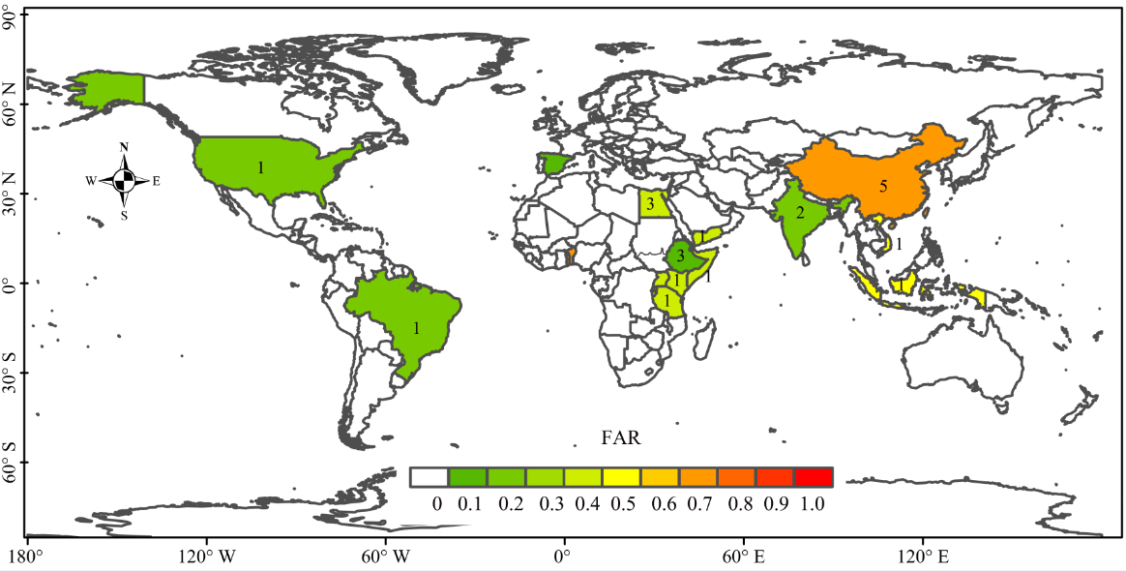

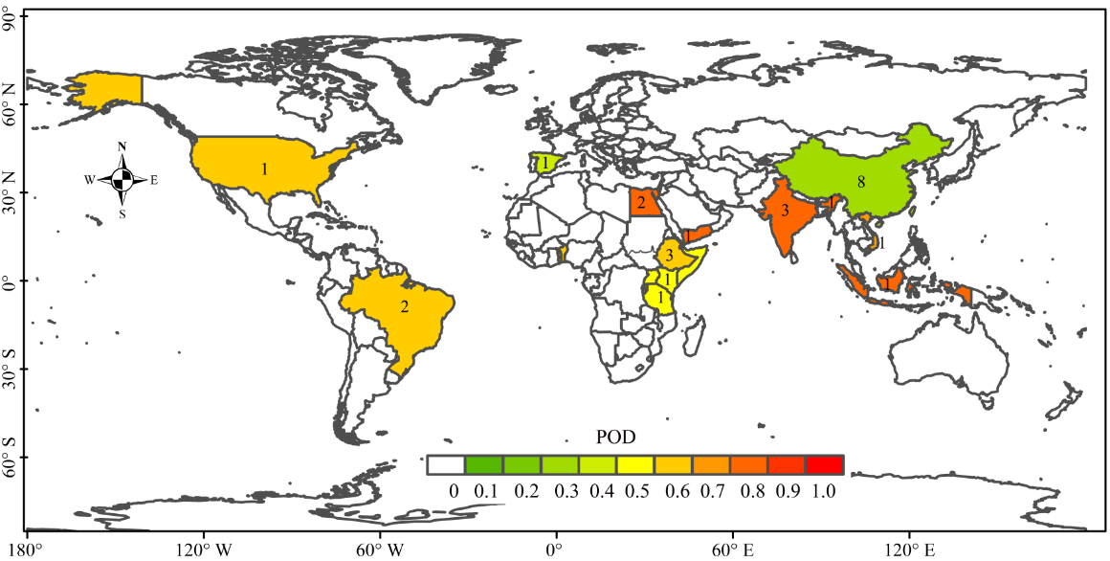

Figure8. Spatial distribution of the (a) POD, (b) FAR and (c) CSI median values in different regions

## 3.4 Hydrological Modelling

CHIRPS is mostly incorporated into the Variable Infiltration Capacity (VIC) model (Funk et al. 2015, Wu et al. 2018), Hydro-BEAM, Xin'anjiang (XAJ) model (Xiang et al. 2021, Zhang et al. 2014), the Tsinghua Hydrological Model (Li et al. 2021), the fully distributed mesoscale Hydrologic Model (mHM) (Dembélé et al. 2020), The Hydrological Modeling (Hydro‑BEAM) (Abdelmoneim et al. 2020), Analysis Platform (HyMAP) routing module (Ghatak et al. 2018), HydrologiskaByrånsVattenbalansavdelning (HBV)(Goshime et al. 2019) and Soil and Water Assessment Tool (SWAT) (Tan et al. 2021). Most of the models were evaluated by one or two studies only, except for the SWAT model which was covered by 11 studies.

Nash-Sutcliffe efficiency (NSE), percentage bias (PBIAS), Nash-Sutcliffe coefficient of efficiency (NSCE) and standard deviation ratio (RSR) are the frequently used statistical indicators in comparing the CHIRPS-based simulated and observed streamflow. In the literature, almost all the CHIRPS validation studies related to hydrological modelling assessment used NSE, hence we compiled the reported NSE values for the daily and monthly scales in Table2.On the monthly scale, the reported NSE values for both the calibration and validation periods are quite consistent. In most studies, the NSE values of CHIRPS werehigherthan 0.63 during the calibration period, while the best NSE reached up to 0.96 during the validation periods. The difference of the NSE values between the calibration and validation periods is slightly larger in the daily scale than that of the monthly scale. The NSE values ranged from-7.75 to 0.9 and -4.48 to 0.82 for the calibration and validation periods, respectively (Table 3). The NSE value of the Lancang River Basin that covering five countries of Myanmar, Cambodia, Laos, Thailand, and Vietnam, was the highest in both monthly and daily scales. Meanwhile, India has the lowest NSE levels, 0.54 on a monthly basis and 0.55 on a daily measure.

Table2. Reported NSE values for monthly and daily streamflow assessment in different parts of the world. (Daily scale: D, Monthly scale: M)

|  |  |  |  |  |  |  |  |
| --- | --- | --- | --- | --- | --- | --- | --- |
| Country/region | Basin | Data | Scale | Model | Calibration | Validation | Author |
| Ethiopia | The upper GilgelAbay Basin | CHIRPS | 0.05° | SWAT | 0.71(M) | 0.85(M) | Duan et al. (2016) |
| Myanmar, Cambodia, Laos, Thailand, Vietnam | the Lower Lancang-Mekong River Basin | CHIRPS | 0.05◦,0.25◦ | SWAT | 0.91 ~ 0.96(M); 0.78 ~ 0.9(D) | 0.82 ~ 0.9(M); 0.78 ~ 0.9(D) | Luo et al. (2019) |
| India | Tungabhadra river basin. | CHIRP v2.0 ,CHIRPS v2.0 | 0.25◦,0.05◦ | SWAT | 0.61 ~ 0.8(M) | 0.68 ~ 0.8(M) | Venkatesh et al. (2020) |
| India | The Gurupura river basin | CHIRPS v2.0 | 0.25◦,0.05◦ | SWAT | 0.54 ~ 0.66(M)  0.55 ~ 0.67(D) | 0.55 ~ 0.65(M)  0.55 ~ 0.62(D) | Sharannya et al. (2020) |
| Egypt | Eastern Nile Basin | CHIPRS v2.0 | 0.05° | SWAT | 0.77 ~ 0.87(M) | 0.79 ~ 0.88(M) | (Abdelmoneim et al. 2020) |
| China | BRB,HRB and LRB basin | CHIRPS | 0.25◦ | CREST | 0.81 ~ 0.87(M)  0.61 ~ 0.62(D) | 0.88 ~ 0.89(M)  0.71 ~ 0.73(D) | (Zhang et al. 2014) |
| West Africa | Lawra | CHIRPS | 0.25◦ | HBV-light | 0.64(M) | 0.71 ~ 0.73(or <0.5)(M) | (Poméon et al. 2017) |
| Ethiopia | upper GilgelAbay Basin | CHIRPS | 0.05° | SWAT | 0.56(D) | 0.52(D) | (Duan et al. 2019) |
| Ethiopia | Lake Ziway Watershed | CHIRPS | 0.05° | HBV | 0.71(D) | 0.64(D) | (Goshime et al. 2019) |
| the USA, Brazil, Spain, Ethiopia, and India | ---- | CHIRPS | 0.05° | SWAT | −0.44 ~ 0.46(D) | −0.39 ~ 0.42(D) | (Dhanesh et al. 2020) |
| Thailand | Huai Bang Sai Watershed | CHIRPS v2.0 | 0.05° | SWAT | 0.55(D) | 0.14(D) | (Gunathilake et al. 2021) |
| The Republics of Benin and Togo | the Mono River Basin | CHIRPS | 0.05° | HBV-light | 0.58(D) | 0.67(D) | (Hounguè et al. 2021) |
| Kenya | Lake Victoria Basin | CHIRPS | 0.05° | SWAT | −7.75 ~ 0.24(D) | −4.83 ~ -0.13(D) | (Le and Pricope 2017) |

## 3.4 Analysis on different time scales

The ability of CHIRPS varies across various time scales. In Nigeria, correlation values on the Monthly and Annual scales were superior to those on the Daily and Dekadal scales, while RMSE values on the Dekadal scale showed a small difference between the Monthly and Seasonal scales (Muhammad Usman, 2018). In Ethiopia, CHIRPS captured the shapes of the rainfall on a monthly scale but less accurately on a seasonal scale (Getachew Dubache). It also demonstrated excellent agreement with ground-observed rainfall data at monthly and seasonal time scales over the Ziway Lake Basin, Ethiopia (Aster Tesfaye Horofa). However, CHIRPS performed poorly at daily and annual scales, whereas seasonal cycles in Togo and Benin were accurately depicted (Nina Rholan Houngu'e). With correlation coefficients of 0.5, CHIRPS was inadequately correlated to gauge data on a daily time scale in Tanzania (Yeganantham Dhanesh) . Five-day aggregation was the minimum time scale that can be used for the products to reach an accuracy better than monthly-mean of gauge data (Yeganantham Dhanesh) .

Compared to in-situ data, CHIRPS performed better on a monthly timescale in the Lower Mekong River Basin (Southeast Asia) (Chelsea Dandridge, 2019). Nevertheless, CHIRPS was in good agreement with rain gauge measurements, which were rated as follows: annual scale, seasonal scale, and monthly scale over the Huanghuaihai Plain (Fanchen Peng).Evidently, the CHIRPS performance on the monthly scale in Bali Island is more good than its performance on the daily scale.(Liu Chian-Yi) Similarly, CHIRPS estimates have a high correlation on dekadal and monthly time scales but a lower correlation for daily estimates. In Turkey, CHIRPS tends to underestimate high precipitation volumes of 25–80 mm per decade and 150–300 mm per month (Hakan Aksu).

For South Africa, CHIRPS data correlate well with observed monthly precipitation data for all used stations, with an average coefficient of determination of 0.6 and bias of 0.95, which is better to the daily scale (J A du Plessis, J K Kibii).

In West Africa, CHIRPS performed relatively well on the seasonal scale (r > 0.90) compared to the annual scale (Winifred Ayinpogbilla Atiah). CHIRPS is helpful for the analysis of all extreme events.

On a global regional scale, the efficacy of CHIRPS was evaluated using CC,RMSE(mm),ME(mm), and BIAS(%), with monthly data being superior to daily data (Yeganantham Dhanesh).

# 4. CHIPRS Performance in Different Continents of the World

## 4.1 Asia

**4.1.1East Asia**

Over the Chinese mainland, CHIRPS performed better in high-precipitation areas, in the summer than in the winter, and exhibited modest sensitivity to typhoon weather(Bai et al. 2018). Corrected CHIRPS can better capture the frequency of precipitation episodes and better reflect the spatial properties of yearly precipitation than uncorrected CHIRPS(Li et al. 2019). Comparing the precipitation estimates of TMPA3B42V7, PERSIANN-CDR and IMERG, CHIRPS performed well after TMPA3B42V7 and IMERG (Jiang et al. 2021, Wei et al. 2020).

On the watershed scale in China, CHIRPS matched precipitation variability of gauge observations at the monthly, seasonal, and annual precipitation estimations quite well(Gao et al. 2018, Yu et al. 2020). When CC, RMSE, Bias and POD were used as indicators, CMORPH and GPM had better performance than CHIRPS in capturing extreme precipitation as well as mountainous and desert areas in the upper Yangtze River Basin(Xiao et al. 2020). In contrast, CHIRPS was inferior than MSWEP and TMPA in the Huaihe River basin. CHIRPS underestimated winter precipitation and overestimated other seasons in the Yellow River Basin and the Jialing River(An et al. 2020, Pang et al. 2020), and performed badly in the Pearl River Basin in precipitation forecasting(Xia et al. 2021).An overestimation of precipitation was observed in the Beijiang, Huai, and Liao basins, with a better performance in the wet areas (R2= 0.86) than dry areas (R2= 0.7)(Zhang et al. 2014).In Tibetan Plateau (TP), CHIRPS V2 performed better under the wet conditions than the dry conditions, and it tendsto underestimate small precipitation events (0-2 mm/day) and to overestimate large precipitation events (2-25 mm/day) (Liu et al. 2019).

In arid zones, CHIRPS showed a moderate performance on the inter-annual precipitation estimation (CC = 0.72, RMSD = 22.39 mm), but it performed well in terms of relative error (SD), with the lowest overestimation of only 5%(Wang et al. 2020). CHIRPS was similar to the site data in the Huanghuaihai Plain (cumulative CC value of 0.92),although it underestimated the rainfall rates of 0-10 mm/month and 200-500 mm/month(He et al. 2018), CHIRPS could describes the temporal variability of precipitation in Taiwan on the seasonal, annual, and inter-annual scales(Hsu et al. 2021).CHIRPS performed exceptionally well in the southwest of China, and it had superiority in hydrological simulation in the southern Tibetan Plateau(Li et al. 2021).

**4.1.2 South Asia**

There was a strong linear relationship (CC> 0.70) between CHIRPS and Surface Precipitation Gauge (SPG) in Pakistan, Sri Lanka and Bangladesh(Alahacoon et al. 2021, Montes et al. 2021, Nawaz et al. 2021, Usman and Nichol 2020).In addition, CHIRPS was able to capture the maximum precipitation in the northeastern region and outperformed PERSIANN-CDR in Pakistan (Nawaz et al. 2021, Ullah et al. 2019).CHIRPS can effectively captured heavy rainfall in Bhutan, but poorly in hilly areas and during the monsoon season(Khandu et al. 2016).In India, CHIRPS showed a better performance in comparison with IMD daily rainfall data in the Nethravathi Basin (Sulugodu and Deka 2019). It was used to study the trend of precipitation over the Bhilangana River basin, demonstrating that it can be reliably used as an alternative GPP in areas where observational data are scarce, incomplete in time series, and difficult to access directly(Banerjee et al. 2020).

CHIRPS was used in drought researchin the Bundelkhand region, where a significant downward trend in SPI-1 at 95% confidence level was observed using CHIRPS throughout the 38-year monsoon season, ranging from -0.16 to -0.33 mm/month(Pandey et al. 2021). Drought hazard mapping of India has been generated using CHIRPS (Ghatak et al. 2018). CHIRPS was used to calculate SPI and RAI, which in turn generated agricultural drought monitoring data(Alahacoon and Edirisinghe 2021).

In the Varahi river basin, the hybrid ML model employing Intrinsic Time-scale Decomposition (ITD) and CHIRPS precipitation data outperforms all other modelsin predicting daily and weekly flows (Wang et al. 2021). The IMD rainfall-driven streamflow emerged as the best followed by the TRMM, CHIRPS05, and CHIRPS25, with theR2, NSE, and PBIAS values were in the ranges of 0.63 to 0.86, 0.62 to 0.86, and −14.98% to 0.87%, respectively(Sharannya et al. 2020). TRMM 3B42 v7, CHIRP, and CHIRPS(0.05) datasets performed better than other datasets and can be used for hydrological modeling and climate change studies in similar topographic and climatic watersheds in India(Venkatesh et al. 2020).

CHIRPS exhibited a strong correlation with gauge data during the wet season in the Lower Lancang-Mekong River Basin as compared to the dry season(Dandridge et al. 2019).The NSE values of CHIRPS in the SWAT model were 0.93 at the monthly scale and 0.84 at the daily scale. As a conclusion, CHIRPS performed well in precipitation estimate and provides a lengthy precipitation time series spanning 1981 to the present, allowing it to be utilized as a substitute precipitation input data for hydrological simulations in in the Lower Lancang-Mekong River Basin(Luo et al. 2019).

**4.1.3 Southeast Asia**

Some studies have been conducted using comparative validation and most of them were on CHIRPS, TRMM, IMERG, PERSIANN and GSMaP data, For a data-sparse region, TRMM and CHIRPS in terms of hydrological and hydraulic aspects may be used to generate a dam-break hazard map and CHIRPS outperformed GPM, and PERSIANN in a Humid Tropic Watershed, CHIRPS have a good performance on wet periods, but satellite-based rainfall has large variance compared with rain gauge data along mountain area in wet periods.(Le et al. 2020, Liu et al. 2020, Rahmawati et al. 2021, Rusli et al. 2021, Wiwoho et al. 2021, Yudianto et al. 2021). Ayoub et al. (2020)found that CHIRPS25 and CHIRPS05 slightly overestimated the rain gauge data in Malaysian.While,CHIRPS did not outperform IMERG at the daily and seasonal scales, but it performed wellat monthly scale.

Basically, CHIRPS overestimated the frequency of moderate(5–10 mm/day)rainfall events while underestimated the frequency of minor (0-1 mm/day) rainfall events and heavy(> 50 mm/day) rainfall events over Indonesia(Liu et al. 2020).In Cambodia, TRMM 3B42V7 performed better than CHIRPS in capturing precipitation(Phoeurn and Ly 2018). At lower rainfall rates, CHIPRS maintained a 6-12 % NRMSE(Wiwoho et al. 2021). CHIRPS showed relatively low bias relatively in Vietnam Basins compared to TMPA, GPM IMERG and PERSIANN, which may be beneficial for long-term drought water planning(Le et al. 2020).

A comparison of CHIRPS,PERSIANN and GPM in streamflowsimulations using SWAT was conducted in the Brantas watershed of East Java, Indonesia, with CHIRPShad a slightly better performance atthe daily scale than other GPPs (Wiwoho et al. 2021). Similarly, theWflow_sbm model driven by CHIRPS also performed well, with an average daily rainfall estimate of 7.80 mm/day in the Upper Citarum basin in Indonesia (Rusli et al. 2021).

**4.1.4 Western Asia**

CHIRPS could be applied on rainfall estimate(Wang et al. 2021)and drought assessments(Alejo and Alejandro 2021) in western Asia due to the good capability in detecting precipitation during the wet seasons. In regions and months dominated by convective precipitation, CHIRPS has a good performance in estimating rainfall, with a strong correlation with elevation variables in Iran(Saeidizand et al. 2018). However, it tended to underestimate precipitation in the ranges of 25-80 mm/10-days and 150-300 mm/month in Turkey, which may be due to the cyclones influenced precipitation the most in winter and the least in spring (Aksu and Akgül 2020).The computed CC values between the areal average of observed and CHIRPS were 0.49, 0.82, and 0.33 for the daily, monthly, and annual time scales in the Kosar Dam basin(Mokhtari et al. 2021).

In Iran,CHIRPS showed good annual performance (CC = 0.80 and FRMSE = 0.57) and poor daily performance (CC = 0.34, FRMSE = 5.72) and was the most accurate in the south and southwest. It detected no/light precipitation the best (POD > 0.9) and mild and moderate rainfallthe worst (POD = 0.1) (Ghozat et al. 2020).A comparison assessment of six different GPPs in Yemen including CHIRPS, NCEP CFSR, PERSIANN-CDR, TRMM3B42, Unified Gauge-Based Analysis of Global Daily Precipitation (CPC) and ERA-5 at the daily scale and the monthly scale , CHIRPS was the most accurate product(Al-Falahi et al. 2020).

## 4.2 Africa

The CHIRPS studies in Africa are mainly related to the agricultural drought monitoring (Agutu et al. 2017). For temporal and spatial trends and variability of rainfall research, the results shows that CHIRPS data had a satisfactory skill to estimate monthly rainfall and also can be used for predicting future rainfall and climate impact research in areas lacking rain gauges (Atiah et al. 2020a, Cattani et al. 2018, Muthoni et al. 2018, Ngoma et al. 2021), Relevant literatures proves that CHIRPS data can be used for Analysis of regional rainfall changes(Wenhaji Ndomeni et al. 2018), dry and wet season detection (Fall et al. 2021), high-intensity rainfall events(Umer et al. 2021) and EI Niño-Southern Oscillation ( ENSO ) (Mesa et al. 2021). Studies have shown that CHIRPS V2.0 reflect the precipitation characteristics of the region as good as the TMPA 3B42V7, and even better than other GPPs in Sub-Saharan Africa (Harrison et al. 2019), East and South Africa(Cattani et al. 2021).

**4.2.1 Western Africa**

In hydrological simulation,CHIRPS had a NSE value of 0.64, which was an average levelin the flow simulation of HBV light model was compared with NCEP CFSR, CMORPHv1.0 CRT, CMORPHv1.0 RAW, PERSIANN CDR, RFE 2.0, TAMSAT, TMPA 3B42V7, TMPA 3B42RTV7 and GPCC FDDv1 in several West African watersheds(Poméon et al. 2017). Hence, CHIRPS was used to the precipitation trend and characteristics analysis in this region, the rainfall increase recent years in West African Sahel,and rainfall has been reported to increase but the average duration of wet spells has greatly decreased over the Gulf of Guinea (Bichet and Diedhiou 2018a, b, Okrah et al. 2019, Sacré Regis M et al. 2020).

The spatial variability of precipitation in the upper east part of Ghana was well distributed; however most (33.76%) of the changes occurred in northeast (Okrah et al. 2019). The performance of CHIRPS waswell in theVeaCatchment with the seasonal CC (0.99), NSE (0.98), and percentage deviation (4.4 and 8.1%) values. Drought frequency in the catchment region was 45.5% in 1999 and 2003 and 54.5% in 1990 and 2013(Larbi et al. 2018).

CHIRPS matched considerably well with the rainfall stations in Nigeria (Ogbu et al. 2020). In the SudanoSahelian zone, CHIRPS performed well in the 10-day (CC = 0.5 to 0.8), monthly (CC = 0.81, RMSE = 63.47 mm/month) and seasonal (CC = 0.79, RMSE = -27.3mm/season) scales (Usman et al. 2018). The studies showed that CHIRPS V2 overestimated low-intensity rain and underestimated high-intensity rain in Ghana, with the strongest connection with the East Coast rainfall stations (CC = 0.77), and good for analyzing extreme events(Atiah et al. 2020a, Atiah et al. 2020b).

**4.2.2 Eastern Africa**

CHIRPS data was used to analysis precipitation characteristics of Eastern Africa(Fenta et al. 2017).Systematic biases of CHIRPS decreased significantly in space on both monthly and annual scales. The biases increase with the amount of rainfall, so it is small in dry months(Kimani et al. 2018). On the time scales of day, 10 days and month, CHIRP and CHIRPS products had a high correlation and low deviation with gauge data(Dinku et al. 2018). Although CHIRPS performed worse than CMORPH and MSWEP in the Lake Victoria basin(Omondi et al. 2021), but research shows that when station data cannot be obtained in East Africa, CHIRPS should be the preferred data source for climate change and hydrological analysis(Gebrechorkos et al. 2018).

In Ethiopia, on the monthly and seasonal time scales in the Ziway Lake Basin, the performance of CHIRPS products was marginally superior to that of GPM-IMERG (Hordofa et al. 2021). In the Upper Blue Nile Basin, it was discovered that CHIRPS had a good consistency with rainfall stations at 10 days, monthly, and seasonal scales(Bayissa et al. 2017), a good ability to detect precipitation (POD = 0.99 to 1.00), high CC values (0.81 to 0.88), and relatively low RMSE values (28.45 mm/10-day to 59.03 mm/month). Changes in altitude had a less impact on CHIRPS(Ayehu et al. 2018). On the Western Margins of the Ethiopian Highlands, CHIRPS slightly overestimated precipitation in low-altitude areas and slightly underestimated precipitation in plateau areas; the proportion of high-intensity daily rainfall events was also overestimated(Belay et al. 2019). The CHIRPS precipitationanalysis in the HorroGuduruWollega Zone revealed a declining trend in most months (Feke et al. 2021). In general, TAMSAT v3.1and CHIRPS-2.0 products outperformed the reanalysis data（ERA5） set with a high correlation coefficient and index of agreement values, as well as low Root Mean Square Error and BIAS values in Ethiopia(Dubache et al. 2021).

The CC values between CHIRPS and station data in Tanzania were less than 0.5(Lu et al. 2020), but CHIRPS, on the other hand, performed well in Burundi at the annual, monthly, and seasonal levels. The CC values of CHIRPS were greater than 0.78, indicating that it could detect rainfall of less than 1 mm/d. However, detecting rain of more than 20 mm/d is problematic (Nkunzimana et al. 2020).CHIRPS also shows good performance in hydrological simulation (Alemu et al. 2020, Alemu and Bawoke 2020, Alquraish and Khadr 2021, Belayneh et al. 2020). In the upper GilgelAbay Basin, CHIRPS outperformed TRMM and CFSR in terms of hydrological simulation of the SWAT model(Duan et al. 2019).

**4.2.3 Southern and NorthernAfrica**

The validation of CHIRPS with 46 South African rainfall stations revealed a good correlation,with an average CC value of 0.6 and a bias value of 0.95(du Plessis and Kibii 2021).CHIRPS was appropriate for estimating the monthly precipitation in the Nile Basin in South Sudan (Basheer and Elagib 2019). AlthoughCHIRPS performed well in Egypt, but it lagged behind IMERG in detecting precipitation. Moreover, CHIRPS fulfilled moderately in hydrological simulationin Egypt(Nashwan et al. 2019).

## 4.3 South America

**4.3.1Northern part of South America**

In Brazil, CHIRPS in the northeastern region was in good agreement with the site data (CC = 0.94), high values were underestimated and low values were overestimated. CHIRPS worked well during the rainy season (March to May, bias= -4.60%), but the ability to detect precipitation is weak (POD = 0.44) (Paredes-Trejo et al. 2017).

The total precipitation increased by 2.8 mm per year, with a maximum of 45.1 mm and a minimum of 37.9 mm over the past 37 years, according to a precipitation analysis of the Amazon Basin’s precipitation trend using CHIRPS. The CC and RMSE values for the Amazon basin were 0.981 and 363.6 mm/year, respectively (Paca et al. 2020). While, the daily scale had low mean absolute error (0.97 mm) and RMSE (3.65 mm/day) (Moraes Cordeiro and Blanco 2021). CHIRPS V2.0 demonstrated an outstandingperformance in February and Novemberin the Cerrado–Amazon Transition, Brazil(Carvalho et al. 2020). In the Mearim River Drainage Basin, CHIRPS was good in estimating daily rainfall, especially from December to May (Xavier et al. 2021). In addition, dnCHIRPS (ME = 0.01 mm/month and PB = 1.1%) corrected by a dense rain gauge network had a better performance than CHIRP (ME = 10.0 mm / month andPB = 23.6 %) and CHIRPS ( ME = 0.08 mm/month and PB = 7.4 %) (Mu et al. 2021).

**4.3.2 Southern Part of South America**

CHIRPS has a good consistency with local station data in the southern part of South America (Rivera et al. 2018, Zambrano et al. 2017). Monthly scale analysis reveals that satellite products overestimatedprecipitation in the northern region of Chile(Zambrano et al. 2017).Using SPI to assess the dry and wet conditions of the semi-arid areas in central and western Argentina, CHIRPS can fully displayed the temporal variation characteristics of SPI in warm-season precipitation-dominated regions, but it overestimated the area of cold-season precipitation(Rivera et al. 2019). A deviation of 11% and an average absolute error of 15.3 mm were recorded in the middle part of the Argentina's Andes Mountains, and CHIRPS shows a significant overestimation of total precipitation from April to June (cold season) and poorly for areas particularly above 1000 m(Rivera et al. 2018).

## 4.4 Europe, Oceania and Pacific Region

In southern Italy, 13 global climate models from the ENSEMBLES project's output set were compared to the E-OBS data set and CHIRPS. GCM-RCM and CHIRPS matched well in terms of mean, error, and standard deviation, with CHIRPS having a CC value of 0.94(Caroletti et al. 2019). In the comparison of precipitation estimated between CHIRPS products and measuring stations in the Crimea region, the mean CC value of CHIRPS was 0.73. The monthly mean readings of stations and CHIRPS were 30.4 mm and 37.2 mm, respectively(Popovych and Dunaieva 2021).

Comparing the GPPs with EI Nino Southern Oscillation (ENSO) and Indian Ocean Dipole (IOD), it discovered that, on an inter-annual scale in Australia, CHIRPS was consistent with the precipitation estimation of the Australian Bureau of Meteorology. From 1981 to 2014, 14 weak-strong ENSO events and 12 IOD events accounted for 12% and 7%, respectively, of total precipitation. During ENSO and IOD, seasonal differences in the precipitation product system were more pronounced (Forootan et al. 2016). Over the Southwest Pacific Region, GSMaP, IMERG, CMORPH, and CHIRPS were compared with MSWEP. CHIRPS had a good consistency with reference data, and the RMSE values of CHIRPS (1.1 - 1.9 mm/day) was lower than that of IMERG ( 1.4 -2.7 mm/day ) and CMORPH ( 1.8 - 2.9 mm/day)(Wild et al. 2021).

Table 3 .The list of CHIRPS performance on different continents of the World

|  |  |  |  |  |
| --- | --- | --- | --- | --- |
| Region | | | CHIRPS performance | Reference |
| Africa | Western Africa | Ghana | The performance of CHIRPS waswell in theVea Catchment with the seasonal CC (0.99) | Larbi et al. (2018) |
| Nigeria | CHIRPS performed well in the 10-day (CC = 0.5 to 0.8), monthly (CC = 0.81, RMSE = 63.47 mm/month) and seasonal (CC = 0.79, RMSE = -27.3mm/season) scales | Usman et al. (2018) |
| Ghana | overestimated low-intensity rain and underestimated high-intensity rain in Ghana，and good for analyzing extreme events | Atiah et al. (2020a); Atiah et al.( 2020b) |
| Eastern Africa | Kenya | CHIRPS performed worse than CMORPH and MSWEP in the Lake Victoria basin | Omondi et al.( 2021) |
| Ethiopia | performance of CHIRPS products was marginally superior to that of GPM-IMERG | Hordofa et al. (2021) |
| Ethiopia | had a good consistency with rainfall stations at 10 days, monthly, and seasonal scales | Bayissa et al.(2017) |
| Tanzania | The CC values between CHIRPS and station data were less than 0.5 | Lu et al. (2020) |
| Burundi | it could detect rainfall of less than 1 mm/d. However, detecting rain of more than 20 mm/d is problematic | Nkunzimana et al. (2020) |
| Ethiopia | shows good performance in hydrological simulation | Alemu et al. (2020); Alemu and Bawoke(2020) |
| Southern and NorthernAfrica | South Africa | CC value of 0.6 | Du Plessis and Kibii (2021) |
| Egypt | performed behind IMERG in detecting precipitation， CHIRPS fulfilled moderately in hydrological simulationin | Nashwan et al.(2019). |
| Asia | East Asia | China | better in high-precipitation areas and in summer(Mainland China) | Bai et al |
| well after TMPA3B42V7 and IMERG(Shanghai) | Wei et al. (2020) |
| CMORPH and GPM had better performance than CHIRPS in capturing extreme precipitation(The upper Yangtze River Basin) | (Xiao et al. 2020) |
| CHIRPS was inferior than MSWEP and TMPA(Huaihe River basin | Pang et al(2020); An et al.(2020) |
| performed badly in precipitation forecasting(The Pearl River Basin | Xia et al.(2021) |
| overestimation of precipitation was observed (The Beijiang) | Zhang et al. (2014) |
| performed better under the wet conditions, and it tends to underestimate small precipitation events and to overestimate large precipitation(The Qinghai-Tibet Plateau) | Liu et al.(2019) |
| CHIRPS performed exceptionally well in the southwest of China, and it had superiority in hydrological simulation(The southern Tibetan Plateau) | Li et al. (2021) |
| South Asia | Pakistan | outperformed PERSIANN-CDR | Nawaz et al. (2021); Ullah et al. (2019) |
| Bhutan | can effectively captured heavy rainfall | Khandu et al. (2016) |
| India | a better performance in comparison with IMD daily rainfall data | Sulugodu and Deka (2019) |
| India | Drought hazard mapping | Pandey et al. (2021) |
| / | used in drought research(Afghanistan, the Tibetan Plateau, China, and Myanmar) | Ghatak et al. (2018) |
| India | can be used for hydrological modeling and climate change studies in similar topographic and climatic watersheds | Venkatesh et al. (2020) |
| Mekong River Basin | performed well in precipitation estimate ,a substitute precipitation input data for hydrological simulations | Luo et al. (2019) |
| Southeast Asia | Malaysia | slightly overestimated the rain gauge data | Ayoub et |
| Indonesia | a slightly better performance atthe daily scale than PERSIANN and GPM in streamflow simulations | Wiwoho et al.(2021) |
| Indonesia | underestimated the frequency of minor (0-1 mm/day) rainfall events and heavy(> 50 mm/day) rainfall events over | Liu et al. （2020） |
| Western Asia | Turkey | underestimate precipitation in the ranges of 25-80 mm/10-days and 150-300 mm/month in Turkey | Aksu and Akgül (2020) |
| Iran | showed good annual performance (CC = 0.80 and FRMSE = 0.57) and poor daily performance | Ghozat et al. (2020) |
| Yemen | CHIRPS was the most accurate product than NCEP CFSR, PERSIANN-CDR, TRMM3B42,and Unified Gauge-Based Analysis of Global Daily Precipitation (CPC),ERA-5 | Al-Falahi et al. (2020) |
| South America | | Brazil | good agreement with the site data (CC = 0.94)， but the ability to detect precipitation is weak (POD = 0.44) | Paredes-Trejo et al. 2017). |
| Brazil | The CC and RMSE values for the Amazon basin were 0.981 and 363.6 mm/year, respectively (Paca et al. 2020). While, the daily scale had low mean absolute error (0.97 mm) and RMSE (3.65 mm/day) | Moraes Cordeiro and Blanco （2021) |
| Chile | products overestimatedprecipitation in the northern region of Chile | Zambrano et al. （2017). |
| Argentina | CHIRPS shows a significant overestimation of total precipitation from April to June (cold season) and poorly for areas particularly above 1000 m | Rivera et al. (2018). |
| Europe, Oceania and Pacific Region | | Italy | GCM-RCM and CHIRPS matched well in terms of mean, error, and standard deviation, with CHIRPS having a CC value of 0.94 | Caroletti et al.( 2019). |
| Crimea | in the Crimea region, the mean CC value of CHIRPS was 0.73. | Popovych and Dunaieva (2021) |
| Australian | CHIRPS was consistent with the precipitation estimation of the Australian Bureau of Meteorology | Forootan et al. (2016). |
| South West Pacific | the RMSE values of CHIRPS (1.1 - 1.9 mm/day) was lower than that of IMERG ( 1.4 -2.7 mm/day ) and CMORPH ( 1.8 - 2.9 mm/day) | Wild et al.(2021). |

# 5. Future directions

## 5.1 Improvement of CHIRPS

The Globally Gridded Satellite (GriSat) TIR observations from 1981 to 2008 and the Climate Prediction Center dataset (CPC) TIR observations from 2000-present were utilized for the creation of CHIRPS. The linear relationships between the TMPA and TIR CCD data were examined from 2000 – 2013 to correct CHIRPS. Eventually, CHIRPS was finally combined with observation gauges, but the data before 2000 (CHIRP) still had a systematic bias(Shen et al. 2020). Hence, CHIRPS should be continuously improved, for example, by adding more reference data for the bias correction, whether on a monthly or daily basis(Gebremedhin et al. 2021). More techniques should be explored to improve the accuracy of CHIRPS. For example, characterizing the sub-pixel spatial heterogeneity within the coarse pixels with a probability distribution function (PDF) technique(Li et al. 2019).

The Gaussian Copula function is useful to calculate the uncertainty of CHIRPS in estimating precipitation (Mokhtari et al. 2021). Overestimation of precipitation by CHIRPS in the region of deep convective systems frequently results from a lack of rain gauges (Kimani et al. 2018).It is worth noting that the use of other correlation functions to assess the sensitivity of bias correction need to be further investigated. For example, the Bayesian approach is suitable for reducing the systematic error, especially for high altitude areas with well-distributed rain gauge networks. Using rain gauge data as a reference, the non-linear power bias correction method was used to correct improve CHIRPS over the Lake Ziway Watershed in Ethiopia. Comparable results were obtained when simulating the daily streamflow using the gauge and the bias-corrected CHIRPS(Goshime et al. 2019).

There is still a lack of in-depth studies on spatial downscaling using CHIRPS that results in products with higher accuracy and finer resolutions products. According to the literature, the nearest-neighbor (NN) and bilinear (BL) methods are commonly used to downscale CHIRPS. While, thedaily bias of CHIRPS can be significantly reduced by using the Geographically Weighted Regression (GWR) merged method, even in areas with complex topography. A better accuracy could eventually be achieved by adding the accuracy-effective explanatory variables (Gebremedhin et al. 2021).Besides that, future research should also consider the improvement of multi-source heterogeneous precipitation data assimilation and fusion algorithm on CHIRPS with other products (Jiang et al. 2021).

## 5.2 Extreme Event Assessment

If gauges are unavailable, drought analysis could be still performed using CHIRPS, whichhelps to develop drought contingency and mitigation plans as well as policies for climate change adaptation(Pandey et al. 2021).CHIRPS is mainly used to measure SPI and Rainfall Anomaly Index (RAI) for quantifying drought, which is helpful for in-depth analysis of the significant impacts of extreme drought events to the agricultural sector(Ngoma et al. 2021). CHIRPS can act as a major precipitation input for different extreme indices calculations, can refer to a list of extreme indices that available in Climpact (<https://climpact-sci.org/>). CHIRPS-based monthly precipitation or extreme indices could also be used to relate drought with El Niño-Southern Oscillation (ENSO), the main driver of global tropospheric water vapor content fluctuations.

Although satellite precipitation products are widely used globally, basins are not prioritized as territorial management units (Xavier et al. 2021).However,compared to TRMM and GPM IMERG, there are fewer studies on the ability to capture extreme precipitation events based on CHIRPS estimates at the watershed scale. However, in certain watersheds, CHIRPS could provide reliable rainfall estimates for streamflow prediction(Alquraish and Khadr 2021). Before applying CHIRPS to hydrological modelling,theprobability distribution matching(Li et al. 2019), power transformations, distribution transfers and empirical correction(Belayneh et al. 2020) could be considered to improve the extreme streamflow simulations.

## 5.3 Hydrological Evaluation

CHIRPS is potentially to replace gauges in low and medium altitudes as well as data-poor areas(Nawaz et al. 2021), but the applicability of CHIRPS needs to be first investigated (Alejo and Alejandro 2021). This is because the choice of precipitation datasets has a significant impact on the uncertainty in the parameters and performance of hydrological models(Sharannya et al. 2020). In a multi-satellite product validation study, the triple collocation method can be used for regions with few gauges or when the reference data is not available(Xia et al. 2021).

Hydrological models are the primary instrument for the management of water resources and ecology. Since the SWAT model has been widely used in the CHIRPS validation studies, so it would be better to use the same model to minimize the uncertainty in the hydrological model selection, so that a fair comparison could be done in the future. The research on bias correction of CHIRPS data, as well as the adjustment and optimization of hydrological model parameters in different regions, can be strengthened in the future.

The capability of CHIRPS in estimating other hydro-meteorological variables, i.e., evapotranspiration, soil moisture and groundwater, should be considered in the future to better understand the spatial hydrological efficiency of CHIRPS(Zhang et al. 2014).CHIRPS is excellent for disaster index building due to their time series and spatial benefits.The multi-hazard approach and disaster risk management are combined in the context of “hydro-climatic intensity”(Fall et al. 2021). There is a need to combine CHIRPS with other high-precision precipitation products such as IMERG and MSWEP for hydrological simulation in different climatic zones (Ghozat et al. 2020).

## 5.4 CHIRPS Validation

Validation of CHIRPS should be performed in areas with varied climatic and geographical conditions, i.e., complex terrain, coastal areas, river basins, and oceans. It helps to enrich the literature content, which would advanced our understanding of how altitude, climate type, longitude, and latitude affect the accuracy of CHIRPS. Although prior research has demonstrated that CHIRPS is appropriate for Asia, but the performance of CHIRPS is not as good as IMERG, CMORPH and GSMaP-Gauge-RNL V6, especiallyin mountainous areas(Venkatesh et al. 2020, Wang et al. 2020, Xiao et al. 2020). Previous studies were carried out in places was conducted in places with dense rain gauge networks, subsequent studies would be conducted in regions with sparse rain gauge networks to expand the existing literature(Xiang et al. 2021).

More CHIRPS validation study is required in dry and semi-arid regions because precipitation in these regions can vary greatly, particularly in the rainfed situations. These potential causes of error should be captured in more detail, which will need observations at higher elevations to fully characterize the precipitation over the area(Rivera et al. 2018).

CHIRPS has been proved to be the most reliable satellite product in Africa (especially in West Africa), and its consistency with gauge data is better than other products such as IMERG and ERA5. The comparative study of CHIRPS in other regions is not sufficient in quantity and structure, and there is no consistent conclusion, such as the study on the applicability of different landforms in the same latitude, different landforms in the same climate, and drought/wet seasons in different climate zones (latitudes). A reliable conclusion needs to be formed to provide a basis for further optimization of CHIRPS data.

## 5.5 Quality control of Reference Data

During the CHIRPS testing process, the vast majority of which are validated through comparison with gauge data. Rain gauge data is generally considered to be real data. Manual or automated weather stations provide the field data. Numerous studies have demonstrated the potential for error in manned station data records. Systemic error also causes problems for automatic stations. Therefore, it is a new direction to study the quality control of site data before CHIRPS validation.

It is known that relocations of climate stations or modifications to measurement techniques and procedures can cause pauses in climate records. Approximately one such split occurs every 15 to 20 years. Moreover, when comparing climate analyses across regions, varying levels of data quality may influence the results and exacerbate extreme event statistics(Desiato 2019).

It is recommended to perform stringent quality checks on climate data sets. The quality controls is generally divided into fundamental integrity, outlier, and spatial consistency (Lawrimore et al. 2011). Station records should be homogenized in order to detect and eliminate non-climatic signals. Different methods are used to homogenize climate variables, such as The Adapted Caussinus-Mestre Algorithm for Homogenizing Networks of Temperature Series (ACMANT) which has been used successfully to homogenize climate variables (precipitation, temperature, and relative humidity) with good results(O.E. Adeyeria 2019). For the relative homogenization procedure to be successful, the time series should be consistent. Similarly, the significance of the spatial consistency test is reliant on having suitable neighboring stations(Hunziker et al. 2018).

There are currently few studies on the quality control of gauge data and examples of gauge data correction prior to CHIRPS verification. Therefore, in order to enhance the reliability of CHIRPS data inspection, it is necessary to conduct out quality control of gauge data. In addition, multiple data synchronization testing is a recommended practice; However, under long-term records, gauge data also contained breakpoints and errors(Vy 2021); Reanalysis products like ERA-5 does not include any direct measurement of rainfall Whether from satellites or a group of sensors(Tang et al. 2020).The reanalysis products that does not rely on the rainfall station can be compared and tested for long time series CHIRPS data.

# 6.Conclusion

This review summarizes the performance of CHIRPS in precipitation estimation and hydrological modelling from123 articles.The performance of CHIRPS has been conducted mostly in China and Africa, while there are a relatively few studies from North America, central Asia, and Europe.The literature with research duration of 31-35 years is the most, accounting for 23.58% of all the articles. In general, the difference of the performance between CHIRP, CHIRPS (0.25°) and CHIRPS (0.05°) is small, but vary in different regions.

On the monthly scale, the reported CC values werehigher in Africa than other regions. The RMSE values reported in East Africa and South West Pacific are better than Asia and South America. The median POD values of Burundi, India, Indonesia and Egypt were better at daily scales, but a relatively poor performance can be found in Chinaand Spain. The FAR values of USA, Spain, Brazil, and Ethiopia are close to 0, and least ideal in China, Togo and Benin. Overall, CHIRPS performedwell on the monthly scale in Asia and Southeast Asia such as Vietnam and Malaysia. In most areas of China, the performance of CHIRPS in precipitation estimationafter TMPA 3B42V7, GPM-IMERG and MSWEP V2.0, but the capturing of regional precipitation events in China is not accurate enough.

CHIRPS performed on par with TRMM-3B43 at the global scale assessment. Previous research had shown that CHIRPS detected all typical drought occurrences in terms of time change, making it more suitable for recent drought monitoring as well as in tropical forests.SWAT is the most popular hydrological model for assessing the capability of CHIRPS in hydrological modelling. On the daily scale, the gap between calibration phase and validation phase NSE values was somewhat greater than on the monthly scale.

Although CHIRPS has some limitations, however, it can be used in areas with few gaugesdue to the temporal and spatial coverage. One of the shortcomings of CHIRPS data algorithm is the lack of uncertain information of inverse distance weighting algorithmwhen combining CHIRP with site data(Chris C. Funk 2013). The limitation of CHIRPS lies in the accuracy and effectiveness of TRMM data as input data, and its snow measurement ability is limited (Bai et al. 2018).

Future CHIRPS validation research should be conducted in regions with complex topography, coastal regions, river basins (mountains, hills, and plains), and oceans with varying climate zones. It is important to develop un-biasing procedures that address the likelihood of precipitation and the amount of precipitation. In addition,a deeper assessment of the impact of altitude, climate type, longitude, and latitude is required for enhancing the research results of CHIRPS. Methods of function, data fusion, and downscaling can be used to enhance CHIRPS' spatial resolution.

In the meantime, CHIRPS can be used to compute hydro-meteorological variables, i.e., evapotranspiration, which can be used to study natural disasters such as floods and droughts and in conjunction with hydrological models to analyze hydrological research under various climatic conditions. For instance, the adjustment and optimization of semi-distributed hydrological model parameters based on CHIRPS.Inaddition,bias correction methods such as probability function and the Gaussian Copula model for CHIRPS can greatly reduce the bias between CHIRPS data and observed data. It is better capture precipitation events and characteristics.

CHIRPS is products that combine gauge data correction and is difficult to avoid the impact of gauge data quality in use. In future research, on the one hand, we can focus on quality control of rain gauge data; and on the other hand, we can strengthen the research on the correction of CHIRPS data through reanalysis products(such as ERA-5) and multiple types of satlite data.

# Acknowledgement

This research was funded by the Ministry of Higher Education Malaysia under Long-term Research Grant Scheme project 2, grant number LRGS/1/2020/UKM-USM/01/6/2 which is under the program of LRGS/1/2020/UKM/01/6. We would also like to thank the editor and reviewers for their suggestions that improved this paper.

# Declarations

The authors declare that they have no conflict of interest.

**Author Contributions**

Mou Leong Tan contributed to the study conception and design. Material preparation, data collection and analysis were performed by Hongrong Du. The first draft of the manuscript was written byHongrongDuand other authors commented and edited on previous versions of the manuscript. All authors read and approved the final manuscript.

**Data availability**

CHIRPS can be retrieved from the website (https://www.chc.ucsb.edu/data/chirps).

# References

Abdelmoneim, H., Soliman, M.R. and Moghazy, H.M. (2020) Evaluation of TRMM 3B42V7 and CHIRPS Satellite Precipitation Products as an Input for Hydrological Model over Eastern Nile Basin. Earth Systems and Environment 4(4), 685-698.

Agutu, N.O., Awange, J.L., Zerihun, A., Ndehedehe, C.E., Kuhn, M. and Fukuda, Y. (2017) Assessing multi-satellite remote sensing, reanalysis, and land surface models' products in characterizing agricultural drought in East Africa. Remote Sensing of Environment 194, 287-302.

Aksu, H. and Akgül, M.A. (2020) Performance evaluation of CHIRPS satellite precipitation estimates over Turkey. Theoretical and Applied Climatology 142(1-2), 71-84.

Al-Falahi, A.H., Saddique, N., Spank, U., Gebrechorkos, S.H. and Bernhofer, C. (2020) Evaluation the Performance of Several Gridded Precipitation Products over the Highland Region of Yemen for Water Resources Management. Remote Sensing 12(18).

Alahacoon, N. and Edirisinghe, M. (2021) Spatial Variability of Rainfall Trends in Sri Lanka from 1989 to 2019 as an Indication of Climate Change. ISPRS International Journal of Geo-Information 10(2).

Alahacoon, N., Edirisinghe, M. and Ranagalage, M. (2021) Satellite-Based Meteorological and Agricultural Drought Monitoring for Agricultural Sustainability in Sri Lanka. Sustainability 13(6).

Alejo, L.A. and Alejandro, A.S. (2021) Validating CHIRPS ability to estimate rainfall amount and detect rainfall occurrences in the Philippines. Theoretical and Applied Climatology 145(3-4), 967-977.

Alemu, M.L., Worqlul, A.W., Zimale, F.A., Tilahun, S.A. and Steenhuis, T.S. (2020) Water Balance for a Tropical Lake in the Volcanic Highlands: Lake Tana, Ethiopia. Water 12(10).

Alemu, M.M. and Bawoke, G.T. (2020) Analysis of spatial variability and temporal trends of rainfall in Amhara region, Ethiopia. Journal of Water and Climate Change 11(4), 1505-1520.

Alquraish, M.M. and Khadr, M. (2021) Remote-Sensing-Based Streamflow Forecasting Using Artificial Neural Network and Support Vector Machine Models. Remote Sensing 13(20).

An, Y., Zhao, W., Li, C. and Liu, Y. (2020) Evaluation of Six Satellite and Reanalysis Precipitation Products Using Gauge Observations over the Yellow River Basin, China. Atmosphere 11(11).

Atiah, W.A., Amekudzi, L.K., Aryee, J.N.A., Preko, K. and Danuor, S.K. (2020a) Validation of Satellite and Merged Rainfall Data over Ghana, West Africa. Atmosphere 11(8).

Atiah, W.A., Tsidu, G.M. and Amekudzi, L.K. (2020b) Investigating the merits of gauge and satellite rainfall data at local scales in Ghana, West Africa. Weather and Climate Extremes 30.

Ayehu, G.T., Tadesse, T., Gessesse, B. and Dinku, T. (2018) Validation of new satellite rainfall products over the Upper Blue Nile Basin, Ethiopia. Atmospheric Measurement Techniques 11(4), 1921-1936.

Ayoub, A.B., Tangang, F., Juneng, L., Tan, M.L. and Chung, J.X. (2020) Evaluation of Gridded Precipitation Datasets in Malaysia. Remote Sensing 12(4).

Bai, L., Shi, C., Li, L., Yang, Y. and Wu, J. (2018) Accuracy of CHIRPS Satellite-Rainfall Products over Mainland China. Remote Sensing 10(3).

Banerjee, A., Chen, R., E. Meadows, M., Singh, R.B., Mal, S. and Sengupta, D. (2020) An Analysis of Long-Term Rainfall Trends and Variability in the Uttarakhand Himalaya Using Google Earth Engine. Remote Sensing 12(4).

Basheer, M. and Elagib, N.A. (2019) Performance of satellite-based and GPCC 7.0 rainfall products in an extremely data-scarce country in the Nile Basin. Atmospheric Research 215, 128-140.

Bayissa, Y., Tadesse, T., Demisse, G. and Shiferaw, A. (2017) Evaluation of Satellite-Based Rainfall Estimates and Application to Monitor Meteorological Drought for the Upper Blue Nile Basin, Ethiopia. Remote Sensing 9(7).

Belay, A.S., Fenta, A.A., Yenehun, A., Nigate, F., Tilahun, S.A., Moges, M.M., Dessie, M., Adgo, E., Nyssen, J., Chen, M., Griensven, A.V. and Walraevens, K. (2019) Evaluation and Application of Multi-Source Satellite Rainfall Product CHIRPS to Assess Spatio-Temporal Rainfall Variability on Data-Sparse Western Margins of Ethiopian Highlands. Remote Sensing 11(22).

Belayneh, A., Sintayehu, G., Gedam, K. and Muluken, T. (2020) Evaluation of satellite precipitation products using HEC-HMS model. Modeling Earth Systems and Environment 6(4), 2015-2032.

Bichet, A. and Diedhiou, A. (2018a) Less frequent and more intense rainfall along the coast of the Gulf of Guinea in West and Central Africa (1981-2014). Climate Research 76(3), 191-201.

Bichet, A. and Diedhiou, A. (2018b) West African Sahel has become wetter during the last 30 years, but dry spells are shorter and more frequent. Climate Research 75(2), 155-162.

Bohnenstengel, S.I., Schlünzen, K.H. and Beyrich, F. (2011) Representativity of in situ precipitation measurements – A case study for the LITFASS area in North-Eastern Germany. Journal of Hydrology 400(3-4), 387-395.

Burton, C., Rifai, S. and Malhi, Y. (2018) Inter-comparison and assessment of gridded climate products over tropical forests during the 2015/2016 El Nino. Philos Trans R Soc Lond B Biol Sci 373(1760).

Caroletti, G.N., Coscarelli, R. and Caloiero, T. (2019) Validation of Satellite, Reanalysis and RCM Data of Monthly Rainfall in Calabria (Southern Italy). Remote Sensing 11(13).

Carvalho, M.Â.C.C.d., Uliana, E.M., Silva, D.D.d., Aires, U.R.V., Martins, C.A.d.S., Sousa Junior, M.F.d., Cruz, I.F.d. and Mendes, M.A.d.S.A. (2020) Drought Monitoring Based on Remote Sensing in a Grain-Producing Region in the Cerrado–Amazon Transition, Brazil. Water 12(12).

Cattani, E., Ferguglia, O., Merino, A. and Levizzani, V. (2021) Precipitation Products’ Inter–Comparison over East and Southern Africa 1983–2017. Remote Sensing 13(21).

Cattani, E., Merino, A., Guijarro, J. and Levizzani, V. (2018) East Africa Rainfall Trends and Variability 1983–2015 Using Three Long-Term Satellite Products. Remote Sensing 10(6).

Chris C. Funk, P.J.P., Martin F. Landsfeld, Die (2013) A Quasi-Global Precipitation Time Series for Drought Monitoring.

Dandridge, C., Lakshmi, V., Bolten, J. and Srinivasan, R. (2019) Evaluation of Satellite-Based Rainfall Estimates in the Lower Mekong River Basin (Southeast Asia). Remote Sensing 11(22).

Dembélé, M., Schaefli, B., van de Giesen, N. and Mariéthoz, G. (2020) Suitability of 17 gridded rainfall and temperature datasets for large-scale hydrological modelling in West Africa. Hydrology and Earth System Sciences 24(11), 5379-5406.

Desiato, G.F.E.P.F. (2019) A new homogenized daily data set for temperature variability assessment in Italy. International Journal of Climatology.

Dhanesh, Y., Bindhu, V.M., Senent-Aparicio, J., Brighenti, T.M., Ayana, E., Smitha, P.S., Fei, C. and Srinivasan, R. (2020) A Comparative Evaluation of the Performance of CHIRPS and CFSR Data for Different Climate Zones Using the SWAT Model. Remote Sensing 12(18).

Dinku, T., Funk, C., Peterson, P., Maidment, R., Tadesse, T., Gadain, H. and Ceccato, P. (2018) Validation of the CHIRPS satellite rainfall estimates over eastern Africa. Quarterly Journal of the Royal Meteorological Society 144(S1), 292-312.

du Plessis, J.A. and Kibii, J.K. (2021) Applicability of CHIRPS-based satellite rainfall estimates for South Africa. Journal of the South African Institution of Civil Engineering 63(3), 1-12.

Duan, Z., Liu, J., Tuo, Y., Chiogna, G. and Disse, M. (2016) Evaluation of eight high spatial resolution gridded precipitation products in Adige Basin (Italy) at multiple temporal and spatial scales. Sci Total Environ 573, 1536-1553.

Duan, Z., Tuo, Y., Liu, J., Gao, H., Song, X., Zhang, Z., Yang, L. and Mekonnen, D.F. (2019) Hydrological evaluation of open-access precipitation and air temperature datasets using SWAT in a poorly gauged basin in Ethiopia. Journal of Hydrology 569, 612-626.

Dubache, G., Asmerom, B., Ullah, W., Ogwang, B.A., Amiraslani, F., Weijun, Z. and Gul, C. (2021) Testing the accuracy of high-resolution satellite-based and numerical model output precipitation products over Ethiopia. Theoretical and Applied Climatology 146(3-4), 1127-1142.

Essou, G.R.C., Arsenault, R. and Brissette, F.P. (2016) Comparison of climate datasets for lumped hydrological modeling over the continental United States. Journal of Hydrology 537, 334-345.

Fall, C.M.N., Lavaysse, C., Drame, M.S., Panthou, G. and Gaye, A.T. (2021) Wet and dry spells in Senegal: comparison of detection based on satellite products, reanalysis, and in situ estimates. Natural Hazards and Earth System Sciences 21(3), 1051-1069.

Feke, B.E., Terefe, T., Ture, K. and Hunde, D. (2021) Spatiotemporal variability and time series trends of rainfall over northwestern parts of Ethiopia: the case of Horro Guduru Wollega Zone. Environ Monit Assess 193(6), 367.

Fenta, A.A., Yasuda, H., Shimizu, K., Haregeweyn, N., Kawai, T., Sultan, D., Ebabu, K. and Belay, A.S. (2017) Spatial distribution and temporal trends of rainfall and erosivity in the Eastern Africa region. Hydrological Processes 31(25), 4555-4567.

Forootan, E., Khandu, Awange, J.L., Schumacher, M., Anyah, R.O., van Dijk, A.I.J.M. and Kusche, J. (2016) Quantifying the impacts of ENSO and IOD on rain gauge and remotely sensed precipitation products over Australia. Remote Sensing of Environment 172, 50-66.

Funk, C., Peterson, P., Landsfeld, M., Pedreros, D., Verdin, J., Shukla, S., Husak, G., Rowland, J., Harrison, L., Hoell, A. and Michaelsen, J. (2015) The climate hazards infrared precipitation with stations--a new environmental record for monitoring extremes. Sci Data 2(1), 21.

Gao, F., Zhang, Y., Ren, X., Yao, Y., Hao, Z. and Cai, W. (2018) Evaluation of CHIRPS and its application for drought monitoring over the Haihe River Basin, China. Natural Hazards 92(1), 155-172.

Gebrechorkos, S.H., Hülsmann, S. and Bernhofer, C. (2018) Evaluation of multiple climate data sources for managing environmental resources in East Africa. Hydrology and Earth System Sciences 22(8), 4547-4564.

Gebremedhin, M.A., Lubczynski, M.W., Maathuis, B.H.P. and Teka, D. (2021) Novel approach to integrate daily satellite rainfall with in-situ rainfall, Upper Tekeze Basin, Ethiopia. Atmospheric Research 248.

Ghatak, D., Zaitchik, B., Kumar, S., Matin, M.A., Bajracharya, B., Hain, C. and Anderson, M. (2018) Influence of Precipitation Forcing Uncertainty on Hydrological Simulations with the NASA South Asia Land Data Assimilation System. Hydrology 5(4).

Ghozat, A., Sharafati, A. and Hosseini, S.A. (2020) Long-term spatiotemporal evaluation of CHIRPS satellite precipitation product over different climatic regions of Iran. Theoretical and Applied Climatology 143(1-2), 211-225.

Goshime, D.W., Absi, R. and Ledésert, B. (2019) Evaluation and Bias Correction of CHIRP Rainfall Estimate for Rainfall-Runoff Simulation over Lake Ziway Watershed, Ethiopia. Hydrology 6(3).

Gunathilake, M.B., Zamri, M.N.M., Alagiyawanna, T.P., Samarasinghe, J.T., Baddewela, P.K., Babel, M.S., Jha, M.K. and Rathnayake, U.S. (2021) Hydrologic Utility of Satellite-Based and Gauge-Based Gridded Precipitation Products in the Huai Bang Sai Watershed of Northeastern Thailand. Hydrology 8(4).

Harrison, L., Funk, C. and Peterson, P. (2019) Identifying changing precipitation extremes in Sub-Saharan Africa with gauge and satellite products. Environmental Research Letters 14(8).

He, K., Ma, Z., Zhao, R., Biswas, A., Teng, H., Xu, J., Yu, W. and Shi, Z. (2018) A Methodological Framework to Retrospectively Obtain Downscaled Precipitation Estimates over the Tibetan Plateau. Remote Sensing 10(12).

Hordofa, A.T., Leta, O.T., Alamirew, T., Kawo, N.S. and Chukalla, A.D. (2021) Performance Evaluation and Comparison of Satellite-Derived Rainfall Datasets over the Ziway Lake Basin, Ethiopia. Climate 9(7).

Hounguè, N.R., Ogbu, K.N., Almoradie, A.D.S. and Evers, M. (2021) Evaluation of the performance of remotely sensed rainfall datasets for flood simulation in the transboundary Mono River catchment, Togo and Benin. Journal of Hydrology: Regional Studies 36.

Hsu, J., Huang, W.-R., Liu, P.-Y. and Li, X. (2021) Validation of CHIRPS Precipitation Estimates over Taiwan at Multiple Timescales. Remote Sensing 13(2).

Huffman, G.J., Adler, R.F., Bolvin, D.T. and Nelkin, E.J. (2010) Satellite Rainfall Applications for Surface Hydrology, pp. 3-22.

Hunziker, S., Brönnimann, S., Calle, J., Moreno, I., Andrade, M., Ticona, L., Huerta, A. and Lavado-Casimiro, W. (2018) Effects of undetected data quality issues on climatological analyses. Climate of the Past 14(1), 1-20.

Jiang, S., Ren, L., Yong, B., Hong, Y., Yang, X. and Yuan, F. (2016) Evaluation of latest TMPA and CMORPH precipitation products with independent rain gauge observation networks over high-latitude and low-latitude basins in China. Chinese Geographical Science 26(4), 439-455.

Jiang, X., Liu, Y., Wu, Y., Wang, G., Zhang, X., Meng, Q., Gu, P. and Liu, T. (2021) Evaluation of the Performance of Multi-Source Precipitation Data in Southwest China. Water 13(22).

Khandu, Awange, J.L. and Forootan, E. (2016) An evaluation of high-resolution gridded precipitation products over Bhutan (1998-2012). International Journal of Climatology 36(3), 1067-1087.

Kidd, C. (2001) Satellite rainfall climatology: a review. International Journal of Climatology 21(9), 1041-1066.

Kimani, M., Hoedjes, J. and Su, Z. (2018) Bayesian Bias Correction of Satellite Rainfall Estimates for Climate Studies. Remote Sensing 10(7).

Larbi, I., Hountondji, F., Annor, T., Agyare, W., Mwangi Gathenya, J. and Amuzu, J. (2018) Spatio-Temporal Trend Analysis of Rainfall and Temperature Extremes in the Vea Catchment, Ghana. Climate 6(4).

Lawrimore, J.H., Menne, M.J., Gleason, B.E., Williams, C.N., Wuertz, D.B., Vose, R.S. and Rennie, J. (2011) An overview of the Global Historical Climatology Network monthly mean temperature data set, version 3. Journal of Geophysical Research 116(D19).

Le, A. and Pricope, N. (2017) Increasing the Accuracy of Runoff and Streamflow Simulation in the Nzoia Basin, Western Kenya, through the Incorporation of Satellite-Derived CHIRPS Data. Water 9(2).

Le, M.-H., Lakshmi, V., Bolten, J. and Bui, D.D. (2020) Adequacy of Satellite-derived Precipitation Estimate for Hydrological Modeling in Vietnam Basins. Journal of Hydrology 586.

Li, K., Tian, F., Khan, M.Y.A., Xu, R., He, Z., Yang, L., Lu, H. and Ma, Y. (2021) A high-accuracy rainfall dataset by merging multiple satellites and dense gauges over the southern Tibetan Plateau for 2014–2019 warm seasons. Earth System Science Data 13(11), 5455-5467.

Li, W., Sun, W., He, X., Scaioni, M., Yao, D., Chen, Y., Gao, J., Li, X. and Cheng, G. (2019) Improving CHIRPS Daily Satellite-Precipitation Products Using Coarser Ground Observations. IEEE Geoscience and Remote Sensing Letters 16(11), 1678-1682.

Liu, C.-Y., Aryastana, P., Liu, G.-R. and Huang, W.-R. (2020) Assessment of satellite precipitation product estimates over Bali Island. Atmospheric Research 244.

Liu, J., Shangguan, D., Liu, S., Ding, Y., Wang, S. and Wang, X. (2019) Evaluation and comparison of CHIRPS and MSWEP daily-precipitation products in the Qinghai-Tibet Plateau during the period of 1981–2015. Atmospheric Research 230.

López López, P., Immerzeel, W.W., Rodríguez Sandoval, E.A., Sterk, G. and Schellekens, J. (2018) Spatial Downscaling of Satellite-Based Precipitation and Its Impact on Discharge Simulations in the Magdalena River Basin in Colombia. Frontiers in Earth Science 6, 23.

Lu, S., Veldhuis, M.-c.t. and van de Giesen, N. (2020) A Methodology for Multiobjective Evaluation of Precipitation Products for Extreme Weather (in a Data-Scarce Environment). Journal of Hydrometeorology 21(6), 1223-1244.

Luo, X., Wu, W., He, D., Li, Y. and Ji, X. (2019) Hydrological Simulation Using TRMM and CHIRPS Precipitation Estimates in the Lower Lancang-Mekong River Basin. Chinese Geographical Science 29(1), 13-25.

Maggioni, V. and Massari, C. (2018) On the performance of satellite precipitation products in riverine flood modeling: A review. Journal of Hydrology 558, 214-224.

Maggioni, V., Meyers, P.C. and Robinson, M.D. (2016) A Review of Merged High-Resolution Satellite Precipitation Product Accuracy during the Tropical Rainfall Measuring Mission (TRMM) Era. Journal of Hydrometeorology 17(4), 1101-1117.

Mesa, O., Urrea, V. and Ochoa, A. (2021) Trends of Hydroclimatic Intensity in Colombia. Climate 9(7).

Mokhtari, S., Sharafati, A. and Raziei, T. (2021) Validation of CHIRPS satellite-based precipitation data against the in situ observations using the Copula method: a case study of Kosar Dam basin, Iran. Acta Geophysica.

Montes, C., Acharya, N., Hassan, S.M.Q. and Krupnik, T.J. (2021) Intense precipitation events during the monsoon season in Bangladesh as captured by satellite-based products. Journal of Hydrometeorology.

Moraes Cordeiro, A.L. and Blanco, C.J.C. (2021) Assessment of satellite products for filling rainfall data gaps in the Amazon region. Natural Resource Modeling 34(2).

Mu, Y., Biggs, T. and Shen, S.S.P. (2021) Satellite-based precipitation estimates using a dense rain gauge network over the Southwestern Brazilian Amazon: Implication for identifying trends in dry season rainfall. Atmospheric Research 261.

Muthoni, F.K., Odongo, V.O., Ochieng, J., Mugalavai, E.M., Mourice, S.K., Hoesche-Zeledon, I., Mwila, M. and Bekunda, M. (2018) Long-term spatial-temporal trends and variability of rainfall over Eastern and Southern Africa. Theoretical and Applied Climatology 137(3-4), 1869-1882.

Nashwan, M.S., Shahid, S. and Wang, X. (2019) Assessment of Satellite-Based Precipitation Measurement Products over the Hot Desert Climate of Egypt. Remote Sensing 11(5).

Nawaz, M., Iqbal, M.F. and Mahmood, I. (2021) Validation of CHIRPS satellite-based precipitation dataset over Pakistan. Atmospheric Research 248.

Ngoma, H., Wen, W., Ojara, M. and Ayugi, B. (2021) Assessing current and future spatiotemporal precipitation variability and trends over Uganda, East Africa, based on CHIRPS and regional climate model datasets. Meteorology and Atmospheric Physics 133(3), 823-843.

Nkunzimana, A., Bi, S., Alriah, M.A.A., Zhi, T. and Kur, N.A.D. (2020) Comparative Analysis of the Performance of Satellite‐Based Rainfall Products Over Various Topographical Unities in Central East Africa: Case of Burundi. Earth and Space Science 7(5).

O.E. Adeyeria, c., ∗, A.E. Lawinb, P. Lauxc, K.A. Isholad, S.O. Igee (2019) Analysis of climate extreme indices over the Komadugu-Yobe basin, Lake Chad region: Past and future occurrences. Weather and Climate Extremes 23.

Ogbu, K.N., Hounguè, N.R., Gbode, I.E. and Tischbein, B. (2020) Performance Evaluation of Satellite-Based Rainfall Products over Nigeria. Climate 8(10).

Okrah, T.M., Quaye-Ballard, J.A., Andam-Akorful, S.A. and Sulemana, I.A. (2019) Assessing Spatial and Temporal Precipitation Dynamics in Upper East Region of Ghana Using Chirps Data from 1981 to 2016. International Journal of Geography and Geology 8(4), 110-127.

Omondi, C.K., Rientjes, T.H.M., Booij, M.J. and Nelson, A.D. (2021) Satellite rainfall bias assessment for crop growth simulation – A case study of maize growth in Kenya. Agricultural Water Management 258.

Paca, V.H.d.M., Espinoza-Dávalos, G., Moreira, D. and Comair, G. (2020) Variability of Trends in Precipitation across the Amazon River Basin Determined from the CHIRPS Precipitation Product and from Station Records. Water 12(5).

Pandey, V., Srivastava, P.K., Singh, S.K., Petropoulos, G.P. and Mall, R.K. (2021) Drought Identification and Trend Analysis Using Long-Term CHIRPS Satellite Precipitation Product in Bundelkhand, India. Sustainability 13(3).

Pang, J., Zhang, H., Xu, Q., Wang, Y., Wang, Y., Zhang, O. and Hao, J. (2020) Hydrological evaluation of open-access precipitation data using SWAT at multiple temporal and spatial scales. Hydrology and Earth System Sciences 24(7), 3603-3626.

Paredes-Trejo, F.J., Barbosa, H.A. and Lakshmi Kumar, T.V. (2017) Validating CHIRPS-based satellite precipitation estimates in Northeast Brazil. Journal of Arid Environments 139, 26-40.

Peng, F., Zhao, S., Chen, C., Cong, D., Wang, Y. and Ouyang, H. (2020) Evaluation and comparison of the precipitation detection ability of multiple satellite products in a typical agriculture area of China. Atmospheric Research 236.

Phoeurn, C. and Ly, S. (2018) Assessment of Satellite Rainfall Estimates as a Pre-Analysis for Water Environment Analytical Tools: A Case Study for Tonle Sap Lake in Cambodia. Engineering Journal 22(1), 229-241.

Poméon, T., Jackisch, D. and Diekkrüger, B. (2017) Evaluating the performance of remotely sensed and reanalysed precipitation data over West Africa using HBV light. Journal of Hydrology 547, 222-235.

Popovych, V. and Dunaieva, I. (2021) Assessment of the GPM IMERG and CHIRPS precipitation estimations for the steppe part of the Crimea. Meteorology Hydrology and Water Management.

Pradhan, R.K., Markonis, Y., Vargas Godoy, M.R., Villalba-Pradas, A., Andreadis, K.M., Nikolopoulos, E.I., Papalexiou, S.M., Rahim, A., Tapiador, F.J. and Hanel, M. (2022) Review of GPM IMERG performance: A global perspective. Remote Sensing of Environment 268.

Rahmawati, N., Rahayu, K. and Yuliasari, S.T. (2021) Performance of Daily Satellite-Based Rainfall in Groundwater Basin of Merapi Aquifer System, Yogyakarta.

Rivera, J.A., Hinrichs, S. and Marianetti, G. (2019) Using CHIRPS Dataset to Assess Wet and Dry Conditions along the Semiarid Central-Western Argentina. Advances in Meteorology 2019, 1-18.

Rivera, J.A., Marianetti, G. and Hinrichs, S. (2018) Validation of CHIRPS precipitation dataset along the Central Andes of Argentina. Atmospheric Research 213, 437-449.

Rusli, S.R., Weerts, A.H., Taufiq, A. and Bense, V.F. (2021) Estimating water balance components and their uncertainty bounds in highly groundwater-dependent and data-scarce area: An example for the Upper Citarum basin. Journal of Hydrology: Regional Studies 37.

Sacré Regis M, D., Mouhamed, L., Kouakou, K., Adeline, B., Arona, D., Houebagnon Saint. J, C., Koffi Claude A, K., Talnan Jean H, C., Salomon, O. and Issiaka, S. (2020) Using the CHIRPS Dataset to Investigate Historical Changes in Precipitation Extremes in West Africa. Climate 8(7).

Saeidizand, R., Sabetghadam, S., Tarnavsky, E. and Pierleoni, A. (2018) Evaluation of CHIRPS rainfall estimates over Iran. Quarterly Journal of the Royal Meteorological Society 144(S1), 282-291.

Sharannya, T.M., Al-Ansari, N., Deb Barma, S. and Mahesha, A. (2020) Evaluation of Satellite Precipitation Products in Simulating Streamflow in a Humid Tropical Catchment of India Using a Semi-Distributed Hydrological Model. Water 12(9), 22.

Shen, Z., Yong, B., Gourley, J.J., Qi, W., Lu, D., Liu, J., Ren, L., Hong, Y. and Zhang, J. (2020) Recent global performance of the Climate Hazards group Infrared Precipitation (CHIRP) with Stations (CHIRPS). Journal of Hydrology 591.

Solakian, J., Maggioni, V. and Godrej, A.N. (2020) On the Performance of Satellite-Based Precipitation Products in Simulating Streamflow and Water Quality During Hydrometeorological Extremes. Frontiers in Environmental Science 8.

Sulugodu, B. and Deka, P.C. (2019) Evaluating the Performance of CHIRPS Satellite Rainfall Data for Streamflow Forecasting. Water Resources Management 33(11), 3913-3927.

Sun, Q., Miao, C., Duan, Q., Ashouri, H., Sorooshian, S. and Hsu, K.L. (2018) A Review of Global Precipitation Data Sets: Data Sources, Estimation, and Intercomparisons. Reviews of Geophysics 56(1), 79-107.

Tan, M.L., Gassman, P.W., Liang, J. and Haywood, J.M. (2021) A review of alternative climate products for SWAT modelling: Sources, assessment and future directions. Sci Total Environ 795, 148915.

Tang, G., Clark, M.P., Papalexiou, S.M., Ma, Z. and Hong, Y. (2020) Have satellite precipitation products improved over last two decades? A comprehensive comparison of GPM IMERG with nine satellite and reanalysis datasets. Remote Sensing of Environment 240.

Ullah, W., Wang, G., Ali, G., Tawia Hagan, D., Bhatti, A. and Lou, D. (2019) Comparing Multiple Precipitation Products against In-Situ Observations over Different Climate Regions of Pakistan. Remote Sensing 11(6).

Umer, Y., Ettema, J., Jetten, V., Steeneveld, G.-J. and Ronda, R. (2021) Evaluation of the WRF Model to Simulate a High-Intensity Rainfall Event over Kampala, Uganda. Water 13(6).

Usman, M. and Nichol, J.E. (2020) A Spatio-Temporal Analysis of Rainfall and Drought Monitoring in the Tharparkar Region of Pakistan. Remote Sensing 12(3).

Usman, M., Nichol, J.E., Ibrahim, A.T. and Buba, L.F. (2018) A spatio-temporal analysis of trends in rainfall from long term satellite rainfall products in the Sudano Sahelian zone of Nigeria. Agricultural and Forest Meteorology 260-261, 273-286.

Venkatesh, K., Krakauer, N.Y., Sharifi, E., Ramesh, H. and Romano, F. (2020) Evaluating the Performance of Secondary Precipitation Products through Statistical and Hydrological Modeling in a Mountainous Tropical Basin of India. Advances in Meteorology 2020, 1-23.

Vy, D.N.T. (2021) Evaluation and comparison of satellite-based rainfall product CHIRPS and reanalysis product ERA5 in West Africa.

Wang, M., Rezaie-Balf, M., Naganna, S.R. and Yaseen, Z.M. (2021) Sourcing CHIRPS precipitation data for streamflow forecasting using intrinsic time-scale decomposition based machine learning models. Hydrological Sciences Journal 66(9), 1437-1456.

Wang, X., Li, B., Chen, Y., Guo, H., Wang, Y. and Lian, L. (2020) Applicability Evaluation of Multisource Satellite Precipitation Data for Hydrological Research in Arid Mountainous Areas. Remote Sensing 12(18).

Wei, L., Jiang, S., Ren, L., Zhang, L., Wang, M. and Duan, Z. (2020) Preliminary Utility of the Retrospective IMERG Precipitation Product for Large-Scale Drought Monitoring over Mainland China. Remote Sensing 12(18).

Wenhaji Ndomeni, C., Cattani, E., Merino, A. and Levizzani, V. (2018) An observational study of the variability of East African rainfall with respect to sea surface temperature and soil moisture. Quarterly Journal of the Royal Meteorological Society 144(S1), 384-404.

Wild, A., Chua, Z.-W. and Kuleshov, Y. (2021) Evaluation of Satellite Precipitation Estimates over the South West Pacific Region. Remote Sensing 13(19).

Wiwoho, B.S., Astuti, I.S., Alfarizi, I.A.G. and Sucahyo, H.R. (2021) Validation of Three Daily Satellite Rainfall Products in a Humid Tropic Watershed, Brantas, Indonesia: Implications to Land Characteristics and Hydrological Modelling. Hydrology 8(4).

Wu, Z., Xu, Z., Wang, F., He, H., Zhou, J., Wu, X. and Liu, Z. (2018) Hydrologic Evaluation of Multi-Source Satellite Precipitation Products for the Upper Huaihe River Basin, China. Remote Sensing 10(6).

Xavier, A.C.F., Rudke, A.P., Serrão, E.A.d.O., Terassi, P.M.d.B. and Pontes, P.R.M. (2021) Evaluation of Satellite-Derived Products for the Daily Average and Extreme Rainfall in the Mearim River Drainage Basin (Maranhão, Brazil). Remote Sensing 13(21).

Xia, X., Liu, Y., Jing, W. and Yao, L. (2021) Assessment of Four Satellite-Based Precipitation Products Over the Pearl River Basin, China. IEEE Access 9, 97729-97746.

Xiang, Y., Chen, J., Li, L., Peng, T. and Yin, Z. (2021) Evaluation of Eight Global Precipitation Datasets in Hydrological Modeling. Remote Sensing 13(14).

Xiao, S., Xia, J. and Zou, L. (2020) Evaluation of Multi-Satellite Precipitation Products and Their Ability in Capturing the Characteristics of Extreme Climate Events over the Yangtze River Basin, China. Water 12(4).

Yilmaz, K.K. and Derin, Y. (2014) Evaluation of Multiple Satellite-Based Precipitation Products over Complex Topography. Journal of Hydrometeorology 15(4), 1498-1516.

Yu, C., Hu, D., Duan, X., Zhang, Y., Liu, M. and Wang, S. (2020) Rainfall-runoff simulation and flood dynamic monitoring based on CHIRPS and MODIS-ET. International Journal of Remote Sensing 41(11), 4206-4225.

Yudianto, D., Ginting, B.M., Sanjaya, S., Rusli, S.R. and Wicaksono, A. (2021) A Framework of Dam-Break Hazard Risk Mapping for a Data-Sparse Region in Indonesia. ISPRS International Journal of Geo-Information 10(3).

Zambrano, F., Wardlow, B., Tadesse, T., Lillo-Saavedra, M. and Lagos, O. (2017) Evaluating satellite-derived long-term historical precipitation datasets for drought monitoring in Chile. Atmospheric Research 186, 26-42.

Zhang, Y., Wu, C., Yeh, P.J.F., Li, J., Hu, B.X., Feng, P. and Jun, C. (2014) Evaluation and comparison of precipitation estimates and hydrologic utility of CHIRPS, TRMM 3B42 V7 and PERSIANN-CDR products in various climate regimes. Atmospheric Research 265(4), 12.

Zhao, H. and Ma, Y. (2019) Evaluating the Drought-Monitoring Utility of Four Satellite-Based Quantitative Precipitation Estimation Products at Global Scale. Remote Sensing 11(17).

ZHENG Jie, L.L., FENG Wen-lan, TU Kun (2016) Spatial Downscaling Simulation of Monthly Precipitation Based on TRMM 3B43 Data in the Western Sichuan Plateau. Chinese Journal of Agrometeorology 37(2), 245-254.