A methodology to support robotic polishing of moulds integrated with CAD/CAM

Wang, K., Ding, L., Dailami, F and Matthews, J*
*Corresponding author (jason.matthews@uwe.ac.uk)
Abstract

Typically, the final process in the manufacture of moulds is mechanical polishing, a process predominantly conducted manually. This is an important process step to improve the surface quality of the mould without affecting the geometry of the cavity. Currently, the European mould manufacturing industry faces two challenges for the polishing phase of manufacture. Firstly, economics when compared to global low-cost production areas. Secondly, the industry is starting to suffer the loss of skilled benchmen specialized in performing such operations. To address these two problems, robotic polishing has been investigated as an alternative or supplement to the conventional manual polishing process in the manufacturing of moulds because of its high efficiency, improved reliability, and robustness. This paper presented a new methodology that allows robotic polishing to replace majority of manual polishing work for the manufacture of moulds and achieves complete information integration with current CAD/CAM systems. Based on a number of experimental works, the types of features that are suitable for robotic polishing have been identified and a new robotic polishing feature classification has been proposed. A new polishing process planning has been developed to integrated with current CAD/CAM systems, which includes: a robotic polishing process knowledge database; a polishing process selection method; and a polishing process sequencing using genetic algorithm aiming to combine minimum polishing time and the specific constraints and rules for polishing process sequencing. Finally, a case study based on the proposed methods has been given, which demonstrates the proposed methodology is able to be implemented in the practical environment to allow robotic polishing to take majority of manual polishing workloads for mould manufacturing and achieve information integration with current CAD/CAM systems.

Keywords: Computer-aided process planning; polishing rules; genetic algorithm; robotics

Introduction
In mass production, a large volume of discrete parts are manufactured by dies and moulds during the production process such as forging, stamping, casting, and injection moulding (Kazmer, 2007; Sama et al., 2018). The global Industrial Mould Manufacturing Market to reach US$95.1 billion by the year 2027 (ReportLinker, 2021). Generally, manufacturers employ Computer-aided design (CAD) technologies to model the mould features; and Computer-aided manufacturing (CAM) technologies to automate the production process through computer-aided process planning and the generation of code to drive computer-controlled machinery such as milling machines etc. (Ding and Matthews, 2009). The output from the machining phases often requires some degree of finishing operations, such as polishing etc. (Kazmer, 2007). As the polishing stage is the last stage in moulds manufacturing process, a good polishing result can improve the quality of the moulds that directly affect product quality (Shiou and Chiu, 2006). Typically, polishing process involves a highly skilled worker with a set of polishing tools in order to remove a layer of material eliminating scratches and blemishes in the cavity (Altan et al., 2001; Lee et al.., 2006). It is time-consuming and costly, and therefore undermines companies’ competitiveness. Further, as more skilled workers have or are reaching retirement age and less young engineers attracted to such manual process, the number of skilled workers specializing in mould finishing operations has been progressively shrinking over the last few decades (European Commission, 2013; Ragaert, Cardon and Balic, 2014; Pfenninger, 2018; Wang et al.. 2019; Husmann et al. 2021). Some of this is attributed to the relatively poor work conditions of this stage of the manufacturing process (Kalt et al. 2016a, Li 2021, Husmann et al. 2021). Robots have advantages with high efficiency and accuracy and have their strengths in the menial or repetitive work., whereas human have the strength in reasoning, problem solving and flexible in tasks (Hentout et al., 2019). Therefore, it can be seen that application of robots to finishing operations (i.e. polishing process) is a prospective solution for companies to address today’s challenges (li et al., 2021; Zheng et al., 2022; Tian et al., 2016). Due to the often-complex shapes and features in the constructure of a mould cavity or insert, a collaborative approach where humans and robots share the work process for the manufacture of the product is seen as the appropriate step towards fully automated manufacture (Villani et al., 2018; Xie et al., 2022; Kana et al. 2021; Hentout et al., 2019). This paper presents a new methodology that has been designed to support this movement towards co-existent robot human collaboration (Hentout et al., 2019). The method integrates process parameters from the components to be polished, the tooling, machinery and provides optimised sequence of operation. Allowing robotic semi-precision polishing and fine polishing operations to replace a large proportion of the manual polishing work. Achieving complete information integration with current CAD/CAM systems.

The remainder of the paper is structured as follows: after a brief review of related work, the framework of the robotic polishing methodology is proposed. Correspondingly, three key issues to achieve the proposed methodology are addressed: polishing feature identification, polishing process selection and sequencing. Following, a case study is given to demonstrate the proposed methodology. Finally, the conclusions are drawn, and future work is discussed.

Related work
As noted in the introduction, since the start of this millennium, the mould making industry, specifically the finishing stages (e.g. polishing) of the mould production, is suffering a major skills shortage. To reduce the polishing time and cost while removing human operators from the polishing process, researchers started to investigate the applications of robotics to support the process.

Aiming to replace manually polishing process for turbine blade overhaul, Ng et al.. (2004) proposed a Robust Profile Re-construction (RPR) algorithm to reconstruct the profile of the used turbine blade. A corresponding prototype system combining with robotic material handling unit, digital scanning machine and the CNC machine was developed for the demonstration. Roswell et al. (2006) applied a model based on the part geometry and a constant force to work out the contact stress to build a model, which then produces the set points for tool force and tool speed. The set points are able to add into NC code to help generating polishing CNC code. Kalt et al. (2016b) developed a mechatronic based device to capture polishing parameters (e.g. force, torque, vibration, polishing pattern, and feed rates) in order to help to understand manual polishing process and its parameters’ setting preferences. Experiments carried out on the components, especially the small complex components used in aerospace industry. Other authors such as (Marquez et al 2005; Wu et al., 2012) have explored and documented specific process parameters for abrasive polishing of materials and profiles.
Fernandez et al. (2015) developed an evolution model that can predict the final surface roughness as well as the number of passes of the abrasive needed, and therefore to minimize process time consumption for setting abrasives changes at the optimum moment. Pan et al. (2019) developed semi-quantitative prediction model to evaluate the tool influencing function (TIF) efficiency of bonnet polishing tool using polishing forces collected online. It increases polishing efficiency by reducing time for offline measurements, and therefore could potentially benefit the optimization of bonnet polishing processes.

Meanwhile, various control strategies are developed for robotic polishing. Sharma et al. (2013) developed an intelligent control scheme aiming to maintain a constant normal force and keep the tool normal to the surface. The design was based on an indirect hybrid force/position controller combining fully-active sensing and contour prediction. Guo et al. (2013) developed a real time control system for polishing force, which is based on a vibration assisted polishing machine. With a load cell, a piezo stage and a linear stage, the proposed control system could precisely control polishing force. Jin et al. (2017) developed a control system for gasbag polishing in order to online control polishing contact force and achieve good surface quality of mold. The control strategy combined with BP neural network PID control strategy and a coupling contact force model proposed based on experimental data. To generate the robot polishing path, Feng-Yun and Tian-Sheng (2005) developed a trajectory generator through a proposed quaternion interpolation algorithm between two Cutter Location (CL) data for better surface quality of a workpiece. Nagata et al. (2013) developed robotic servo controller for industrial robot RV1A. The proposed controller is able to directly drive robot to move along CL data without involving any robot language and teaching system. Chaves-Jacob, Linares and Sprauel (2013) tried to develop an optimal tool path for free-form surface polishing. Two optimized patterns, Spade and Triangular were found, which could lead to uniform tool wear and surface covering. The tool path pattern used in this project is simple due to the limits of the sizes of the polishing tool and workpiece.

In addition, to monitor the robotic polishing process, different potential sensors are explored. Ahn et al., (2002) upgraded a 5-axis polishing machine by attaching acoustic emission (AE) sensors. The polishing parameters, such as pressure and feed rate, can be adjusted according to the change of the polishing status captured by AE sensors. Pilný et al. (2016) continually investigated the possibility of applying AE sensor to in-process monitor surface roughness during robot-assisted polishing. The results of experiments on a cylindrical workpiece show a clear qualitative correlation between AE signal and surface roughness. In order to automatically detect of process end point, measure surface roughness and identify local defects, Pilný and Bissacco (2015) developed a monitoring and control strategy for robotic polishing based on a multisensory - a polishing arm with AE, process force sensors and an angular resolved scattered light sensor.

Although human workers mainly perform the polishing process, there have been some efforts to support polishing process using AI techniques. Tsang et al. (2007) created a web-based portal system aiming to collect polishing knowledge, information sharing cross the companies to support parameter settings using fuzzy logic and genetic algorithms. Zhang et al. (2010) applied case-based reasoning to mimic the experience-based polishing process planning. Fuzzy set theory is used to address two relationships: relationship between product features and process parameters; and relationship between process parameters and polishing quality. Hong and Wang (2017) proposed a polishing algorithm by using neural network and genetic algorithm (GA) to deal with the over and under-polishing problems caused by uneven material removal. For better surface quality and the contact area per path, Mohsin et al.. (2019) proposed a method including planning tool path, controlling force and evaluating the optimized polishing parameters by design of experiments. Liu et al. (2022) proposes a robotic polishing planning specially for sheet metal parts. Considering the deformation of polishing surface shape, the proposed method tried to generate an optimal path to ensure better surface quality, including computing the contact areas using Hertz theory; calculating deformation under a contact force through finite element method; reconstructing the deformed surface and updating the contact areas correspondingly. Much of the previous work with robot polishing has concentrated around the tooling, specifically targeting pressure and force (Moishin et al 2017; Liu et al 2018; Xu et al., 2017) mainly due to the uncertainty of location of the robot end effector. But with modern design collaborative robots (Cobots) such as the I5 by Aubo (Aubo, 2022), the TX2-60L from STÄUBL (Staubli, 2022) and the Fanuc CR 4iA (Fanuc-America) with repeatability of +/-0.05mm, +/- 0.08mm and +/- 0.03mm respectively, and these systems having safety, power and force feedback, the research directions have changed including investigation robot and process optimisation (Chowdhry, 2022; Mitropoulos et al., 2022) and planning (Xiao et al., 2021; Zhang et al, 2022), and some of the wider human factors (Gualtieri et al., 2021).

From the review, it can be seen that the efforts have been made to improve the stability and efficiency of robotic polishing and have undoubtedly achieved a certain level of success. However, most of the research work focuses on just one part of the whole robotic polishing process e.g., monitoring of the polishing process, toolpath generation, reduction of polishing time or for one off specific product geometries. There are limited considerations in exploring the feasibility of using robotic polishing technologies to replace most manual polishing work for non-uniform, complex and low volume products such as moulds. In addition, the work for robotic polishing process planning, especially for integrating with current CAD/CAM systems is still lacking. Thus, this research develops a methodology to build a bridge between current CAD/CAM knowledge and robotic polishing. It aims to replace a majority of manual polishing activities by robots and accomplishing complete information integrating with current CAD/CAM systems. The features investigated in the research covers 2.5D prismatic machining features and free-form surface features that can be expressed or approximately expressed by mathematical model, which are likely to be interest for the application of polishing process on the components of moulds. The methodology seeks to provide a solution to promote robotic polishing for mould production in order to address the previously noted issues such as costing and lack of skilled workers. As the methodology includes an extendable polishing feature classification and an adaptive knowledge database, its applications are able to extend to the polishing process in other industry sectors.

Framework of the methodology for robotic polishing
CAD/CAM technologies aim to seamless integration between design stage with manufacturing processes. As shown in Figure 1, two key techniques are widely used to build the information bridge between design and manufacturing: feature technology and computer-aided process planning (CAPP). Meantime, advances on CNC technologies, especially CNC machines and machine centres universally applied in the manufacturing processes, like milling and turning, further automate manufacturing, reduce labour, and speed productions. However, in today’s industry, most of polishing work tasks are still manually. Specifically conducted for moulds (Ferragutti et al.., 2019; Kakinuma et al. 2022; Li and Wang, 2019; Ochoa and Cortesão, 2022; Zheng et al. 2022), this is also true of other similar manufacturing polishing tasks, (Fang et al. 2020; Hong et al. 2019; Lin et al. 2018; Liu et al., 2023; Koto et al., 2021; Iuvshin et al. 2021; Lin, 2020).

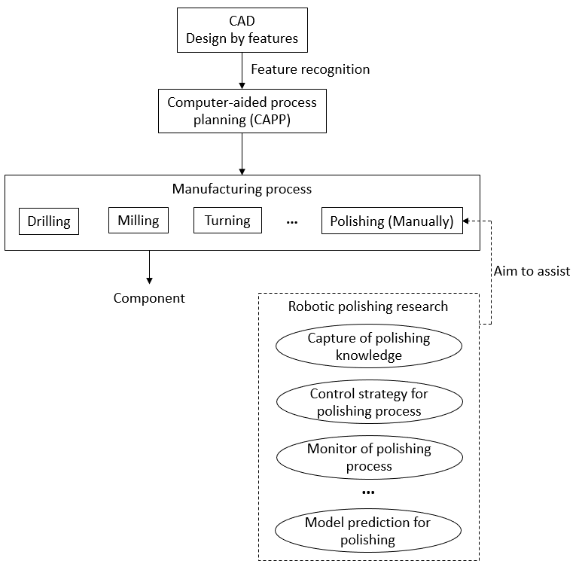
Figure 1 Current status of polishing process

Robot technologies have been rapidly developing since their adoption into manufacturing in the 1980’s, but its application to the polishing process is still limited. This is mainly because of two reasons. Firstly, research on robotic polishing have been carried out on various topics, such as model prediction for specific polishing process, control strategy for polishing process and polishing process monitoring. However, these efforts are restricted to, how to apply robot to carry out some polishing tasks which the manual work cannot or is difficult to fulfil efficiently. In other words, previous work on robot technology largely aims to assist manual polishing rather than substitute it. Secondly, it lacks information integration between current CAD/CAM systems and robotic polishing. As shown in Figure 2, a component is designed in a CAD system. Then through feature technology and an artificial intelligence-based CAPP, a manufacturing process planning is generated. As it can be seen, the generated process planning includes all machining processes (e.g., drilling, milling, turning, etc.) through all manufacturing stages from blank, rough machining, semi-finishing, and finishing. Obviously, the information related to the polishing processes (e.g., features 1 to 7 need polishing process and they will be carried out after grinding) is too general and is impossible to directly link to Robots. More detailed information is needed for robotic polishing processes, such as types of polishing tools, abrasive papers, polishing paths, process variable settings, and optimizing sequence of these robotic polishing processes. The gap between current CAD/CAM system and the robotic polishing needs to be filled.

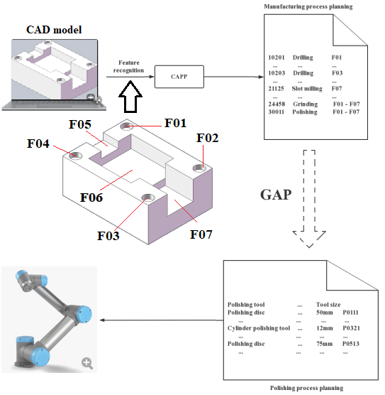
Figure 2 Obstacle to integrating robotic polishing with current CAD/CAM system

To solve these problems, a methodology is developed aiming to integrate robotic polishing with current CAD/CAM systems so as to replace majority manual polishing work. As shown in Figure 3, the proposed methodology includes two key tasks. Firstly, polishing features identification: An exploration is necessary to identify what types of features that robotic polishing is able to manipulate. Meantime, the characteristics of a small number of features that still need human polishing need to be investigated. Further, polishing process is usually carried out after finishing a series of cutting manufacturing operations. Though passed down from manufacturing features, polishing features could be different due to the different requirements of polishing process. A new classification of robotic polishing features based on the specific requirements of polishing process is needed to support following knowledge database development and automatic robotic polishing process planning. Secondly, robotic polishing process planning: A fast and automatic generation of polishing process plan is essential for an efficient robotic polishing. Different from general cutting manufacturing process planning, the work on polishing process planning is extremely limited. This research starts with designing a proper polishing process knowledge database integrated with the proposed new classification of polishing features. Then, constraints and evaluating system for polishing process sequencing are needed to design based on the specific requirements for polishing process. Finally, an enhanced polishing process sequencing algorithm can be developed.

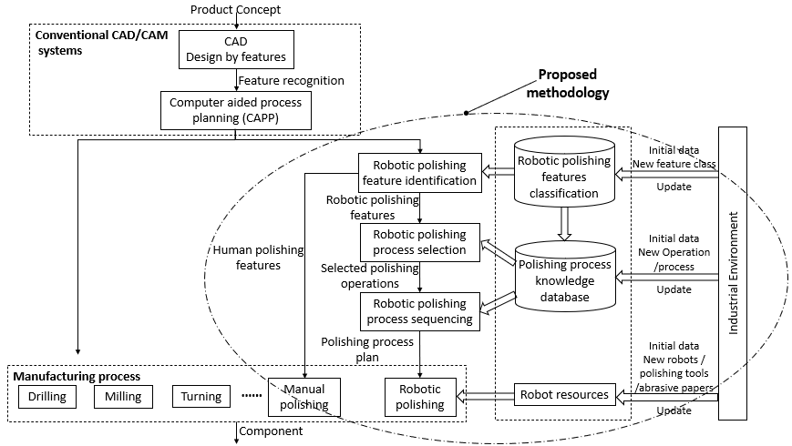

Figure 3 Framework of the methodology for robotic polishing

Currently, this research focuses on the manufacture of moulds. However, the proposed methodology is built on extendable structures, including i) an open, hierarchical structure for the new polishing feature classification is able to expand from different levels when a new feature class required; ii) The polishing process knowledge database is adaptable for a new industrial environment (e.g. new feature class required, different polishing tools and robots, etc.) through collecting initial data and knowledge from experts, updating day-to-day practices, and proper database management; iii) The rules of polishing process sequencing are designed on a hierarchy structure and can be expanded easily based on new requirements. Meanwhile, the related weights of constraints are able to update according to the different industry requirements. Therefore, the proposed methodology has the capability to broaden to universal applications.

Polishing feature identification

Robotic polishing features
A series of experiments are carried out to explore robotic polishing on various machining features, especially features on the components of moulds. As shown in Figure 4, all these experiments use a six degree of freedom UR5 (Universal-robotics, 2022) Cobot integrated with various types of polishing tools, which are mounted on the polishing end-effector module of the robot arm. Some examples of the application of the industrial abrasive polishing tools are shown in Figure 5. The system has 16 unique polishing tools all supportive of the fine grain polishing methods under contact mechanics theory (Preston, 1927). Ranging from white corundum, points, cylinders, and discs for hardened moulds to quick change disc and flap cylinders for generic polishing and woollen pad disc and cylinders for buffing operations. The range of tooling is also expanded as the 25mm and 50mm quick change tooling has replaceable discs ranging from 400 to 2000 grit (FEPA Standards 42-1:2006) and (ISO 8486) as shown in Figure 6. The woollen tool range is also expanded further using blue to yellow range lapping/ polishing compounds (Engis.com, 2023). Although use of these requires an additional ‘dipping’ process to regularly replenish the compounds. Within the polishing process knowledge database (cf. Figure 3), the rotational speeds and feed rates and number of passes for the respective tools are retained. These have been derived from pre-existing process models, data driven models and further testing by the authors for specific tooling (Fernandez et al, 2015; Rososhansky and Xi, 2022; Wu et al., 2022; Marquez et al 2005; Wang et al., 2019). The current execution of the approach is reliant on fixed constant pressure derived from compliance in the tools and collaborative robot (Wang et al., 2019). In the current setup the polishing motion paths follow a raster pattern, and for protrusion type feature follows an edge path trajectory.

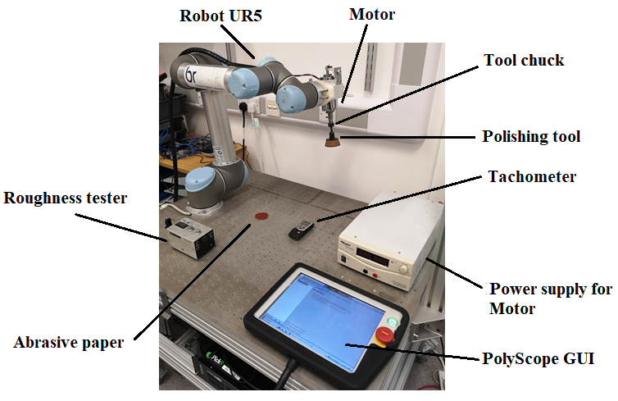

Figure 4 Polishing experiments using a UR5 robot

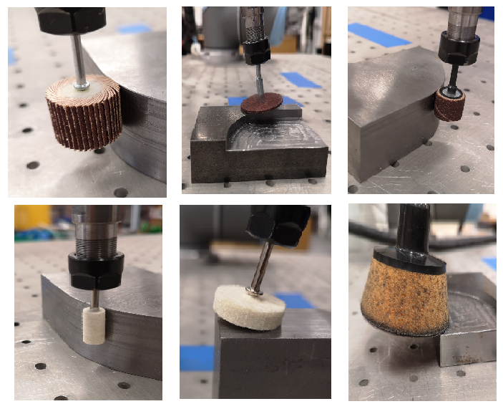
Figure 5 Robotic polishing with different tools

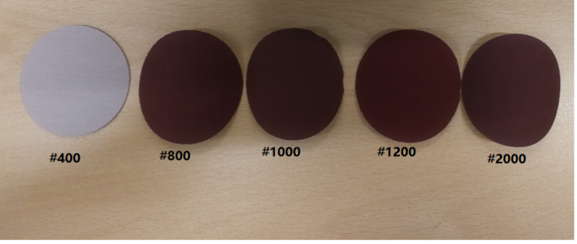
Figure 6 Different types of abrasive papers

An example is shown in Figure 7, which includes three polishing features: a slot, an edge protrusion, and a flat surface, each of which has a starting surface roughness (Ra) of 1.14µm to 1.41µm for flat surfaces and 1.01µm to 1.12 µm for the vertical. prior to the polishing process. Two types of polishing tools (i.e., polishing disc and cylinder polishing tool) with four types of abrasive papers (i.e., #400 to #1200) are involved with this polishing. Where the number, #400 etc. relates to size of the grain of abrasive media on the pad. The feed rate and the tool rotation speed are set to 400 mm/min and 1500rpm, respectively. With the depth value of 0.75mm, the final Ra of the workpiece is achieved to 0.1 µm. The whole polishing process lasted about 400 secs.

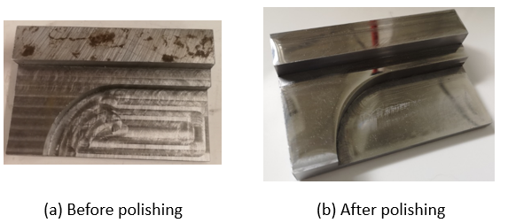
Figure 7 A component with three different features for polishing experiments

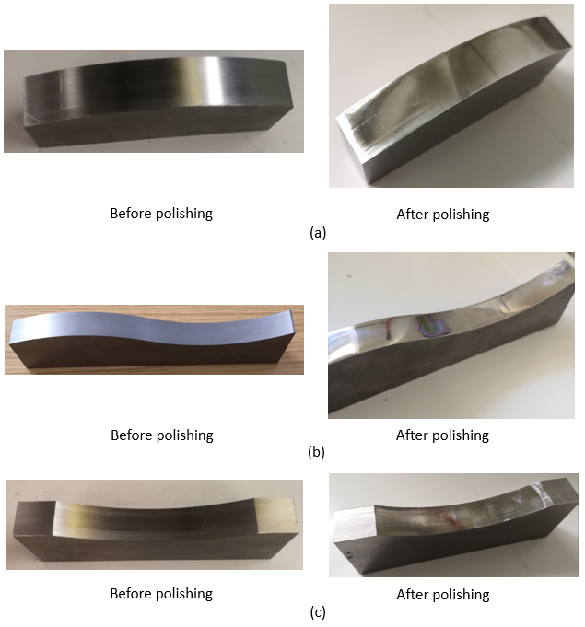
Figure 8 Polishing experiments of test components with different features

More examples are given in Figure 8 (a) – (c). Based on these experiments, it can be seen that a number of features can be efficiently polished by robots, including most of 2.5D prismatic machining features and free-form surface features.

Human-polishing features
Although robots are capable of polishing a number of manufacturing features, there are still a small number of features need human-polishing. Based on the experiments in this research, it can be seen that there are various reasons, which make features not suitable for today’s robotic polishing, such as polishing tools on robots are unable to access features, or robotic polishing tools cannot satisfy accuracy requirements, etc. Figure 9 illustrates examples, which polishing must be carried out by human operator. In general, the following polishing situations are considered to set by human:

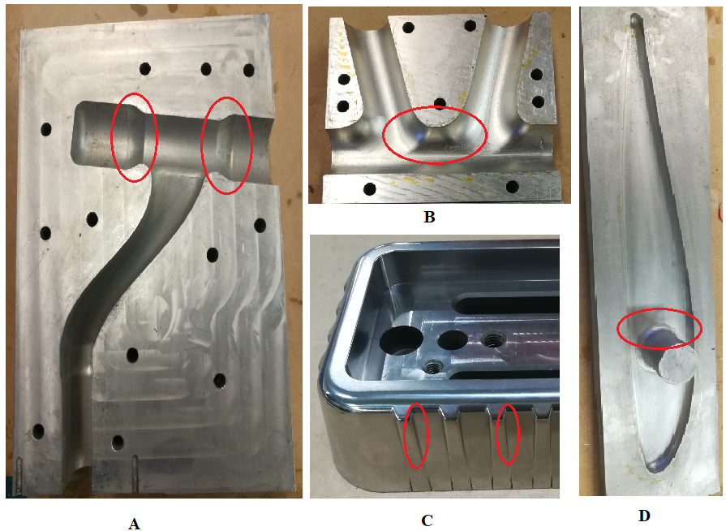

Figure 9 Unsuitable features for robotic polishing

- Complicated geometrical section, especially the interacting area of two complex features. Such sections usually are difficult to describe using mathematical expressions, which make it is impossible for robots to plan the tool path for (e.g., Figure 9 – A and B).
- The features, which are difficult to access by robots due to the restrictions of the polishing tools that can be mounted on the robot arm. This could be due to the locations of the features (as shown in Figure 10, where it is hard to access in the vertical plane); the tiny size of the polishing area or some polishing tools that may not be supported by robots.
- Extremely high requirements on accuracy, which would be difficult for robots to achieve on their own. Additionally, tools (for example a felt and a diamond paste) would be required for further improvements on surface roughness.
- The narrow area with a high accuracy, which robotic polishing tools cannot avoid damage to other part (e.g., Figure 9 - C and D).

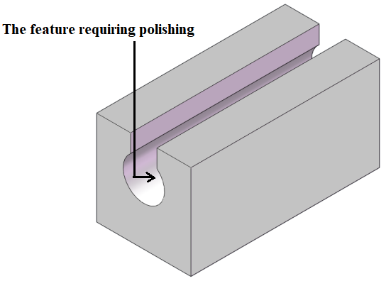
Figure 10 Exemplary feature unsuitable for robotic polishing

Classification of robotic polishing features

As described in section 4.1, the features, which can be polished by robot, cover widely from a simple geometrical feature (e.g., a through hole) to a complex surface (e.g., free-form surface). Thus, in this research, the features considered cover a majority of the primitive features, which are likely to be of interest for the application of polishing process on the components of moulds, including:
- 2.5D prismatic machining features
- Free-form surface features which can be expressed or approximately expressed by mathematical model.

The polishing processes for these features could be completely different in various aspects, e.g., operation variables setting. Figure 11 gives different polishing process settings for a through hole feature and a wave curved surface feature, respectively. To support rapid robotic polishing process planning, including tools selection, operation variables setting (e.g., polishing tool approach direction) and process sequencing etc., a robotic polishing feature classification needs to be defined.

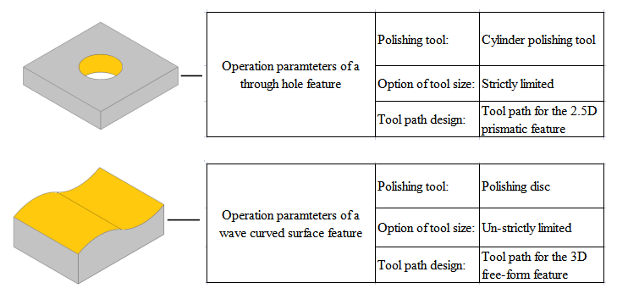
Figure 11 Different polishing process settings for two features

There are several manufacturing feature classification methods according to different applications (e.g. Babic, Nesic and Miljkovic, 2008, Verma and Rajotia, 2009, Zehtaban and Roller, 2016). Generally, those classifications are based on either the features’ geometry, machining attributes (e.g., operations associated with turning machining, milling machining or three-axis machining centre), combined geometry and machining operations (e.g., Opitz coding system, or international standard, i.e., STEP (STandard for External representation of Product data). However, these traditional classifications are designed by general manufacturing process view, which consider crossing rough, semi-finish to finish machining, and are related to various types of machining, like milling, turning, drilling. Obviously, the requirements for robotic polishing processes are completely different. Issues related to operation control, polishing tools selection, tool path generation are major factors needed to be considered for robotic polishing feature classification. For example, the UR5 robot can uses simple MoveL commands to create a linear movement on the surface of the component. Differently, for a component with the 3D free-form features, a series of circle move commands, called MoveP, is usually used for creating more sophisticated tool path. Another example presents in Figure 12. For the top surface of the external feature (shown in Figure 12 (a)), a large polishing tool size is likely chosen due to better efficiency (i.e., ø75mm). On contrary, for the bottom surface of the internal feature (shown in Figure 12 (b)), a small tool size is selected because of the constriction of feature dimensions (e.g., ø50mm).

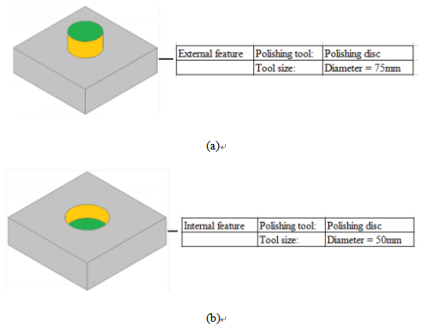
Figure 12 Tool size selections for different features

Figure 13 gives another example about requirement of different tool approach directions. For the closed features, the polishing tool needs to move over the feature firstly and then move down to the surface of the feature. However, for the open features, the polishing tool can move directly down to the same horizontal plane as the feature surface and then slowly move close to the feature surface.
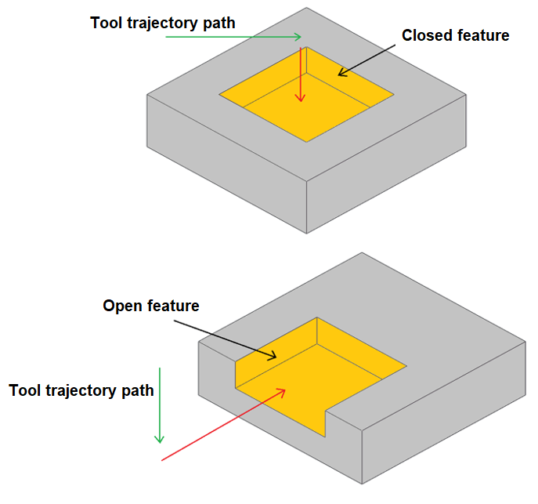
Figure 13 Tool trajectory paths for the closed and open features

Therefore, based on polishing process attributes, including types of operation control, selections of tool sizes, generation of tool path and tool approach directions, a new feature classification specially for polishing process is proposed, which is shown in Figure 14. The classification covers polishing features that are most likely to be interest for the application of polishing process on the components of moulds. Meanwhile, the proposed classification is hierarchical, where a subclass inherits common properties from a higher class. Thus, as an open structure, without damaging current feature classes, the classification is able to expand across different levels for a new polishing feature class which could appear in the future due to technology development and new requirement of polishing environment, such as self-defined class.

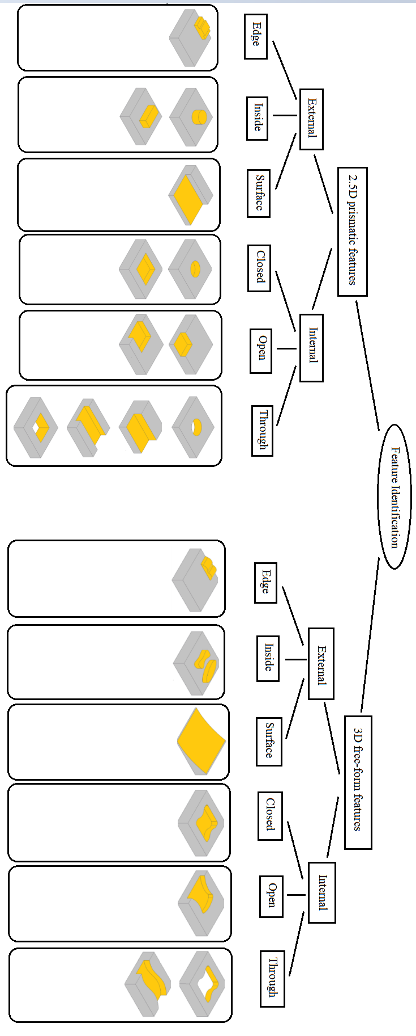
Figure 14 Illustration of feature identification

Selection of polishing process

Polishing process knowledge database
To efficiently support robotic polishing, a fast and effective generation of polishing process plan is essential. It involves two aspects:
- Determination of appropriate polishing operations: including selecting polishing machine, polishing tools, and abrasive papers; and setting polishing process parameters, e.g., rotation speed, feed rate, etc.
- Rapid generation of process sequence based on relevant rules and constraints.

Both parts are heavily dependent on broad polishing process knowledge and supporting resources information. Thus, a suitable polishing process database is needed. However, the requirements of the polishing process database are different from the database for traditional cutting manufacturing process. For the cutting manufacturing process planning, the component is firstly identified as a number of manufacturing features. Then, one/multiple cutting operations are chosen for each feature according to its feature type. For a manufacturing feature, all of its geometrical parts are made by same machines and cutting tools at the same time. For example, slot milling operation is chosen for the feature shown in Figure 15 based on its feature type (i.e. blind slot). Its geometry is produced on a milling machine with a slot milling tools. Thus, cutting manufacturing process database is generally built based on manufacturing features (i.e. feature-based process and operation libraries). Differently, polishing process is carried out after cutting manufacturing, which the basic shape has already been generated. Thus, it is not necessary all geometry of a feature use same polishing tools and abrasive papers, even if same polishing machine. The same example shown in Figure 15, two type of polishing tools are choose for the blind slot feature. Polishing disc is used for the base surface (Part 1) while cylindrical polishing tool is applied for the face chain (Part 2). Each of these geometrical groups (e.g. Part 1 or Part 2) in a feature, which is polished using same tools, abrasive papers, and setups, is defined as polishing operation-part. Obviously, feature-level is not enough for polishing process database and further break down to polishing operation-part level is needed.
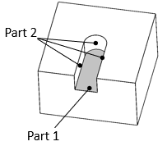
Figure 15 A component with a blind slot
As shown in Figure 16, a database for the polishing process planning is designed, which consists of 11 libraries covering three aspects: polishing operation-parts information, polishing resources, evaluation information for polishing process sequencing. Polishing operation-parts information includes the information described the polishing feature types and their polishing operation-parts. The feature type library is constructed based on the classification of the polishing features defined in the Section 4.3. As it can be seen, the feature type library is further divided into a number of polishing operation-part libraries. The polishing operation library and the process library are directly linked to the polishing operation-part libraries rather than feature type library. Polishing resources consist of five libraries, describing the information of various polishing operations and processes, and the corresponding resources provided in the industrial environment, such as robots, polishing tools, and abrasive papers. Evaluation information for polishing process sequencing stores the information supporting evaluation of the polishing process optimization, which is discussed in the Section 6, such as Tools change library.

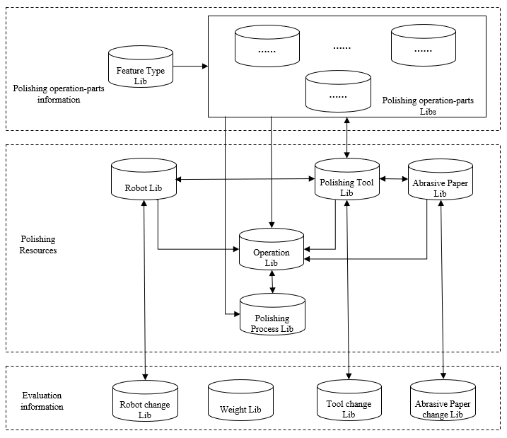
Figure 16 Database for the polishing process planning

Obviously, the above libraries are not isolated and possibly link with each other. For example, the operation library has a Many-to-One relationship with the polishing operation-parts library, which means the specific polishing operation-part for a certain feature class can be related to multiple operations stored in the library, but each operation is only linked to one specific polishing operation-part of a certain feature class. To increase the effectiveness and validation, the procedures for database management are introduced. For example, when a new feature class in introduced, the class and its corresponding polishing operation-parts have to be stored in the library firstly. A new operation can and only can be stored in the library when its related polishing operation-part has already existed in the library. On the other hand, when a certain feature class becomes obsolete, its corresponding polishing operation-parts will be abandoned in the library, and therefore all operations linked to these polishing operation-parts will be removed from the library at the same time. There is a same Many-to-One relationship between polishing process library and the polishing operation-parts library. Such relationship is kept consistent through the operation library. A valid polishing process consists of a number of operations which link to the same polishing operation-part. Thus, the process inherits the linkage to polishing operation-part from the operations. One process is only linked to one polishing operation-part, while a polishing operation-part could link to one or more processes. Furthermore, a new process is only allowed when the operations it includes are already stored in the library. Thus, the polishing operation-part the process linked to has to be exist in the library. When a polishing operation-part is abandoned, its related operations will be removed, and therefore processes include this operation will be removed simultaneously. Similar relationship also exists between the operation library and polishing tool library. Each polishing tool can be used by multiple operations, but each operation only uses one polishing tool. An operation is only valid when the polishing tool it used has stored in the library. When the polishing tool is removed from the library, the correspond operations will be invalid and abolished from the library. The relationships among the libraries and the procedures to maintain these relationships make the polishing process knowledge database to avoid any conflict occurs during future adaption to meet new requirements.

The polishing process knowledge database should be based on a number of working experiences and various of the knowledge from experts, skilled workers, and a range of pre-existing. In this research, the initial data is collected from a number of experimental works. As the proposed database has an open structure, it is able to continually update knowledge according to the different production environments, day-to-day practices, and future technology development, e.g., different models of robots and new sets of polishing tools.

5.2 Polishing process selection
Based on the polishing process knowledge database, an appropriate polishing process can be determined for each polishing operation-part according to its polishing specifications, such as feature and part type, dimensions, start surface finish, final surface finish requirement, etc. As shown in Figure 17, the selection procedure includes three main steps:
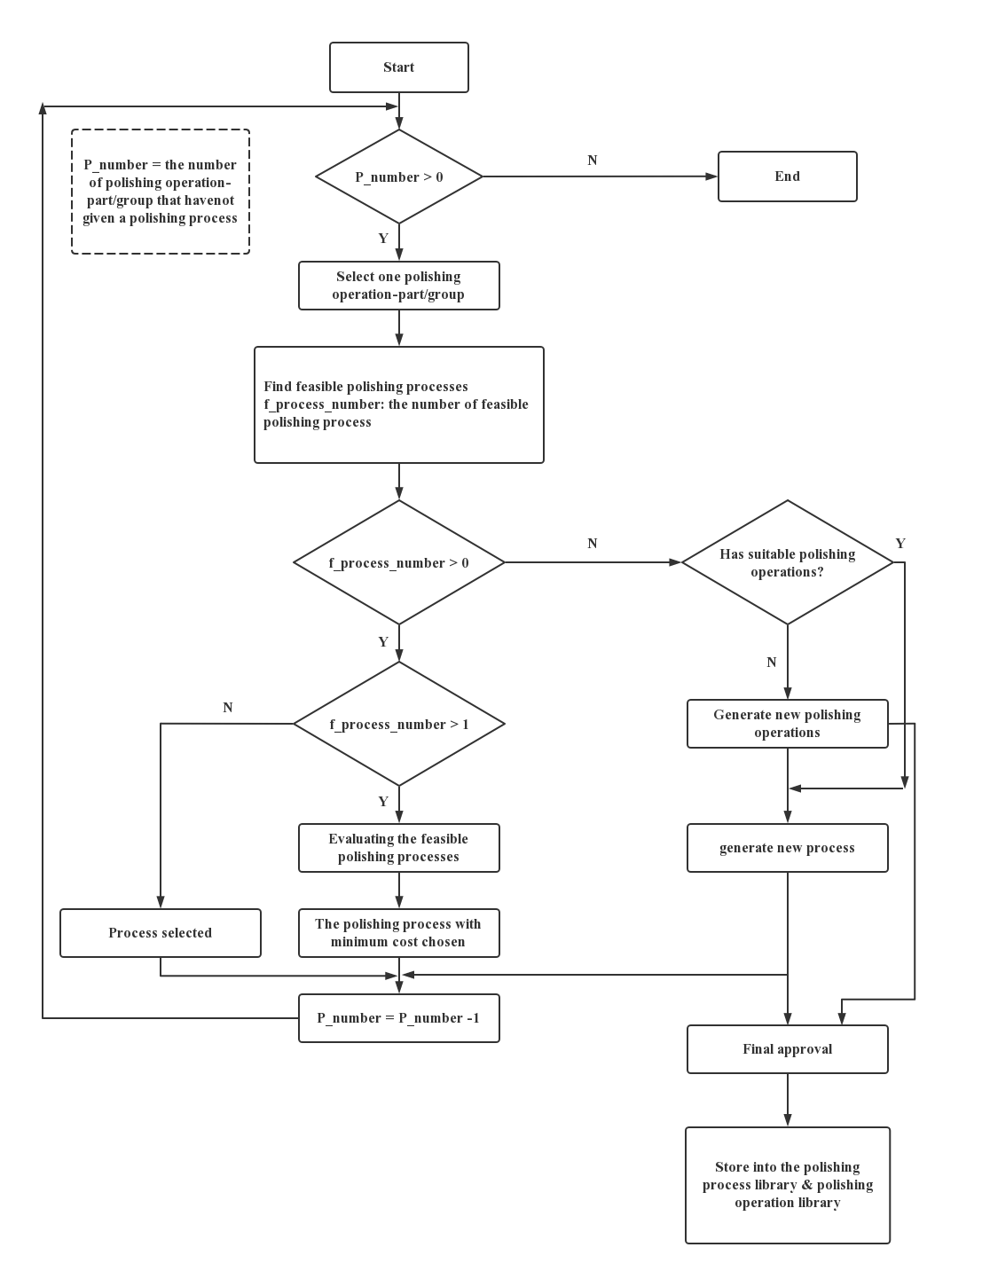
Figure 17 The procedure of polishing process selection
Step 1: Find all feasible polishing processes from the polishing process library for a polishing operation-part based on its type, size, start/final surface finish requirements, etc.
Step 2: If a polishing operation-part has more than one feasible process, these possible polishing processes will be evaluated and the one with minimum polishing cost will be chosen.
Step 3: If there is no feasible process for the polishing operation-part, a polishing process can be generated manually using the polishing operation library; or using machine library, polishing tool library and abrasive paper library to create polishing operations firstly. All these new processes and operations can be stored into library for future reuse through a final approve.

Robotic polishing process sequencing
Operation sequencing plays an important role in the polishing process planning. An optimal process sequence could largely increase the polishing efficiency, decrease the polishing time, and support fully implementation of robotic polishing.

Process sequencing rules for robotic polishing
In general, the process sequence rules consist of two aspects: precedence constraints and successive constraints. The process sequence rules for general cutting manufacturing and polishing process share some same principles. Some of basic process sequence rules are consistent, such as for a geometrical entity, its rough operation must be arranged before its fine operation; or for better efficiency, the operations with same machine, setup or tools should carry out successively to minimum changing time and cost. However, on the other hand, sequencing rules for cutting manufacturing process and polishing process have different requirements and focus on different considerations. Firstly, the general cutting operations are feature-based, and therefore the corresponding sequencing is feature-based as well. Differently, as discussed in Section 5, the polishing operations are further broken down to the subparts – polishing operation-parts. Thus, its sequencing process requires polishing operation-part-based. It means the polishing operations on different parts of a feature may not be arranged together due to various reasons, such as they could use different polishing tools or have different surface finish requirements. Secondly, the relationship of features plays a key role in general cutting manufacturing process sequencing, as its heavy impact on tool accessibility and efficient material removing. For example, as shown in Figure 18, obviously, the route II (i.e. machining the through slot before the pocket) is a better design than the route I (i.e. machining the pocket firstly, then machining the through slot) because the route II eliminates the repeated material removing. However, because polishing process is usually at later stage of manufacturing and majority of geometry have been generated by a number of cutting operations, the constraints due to such feature relationships, like tool access or repeated material removal, are not exist anymore. Instead, surface finish requirements between these connected entities decide the priority of their polishing operations. As the example in the Figure 18, if the parts of the pocket have lower surface finish requirements than the parts of the through slot, the parts of the pocket should be polished firstly. In addition, beside machine and cutting tools, an additional factor, abrasive paper is needed to consider in the polishing process.
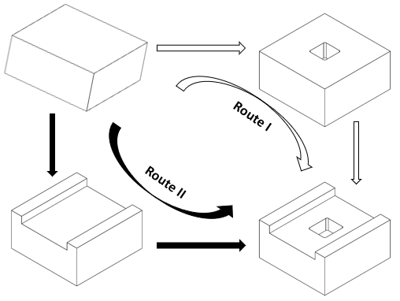
Figure 18 Example of manufacturing process planning

According to the requirements on both of polishing quality and efficiency, a hierarchy structure for polishing process sequencing rules has been developed, which is shown in Figure 19.

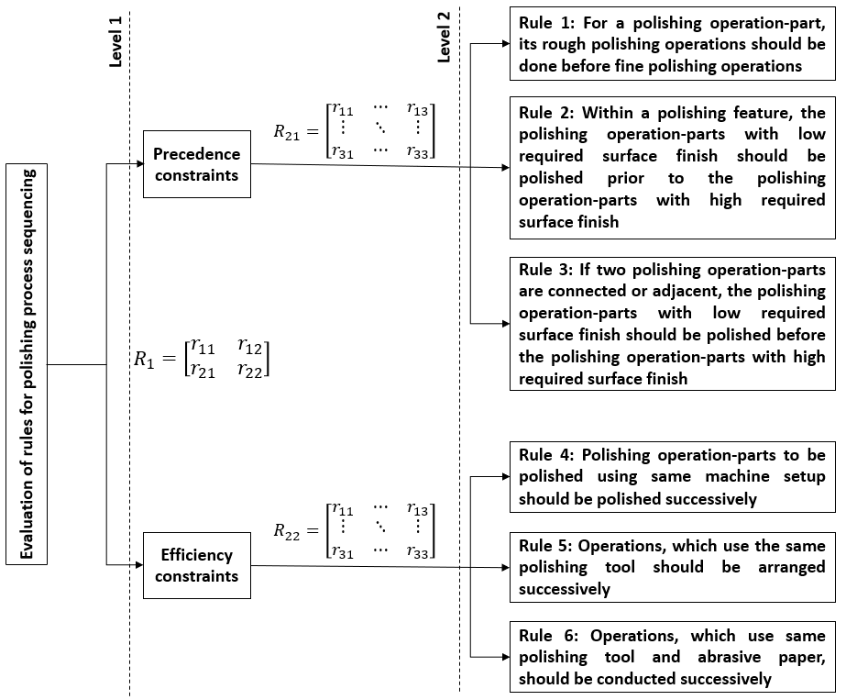
Figure 19 Structure for polishing process sequencing rules

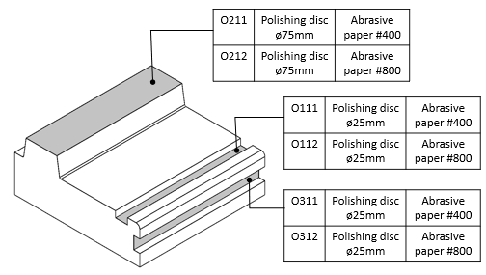

Figure 20 Example of rule conflictions of polishing process sequencing

In practice, it can be impossible to satisfy all sequence rules at the same time while some conflicts could be happened for a polishing process. For example, as shown in Figure 20, O₁₁₁ and O₂₁₁ should be performed successively due to the rule of polishing operations using same machine setup should be performed successively, but it does not satisfy with the rule of operations using same polishing tool and abrasive paper should be carried out successively. O₁₁₁ and O₃₁₁ give an opposing example. They should not be arranged successively according to different machine setups, but it conflicts as they use same polishing tool and abrasive paper. To avoid such conflicts, Analytic Hierarchy Process (AHP) has been applied. As shown in Figure 19, firstly, experts assess the relative importance by comparing each pair of two rules (i.e. r_{ij}) and specify the pairwise comparison matrixes. Then the weights of every element throughout this hierarchical structure are calculated using the Equation 1:

$$W_{i}=\frac{1}{n}\sum_{j=1}^{n}{\frac{r_{ij}}{\sum_{i,j=1}^{n}{r_{ij}}}}$$ | (1)

where j represents the column;
i represents the row.
n is the number of the columns (= rows) in the matrix R.

Each pair of operations in a generated polishing process sequence is evaluated on whether they are satisfied with these sequencing rules and corresponding positive decimal value is given for each rule, V_{kij} , which represents the satisfaction degree for rule k for operation pair i and j (i.e. the operation i prior to operation j). If the operation pair is against rule k, a large positive value is given (i.e., V_{kij}>1). The more conflict, the larger value. Finally, the degree of satisfaction of rules for the polishing process sequence, f_{p}, can be calculated using the equation 2.

$$f_{p}=\sum_{k=1}^{n}{\sum_{i=1}^{m}{\sum_{\begin{aligned}j=1 \\ O_{i}>O_{j}\end{aligned}}^{m}{{W_{q}W_{kq}^{s}V}_{kij}}}}$$ | (2)

Where $W_{q}$is the weight of the qth rule in the Level 1 for the polishing ability;
$W_{kq}^{s}$ is the weight of the kth rule (Level 2) for the qth rule in the Level 1;
V_{kij} is the degree of satisfaction for the kth rule (Level 2) if operation i is performed prior to operation j.

It can be seen that f_{p}≥0, and the lower the value is, the better satisfaction with the rules for polishing process sequence. In addition, this is an open evaluation structure, which is possible to adapt according to different industrial environment and future technology development.

Polishing process sequencing
Process sequencing is a complicated issue as it is influenced by several constraints, such as geometrical relationships, tool changing time, surface finish requirements, and so on. The Genetic algorithm (GA) is an adaptive heuristic search method based on population genetics (Kumar et al., 2010). The genetic algorithm has been widely used to process sequencing (e.g. Bo, Hua, and Yu (2006) and Fan and Wang (2012)) due to its advantages on solving complex and multiple constrained optimization and search problems. Recent work on GA-based manufacturing process optimisation is continued, such as Qi et al. (2017), Knust et al. (2017), Romero, Gengis and Baidya (2017), Su et al. (2018), Čuboňová, Dodok and Ságová, (2019), Wu and Li (2021). However, most of earlier efforts are made for general cutting manufacturing process or a specify process like hot forging process, and limited work on polishing process, such as the work by Khalick-Mohammad et al. 2017; Márquez et al., 2005; Mitropoulos et al., 2022; Pilný et al.,2016). As discussed before, comparing to cutting manufacturing process sequencing, polishing process sequencing has its own characteristics and priority considerations. To support the wider methodology, this research presents an enhanced GA-based polishing process sequencing modified based on the method proposed by (Wang et al., 2022) through an improved initialization algorithm and new crossover strategy.

    - Fitness function

Fitness function is a critical component for a GA, which represents the searching objective during the evolution process. A suitable fitness function has to be defined based on the requirements of polishing process sequence, including process efficiency, polishing quality, and special rules of polishing process sequencing. Thus, a fitness function, which considers both processing time and polishing process rules, is used:

$$Fitness=W_{t}f_{t}+W_{p}f_{p}$$ | (3)

Where f_{t} is the relative evaluating value for polishing process time, $f_{t}=\frac{T_{total_time}}{T_{max}}$
T_{total_polishing} is the time needed for the whole polishing process
T_{max} is the maximum polishing time allowed
f_{p} is the degree of satisfaction with polishing process sequence rules
W_{t} and W_{p} are the weights for evaluations of f_{t} and f_{p}, respectively. The values are given by the experts and therefore their values are able to be adapted according to the industrial environment.

    - Initialization

Initialization refers to a process that generate a number of solutions for polishing process sequence of a component as initial populations for GA search. In this research, an improved constraint-based initialization method is proposed. As shown in Figure 21, it considers two aspects:

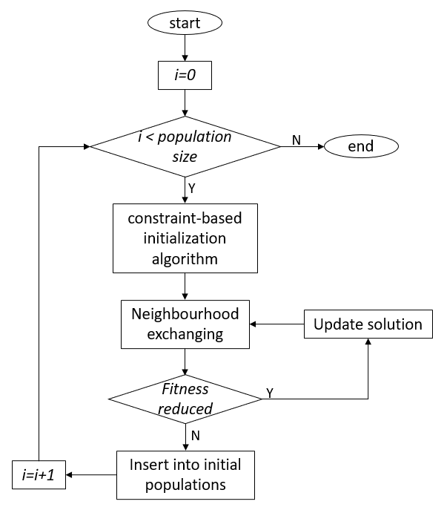
Figure 21 Improved constraint-based initialization

- Producing various valid solutions spanning the searching areas as wide as possible. Some constraints for polishing process sequence are not strictly needed (i.e., soft requirements), such as the constraints among polishing operation-parts, even if the polishing operation-parts belong to one feature. The hard requirement for a valid polishing process sequencing is the rough polishing operations of a polishing operation-part must be carried out before its fine polishing operation. Thus, the constraint-based initialization algorithm proposed by (Wang et al., 2022) is applied. As shown in Figure 22, an unselected polishing operation-part is picked up randomly. Then, each of all polishing operations for the picked polishing operation-part is assigned as an unoccupied position randomly, but in a strict sequence with its rough operation first, then semi-fine and finally fine operations. Such process is repeated until all polishing operation-parts are selected。

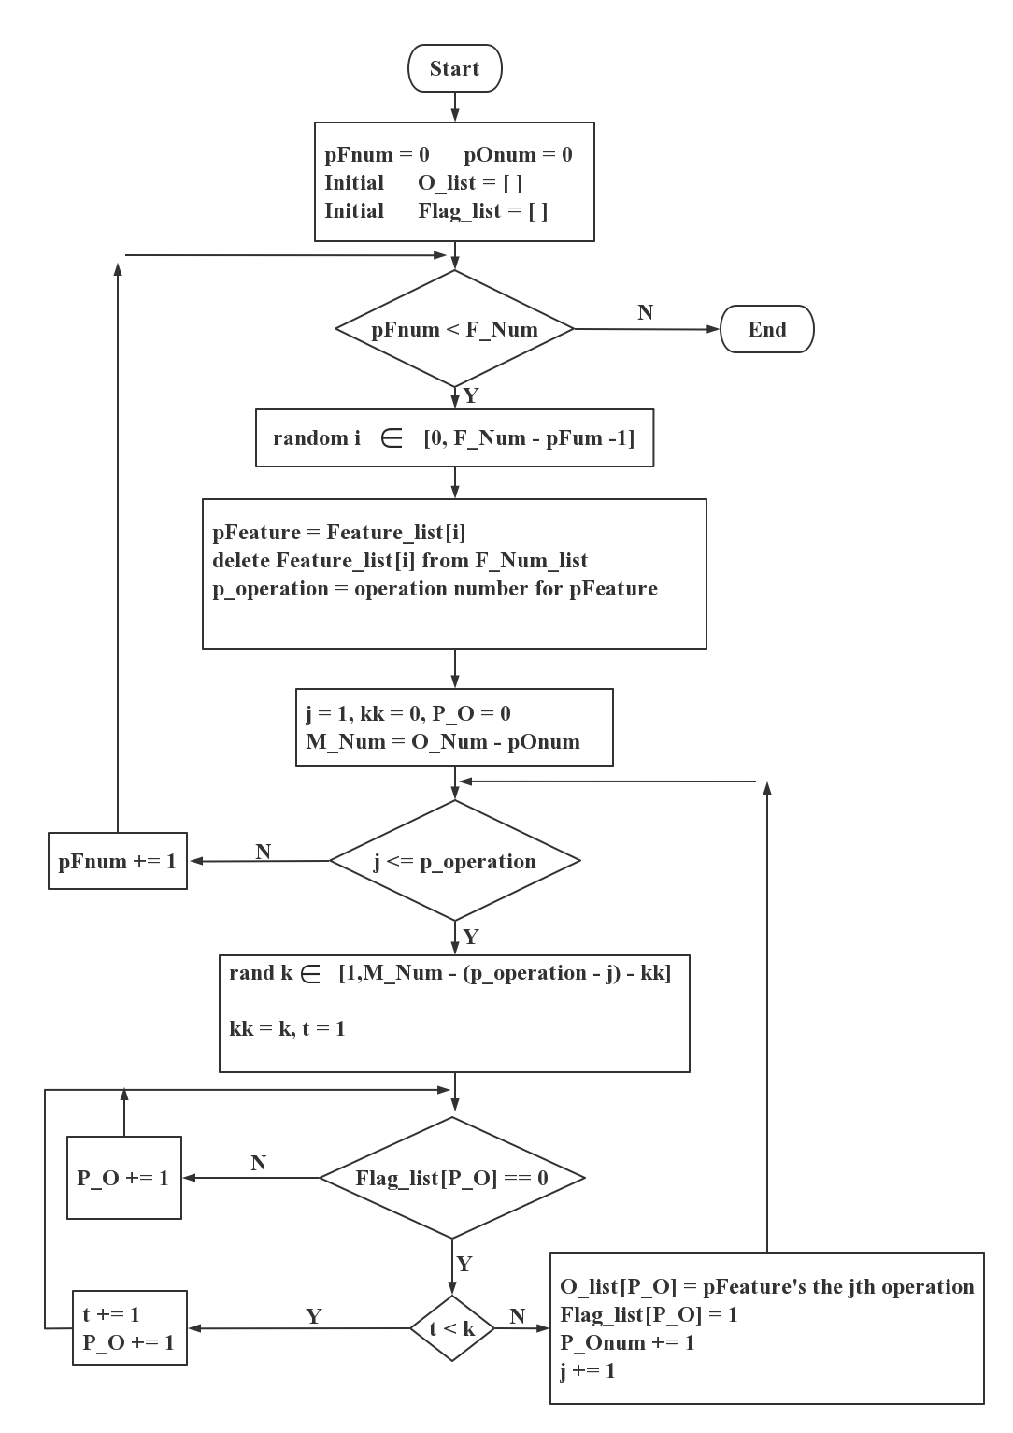
Note: F_Num: Number of polishing operation-part;
O_Num: Number of operations;
pFnum: Number of polishing operation-parts already sequenced;
pOnum: Number of operations already sequenced;
Figure 22 Procedure of initial algorithm

- Moving the solutions to the optimal or near optimal positions within their local search regions. As shown in Figure 23, a neighbourhood exchanging strategy, which two randomly selected adjacent operations are exchanged, is used. The iterating neighbourhood movement is continued until the fitness stops to reduce.

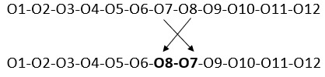
Figure 23 Examples of neighbourhood exchanging

    - Operators

Genetic algorithm includes three operators: selection, crossover, and mutation.

- Selection: Selection is used to choose individuals from populations as parents, which are able to reproduce new generation through genetic operations, such as crossover and mutation. In this research, the 'roulette wheel selection' strategy (Faris et al. 2019]) is applied. As expressed in the Equation 4, the selection probability (P_{i}) for each individual of the populations is calculated based on its fitness (F_{i}):

$$P_{i}=\frac{1/{F_{i}}}{\sum_{i=1}^{n}{1/{F_{i}}}}$$ | (4)

Where F_{i} is the fitness of the ith individual of the populations
n is the size of the populations

As the lower the value of F_{i} is, the better fitness. Thus, the individual with better fitness will have higher selection probability and therefore has more chance to be chosen as a parent.

- Crossover: Crossover operator is conducted after selection operator. It splits the selected ‘parents’ and then reassembles to form new ‘children’ for the next generation. To ensure the generated ‘child’ is valid polishing process sequencing, the type of crossover chosen is able to guarantee a) all operations must be included in a ‘child’ solution; b) each operation can appear only once in a ‘child’ solution; c) maintaining the precedence constraints in the ‘parents’ as much as possible. To satisfy with these requirements, two crossover methods are considered: a modified one-point crossover operator (Li, et al. (2002)) and Order Crossover operator (Kora and Yadlapalli, 2017).
As shown in Figure 24, for the modified one-point crossover operator, ‘parent’ is divided into two parts (i.e., part-I and part-II) by a random splitting point. The first ‘child’ is created by the part-I of the first ‘parent;’ and the bits of part-II of the first ‘parent’ but with their sequences in the second ‘parent.’ The second ‘child’ is composed of the part-I of the second ‘parent;’ and the bits of part-II of the second ‘parent’ in the order of they are in the first ‘parent.’

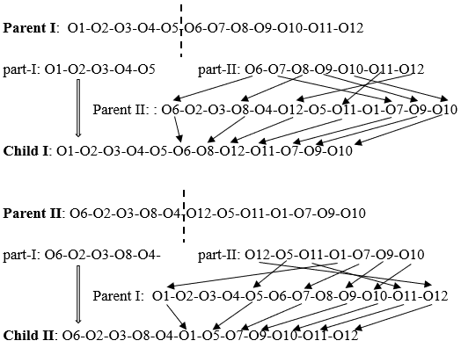
Figure 24 Examples of modified one-point crossover

For Order Crossover operator, as shown in Figure 25, a subpart is randomly selected. The first ‘child’ is produced by copying the selected subpart of first ‘parent’ into the corresponding position and the unselected bits with the orders in the second ‘parent.’ Same, the second ‘child’ is produced with the selected subpart of second ‘parent’ in the corresponding position and the unselected bits based on the sequences in the first ‘parent.’
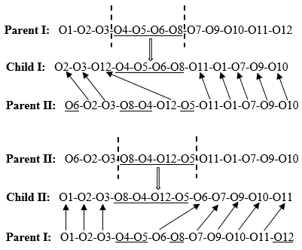
Figure 25 Example of Order Crossover

The modified one-point crossover operator and the Order Crossover operator provide different possibility for new generated ‘child,’ but both ensure the valid solution with the intention to preserve the precedence constraints in the ‘parent.’ It does not show much difference on performance when either the modified one-point crossover or the Order Crossover is applied individually. Meanwhile, the running time is obviously doubled when both of crossover operators are used for the same parents at every crossover step. Thus, a multi-crossover method, which randomly choose one of these crossover operators at each crossover step, is adopted. The application of the multi-crossover method shows a good improvement on performance without extra running time. The performance will be further discussed in the section 6.3.
- Mutation: Mutation may be used after crossover through randomly altering one or more bits of the new generated ‘child’ solution. Same with crossover, the mutation strategy needs to ensure that the new solution includes all operations, and each operation appears once only. Thus, the mutation operation applied in this research is randomly choosing and swapping two bits of the solution.

    - GA parameters and performance

Figure 26 described the procedure of the proposed enhanced GA-based polishing process sequencing. Once the fitness function does not decrease anymore (i.e., termination condition), the searched solution (i.e. the final polish process sequencing) reaches its best optimal point, and therefore the iterative search process stops.

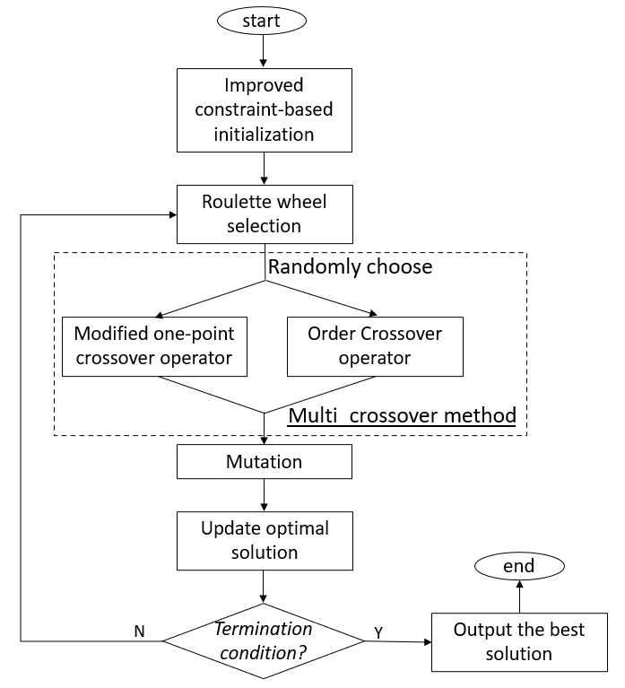
Figure 26 Procedure of the enhanced GA-based polishing process sequencing

With the improved constraint-based initialization, polishing operations for each polishing operation-part is strictly obey the precedence rule, that is, its rough operation is always arranged before its fine operation. This precedence constraint could largely reduce the valid search space. In general, polishing process for a polishing operation-parts includes one to five polishing operations. Therefore, with same number of operations, the search area for polishing process sequencing may be much smaller compared to other optimization problems with randomly initialization. Based on experimental results, in this research, the population size is specified as six times of the number of polishing operation parts, which the polishing process involves.

Figure 27 shows an example of GA search process with and without mutation. It can be seen that without mutation, the fitness is reduced sharply, but quickly converges at a high value – a local minimum. Oppose, although the search process with mutation may be a little slow, but it is able to converge a better fitness, which means receiving better solution. It is because mutation allows more search area and avoids local minimum. However, on the other hand, too high mutation rate could convert search process into a random walk and prevent to converge to any appropriate solutions. Therefore, the mutation rate in this research is set as 0.1.

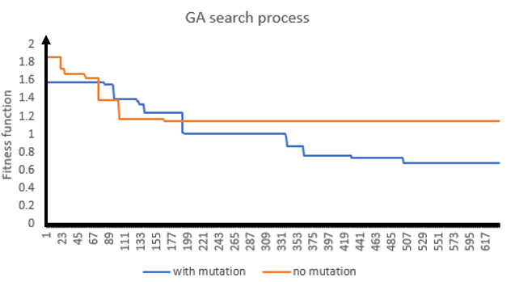
Figure 27 Comparation of GA searching process with and without mutation

Comparing to GA-based polishing process sequencing proposed by Wang et al (2022), the enhanced method applied multi-crossover method and new improved constraint-based initialization. The experimental results show that the proposed enhanced method achieved the better performance. Figure 28 presents an example of polishing process sequencing, which is composed of eight polishing operation parts and thirty operations. The population size is setting as 48, the crossover rate is chosen as 0.8 and mutation rate is 0.1. It can be seen that both methods are able to conduct optimization successfully. Two methods converge to similar optimum result, though the enhanced method gains a slight better fitness. However, the enhanced GA-based method optimizes faster, which the enhanced method shows a more rapid fall in the Figure 28. Moreover, it also shows that the enhanced method arrives the optimizing point quickly with less steps.
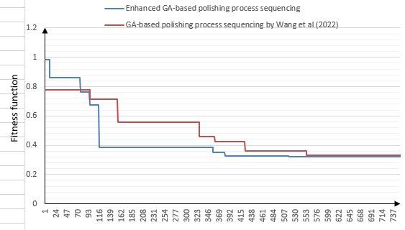
Figure 28. Comparison of proposed enhanced GA-based polishing process sequencing and the GA-based polishing sequencing by Wang et al (2022)

Implementation and case study
- Phase I: Design component

The component is firstly designed in the Solidworks 2020 environment. The CAD model (shown in Figure 29) and the corresponding cutting manufacturing information are then passed to both workshop and the polishing feature identifier for the next stage.

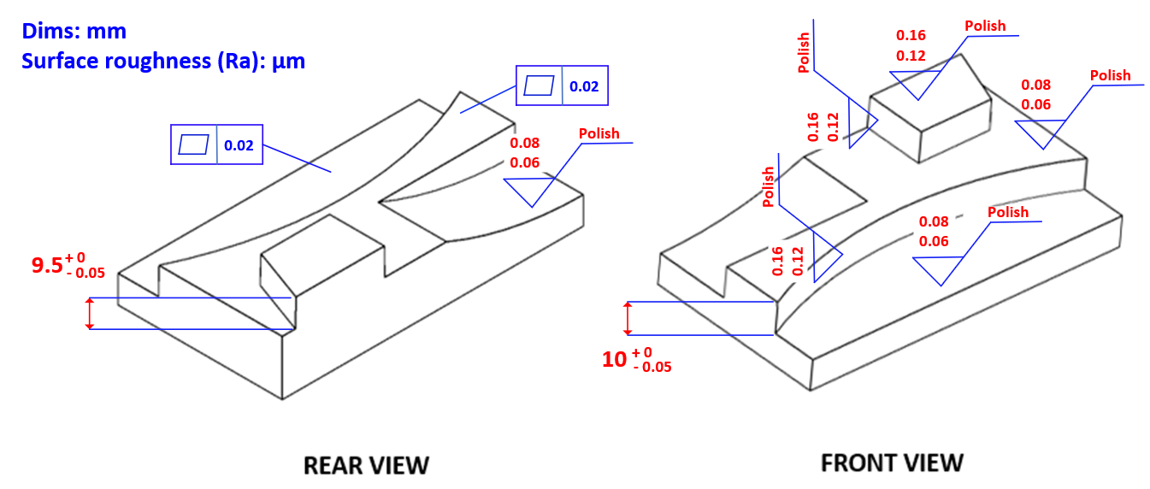

Figure 29 Finishing CAD model of component
- Phase II: Polishing feature identification
On one hand, the metal stock is sent to the workshop to implement all cutting machining prior to polishing process so as to gain required starting surface roughness values. The die insert is manufactured from P 20 steel with a hardness of 300HBhn (composition : Carbon – 0.33%, Manganese – 0.80%, Silicone - 0.65%, Chromium - 1.75% , Molybdenum - 0.40%). The cutting machining process are carried out on a 3-axis Bridgeport VMC 600 Vertical Machining Centre. The draft angle on the vertical faces was cut use a 1⁰ conical end mill. Figure 30 is the component which all cutting machining prior to polishing process have been finished, with its post machining surface roughness’. The surface roughness was measured using a Mitutoyo Surftest SJ210 profilometer, with an evaluation length of 4mm (ISO 4287: 2000).

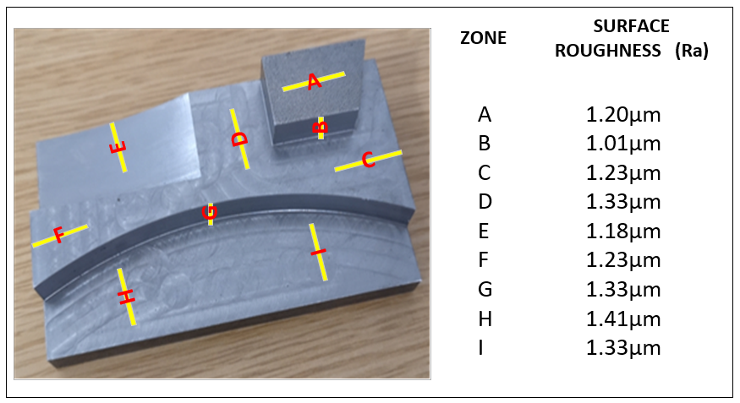
Figure 30 The post machined component

On the other hand, its robotic polishing features and their related operation-parts have been identified according to the proposed robotic polishing feature classification. The details are given in Figure 31, which include four polishing features and seven polishing operation-parts.

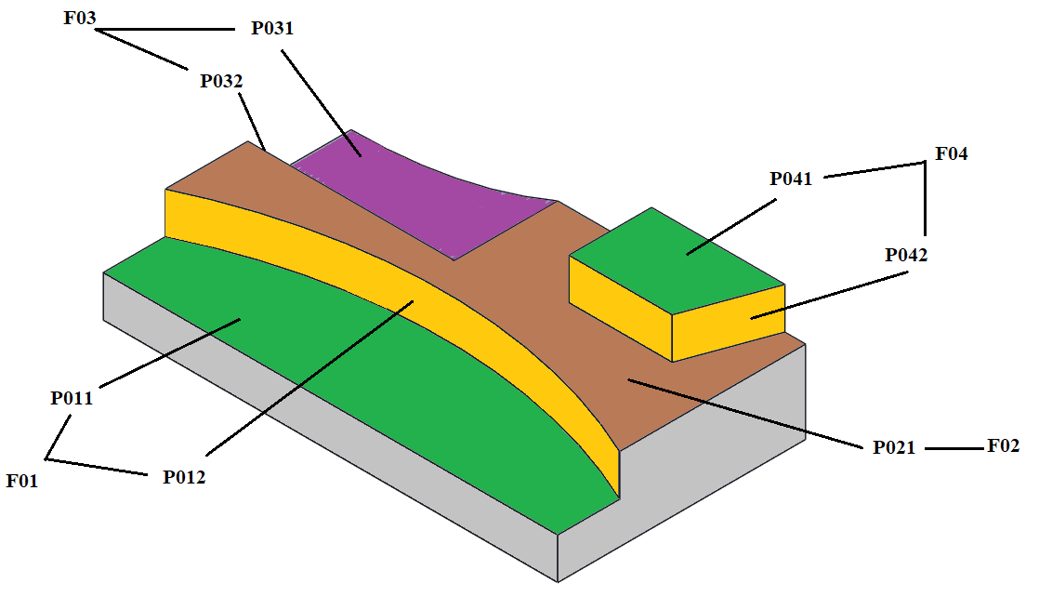
Figure 31 Polishing features and their polishing operation-parts for case study

- Phase III: Polishing process planning

A prototype system based on the proposed method has been implemented to carry out the polishing process planning using Python 3.9.6. It includes three modules: polishing process selection, polishing operations sequencing, and an assistant database management. As shown in Figure 32, the module of polishing process selection has been used to generate a suitable polishing process for each polishing operation-part, each of which includes one or more operations. The selection is given in the Table 1. Where Part_ID refers to the ID of polishing operation-part shown in Figure 31; The robot (i.e., Robot_ID: M001) is UR5 Cobot robot, and Table 2 gives the detailed information of polishing tools.
.
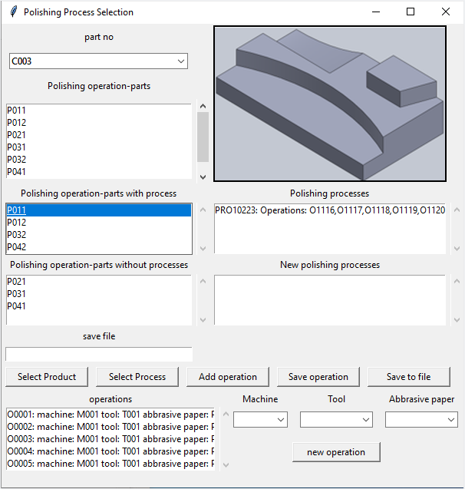
Figure 32 The module of polishing process selection for case study I

Table 1 The output of the polishing process selection for the component

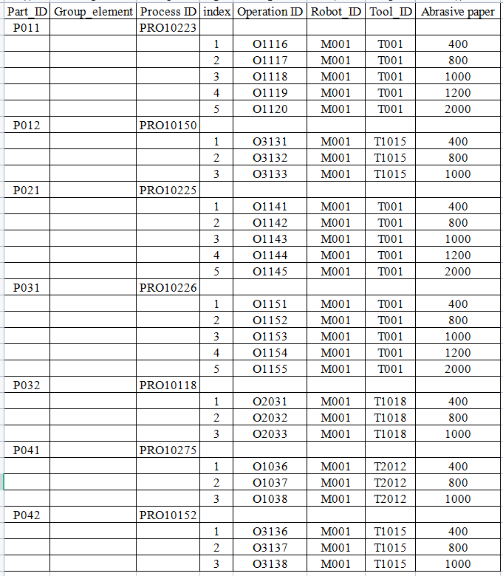

Table 2 The information of polishing tools
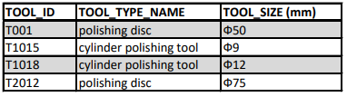

All these polishing operations were passed to the module of polishing process sequencing (shown in Figure 33) and optimized for best fitness. The final process plan is presented in Table 3.

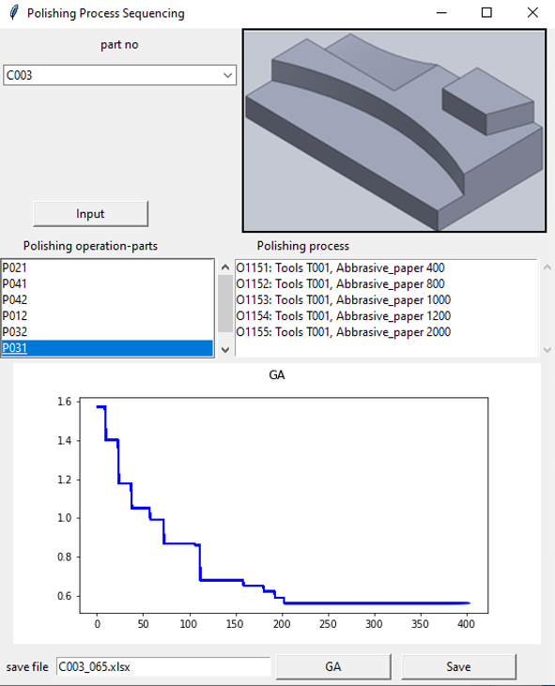
Figure 33 Polishing process sequencing for the component

Table 3 The final process plan for the component

Sequence  No | Operation  ID | Part  ID | Sequence  No | Operation  ID | Part  ID | Sequence  No | Operation  ID | Part  ID
1 | O1141 | P021 | 10 | O1038 | P041 | 19 | O1143 | P021
2 | O1151 | P031 | 11 | O2032 | P032 | 20 | O1118 | P011
3 | O1116 | P011 | 12 | O2033 | P032 | 21 | O1153 | P031
4 | O2031 | P032 | 13 | O3132 | P012 | 22 | O1144 | P021
5 | O3131 | P012 | 14 | O3133 | P012 | 23 | O1119 | P011
6 | O3136 | P042 | 15 | O3138 | P042 | 24 | O1154 | P031
7 | O3137 | P042 | 16 | O1117 | P011 | 25 | O1155 | P031
8 | O1036 | P041 | 17 | O1142 | P021 | 26 | O1120 | P011
9 | O1037 | P041 | 18 | O1152 | P031 | 27 | O1145 | P021

- Phase IV: robotic polishing
A UR5 commercial Cobot is used for carrying out each polishing operation in order based on the generated sequence. The robot settings: speed of robot was 1500 rpm; the feed rate was 400 mm/min; and polishing depth was set to 0.75mm. There are four polishing tools, and eight types of abrasive papers were involved in these operations. Figure 34 gives the component after polishing process.

Figure 34 The polished component with surface roughness values
An Aberlink Extreme 350 co-ordinate measuring machine (CMM) is employed to measure the final component. The final dimensions of the part stated well within the tolerance (not surprising as the material removed during polishing already sat within the machining tolerance band). The feature that is often a consideration in polishing is flatness, with various abrasive tools, which can be a different polishing rate at the edge of features or a point where the tool enters and leaves the work piece. Measurements across zones ‘C’ –‘ F’ and zone ‘I’ –‘ H’ showed only a 0.005 deviation to flatness, across the whole face and edges.

Discussion
The results of the case study show the capability that robotic polishing takes on the daily mould polishing workload. Meantime, the automatic polishing process planning based on the proposed methods is demonstrated in the case study using the prototype system developed, including: firstly, a knowledge-based polishing process selection and, secondly, a GA approach for polishing process sequencing. Furthermore, the information integration of robotic polishing with CAD/CAM systems is achieved within the case study through the identification of robotic polishing features and their polishing operation-parts, and the automatic polishing process planning strategy. In conclusion, the case study shows that the proposed methodology is able to be implemented in the practical environment to allow robotic polishing to take majority of manual polishing workloads for mould manufacturing and achieve information integration with current CAD/CAM systems.

There were a few observations of the final results from the case study presented and some of the other soft and hard mould trials conducted, namely:

- Under polishing: As with many robotic finishing processes using direct paths from generated CAD, the approach suffers from under polishing on many of the tool materials combinations (Fernadez, 2015; Jin et al., 2017). Some of this may relate to the tolerance of the mean grain size of up to +/− 20% (FEPA Standards 42-1:2006; ISO 8486). Although the Cobot has high repeatability and angle accuracy there may cases where the deviation in actual position and required position may take polishing tool beyond the compliance of the tooling. It is this compliance which is relied upon to guarantee constant pressure (Wang et al., 2019). Additional rules in the process planning could potentially alleviate this, but also the design of new tooling such as that by Wei and Xu, 2022, can also counter this issue.

- Surface blemishes: It was observed that care had to be taken when polishing with #1200 and #2000 grit, scratching, shadows from previous polishing media and burning the surface of the workpiece can readily happen. Stopping motion path changes happening in the work piece, and changing the raster path by 90⁰, has shown to improve the outcome. But as a worst case this can leave a small amount of work for the human collaborative worker to conduct to rectify these blemishes.

Conclusions

To address the issues for the European manufacturing sector or low-cost production zones competition and the loss of skilled workers in the finishing phase of mould production, this paper has proposed a methodology to allow robotic polishing to take the place of majority of manual polishing activities for the manufacture of moulds and achieve information integration with current CAD/CAM systems. Although this research concentrated on the application of polishing process for the manufacturing of moulds, with the extensibility of the feature classification and the adaptability of polishing process knowledge database, the proposed methodology is able to expand to universal applications. This work has developed a number of new concepts, algorithms, and methods, which are highlight as below:

- Manufacturing features for robotic polishing have been investigated. The types of features that robotic polishing is able to process have been identified based on the results of the experimental work. The results show that the features, including 2.5D prismatic machining features and the free-form surface features that are able to be expressed or approximately expressed by mathematical model, can be efficiently polished by robots. Meanwhile, the main characteristics of features that need human-based polishing have been discussed and explained. Four situations that need to set by human have been pointed out.
- A new robotic polishing feature classification has been defined based on the specific requirements of polishing process. Combining with new concept called polishing operation-part, it provides a foundation for the polishing process planning. The proposed classification is an open, hierarchical structure and therefore is easily extended for a new robotic polishing feature class which could appear in the future for a new industrial environment. Such extension is allowed to happen at any levels without destruction of existing feature classes and their corresponding hierarchical arrangements. Thus, although the classification was initially proposed based on the majority of polishing features on components of the mould, including 2.5D prismatic machining features and Free-form surface features, the presented classification can be considered to be generally applicable, not only limited to the mould manufacturing.

- Polishing process planning has been developed to extend current CAD/CAM for efficient robotic polishing. The robotic polishing process knowledge database has been built to support rapid generation of polishing process plan. Correspondingly, a method for polishing process selection has been proposed based on the robotic polishing knowledge database. The database has an open and flexible architecture and therefore make the polishing process planning system have the capability to be adaptive to different user requirements and dynamic environments. Meanwhile, the maintaining procedures for database management ensures the validation of the knowledge database, no matter whether the feature classification extended or polishing resources (e.g., robots, polishing tools) changed. The adaptability of the robotic polishing process knowledge database makes its applications could be in broader areas, not only the mould industry.
- An enhanced GA-based polishing process sequencing has been presented so that an efficient robotic polishing can be achieved. The strategy is based on the specific constraints and rules for polishing sequencing. The AHP has been applied to define the fitness function for the optimization, which is able to consider minimum polishing time and the best satisfaction of polishing process sequence rules simultaneously. The enhanced method applied multi-crossover method and a new improved constraint-based initialization. Comparing to the previous method (Wang et al., 2022), the enhanced method shows a better performance with faster optimal speed and less steps to achieve best solution.
- Finally, a case study has been conducted based on the proposed methods and the developed prototype system. The results have been demonstrated the capabilities and practicalities of the proposed methodology implemented in the practical environment.

Future work

This paper has proposed a methodology for robotic polishing on daily mould polishing workload with a complete integration with current CAD/CAM environment, which few previous research considered. There are couples of opportunities for improvement for the proposed methodology, including: firstly, it could take time to collect data and knowledge for the polishing process knowledge database at the starting point when it is built in a new industrial environment; secondly, currently, human interactions (e.g. identification of robotic polishing features, and integration of the polishing process plan with the robot control and drive system) are still needed for the implementation of the proposed methodology, which further work is necessary

- An automatic robotic polishing feature identification is needed. Combining the advances of feature recognition technology with the proposed new classification of robotic polishing features, an automatic robotic polishing feature identification method can be expected in the future.
- The research can be extended to interface with robot control system to implement a completely unmanned operation environment. Integration of the polishing process plan with the robot control and drive system is required. Obviously, cooperation with robot companies is crucial.

- Acknowledgements
The authors express their gratitude to Mark Allonby (workshop technician UWE) and Nathan Churchill (technicians at BRL Sabre lab) for their assistance and facilitating the research during the COVID-19 pandemic. To the Bristol Robotics Laboratory for supporting the practical investigations and to the UWE Faculty of Environment and Technology bursary scheme for partially supporting the work.

References

- Ahn, J.H., Lee, M.C., Jeong, H.D., Kim, S.R. and Cho, K.K. (2002) Intelligently automated polishing for high quality surface formation of sculptured die. Journal of Materials Processing Technology. 130–131 pp. 339–344.
- Altan, T., Lilly, B., and Yen, Y.C. (2001) Manufacturing of dies and molds. CIRP Annals - Manufacturing Technology. 50 (2), pp. 404–422.
- Aubo (2022) https://www.aubo.hu/product-details/aubo-i5/?lang=en accessed 11/10/2022.
- Babic, B., Nesic, N. and Miljkovic, Z. (2008) A review of automated feature recognition with rule-based pattern recognition. Computers in Industry. 59 (4), pp. 321–337.
- Bo, Z.W., Hua, L.Z. and Yu, Z.G. (2006) Optimization of process route by Genetic Algorithms. Robotics and Computer-Integrated Manufacturing. 22 (2), pp. 180–188.
- Chaves-Jacob, J., Linares, J.M. and Sprauel, J.M. (2013) Improving tool wear and surface covering in polishing via toolpath optimization. Journal of Materials Processing Technology. 213 (10), pp. 1661–1668.
- Chowdhry, E.S., 2022. Structural Design, Analysis and Optimisation of Robotic Arm. International Research Journal of Engineering and Technology, 9(5).
- Čuboňová, N., Dodok, T. and Ságová, Z. (2019) Optimisation of the machining process using genetic algorithm. Scientific Journal of Silesian University of Technology. Series Transport. 104 (104), pp. 15–25.
- Ding, L. and Matthews, J. (2009) A contemporary study into the application of neural network techniques employed to automate CAD/CAM integration for die manufacture. Computers and Industrial Engineering. 57 (4), pp. 1457–1471.
- Engiscom (2023) https://www.engis.com/polishing-compounds. Accessed 07/01/2023.
- European Commission (2013) Final Report Summary - POLIMATIC (Automated Polishing for the European Tooling Industry). Available from: https://cordis.europa.eu/project/id/246001/reporting [Accessed 11 March 2022].
- Fan, S.C., and Wang, J.F. (2012) Multi-Objective Decision and Optimization of Process Routing Based on Genetic Algorithm (GA). Advanced Materials Research. 457 pp. 1494–1498.
- Fang, Z., Li, J., Zhang, C. and Yang, G., 2020. Vision-based initial point alignment control for the wheel hubs in the robotic polishing system. The International Journal of Advanced Manufacturing Technology, 111(5), pp.1471-1481.
- FEPA Standards 42–1:2006. Federation of European producers of abrasives. Grains of fused aluminium oxide, silicon carbide and other abrasive materials for bonded abrasives and for general applications Macrogrits F 4 to F 200.
- Faris, H., Al-Zoubi, A.M., Heidari, A.A., Aljarah, I., Mafarja, M., Hassonah, M.A. and Fujita, H. (2019) An intelligent system for spam detection and identification of the most relevant features based on evolutionary Random Weight Networks. Information Fusion. 48 pp. 67–83.
- Feng-Yun, L. and Tian-Sheng, L. (2005) Development of a robot system for complex surfaces polishing based on CL data. International Journal of Advanced Manufacturing Technology. 26 pp. 1132–1137.
- Ferraguti, F., Pini, F., Gale, T., Messmer, F., Storchi, C., Leali, F. and Fantuzzi, C., 2019. Augmented reality-based approach for on-line quality assessment of polished surfaces. Robotics and Computer-Integrated Manufacturing, 59, pp.158-167.
- Fernandez, A., Jose Antonio, D., Javierre, C. and Jorge, S. (2015) Surface Roughness Evolution Model for Finishing Using an Abrasive Tool on a Robot. International Journal of Advanced Robotic Systems. 12 (9), pp. 1–11.
- Gualtieri, L., Rauch, E. and Vidoni, R., 2021. Emerging research fields in safety and ergonomics in industrial collaborative robotics: A systematic literature review. Robotics and Computer-Integrated Manufacturing, 67, p.101998
- Guo, J., Suzuki, H., Morita, S.Y., Yamagata, Y. and Higuchi, T. (2013) A real-time polishing force control system for ultraprecision finishing of micro-optics. Precision Engineering. 37 (4), pp. 787–792.
- Hentout, A., Aouache, M., Maoudj, A. and Akli, I., 2019. Human–robot interaction in industrial collaborative robotics: a literature review of the decade 2008–2017. Advanced Robotics, 33(15-16), pp.764-799.
- ISO, 2018. 4287: 2000 Geometrical product specification (GPS). Surface texture: profile method-terms, definitions, and surface texture parameters. Geneva.
- Iuvshin, A.M., Tretyakov, S.D. and Egorov, S.V., 2019, September. Development of Complex Surfaces Adaptive Polishing Method for Robotic Cell. In 2019 International Russian Automation Conference (RusAutoCon) (pp. 1-5). IEEE.
- Jin, M., Ji, S., Pan, Y., Ao, H. and Han, S. (2017) Effect of downward depth and inflation pressure on contact force of gasbag polishing. Precision Engineering. 47 pp. 81–89.
- Kalt, E., Monfared, R. and Jackson, M. (2016a) Towards an automated polishing system - capturing manual polishing operations. International Journal of Research in Engineering and Technology. 5 (7), pp. 182–192.
- Kalt, E., Monfared, R and Jackson, M (2016b). Development of an Intelligent Automated Polishing System. euspen’s 16th International Conference & Exhibition, Nottingham, UK, May 2016.
- Kazmer, D.O. (2007) Injection mold design engineering. Munich: Hanser.
- Khalick-Mohammad, A. El, Hong, J. and Wang, D. (2017) Polishing of uneven surfaces using industrial robots based on neural network and genetic algorithm. International Journal of Advanced Manufacturing Technology. 93 (1–4), pp. 1463–1471.
- Kim, D.H. (2018) A Study on the Design Efficiency of Mold Design Using Design Automation Method in the CAD System. Journal of the Korean Society of Mechanical Technology. 20 (6), pp. 824–829.
- Knust, J., Podszus, F., Stonis, M., Behrens, B.A., Overmeyer, L. and Ullmann, G. (2017) Preform optimization for hot forging processes using genetic algorithms. International Journal of Advanced Manufacturing Technology. 89 pp. 1623–1634.
- Kumar, M., Husain, M., Upreti, N. and Gupta, D. (2010) Genetic Algorithm: Review and Application. Journal of Information & Knowledge Management. 2 (2), pp. 451–454.
- Kakinuma, Y., Ogawa, S. and Koto, K., 2022. Robot polishing control with an active end effector based on macro-micro mechanism and the extended Preston's law. CIRP Annals.
- Kora, P. and Yadlapalli, P., 2017. Crossover operators in genetic algorithms: A review. International Journal of Computer Applications, 162(10).
- Kana, S., Lakshminarayanan, S., Mohan, D.M. and Campolo, D., 2021. Impedance controlled human–robot collaborative tooling for edge chamfering and polishing applications. Robotics and Computer-Integrated Manufacturing, 72, p.102199.
- Koto, K., Tsukada, T., Ogawa, S. and Kakinuma, Y., 2021, June. Performance Evaluation of Robot Polishing in Macro-Micro System Based Polishing Robot. In International Manufacturing Science and Engineering Conference (Vol. 85062, p. V001T05A013). American Society of Mechanical Engineers.
- Lee, H.S., Park, M.S., Kim, M.T. and Chu, C.N. (2006) Systematic finishing of dies and moulds. International Journal of Machine Tools and Manufacture. 46 (9), pp. 1027–1034.
- Li, W.D., Ong, S.K. and Nee, A.Y.C. (2002) Hybrid genetic algorithm and simulated annealing approach for the optimization of process plans for prismatic parts. International Journal of Production Research. 40 (8), pp. 1899–1922.
- Li, Z. and Wang, W., 2019, April. Path Planning for Industrial Robots in Free-Form Surface Polishing. In 2019 5th International Conference on Control, Automation and Robotics (ICCAR) (pp. 183-187). IEEE.
- Li, J., Zhang, T., Liu, X., Guan, Y. and Wang, D., 2018, December. A survey of robotic polishing. In 2018 IEEE International Conference on Robotics and Biomimetics (ROBIO) (pp. 2125-2132). IEEE.
- Lin, H.I. and Wahyudi, Y.R., 2020, November. Haptic based robot teaching method for wooden furniture polishing. In 2020 International Automatic Control Conference (CACS) (pp. 1-6). IEEE.
- Liu, Y., Chen, Z., Xi, F. and Lu, K. (2022) Path and trajectory generation for robotic polishing of sheet metal parts. In: The International Journal of Advanced Manufacturing Technology. 2022 06 January London: Springer.
- Liu, Z., Li, R., Zhao, L., Xia, Y., Qin, Z. and Zhu, K., 2023. Automatic joint motion planning of 9-DOF robot based on redundancy optimization for wheel hub polishing. Robotics and Computer-Integrated Manufacturing, 81, p.102500.
- Márquez, J.J., Pérez, J.M., Rıos, J. and Vizán, A., 2005. Process modeling for robotic polishing. Journal of Materials Processing Technology, 159(1), pp.69-82.
- Mitropoulos, T., Avrampos, P. and Vosniakos, G.C., 2022. Determining favourable process parameters in computer numerically controlled polishing of metal surfaces. International Journal of Manufacturing Research, 17(3), pp.310-325.
- Mohsin, I., He, K., Li, Z. and Du, R. (2019) Path planning under force control in robotic polishing of the complex curved surfaces. Applied Sciences (Switzerland). 9 (24), pp. 54–76.
- Nagata, F., Yoshitake, S., Otsuka, A., Watanabe, K., and Habib, M.K. (2013) Development of CAM system based on industrial robotic servo controller without using robot language. Robotics and Computer-Integrated Manufacturing. 29 (2), pp. 454–462.
- Ng, B.T.J., Lin, W.J., Chen, X., Gong, Z. and Zhang, J. (2004) Intelligent system for turbine blade overhaul using robust profile re-construction algorithm. In: 2004 8th International Conference on Control, Automation, Robotics and Vision (ICARCV). 2004 6-9 Dec Kunming: IEEE. pp. 178–183.
- Pan, R., Zhao, W., Zhong, B., Chen, D., Wang, Z., Zha, C. and Fan, J. (2019) Evaluation of removal characteristics of bonnet polishing tool using polishing forces collected online. Journal of Manufacturing Processes. 47 pp. 393–401.
- Pfenninger, R. (2018) Actionable Strategies and Best Practices for Recruiting Millennials
- The American Mold Builder magazine. Fall 2018. PP 6-8.
- Pilný, L. and Bissacco, G. (2015) Development of on the machine process monitoring and control strategy in Robot Assisted Polishing. CIRP Annals - Manufacturing Technology. 64 (1), pp. 313–316.
- Pilný, L., Bissacco, G., De Chiffre, L. and Ramsing, J. (2016) Acoustic emission-based in-process monitoring of surface generation in robot-assisted polishing. International Journal of Computer Integrated Manufacturing. 29 (11), pp. 1218–1226.
- Qi, D., Zhang, S., Liu, M. and Lei, Y. (2017) An improved hierarchical genetic algorithm for collaborative optimization of manufacturing processes in metal structure manufacturing systems. Advances in Mechanical Engineering. 9 (3), pp. 1–10.
- Ragaert, K., Cardon, L. and Balic, J. (2014) Implementation and evaluation of the ReMOULD VET programme for retraining of ageing technical workers to the injection moulding industry. In: 6th Polymers & Mould Innovations International Conference. 2014 10-12 September Portugal: Guimaraes.
- ReportLinker (2021) Global Industrial Mold Manufacturing Industry. Available from: https://www.reportlinker.com/p05960643/Global-Industrial-Mold-Manufacturing-Industry.html [Accessed 11 March 2022].
- Romero-Hdz, J., Toledo-Ramirez, G. and Saha, B. (2016) Deformation and Residual Stress Based Multi-Objective Genetic Algorithm for Welding Sequence Optimization. Research in Computing Science. 132 (132), pp. 155–179.
- Roswell, A., Xi, F. and Liu, G. (2006) Modelling and analysis of contact stress for automated polishing. International Journal of Machine Tools and Manufacture. 46 (3–4), pp. 424–435.
- Sama SR, Wang J, Manogharan G. Non-conventional mold design for metal casting using 3D sand-printing. Journal of Manufacturing Processes. 2018 Aug 1;34:765-75.
- Sharma, K., Shirwalkar, V. and Pal, P.K. (2013) An intelligent indirect-hybrid force/position controller for smooth and accurate tracking of unknown contours. In: Association for Computing Machinery (ed.). ACM International Conference Proceeding Series. 2013 New York: Association for Computing Machinery. pp. 1–6.
- Shiou, F.J. and Chiu, J. Te (2006) Surface Finishing of Plastic Injection Mold Steel with Ball Burnishing and Spherical Polishing Processes on a Machining Center. Materials Science Forum. 505–507 pp. 799–804.
- Su, Y., Chu, X., Chen, D. and Sun, X. (2018) A genetic algorithm for operation sequencing in CAPP using edge selection-based encoding strategy. Journal of Intelligent Manufacturing. 29 (9–10), pp. 313–332.
- Staubli.com. https://www.staubli.com/global/en/news/the-tx2-range-gives-you-even-more.html. Accessed 11/10/22.
- Tang, D., Li, F., Jiang, J., Song, S. and Zeng, Y., 2023. A Review on End-effectors of Robotic Grinding. Recent Patents on Engineering, 17(1), pp.85-101.
- Tian, F., Lv, C., Li, Z and Liu, G. Modelling, and control of robotic automatic polishing for curved surfaces, CIRP J. Manuf. Sci. Technol., vol. 14, pp. 55-64, Aug. 2016.
- Tsang, V.Y.M., Ngai, B.K.K., Huang, G.Q., Lo, V.H.Y. and Cheng, K.C. (2007) Web-based Polishing Process Planning Using Data-mining Techniques. In: Process Planning and Scheduling for Distributed Manufacturing. London: Springer. pp. 31–59.
- Universal-Robotics (2023) UR5 collaborative robot arm | Flexible and lightweight cobot (universal-robots.com) Accessed 11/10/2022.
- Villani, V., Pini, F., Leali, F. and Secchi, C., 2018. Survey on human–robot collaboration in industrial settings: Safety, intuitive interfaces, and applications. Mechatronics, 55, pp.248-266.
- Verma, A.K. and Rajotia, S. (2009) Hybrid manufacturing feature recognition system. International Journal of Manufacturing Research. 4 (3), pp. 343–361.
- Wang, K., Dailami, F., and Matthews, J. (2019) Towards collaborative robotic polishing of mould and die sets. Procedia Manufacturing, (38), pp 1499-1507.
- Wang, K., Ding, L., Dailami, F and Matthews, J. (2022). GA-AHP method to support robotic polishing process planning. Digital Manufacturing Technology. 2(2) pp.23-44.
- Wei, Y. and Xu, Q., 2022. Design of a new passive end-effector based on constant-force mechanism for robotic polishing. Robotics and Computer-Integrated Manufacturing, 74, p.102278.
- Wu, X. and Li, J. (2021) Two layered approaches integrating harmony search with genetic algorithm for the integrated process planning and scheduling problem. Computers and Industrial Engineering. 155 (11), pp. 107-194.
- Xu, P., Cheung, C.F., Li, B., Ho, L.T., and Zhang, J.F., 2017. Kinematics analysis of a hybrid manipulator for computer controlled ultra-precision freeform polishing. Robotics and Computer-Integrated Manufacturing, 44, pp.44-56.
- Xiao, M., Ding, Y. and Yang, G., 2021. A model-based trajectory planning method for robotic polishing of complex surfaces. IEEE Transactions on Automation Science and Engineering.
- Xie, H.L., Wang, Q.H., Ong, S.K., Li, J.R. and Chi, Z.P., 2022. Adaptive human-robot collaboration for robotic grinding of complex workpieces. CIRP Annals.
- Zehtaban, L. and Roller, D. (2016) Automated Rule-based System for Opitz Feature Recognition and Code Generation from STEP. Computer-Aided Design and Applications. 13 (3), pp. 309–319.
- Zhang, J., Liu, J. and Yang, S., 2022. Trajectory planning of robot-assisted abrasive cloth wheel polishing blade based on flexible contact. The International Journal of Advanced Manufacturing Technology, 119(11), pp.8211-8225.
- Zhang, Y., Huang, G.Q., Ngai, B.K.K. and Chen, X. (2010) Case-based polishing process planning with Fuzzy Set Theory. Journal of Intelligent Manufacturing. 21 (6), pp. 831–842.
- Zhen, X., Seng, J.C.Y. and Somani, N., 2019, September. Adaptive automatic robot tool path generation based on point cloud projection algorithm. In 2019 24th IEEE International Conference on Emerging Technologies and Factory Automation (ETFA) (pp. 341-347). IEEE.
- Zheng, Q., Xiao, J., Wang, C., Liu, H. and Huang, T., 2022. A robotic polishing parameter optimization method considering time-varying wear. The International Journal of Advanced Manufacturing Technology 2022 121:6723–6738.

