**Advancing South American Water and Climate Science**

**Through Multi-Decadal Convection-Permitting Modeling**

Francina Dominguez1*, Roy Rasmussen2, Changhai Liu2, Kyoko Ikeda2, Andreas Prein2, Adam Varble3, Paola A Arias4, Julio Bacmeister2, Maria Laura Bettolli5, Patrick Callaghan2, Leila M. V. Carvalho6, Christopher L. Castro7, Fei Chen2, Divyansh Chug8, Kwok Pan (Sun) Chun9, Aiguo Dai10, Luminita Danaila11, Rosmeri Porfírio da Rocha12, Ernani de Lima Nascimento13, Erin Dougherty2, Jimy Dudhia2, Trude Eidhammer2, Zhe Feng3, Lluís Fita6, Rong Fu14, Julian Giles6, Harriet Gilmour15, Kate Halladay16, Yongjie Huang17, Angela Maylee Iza Wong18, Miguel Ángel Lagos-Zúñiga19, Charles Jones7, Jorge Llamocca20, Marta Llopart21, J. Alejandro Martinez4, J. Carlos Martinez2, Justin R. Minder11, Monica Morrison2, Zachary L. Moon2, Ye Mu7, Richard B. Neale2, Kelly M. Núñez Ocasio2, Sujan Pal22, Erin Potter11, German Poveda23, Franciano Puhales24, Kristen L. Rasmussen25, Amanda Rehbein13, Rosimar Rios-Berrios2, Christoforus Bayu Risanto8, Alan Rosales26, Lucia Scaff27, Anton Seimon28, Marcelo Somos-Valenzuela29, Yang Tian2, Peter Van Oevelen30, Daniel Veloso-Aguila26, Lulin Xue2, Timothy Schneider2

1: University of Illinois at Urbana-Champaign, Urbana, Illinois, USA

2: National Center for Atmospheric Research, Boulder, Colorado, USA

3: Pacific Northwest National Laboratory, Richland, Washington, USA

4: Universidad de Antioquia, Medellín, Colombia

5: Universidad de Buenos Aires-CONICET, CNRS/IRD IRL 3351 IFAECI, C. A. Buenos Aires, Argentina,

6: University of California, Santa Barbara, California, USA

7: University of Arizona, Tucson, Arizona, USA

8: Princeton University, Princeton, New Jersey, USA

9: University of the West of England, Bristol, UK

10: University at Albany, SUNY, Albany, New York, USA

11: Université de Rouen Normandie. Rouen, France

12: Universidade de São Paulo (USP), São Paulo, Brazil

13: Universidade Federal de Santa Maria, Santa Maria, Brazil.

14: University of California, Los Angeles, California, USA

15: University of Exeter, Exeter, U.K.

16: Met Office Hadley Centre, Exeter, UK

17: University of Oklahoma, Norman, Oklahoma, USA

18: National Institute of Meteorology and Hydrology (INAMHI), Quito, Ecuador.

19: Center for Climate and Resilience Research and Advanced Mining Technology Center, Universidad de Chile, Santiago, Chile

20: Servicio Nacional de Meteorología e Histología- SENAMHI-PERU, Peru

21: Universidade Estadual Paulista (Unesp), Bauru, São Paulo, Brazil

22: Environmental Science Division, Argonne National Laboratory, Lemont, Illinois, USA

23: Department of Geosciences and Environment, Universidad Nacional de Colombia, Medellín, Colombia

24: Universidade Federal de Santa Maria (UFSM), Santa Maria, RS, Brazil

25: Colorado State University, Fort Collins, Colorado, USA

26: Central Michigan University, Mount Pleasant, Michigan, USA

27: University of Concepción, Concepción, Chile

28: Bard College, Annandale-on-Hudson, New York, USA

29: University of La Frontera, Temuco, Chile,

30: International GEWEX Project Office, George Mason University, Fairfax, Virginia, USA

*\*Corresponding author:* Francina Dominguez, francina@illinois.edu

**Creating the SAAG**

The South America Affinity Group (SAAG) was established in early 2019 by the National Center for Atmospheric Research (NCAR) Water Systems Program as a community effort focused on improving hydroclimate science over South America. SAAG supports large research efforts such as the ANDEX Regional Hydroclimate Program (Espinoza et al. 2020) as well as individual research groups. The group started with a dozen members and quickly grew to over 100 participants from more than ten countries. For the past four years, the SAAG has been meeting online every two weeks and has organized sessions at international conferences such as the American Geophysical Union Fall Meeting and the Convection-Permitting Climate Workshop (Prein et al. 2022).  At the core of the SAAG effort are two multi-decadal convection-permitting (CP) model simulations with 4-km grid spacing for historical and future climates over the South American continent. Additionally, a major observational data collection effort has been undertaken, including in-situ station data from South American meteorological and water services, gridded products, satellite-based observations, and field campaign data (NCAR, 2023a). This article discusses the research needs and scientific goals that drive this community of scientists with diverse backgrounds and interests.

**Motivation**

South America’s hydroclimate sustains vibrant communities and natural ecosystems of extraordinary biodiversity including the Andes Cordillera, and the Orinoco, La Plata, and Amazon basins. Global warming and land use change are endangering ecosystem health, exacerbating hydrometeorological extremes, and threatening water and food security for millions of people on the continent (Castellanos et al. 2022). Reductions in rainfall and streamflow have been observed in southern Amazonia, the Cerrado region, northeast Brazil, and Chile (Muñoz et al. 2020; Garreaud et al. 2020; Espinoza et al. 2019; Fu et al. 2013). The increased aridity has affected agricultural yield, water supply for reservoirs, hydropower generation and impacted tens of millions of people in the large metropolitan areas of Sao Paulo, Rio de Janeiro, and Santiago de Chile (Nobre et al. 2016). Andean glaciers, an important source of water, have lost 30% of their area in the tropics and up to 60% in the southern Andes- the highest glacier mass loss rates in the world (Braun et al. 2019; Dussaillant et al. 2019; Reinthalher et al. 2019; Masiokas 2020; Fox-Kemper et al. 2021). Conversely, southeastern South America is facing increasing annual rainfall and intensification of heavy precipitation since the early 20th century (Doyle et al. 2012; Barros et al. 2015; Pabón-Caicedo et al. 2020; Arias et al. 2021; Gutierrez et al. 2021; Morales-Yokobori 2021; Seneviratne et al. 2021). Extreme precipitation is projected to intensify throughout the continent (Arias et al. 2021; Seneviratne et al. 2021). This poses significant risk to people and infrastructure along the Andes and other mountainous areas, particularly for lower-income communities living in informal housing (Poveda et al. 2020; Ozturk et al. 2022).

Sustainable development in the region requires improved understanding of key hydroclimate processes and their evolution in a changing climate. There are several barriers to our understanding of, and adaptation to climate change over South America. First, there is insufficient data coverage, as observations are sparse (Condom et al. 2020; Lagos-Zúñiga et al. 2022). This limits our physical understanding and quantification of trends, which hinders climate attribution studies. Furthermore, state-of-the-art global climate models (GCMs) and regional climate models (RCMs) routinely used to make future climate projections are unable to capture details of the continental hydroclimate and have significant biases. Part of the problem is their coarse spatial resolution, with typical grid spacing of ~100–200 km for GCMs, ~50 km for high-resolution Coupled Model Intercomparison Project (CMIP6; Eyring et al. 2016) HIghResMIP GCMs (Haarsma et al. 2016) and ~25 km for RCMs (Giorgi et al. 2022). Complex topography is not captured at coarse resolutions, causing large biases in orographic precipitation/snowfall, mountain snowpack/glaciers (Rasmussen et al. 2011; Pabón-Caicedo et al. 2020), and a misrepresentation of the climate in regions downstream of the Andes (Carril et al. 2012; Solman et al. 2013). In addition, key hydrometeorological features such as cyclones, low-level jets and organized moist convection are poorly represented in GCMs and remain a challenge even in RCMs (Crespo et al. 2022; Falco et al. 2019). CP simulations, at kilometer-scale horizontal grid spacings can alleviate many of the problems in GCM and RCM simulations because parameterizations of deep convection are not used, and surface heterogeneities are represented in greater detail (Kendon et al. 2021, Lucas-Picher et al. 2021). Consequently, these simulations significantly reduce many existing coarser model biases and represent hydroclimate processes with unprecedented detail (Liu et al. 2017; Gutowski et al. 2020; Bettolli et al. 2021; Paccini and Stevens, 2023).

**Science Goals and Questions**

The overarching goals of the SAAG community are two-fold: improved physical understanding and application-relevant research. Two multi-decadal convection-permitting simulations are at the heart of SAAG. The historical simulation will allow us to validate the model and better understand detailed hydroclimate features over the continent, while the future climate simulation will show the projected changes of these features in a warmer climate. Furthermore, SAAG scientists are working directly with local communities, so the information can be used for improved decision making. The specific goals and science questions are:

GOAL 1) PHYSICAL UNDERSTANDING: advance insights and improve prediction of key hydroclimate processes in the region including projected changes in a changing climate.

   1)     How well can convection-permitting simulations represent and improve our understanding of critical multi-scale features of the hydroclimate over South America?

   2)     How does climate change affect the hydroclimate of South America including the spatiotemporal distribution of precipitation, evaporation, and intensity/duration/frequency of extreme events?

GOAL 2) APPLICATIONS: provide information that can be used by local communities and stakeholders for better informed decision-making in a changing climate.

  1)       How can SAAG provide information related to water availability and extreme hydrometeorological events in a changing climate that informs societally relevant decisions?

Table 1 provides a comprehensive overview of the broad topics and specific areas of ongoing research by SAAG research groups.

Table 1 Broad topics (left) and specific areas (right) of ongoing research by SAAG research groups to address the goals of Improved Physical Understanding (top) and Application-Driven Research (bottom).

|  |  |
| --- | --- |
| **Goal 1: Improved Physical Understanding** | |
| **Broad Topic** | ***Specific areas of investigation*** |
| Hydrometeorological Extremes and Severe Weather | *Floods, droughts, severe storms, warm and cool season tornadoes, heat waves, extreme temperature, vapor pressure deficit, seasonality, frequency/duration/intensity of extreme events.* |
| Mountain Weather and Climate | *Glacier mass balance, rainfall vs. snowfall partitioning, feedbacks from snow cover retreat, rain on snow events, elevation-dependent warming.* |
| Moist Convection | *Deep convection initiation and upscale growth, identification and tracking, mesoscale convective system, severe storms, system lifecycle controls and impacts, orographic interactions, diurnal, seasonal, and geographic variability.* |
| Low-Level Jets (LLJ) and Atmospheric Rivers | *South American, Choco, Caribbean, and Orinoco LLJ interactions and effects on clouds and precipitation, moisture transport, barrier jet and blocking processes, intraseasonal-to-interannual variability, orographic effects on atmospheric rivers.* |
| Land-Atmosphere Interactions, Land Use and Land Cover Change | *Surface heterogeneity, urban climates, urban heat island, groundwater effects, snowpack dynamics, turbulent flux analysis, soil moisture - vegetation - atmosphere interactions, precipitation and evapotranspiration recycling, deforestation, slash and burn, fires including effects on clouds and precipitation.* |
| Atmospheric Waves | *Tropical, mountain, gravity, equatorial and easterly waves.* |
| Hydroclimate | *Precipitation-evapotranspiration interactions, interannual (e.g., ENSO), intraseasonal (e.g., MJO), and diurnal precipitation variability.* |
| **Goal 2: Application-Driven Research** | |
| Hydrology and Water Resources | *Forcing for hydrologic and hydrodynamic models for runoff and streamflow evaluation, snow spatiotemporal distribution, rain-on-snow events, heavy rainfall on steep slopes, hydrologic hazards such as floods and landslides, coupling land surface-atmosphere models.* |
| National Weather Services | *Comparison of SAAG and local weather service models.* |
| Framework to Collect Stakeholder/End-user Feedback | *Mechanisms for effective collaboration through shared/co-designed experiments and simulations, and effective translation of model output into stakeholder/community partner contexts.* |
| Regional Downscaling | *Comparison with the Coordinated Regional Downscaling Experiment (CORDEX) and other regional simulations including high-resolution modeling over sub-regions and metropolitan areas.* |
| Model Improvement | *Intercomparison of models including the Unified Model from the UK Met Office (Halladay et al. 2023) and CAM model from NCAR.* |
| Guidance for observational strategies | *Optimal design of monitoring networks for climate and land use change, weather events, and key land and atmosphere processes.* |
| Impacts of Weather Extremes | *Impacts from severe weather, winds, flooding, heat waves, and weather facilitating fires and poor air quality with modulation by factors such as ENSO, urban heat islands, and land cover change.* |

**Simulations**

We use the Weather Research and Forecasting (WRF) model version 4.1.5 (Skamarock et al. 2019) with 4-km grid spacing over a domain of 1472 x 2028 grid points with 61 vertical levels extending to 10 hPa encompassing the entire South American continent and nearby waters (Fig. 1). The historical and future convection permitting simulations are unprecedented in their spatial resolution, continental scale, and length. The major subgrid parameterizations are summarized in Fig 1. A 22-year retrospective/control simulation (Jan 2000 – Dec 2021) was completed in 2022. Hourly, 0.25o  ECMWF atmospheric reanalysis (ERA5) data (Hersbach et al. 2020) provide boundary and initial conditions. Before the simulation began, the SAAG community agreed on the subgrid parameterizations based on sensitivity experiments and similar simulations over North America (Rasmussen et al. 2023). The group also agreed on the output variables that include many hydrological variables not available in the default WRF output. Sensitivity experiments showed negligible difference between simulations with and without spectral nudging, and therefore, spectral nudging was not used. The length of simulations was constrained by computational cost. The historical 22-year simulation required ~24 million core hours, which corresponded to a wall-clock time of ~225 days when 124 full nodes were used on NCAR’s Cheyenne supercomputer (Computational and Information Systems Laboratory 2019). The 22-year 3D raw hourly WRF output is approximately 1 petabyte (PB). Reduced-size files of key variables at hourly temporal resolutions were extracted and made easily available to facilitate file transfer and analysis for the global research community (Rasmussen et al. 2022). A select group of variables, including accumulated surface precipitation, were saved every 15 minutes.

The future simulation follows the Pseudo Global Warming (PGW) approach (Schär et al. 1996; Rasmussen et al. 2011; Liu et al. 2017). In PGW, reanalysis-derived initial and boundary conditions for the same 22-year current climate period are perturbed with climate change signals. The climate change signals are obtained from the mean of the 100-member large ensemble (LENS2) of climate change projections using the Community Earth System Model version 2 (CESM2) (Rodgers et al. 2021). The LENS2 simulation follows the historical and SSP3-7.0 scenario provided by CMIP6 (Eyring et al. 2016). The SSP3-7.0 is a relatively high emissions scenario, useful for separating the forced changes from natural variability (O’Neill et al. 2016). LENS2 components use nominal 1 horizontal resolution and 32 vertical levels. Figure 1 shows the 2-m temperature and precipitation for the ensemble average of 100 LENS2 individual realizations for the period 2000-2021.

*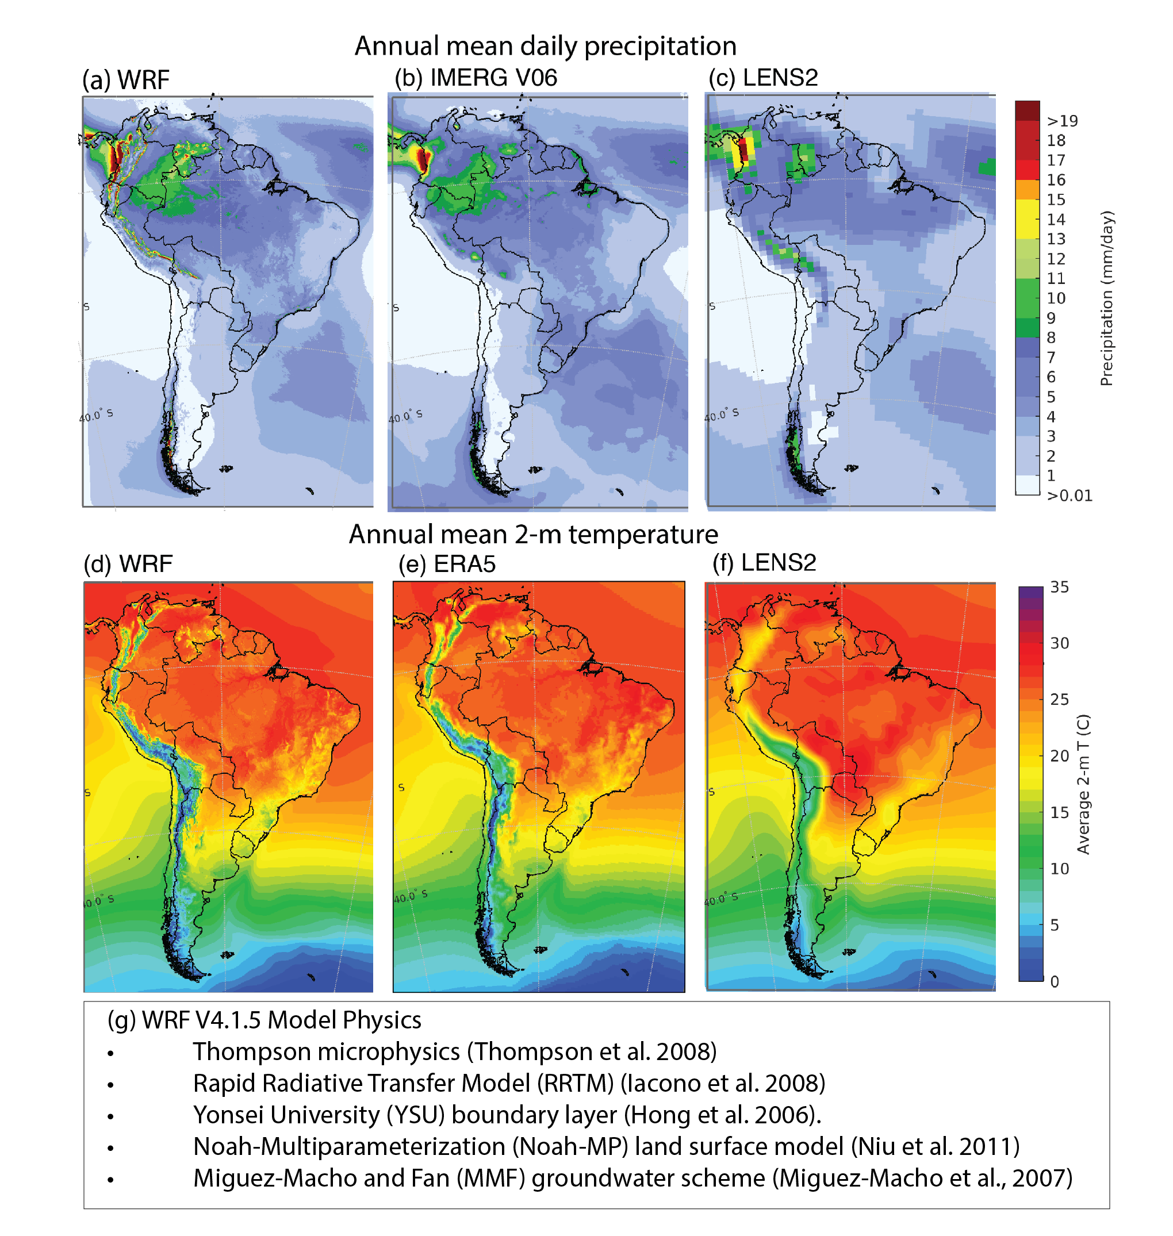Figure 1: Climatological (2000-2021) annual precipitation from (a) WRF, (b) Integrated Multi-satellite Retrievals for GPM (IMERG), and (c) a 100-member LENS2 ensemble; climatological (2000-2021) annual-mean 2-m temperature from (d) WRF, (e) ERA5, and (f) a 100-member LENS2 ensemble; and (g) parameterizations used in the WRF simulations.*

We derive monthly LENS2 climatologies, corresponding to the 2000-2020 period and the 2060-2080 period. We choose the period 2060-2080 from the future period as it corresponds to a ~3°C change in global mean 2-m temperature from pre-industrial and a change of ~2.5°C in 2-m temperature over South America. These monthly data are interpolated to the WRF grid and the ERA5 pressure levels. The same monthly deltas are applied to all the 22 years. The physical fields perturbed in the PGW approach include horizontal winds, geopotential, temperature, relative humidity, sea surface temperature, soil temperature, sea ice, and sea level pressure. Greenhouse gasses are changed according to the SSP3-7.0 emission scenario. The mathematical expression for the PGW simulation is shown in Eq. 1:

                     WRFinput  =  ERA5(Jun1999-Dec2021)  +  DLENS2SSP3-7.0                (1)

                     DLENS2SSP3-7.0 = LENS22060-2080 – LENS22000-2020

where LENS2 indicates the ensemble monthly averages for the time periods indicated in the subscript. Figure 2 shows the future LENS2 projected changes in 2-m temperature, relative humidity (RH) and precipitation. The global model ensemble projects greatest increases in temperature and decreases in RH and precipitation in the northern and central parts of the continent, while over the southern and eastern parts of the continent, there are increases in RH and precipitation with smaller increases in temperature.

*Figure 2: LENS2 ensemble difference between 2060-2080 and 2000-2020 for (a) annual surface air temperature; (b) annual surface relative humidity (c) annual surface precipitation.*

PGW is computationally more efficient than alternative downscaling methods, enabling us to harness the capabilities of CP simulations to project future climate. PGW relies on a historical simulation driven by reanalysis, not GCM simulations. Hence, the representation of historical climate is closer to observations and enables users to assess the model’s downscaling ability. The PGW climate change response is primarily related to thermodynamic changes and lapse rate differences (Prein et al. 2016). However, the PGW perturbations include winds and geopotential heights, therefore, the atmospheric circulations between the historical and PGW simulations are not identical. The PGW approach provides unique and critical information that complements traditional climate models for improved decision-making by providing a detailed and physically consistent picture of what future weather might look like (Hazeleger et al. 2015). As an example, precipitation associated with an atmospheric river (AR) that impacted Chile on March 8, 2021 is well captured in the WRF-CTL simulation (Fig 3c,d). The projected changes in a warmer climate show more intense vapor transport and a shift of this AR, resulting in enhanced precipitation around 45°S but decreased precipitation north of this region (Fig 3b,e). Current work is evaluating the climatological changes in the population of simulated ARs as projected by the PGW simulation. A disadvantage of the PGW approach is that it does not represent potential systematic changes in synoptic circulations that will influence future weather events since the forced climate signal is added to current climate. In addition, the sequence of synoptic circulations does not change, and this impacts slow-response features such as terrestrial moisture and temperature.

**Model Evaluation**

While the historical 22-year simulation was in production, the team continuously evaluated the WRF output results. An important challenge associated with the evaluation of the simulation is the lack of reliable high spatiotemporal resolution observations, particularly sub-daily extreme events (Lucas-Picher et al. 2021) and this is especially challenging over South American mountainous regions. As such, a major observational data collection effort leveraging the community networking has brought together in-situ meteorological station data, radiosondes, field experiment datasets, gridded products, and satellite-based observations for model evaluation. NCAR, 2023a presents a summary of all products including links to the data. Additional information is also presented in Condom et al. (2020). The process is streamlined in an online [dashboard](https://lookerstudio.google.com/u/0/reporting/33013d29-b61e-49d4-85f3-51efd96b7739/page/p_nlqpsl4qpc) (NCAR, 2023b), which facilitates real-time monitoring and discussion of model performance. Annual and seasonal analyses for the continent and sub-regions can be easily visualized using the dashboard. The subregions follow the same delineation as in the Sixth Assessment Report of the Intergovernmental Panel on Climate Change (Iturbide et al. 2020). The dashboard shows that WRF simulated precipitation and 2-m temperature averaged over the continent are within the envelope of uncertainty estimated from various observational and reanalysis products. The spatial pattern is well represented. Spatial correlation between WRF annual mean 2-m temperature and various observational and reanalysis products is above 0.95. Annual mean precipitation has correlations that range between 0.65 and 0.8. Areas over the tropical and high-latitude Andes show larger discrepancies. Kilometer-scale models tend to overestimate the intensity of heavy rainfall events since convection is not fully resolved (Kendon et al., 2021). Furthermore, observations over mountainous regions are limited and remote sensing retrievals are highly uncertain with likely biases (Birkel et al. 2022). Further comparisons with surface stations are needed to assess the value added by WRF in mountainous areas.

*Figure 3: WRF CTL and PGW representation of an atmospheric river event that impacted Chile in March of 2001. (a) Integrated vapor transport (IVT) from WRF CTL simulation and (b) WRF PGW-CTL IVT at 22 UTC on March 8, 2021; accumulated precipitation for March 6-9, 2001 from (c) station observations, (d) WRF CTL, and (e) WRF PGW-CTL.*

The accuracy and value of the 4-km WRF simulation in representing precipitation is already evident when analyzing a single southern hemisphere warm season (Fig 4). When compared to GPM-IMERG, the diurnal timing of peak precipitation is better captured by the 4-km WRF simulation than by ERA5 and a test 24-km WRF simulation (Fig 4a-e). Similar improvements were obtained in 4.5-km CP simulations with the UK Met Office Unified Model (Halladay et al. 2023). The 4-km WRF simulation can capture the evening and nocturnal peaks in precipitation just inland of many coastlines of the continent (Fig 4a-e). Comparison with surface station observations over southwestern Brazil clearly shows the improvement in nocturnal precipitation (Fig 4e), where 4-km WRF also captures station-observed high intensity events that are not captured by 24-km WRF, ERA5, or GPM-IMERG (Fig 4f).

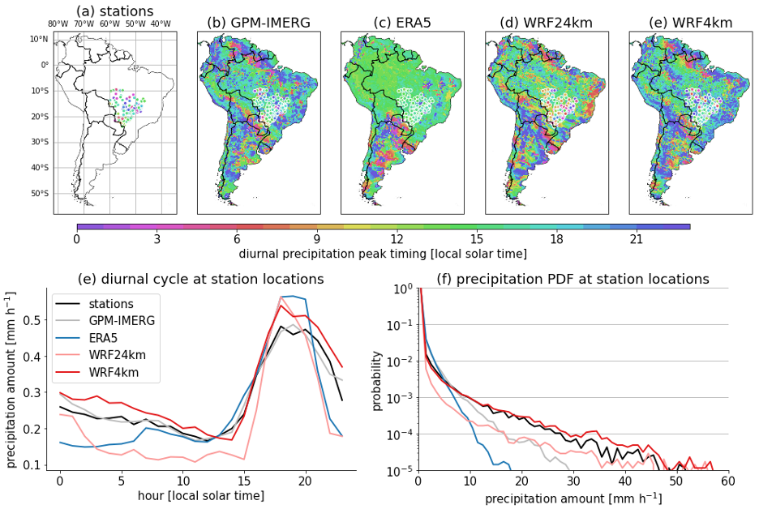

*Figure 4: Diurnal precipitation peak at local solar time for November 2018 to March 2019 for (a) surface stations in southwest Brazil, (b) IMERG, (c) ERA5, (d) 24-km WRF, and (e) 4-km WRF. The average precipitation diurnal cycle at surface station locations (circle symbols in maps) and the hourly precipitation probability density function are shown in (f) and (g), respectively, for the same period and datasets.*

**Lessons Learned**

The success of SAAG has relied on a process that benefits individual researchers’ interests, while working towards the common goal of improving understanding and projection of South America’s hydroclimate for better-guided societal decisions as the climate changes. For four years, researchers from more than 10 (mostly South American) countries have consistently attended online meetings that were open to all. The online format has enabled participation from different locations. During the meetings, respectful and open communication has facilitated the exchange of ideas and promoted collaboration between different individuals and groups. This dialogue led to an agreed-upon experimental design of the WRF simulations, and identification of key science questions concerning the hydroclimate of South America. From these, science topical subgroups have been formed to facilitate collaborative research around the simulations. In addition to online meetings, several sessions at international meetings have promoted in-person exchanges and social cohesion. In particular, the 2022 Convection-Permitting Climate Modelling Workshop held in Buenos Aires, Argentina was a way to bring together the international CPM community with a focus on South America (Prein et al. 2022).

All SAAG members are invested in the success of the WRF historical and future simulations. The computational cost prohibited individual research groups from performing the simulations, so having NCAR perform them was critical. High performance computing resources from the University of Illinois and the U.S. Department of Energy National Energy Research Scientific Computing Center (NERSC) provided shared solutions to store the 2 PB of hourly output. Open discussion about the numerical details (parameterizations, nudging, output variables, output frequency) ensured that individual research needs were addressed. The online dashboard has been an important tool for real-time analysis, verification, and discussion. Finally, reduced size output of key variables has been made available through NCAR’s Research Data Archive service (<https://rda.ucar.edu/datasets/ds616-0/>). This has facilitated the use of this very large dataset, although data challenges remain.

The computational burden of analyzing such high-resolution continental-scale simulations is a major barrier to usage. There are currently no computational facilities in South America to perform or adequately analyze kilometer-scale climate simulations. A possible solution is the formation of a centralized computational facility where SAAG and other data is stored for access and processing without the need for data downloading. This hub could also be a regional center for education, outreach, and capacity building for a diverse set of users including scientists, stakeholders, and decision-makers interested in using kilometer-scale climate data.

**Future areas of interest/focus and invitation to the research and applications community**

We have only begun to analyze the SAAG simulations, but their potential uses are much wider. We include a non-comprehensive list of possible topics for future research in Table 2. We invite the community to join the SAAG effort by reaching out to Andreas Prein (prein@ucar.edu), Roy Rasmussen (ramsus@ucar.edu), Francina Dominguez (francina@illinois.edu) or any of the authors of this work.

*Table 2: Non-comprehensive list of possible topics for future research.*

|  |
| --- |
| **Potential Future Areas of Research** |
| Impact of deforestation on water and energy budgets at continental, regional and local scales, including changes caused by altered circulations. |
| Impacts of aerosols (particularly biomass burning) on clouds and precipitation. |
| Changes in moisture transport by LLJs and atmospheric rivers affecting regional sources of water. |
| Future changes in severe convective storm environments. |
| Changes in spatial patterns of convective precipitation due to changes in soil moisture, vapor sources, and circulations. |
| Compound extremes such as extreme heat and drought or serial flood events. |
| Groundwater assessment (observation/baseline), extraction and recharge. |
| Impacts of climate change and air pollution on human health outcomes. |
| Understanding the physical mechanisms associated with the formation and movement of floods in South America. |
| Revisiting and updating adaptation plans to climate change. |

**Acknowledgements**

Work supported by National Science Foundation (NSF) AGS 1852709 and the U.S. Department of Energy’s Office of Science Biological and Environmental Research as part of the Atmospheric System Research program. NCAR is sponsored by the NSF under Cooperative Agreement 1852977.

**Data Availability Statement**

Hourly and 15-min output of SAAG simulations for select variables is available at NCAR CISL Research Data Archive (Rasmussen et al. 2022). Publicly available in-situ observations, satellite and Reanalysis Data used in our analysis can be found in NCAR (2023a).

**References**

Arias, P.A., and Coauthors, 2021: Technical Summary. In Climate Change 2021: The Physical Science Basis. Contribution of Working Group I to the Sixth Assessment Report of the Intergovernmental Panel on Climate Change [Masson-Delmotte, V., P. Zhai, A. Pirani, S.L. Connors, C. Péan, S. Berger, N. Caud, Y. Chen, L. Goldfarb, M.I. Gomis, M. Huang, K. Leitzell, E. Lonnoy, J.B.R. Matthews, T.K. Maycock, T. Waterfield, O. Yelekçi, R. Yu, and B. Zhou (eds.)]. Cambridge University Press, Cambridge, United Kingdom and New York, NY, USA, pp. 33−144. doi:10.1017/9781009157896.002.

Barros, V. R., J. A. Boninsegna, I. A. Camilloni, M. Chidiak, G. O. Magrín, and M. Rusticucci, 2015: Climate change in Argentina: trends, projections, impacts and adaptation. *Wiley Interdiscip Rev Clim Change*, 6, 151–169, https://doi.org/10.1002/wcc.316.

Bettolli, M.L., and Coauthors, 2021: The CORDEX Flagship Pilot Study in southeastern South America: a comparative study of statistical and dynamical downscaling models in simulating daily extreme precipitation events. *Climate Dyn*., **56**, 1589–1608, https://doi.org/10.1007/s00382-020-05549-z.

Birkel, S. D., P. A. Mayewski, L. B. Perry, A. Seimon and M. Andrade-Flores, 2022: Evaluation of reanalysis temperature and precipitation for the Andean Altiplano and adjacent Cordilleras. *Earth and Space Science*, **9**, e2021EA001934. https://doi. org/10.1029/2021EA001934

Braun, M. H., and Coauthors, 2019: Constraining glacier elevation and mass changes in South America. *Nat. Clim. Change*, **9**, 130–136, https://doi.org/10.1038/s41558-018-0375-7.

Carril, A.F., and Coauthors, 2012: Performance of a multi-RCM ensemble for South Eastern South America. *Climate Dyn.,* **39**, 2747-2768, https://doi.org/10.1007/s00382-012-1573-z.

Castellanos, E., and Coauthors, 2022: Central and South America. In: Climate Change 2022: Impacts, Adaptation and Vulnerability. Contribution of Working Group II to the Sixth Assessment Report of the Intergovernmental Panel on Climate Change [H.-O. Pörtner, D.C. Roberts, M. Tignor, E.S. Poloczanska, K. Mintenbeck, A. Alegría, M. Craig, S. Langsdorf, S. Löschke, V. Möller, A. Okem, B. Rama (eds.)]. Cambridge University Press, Cambridge, UK and New York, NY, USA, pp. 1689–1816, doi:10.1017/9781009325844.014.

Computational and Information Systems Laboratory. 2019. Cheyenne: HPE/SGI ICE XA System (University Community Computing). Boulder, CO: National Center for Atmospheric Research. doi:10.5065/D6RX99HX.

Condom, T., and Coauthors, 2020: Climatological and Hydrological Observations for the South American Andes: In situ Stations, Satellite, and Reanalysis Data Sets. *Front. Earth Sci.*, **8**, https://doi.org/10.3389/feart.2020.00092.

Crespo, N. M., and Coauthors, 2022: Assessment of the RegCM4-CORDEX-CORE performance in simulating cyclones affecting the western coast of South America. *Climate Dyn.*, **60**, 2041–2059, https://doi.org/10.1007/s00382-022-06419-6.

Doyle, M. E., R. I. Saurral, and V. R. Barros, 2012: Trends in the distributions of aggregated monthly precipitation over the La Plata Basin. *Int. J. Climatol.*, **32**, 2149–2162, https://doi.org/10.1002/joc.2429.

Dussaillant, I., and Coauthors, 2019: Two decades of glacier mass loss along the Andes. *Nat. Geosci.*, **12**, 802–808, https://doi.org/10.1038/s41561-019-0432-5.

Espinoza, J. C., J. Ronchail, J. A. Marengo, and H. Segura, 2019: Contrasting North–South changes in Amazon wet-day and dry-day frequency and related atmospheric features (1981–2017). *Climate Dyn.*, **52**, 5413–5430, https://doi.org/10.1007/s00382-018-4462-2.

Espinoza, J. C., R. Garreaud, G. Poveda, P. A. Arias, J. Molina-Carpio, M. Masiokas, M. Viale, and L. Scaff, 2020: Hydroclimate of the Andes Part I: Main Climatic Features. *Frontiers Earth Sci*., 8, 64, https://doi.org/10.3389/feart.2020.00064.

Eyring, V., and Coauthors, 2016: Overview of the Coupled Model Intercomparison Project Phase 6 (CMIP6) experimental design and organization. *Geosci. Model Dev.*, **9**, 1937–1958, https://doi.org/10.5194/gmd-9-1937-2016.

Falco, M., A. F. Carril, C. G. Menéndez, P. G. Zaninelli, and L. Z. X. Li, 2019: Assessment of CORDEX simulations over South America: added value on seasonal climatology and resolution considerations. *Climate Dyn.*, **52**, 4771–4786, https://doi.org/10.1007/s00382-018-4412-z.

Fox-Kemper, B., and Coauthors, 2021: Ocean, Cryosphere and Sea Level Change. In Climate Change 2021: The Physical Science Basis. Contribution of Working Group I to the Sixth Assessment Report of the Intergovernmental Panel on Climate Change [Masson-Delmotte, V., P. Zhai, A. Pirani, S.L. Connors, C. Péan, S. Berger, N. Caud, Y. Chen, L. Goldfarb, M.I. Gomis, M. Huang, K. Leitzell, E. Lonnoy, J.B.R. Matthews, T.K. Maycock, T. Waterfield, O. Yelekçi, R. Yu, and B. Zhou (eds.)]. Cambridge University Press, Cambridge, United Kingdom and New York, NY, USA, pp. 1211–1362, doi:10.1017/9781009157896.011.

Fu, R., and Coauthors, 2013: Increased dry-season length over southern Amazonia in recent decades and its implication for future climate projection. *Proc. Natl. Acad Sci. U.S.A.,* **110**, 18110-18115,

https://doi.org/10.1073/pnas.1302584110

Garreaud, R. D., and Coauthors, 2020: The Central Chile Mega Drought (2010–2018): A climate dynamics perspective. *Int. J. Climatol.*, **40**, 421–439, https://doi.org/10.1002/joc.6219.

Giorgi, F., and Coauthors, 2022: The CORDEX-CORE EXP-I initiative: description and highlight results from the initial analysis. *Bull. Amer. Meteor. Soc.*, **103**, E293–E310, https://doi.org/10.1175/BAMS-D-21-0119.1.

Gutiérrez, J.M., and Coauthors, 2021: Atlas. In Climate Change 2021: The Physical Science Basis. Contribution of Working Group I to the Sixth Assessment Report of the Intergovernmental Panel on Climate Change [Masson-Delmotte, V., P. Zhai, A. Pirani, S.L. Connors, C. Péan, S. Berger, N. Caud, Y. Chen, L. Goldfarb, M.I. Gomis, M. Huang, K. Leitzell, E. Lonnoy, J.B.R. Matthews, T.K. Maycock, T. Waterfield, O. Yelekçi, R. Yu, and B. Zhou (eds.)]. Cambridge University Press, Cambridge, United Kingdom and New York, NY, USA, pp. 1927–2058, doi:10.1017/9781009157896.021.

Gutowski, W. J., and Coauthors, 2020: The Ongoing Need for High-Resolution Regional Climate Models: Process Understanding and Stakeholder Information. *Bull. Amer. Meteor. Soc.*, **101**, E664–E683, https://doi.org/10.1175/BAMS-D-19-0113.1.

Haarsma, R. J., and Coauhtors, 2016: High Resolution Model Intercomparison Project (HighResMIP v1.0) for CMIP6, *Geosci. Model Dev*., **9**, 4185-4208, doi:10.5194/gmd-9-4185-2016.

Halladay, K., Kahana, R., Johnson, B., Still, C., Fosser, G., & Alves, L. (2023). Convection-permitting climate simulations for South America with the Met Office Unified Model. *Climate Dynamics*, 1-23, https://doi.org/10.1007/s00382-023-06853-0

Hazeleger, W., and Coauthors, 2015: Tales of future weather. *Nat. Climate Change*, **5**, 107–113, https://doi.org/10.1038/nclimate2450.

Hersbach, H, and Coauthors, 2020: The ERA5 global reanalysis. *Quart. J. Roy. Meteor. Soc.*, **146**, 1999– 2049, https://doi.org/10.1002/qj.3803

Hong, S. -Y., Noh, Y., and J. Dudhia, 2006: A new vertical diffusion package with an explicit treatment of entrainment processes. *Mon. Wea. Rev.*, **134**, 2318-2341. doi:10.1175/MWR3199.1.

Iacono, M. J., and Coauthors, 2008: Radiative forcing by long-lived greenhouse gases: Calculations with the AER radiative transfer models, *J. Geophys. Res. Atmos.*, **113**, D13103, doi:10.1029/2008JD009944.

Iturbide, M., and Coauthors, 2020: An update of IPCC climate reference regions for subcontinental analysis of climate model data: definition and aggregated datasets, *Earth Syst. Sci. Data*, **12**, 2959–2970, <https://doi.org/10.5194/essd-12-2959-2020>.

Kendon E. J., Prein, A. F., Senior, C. A., Stirling, A., 2021: Challenges and outlook for convection-permitting climate modeling. Phil. Trans. R. Soc. A379: 20190547. <https://doi.org/10.1098/rsta.2019.0547>

Lagos-Zúñiga, M. A., and Coauthors, 2022: Extreme indices of temperature and precipitation in South America: trends and intercomparison of regional climate models. *Climate Dyn*., https://doi.org/10.1007/s00382-022-06598-2.

Liu, C., and Coauthors, 2017: Continental-scale convection-permitting modeling of the current and future climate of North America. *Climate Dyn.*, **49**, 71–95, https://doi.org/10.1007/s00382-016-3327-9.

Lucas‐Picher, P., D. Argüeso, E. Brisson, Y. Tramblay, P. Berg, A. Lemonsu, S. Kotlarski, and C. Caillaud, 2021: Convection‐permitting modeling with regional climate models: Latest developments and next steps. Wiley Interdiscip. Rev.: Clim. Chang., 12, https://doi.org/10.1002/wcc.731.

Masiokas, M. H., and Coauthors, 2020: A Review of the Current State and Recent Changes of the Andean Cryosphere. *Front. Earth Sci*., **8**, https://doi.org/10.3389/feart.2020.00099.

Morales-Yokobori, M. L., 2021: Recent Advances in Environmental Science from the Euro-Mediterranean and Surrounding Regions (2nd Edition), Proceedings of 2nd Euro-Mediterranean Conference for Environmental Integration (EMCEI-2), Tunisia 2019. Environ Sci Eng, 949–955, https://doi.org/10.1007/978-3-030-51210-1_148.

Miguez-Macho, G., and Coauthors, 2007: Incorporating water table dynamics in climate modeling: 2. formulation, validation, and soil moisture simulation. *J. Geophys. Res. Atmos*., **112**,

https://doi.org/10.1029/2006JD008112

Muñoz, A. A., and Coauthors, 2020: Water Crisis in Petorca Basin, Chile: The Combined Effects of a Mega-Drought and Water Management. *Water*, **12**, 648, https://doi.org/10.3390/w12030648.

National Center for Atmospheric Research-NCAR, 2023a: Observational Datasets in South America. Url: <https://ral.ucar.edu/projects/south-america-affinity-group-saag/observational-datasets>

National Center for Atmospheric Research-NCAR, 2023b: South America Affinity Group - Online Dashboard Url: https://lookerstudio.google.com/u/0/reporting/33013d29-b61e-49d4-85f3-51efd96b7739/page/p_nlqpsl4qpc

Niu, G.-Y., and Coauthors, 2011: The community Noah land surface model with multiparameterization options (Noah-MP): 1. Model description and evaluation with local-scale measurements. *J. Geophys. Res. Atmos*., 116, D12109, https://doi.org/10.1029/2010JD015139.

Nobre, C. A., J. A. Marengo, M. E. Seluchi, A. C. L., and L. M. Alves, 2016: Some Characteristics and Impacts of the Drought and Water Crisis in Southeastern Brazil during 2014 and 2015. *J. Water Resour. Prot.*, **8**, 252-262, https://doi.org/10.4236/jwarp.2016.82022.

O’Neill, B. C., and Coauthors, 2016: The Scenario Model Intercomparison Project (ScenarioMIP) for CMIP6. *Geosci. Model Dev*., **9**, 3461–3482, https://doi.org/10.5194/gmd-9-3461-2016.

Ozturk, U., and Coauthors, 2022: How climate change and unplanned urban sprawl bring more landslides. *Nature*, **608**, 262–265, https://doi.org/10.1038/d41586-022-02141-9.

Paccini, L. and B. Stevens, 2023: Assessing Precipitation Over the Amazon Basin as Simulated by a Storm‐Resolving Model. *J. Geophys. Res. Atmos*., 128, e2022JD037436, https://doi.org/10.1029/2022JD037436

Pabón-Caicedo, J.D, and Coauthors, 2020: Observed and projected hydroclimate changes in the Andes. *Front. Earth Sci.*, **8**, doi: 10.3389/feart.2020.00061.

Poveda G, and Coauthors, 2020: Review paper. High impact weather events in the Andes. *Front. Earth Sci.,* **8**, https://doi.org/10.3389/feart.2020.00162.

Prein, A. F., L. Fita, M. L. Bettolli and R. Rasmussen, 2022: Convection-Permitting Modeling in South America and Beyond: A Summary of the 6th Convection-Permitting Modeling Workshop, GEWEX quarterly, 32 (4), 18-19

Rasmussen, R., and Coauthors, 2011: High-Resolution Coupled Climate Runoff Simulations of Seasonal Snowfall over Colorado: A Process Study of Current and Warmer Climate. *J. Climate*, **24**, 3015–3048, https://doi.org/10.1175/2010jcli3985.1.

Rasmussen, R., C. Liu, K. Ikeda, and F. Dominguez. 2022. Multi-decadal Convection-permitting Simulation of Current Climate over South America using WRF. Research Data Archive at the National Center for Atmospheric Research, Computational and Information Systems Laboratory. https://doi.org/10.5065/6XQW-ZB02. Accessed 10 May, 2023

Rasmussen, R. M., and Coauthors, 2023. The NCAR/USGS 4-km long-term regional hydroclimate re-analysis over the CONUS*. Bull. Amer. Meteor. Soc.,* (in review).

Reinthalher, J., F. Paul, H. D. Granados, A. Rivera, and C. Huggel, 2019: Area changes of glaciers on active volcanoes in Latin America between 1986 and 2015 observed from multi-temporal satellite imagery. *J. Glaciol.*, **65**, 542–556, https://doi.org/10.1017/jog.2019.30.

Rodgers, K. B., and Coauthors, 2021: Ubiquity of human-induced changes in climate variability*. Earth Syst. Dyn*., **12**, 1393–1411, https://doi.org/10.5194/esd-12-1393-2021.

Schär, C., C. Frei, D. Lüthi, and H. C. Davies, 1996: Surrogate climate‐change scenarios for regional climate models*. Geophys. Res. Lett*., **23**, 669–672, https://doi.org/10.1029/96gl00265.

Seneviratne, S.I., and Coauthors, 2021: Weather and Climate Extreme Events in a Changing Climate. In Climate Change 2021: The Physical Science Basis. Contribution of Working Group I to the Sixth Assessment Report of the Intergovernmental Panel on Climate Change [Masson-Delmotte, V., P. Zhai, A. Pirani, S.L. Connors, C. Péan, S. Berger, N. Caud, Y. Chen, L. Goldfarb, M.I. Gomis, M. Huang, K. Leitzell, E. Lonnoy, J.B.R. Matthews, T.K. Maycock, T. Waterfield, O. Yelekçi, R. Yu, and B. Zhou (eds.)]. Cambridge University Press, Cambridge, United Kingdom and New York, NY, USA, pp. 1513–1766, doi:10.1017/9781009157896.013.

Skamarock W., and Coauthors, 2019: A Description of the Advanced Research WRF Model Version 4.1 (No. NCAR/TN-556+STR). NCAR, http://dx.doi.org/10.5065/1dfh-6p97

Solman, S. A., and Coauthors, 2013: Evaluation of an ensemble of regional climate model simulations over South America driven by the ERA-Interim reanalysis: model performance and uncertainties. *Climate Dyn.*, 41, 1139-1157, http://dx.doi.org/10.1007/s00382-013-1667-2.

Thompson, G., P. R. Field, R. M. Rasmussen, W. D. Hall, 2008: Explicit forecasts of winter precipitation using an improved bulk microphysics scheme. Part II: Implementation of a new snow parameterization. *Mon. Wea. Rev.*, **136**, 5095–5115, <https://doi.org/10.1175/2008MWR2387.1>.