**Template for engineering journal articles**

* Research paper
* Date text written 4th December 2019.
* Number of words = 5597.
* Six figures and 1 tables.

-------------------------------------------------------------------------------------------------------------------------------

Investigating the use of Joint Probability Curves in Coastal Engineering Practice

Author 1

* Dominic P. Hames, BEng., MSc., PhD., CEng, MCIWEM
* Principal Engineer, HR Wallingford Ltd., Oxfordshire, UK
* Visiting Lecturer, Brunel University, Uxbridge, UK
* 0000-0001-9506-280X

Author 2

* Ben P. Gouldby, BSc.
* Chief Technical Director, HR Wallingford Ltd., Oxfordshire, UK
* Visiting Professor, Southampton University, Southampton, UK
* 0000-0003-0415-5897

Author 2

* Peter J. Hawkes, BEng., PhD.
* Principal Engineer (retired), HR Wallingford Ltd., Oxfordshire, UK
* 0000-0002-4616-1155

**Full contact details of corresponding author.**

Dominic Hames, HR Wallingford, Howbery Park, Wallingford, Oxfordshire, OX10 8BA

United Kingdom. Tel: 01491 822298. (d.hames@hrwallingford.com)

*Editor’s note: your article’s title and abstract are the main ways that readers will find your work. For each, aim to make them:*

*o clear and interesting*

*o include keywords that your peers might type into a search engine*

*o place such keywords at the beginning of the first sentence. Google will then find them more easily*

*Each keyword only needs to be mentioned once, after that use plenty of other similar words.*

**Abstract**

This paper investigates the inherent inaccuracy in the estimation of various extreme response variables for different sea defence structures using joint exceedance curve approaches in common use around the UK. Utilising stochastically generated nearshore data sets that include extreme wave and sea level conditions determined at regular intervals around the English coastline as part of a previous study, and asset information from the Environment Agency’s AIMS database, this paper assesses 592 sea defence structures and their associated extreme response using different joint exceedance curve approaches when compared against the response variable approach. This paper highlights that extreme response variables are often under-estimated when using a joint exceedance curve approach, which in many cases can be significant. This suggests that the performance of many sea defence structures are incorrectly estimated. As a consequence, joint exceedance curve approaches may under-design sea defence structures to a greater level than previously indicated, or significantly underestimate extreme response variables when assessing the performance of existing structures.

**Keywords** **chosen from ICE Publishing list**

Coastal engineering, Risk & probability analysis, Sea defences.

**List of notation**

AIMS Asset Information Management System

*CF* correlation factor

CoMJEC Composite marginal joint exceedance curve

*Hs* significant wave height

InJoPA Intuitive joint probability assessment

NFCDD National Flood and Coastal Defence Database

*pE* probability of response

RPRR return period response ratio

*RV* response variable

*η* sea level

**1. Introduction**

It has long been recognised that it is necessary to account for extreme sea conditions (waves and sea levels), in the design of sea defence structures and in the assessment of flood risk. However, until the introduction of simplified joint exceedance curve approaches (commonly known as joint probability curves) in the mid-late 1980s, there were no formal methods to quantify the joint occurrence of extreme waves and sea levels and their effect on the performance of sea defence structures, Hames *et al.*, (2019). With the introduction of these approaches, and the increased availability of wave and sea level data from about this time, these approaches started to become established within the coastal engineering community. This was particularly the case following the Towyn floods in February 1990, and the widely disseminated report looking at the joint probability relationship between waves and sea levels following this event, Hydraulics Research Ltd (1990).

The increased awareness and ease of use of these approaches, as well as their more sound scientific principles compared to previous approaches based on “engineering judgement” meant that they quickly became embedded in many engineering studies, forming the basis of many engineering designs and risk & probability analyses over the 1990s, Hames *et al.*, (2019). The similarities to previous approaches based on engineering judgement may also have explained the rapid acceptance and adoption of these approaches at this time.

However, these approaches, developed at a time when a lack of data and computing power meant that more rigorous approaches were not feasible, contained a known inaccuracy in that they are based upon defining the likelihood of extreme wave and sea level combinations which do not directly relate to extremes of the response variable (RV) of interest. This could include such things as wave overtopping, economic damage, loss of life, Hawkes *et al.*, (2002) and Gouldby *et al.*, (2017). In addition, the application of these methods commonly had to rely on restrictive assumptions regarding other wave parameters such as wave period and direction. The introduction of JOIN-SEA, HR Wallingford/Lancaster University (2000a and 2000b) and Hawkes *et al.*, (2002), as well as the more recent use of the Heffernan and Tawn (2004) approach in directly assessing extremes of RVs, using robust, risk-based, statistical methods has removed these limitations, and these have been increasingly used in coastal engineering studies since their introduction, Hames *et al.*, (2019).

However, despite the introduction of these RV approaches, joint exceedance curve approaches continue to be used extensively in studies. This can lead to the potential under-design of sea defence structures and the underestimation of the performance of sea defence structures to a greater level than previously suggested, unless correction factors are applied. It is of note however, that currently there is limited information on which to base these correction factors.

This paper therefore investigates the potential inaccuracy in the use of the different joint exceedance curve approaches in most common use around the UK today. Utilising multivariate extreme nearshore sea condition data from a previous study, HR Wallingford (2015) and Gouldby *et al.*, (2017), and asset information from the Environment Agency AIMS database, Environment Agency (2019), estimates of three different responses using different joint exceedance curve approaches are compared to the RV approach for 592 different sea defence structures across England. This gives an indication of the potential errors when using the different joint exceedance curve approaches in terms of their overtopping performance, as well as estimation of levels of damage for rock armoured revetments and wave forces for vertical walls.

***1.1 Approaches considered***

Two different joint exceedance curve approaches are currently believed to be in common use around the UK coastline. These are briefly described below, with a more detailed description given in Hames *et al.*, (2019).

* Composite Marginal Joint Exceedance Curve (CoMJEC) Approach

The probability of the response, *pE*,, is represented in terms of combinations of wave heights and sea levels that have the same exceedance probability over the same unit of time. This gives a continuous curve of combinations with *pE* defined as:

$$p_{E}=p\left(H_{s}≥y∩η≥x\right)$$

1.

* Intuitive Joint Probability Assessment (InJoPA) or Correlation Factor Approach

The probability of the response is defined as a product of the marginal probabilities of the wave height (*Hs*) and the sea level (*η*) multiplied by a correlation factor (CF). This therefore approximates the continuous curve of combinations, *pE* as:

$$p_{E}≈C_{F}p\left(H_{s}≥y\right)p\left(η≥x\right)$$

2.

Of these approaches, the InJoPA can be applied in two different ways known as the simplified approach or the desk-study approach. In addition, each approach has to rely on assumptions regarding wave period and direction. Three different approaches are therefore considered, and these are assessed based on three different assumptions on how wave period and direction are assessed. This gave a total of nine comparisons to assess against the RV approach, which are outlined in Section 4.

**2. Assessment methodology**

***2.1 Introduction***

To investigate the potential inaccuracy in the use of the different joint exceedance curve approaches, firstly, benchmark results were established using the RV approach. This approach involves the stochastic simulation of all the relevant input parameters using a nationally consistent data set . The different joint exceedance curve approaches were then applied, as they would be in practice, Hames *et al.*, (2019). The results were then compared to the benchmark.

Comparing the joint exceedance curve approaches against the RV approach for a large number of sea defence structures therefore gives a measure of investigating the distribution of the potential error in their application. The comparative approach means that the robustness or otherwise of the response functions used is not considered significant. This therefore also enables potential correction factors to be suggested in cases where the RV approach could still be considered difficult to use, such as in the optimisation of designs in physical model tests. To investigate these potential errors, this paper has used a consistent baseline dataset of nearshore stochastically generated wave and sea level data around the entire English coastline derived on a previous study (HR Wallingford, 2015 and Gouldby *et al.*, 2017). This data has been applied utilising the Environment Agency’s Asset Information Management System (AIMS) database for all sea defence structures in England (as it stood in 2017). Details of the AIMS database and how this has been utilised, together with the baseline wave and sea level datasets utilised in this investigation are outlined in Sections 2.2 and 2.3 below.

***2.2 Asset Information Management System (AIMS) database***

The AIMS database is a national inventory of flood risk assets maintained by the Environment Agency. Launched in 2014 to replace the existing National Flood and Coastal Defence Database (NFCDD), it contains an inventory of over 8000 coastal assets around the coastline of England. It is continually improved, and was substantially updated following the winter 2013/14 storms, when the military assisted the Environment Agency to survey the assets.

Assets are described as a variety of different types, such as seawalls and embankments, as well as sub-types such as a brick or concrete seawall. In total, there are 62 different types of defences defined using a categorisation system (Hall *et al.*, 2003 and HR Wallingford, 2004). A variety of information is given, with standardised characteristics given for certain parameters such as structure slope. As a consequence, each defence can be simply discretised so that their performance can be assessed for a variety of different response functions. Further details on the AIMS database can be obtained from the asset management team at appropriate area Environment Agency Offices.

Although there were potentially in excess of 8000 assets to be considered for this paper, certain assets were removed if they did not fulfil certain criteria which are outlined below. This was to remove assets that may potentially skew the analysis, due to unusually low variable responses (such as a high natural defence), resulting in potentially large variations in relative rates, or unusually high variable responses, potentially indicative of an asset that does not fulfil a normal sea defence function. For example, the marine saltwater lake at West Kirby on the Wirral is listed as a flood defence, however, it has been deliberately designed to overtop significantly under non extreme events.

The rules applied to remove assets include any defence where the;

* crest height was more than 4m above the 100 year extreme sea level,
* crest height was less than the 10 year extreme sea level,
* toe level was more than the 1 year extreme sea level minus 1m,
* insufficient structure details given in the AIMS database.

To apply these rules, the extreme sea levels used were those published in the Coastal Flood Boundaries report, Environment Agency (2011). The updated Coastal Flood Boundaries report, Environment Agency (2018) was not used as it was not available when the original analysis was carried out, but would be expected to make no noticeable difference to the results. These levels were updated to the present day to account for changes in mean sea levels and localised isostatic rebound rates using the approach outlined in HR Wallingford (2015). This resulted in 592 sea defence structures to assess, the location of which are shown in Figure 1. Based on the categorisation system of Hall *et al.*, (2003) and HR Wallingford, (2004), this gave 288 sea defence structures classified as a sloping revetment, 270 as a vertical wall and 34 as a shingle beach. The large number of assets removed was mainly due to high asset toe levels, a significant number of which were classified as shingle beaches.

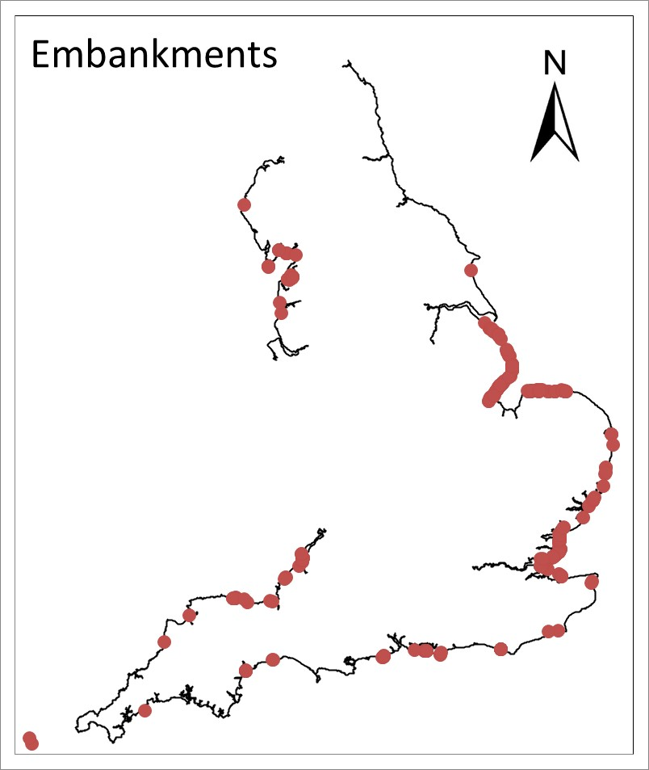 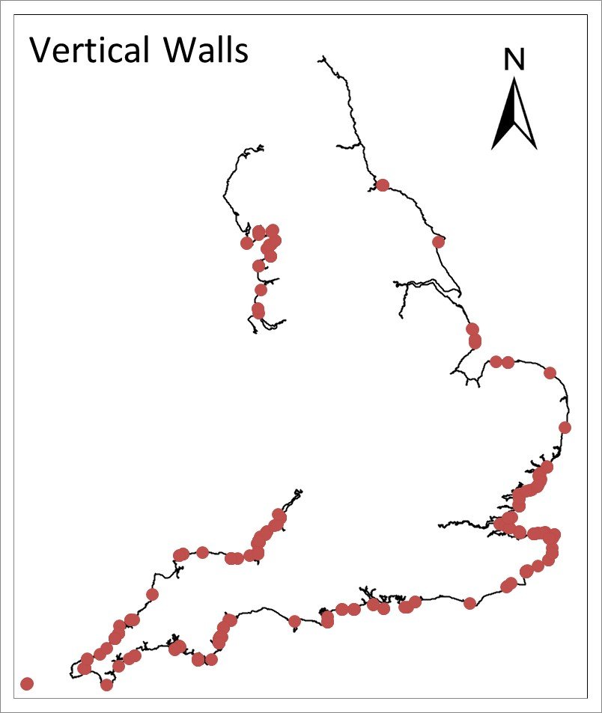 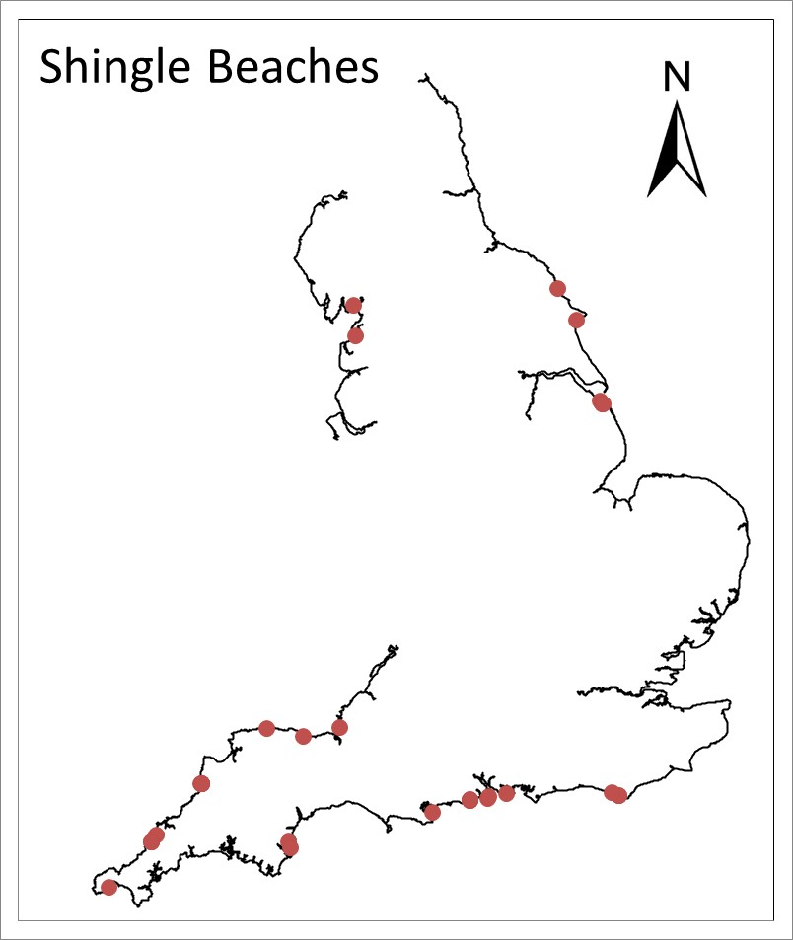

Figure 1. Location of sea defence structures assessed in this paper.

**2.3 Nearshore multivariate extreme data sets**

The baseline extreme wave and sea-level dataset used in this analysis comprised a 10,000-year sample of present-day stochastically simulated wave and sea level conditions at a number of offshore points around the English coastline. These baseline datasets were generated through the application of a multivariate extreme value model to offshore data based on Met. Office 8km WaveWatch III hindcast data and a combination of tide gauge data from the UK National Tide Gauge Network and the Environment Agency . Accounting for seabed bathymetry, these conditions were then transformed to the nearshore across several wave model grids covering the entire English coastline using the SWAN wave model, Booij *et al.*, 1999. This was done taking account of the spatial variation in the nearshore sea levels within each model grid. This resulted in the region of 2,500 nearshore predictions points of wave and sea level conditions at 1km spacing. Typically the nearshore points were located at the -5mAOD sea bed contour, although a higher level was used if this was considered too far offshore. This methodology is outlined in detail in HR Wallingford (2015) and Gouldby *et al.*, (2017).

As the requirement for this paper was to replicate methods that are typically implemented by the industry in practice, wave conditions were therefore transformed to the individual structure toes using the methodology proposed by Goda (2010), based on the nearest nearshore prediction point. Nearshore beach slopes for use in the nearshore wave modelling were based on the average beach slope in front of the structure toe over a distance approximately equal to one wavelength in this region. The process of evaluating nearshore beach profiles and the location of individual structure toes is outlined in HR Wallingford (2015).

The output of this analysis gave a robust set of the equivalent of 10,000 years of wave and sea level conditions at each of the 592 structures considered in this paper. From these data, the different joint exceedance curves were determined for a range of return periods, with the response of interest set as the largest response from all combinations of wave and sea level conditions along these curves. For the RV approach, the responses were determined for all combinations of wave and sea level conditions, with the response for the required return period determined by a countback of the ranked response variables. This process is outlined in Hames *et al.*, (2019).

**3. Response variables and functions assessed**

***3.1 Response variables***

In this analysis, three response variables were considered:

* Wave overtopping rate
* Damage to rock armoured embankments

A non-dimensionless parameter defined as the eroded cross-sectional area of the rock armoured revetment divided by the mean diameter of the rock defence blocks squared, Van Der Meer, (1987).

* Wave forces on vertical walls

These were analysed for 10 different return periods from 1 year to 1000 years. Results for wave overtopping rate were considered in terms of return period as potential inaccuracies are typically stated in terms of this parameter as opposed, for example, to overtopping rate (Defra, 2005). Results for wave overtopping rate were considered for each defence type (i.e. sloping revetments, vertical walls and shingle beaches), as well as all three of these structure types combined. Damage was considered for rock armoured defence structures, as this is the main parameter by which performance is measured (Van Der Meer, 1987). For vertical walls, there is no conventional means of measuring potential inaccuracies or performance, so results have been considered in terms of wave force. No weighting of the results were applied for defence lengths, return period or for the magnitude of the response variables considered.

For joint exceedance curve approaches, there are no formal methodologies that explicitly define the handling of wave periods and directions. Wave periods and directions were therefore considered based on the average offshore wave steepness of the highest 1% of nearshore wave heights, as well as the average wave direction to the shore normal over the same set of conditions. Wave periods were also considered based on a constant offshore wave steepness of 0.040, a value typically considered in the calculation of responses variables, although some tests were also undertaken considering a wave steepness of 0.035. To account for the potential variation in the wave direction, wave directions were also considered uniformly distributed 15º either side of the average determined from the highest 1% of nearshore wave heights, as well as parallel to the shore normal. This was anticipated to cover the range of conditions likely to be considered typical, including many studies that assume a normal angle of attack.

**3.2 Response functions**

The response functions considered in this paper were based on equations typically applied in standard practice across the coastal engineering community in the UK. These are given below. It should be noted that as the purpose of this paper was to consider the relative differences between different joint exceedance curve approaches when compared to the RV approach, the choice of response function was not critical, provided they were applied consistently across the different approaches. Different response functions could be anticipated to give similar comparative results, so the results presented in this paper are considered to be broadly the same for a specific response, regardless of the choice of response function.

* Wave overtopping

Recommended methodologies outlined for sloping structures and vertical walls in the EurOtop manual, Pullen *et al.*, (2007). Note that the updated version of the EurOtop manual, Van Der Meer *et al.*, (2018) was not finalised when the original analysis for this paper was carried out.

* Rock armour design

Van Der Meer’s equation, Van Der Meer (1987)

* Wave forces on vertical walls

Goda (2010)

For all functions, the potential errors in the estimated value of the extreme responses were considered based on the ratio given by equation 3, where this ratio was defined in terms of return period for overtopping rate, damage for rock armoured embankments and wave forces for vertical walls. This is termed the ratio of the return response ratio, and given the notation RPRR. A value of the RPRR less than 1 indicates an underestimate of the response and a value greater than 1 indicates an overestimate of the response.

$$RPRR= \frac{maximum of curve response}{response variable response}$$

3.

**4. Results**

This section outlines the results for the different approaches and response functions considered in this paper. As there are three different approaches based on three different sets of assumption (9 approaches in total), these have been identified in Table 1 for ease of reference. Comments in the results section have concentrated on the CoMJEC approach, identified as JP1 in Table 1, as this is considered the most robust way to assess the performance of a sea defence structure using a joint exceedance curve.

|  |  |  |
| --- | --- | --- |
| **Number** | **Code** | **Description** |
| 1 | JP1 | CoMJEC, with steepness calculated from the highest 1% of nearshore wave heights |
| 2 | JP2 | CoMJEC, with steepness set as 0.04 |
| 3 | JP3 | CoMJEC based on a constant steepness of 0.04, with waves parallel to the shore normal |
| 4 | JP4 | InJoPA (simplified approach), with steepness calculated from the highest 1% of nearshore wave heights |
| 5 | JP5 | InJoPA (simplified approach) , with steepness set as 0.04 |
| 6 | JP6 | InJoPA (simplified approach) , based on a constant steepness of 0.04, with waves parallel to the shore normal |
| 7 | JP7 | InJoPA (desk-study approach), with steepness calculated from the highest 1% of nearshore wave heights |
| 8 | JP8 | InJoPA (desk-study approach) , with steepness set as 0.04 |
| 9 | JP9 | InJoPA (desk-study approach) , based on a constant steepness of 0.04, with waves parallel to the shore normal |

Table 1. Different joint exceedance curve approaches assessed.

**4.1 Overtopping**

***4.1.1 Overtopping for all defence types***

Figure 2 shows the cumulative distribution function of the RPRR for the different approaches considered for all structure types. Results are not shown for JP7, JP8 and JP9 as they are generally similar to JP4, JP5 and JP6 respectively, although relevant comments on the result of the analysis on these approaches are given.

Figure 2 indicates that the return period estimated by a joint exceedance curve is most likely to underestimate the benchmark return period (RPRR<1), which in some cases can be significant. JP1 gives return periods most consistent with the RV approach, with the RPRR calculated from JP1 being within a factor of 2 of the benchmark return period for about 40% of the defences tested. For approximately 7% of the defences tested, JP1 can underestimate the benchmark return period by a factor of at least 10. This suggests that about 1 in 15 structures designed or assessed to limit design overtopping rates to a return period of 100 years using JP1, actually have a design standard for overtopping of less than 10 years if no correction factors are applied. JP2 unsurprisingly closely mirrors JP1 as the joint exceedance curve has been derived in the same way, with the only difference based on how wave period has been determined. However, the choice of period based on assumptions on wave steepness rather than an assessment of the data means that JP2 is more likely to result in a greater variation in the return period when compared to the benchmark return period, although generally a better approximation than the other joint exceedance curve approaches.

For the other approaches, the variation in RPRR can be significantly greater. The InJoPA approaches (JP4-JP5 and JP7-JP8) are much more likely to underestimate the benchmark return period when compared to the JP1 approach. With JP1 underestimating the benchmark return period by a factor of at least 10 7% of the time, this underestimate increases to about 39% for JP4 and JP5, and about 32% for JP7 and JP8. When wave direction is not accounted for (JP6 and JP9) these differences are not as great, however this is a factor of overtopping increasing when not accounting for direction, and therefore masking the general underestimate of overtopping rates when using one of the InJoPA approaches. Conversely this also indicates that the return period is much more likely to be over-estimated when direction is not accounted for when using one of the InJoPA approaches, JP6 and JP9, which occurred for about 27% of the defences tested. Unsurprisingly considering the comments above, the RPRR calculated using JP3 is least likely to underestimate the benchmark return period, although the effect of not accounting for direction when using this CoMJEC approach still results in an underestimate of the benchmark return period for most defences tested.

For all approaches, the method of choosing wave period generally makes little difference. The exception to this is for the lowest RPRRs (less than about 0.3), where the Simplified approach of the InJoPA is more likely to underestimate the benchmark return period than the Desk Study approach. This is mainly a result of analysis for defences along the North Cornish, South Essex and North Kent coastlines where it is noted that the Simplified approach indicates lower levels of dependency between sea levels and wave heights than the Desk Study approach relative to other parts of the English coastline. This therefore tends to predict lower extreme overtopping rates. It is also significant that for about 30-40% of the defences tested, JP4, JP7, JP5 and JP8 estimate a RPRR of less than 0.1, which suggests that these defences have an actual return period a factor of 10 or more less than the benchmark return period. This indicates that structures designed or assessed to limit design overtopping rates to a return period of 100 years based on these approaches can for about a third of the time actually have a design standard for overtopping of less than 10 years if no correction factors are applied.

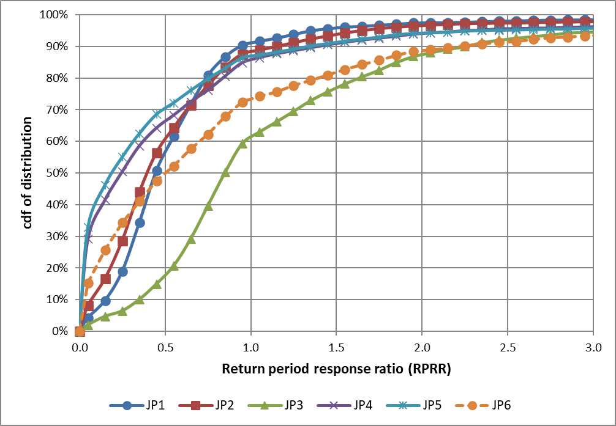

Figure 2. Cumulative distribution function of the peak overtopping return period ratio for different joint exceedance curve approaches relative to the RV approach.

***4.1.2 Overtopping for different defence types***

Figure 3 shows the cumulative distribution function of the RPRR for the different defence types considering JP1 only. This figure also shows the aggregated result for all defence types, i.e. the same result for JP1 as shown in Figure 2.

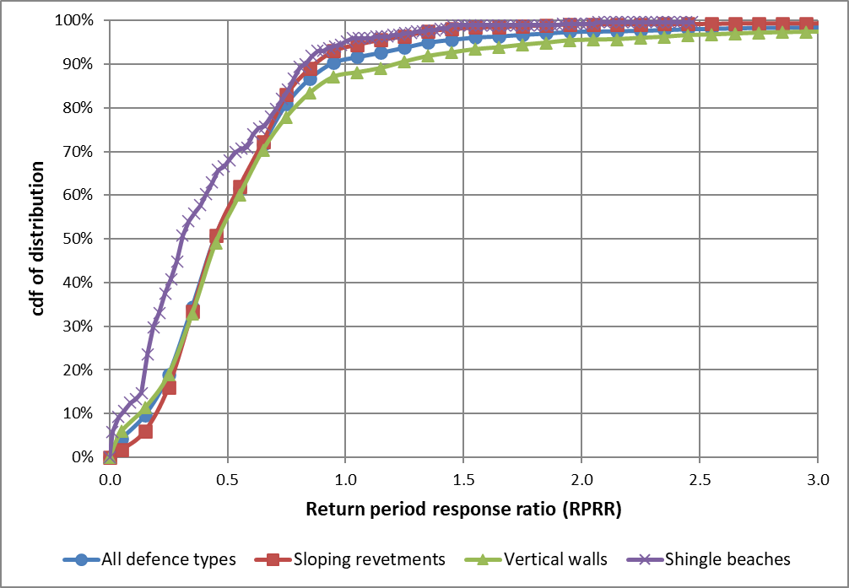

Figure 3. Cumulative distribution function of the peak overtopping return period ratio for different joint exceedance curve approaches relative to the RV approach for different RASP defence types (JP1 only).

Comparing the results for sloping revetments against vertical walls indicates little difference, except that vertical walls are more likely to have an actual return period greater than the benchmark return period. This is due to the wave breaking process on vertical structures, particularly where the structure toe level is high relative to the crest height of the structure. Under these conditions this can result in impulsive waves, waves that break violently onto vertical or steep walls leading to much greater levels of overtopping than would occur for the same wave conditions at a higher sea level, see Pullen *et al.*,(2007). As water depth, or sea level, is the key factor in whether waves breaks impulsively or non-impulsively, a key component in this is also the wave period. Typically a larger wave period based on the response function considered in this paper (Section 3.2) would mean that waves are more likely to be impulsive, leading to greater levels of overtopping. An under-estimate of the wave period is therefore more likely to under-estimate the wave overtopping rate compared to the wave overtopping rate using the correct wave period, and vice versa.

For shingle beaches, the RPRR follows a similar distribution to sloping revetments for ratios greater than about 0.7, yet a much greater chance of a smaller ratio below this value. This may be a function of the types of waves, with shingle beaches more likely to be impacted by surging waves than sloping revetments. However, it is more likely that this is just a function of the limited number of shingle beaches assessed in this paper (34), and a larger more widespread array of shingle beaches would probably suggest that the distribution of RPRR for shingle beaches is similar to that as for sloped revetments.

***4.2 Damage to Rock Armoured Structures***

The results in this section are based on calculating the rock sizes required to limit the damage level to 2, a level often considered as the “no damage” criterion, Van Der Meer (1987). This is the damage level typically used in design calculations. The damage levels for the different joint exceedance curve approaches are then redefined using the wave parameters from the RV approach to estimate the change in the damage level.

Figure 4 shows the effect on levels of damage to rock armoured revetments for the different joint exceedance curve approaches. This considers sloping revetments only. Figure 4 indicates that often the actual level of damage could be much greater than assessed or designed for when using the different joint exceedance curve approaches. This is particularly the case for JP1. For this approach, damage levels are less than the benchmark level of 2 for only about 2% of the defences tested, and therefore greater than the benchmark level for about 98% of the defences tested. However, damage levels using the JP1 approach are much less likely to be significantly greater (more than double) the benchmark level. For the defences tested, there is approximately a 6% chance that actual damage levels are more than double the benchmark level, but rarely more than three times the benchmark level. With “failure” considered to occur at a level of 10 or greater, Van Der Meer (1987), it would therefore not be expected that a revetment robustly designed for a damage level of 2 using the JP1 approach would fail under design conditions.

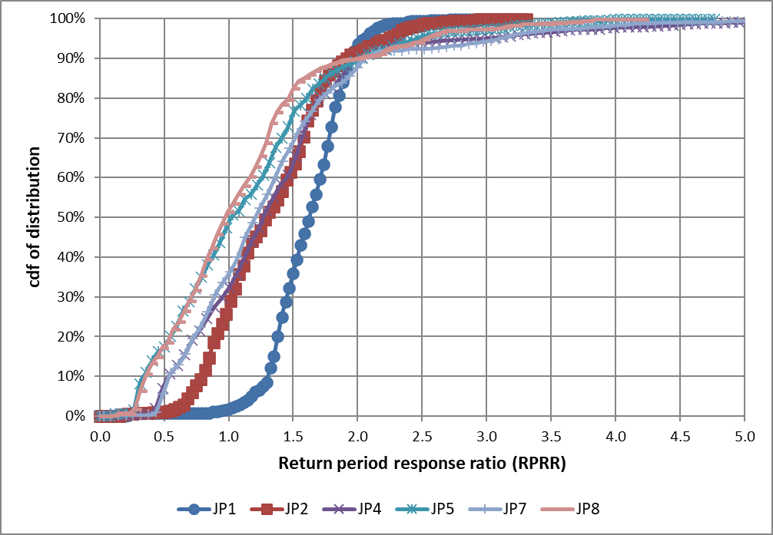

Figure 4. Cumulative distribution function of damage ratio for different joint exceedance curve approaches relative to the RV approach.

Differences though are a lot greater when considering the other joint exceedance curve approaches, particularly those based on the InJoPA approach (JP4-JP5 and JP7-JP8). Often levels of damage are greater than the benchmark level, although typically levels of actual damage are less than those structures assessed by the JP1 approach. However, significant levels of damage are much more likely in comparison to the JP1 approach. This includes a 1% chance that damage levels are potentially under-estimated by a factor of 5 or more using either the JP4 or JP7 approach for the defences tested. This would mean that the actual damage level would be 10 or greater, resulting in failure of the revetment under design storm conditions.

Damage to rock armoured revetments is though greater when impacted by long period waves. The effect of a wave steepness of 0.035 was therefore also investigated, and this is shown in Figure 5 for JP2 only. This suggests that a lower steepness value would in general result in a higher ratio for all joint exceedance curve approaches considered (JP5 and JP8 are not shown, but show similar results). This means that damage levels are more likely to be greater than the benchmark level. As a consequence, rock armoured structures more exposed to long-period swell waves, such as on the south-west coast of England, are at greater risk of failure when designed based on a joint exceedance curve approach when compared to regions where damage is driven by high steepness locally generated wind waves such as in Liverpool Bay. However, the issue being considered in this paper is the effect of how the joint exceedance curves are typically applied, not how best to apply them. Figures 4 and 5 therefore demonstrate that an assumed wave steepness using any of the joint exceedance curves considered in this paper can have a significant effect on the estimation of damage levels. In general, levels of damage are under-estimated, however, this would not be expected to lead to failure of a revetment, although this is more likely if using one of the InJoPA approaches.

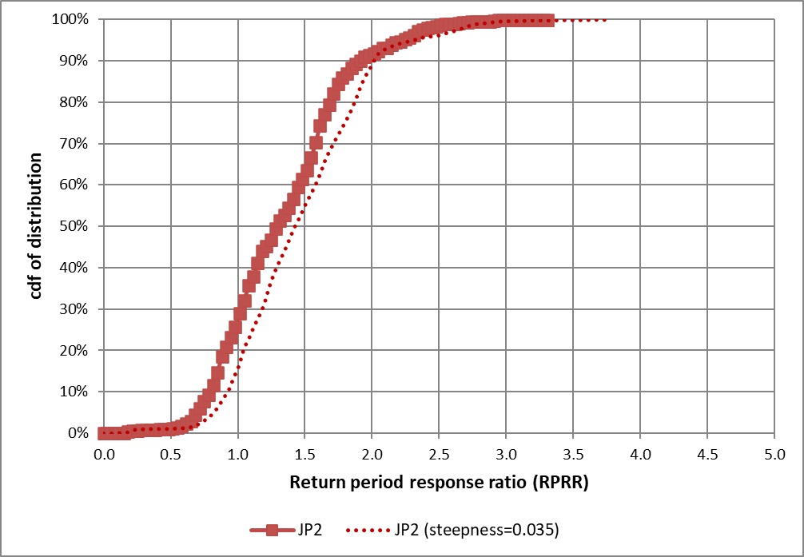

Figure 5. Cumulative distribution function of damage ratio for different joint exceedance curve approaches relative to the RV approach for different steepness values.

***4.3 Wave Forces***

Figure 6 shows the effect on the calculation of wave forces on vertical walls for the different joint exceedance curve approaches assessed. This considers vertical walls only. Results for JP2, JP7 and JP8 are not shown as they are similar to JP1, JP4 and JP5 respectively.

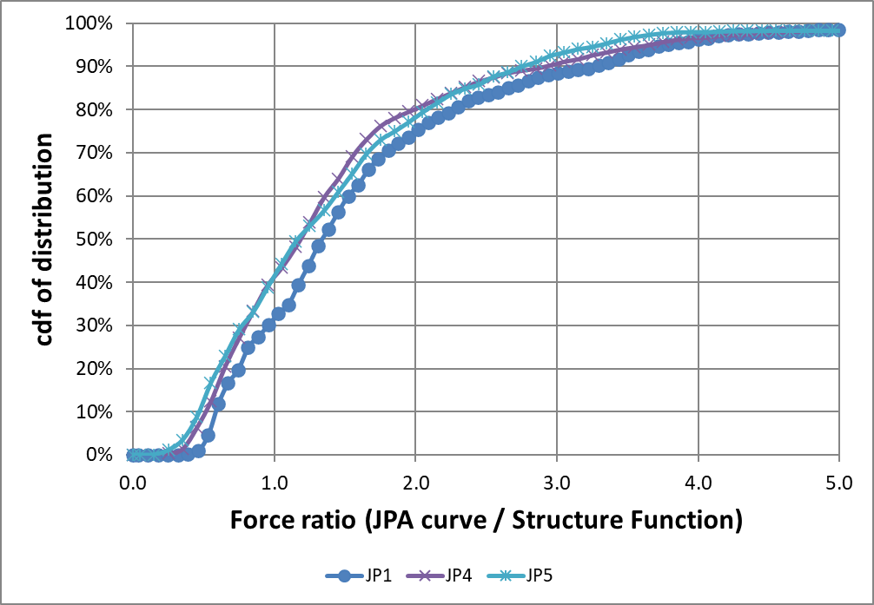

Figure 6. Cumulative distribution function of wave force ratio for different joint exceedance curve approaches relative to the RV approach.

Unlike the calculation of overtopping rates or damage levels, the effect of the choice of the joint exceedance curve approach does not appear to noticeably affect the calculated wave force when compared against the RV approach. In addition, the choice of joint exceedance curve approach makes little difference to the result obtained. Wave forces are also noted to be a lot less affected by wave period relative to wave height than overtopping rates and damage levels. Wave forces are also an approximate linear function of wave height, whereas they are typically a function of wave height to a power of 1.5 or greater for overtopping rates and damage levels.

As a consequence, these results suggest that wave forces are over-estimated for about 70% of the defences tested, and are over-estimated by factors of 2 and 3 for approximately 25% and 10% of the defences tested respectively.

**5. Conclusions**

This paper compares the different joint exceedance curve approaches in common use around the UK. This is to investigate the inherent inaccuracy in the estimation of various extreme response variables as a result of these curves not being related to the response variable considered. The results suggest that often, a joint exceedance curve approach underestimates the true response of the different variables considered, with the level of accuracy dependent on the response variable being considered, and the joint exceedance curve approach used.

***5.1 Overtopping***

All of the joint exceedance curve approaches generally underestimate peak overtopping rates, and in many cases this can be significant. JP1 gives the most consistent results to the benchmark return periods, however, this approach still indicates that 7% of sea defence structures tested underestimate the peak overtopping rate by a factor of 10 or more. This suggests, for example, that structures designed for overtopping to a 100-year design standard have a 1 in 15 chance of having an actual design standard of 10 years or less.

For other joint exceedance curve approaches, the differences can be significantly greater. The greatest differences are observed using the InJoPA approaches, where the actual return periods are often much more likely to be under-estimated than the JP1 or other CoMJEC approaches. Generally little difference is observed whether the simplified or the desk study approach is used to estimate return period overtopping rates, or whether the wave period is estimated from the data or an assumed steepness is applied. However, determining the wave period based on the data as opposed to an assumed steepness appears to give a closer result to the benchmark return period, although the choice of a lower steepness generally results in less chance of underestimating the true response (but also conversely a greater chance of overestimating the true response). Not accounting for wave direction was also seen to significantly affect results, with overtopping rates typically significantly higher.

Comparing overtopping rates for different defence types for JP1 suggests that actual return periods for sloping structures (e.g. revetments) more accurately represent the benchmark return periods than those for vertical structures. However, a joint exceedance curve approach is more likely to result in an overestimate of the peak overtopping rate for a vertical structure, particularly when you have a relatively high toe level. Shingle beaches appear to be more likely to under-estimate the actual return period than sloping structures or vertical walls. However, this is probably a result of the limited structures available to assess for this paper.

***5.2 Damage***

Damage levels, as for overtopping , are often under-estimated using the different joint exceedance curve approaches, particularly for JP1. However, damage levels using the JP1 approach do not have the spread of errors when compared to the other joint exceedance curve approaches, and a revetment robustly designed for a damage level of 2 using the JP1 approach would not be expected to fail under design conditions. However, the greater spread of errors for the InJoPA approaches means that significant levels of damage are much more likely in comparison to the JP1 approach, meaning that failure of a revetment when designed or assessed using an InJoPA approach is more likely, particularly if the wave steepness is over-estimated.

***5.3 Wave forces***

The effect of the choice of joint exceedance curve often does not appear to significantly affect the calculated wave force when compared against the RV approach, particularly as wave forces are a lot less affected by wave period relative to wave height than overtopping rates and damage levels. Wave forces are typically over-estimated for about 70% of the defences tested using a joint exceedance curve approach, and are rarely under-estimated by more than about 50% for the defences tested.

***5.4 Effect of climate change***

With most sea defence structures designed in this country to a design standard at some point in the future, it is likely that any potential under-design of a structure may not yet be appreciated. Overtopping as a result of rises in sea levels will generally increase, as will damage and forces as larger waves will now be able to impact structures. Many structures will therefore not yet have been exposed to the levels of sea levels and wave conditions that they were designed for. This is particularly the case for those structures built since the severe winter storms of 2013/14. It is possible therefore that as they come towards the end of their design life, structures designed or assessed based on a joint exceedance curve approach may be prone to failure or excessive levels of overtopping under relatively small storm events. This may even be the case when they may have withstood much worse storms when they were built, but when the effects of lower sea levels may have resulted in lower wave loads.

***5.5 Concluding remarks***

All of these results suggest that a large number of sea defence structures assessed based on a joint exceedance curve approach may be incorrectly defined, particularly when considering the InJoPA approach. This means that wave loads, and in particular overtopping rates may be significantly under-estimated, and certain defences significantly under-designed. In a few cases, the performance of some sea defence structures may have been overestimated leading to an expensive over-designed structure, particularly when using one of the InJoPA approaches.

The under design of a sea defence structure could have serious consequences in terms of the performance and lifetime of these structures, with consequent economic and social impacts. It also suggests that the assessment of flood levels may be greatly under-estimated, with consequent effects on the levels of damage and costs incurred in the flood zone. It is therefore recommended that where suitable and appropriate, a joint exceedance curve approach should not be used to assess the performance of a sea defence structure. However, more work is required where the RV approach is not considered suitable and a joint exceedance curve approach is still considered appropriate such as in the optimisation of designs in physical model tests where it is feasible to only consider relatively few test conditions.

**Acknowledgements**

The analysis carried out in this paper is based on the nearshore sea level and wave height datasets produced as part of the Environment Agency State of the Nation project, Gouldby *et al.*, (2017). We would therefore like to thank Tim Hunt and Dave Hornby at the Environment Agency for their agreement for the use of these datasets as well as their helpful comments and patience in the writing of this paper.

**References**

Booij N, Ris RC, Holthuijsen LH (1999) “A Third-Generation Wave Model for Coastal Regions. Journal of Geophysical Research **104(C4)**: 7649–7666.

Defra (2005) Joint Probability: Dependence Mapping and Best Practice: Technical Report on Dependence Mapping, R&D Technical Report FD2308/TR1.

Environment Agency (2011) Coastal Flood Boundary Conditions for UK Mainland and Islands, Project: SC060064/TR2: Design Sea Levels, Horizon House, Bristol.

Environment Agency (2018) Coastal Flood Boundary Conditions for the UK: 2018 Update, Project: SC060064/TR6: Technical Summary Report, Horizon House, Bristol.

Environment Agency (2019) Environment Agency AIMS Defence Database. See https://data.gov.uk/dataset/aims_defence (accessed 28/11/19).

Goda Y (2010) Random Seas and Design of Maritime Structures: Advanced Series on Ocean Engineering **15**.

Gouldby B, Wyncoll D, Panzeri M, Franklin M, Hunt T, Hames D, Tozer N, Hawkes P, Dornbusch U and Pullen T (2017) Multivariate Extreme Value Modelling of Waves, Winds and Sea Levels Around the Coast of England. Proceedings of the Institution of Civil Engineers – Maritime Engineering **170(1)**: 3–20.

Hall JW, Dawson RJ, Sayers PB, Rosu C, Chatterton JB and Deakin R (2003) A Methodology for National-Scale Flood Risk Assessment. Proceedings of the Institution of Civil Engineers - Water Maritime and Engineering **156(3)**: 235-248.

Hames D, Gouldby B and Hawkes P (2019) Evolution of joint probability methods in coastal engineering practice in the UK. Proceedings of the Institution of Civil Engineers - Water Maritime and Engineering **172(2)**: 45-54.

Hawkes PJ, Gouldby BP, Tawn JA and Owen MW (2002) The Joint Probability of Waves and Water Levels in Coastal Engineering Design. Journal of Hydraulic Research **40(3)**: 241–251.

Heffernan JE and Tawn JA (2004). A Conditional Approach for Multivariate Extreme Values (with discussion). Journal of the Royal Statistical Society, Series B (Statistical Methodology) **66(3)**: 497–546.

HR Wallingford (2004) National Flood Risk Assessment 2004: Supported by the RASP HLM plus: Methodology, September 2004. Report for the Environment Agency.

HR Wallingford (2015) State of the Nation: Coastal Boundary Conditions Report for the Environment Agency, Report Number 30, Reference MCR5389-30-R00-01.

HR Wallingford / Lancaster University (2000a) The Joint Probability of Waves and Water Levels : JOIN-SEA – A Rigorous but Practical New Approach. HR Wallingford Report SR537, May 2000.

HR Wallingford / Lancaster University (2000b) The Joint Probability of Waves and Water Levels : JOIN-SEA – Version 1.0, User Manual, Report TR71, May 2000.

Hydraulics Research Limited (1990) Joint Probability of Waves and Water Levels on the North Wales Coast, Report Number EX 2133, May 1990.

Pullen T, Allsop NWH, Bruce T, Kortenhaus A, Schüttrumpf H and Van Der Meer JW (2007) EurOtop: Wave Overtopping of Sea Defences and Related Structures: Assessment Manual.

Van Der Meer JW (1987) Stability of Breakwater Armour Layers – Design Formulae. Coastal Engineering, **11**: 219-239.

Van der Meer JW, Allsop NWH, Bruce T, De Rouck J, Kortenhaus A, Pullen T, Schüttrumpf, H, Troch P and Zanuttigh B (2018) EurOtop Manual on Wave Overtopping of Sea Defences and Related Structures.