**Determination of Licit and Illicit Drugs and Metabolites in Human Sweat by** **Liquid Chromatography-Tandem Mass Spectrometry**

**Margaret Sotom, Paul Bowdler and Kevin C. Honeychurch\***

School of Applied Sciences, University of the West of England, Frenchay Campus, Coldharbour Lane, Bristol BS16 1QY, Bristol, UK

*\*Corresponding Author, Tel +4411732 87357, email* [*kevin.honeychurch@uwe.ac.uk*](mailto:kevin.honeychurch@uwe.ac.uk)

**Graphical Abstract**

**Abstract**

A liquid chromatography-tandem mass spectrometry screening method in sweat was developed for the simultaneous determination of three licit drugs (nicotine, paracetamol and caffeine); four illicit drugs (cocaine, ketamine, 25I-NBOMe and methamphetamine) and two metabolites (benzoylecgonine and cotinine). Target drugs were liberated from sweat patches with pH 5 sodium acetate buffer and further purified by solid phase extraction (SPE) utilising Strata-X-Drug B cartridges. Optimal solvent constituents for SPE organic wash and elution were 70% *v/v* methanol in deionised water and 5% *v/v* ammonium hydroxide in methanol respectively. Chromatographic separation was achieved using a superficially porous particle C18 column with gradient elution, using (A) 0.1% formic acid in water and (B) acetonitrile as mobile phase constituents. Target drugs were identified using a combination of retention time, and the ion ratios for two precursor-product ion transitions for each analyte monitored in multiple reaction monitoring (MRM) mode. The method was linear for all target drugs from 1.0 – 150.0 ng/mL with corresponding limits of quantitation of 1.0 ng/mL. Limits of detection were found to range from 0.1 - 0.6 ng/patch. The method was subsequently applied to the analysis of sweat samples from five male and four female participants aged 20-25 years. Sweat was collected from two areas (right forearm and left thigh) using protected layers of gauze. All eighteen patches tested positive for at least one target analyte. The results of this study not only show a multi-substance screening method was achieved but also that sweat patches can be used to indicate an individual’s drug use. Therefore, they can provide an alternative non-invasive technique for forensic applications.

**Keywords**

Sweat, illicit drugs, licit drugs, SPE, LC-MS/MS, chromatography, mass spectrometry.

**1. Introduction**

Sweat offers a number of possible advantages for monitoring drug usage; overcoming possible adulteration issues seen with urine, the short detection window offered by blood, or the external contamination that can be seen for hair. It is a watery fluid secreted from the eccrine and apocrine glands distributed over the human body to maintain and regulate constant body temperature.[1] The variability in quantity perspired by an individual depends on their sweat secretion per gland and is subject to change by daily activity, emotional state, and thermal stimuli.[2] Differences in sweat gland density across the body mean sample collection from different parts of the body can impact on the results gained.[3] However, investigations of the relative effectiveness of sweat patches compared with more conventional urine analysis for the screening of cocaine and opiates showed that sweat samples gave more favourable and reliable results;[4]’[5] however, a number of reports have highlighted the possibility of determine drugs residues in fingermarks[6],[7] as well.

Sweat has low tonicity and is more acidic than blood, on average pH 6.3, meaning, based on the pH partition, basic drugs preferably accumulate in sweat than in blood.[8],[9] The concentration gradient between blood and sweat enables the free fraction of the drug to diffuse through the lipid bilayer, followed by sweat excretion onto the skin. Although passive diffusion is the primary pathway excretion through sebum and intracellular diffusion also have a role.[10],[11] In sweat the lower pH environment can result in ionisation of the drug, and its possible accumulation.

Compared to other bodily fluids, sweat samples can be collected via relatively tamper-proof collection methods and avoid problems with loss of privacy during sampling and the need for the transportation of possible biological hazards. However, the small sample sizes and the similarly small amounts of drugs present requires sensitive techniques such as gas chromatography mass spectrometry (GC-MS) or liquid chromatography-tandem mass spectrometry (LC-MS/MS). Nevertheless, Cone *et al.*9 have shown that a dose as low as 1-5 mg of cocaine to be sufficient to give detectable levels of cocaine and its metabolites in sweat.

The aim of this present study was to investigate the effectiveness of sweat patches for the collection of the drugs; nicotine, paracetamol, caffeine, cocaine, ketamine, 25I-NBOMe, methamphetamine and the two metabolites; benzoylecgonine and cotinine present in human sweat. We selected these drugs as they are commonly used in Bristol, UK, our study area. The city has been shown to be one of the top consumers of methamphetamine, ketamine and cocaine (as benzoylecgonine) in Europe in a recent study of drug levels in wastewater.[12] We also included the legal drugs; nicotine, and its metabolite, cotinine, as markers of possible smoking and/or vaping; an increasing trend[13] in the age group investigated. Coming out of a pandemic, both paracetamol and caffeine were also studied as markers of the health status of the age group investigated. We were also interested in the possibility that unlike urine, non-metabolised drugs could be determined in sweat.

In the first part of this investigation, the LC-MS/MS conditions required for the simultaneous determination of the target analytes were optimised. In the following study, the possibility of determining the levels of these compounds in the sweat collected from five males and four female volunteers in the age range 20-25 was investigated. Sweat was collected from these volunteers from patches positioned on both their arm and legs. The possibility of extracting the target analytes from the patches was then explored by SPE for quantification by LC-MS/MS.

**2. Materials and methods**

*2.1 Chemicals and reagents*

Certified reference materials of solutions of 1.0 mg/mL standards of ketamine hydrochloride, nicotine, cotinine, cocaine, methamphetamine, benzoylecgonine, 25I-NBOMe, and methamphetamine-D14, and 100 μg/mL standards of nicotine-D4, cocaine-D3, ketamine-D4 and benzoylecgonine-D3 in methanol were used. All standards were obtained from Merck Life Sciences (Gillingham, Dorset, UK). Anhydrous sodium acetate, water with 0.1% formic acid, acetonitrile, methanol, ammonium hydroxide 35% solution and glacial acetic acid were all LC-MS grade and purchased from Fischer Scientific (Loughborough, UK). Individual drug standard solutions at 2.0 mg/L were prepared by dilution of the primary stock solution in mobile phase (20% acetonitrile, 80% water containing 0.1 % formic acid) and a mixed drug standard solution of 50ng/mL also prepared by dilution in mobile phase. All working solutions with drugs were stored at 3 $±$ 2 °C. Deionised water was obtained from a Purite RO200 – Stillplus HP system (Purite Oxon, UK). Solid phase extraction was performed using Strata-X-Drug B 33 *µ*m Polymeric Strong Cation Mixed-Mode Polymer sorbent 30mg/1mL cartridges from Phenomenex (Torrance, CA, USA).

Artificial sweat was made from the formula used by Skopp *et al.*[14] based on the 3160/2 ISO standard.[15] The composition was 20 g/L sodium chloride, 17.5 g/L ammonium chloride, 5.0 g/L urea, 2.5 g/L acetic acid, and 15 g/L lactic acid at pH 4.7 adjusted using of 1.0 M sodium hydroxide.12

Sweat patches were formed from Premium Sterile Gauze Swabs 5 cm x 5 cm purchased from JFA Medical (Ashton-under-Lyne, UK) with 3M Transpore Surgical tape 1.25 cm x 9 m from (Bracknell, UK). Protection layer used Co-op Non-PVC Cling Film 45 m x 350 mm (UK). The collection site was cleaned using Pre-Injection Alcohol Wipes, 70% isopropyl alcohol disposable wipes from Farla Medical (London, UK).

*2.2 Solid-phase extraction*

Worn sweat patches were placed into 17 mm x 60 mm glass screw-top vials containing 5.0 mL of 0.1 M acetate buffer (pH 5). The vials were shaken for 5 minutes to extract the drugs from the patch. Solid-phase extraction was undertaken using Strata-X-Drug B polymeric strong cation mixed-mode polymer sorbent 30mg/1mL cartridges. The SPE cartridge was first conditioned with 1.0 mL of methanol and 1.0 mL of 0.1 M pH 5.0 acetate buffer. An aliquot of 0.50 mL sample was then loaded to the SPE. The SPE was then washed with 1.0 mL of 70% *v/v* methanol in deionised water and the extract then eluted with 1.0 mL of 5% solution of ammonium hydroxide in methanol. The resulting extract was then evaporated to dryness under nitrogen flow and reconstituted in 1.0 mL of the optimised mobile phase (20% acetonitrile:80% formic acid (0.1%) in water), containing 50 ng/mL of each internal standards. This was then examined using the optimised LC-MS/MS conditions.

*2.3 Instrumentation*

All investigations were undertaken using an Agilent Technologies 1260 Infinity high performance liquid chromatograph coupled with an Agilent Technologies 6460 triple quadrupole mass spectrometer. Separations were carried out using an Agilent Technologies Infinity Lab Poroshell 120 EC C18 column (2.7 µm particle size, 3.0 mm x 50 mm) maintained at 30oC with gradient elution. The injection sample volume was 20 µL. The mobile phase, delivered at a flow rate of 0.4 mL/min, consisted of Solvent A, 0.1% formic acid in water, and Solvent B, acetonitrile. The gradient elution conditions were programmed as follows: 0-1 min 80% A and 20% B, 1-4 min gradient elution to 20% A and 80% B, 4-9 min 20% A and 80% B. The total run time was 9 minutes including an equilibrium time of 3 minutes. Data was acquired in multiple reaction monitoring (MRM) mode. MassHunter Optimizer software was used to optimize MRM parameters, MassHunter Acquisition Software was used for data acquisition and MassHunter Quantitative Analysis (QQQ) software was used for data analysis. The most abundant product ion was chosen as the quantifier and the next most abundant as the qualifier. All product ions, precursor ion, fragment or voltage and collision energy values for each investigated compound and associated internal standards are shown in Table 1.

**Table 1**. Multiple reaction monitoring (MRM) transitions parameters for all substances including deuterated compounds. Analytes listed in order of elution. CA abbreviation for Cell Accelerator.

|  |  |  |  |  |  |  |  |
| --- | --- | --- | --- | --- | --- | --- | --- |
| **Substance** | **Precursor Ion (m/z)** | **Product Ion Quantifier (m/z)** | **Product Ion Qualifier (m/z)** | **Fragmentor Voltage (V)** | **Collision Energy, V** | **CA* Voltage** | **Dwell Time, ms** |
| Nicotine | 163.1 | 130 | 117 | 74 | 22 and 26 | 4 | 20 |
| Nicotine-D4 | 167.1 | 136.1 | 134.1 | 72 | 18 and 22 | 4 | 20 |
| Cotinine | 177.1 | 98.1 | 80.1 | 108 | 22 and 26 | 4 | 20 |
| Paracetamol | 152.1 | 110 | 93.1 | 108 | 18 and 22 | 4 | 20 |
| Caffeine | 195.1 | 138 | 110 | 114 | 18 and 22 | 4 | 20 |
| Methamphetamine | 150.1 | 119 | 91.1 | 74 | 10 and 18 | 4 | 20 |
| Methamphetamine-D14 | 164.2 | 130.1 | 98.1 | 80 | 10 and 18 | 4 | 20 |
| Ketamine | 238.1 | 220 | 125 | 74 | 14 and 30 | 4 | 20 |
| Ketamine-D4 | 242.1 | 224.1 | 129 | 84 | 14 and 30 | 4 | 20 |
| Benzoylecgonine | 290.1 | 168.1 | 105 | 104 | 18 and 30 | 4 | 20 |
| Benzoylecgonine-D3 | 293.2 | 170.1 | 105 | 106 | 18 and 30 | 4 | 20 |
| Cocaine | 304.2 | 182.1 | 105 | 106 | 18 and 34 | 4 | 20 |
| Cocaine-D3 | 307.2 | 185.1 | 105 | 112 | 18 and 34 | 4 | 20 |
| 25I-NBOMe | 428.1 | 121 | 91.1 | 116 | 22 and 66 | 4 | 20 |

**Table 2.** Linear dynamic range of drugs investigated; retention times, equation for each calibration curve with correlation coefficient (r2) and limits of quantitation (LOQ).

|  |  |  |  |  |
| --- | --- | --- | --- | --- |
| **Analyte** | **Retention Times (minutes)** | **LOQ (ng/mL)** | **Regression equation** | **r2** |
| Nicotine | 0.603 | 1.0 | y = 4.83751x + 0.072903 | 0.999 |
| Cotinine | 0.628 | 1.0 | y = 2.025538x + 0.008500 | 0.999 |
| Paracetamol | 0.908 | 1.0 | y = 0.059650x+ 0.002118 | 0.991 |
| Caffeine | 0.990 | 1.0 | y = 0.042575x + 2.327465 | 0.995 |
| Methamphetamine | 1.03 | 1.0 | y = 1.478029x + 0.001490 | 0.991 |
| Ketamine | 1.20 | 1.0 | y = 1.803833x + 5.539614 | 0.997 |
| Benzoylecgonine | 1.29 | 1.0 | y = 1.183743x + 7.368519 | 0.998 |
| Cocaine | 2.35 | 1.0 | y = 1.137681x + 6.231642 | 0.998 |
| 25I-NBOMe | 4.10 | 1.0 | y = 4.183107x + 0.009668 | 0.996 |

*2.4 Sample preparation and extraction*

All sweat patches were formed by three layers of gauzes taped and protected by cling film. Each participant wore two patches; one on the right forearm and the other behind the left thigh just above the knee, each applied with new nitrile gloves to avoid contamination. These collection sites were chosen for practicality and comfort for the participants. The two skin collection sites were cleaned prior to the application of the sweat patches using 70% isopropyl alcohol wipes. These patches were worn for five hours before being removed with nitrile gloves and placed into 17 mm x 60 mm glass screw-top vials containing 5.0 mL of 0.1 M acetate buffer (pH 5). The vials were shaken for 5 minutes to extract the drugs from the patch.

*2.5 Method validation*

Single analyte solution injections were used to obtain MRM transition signals. Standard calibration curves were generated using least-squares linear regression. The limit of quantitation (LOQ) was selected as the lowest calibrator concentration for each analyte. The theoretical limit of detection was estimated form the standard deviation of the residuals of the calibration curve. Investigations from SPE extracted sweat samples were used to evaluate extraction recoveries.

Calibrator solutions in mobile phase were made from the fourteen individual drug standard solutions at 2 mg/L. A seven-point calibration curve was constructed using these solutions at concentrations, 1.0, 5.0, 10.0, 25.0, 50.0, 100.0 and 150.0 ng/mL for each target drug and 50 ng/mL for each deuterated internal standard. The concentrations of 25I-NBOMe, caffeine and paracetamol were determined using cocaine-D3. Typical chromatograms obtained for all nine target species are shown in supplementary material, Fig. S1. and Fig. S2.

*2.6 Volunteer Participants*

Nine participants, comprising of five males and four females aged 20-25 years, volunteered for this study and gave their written consent to participate. They also completed a questionnaire, shown in supplementary material, Fig S3, to indicate their drug consumption, or lack thereof, for results comparison at the end.

**3. Results and discussion**

*3.1 Method development*

The objective of developing this approach was to create a fast and sensitive method of analysis for simultaneously identifying and quantifying the presence of drugs in sweat. There are many factors that affect good chromatographic resolution and peak symmetry, hence the investigation and optimisation of these which included flow rates, organic modifier concentration and the column stationary phase A mobile phase consisting of A) 0.1% formic acid in water and B) acetonitrile, with a 3-minute gradient elution to 80 % acetonitrile then held isocratically for 5-minutes was found to be optimum. This was undertaken at a 2.7 µm C18 column allowing for the elution of all nine compounds including the deuterated internal standards. Individual standards at 2 mg/L were injected to determine the optimal MRM transitions for quantifier and qualifier ions for each compound. These were chosen as the most abundant product ion and second-most abundant product ion respectively. Other instrumentational parameters along with these results are presented in Table 1.

Seven point calibration curves were generated for the nine compounds were formed by plotting peak area ratio against concentration, over the range of 1.0 – 150 ng/mL. Acceptable linearity was achieved when correlation coefficient (r2) values were >0.990 as shown in Table 2. Limit of quantitation (LOQ) for all analytes was 1.0 ng/mL and limit of detection (LOD) was estimated to be between 0.1 and 0.6 ng/patch. These results correlate well with the data obtained in a similar study by Concheiro *et al.*8 where the LOQs were 1 ng/patch and LODs ranged from 0.5 – 2.5 ng/patch.

Mixed mode SPE with reversed phase and strong cation exchange was chosen to selectively retain the target compounds whilst removing the majority of interferences present. A major cause for low percentage recoveries results from variables such as volume of sample, strength of organic wash and elution solvent, and interactions within the cartridge, hence the investigation for optimal parameters. The elution solvent must be strong enough to disrupt the retentive interactions between the analytes and sorbent. Extractions of mixed drug standards (1.0 ng/mL) using three different ammonium hydroxide percentages in methanol for the target analyte elution were investigated (Fig. 1.). For accuracy and precision, all extractions were repeated three times. Cotinine and caffeine showed a 55% and 13% increase in recovery, respectively, when ammonium hydroxide concentration was increased, whilst methamphetamine and 25I-NBOMe showed a decrease in recovery of 17% and 12% respectively. Paracetamol was not detected in both elution solvent and organic wash optimisation may have likely been the result of a poor elution solvent for this analyte. A study conducted by Chen, *et al.*[16] showed high and consistent recoveries for paracetamol when using a polar organic solvent for elution. This indicated that paracetamol may have been prematurely eluted during the organic wash step resulting in it not being present in the final elution. Based on the results, presented in Fig.1., little differences between the three investigated percentages could be seen for methamphetamine, ketamine, caffeine, cotinine and 25I-NBOMe. However, for both cocaine and benzoylecgonine the percentage recovery drops off markedly at ammonium hydroxide concentrations of 10 %. This would seem more a reflection of dilution of the methanol with the increasing concentrations of aqueous based ammonium hydroxide solution. There is not a marked difference between the pKa values for the compounds investigated, it would appear that elution of cocaine and benzoylecgonine is notably influenced by solvent elution strength as well. Consequently, it was concluded that a 5% *v/v* ammonium hydroxide in methanol solution would be the optimal elution solvent in this study.

The solvent used in the SPE wash step is also very important, allowing for the removal of co-extracted sample compounds from the SPE. However, the application of too strong an eluting solution in this step could also lead to possible poor target analyte recoveries. The wash solution needed to be strong enough to remove any interferences present in sweat, while retaining all target compounds in the SPE cartridge in order to be eluted in the subsequent elution collection step. The investigation for optimal concentration of methanol in water used for the organic wash step in SPE was therefore undertaken in 10% intervals of increasing methanol concentration. Extraction recoveries, shown in Fig. 2., were found to vary for each target compound. A general drop in recovery occurred when the percentage of methanol was too high. Nicotine recovery started to decrease after 50% methanol:water whereas ketamine, benzoylecgonine and cocaine dropped after 70% methanol. Caffeine and 25I-NBOMe appeared to not be affected by high methanol concentration, and both obtained reproducible and efficient recoveries of >82 % and >64% respectively. Accordingly, 70% *v/v* methanol in deionised water was chosen to be the organic solvent percentage for further investigations.

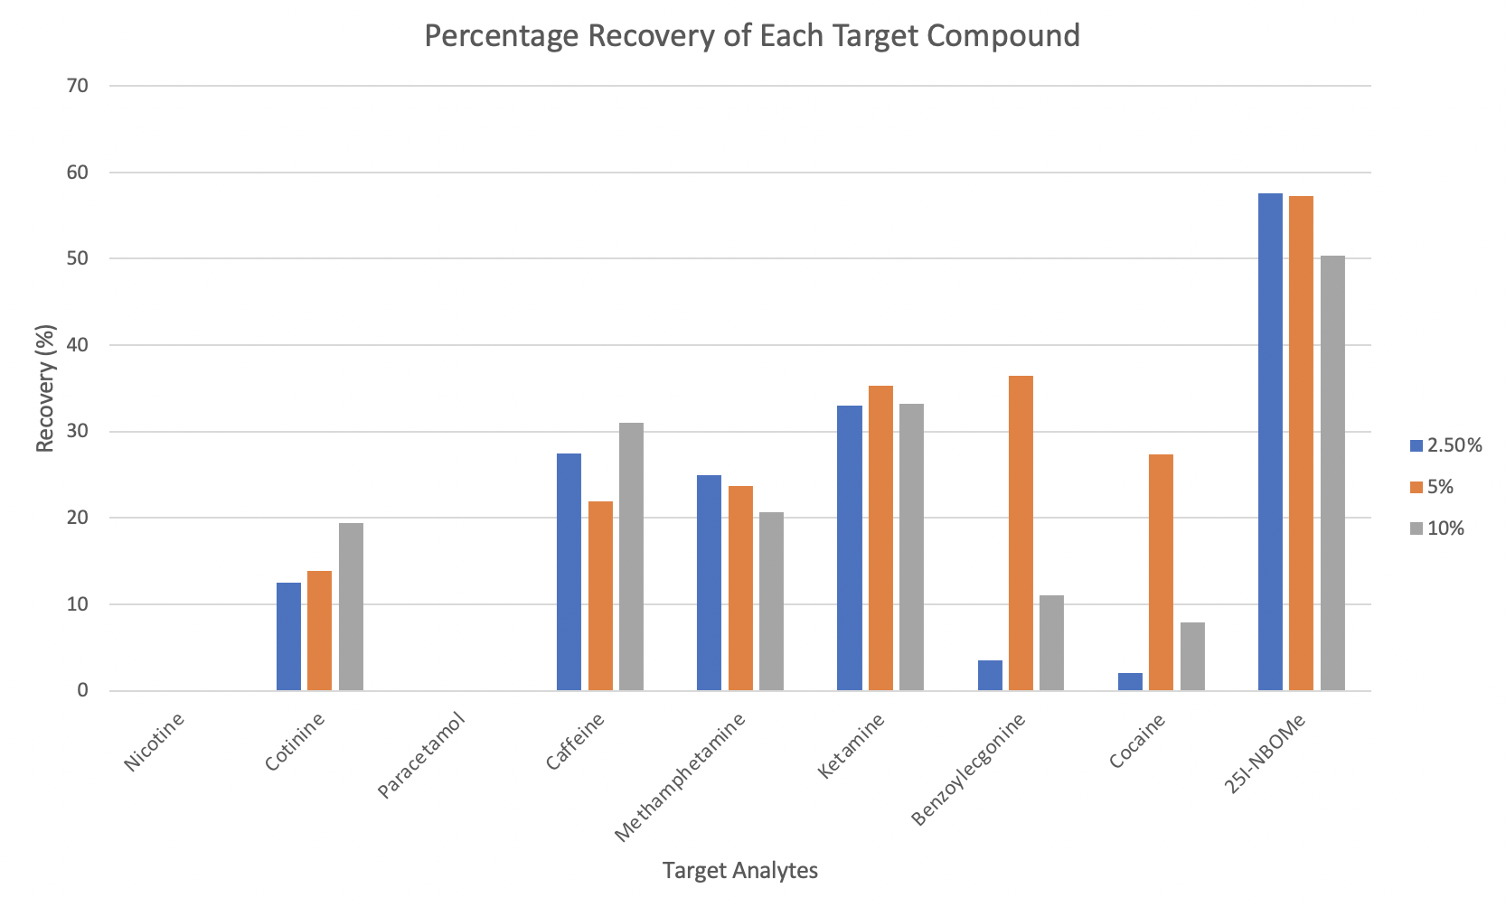

**Fig. 1.** The effect of different concentrations of ammonium hydroxide in methanol for the solid-phase elution solvent on the mean (n = 3) percentage recoveries of each compound (1.0 ng/mL). Blue 2.5 %, orange 5 % and grey 10 % ammonium hydroxide in methanol.

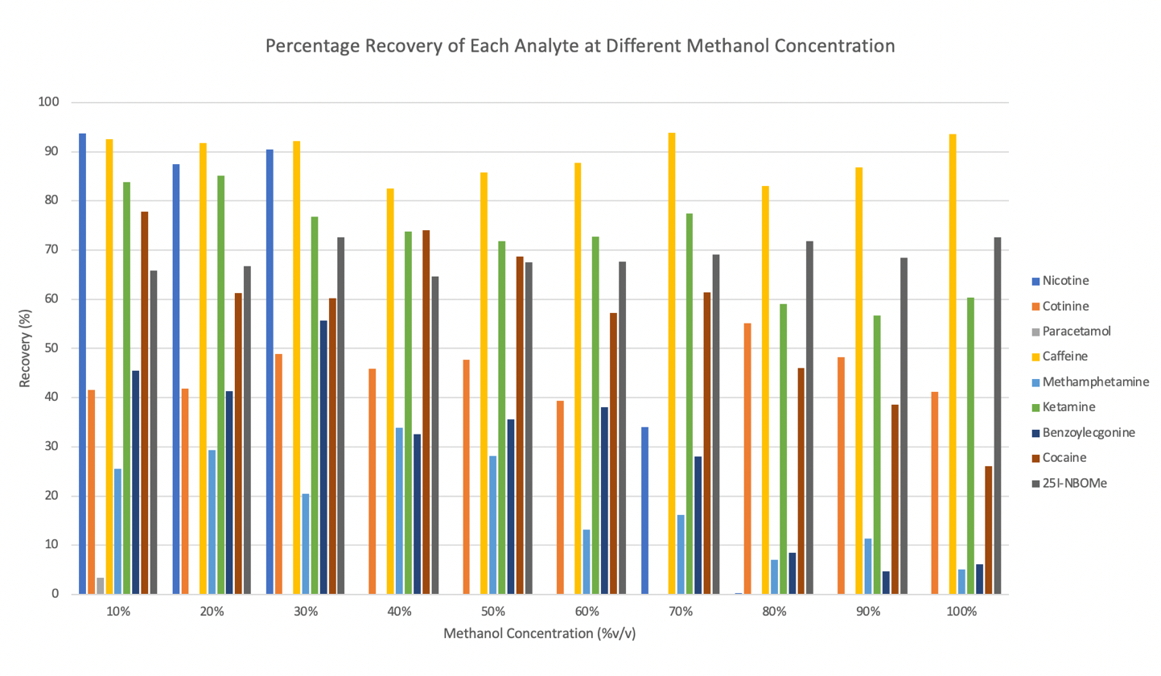**Fig. 2.** The effect of percentage of methanol/water used for the solid phase extraction wash step on the recovery of each drug (5.0 ng/mL).

Precision was evaluated by the analysis of freshly made batches of 10 ng/mL (QC) samples in each LC-MS/MS run. The results regarding precision are shown in Table 3. All analytes, except paracetamol, have low coefficient of variation (CV) values, as shown in Table 3. The highest CV was 4.22% for caffeine and the lowest was 1.02% for 25I-NBOMe. These show there were lower levels of variability around the mean indicating good precision and reliability. The high CV value for paracetamol (77.36%) showed instability and was deemed inaccurate due to the constant errors risen from this analyte. As a result, paracetamol was not quantified further in this present study. Future studies to support these findings should examine blank patches spiked with calibration standards and extracted using the optimal extraction conditions.

**Table 3.** Mean, standard deviation and coefficient variation for 10 ng/mL quality control (QC) standard (n=4) measured during each sample batch run.

|  |  |  |  |
| --- | --- | --- | --- |
| **Analyte** | **Mean (ng/mL)** | **Standard Deviation** | **Coefficient Variation (%)** |
| Nicotine | 9.052 | 0.355 | 3.92 |
| Cotinine | 9.12 | 0.190 | 2.08 |
| Paracetamol | 6.886 | 5.327 | 77.36 |
| Caffeine | 9.668 | 0.408 | 4.22 |
| Methamphetamine | 9.580 | 0.151 | 1.58 |
| Ketamine | 9.660 | 0.165 | 1.32 |
| Benzoylecgonine | 9.599 | 0.198 | 2.06 |
| Cocaine | 9.561 | 0.217 | 2.27 |
| 25I-NBOMe | 9.095 | 0.092 | 1.02 |

*3.2 Sweat samples*

Eighteen sweat samples from nine participants were analysed to investigate the applicability of the developed method. Subjects wore the patches with minimal discomfort for five hours with no tampering or contamination of the patches. This allowed for the simultaneous detection of multiple licit and illicit drugs. Results from the sweat patches are shown in Table 4, quoted as concentration per patch (ng/patch). Patches were positive for nicotine in four participants, cotinine in three, ketamine in two, cocaine in one and caffeine in nine. All sweat patches showed the presence of caffeine in a range of 1.7 to 8.9 ng/patch concurrent with the admissions of all nine participants to drinking caffeinated drinks daily. The presence of nicotine and its metabolite, cotinine would be expected if nicotine had been consumed by the individual which we found to be true for three out the four cases here. However, in one case we did detected cotinine. We believe this is could be a result of third-hand smoking,[17],[18] or the time required for cotinine to be formed and then be detectable in the sweat sample.

Participants 3, 5 and 7 all admitted to having smoked tobacco recently when they completed the questionnaire. These admissions strongly correlated with the results obtained from those participants’ sweat samples as all three tested positive from both nicotine and cotinine. The presence of nicotine could be due to surface contamination however the presence of its metabolite, cotinine, would suggest consumption. Participant 6 denied smoking, yet sample their leg patch showed 0.298 ng/patch of nicotine which appeared to be correct, due to a high signal-to-noise ratio of 48.7. On the basis that all questionnaires were answered truthfully, this result may have been due to second hand smoking or third hand smoke15,16 as concentrations detected for cotinine and cocaine were the result of background noise. The levels found for nicotine varied from 0.0322 – 1.337 ng/patch and 0.13 – 2.99 ng/patch for cotinine, which are much lower results than those obtained by Koster *et al.*[19] ranging from 60 – 17,224 ng/patch and 4.0-570 ng/patch respectively. These patches were worn for seven consecutive days allowing a greater concentration to be accumulated in the sweat patch. Concheiro *et al.*[20] analysed consumption of tobacco in pregnant women and found a mean concentration of cotinine in weekly sweat patches of 78.5 ng/patch. The lower concentrations found in the sweat patches of this study are likely as a result of shorter length of patch wear.

Participant 6 tested positive for ketamine with a higher concentration detected in the leg patch (317 ng/patch) compared to the arm (17.0 ng/patch). Conversely, participant 7 was the only other to test positive for ketamine but presented a higher concentration in the arm patch (238 ng/patch) than the leg patch (170 ng/patch). These were the highest concentrations of any analytes collected from the sweat patches. There is a lack of studies involving ketamine as a target analyte in sweat analysis but it is more common in research concerning hair analysis.[21]

Results from participant 7 showed cocaine levels from their arm of 0.099 ng/patch and leg of 0.115 ng/patch . The cocaine peaks in both patches have a high signal-to-noise ratio of 128.97 and 57.79 respectively and trace amounts of benzoylecgonine were also detected. Therefore, in future studies, we will explore a further concentration step, such as decreasing the final volume used to reconstitute the sample extract. Further applicability to smaller sample sizes could be performed by analysing sweat samples after a 1 in 10 dilution and comparing the results. The most common compounds targeted in sweat are cocaine and its metabolites, for which there have been multiple studies published.4,18,[22] However, a comparison cannot be made between this study and others due to the lack of positive results obtained. Also, interestingly, both methamphetamine and 25I-NBOMe were not detected in any participants indicating that these drugs may not be common in the Bristol area where this study was carried out, and therefore not frequently abused. However, other factors such as low concentrations in sweat and the low number of samples tested in the study might not be sufficient for a conclusion regarding these drugs prevalence in a population.

Skin collection site has been shown to affect the volume of sweat collected due to the non-even distribution of sweat glands around the body.3 The arm and thigh were the collection sites chosen for this study due to practicality and comfort for the participants, however, these may not have been the areas to yield the best results. The investigation presented split results of some sweat samples yielding greater concentration from the arm patch than others from the leg patch. The study by Huestis *et al.[23]* compared the results of sweat patches worn on the palm of the hand and the abdomen and exhibited higher concentrations in the former. The concentrations of cocaine were more than two-fold greater in the palm sweat patch compared to the abdomen. This could be explained by the differences in physiology of the skin but also due to the palms and soles containing the highest sweat gland density across the body surface.2 Similarly, the study by Uemura *et al.*3 showed much higher concentrations of cocaine and metabolites collected from patches placed on the lower back compared to the upper shoulder. Multiple factors such as length of wear, extent of exercise, natural levels of perspiration in an individual, may have all impacted these findings, therefore resulting in an unreliable conclusion in distinction between the two. Additionally, arms and legs have a sweat gland density 2-5-fold lower than that on palms or soles2 which may be the result of the smaller concentration recorded in this study. Conversely, sweat samples from participant 6 arm (6Arm) and leg (6Leg), and participant 7 arm (7Arm) and leg (7Leg) exhibiting higher drug concentrations, showed that the leg patch excreted a greater concentration of drugs than that from the arm (Fig. 3). The most suitable sampling site could be argued to be the palms or soles of an individual; however, these are very susceptible to contamination or removal of patch during the study. Therefore, the lower back would seem to be the appropriate collection site for such testing. All of these findings conclude that the collection site of samples must be carefully considered when evaluating sweat patch results.

**Table 4.** Analyte concentration (ng/patch) detected in participant sweat patches from right arm and left leg.

|  |  |  |  |  |  |  |  |  |  |  |  |  |  |  |  |  |  |  |
| --- | --- | --- | --- | --- | --- | --- | --- | --- | --- | --- | --- | --- | --- | --- | --- | --- | --- | --- |
| **Analyte** | **Participants** | | | | | | | | | | | | | | | | | |
| **1** | | **2** | | **3** | | **4** | | **5** | | **6** | | **7** | | **8** | | **9** | |
| **Arm** | **Leg** | **Arm** | **Leg** | **Arm** | **Leg** | **Arm** | **Leg** | **Arm** | **Leg** | **Arm** | **Leg** | **Arm** | **Leg** | **Arm** | **Leg** | **Arm** | **Leg** |
| Nicotine | - | - | - | 0.00829 | 1.34 | - | - | - | 0.0322 | - | - | 0.298 | 0.356 | 0.413 | - | - | - | - |
| Cotinine | - | - | - | - | 0.130 | 0.183 | - | - | 0.523 | 0.525 | - | 0.136 | 0.626 | 2.994 | - | - | - | - |
| Caffeine | 3.39 | 2.01 | 2.44 | 2.29 | 2.86 | 2.52 | 2.18 | 1.97 | 1.91 | 1.79 | 1.88 | 4.48 | 6.24 | 8.80 | 1.77 | 1.80 | 1.82 | 1.66 |
| Methamphetamine | - | - | - | - | - | - | - | - | - | - | - | - | - | - | - | - | - | - |
| Ketamine | - | - | - | - | - | - | - | - | - | - | 17.0 | 317 | 238 | 170 | - | - | - | - |
| Benzoylecgonine | - | - | - | - | - | - | - | - | - | - | - | - | 0.00326 | 0.00244 | - | - | - | - |
| Cocaine | - | - | - | - | - | - | - | - | - | - | - | 0.0088 | 0.099 | 0.115 | - | - | - | - |
| 25I-NBOMe | - | - | - | - | - | - | - | - | - | - | - | - | - | - | - | - | - | - |

|  |  |
| --- | --- |
|  |  |
|  |  |
|  |  |

**Fig. 3.** Concentration (ng/patch) of each target analyte determined in the sweat patches from participants 6 and 7. A abbreviation for Arm, L abbreviation for Leg.

The results of the present study suggest that the quantitative sweat patch measure has good reliability and sufficient sensitivity. The correlation between quantitative sweat patch results and self-reported use was significant. Analysis of patches showed that a length of wear of five hours was enough to generate detectable analyte levels, consistent with the study by Liberty and Johnson18 where two hours proved to be the minimum for detectable levels.

This study was a dose uncontrolled field experiment which presented limitations. These results are contingent on the subjects' typical consumption levels of each analyte, as well as the purity of all of these substances accessible on the street at the time the study was undertaken. The small number of participants, and the lack of knowledge on the drug consumption of some analytes, makes it unclear whether this method would generate results for all analytes targeted. Overall, the results fall into a single standard deviation for ten people and indicate that this method successfully identify licit and illicit compounds present in sweat. The use of sweat patches, usually employed in rehabilitation cases, are proving to be a good non-invasive alternative technique that can be suitable for forensic applications.

**4. Conclusion**

The present study demonstrates the development and application of simple sweat sampling patches and their subsequent extraction into acetate buffer and SPE for the simultaneous determination of nine licit, illicit drugs and metabolites by LC-MS/MS. Good precision and accuracy were obtained for each target analyte in the linear range from 1 – 150 ng/mL. However, we were unable to successfully extract and quantify paracetamol using this approach. This technique was successfully applied to the analysis of 18 sweat patches collected from two sites on nine participants. These two collection sites presented no major differences in concentrations of target analytes; however, results may be affected if collection sites are changed or if collection period is extended. A sweat patch on the lower back worn for 24 hours is predicted to yield higher concentrations of target analytes. The use of sweat patches provides an alternative matrix to urine or blood samples that can be obtained more easily, with less uncomfortable sample collection and without extensive sample preparation. With further method validation and repeats, this method of sweat patch analysis has potential to be developed into a non-invasive test for use or abuse of drugs. Further research into the mechanisms involved in drug disposition into sweat and future development of collection devices and methods are likely to lead to further advancements in sweat testing technologies that could be applied to the world of forensics.

**5. Author contributions**

Each author contributed to the article's design and conceptualization. All authors read the final draft before giving their approval.

**6. Conflict of Interest Statement**

The author confirms that they have no competing interests.

**7. Acknowledgements**

This work was supported by the School of Applied Sciences at The University of the West of England. This research did not receive any specific grant from funding agencies in the public, commercial, or not-for-profit sectors.

**References**

1. Gambelunghe, C., Rossi, R., Aroni, K., Bacci, M., Lazzarini, A., De Giovanni, N., Carletti, P., & Fucci, N. (2013). Sweat Testing to Monitor Drug Exposure. *Annals of Clinical and Laboratory Science*, *43*(1), pp. 22–30.
2. Baker L. B. (2019). Physiology of Sweat Gland Function: The Roles of Sweating and Sweat Composition in Human Health. *Temperature*, *6*(3), pp. 211–259. <https://doi.org/10.1080/23328940.2019.1632145>
3. Uemura, N., Nath, R. P., Harkey, M. R., Henderson, G. L., Mendelson, J., & Jones, R. T. (2004). Cocaine Levels in Sweat Collection Patches Vary by Location of Patch Placement and Decline Over Time. *Journal of Analytical Toxicology*, *28*(4), pp. 253–259. <https://doi.org/10.1093/jat/28.4.253>
4. Preston, K. L., Huestis, M. A., Wong, C. J., Umbricht, A., Goldberger, B. A., & Cone, E. J. (1999). Monitoring cocaine use in substance-abuse-treatment patients by sweat and urine testing. *Journal of Analytical Toxicology*, *23*(5), pp. 313–322. <https://doi.org/10.1093/jat/23.5.313>
5. Huestis, M. A., Cone, E. J., Wong, C. J., Umbricht, A., & Preston, K. L. (2000). Monitoring Opiate Use in Substance Abuse Treatment Patients with Sweat and Urine drug Testing. *Journal of Analytical Toxicology*, *24*(7), pp. 509–521. <https://doi.org/10.1093/jat/24.7.509>
6. Jang M., Costa C., Bunch J., Gibson B., Ismail M., Palitsin V., Webb R,, Hudson M., Bailey M. J. (2020) The relevance of cocaine detection in a fingerprint. *Scientific Reports,* 6(10), pp 1974. doi: 10.1038/s41598-020-58856-0.
7. Bailey M. J., Bradshaw R., Francese S., Salter T. L., Costa C., Ismail M. P., Webb R., Bosman I., Wolff K., de Puit M. (2015) Rapid detection of cocaine, benzoylecgonine and methylecgonine in fingerprints using surface mass spectrometry. *Analyst*. 21,140(18) pp. 6254-6259. doi: 10.1039/c5an00112a.
8. Jadoon, S., Karim, S., Akram, M. R., Kalsoom Khan, A., Zia, M. A., Siddiqi, A. R., & Murtaza, G. (2015). Recent Developments in Sweat Analysis and Its Applications. *International Journal of Analytical Chemistry*, 164974, pp. 1-7. <https://doi.org/10.1155/2015/164974>
9. Caplan, Y. H., & Goldberger, B. A. (2001). Alternative Specimens for Workplace Drug Testing. *Journal of Analytical Toxicology*, *25*(5), pp. 396–399. <https://doi.org/10.1093/jat/25.5.396>
10. Concheiro, M., Shakleya, D. M., & Huestis, M. A. (2011). Simultaneous Analysis of Buprenorphine, Methadone, Cocaine, Opiates and Nicotine Metabolites in Sweat by Liquid Chromatography Tandem Mass Spectrometry. *Analytical and Bioanalytical Chemistry*, *400*(1), pp. 69–78. <https://doi.org/10.1007/s00216-010-4392-2>
11. Cone, E. J., Hillsgrove, M. J., Jenkins, A. J., Keenan, R. M., & Darwin, W. D. (1994). Sweat Testing for Heroin, Cocaine, And Metabolites. *Journal of Analytical Toxicology*, *18*(6), pp. 298–305. <https://doi.org/10.1093/jat/18.6.298>
12. The European Monitoring Centre for Drugs and Drug Addiction (EMCDDA), Wastewater analysis and drugs — a European multi-city study, 2019, Available from http://www.emcdda.europa.eu/topics/pods/waste-water-analysis_en Accessed 15/03/2019.
13. Action on Smoking and Health (ASH). Use of e-cigarettes (vapes) among young people in Great Britain. 2023. Available form: <https://ash.org.uk/uploads/Use-of-vapes-among-young-people-GB-2023.pdf?v=1686042690> Accessed; 25/07/2023.
14. Skopp, G., Pötsch, L., & Moeller, M. R. (1997) On Cosmetically Treated Hair--Aspects and Pitfalls of Interpretation. *Forensic Science International*, 1997, *84*(1-3), pp. 43–52. <https://doi.org/10.1016/s0379-0738(96)02047-6>
15. Randin J. P. (1988). Corrosion Behavior of Nickel-Containing Alloys in Artificial Sweat. *Journal of Biomedical Materials Research*, *22*(7), pp. 649–666. <https://doi.org/10.1002/jbm.820220706>
16. Chen, X., Huang, J., Kong, Z., & Zhong, D. (2005). Sensitive liquid chromatography-tandem mass spectrometry method for the simultaneous determination of paracetamol and guaifenesin in human plasma. *Journal of Chromatography. B, Analytical Technologies in the Biomedical and Life Sciences*, *817*(2), pp. 263–269. <https://doi.org/10.1016/j.jchromb.2004.12.011>
17. Silva, S.I.S., Bowdler, P., Giltrow, D., Riddell, S., & Honeychurch, K.C., (2016) A simple and rapid method for the determination of nicotine in third-hand smoke by liquid chromatography and its application for the assessment of contaminated outdoor communal areas, *Drug Testing and Analysis*, *8*(16), pp. 676-681. https://doi.org/10.1002/dta.1822
18. Peng, X., Giltrow, D., Bowdler, P., & Honeychurch K.C., (2017). Liquid Chromatography Electrochemical Determination of Nicotine in Third-Hand Smoke, *Electroanalysis* *29*, pp. 374–379. DOI: 10.1002/elan.201600302
19. Koster, R. A., Alffenaar, J. W., Greijdanus, B., VanDerNagel, J. E., & Uges, D. R. (2014). Application of Sweat Patch Screening for 16 Drugs and Metabolites Using a Fast and Highly Selective LC-MS/MS Method. *Therapeutic Drug Monitoring*, *36*(1), pp. 35–45. <https://doi.org/10.1097/FTD.0b013e3182a04feb>
20. Concheiro, M., Shakleya, D. M., & Huestis, M. A. (2011). Simultaneous Analysis of Buprenorphine, Methadone, Cocaine, Opiates and Nicotine Metabolites in Sweat by Liquid Chromatography Tandem Mass Spectrometry. *Analytical and Bioanalytical Chemistry*, *400*(1), pp. 69–78. <https://doi.org/10.1007/s00216-010-4392-2>
21. Tabernero, M. J., Felli, M. L., Bermejo, A. M., & Chiarotti, M. (2009). Determination of Ketamine and Amphetamines in Hair by LC/MS/MS. *Analytical and Bioanalytical Chemistry*, *395*(8), pp. 2547–2557. <https://doi.org/10.1007/s00216-009-3163-4>
22. Liberty, H. J., Johnson, B. D., & Fortner, N. (2004). Detecting Cocaine Use Through Sweat Testing: Multilevel Modeling of Sweat Patch Length-Of-Wear Data. *Journal of Analytical Toxicology*, *28*(8), pp. 667–673. <https://doi.org/10.1093/jat/28.8.667>
23. Huestis, M. A., Oyler, J. M., Cone, E. J., Wstadik, A. T., Schoendorfer, D., & Joseph, R. E. (1999). Sweat Testing for Cocaine, Codeine and Metabolites by Gas Chromatography-Mass Spectrometry. Journal of Chromatography. B, Biomedical Sciences and Applications, *733*(1-2), pp. 247–264. <https://doi.org/10.1016/s0378-4347(99)00246-7>

    **Supplementary Material**

    **Chart

    Description automatically generated**

    **Fig. S1.** LC/MS/MS chromatogram from 50 µg/L calibration standard.

    |  |  |  |
    | --- | --- | --- |
    |  |  |  |
    |  |  |  |
    |  |  |  |

    **Fig. S2.** Chromatograms of the nine target compounds (50 µg/L).

    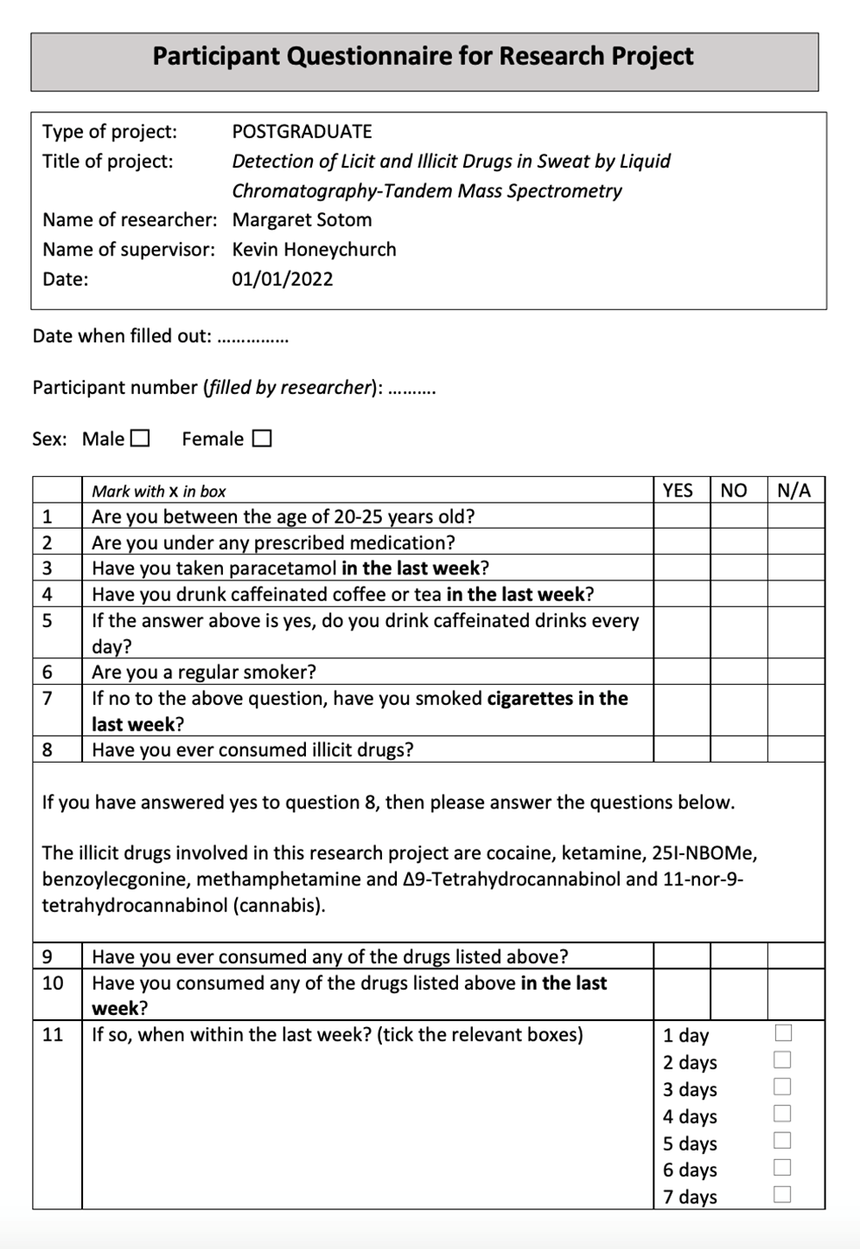

    **Fig. S3**. Blank questionnaire filled by all participants.