Title: Feeling the Earthship House: Eliciting a Perspective of Posterity through Immersive Virtual Reality
Authors:
- Gargy M Sudhakaran
Gargy.MakkanaiSudhakaran@uwe.ac.uk
University of the West of England(UWE Bristol), Faculty of Engineering and Technology(FET), Frenchay Campus, Coldharbour Ln, Bristol BS16 1QY
- Dr Abhinesh Prabhakaran
Abhi.Prabhakaran@uwe.ac.uk
University of the West of England(UWE Bristol), Faculty of Engineering and Technology(FET), Frenchay Campus, Coldharbour Ln, Bristol BS16 1QY
- Dr Abdul Majeed Mahamadu
a.mahamadu@ucl.ac.uk
University College London(UCL), Faculty of the Built Environment, Gower St.London, WC1E6BT
- Prof. Colin Booth
Colin.Booth@uwe.ac.uk
University of the West of England(UWE Bristol), Faculty of Engineering and Technology(FET), Frenchay Campus, Coldharbour Ln, Bristol BS16 1QY
- Grazyna Wiejak Roy
Grazyna.Wiejak-Roy@uwe.ac.uk
University of the West of England(UWE Bristol), Faculty of Engineering and Technology(FET), Frenchay Campus, Coldharbour Ln, Bristol BS16 1QY

Abstract

Purpose
The surging cost of living and shortage of affordable and sustainable homes fuel the global housing crisis. Earthship buildings are marketed as the epitome of affordable and sustainable alternative housing. This paper aimed to elicit the perception of Earthship buildings among youngsters in the United Kingdom using immersive Virtual Reality technology. Additionally, the impact of Virtual Reality on perception compared with two-dimensional drawings was investigated in the study.

Design/methodology/approach
A three-phase, experiment-based survey was adopted: Phase 1: literature review, Earthship house model conception, and the virtual environment creation; Phase 2: two-dimensional drawing-based pre-visualisation survey; Phase 3: Virtual Reality-based post-visualisation survey.

Findings
The findings indicated that youngsters had a remarkable, positive change in attitude towards the uptake of the Earthship houses after Virtual Reality visualisation. In contrast, sustainability experts shared more concerns regarding the concept's viability in the United Kingdom, even after the Virtual Reality visualisation. However, both youngsters and experts agreed with the pre-eminence of Virtual Reality over two-dimensional drawings.

Originality
The lack of awareness about Earthship buildings for posterity was noted in previous studies, which could be attributed to there being very few Earthship buildings in the United Kingdom. The importance of this awareness among youngsters cannot be over-emphasised since youngsters are affected most by the shortage of affordable and sustainable homes. This gap was addressed by enlightening the youth about Earthship houses and imparting awareness through near-real-life Virtual Reality visualisation.

Keywords
Sustainable and affordable UK housing, Earthship house, Virtual Reality, 2D drawing, Immersive technology, Visualisation, Youngsters, Sustainability experts.
Paper type: Research Paper

Introduction
Affordable housing is a massive concern that profoundly impacts individual households and impacts the environment and sustainability (Cygas et al., 2011). Research conducted by Heriot-Watt University on behalf of the National Housing Federation revealed that 3.6 million individuals in the United Kingdom (UK) resided in over-crowded housing, 1.4 million individuals lived in sub-standard housing, and 400,000 people were either homeless or at risk of being so (BBC News, 2019). Moreover, it was estimated that, in 2021, an individual would spend approximately 9.1 times their annual income on purchasing a home, while average incomes in England decreased by approximately 1% in 2021 (Housing affordability, 2022). The younger population, who are also first-time home buyers in the UK, are most affected by the housing crisis due to the rising entry-level property costs, more stringent mortgage lending regulations, and housing shortages.
The UK government’s affordable housing policy recognises that a sustainable community is an imperative environment for affordable housing (Wilson, 2021). Moreover, the UK strives to achieve net-zero carbon emission targets by 2050. Whereas a significant concern is the need to retrofit the existing 25 million residential stock to decarbonise heating demand, as it has high embodied and operational carbon emissions (Li et al., 2022), this pinpoints the need for a sustainable design solution for newly-constructed and retrofitted residences. According to Booth et al. (2021), Earthship buildings represent the epitome of both sustainability and climate change agendas. United States Architect, Michael Reynolds, pioneered the Earthship houses, which proved to be an autonomous structure created using reclaimed materials and renewable resources and surviving off the grid (Earthship biotecture, 2022).
Although there are approximately 20,000 Earthship buildings globally across 40 countries with varying climatic conditions, the UK contains only two Earthship buildings, one in Brighton (2006) and the other in Fife (2004) (Ip and Miller, 2009). Even after these many years, the count being limited to two, and the strange opposition to the Earthship concept among the public is thought-provoking. This is attributed to a myriad of complex and interrelated factors associated with the conventional notion of the prevailing building design and related hedonic and aesthetic elements that are very difficult to understand. In addition, the constraints of the planning and building regulations and the difficulty of obtaining mortgages and loans to construct Earthship houses add to the hesitation towards adopting them (Booth et al., 2021).
Attempts to address these issues have been made in previous studies by assessing the perception of the Earthship concept, using the two-dimensional (2D) drawings of the Earthship house in Brighton among online social media group members inclined towards sustainability. Furthermore, recognising the shortfall in available, affordable housing for younger generations, it was suggested in a previous study that opinions on the uptake of Earthship houses amongst 20–35-year-olds should be the focus of future studies (Booth et al., 2022). Hence, the first Earthship house in Brighton was used in the present research as a case study to assess the younger generation's perception of accepting Earthship houses as alternative homes, along with addressing the dearth of previous studies.
Assessing the perception of members of the public who are ignorant of the scope and benefits of the Earthship houses in terms of sustainability, aesthetic qualities and cost-effectiveness using a probability sampling approach is worthless if the concept is not introduced to the public. State-of-the-art technologies, such as Building Information Modelling (BIM) and Virtual Reality (VR), can make Earthship houses known to broader participants to impart dissent in public thought. As in this study, the VR system is more viable and effective than 2D computer-aided design. BIM is a multi-dimensional model and an information integrating technology that also demonstrates the design intent of project participants. Integration of BIM with VR can enhance efficiency and user experience (Kamari et al., 2021). Combined with the visual experience during the walkthrough, VR facilitates interaction in the virtual environment and enhances collaboration and decision-making.
This paper aimed to elicit the perception of an Earthship building among the younger population in the UK using immersive VR technology. Additionally, the impact of VR on perceiving a novel concept compared with 2D drawings was investigated in the study.

Literature review

Housing crisis and the sustainability synergy in the UK
The policies of the UK Government are focused on the synergy of housing affordability and sustainability, which is centred on minimising the use of primary resources, creating savings, and minimising harmful environmental effects and housing policies. This guarantees a "higher quality of life for everyone" and incorporates "economic, social, and environmental factors in ways that reinforce each other" (Housing Affordability and Sustainability Analytical, 2019). Housing is responsible for 27% of carbon dioxide emissions in the UK (Stevenson & Arch, 2009). According to the MHCLG annual report (2021), in response to Government’s Future Homes Standard (FHS) consultation in January 2021, a significant improvement in energy efficiency criteria for new homes will be made, starting in 2025, which mandates that new dwellings will emit at least 75% less CO₂ than houses constructed to current standards. To achieve carbon emission reductions by 2050, sustainable housing solutions, ranging from low-tech options, such as off-grid homes made of recycled consumer waste, to high-tech smart homes that use "modern" construction techniques, are prevailing (Seyfang, 2010). Williamson et al. (2003) have proposed a checklist of criteria for a sustainable outcome, including discourse issues such as climate change, pollution, resource depletion, biodiversity, indigenous flora and fauna, society and culture, health, comfort, cost-effectiveness, and longevity. According to a study conducted by Freney (2014), the design of an Earthship building follows all these criteria.

Overview of Earthship houses
Earthship is a revolutionary innovation credited to the architect, Michael Reynolds, of Earthship Biotecture in the United States. Earthship buildings are designed according to the concept of an independent vessel, which relies on itself for temperature control, electricity, food, water, and waste disposal by affording users an “off-grid” existence. Also, the concept uses reclaimed materials and renewable technologies such as passive solar heating and cooling, photovoltaic power systems, rainwater harvesting, and solar hot-water heating with a black and grey water treatment system. The concept reinforces radical sustainability through a zero-waste approach. Almost 20,000 Earthship buildings have been constructed to date in at least 40 countries with various climates, and serve various functions ranging from schools to homes.
In the UK, two Earthship projects have been completed. The Low Carbon Trust built an Earthship house that currently serves as a community centre in Brighton, England (2006), and the Sustainable Communities Initiatives (SCI) opened a visitor centre in Fife, Scotland (2004) (Ip & Miller, 2009).

Case study: Earthship House Brighton
Earthship House Brighton is an exemplary, autonomous building that covers 134 m² and costs GBP 80,000 to construct (Booth et al., 2021a). The structural walls are built of a vertically-stacked layer of reclaimed EOL tyres of 1.5 m depth on an undisturbed earth surface and an eco-cement render finish. The gaps between the tyres are filled with reused aluminium cans or bottles. The pinnacle benefit of the Earthship house is the earth-sheltered wall, which acts as a climatic-responsive thermal battery. Timber stud partitions are used for internal walls. Many walls have colourful glass bottles embedded to improve their aesthetics while using recycled, regular household waste. The roof is a vapour barrier-covered timber deck externally protected by metal sheets. The south-facing, front, glass facade slants at an angle of 22°, allowing maximum exposure to sunlight during winter and reflection away during summer (Earthship Biotecture, 2022).
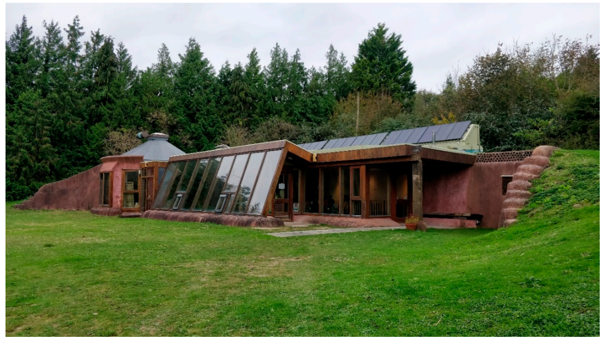
Figure 1: Exterior of Earthship Brighton with slanting glass walls flanked by Earth-rammed tyre walls and solar panels on the roof (Booth et al., 2021) (Credited to Sona Rasheed)

The house is built on undisturbed, stable earth without foundation and is huddled in with the surrounding landscape, as shown in Figure 1. The building layout is shown in Figure 3, comprising mainly a nest of 84 m², a buffer-zone conservatory of 30 m², and a circular hut module of 20 m². Figure 2 illustrates further details of the Earthship house.
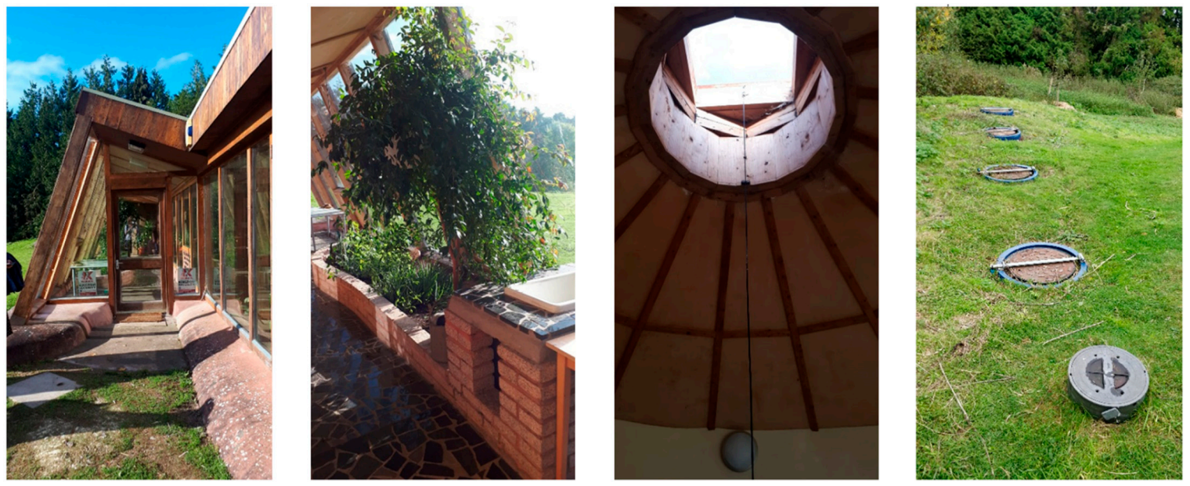
Figure 2: a) entrance b) planters inside the conservatory with grey water harvesting system c) skylight d) Underground rainwater storage tanks (Booth et al., 2021) (Credited to Sona Rasheed)

Previous studies
Most of the research about Earthship buildings is focused on the thermal behavioural characteristics of the buildings, which includes the study undertaken by Ip and Miller (2009) and the thesis submitted by Freney (2014) addressing the post-occupancy evaluation, thermal performance, and life-cycle assessment of the Earthship building. In studies conducted by Booth et al. (2021) and Booth et al. (2022), the significant benefits and barriers of the Earthship House in the UK were assessed. The studies were conducted among online social media group members inclined towards the ideologies of sustainability, using a 2D Plan of an Earthship house.
Cumulative items of evidence suggested a dearth of literature in which the public’s perception of Earthship buildings as alternative, affordable and sustainable accommodation has been investigated. Furthermore, in those studies in which users' perceptions of Earthship buildings have been elicited, planar images were used as a stimulus to capture the perceptions. Mahamadu et al. (2021) stated in a study the inefficiencies of 2D pictures, such as reduced dimensionality and difficulty replicating the environmental factors. Studies have suggested that images used in planning are deficient in delivering sense and depth of space, resulting in users' inability to provide valid opinions. Prabhakaran et al. (2022) noted that the VR system is more viable and effective than 2D computer-aided design in delivering an experience closer to real-world experience. Hence, immersive VR was used in this study to offer the users an immersive experience of Earthship buildings.
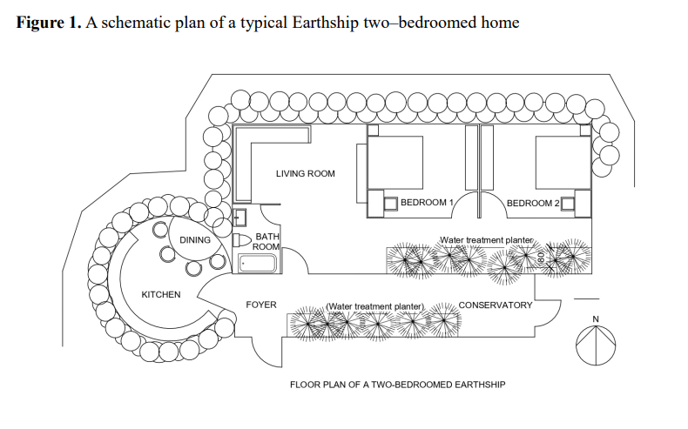
Figure 3: A Schematic plan of a typical Earthship two-bedroomed home (Booth et al., 2022) (Credited to Gargy Sudhakaran)

Immersive technology for visualisation
Immersive VR is the technology used to immerse the user completely inside computer-generated world, virtually giving a real and/or believable experience (Furht, 2018).
Integrating BIM with VR facilitates data access and improvises collaboration and communication (Sampaio, 2019). The BIM-VR synergy occurs in two different ways: Walkthrough and Consulting data. The walkthrough is the most popular, as the user can view the 3D model in a virtual environment in real-time from multiple perspectives of the building, both inside and outside (Sampaio, 2019). BIM applications such as Autodesk Revit support creating a VR environment, enabling the computation of sophisticated and detailed visualisation (Yılmaz, 2019). Furthermore, Autodesk Revit allows retaining metadata after importing to Unity Software, a software that generates a virtual environment.
According to Hernandez et al. (2019), visual information presented in VR is more effective in perceptual accuracy and retention. Also, the immersive VR tool is appropriate for people with limited ability in spatial perception since it enhances traditional 2D representations.
Furthermore, the sense of presence in the virtual environment affects the level of interaction in the virtual world and, thereby, the perception (Lorenz et al., 2018). Users feel as though they are fully engaged in their surroundings since the display responds to their head and body motions as the computer records them (Zaker & Coloma, 2018). Moreover, being cut off from the outside, the external world might be attractive for certain people, especially the younger generation, who widely accept VR technology for gaming (MirageVR, 2022). The physiological issues that might arise, including motion or simulated sickness, are the method's drawbacks. A poor experience might also result from wearing the head-mounted devices (HMDs) for a prolonged period or finding it difficult to adjust to the surroundings and controls in hand (Zaker 7 Coloma, 2018).

Research methodology
In line with the beliefs and assumptions that Saunders and Lewis (2019) discussed, a pragmatic philosophical underpinning combined with embedded mixed-methods research with an abductive approach was adopted. Therefore, exploratory, explanatory, and evaluative techniques were combined in the research design. The axiological assumptions led to value-driven research, using quantitative and qualitative methods that provided remarkable data to reinforce the solutions. However, considering the time constraint, a cross-sectional time horizon was applied for the study.
Referring to the methodology adopted by Prabhakaran et al. (2022), a three-phase design was followed, as illustrated in Figure 4. The first phase involved a systematic literature review (see Literature review) and Earthship VR environment creation (Figure 7). Phase 2 involved the experiment-based, pre-visualisation survey, with the aid of 2D drawings of an Earthship house, and Phase 3 involved a post-visualisation survey, relying on VR visualisation of an Earthship house. The literature review and the case study of Earthship Brighton (see Case Study: Earthship House Brighton) supported the model and the VR environment creation. The experiment assess and compare the acceptance of Earthship houses as future alternative housing among youngsters in the UK, using a five-point Likert Scale, ranging from Strongly Disagree to Strongly Agree. In addition, experiment-based, open-ended interviews were conducted among sustainability experts in Phase 2 to assess the scope of Earthship houses in the UK.
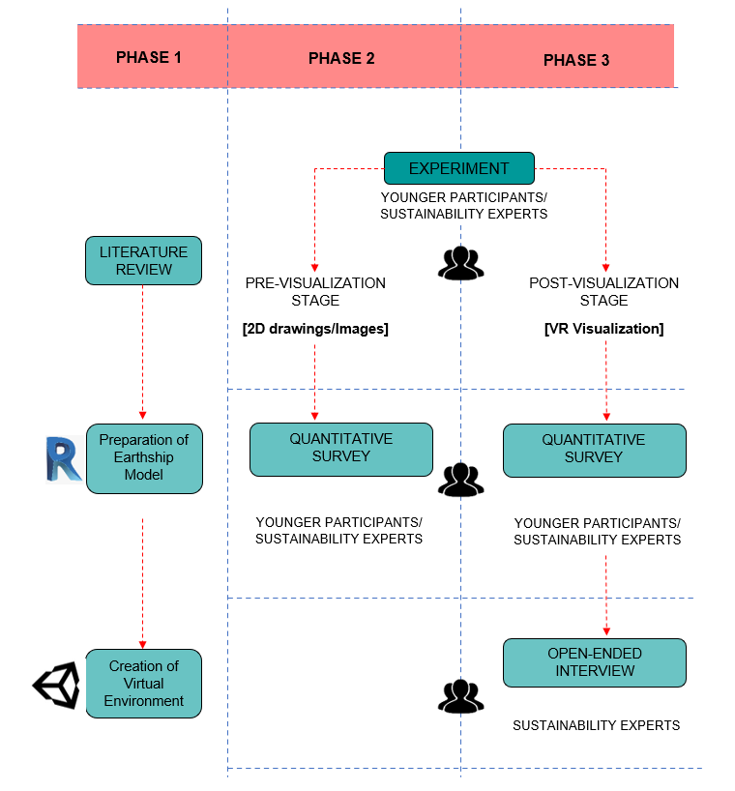
Figure 4: Research framework (author’s construct)
Furthermore, the questionnaires addressed the users’ sense of presence (SoP) to analyse the immersion in the virtual environment. Prabhakaran et al. (2022) pointed out that the sense of presence can provide many insights into users’ perceptions of space in a virtual environment. The final stage of the research involved the analysis, for which MS Excel, IBM SPSS and NVivo were used for the ranking, descriptive statistical analysis, and thematic analysis, respectively.

Demographics of Participants
Considering the objectives of the study, the participants for the experiment-based survey were youngsters between the age of 20 and 35 residing in the UK(Figure 5) and sustainability experts in the UK(Figure 6).
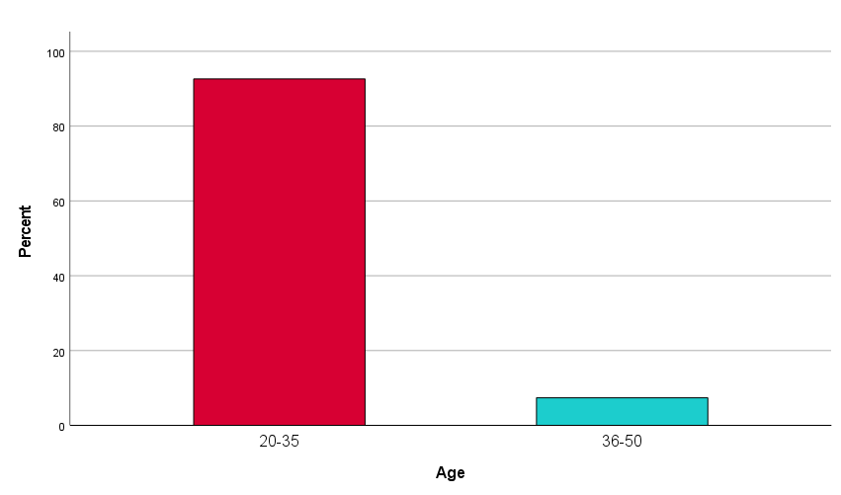
Figure 5: Age of the participants(Author’s Own)

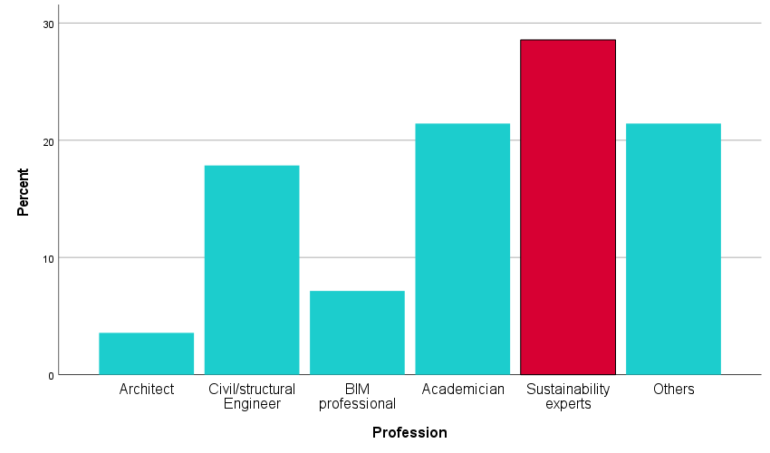
Figure 6: Professional background of experts(Author’s Own)

The future scope of the Earthship buildings in a country or state could be defined by assessing the perception of youth in adopting it as alternative housing, whereas the sustainability experts could have a justifiable comment about the same based on their experience and expertise.

Task/Activity

Phase 1: Literature review and VR environment creation
Further to the literature review (see Literature review), and the Earthship Brighton case study, the Earthship virtual environment was created to introduce the concept of Earthship houses to the participants. As illustrated in Figure 7, the model of the Earthship house was conceived using Autodesk Revit, a BIM authoring software. Further to the model creation, "Reflect", a native Unity3D plugin, and real-time rendering engine that supports large BIM files, was used as the inter-operability enabler to create the immersive and interactive VR environment.
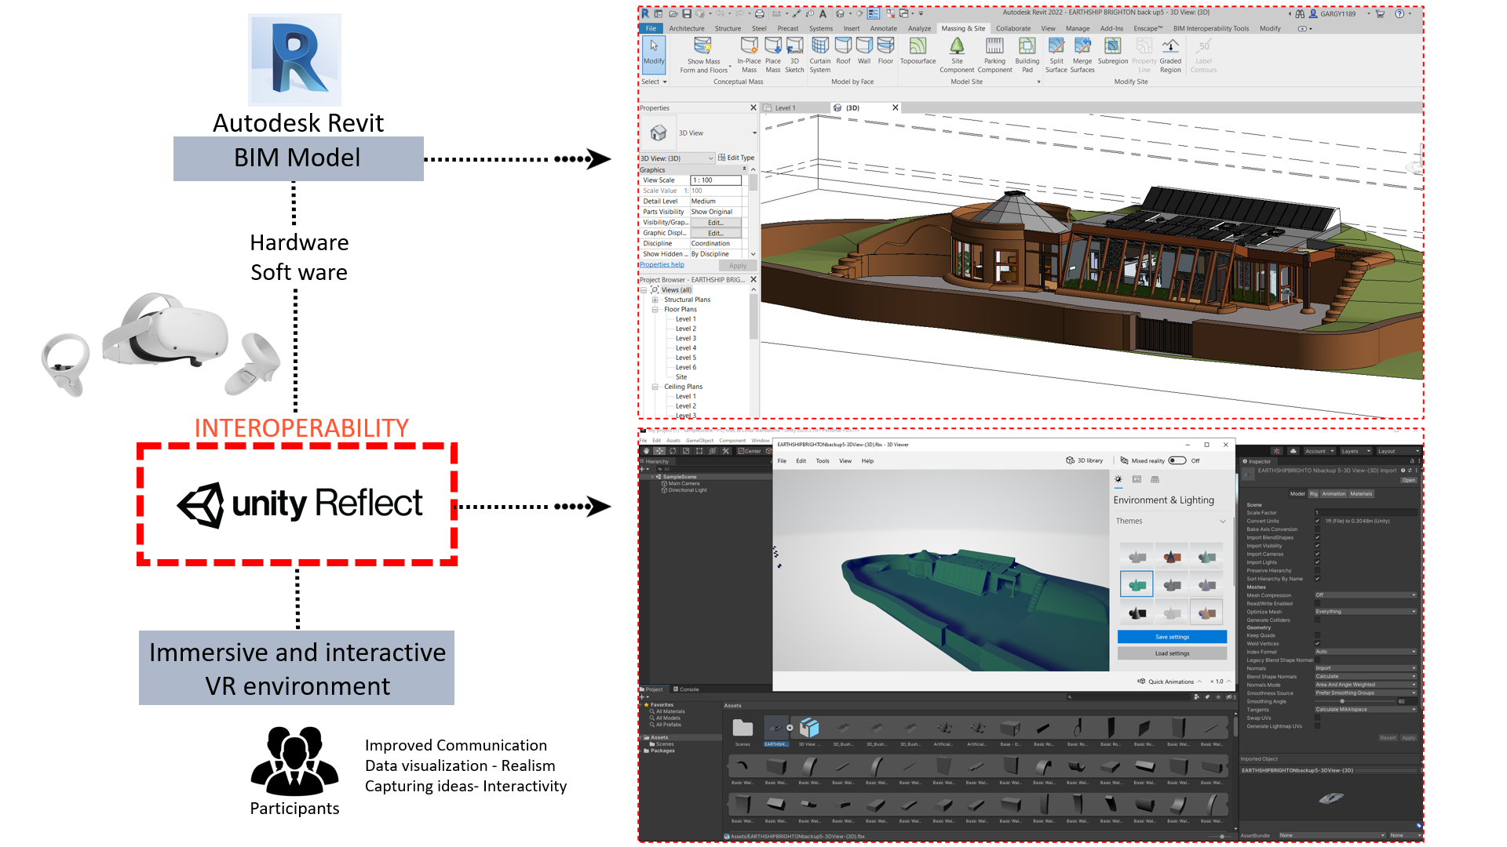
Figure 7: Earthship model preparation process (Author’s construct)

VR experiment procedure
Before the survey, the hardware and software performance was verified to prevent crashes and issues. Both the younger participants (n = 122) and experts (n = 28) were involved in the experiment. The willing participants were briefed regarding the experiment, VR usage and Earthship house orally and using a presentation. Approximately 10-15 minutes were allocated per person for the experiment-based survey.
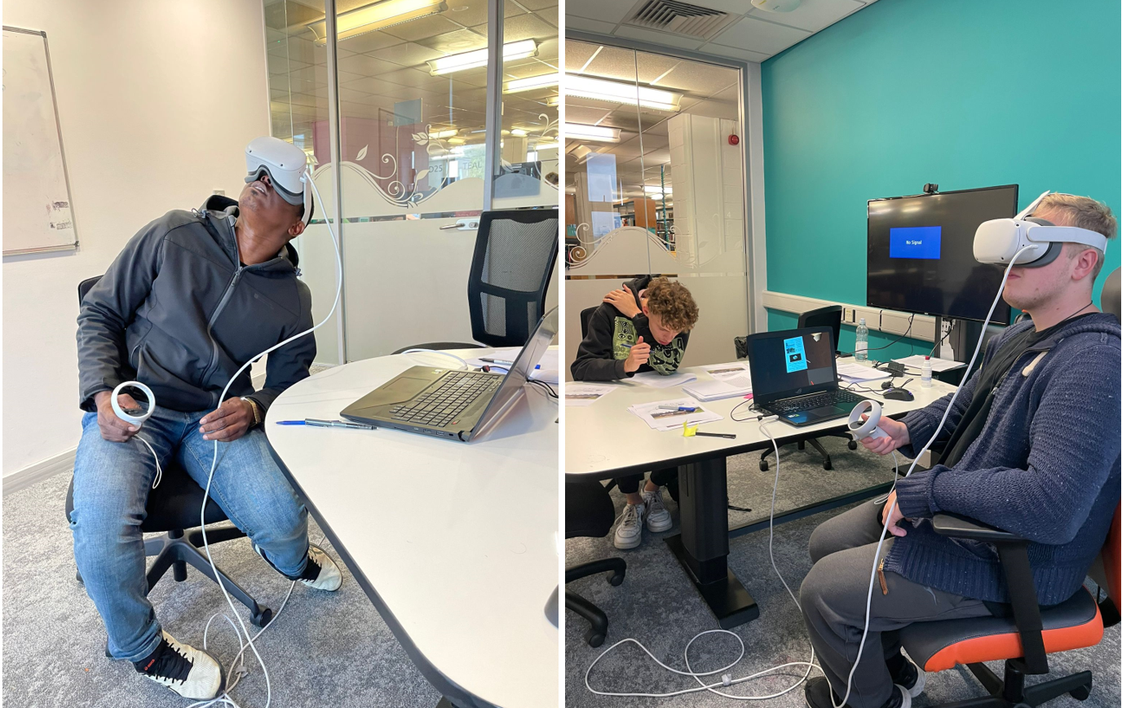
Figure 8: Experiment(Author’s Own)

Data collection
The entire data collection process was done face-to-face, which assured a 100% response rate, and involved the pre-visualisation and post-visualisation phases consecutively. The process required a portable system for immersive VR visualisation, including an Oculus Quest 2 HMD, controllers for interaction, the Unity project file, and a graphics card-compatible Laptop together with the hardcopies of the questionnaires (Figure 8). The previsualisation phase involved acquiring quantitative data relevant to assess the perception of the Earthship house based on 2D drawings from both youngsters (sample size, n = 122) and experts (sample size, n = 28). The subsequent post-visualisation phase, which involved the VR experience of the virtual Earthship house, was intended to gauge the change in perception of Earthship houses among the participants after VR visualisation. An open-ended, structured interview approach was adopted with the experts, which encouraged open discussion leading to rich data that were free from bias. At the same time, quantitative data were acquired from the younger participants.

Sampling
A concurrent sampling approach was adopted, according to which younger participants (sample size, n = 122) were chosen using a probability sampling approach. it promotes acquiring non-biased answers from the general public inclined or disinclined towards sustainable living. Moreover, the sample could be generalised to a larger population. The sustainability experts (sample size, n = 28) were selected based on a purposive sampling approach to obtain elementary responses. The margin of error was reduced using the large sample size (n = 150).

System architecture
Figure 9 below illustrates how various components interacted and connected to accomplish the determined outcome.
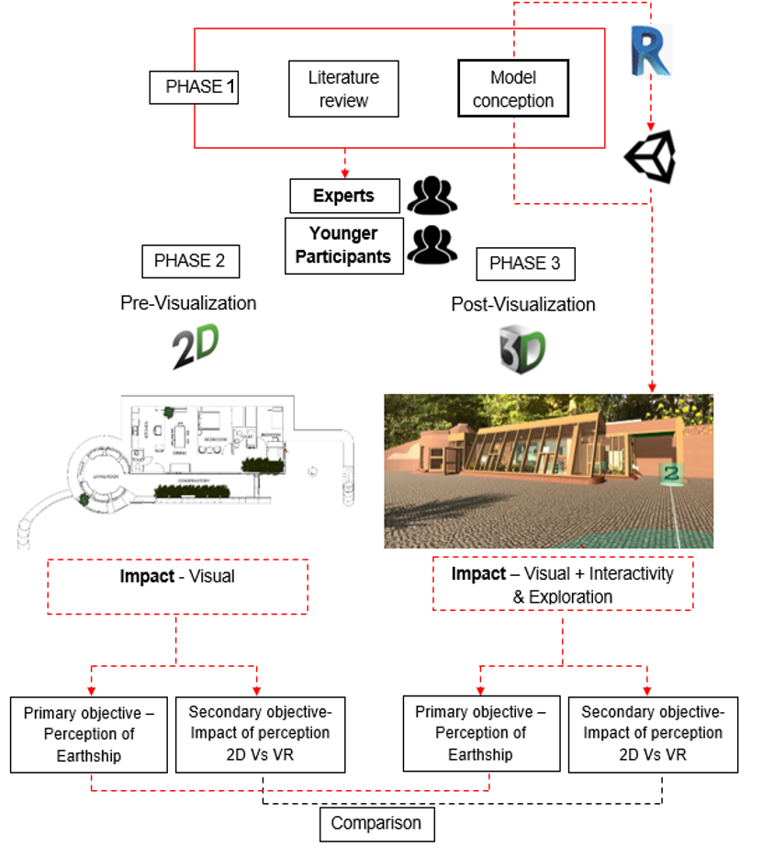
Figure 9: System architecture(Author’s Own)

Movement in a Virtual Environment
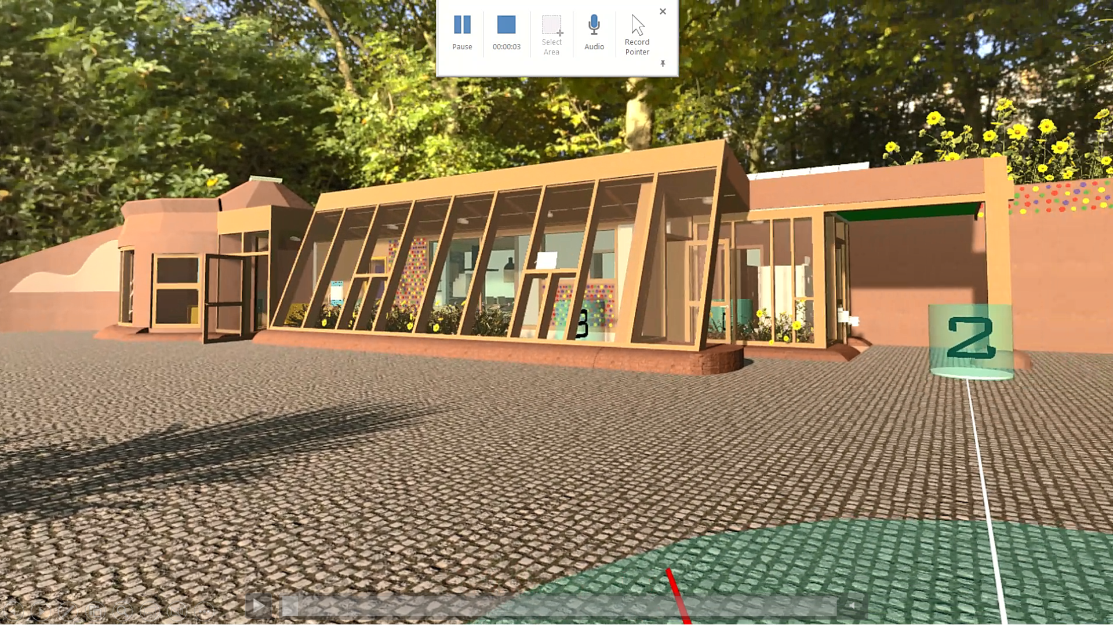
Figure 10: Earthship exterior in Virtual Environment(Author’s Own)

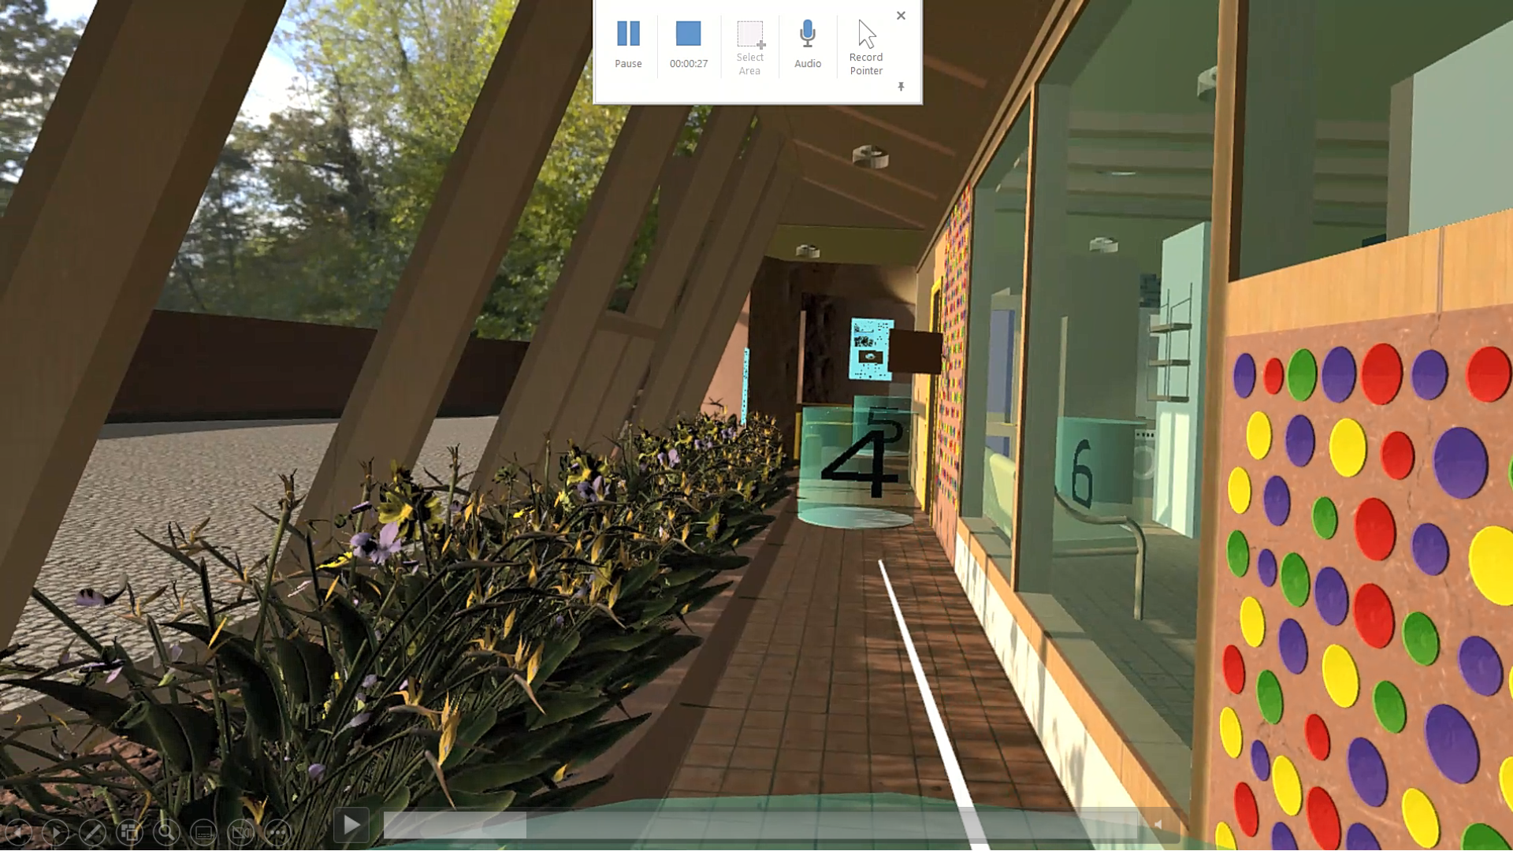
Figure 11: Earthship Interior in Virtual Environment with numbered halos(Author’s Own)

Among the various locomotion methods, teleportation, a commonly-used virtual locomotion methodenabled the participants to navigate easily through numbered station points (n = 10) marked with halos, using the hand remote controller, as shown in Figures 10 and 11. This is safer for the users, as natural locomotion initiates motion sickness in some users.

Interactivity in a Virtual Environment
The pertinent data, compiled with the aid of Adobe Photoshop, was merged with the virtual Earthship model in the Unity programme in such a way that the data were displayed in the VR environment as the participants interacted with the model.
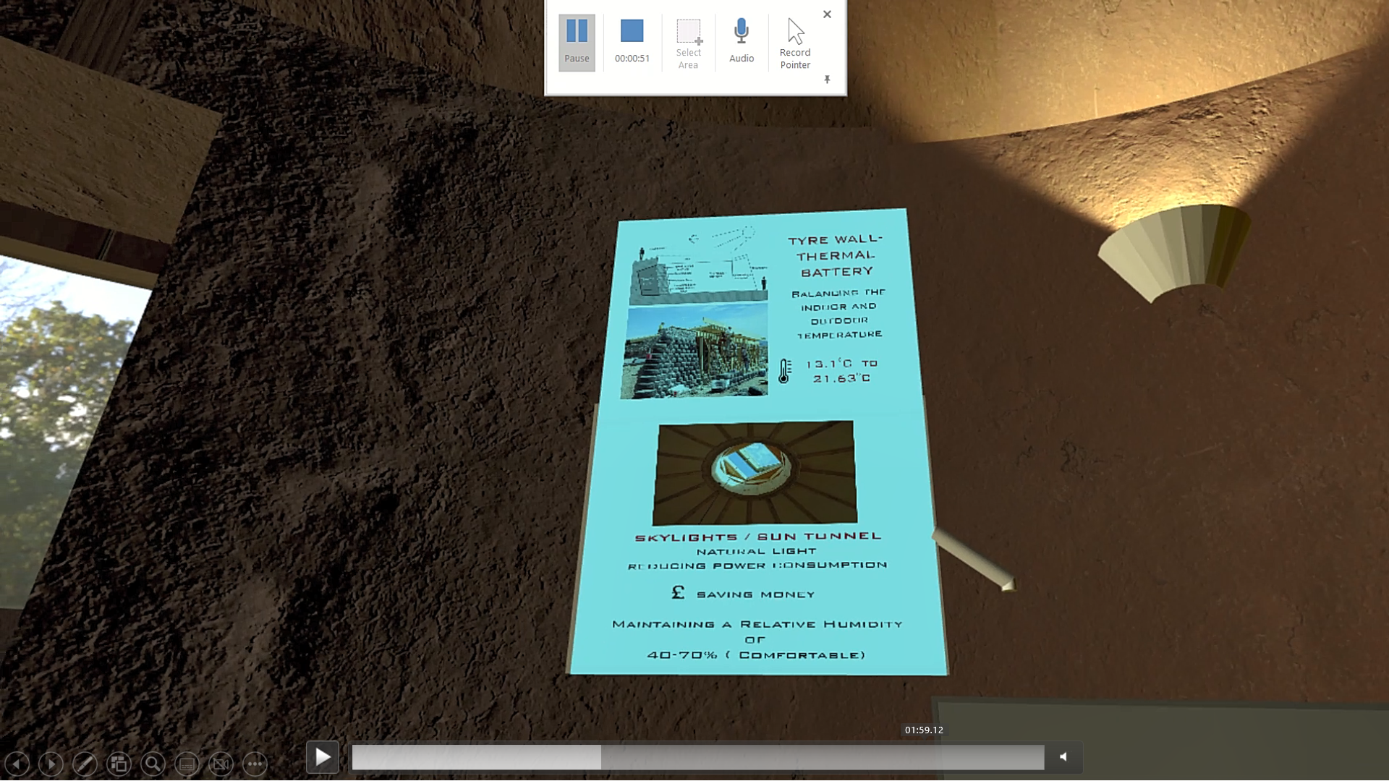
Figure 12: Interactive display boards in the interiors(Author’s Own)

The interactive data were provided at specific points near the numbered halo points, as shown in Figures 12 and 13, which the participants could read easily. Hence, as the participants navigated through the 10 station points, they were enlightened about the Earthship concept and visualisation.
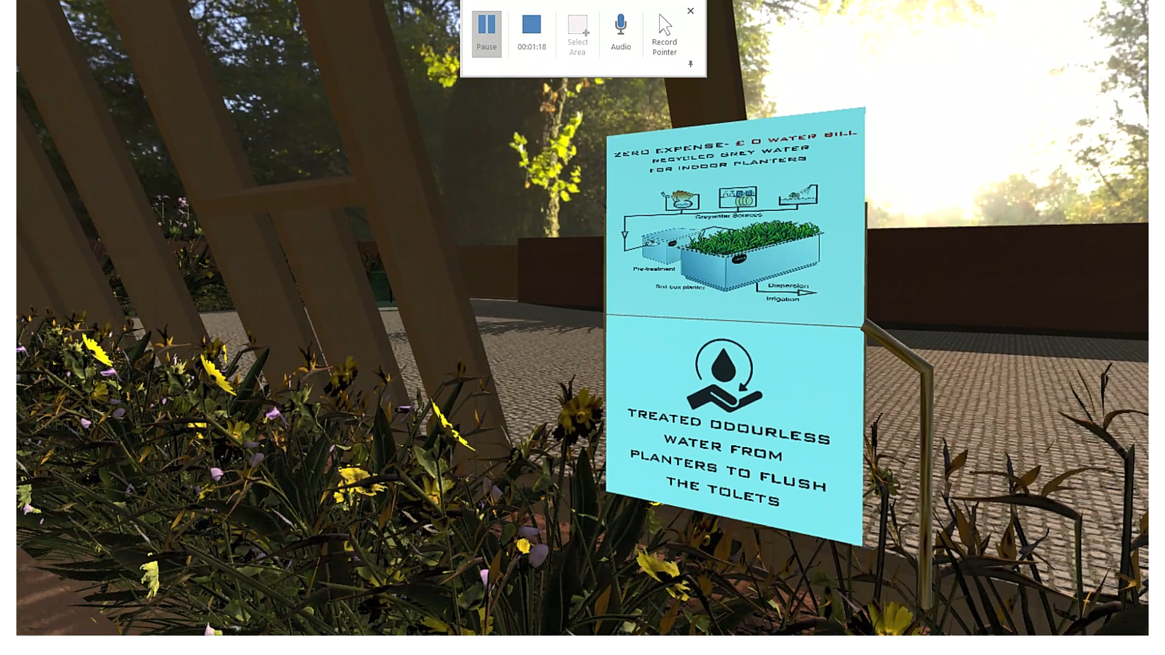
Figure13: Interactive display boards in the interiors(Author’s Own)

Pre/Post-visualisation questionnaire
The data were sought with the aid of a questionnaire, and the collected data was handled in compliance with GDPR(General Data Protection Regulation) guidelines, which assures that the personal data collected is well protected(Data Protection Act 2018) Prior toquestionnaire dissemination ethical approval was obtained., Additionally a risk assessment was completed as the VR demonstration was an integral part of the survey. All participants were notified in a cover letter containing participant information that their participation was optional and their decision to complete and submit their completed questionnaires constituted their consent to participate in the study.. Additionally, it was explicitly stated to participants that their identities would be kept anonymous, and there would be no opportunity to withdraw once their questionnaires are returned.

Pre-visualisation questionnaire
The pre-visualisation questionnaires (Phase 2) contained quantitative questions to achieve the primary objective: gauge the public perception of Earthship houses. Secondly, the questionnaire aimed to ascertain the impact of VR visualisation on the perception of a novel concept compared with 2D drawings. The questionnaires were prepared using a Likert Scale with a range from “Strongly Agree” to “Strongly Disagree” and “Yes” or “No”.
For youngsters, Phase 2 started with background information such as gender, age, professional background, employment status, home-ownership status etc. The participants’ general awareness of sustainability was also captured in this section. For experts, Phase 2 started with background information such as professional background, years of experience in the UK etc. Phase 2 continued with questions to gauge impressions about sustainability approaches and public attitude towards sustainability in the UK, based on professional experience. For the youngsters and experts, the conclusion of this section marked with the beginning of the experiment, where a 2D drawing of an Earthship house was introduced, as shown in Figure 14, and the impression of the Earthship house based on the 2D drawing was inquired.

Post-visualisation questionnaire
Phase 3 of the research was conducted after the VR visualisation experiment to assess perceptions in the immersive VR environment. In this section, the participants’ changes in attitude towards the uptake of Earthship buildings as alternative housing for their futurewere compared between viewing an Earthship building in 2D and Immersive 3D. The questionnaires were prepared for the younger participants on a Likert Scale with a range from “Strongly Agree” to “Strongly Disagree” and “Yes” or “No”. Moreover, after the VR visualisation experiment, general comments from the youngsters regarding the Earthship concept were gathered as qualitative data.
At the same time, the experts' opinions regarding the scope and limitations in the uptake of the Earthship houses as an alternative housing option in the UK were obtained during Phase 3 through open-ended questions.
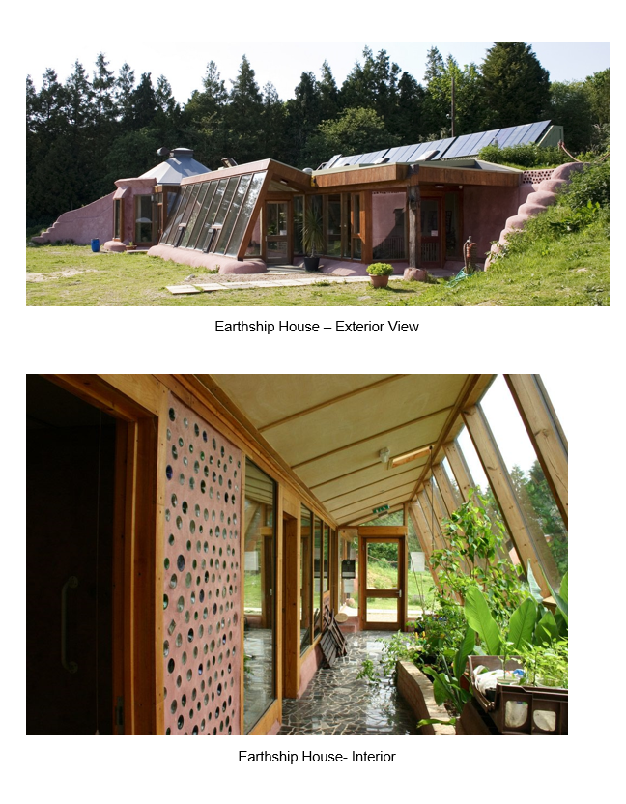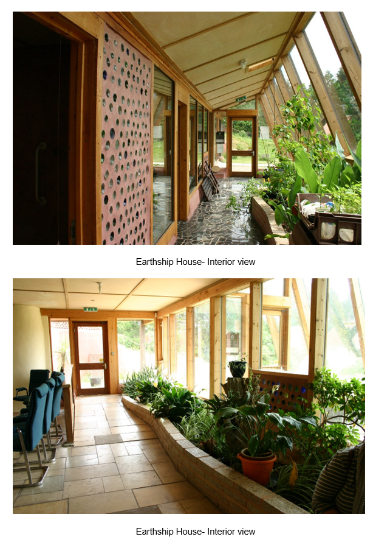

Figure 14: Images of Earthship House (Credited to London Perma culturists)

Questionnaire to assess Sense of Presence (SoP)
An integral part of successful VR is a high SoP – a feeling of “being there in the virtual scenario” (Lorenz et al., 2018). The final section of the questionnaire contained questions to assess SoP using a Likert Scale ranging from “Excellent” to “Poor”. This part of the questionnaire was the same for the younger participants and the sustainability experts.

Observations
Phase 3 of the research was followed by scrutiny of the data collected from 150 participants and transcribing the sorted data into MS Excel. The quantitative data were coded further and imported to IBM SPSS Statistics for descriptive statistical analysis and an independent sample T-test. The qualitative data from MS Excel were imported to NVivo Software for further coding and thematic analysis.

Demographic details
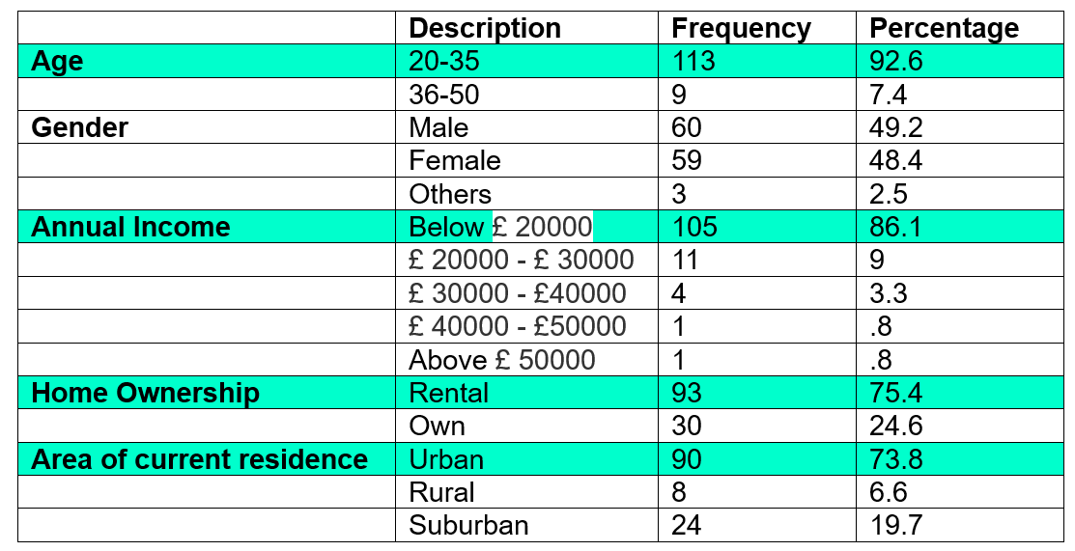
Table 1: Profile of younger participants (n = 122) (Author’s Own)

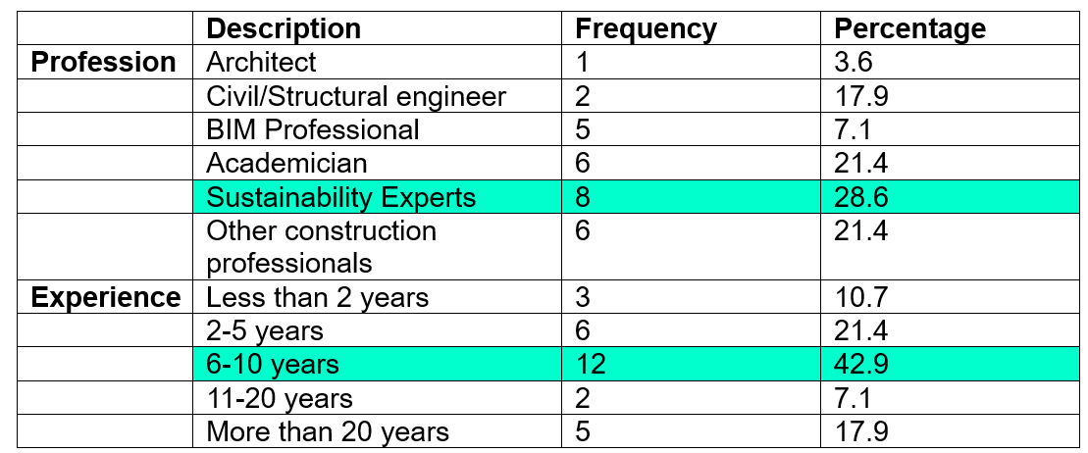
Table 2: Profile of experts (n = 28)(Author’s Own).

A detailed survey was conducted among youngsters (n = 122) and professionals(n=28). The descriptive analysis of the youngster’s survey data using IBM SPSS statistics indicates that 92.6% of the participants are 20-35 years old, as shown in Table 1. Moreover, the gender data stipulates equal participation of males and females. All the participants are UK residents with approximately 35 different professional backgrounds. The analysis shows that the annual income of 86.1% of the employed participants was below £20,000. Moreover, 73.8% lived in urban areas and 6.6 % in rural areas. Among the professionals(n=28), 28.6% of the participants are sustainability experts based in the UK, while 42.9 % and 17.9% of the participants had 6-10 years and more than 20 years, of experience, respectively(Table 2).

Attitude towards sustainability
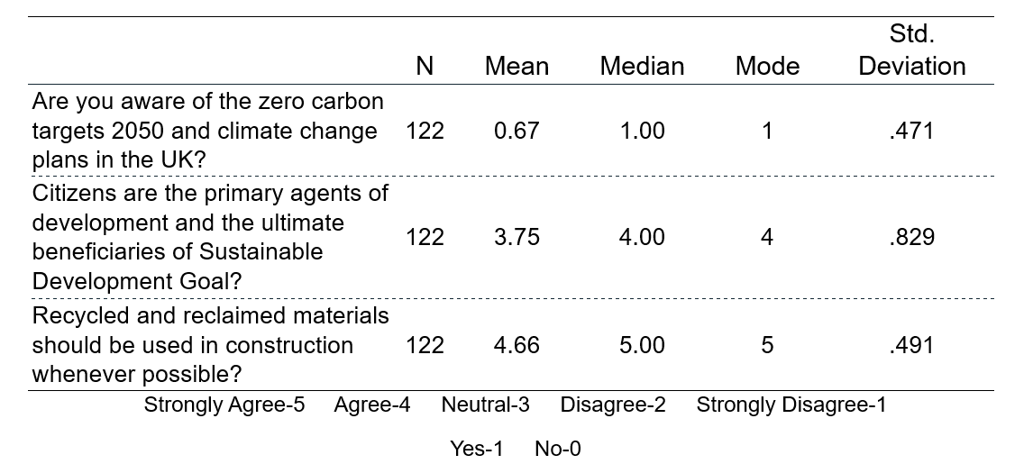
Table 3: Statistical analysis of the observations from the younger participants(Author’s Own).

In Phase 2, the collection of background data was followed by assessing the awareness of youngsters' sustainability approaches(Table 3) and gauging the opinion of experts regarding the sustainability approaches in the UK based on their experience.
67.2 % of the youngsters justified being aware of the UK's zero carbon targets for 2050 and climate change plans, and agree that citizens are the primary agents of development and the ultimate beneficiaries of sustainable development goals. Also, the youngsters firmly indicated having a positive attitude towards adopting recycled and reclaimed materials in construction.

Figure 15: Sustainability features in participants’ existing house(Author’s Own)

As shown in Figure 15, when the youngsters specified the sustainability features in their current dwellings, 53% d having effective insulation while, surprisingly, 38% of the younger participantswere unsure of this. From the experts’ points of view, according to the statistical data shown in Table 4, participants strongly agree following sustainability principles is essential for the construction industry and that retrofitting existing buildings with sustainability measures is possible in the UK. Also, they strongly recommend using recycled and reclaimed materials.
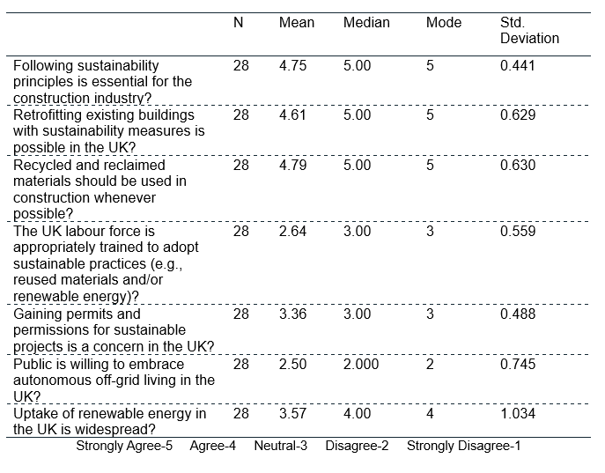

Table 4: Statistical analysis of the opinions of experts regarding approaches to sustainability(Author’s Own).

57.1% of the experts had a neutral opinion regarding the capability of the UK workforce in sustainability practices. Also, the expert participants had an impartial opinion regarding gaining permits and permission for off-grid projects in the UK, as such projects are rare. 53.6% of the experts disagreed that the public is willing to embrace off-grid living in the UK. However, the majority of the participants agree that the uptake of renewable energy in the UK is widespread.

Perception of Earthship House

Pre-visualisation data (Younger participants)
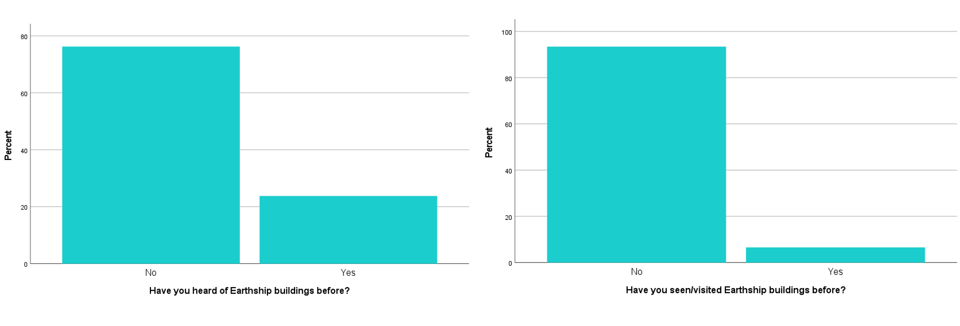
Figure 16: Familiarity of younger participants with Earthship(Author’s Own)

Based on the survey among youngsters, 76.2% of the participants had not heard of, and 93.4% had not seen, an Earthship house (Figure 16).
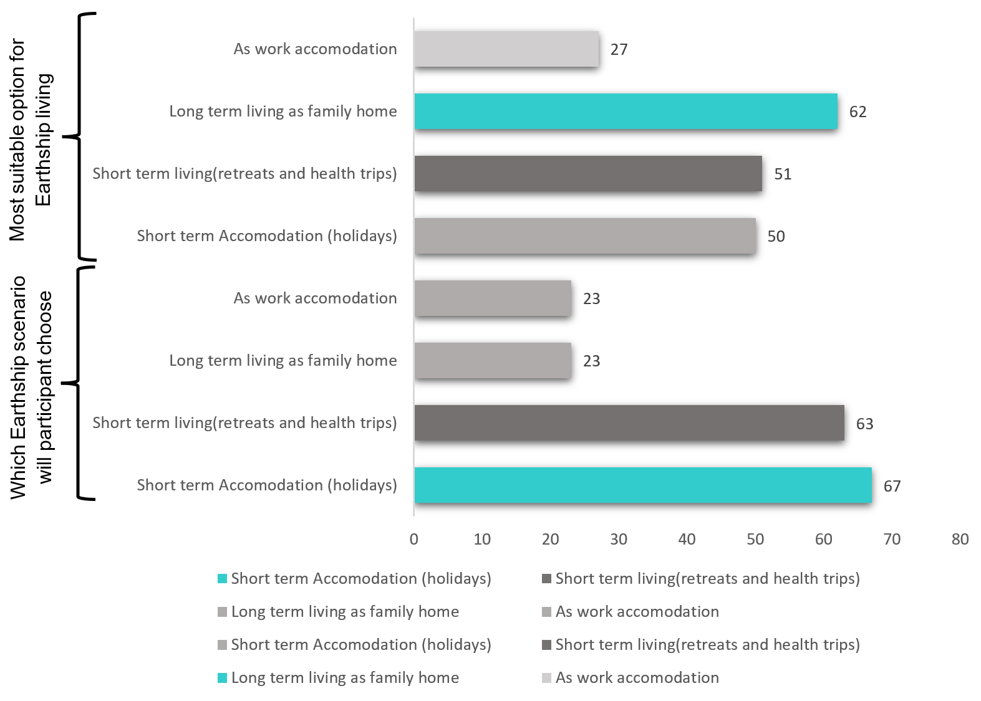
Figure 17: Earthship appropriateness in Younger Participant’s perspective (Pre-visualisation Phase) (Author’s Own)

Figure 17 demonstrates that although younger participants indicated Earthship homes could be intended for long-term habitation as a family home, only 23% of them preferred opting for Earthship for this use. whereas 67% of the participants elected Earthship as short-term accomodation (holidays).Post-visualisation data (younger participants)

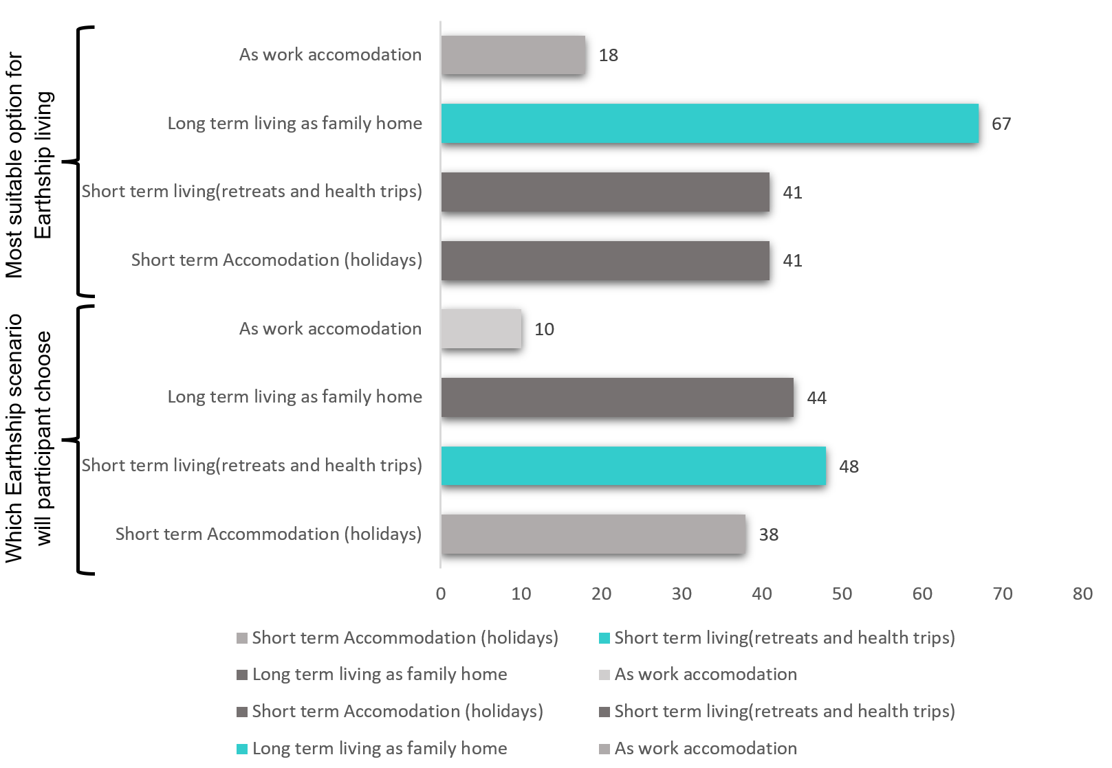
Figure 18: Earthship appropriateness in Younger Participant’s perspective (Post-visualisation Phase) (Author’s Own)

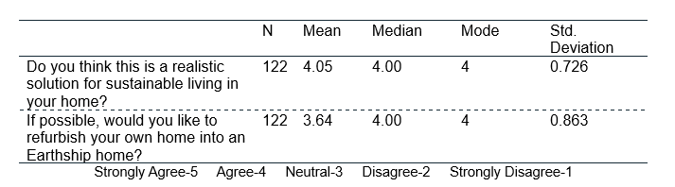
Table 5: Perception of Earthship(Author’s Own).

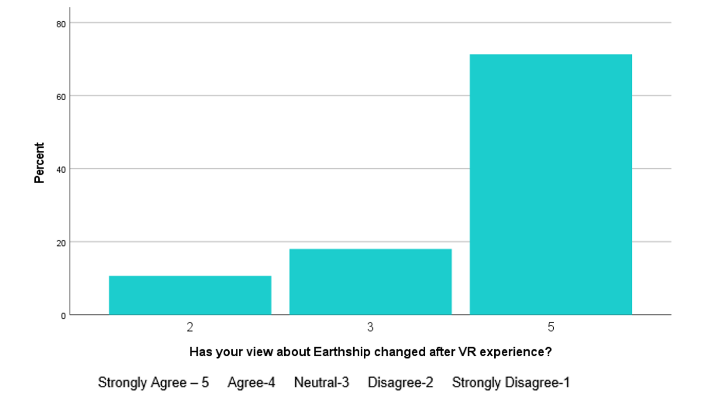

Figure 19: VR influence on change of opinion(Author’s Own)
Post-visualisation, the percentage of younger participants suggesting Earthship buildings for long-term living increased to 67%, and those who preferred long-term Earthship living increased to 62% (Figure 17). According to the Figure 19, 71.3% of the younger participants strongly agreed that their perception of Earthship had been augmented post-VR visualisation. Moreover, the youngsters agreed that Earthship buildings are realistic solutions to sustainable living in the future. Also, they indicated a willingness to refurbish their homes into Earthship buildings(Table 5). The general observations of the youngsters (qualitative data) were analysed using NVivo software(Figure 20). The integration of data using NVivo is done based on codes that are created. “Negative” and “Positive” codes were used in the context illustrated in Figure 18, and participants were considered as cases (e.g. P004, P005 etc.).
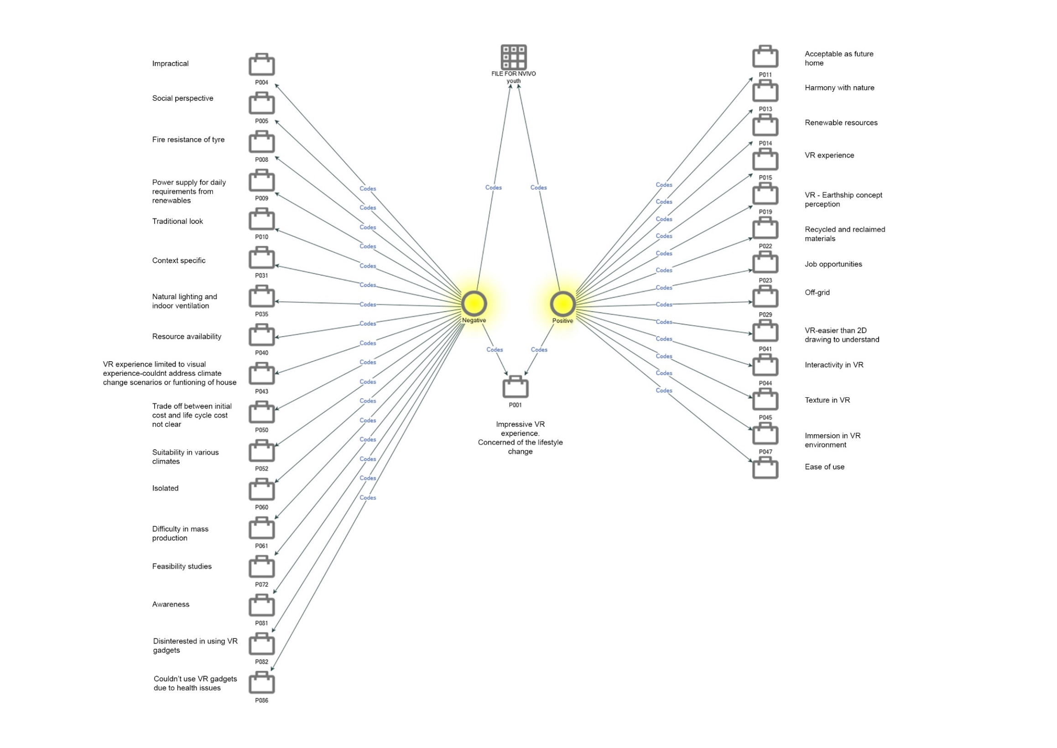

A Participant with mixed opinion

Figure 20: Thematic analysis of observations by younger participants post-visualisation(Author’s own)

Pre-visualisation data (experts)

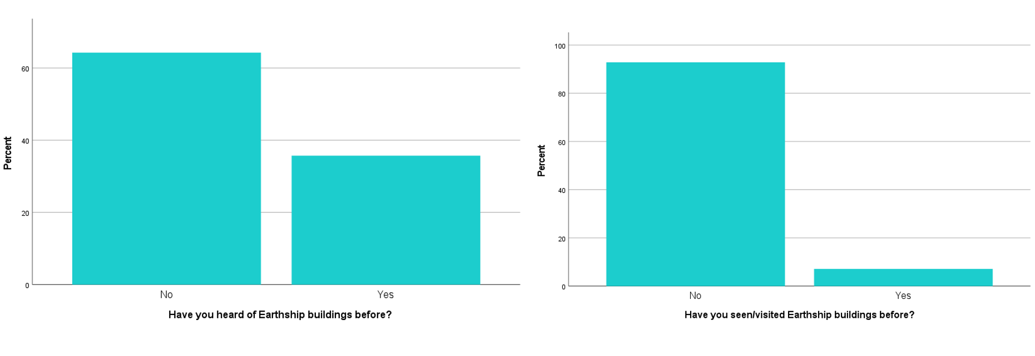
Figure 21: Familiarity of experts with Earthship (Author’s Own)

As per the statistics (Figure 21) hardly 35.7% of the experts had heard of, and 7.1% had seen, the Earthship houses in the UK. The figure below illustrates the broad observations of the experts, where "concern" and "scope" were the codes used to compare cases with participant codes P010, P017, etc.
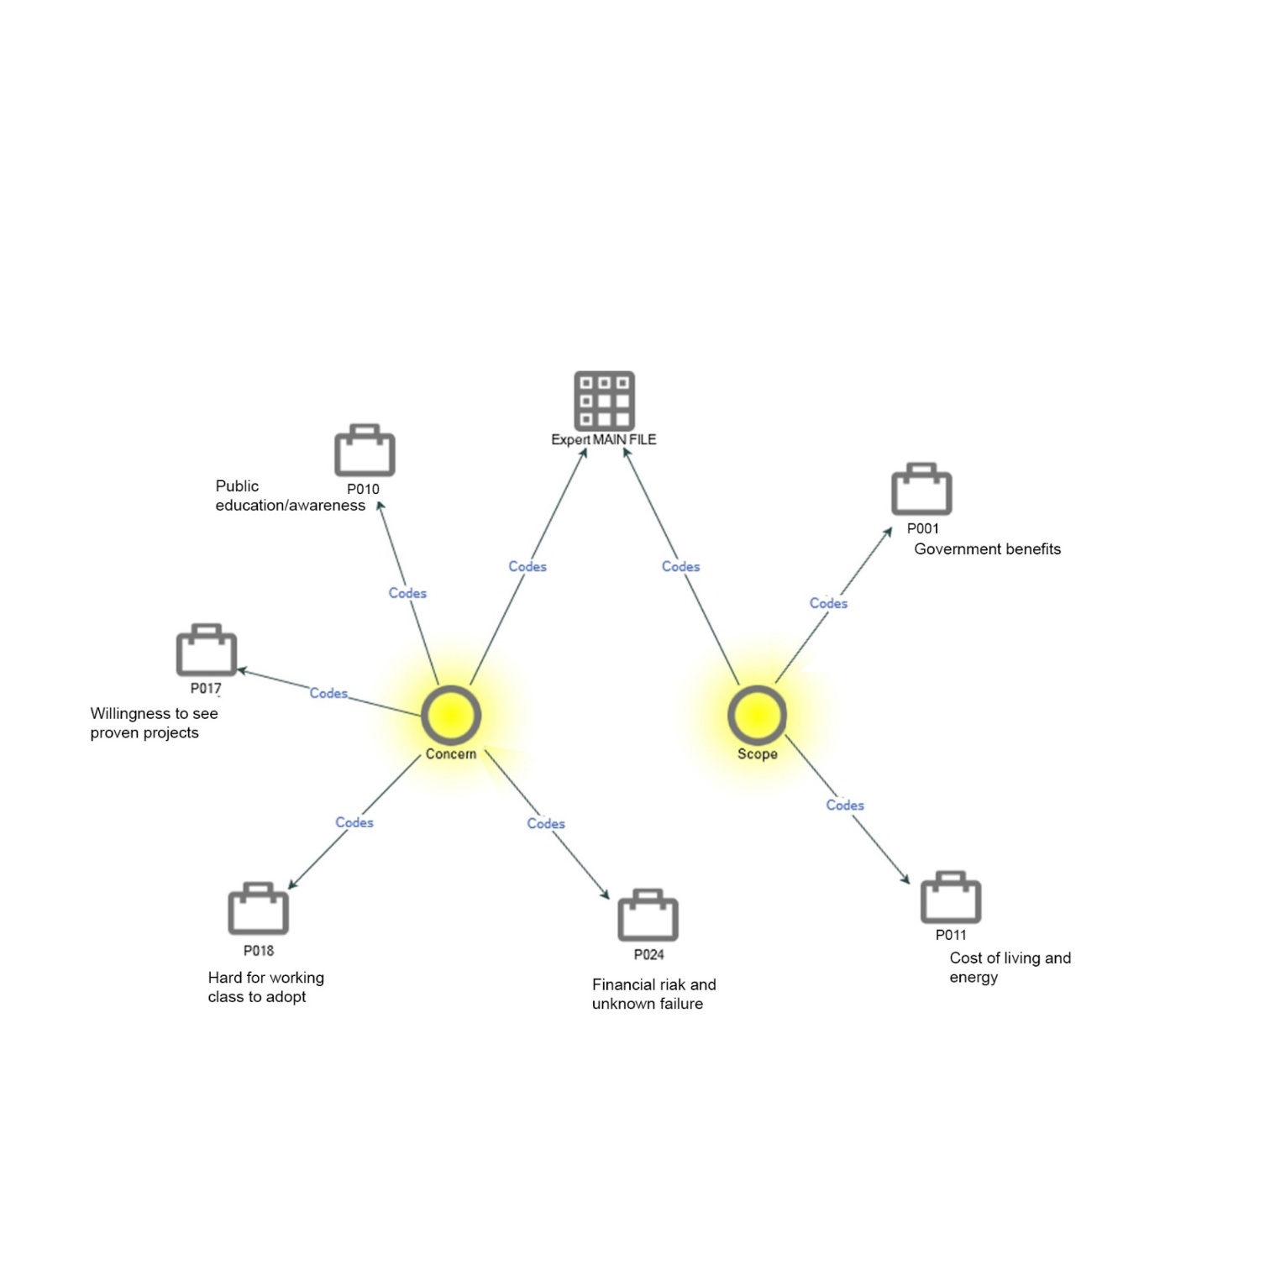
Figure 22: Thematic analysis of observations by younger participants pre-visualisation(Author’s Own)

Post-Visualisation data (experts)
The qualitative data collected from the experts (n=28) post-visualisation were thematically analysed using NVivo Software. The descriptive statistical analysis of the supporting quantitative data was carried out using SPSS Statistics Software.
The experts agreed to the versatility of the Earthship concept and the scope of adopting the concept in small-scale commercial buildings, tourist attractions/holiday homes, art galleries, museums, schools, libraries, common halls, farmhouses, industrial workshops, old age homes, and leisure centres. In addition, experts advised adopting this idea for short-term accommodation or places to visit that would encourage the public to acclimatise to the Earthship concept gradually.
The majority of the participants agreed that Earthship buildings could contribute to the UK net zero carbon target for 2050. In this instance, P001, P003 etc. represented the participants/cases, and “cannot judge” and “contributes to target” were the codes based on which the comparison was made.
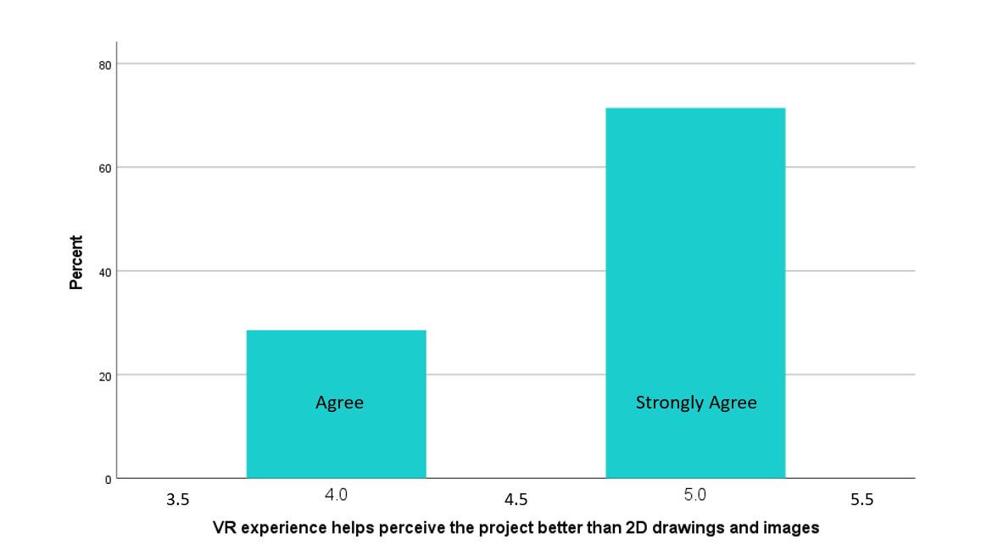
Figure 23: Pre-eminence of VR over 2D drawings(Author’s Own)
Furthermore, the general analysis of the issues and benefits of considering an Earthship house as an alternative house for youngsters in the UK was carried out using NVivo, where the data comparison was conducted considering “concern” and “scope” as the codes (Figure 22). The experts strongly agreed with the strong influence of VR
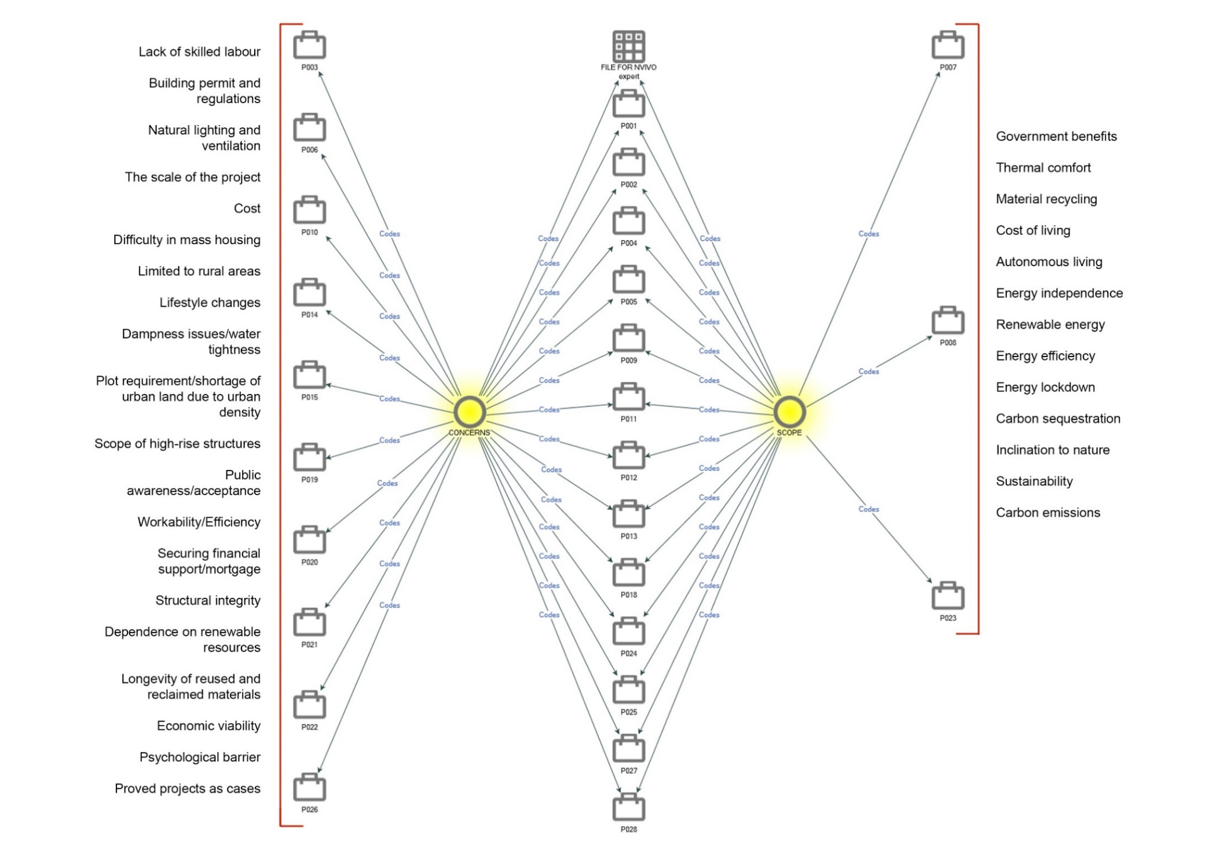

Figure 24: Thematic analysis of the concerns and scope of Earthship buildings(Experts)(Author’s Own)
visualisation on perception (Figure 23). Additionally, as shown in figure 24 , the experts suggested aspects which could have improved their perception of VR such as a change in navigation mode from teleportation to walkthrough, including more details such as cross-sections, structural/construction details, adding play of light and shadows, and providing multiple design options.

Experiment - Comparison of notion perception in pre- and post-visualisation phases: 2D drawings vs VR visualisation
Independent T-tests (Tables 6 and 7) were conducted to identify the significant differences in perceptions of the Earthship building concept during pre-visualisation(planar images) and post-visualisation (VR visualisation) phases among the youngsters and the experts. The pre- and post-visualisation sessions were considered as categorical variables, and the perception of Earthship was considered a continuous, dependent variable.
In the case of the younger participants, the T-test indicated a significant difference in the scores for perception during pre-visualisation (M = 3.29, SD = 0.77) and those during post-visualisation (M = 4.30, SD = 0.79), where t(242) = -10.126 and p = <0.001. Since the significance value (<0.001) was less than 0.05, it was statistically evident that the magnitude of the difference was significant.
Similarly, in the case of experts, the T-test indicated a significant difference in the scores for perception during pre-visualisation (M = 2.82, SD = 0.77) and those during post-visualisation (M = 3.00, SD = 1.01)m where t(54) = -0.739 and p = 0.231. The significance value (0.231), which was greater than 0.05, showed that the magnitude of the difference was insignificant (Figure 25&26).
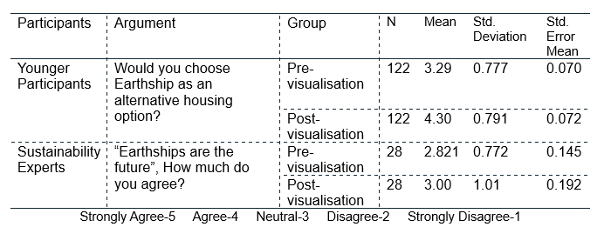
Table 6: Pre-visualisation and Post-visualisation- Mean comparison(Author’s Own).
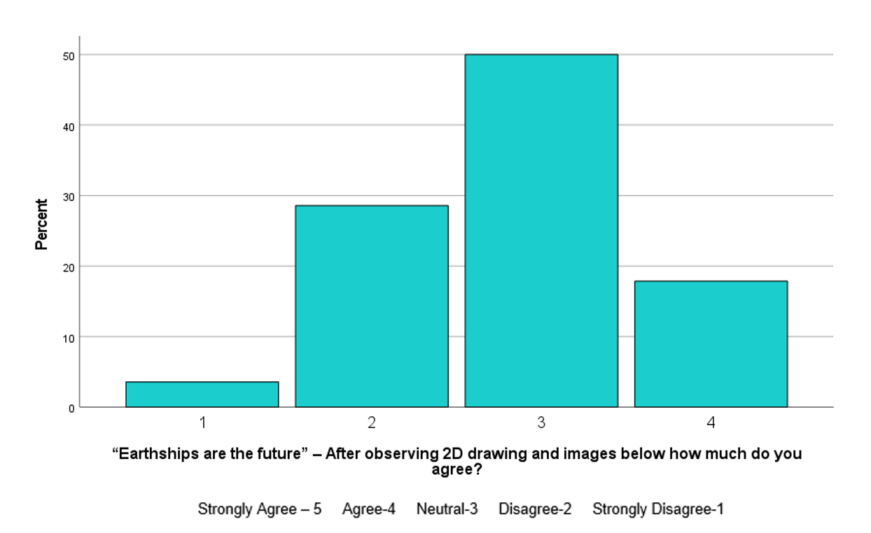
Figure 25: Experts’ views during the pre-visualisation phase(Author’s Own)

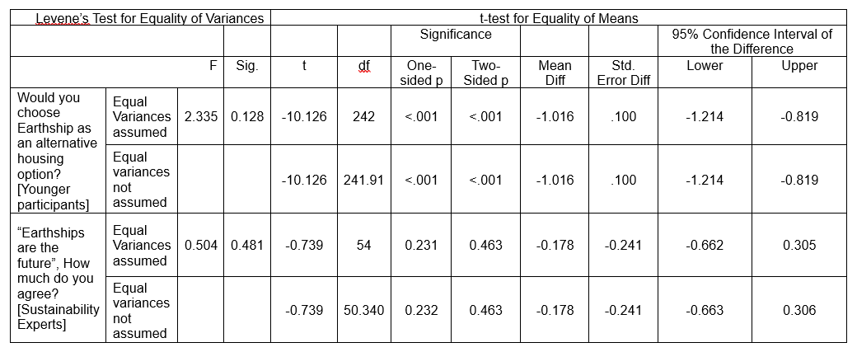

Table 7: Independent sample T-test(Author’s Own).

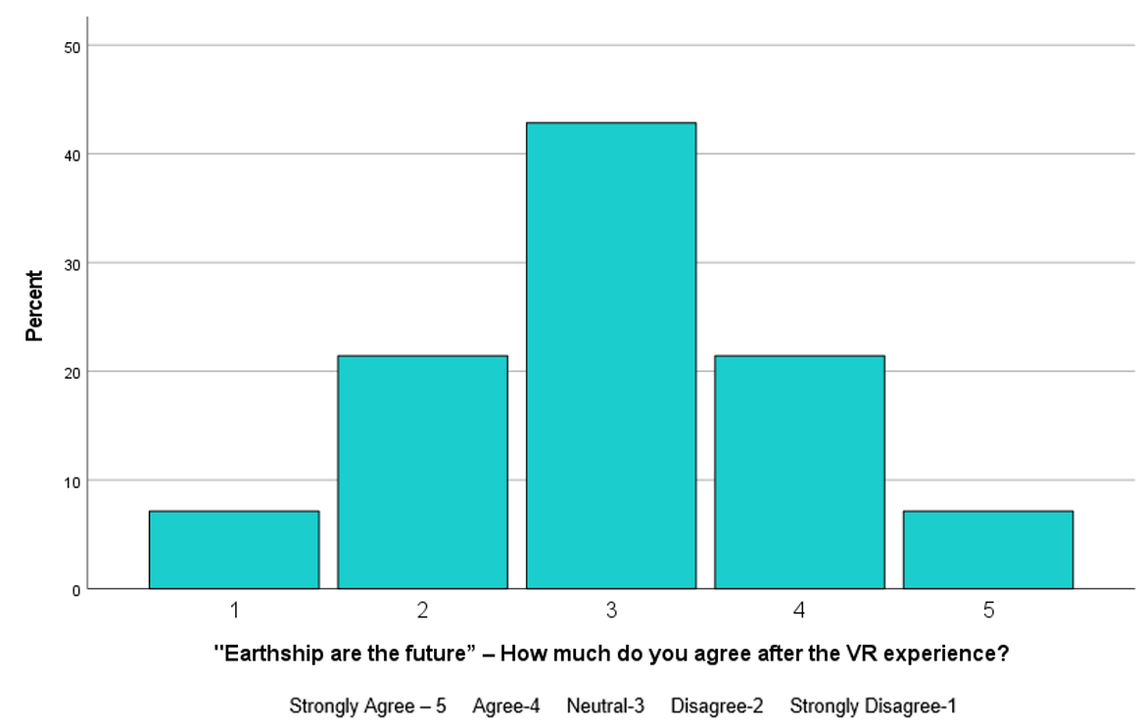
Figure 26: Experts’ views during post- visualisation phase(Author’s Own)

Sense of presence(SoP)
The youngsters and experts agreed to experience a high sense of physical space and engagement in the virtual environment. Tables 8 and 9 indicate that the participants had a higher feeling of “being there” while interacting with features in the virtual Earthship environment. The participants also agreed that the virtual environment presented a near-real-life Earthship experience. Furthermore, the participants actively engaged with the Earthship environment, which suggested involvement and interest in the content delivered. The data indicated higher immersion and interest among youngsters in VR than the experts.
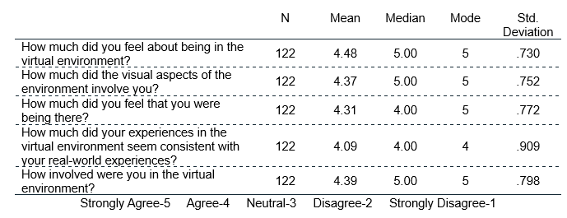
Table 8: Younger participants’ opinions(Author’s Own).
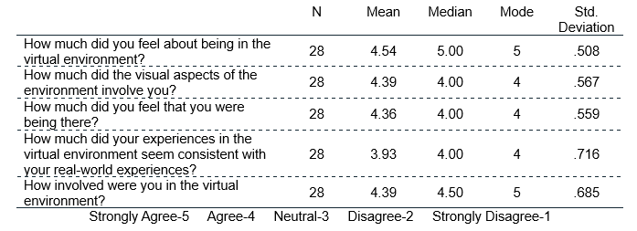
Table 9: Experts’ opinions(Author’s Own).

Discussion

Perception of Earthship houses among the younger generation

Demographics
The demographic analysis of participants demarcates the focus of the study. A large sample of youngsters (n = 122, age 20-35) from various professional backgrounds through random sampling assured unbiased results. The Health Foundation (2022) indicated that 14% of 16-34 year olds are forced to spend more on housing in relation to income, thereby delaying the dream of buying their first home to the age of 34. The statistical data analysis affirmed the literature review findings that most of the UK's youth have insufficient income to afford a house. Housing Affordability and Sustainability Analytical (2019) and the findings of this research pinpoint the need to adopt an affordable and sustainable housing solution for the youth in the UK. Hence, the need to assess the outlook of youngsters towards sustainable housing is necessary.

Attitude towards sustainability
The statistical analysis of the youngster’s attitude towards sustainability stresses the lack of awareness about personal contribution in their day-to-day lives. The sustainability experts’ opinion, based on their professional experience, opinionated that even though the uptake of renewable energy is widespread in the UK, the public is unwilling to embrace off-grid living in the UK, which affirms the findings above. However, the experts strongly agree that following sustainability principles in the construction, retrofitting the existing buildings with sustainability measures, and using recycled and reclaimed materials contribute positively to achieving the sustainable development goals (SDGs). The significant obstacles identified by the experts in attaining acceptance of off-grid living in the UK are the unskilled UK workforce to undertake sustainability practices and the laborious procedures involved in obtaining permits and permissions to undertake projects for sustainability.
Hence, the findings showed that the dearth of awareness about the sustainability concept among youngsters would make the roll-out of sustainable housing solutions challenging. Therefore, an insightful methodology to create awareness about sustainability is imperative. Hence the findings proved that adopting VR visualisation for the study was appropriate.

Insight into Earthship
Based on the literature review, the Earthship houses are praised as being affordable and sustainable alternative housing, and two of them exist in the UK. Remarkably, however, the findings demonstrated that most youngsters and experts were unaware of Earthship houses in the UK. This indicated the need for an appropriate medium to present and instigate this novel concept to the participants.
During the pre-visualisation phase, when the planar images of the Earthship house were introduced, even though most of the participants expressed the opinion that the Earthship house had the potential for long-term living as a family home, a very few chose to adopt it as a personal, long-term, living space.
Prior to the VR visualisation of the Earthship house with interactivity, a significant change in opinion was evident. Together with an increase in the number of participants suggests the scope of the Earthship house as a long-term living space. The youngsters agreed strongly that VR changed their opinions about the Earthship house post-visualisation. While youngsters were uncertain of the advantages of having sustainability features in their homes during the pre-visualisation phase, after VR visualisation, most of the youngsters agreed that Earthship houses are realistic solutions for sustainable living in the future, and they agree with the idea of refurbishing their own homes into an Earthship house.
However, the general observations shared by youngsters indicate that the younger public is more concerned about existing social perspectives on housing and changes in lifestyle. The use of waste/recycled materials and the traditional look in contrast to conventional materials and modern design was a thought-provoking recommendation by the youngsters. Moreover, they questioned the longevity of recycled and reclaimed materials. The observations showed that the majority (74%) of the youngsters resided in urban areas and, hence, their opinions demonstrated their curiosity about the concept of Earthship houses in an urban context as well as high-rise or large-scale projects.
A common concern was the lack of skilled labour, whereas a prospective architecture student noted the concept's scope for creating extensive job opportunities. The comment recalled the thought that each concern could be an opportunity. Despite the concerns, the underlying principles of the Earthship buildings, such as materials, off-grid concept, and harmony with nature, together with the experience of virtual Earthship, were noted as attractions. All the participants' concerns indicated a demand for more proven projects and awareness.

The scope and limitations of implementing the Earthship project in the UK

Expert stance towards the Earthship concept
The recommendations from the experts were supported by their expertise in the field. During the pre-visualisation phase, the experts shared various concerns regarding the Earthship concept, such as the need for public education, working-class adoption because of initial cost, financial risk and unknown errors, whereas government benefits and cost of living and energy as benefits. During the immersive visualisation and interactivity phase, even though most of the experts agreed that the Earthship buildings contribute to the UK net-zero carbon target for 2050, they expressed concerns about the scope of conceiving Earthship houses as a future alternative. An expert referred to such developments as a “move to energy lockdowns”. Carbon sequestration and energy efficiency further added to the positives of the project.
In contrast, the lack of skilled labour in the UK was identified as an obstacle to project advancement. The construction techniques lead to uncertainty in conceiving large-scale or high-rise projects, limiting the concept's acceptance. The participants preferred to have the Earthship houses in a rural setting because of the unavailability of urban land. The workability/efficiency of the project in the UK context was also questioned. Moreover, the participants were concerned about building permits, regulations, and financial support/mortgages. One of the participants, an experienced civil engineer, shared concerns about the project's structural integrity, particularly issues about dampness and waterproofing. Another major concern was the public's psychological barrier to adapting to a new concept. This indicates the need for further research about Earthship buildings to address the concerns raised by both the youngsters and the experts in sustainability in order to educate, encourage, and enable the public regarding the adoption of Earthship houses for multi-use.

Experiment - 2D drawings vs VR Visualisation
The experiment was intended to investigate the pre-eminence of VR visualisation over planar drawings. The T-test results of the experiment were conducted in two phases, the pre-visualisation phase with the aid of 2D drawings and post visualisation phase using VR visualisation with interactivity consecutively. Most of the youngsters ardently agreed that they had a better perception and understanding of the Earthship building and the concept in VR real-time experience of the project (p < 0.05). In contrast, even though the experts felt that the VR visualisation was impressive compared with the planar drawings, there was not a significant change in their attitude towards the Earthship concept post-visualisation (p > 0.05). The experts' familiarity with reading the 2D drawings and the concerns raised based on their professional experience prevented them from mindlessly accepting the Earthship concept. Furthermore, the VR visualisation improvements (Post-visualisation data [experts]) suggested by the experts displayed their focus on construction details and workability rather than the visual experience.
Additionally, according to Prabhakaran et al. (2022), users' perceptions of space in a virtual world can be influenced significantly by their SoP. The descriptive statistical analysis of the SoP data shows that the youngsters experienced a strong SoP in the virtual environment compared with the experts. Hence, there is a higher probability that VR visualisation influences youngsters compared to the experts. The findings indicated justification for the repudiation of the statement “Earthships are the future”, which concurred with the concerns shared by the experts.
Hence the analysis of the T-test results and the suggestions by experts for aspects to be included in VR visualisation for improved perception indicates the need for further research and fabrication of a virtual environment with advanced facilities and interaction that address all the possible concerns, which might impress experienced professionals.
However, two participants withdrew from the experiment due to health conditions and disinterest in the VR experience, which is identified as a limitation of adopting VR for experiments.

Conclusion
This paper aimed to examine the perceptions of Earthship buildings among the younger population using immersive VR technology. In addition, the pre-eminence of VR visualisation over 2D drawings was also assessed in the study. Accordingly, a concurrent-embedded, abductive, mixed-methods approach was adopted for the study to attain the research aim. The overview of the discussion confirmed that the public, especially the younger population within the age range of 20-35, requires stimulated awareness for a change in attitude towards approaches to sustainability and an understanding of the sole contribution to climate change. The experiment was conducted in two phases (pre-visualisation and post-visualisation), where VR visualisation with interactivity induced a change of perspective among the youngsters about the Earthship house. Even though most of the youngsters re-appraised the Earthship concept post-VR visualisation, the youngsters had more concerns about this novel concept. The expert opinions affirmed these concerns. The probability of Earthship houses being embraced as a choice of housing in the UK was enhanced by the positive attitude of youngsters toward them. Still, it will be challenging to persuade youngsters to change their instilled perceptions of current housing concepts, which requires decisive education and encouragement to enable the public to adopt Earthship buildings for multiple uses. Based on the study, it was found that most participants had not seen or heard of the Earthship buildings before. Still, the interactivity in the virtual Earthship environment, with laudable details, instigated acceptance of the concept of Earthship buildings. Hence it is recommended to employ VR technology with advanced interacttivities to address all the possible concerns shared to impart a gratifying perception of Earthship buildings among youngsters.
The research has both social and practical implications. The demand for more affordable, sustainable housing is crucial as the global housing crisis escalates. Previous studies have proposed Earthship houses as the epitome of affordable and alternative housing. However, the first Earthship house in Brighton, UK, was built in 2006, and only two Earthship dwellings have been built in the UK during the last 26 years, highlighting the lack of awareness among the public. The findings of the literature review substantiated this assumption. Hence, the research was conducted in three phases to enhance awareness among the younger population about sustainability, the off-grid housing concept and approaches to sustainable housing. The VR visualisation with interactivity was used to present a near real-life experience of Earthship buildings and their characteristics, thereby achieving a remarkable change in perception and elevating the probability of accepting Earthship as a future alternative for housing.
The study's finding recommends future research in Earthship buildings with the aid of VR. The assessment of the study points out the need for further research in the perception of Earthship buildings among the age-old group who are prospective second-time home buyers.

Limitations
In this study further concerns regarding the potential uptake of Earthship as an alternative housing solution, includ complexities related to building permits, lack of sufficient labour force etc., which warrant future investigation. Any how such concerns cannot be addressed within the precinct of VR. Similarly, VR-integrated research works have limitations, such as the user acceptance of VR trials is limited as it is a personal choice. Additionally, the virtual environment is created with high fidelity to ensure a superior user experience which demands a high-end computer facility for the experiment.

REFERENCE
Adabre, M.A.; Chan, A.P.C. Critical success factors (CSFs) for sustainable affordable housing. Build. Environ. 2019, 156, 203–214.
Analytical report (2019) Housing affordability and sustainability in the EU [online]. UK: European Construction Sector Observatory. Available from: https://ec.europa.eu/docsroom/documents/38481/attachments/1/translations/en/renditions/native [Accessed 05 November 2022].
Bacter, C., Săveanu, S., Buhaș, R., & Marc, C. (2021). Housing for sustainable societies. Children′s perception and satisfaction with their house in countries around the world. Sustainability (Switzerland), 13(16). https://doi.org/10.3390/su13168779
BBC (2007). ‘Earthships’ Get Planning Consent. Available online: http://news.bbc.co.uk/1/hi/england/sussex/6592895.stm (accessed on 5 December 2022)
BBC News(2019) Housing crisis affects an estimated 8.4 million in England-research. Available from: https://www.bbc.co.uk/news/uk-49787913 [Accessed 16 November 2022].
Bond Ralph, 2017. area.autodesk.com/blogs/buildings-in-motion/from-3ds-max-to-vr.
Booth, C. A., Horry, R., Isaac, C., Mahamadu, A. M., Manu, P., Awuah, K. G. B., Aboagye-Nimo, E., Georgakis, P., & Prabhakaran, A. (2022). Earthship buildings: Stakeholder opinions of their contribution towards sustainable alternative housing in the United Kingdom. Proceedings of Institution of Civil Engineers: Management, Procurement and Law. https://doi.org/10.1680/jmapl.22.00026
Booth, C. A., Rasheed, S., Mahamadu, A. M., Horry, R., Manu, P., Awuah, K. G. B., Aboagye-Nimo, E., & Georgakis, P. (2021a). Insights into public perceptions of earthship buildings as alternative homes. Buildings, 11(9). https://doi.org/10.3390/buildings11090377
Booth, C. A., Rasheed, S., Mahamadu, A. M., Horry, R., Manu, P., Awuah, K. G. B., Aboagye-Nimo, E., & Georgakis, P. (2021b). Insights into public perceptions of earthship buildings as alternative homes. Buildings, 11(9). https://doi.org/10.3390/buildings11090377
Broer, S. and Titheridge, H. (2010) Eco–self–build housing communities: Are they feasible and can they lead to sustainable and low carbon lifestyles? Sustainability, 2, 2084–2116.
Chatterton, P. (2013) Towards an agenda for post–carbon cities: Lessons from Lilac, the UK’s first ecological, affordable cohousing community. International Journal of Urban and Regional Research, 37, 1654–1674.
Chiveralls, K. Reuse in Earthship construction: Reclaiming the past to shape the future. In Subverting Consumerism: Reuse in an Accelerated World; Crocker, R., Chiveralls, K., Eds.; Routledge Publishing: Abingdon, UK, 2018; ISBN 9780367665951.
CIBSE. Guide A: Environmental Design; Chartered Institution of Building Services Engineers: London, UK, 2006; ISBN 9780900953293.
Clapham, D., Mackie, P., Orford, S., Thomas, I., & Buckley, K. (2014). The housing pathways of young people in the UK. Environment and Planning A, 46(8), 2016–2031. https://doi.org/10.1068/a46273
CLG (2012) Ministry of Housing and Local Government. Available from: https://www.gov.uk/government/organisations/ministry-of-housing-communities-and-local-government [Accessed 22 December 2022].
Coimbra, J.; Almeida, M. Challenges and benefits of building sustainable cooperative housing. Build. Environ. 2013, 62, 9–17.
Collins, G. Living off the Grid: What to Expect while Living the Life of Ultimate Freedom and Tranquillity; Second Nature Publishing: Albuquerque, NM, USA, 2019; ISBN 9781570673733.
Creswell, J. (2009) Research Design : Qualitative, Quantitative, and Mixed Methods Approaches.
Creswell, J.W. and Creswell, J.D. (2017) Research Design: Qualitative, Quantitative, and Mixed Methods Approaches. 4th ed. Sage, Newbury Park.
Cygas, Donatas., Froehner, K. Dieter., & Breznikar, A. (2011). Environmental engineering : selected papers. Vol. 3, Sustainable urban development. Roads and Railways. Technologies of Geodesy and Cadastre. Vilnius Gediminas Technical University Press “Technika.”
Data Protection Act 2018, c.12. Available at: http://www.legislation.gov.uk/ukpga/2018/12/contents/enacted(Accessed: 13 July 2023)Earthship biotecture(2022) Earthship global; Michael Reynolds. Available from: https://www.earthshipglobal.com/home [Accessed 10 December 2022].
Eco-house (2022) Eco Open Houses Brighton and Hove. Available from: http://ecoopenhouses.org/ [Accessed 22 December 2022].
EmeraldInsight (2022) Emerald group publishing. Available from: https://www.emerald.com/insight/[Accessed 22 June 2022].
Finder(2022) First-time buyer statistics: Average age to buy a house in the UK. Available from: https://www.finder.com/uk/first-time-buyer-statistics [Accessed 16 November 2022].
Freney, M. (2014) Earthship Architecture: Post-occupancy evaluation, thermal performance& life cycle assessment. PhD, The University of Adelaide.
Furht, B. (2018) Encyclopedia of Multimedia. 2nd ed. Ny: Springer New York,.
Greene, J.C. (2007) Mixed Methods in Social Inquiry. San Francisco, Calif; Chichester: Jossey-Bass.
Growth, place or people (2017)The housing association of 2022 [online]. United Kingdom: PWC. Available from: https://www.pwc.co.uk/government-public-sector/local-government/housing-association.pdf [Accessed 08 December 2022].
Harkness, R. (2011). Earthships. Anthropology Now, 3(1), 54–65. https://doi.org/10.1080/19428200.2011.11869122
Heffernan, E.; de Wilde, P. Group self-build housing: A bottom–Up approach environmentally and socially sustainable housing. J. Clean. Prod. 2020, 243, 118657.
Hernandez,C., et al. (2019) Comparing Virtual Reality and 2-Dimensional Drawings for the Visualisation of a Construction Project., ed. ASCE International Conference on Computing in Civil Engineering 2019. Place of conference, June 2019.
Hewitt, M. and Telfer, K. (2007) Earthships: Building a Zero Carbon Future for Homes. IHS Building Research Establishment: Bracknell, UK, ISBN 9781860819728.
Housing affordability (2022) Office for National Statistics: Housing affordability in England and Wales:2021. Available from: https://www.ons.gov.uk/peoplepopulationandcommunity/housing/bulletins/housingaffordabilityinenglandandwales/2021#:~:text=In%202021%2C%20we%20estimate%20that,their%20workplace%2Dbased%20annual%20earnings. [Accessed 1 November 2022].
Ip, K., & Miller, A. (2009). Thermal behaviour of an earth-sheltered autonomous building - The Brighton Earthship. Renewable Energy, 34(9), 2037–2043. https://doi.org/10.1016/j.renene.2009.02.006
Jokhio, I. and Chalmers, I. (2022) Using Your Logical Powers: Abductive Reasoning for Business Success User Experience Magazine2022 [online]. Available from: https://uxpamagazine.org/using-your-logicalpowers/ [Accessed 2 September 2022].
Kamari, A., Paari, A., & Torvund, H. Ø. (2021). Bim-enabled virtual reality (Vr) for sustainability life cycle and cost assessment. Sustainability (Switzerland), 13(1), 1–24. https://doi.org/10.3390/su13010249
Li, X., Arbabi, H., Bennett, G., Oreszczyn, T., & Densley Tingley, D. (2022). Net zero by 2050: Investigating carbon-budget compliant retrofit measures for the English housing stock. Renewable and Sustainable Energy Reviews, 161. https://doi.org/10.1016/j.rser.2022.112384
Lorenz, M., Brade, J., Diamond, L., Sjölie, D., Busch, M., Tscheligi, M., Klimant, P., Heyde, C. E., & Hammer, N. (2018). Presence and User Experience in a Virtual Environment under the Influence of Ethanol: An Explorative Study. Scientific Reports, 8(1). https://doi.org/10.1038/s41598-018-24453-5
M. K. Trochim William, “Descriptive Statistics,” Research Methods Knowledge Base, 2006 http://www.socialresearchmethods.net/kb/statdesc.php
Mahamadu, A., Prabhakaran, A., Clark, K., Dziekonski, K., Okeke, U., Zhang, W., …Aigbavboa, C. O. (2021). The application of eye-tracking technology in architecture engineering and construction industry: A systematic review. In N. Dawood, F. Pour Rahimian, & M. Sheikhkhoshkar (Eds.), Proceedings of the 21st International Conference on Construction Applications of Virtual Reality (56-64).
Matschoss, K., Mikkonen, I., Gynther, L., Koukoufikis, G., Uihlein, A., & Murauskaite-Bull, I. (2022). Drawing policy insights from social innovation cases in the energy field. Energy Policy, 161. https://doi.org/10.1016/j.enpol.2021.112728
MHCL Annual Report (2021) Annual report and accounts 2020-21. Harmondsworth: Ministry of Health, communities and Local Government.
MirageVR (2022) Teens and virtual Reality. Available from: https://www.miragevr.ca/teens-and-virtual-reality#:~:text=Virtual%20reality%20has%20enhanced%20the,audio%20effects%2C%20and%20intuitive%20controls. [Accessed 22 December 2022].
NaturalEnglandGov.UK (2022) Wildlife, animals, biodiversity, and ecosystems: Over 80% of young people eager to take action to help the environment. Available from: https://www.thenbs.com/knowledge/sustainable-housing [Accessed 10 November 2022].
NBS (2022) National Building Specification: Sustainable housing. Available from: https://www.thenbs.com/knowledge/sustainable-housing [Accessed 10 November 2022].
Paradis, E., O'Brien, B., Nimmon, L., Bandiera, G. and Athina, M. (2016) Design: Selection of Data Collection Methods. Journal of Graduate Medical Education [online].
Prabhakaran, A. (2004) The impact of macro BIM maturity on organisation’s implementation of BIM in Qatar & the United Kingdom. MSc, University of the West of England.
Prabhakaran, A., Mahamadu, A. M., Mahdjoubi, L., & Boguslawski, P. (2022). BIM-based immersive collaborative environment for furniture, fixture and equipment design. Automation in Construction, 142. https://doi.org/10.1016/j.autcon.2022.104489
Prabhakaran, A., Mahamadu, A. M., Mahdjoubi, L., Booth, C., & Aigbavboa, C. (2022). Virtual reality utility and usefulness in the furniture, fixture and equipment sector: a validation of interactive and distributed immersion. Smart and Sustainable Built Environment. https://doi.org/10.1108/SASBE-02-2022-0038
Prabhakaran, A., Mahamadu, A., Mahdjoubi, L., Andric, J., Manu, P. and Mzyece, D. (2021) An Investigation Into Macro Bim Maturity and Its Impacts: A Comparison of Qatar and the United Kingdom. [online]. [Accessed 05 December 2022].
Prinz, R.P. Hacking the Earthship: In Search of an Earth–Shelter That Works for Everyone; Archinia Press: Taos, NM, USA, 2015; ISBN 9780986115516.
Purdy, E.R. Earthships. In Green Technology: An A–to–Z Guide; Mulvaney, D., Ed.; SAGE Publications: Los Angeles, CA, USA, 2011; ISBN 9781412996921.
Reynolds, M. Comfort in Any Climate; Solar Survival Architecture Press: Taos, NM, USA, 2001; ISBN 0962676748.
Reynolds, M. Earthship: Evolution Beyond Economics; Solar Survival Architecture Press: Taos, NM, USA, 1993; Volume 3, ISBN 0962676721.
Reynolds, M. Earthship: How to Build Your Own Earthship; Solar Survival Architecture Press: Taos, NM, USA, 1990; Volume 1, ISBN 0962676705
Reynolds, M. Earthship: Systems and Components; Solar Survival Architecture Press: Taos, NM, USA, 1991; Volume 2, ISBN 0962676713.
Reynolds, M. Water from the Sky; Solar Survival Architecture Press: Taos, NM, USA, 2005; ISBN 0962676756.
RIBA (2022) National Building Specification: Sustainable housing. Available from: https://www.thenbs.com/knowledge/sustainable-housing [Accessed 10 November WorldBenchmarkingAlliance (2018) Young people and the sustainability agenda:Three avenues for impact. Available from: https://www.worldbenchmarkingalliance.org/news/young-people-and-the-sustainability-agenda-three-avenues-for-impact/ [Accessed 9 November 2022].
RIBA2030climatechallengeversion2(2019) RIBA Sustainability outcomes [online]. Available from: RIBA Sustainable Outcomes Guide – GHA Knowledge Base (goodhomes.org.uk) [Accessed 31 November 2022].
Rodda, N., Carden, K. and Armitage, N. (2010) Sustainable Use of Greywater in Small-scale Agriculture and Gardens in South Africa : Technical Report : Report to the Water Research. South Africa: .
SABSE (2022) Emerald group publishing. Available from: https://www.emeraldgrouppublishing.com/journal/sasbe [Accessed 22 June 2022].
SABSEguidelines(2022) Emerald group publishing. Available from: https://www.emeraldgrouppublishing.com/journal/sasbe#author-guidelines [Accessed 22 June 2022].
Samardzioska, T., Salih, N., Grujoska, V. and Jovanoska, M. (2019) Design of Earthship For Climate Conditions in Macedonia. Earth and Environmental Science [online]. [Accessed 05 December 2022].
Samardzioska, T.; Salih, N.; Grujoska, V.; Jovanoska, M. Design of Earthship for climate conditions in Macedonia; IOP Conf. Series: Earth and Environmental Science. In Proceedings of the Sustainable Built Environment Conference 2019 Wales: Policy to Practice, Cardiff, Wales, 24–25 September 2019; Paper 012052; Volume 329.
Sampaio, A. Z. (2019). BIM capacities improved with VR technology in the building project. Multi Conference on Computer Science and Information Systems, MCCSIS 2019 - Proceedings of the International Conferences on Big Data Analytics, Data Mining and Computational Intelligence 2019 and Theory and Practice in Modern Computing 2019, 214–218. https://doi.org/10.33965/tpmc2019_201907c028
Saunders, M., & Thorhill, A. (2012) Research methods for business students [online]. Harlow, Pearson. Available from: https://books.google.com/books/about/Research_Methods_for_Business_Students.html?id=u4ybBgAAQ BAJ [Accessed 13 November 2022].
Saunders, M.A. and Lewis, P. (2019) Research Methods for Business Students Eights Edition Research Methods for Business Students Research Methods for Business Students. [online]. Available from: www.pearson.com/uk%0Ahttps://www.amazon.com/Research-Methods-for-BusinessStudents/dp/1292208783/ref=sr_1_2?dchild=1&qid=1614706531&refinements=p_27%3AAdrian+Thornhil l+%2F+Philip+Lewis+%2F+Mark+N.+K.+Saunders&s=books&sr=1-2&text=Adrian+Thornhill+%2F+Phili [Accessed 13 November 2022].
Scott, F., Jones, C. and Webb, T. (2014) What Do People Living in Deprived Communities in the Uk Think About Household Energy Efficiency Interventionsα. Energy Policy [online]. 66, pp. 335-349. [Accessed 05 December 2022].
SDG(2022) Youth and the SDGs. Available from: https://www.un.org/sustainabledevelopment/youth/ [Accessed 12 November 2022].
Seyfang, G. (2010) Community action for sustainable housing: Building a low–carbon future. Energy Policy, 38, 7624–7633.
Smith, P.F. Architecture in a Climate of Change; Routledge Publishers: London, UK, 2012; ISBN 9781135139766.
Soebarto, V.; Williamson, T.J.; Freney, M. Investigating the impact of earth tubes in an Earthship. In Proceedings of the Fifteenth International Building Performance Simulation Association (IBPSA), San Francisco, CA, USA, 7–9 August 2017.
Statistical Bulletin (2022) UK House Price Index Statistical Bulletins. Available from: https://www.ons.gov.uk/economy/inflationandpriceindices/ bulletins/house price index/previousreleases [Accessed on 2 December 2022].
Statistical bulletins (2022) Office for National Statistics: UK House Price Index Statistical bulletins. Available from: https://www.ons.gov.uk/economy/inflationandpriceindices/bulletins/housepriceindex/previousReleases [Accessed 1 November 2022].
Stevenson, F., & Arch, M. A. (2009). Proceedings of the Institution of Civil Engineers Urban Design and Planning. 3, 123–130. https://doi.org/10.1680/udap.2009.162
Suhaida, M.S.; Tawil, N.M.; Hamzah, N.; Che-Ani, A.I.; Basri, H.; Yuzainee, M.Y. Housing affordability: A conceptual overview for house price index. Procedia Eng. 2011, 20, 346–353.
The Health Foundation (2022) Inequalities in housing affordability. Available from: https://www.health.org.uk/evidence-hub/housing/housing-affordability/inequalities-in-housing-affordability [Accessed 10 November 2022].
The Health Foundation (2022) Inequalities in housing affordability. Available from: https://www.health.org.uk/evidence-hub/housing/housing-affordability/inequalities-in-housing-affordability [Accessed 10 November 2022].
Underwood, J. and Isikdag, U. (2010) Handbook of Research on Building Information Modeling and Construction Informatics: Concepts and Technologies. IGI Global. http://dx.doi.org/10.4018/978-1-60566-928-1
Vale, B.; Vale, R.J.D. The New Autonomous House: Design and Planning Sustainability; Thames and Hudson Ltd. Publishers: London, UK, 2002; ISBN 9780500282878.
Williamson, T.J., Radford, A. & Bennetts, H.(2003). Understanding sustainable architecture. New York: Spon Press YouGov(2022) What are the problems with housing in the UK. Available from: https://yougov.co.uk/topics/politics/articles-reports/2021/12/17/what-are-are-problems-housing-uk [Accessed 11 November 2022].
Wilson, J. (2014) Essentials of Business Research: A Guide to Doing Your Research Project. Second ed. London: SAGE
Wilson, W., & Barton, C. (2021). Overcrowded housing (England).
Wong, J. Y., Yip, C. C., Yong, S. T., Chan, A., Kok, S. T., Lau, T. L., Ali, M. T., & Gouda, E. (2020). BIM-VR framework for building information modelling in engineering education. International Journal of Interactive Mobile Technologies, 14(6), 15–39. https://doi.org/10.3991/IJIM.V14I06.13397
Xu, Y., Freney, M., Hassanli, R., Zhuge, Y., Rahman, M. M., & Rajibul Karim, M. (2022). Experimental study on the structural performance of full-scale tyre wall for residential housing applications. Engineering Structures, 259. https://doi.org/10.1016/j.engstruct.2022.114181
Yılmaz, M. (2019). Virtual Reality As A Tool For Participatory Architectural Design. https://www.researchgate.net/publication/337334259
YouGov(2022) What are the problems with housing in the UK. Available from: https://yougov.co.uk/topics/politics/articles-reports/2021/12/17/what-are-are-problems-housing-uk [Accessed 11 November 2022].
Zaker, R., & Coloma, E. (2018a). Virtual reality-integrated workflow in BIM-enabled projects collaboration and design review: a case study. Visualisation in Engineering, 6(1). https://doi.org/10.1186/s40327-018-0065-6

