Defensive behavior in Dipsas articulata (COPE, 1868)

Todd R. LEWIS, Owen J. J. LEWIS

4 Worgret Road, Wareham, Dorset, BH20 4PJ, United Kingdom < ecolewis@gmail.com >

KEY WORDS: Reptilia: Squamata: Serpentes: Dipsadinae: Dipsas articulata, defensive behavior, balling posture, ethology, Caño Palma Biological Station, Costa Rica

Snakes evolved a plethora of diverse antipredator mechanisms (LANCINI 1986; GREENE 1988). Typically, most snakes escape from threats fleeing. This behavior can be affected by body temperature, sex, reproductive condition, body size, ecdysis, resting posture as well as the intensity of stimuli (GIBBONS & DORCAS 2002; GLAUDAS et al. 2005). Some snakes do retract, coil, hiss and/or strike at threats when cornered, although many species are “cowards first, bluffers second and warriors last” (POPE 1958). A number of species developed elusive defensive behaviors such as cryptic and aposematic coloration to avoid detection (LA MARCA & SORIANO 2004; LANCINI 1986; LOTZKAT 2007). Some colubrid snakes adopt a defensive posture by inflating the anterior part of their bodies or opening their mouths in a threatening posture (GODLEY 1982; LA MARCA & SORIANO 2004; LOTZKAT 2007; NATERA-MUMAW et al. 2008). In arboreal snakes the body is sometimes laterally compressed and made rigid (GREENE 1979; MARQUES 1999).

Some snakes also exhibit more unusual defence protocols such as musking from the vent or death feigning (immobilization reflex) to detract a predator’s attention (USHAKOV 2007; MENDOZA 2009). A less documented defence behavior is ‘balling’, where a snake conceals its head among coils of its body from threat. The behavior is best known from the Royal or Ball Python Python regius (SHAW, 1802), from West Africa (BARKER & BAKER 2006). Balling behavior has also been reported for Boidae, Colubridae and Elapidae (BUSTARD 1969; MITCHELL 1978; ARNOLD & BENNETT 1984; MADSEN & UJVARI 2004). Even dangerously venomous species will resort to using balling rather than biting (MADSEN & UJVARI 2004).

In December 2004 we encountered an adult American Snail-eater Dipsas articulata (COPE, 1868) in an area of Manicaria palm swamp forest (MYERS 1990; SAVAGE 2002) at Cano Palma Biological Station near the Tortuguero National Park, Costa Rica (Fig. 1). Upon capture to verify identification, the snake promptly but casually retracted into a ball, concealing its head (Fig. 2). It remained in this state motionless for several minutes. After placement in a vivarium the snake resumed a normal posture but continued to ball and also flattened its head and created neck coils when handled. To the best of our knowledge this is the first recorded case of balling defence behavior by D. articulata.
Defensive behavior has been recorded for Dipsas albifrons (SAUVAGE, 1884), D. catesbyi (SENTZEN, 1796), D. indica LAURENTI, 1768, D. nicholsi (DUNN, 1933), D. oreas (COPE, 1868), D. pavonina SCHLEGEL, 1837, D. temporalis (WERNER, 1909) and D. viguieri (BOCOURT, 1884) (PETERS 1960; CADLE & MYERS 2003; CADLE 2005). Only D. nicholsi has previously been reported to exhibit body coiling as a defensive trait. This differs from ‘balling’ as the coils are more uniform in shape (see MYERS & CADLE 2003). Snakes of the genus Dipsas are known for their docile response to threat and capture. Dipsas oreas exhibits a defensive posturing which is common among the Dipsadini (CADLE & MYERS 2003). It includes head triangulation, raising the anterior part of the body and bringing the head and neck back into an S-shaped loop. The posturing and head triangulation defences of D. oreas, and herein by D. articulata, resemble the defensive behaviors of some vipers (GREENE 1988) and thus are potentially a form of behavioral mimicry.

REFERENCES:

ARNOLD, S. J. & BENNETT, A. F. (1984): Behavioural variation in natural populations. III: Antipredator displays in the garter snake Thamnophis radix.- Animal behaviour, Oxford; 32 (4): 1108- 1118.

BARKER, D. G. & BARKER, T. M. (2006): Ball pythons: the history, natural history, care and breeding (Pythons of the World, Vol. 2). VPI (Vida Preciosa International, Inc.) Library, pp. 320.

BUSTARD, H. R. (1969): Defensive behaviour and locomotion of the Pacific boa, Candoia aspera, with a brief review of head concealment in snakes.- Herpetologica, Lawrence; 25 (3): 164-170.

CADLE, J. E. (2005): Systematics of snakes of the Dipsas oreas complex (Colubridae: Dipsasinae) in western Ecuador and Peru, with revalidation of D. elegans (BOULENGER) and D. ellipsifera (BOULENGER).- Bulletin of the Museum of Comparative Zoology, Cambridge; 158 (3): 67–136.

CADLE, J. E. & MYERS, C. W. (2003): Systematics of snakes referred to Dipsas variegata in Panama and western South America, with revalidation of two species and notes on defensive behaviours in the Dipsadini (Colubridae).- American Museum novitates, New York; 3409: 1-47.

GIBBONS, J. W. & DORCAS, M. E. (2002): Defensive behaviour of cottonmouths (Agkistrodon piscivorus) toward humans.- Copeia, Washington; 2002 (1): 195-198.

GLAUDAS, X. & FARRELL, T. M. & MAY, P. G. (2005): Defensive behaviour of free-ranging pygmy rattlesnakes (Sistrurus miliarius).- Copeia, Washington; 2005 (1): 196-200.

GODLEY, J. S. (1982): Predation and defensive behaviour of the striped swamp snake (Regina alleni).- Florida Field Naturalist, Gainesville; 10 (2): 31-36.

GREENE, H. W. (1979): Behavioural convergence in the defensive display of snakes.- Experientia, Basel; 35: 747-748.

GREENE, H. W. (1988): Antipredator mechanisms in reptiles; pp. 1-152. In: GANS, C. & HUEY, R. B (eds.): Biology of the Reptilia. Vol. 16. New York (Alan R. Liss).

LA MARCA, E. & SORIANO, P. J. (2004): Reptiles de los Andes de Venezuela. Mérida, Venezuela (Fundación Polar, Conservación Internacional, Fundacite Mérida), pp. 173.

LANCINI, A. R. (1986): Serpientes de Venezuela (2nd edition). Caracas (Editorial Armitano), 264 pp.

LOTZKAT, S. (2007): Taxonomía y zoogeografía de la herpetofauna del Macizo de Nirgua, Venezuela. PhD Thesis. Department of Biological Sciences, Johann Wolfgang Goethe- Universität Frankfurt am Main, Germany; pp. 161.

MADSEN, T. & UJVARI, B. (2004): Dendroaspis polylepis (Black Mamba). Defensive behaviour.- Herpetological Review, New York; 35 (3): 275.

MARQUES, O. A. V. (1999): Defensive behaviour of the green snake Philodryas viridissimus (LINNAEUS) (Colubridae, Reptilia) from the Atlantic Forest in northeastern Brazil.- Revista Brasileira de Zoologia, São Paulo; 16 (1): 265-266.

MENDOZA, I. (2009): Defensive behaviour in Leptodeira annulata ashmeadii (HALLOWELL, 1845).- Herpetotropicos, Mérida, Venezuela; 5 (1): 67.

MITCHELL, J. C. (1978): Balling behaviour in Chionactis occipitalis.- Journal of Herpetology, Houston; 12 (3): 435-436.

MYERS, R. L. (1990): Ecosystem of the World 15; Forested Wetlands. Amsterdam (Elsevier), pp. 527.

NATERA-MUMAW, M. & DIASPARRA, J. P. & NOVOA, J. & JIMÉNEZ, D. (2008): Defensive behaviour in Philodryas viridissima (LINNAEUS, 1758).- Herpetotropicos, Mérida, Venezuela; 4 (1): 40.

PETERS, J. A. (1960): The snakes of the subfamily Dipsadinae.- Miscellaneous Publications of the Museum of Zoology, University of Michigan, Ann Arbor; 114: 1-224.

POPE, C. H. (1958): Snakes alive and how they live. New York (Viking Press), pp. 238.

SAVAGE, J. M. (2002): The amphibians and reptiles of Costa Rica: a herpetofauna between two continents, between two seas. Chicago, London (The University of Chicago Press), pp. XX, 934.

USHAKOV, M. V. (2007): On the defensive behaviour of the grass snake Natrix natrix (LINNAEUS, 1758).- Russian Journal of Ecology, New York, Moskva; 38 (2): 124–127.

Fig. 1: Dipsas articulata (COPE, 1868).

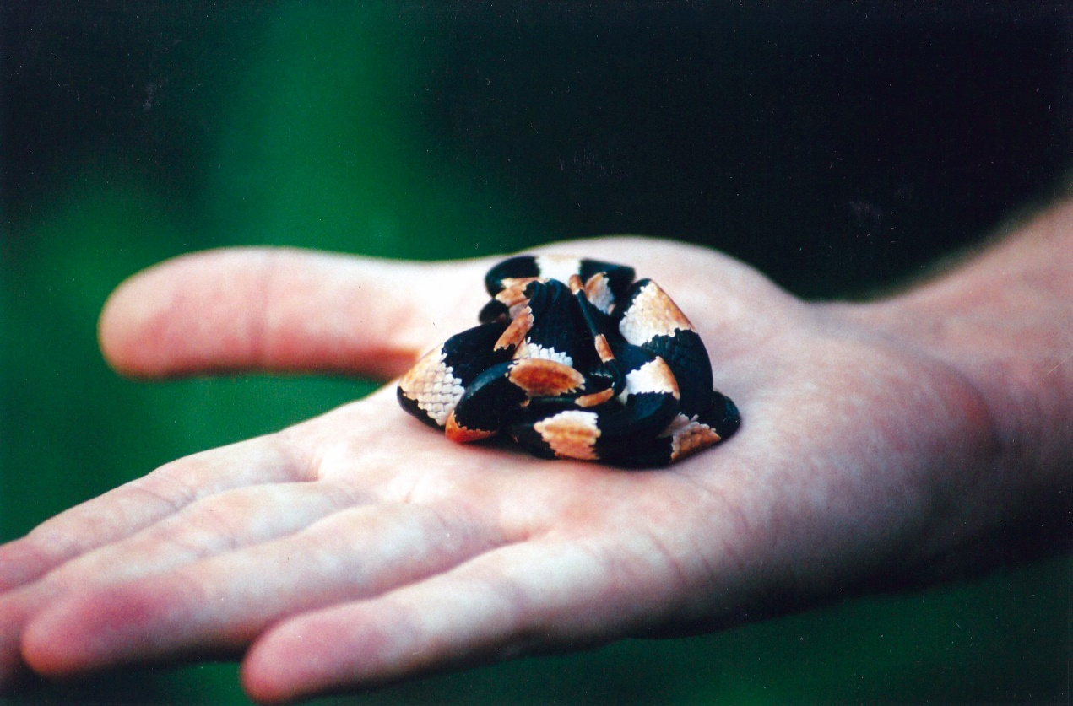

Fig. 2: Dipsas articulata (COPE, 1868) in ‘balling’ defence posture.

