**AUTOMATED CODE COMPLIANCE CHECKING THROUGH BUILDING INFORMATION MODELLING**

**1. Bilal Aslam**

Project Controls Engineer

Turner & Townsend, London, UK.

Email: [bilalaslamhijazi@gmail.com](mailto:bilalaslamhijazi@gmail.com)

**2. EUR ING Tariq Umar PhD, CEng MICE, FHEA**

Senior Lecturer in Construction Project Management, University of the West of England, UK

Email: [tariqumar1984@gmail.com](mailto:tariqumar1984@gmail.com)

**AUTOMATED CODE COMPLIANCE CHECKING THROUGH BUILDING INFORMATION MODELLING**

**Abstract**Design, construction and handing over of the building need to be complaint with the rules set by the local authority. Manual assessment of the drawings and plans against variable and complex set of rules is quite cumbersome, inconsistent, expensive, and prone to human error leading to huge delays in the construction projects. This research therefore develops an automated code compliance checking process using BIM. The drawbacks of the manual code compliance were delivered through the review of the existing system and then confirmed by the interviews (15 numbers) held the officials of Capital Development Authority (CDA) in Pakistan. The feedback from the customers and CDA concerned employees were sought through interviews (30 numbers) on the newly developed automated code compliance system with BIM integration. While the new programme of the code compliance reduced the time involved from one week to six hours, the customers reported that they would require to pay more fee to the architect to develop the complete set of BIM models. The automated code compliance and the BIM integration in local municipality can raise the profile of Pakistan in industry innovations and can pave the road towards several United Nations Sustainable Development Goals.

**Keywords: Building Information Modelling, Developing Countries, United Nations Sustainable Development Goals**

**List of Abbreviations**

2D Two Dimensional

3D Three Dimensional

AEC Architecture, Engineering and Construction

API Application Programming Interface

ASCE American Society of Civil Engineers

ACI American Concrete Institute

BCA Building Control Authority

BIM Building Information Modelling

CAD Computer Aided Desi.gn

CDA Capital Development Authority

EDA Express Data Manager

HVAC Heat Ventilation and Cooling

PTC Parametric Technology Corporation

RFID Radio Frequency Identification

SCA Singapore Construction Authority

# INTRODUC.TION

Compliance checking is the verification of plans or a built structure with the set of rules defined by a local authority, before or after the construction, respectively. Construction drawings and plans are currently checked manually in Pakistan against a set of changing and complex set of rules. This can be quite a hectic task for both the Client and the Engineer, and in most cases, leads to anomalies, inconsistencies, and delays in the entire construction process (Malsane, 2010). The traditional practice of code compliance checking has been largely a manual process, in the construction industry, which makes in cumbersome, expensive, and prone to errors (Dimyadi, J. and R. Amor, 2013). Verifying the functionality of plans or a built structure is a very complex task. In situations like Building inspector’s role under the BCA (Building Control Authority), Code Compliance is an important factor that needs to be carried out smoothly and accurately (Asim et al., 2017). However, some obstacles may arise in recent practices of manual process; some of them involve interpreting complex technical documents.

The Code Compliance process requires profound information of the strategies, perception of changes and great knowledge of the construction process as an Automatic rule checking has been perceived a hypothetically giving remarkable incentive to the AEC business from both administrative and industry points of view. Some key challenges to an effective standard check execution are simply the complexities characteristic of the guidelines and the wide conditions they should apply to. Due to a considerable number of building standards and a hypothetically endless number of principles that can be characterized, it is essential that the principles be systematized to make the guideline project sensible. (Solihin and Eastman, 2015).

It is an extensive process that involves the user having to visit the Building Control Authority office multiple times for Reviewing, correction, and approvals of a building plan. To achieve these efficiencies, designers need to change their working practices and move away from building definitions in multiple and disparate documents to a single coherent building model that generates documentation (Malsane, 2010). It is claimed that automated compliance checking would not only prove beneficial to designers but to also building certifiers, consultants, building code authorities, specification writers and builders (Tan et al., 2010).

Even though the concept of BIM is being understood by the licensed/prominent architectural and design firms in Pakistan, it has not been widely accepted for use as a design approach (Masoody et al, 2014). Architectural and design firms wanting to use BIM design approach and Clients wanting to gain from additional information, accuracy and integration need to come to a compromise and agree to develop the BIM in different stages and with different information levels. Practically in the AEC industry in Pakistan, the uses of modern tools are not encouraged on certain levels (Abbas et al., 2016). Many of the people involved with the industries are rather incapable of using it because of their thinking that they are comfortable using the traditional methods and they are not compliant with new generation progressive devices. This causes lack of coordination between different project stakeholders eventually leading to project failure in cost and time constraints (Gazder and Khan, 2018). This results in the poor performance of the project deliverables and in due course the collective productive outcome of the AEC industry slack (Abdullah, 2013).

Manual work and human interpretation lead to inconsistencies in the application of compliance with building regulations (Solihin & Eastman, 2015). Interpreting building regulations can involve subjective judgments. Different individuals may have varying interpretations or understanding of the regulations, leading to inconsistent application. Likewise, building regulations can be complex and extensive, with numerous requirements and specifications (Stack, 2012). Human errors or oversights can occur during the interpretation and application process, resulting in inconsistencies (Harati-Mokhtari et al., 2007). More often, building regulations are regularly updated and can be extensive, making it challenging for individuals to stay fully informed about all the requirements. Lack of awareness or understanding of specific regulations can lead to inconsistencies in their application. Similarly, Individuals responsible for enforcing building regulations may not receive comprehensive training or ongoing professional development (Mpofu and Hlatywayo, 2015). This can result in inconsistent knowledge and understanding of the regulations, leading to inconsistent enforcement. Building regulations can have local variations or specific interpretations based on regional practices or norms. This can lead to inconsistencies when different jurisdictions apply the regulations differently. Regulatory agencies or departments may have limited resources, such as staff or time, to thoroughly review every building project for compliance (Scott, 2005). This can result in inconsistent enforcement or reliance on self-reporting, which may not always be accurate. Building regulatory bodies may prioritize certain aspects of compliance over others due to resource constraints or policy decisions. This can lead to variations in the level of scrutiny or enforcement applied to different aspects of the regulations. Therefore, there is a need for the compliance checking process automation. The process is already automated in most of the emerging countries, so if it is not done now, Pakistan will lag behind in this race of advancement in construction practices.

The objectives of this research were to identify the problems present in the existing code compliance (Byelaws) processes and develop a framework for Automated Code Compliance checking through BIM based visual programming. The research furthered aimed to integrate the framework to a web-based data management system for efficient service delivery management of automated code compliance checking. The outcomes of this research can be applied to all civil engineering works, however in this project our main focus is on residential buildings. The methodology followed to verify the code compliance for any civil engineering project. The framework developed can be used throughout the life cycle of the project for compliance checking. Its ability to address all these applications through 3-D visualization will enable it to be incorporated in the construction industry of Pakistan for sustainable development and building operations and management.

# LITERATURE REVIEW

## 2.1 BACKGROUND

Whenever a construction project is about to start some problems arise (Haseeb et al., 2011). The most important issue when planning and constructing a project is to maintain the safety and quality of project planning at a high level and according to the standards. Therefore, this quality must be constantly reviewed in terms of compliance and accuracy with the codes and guideline applicable throughout the project. Today, this verification process is difficult, bulky, laborious and error prone because it is basically done manually, based on a two-dimensional drawings and repeatable layout, with each layout change done by the administrator's planning engineer. Recently, many automation methods have proven this process extremely relevant by using numerical methods, such as by using building information modelling, to change the way it is done, reducing the amount of work and simultaneously improve the design quality (Hardin and McCool, 2015).

We live in an environment made by human, designed per some rules and regulations for our safety and well-being. A few regulatory compliance assessments are done for a building throughout its entire useful life. It is thus the duty of the designer to design the building in such a way that every aspect of it is in accordance with the various standards and regulatory requirements. The design is then formally audited by the local building council for approval. The process of auditing continues during construction and installation of various structural and MEP components etc. both before and after installation to check for the quality of product and workmanship confirmation to the required standard. Regular audits are also done after the construction to ensure that the usage of building and maintenance is as per designed and planned. Even at the stage of demolition, conformance to standards is necessary to ensure the safety of all nearby citizens (Dimyadi & Amor, 2013).

In short Building codes also called building regulations or building control is a set of rules for construction of building and non-building structures based on some previously defined set of standards. Building codes are of many types such as, for energy systems & for residential buildings. Conformance to the building codes is necessary to obtain planning permission from local council.

## 2.2 AUTOMATION OF COMPLIANCE/CODE CHECKING

The traditional practice of building code compliance checking is a manual process consisting of examining the 2D drawings against every rule one by one which is laborious, costly, and subjected to errors. Various attempts have been done to automate the process for the past several decades, but the process is slow. Several reasons for failure to adapt to the automated process is the diverse nature of the construction industry, complex network of stakeholders, high competitiveness, decreasing productivity and less or no motivation to adapt to the new technology from traditional manual methods (Dimyadi & Amor, 2013).

Automated Code Compliance Checking is a particular case of Building Model Checking, that approves Building Information Models and structure basics by observing and comparing the parameters of the data from BIM model against standard codes and plans but it depends on the consolidated utilization of strategies gotten from standardizing requirements at zone, national, and universal dimension customers’ requirements and best understanding initiating from self-involvement with a three-dimensional(3D) and object based design. (Ciribini, Ventura, & Paneroni, 2016). With regards to construction regulation consistence checking of a structure configuration venture, inputs are the regular structure parts investigated and assessed by a procedure, Yields are the status of code consistence derived approximately because of the changes/checking of the contributions by the procedure. Controls are the principles, criteria, rules, and so forth., that direct the evaluation procedure (for example construction regulations/guidelines) Systems of the code checking apparatuses/strategies or procedures, for example calculations to reason complex structure data and capacities to check for code consistence, which achieve the activities depicted inside the procedure (Nguyen & Kim, 2011) – figure 1.

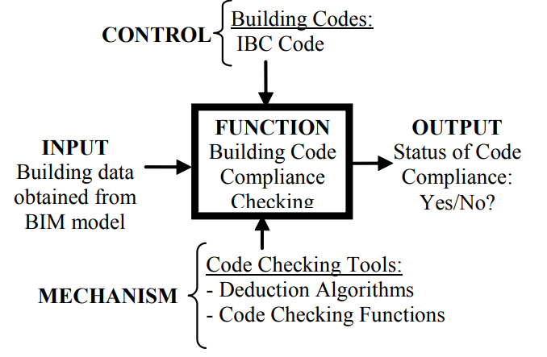

Figure 1 – Automated Code Compliance Checking Framework (Nguyen & Kim, 2011)

## 2.3 STRATEGIES AND APPROACHES TO AUTOMATED CODE COMPLIANCE CHECKING

While there are several strategies and approaches to the automated conde compliance, few of the famous approaches towards automated compliance checking are given below.

### 2.3.1 E-PLAN CHECK SINGAPORE

The E-Plan Check scheme was a determination to check construction commandments naturally through Industry foundation classes (IFC) and Computer Aided designing. The software was made by CORENET in the year 2000 in the Singapore Construction Authority. The framework flopped at first because of the exclusive idea of the application and its failure to deal with awful information or bad data. It was gone for Building and Architecture components checking. The arrangement point of the scheme was to decrease the problem of consistence to strategies. This exertion united proficient information of guidelines, artificial aptitude and BIM Technology. (Khemlani, 2015).

The complexity of the instructions in Singapore led to the execution of an automatic rule within a mechanized framework by as much as 30% of the overall time. The intricacy of Building rules and Regulations and varieties of understanding are average highlights of automation strategies. An examination by FIATECH affirmed Building Inspectors from shifting nearby specialists gave distinctive elucidation of structure guidelines. The CORENET framework experienced a few cycles because of human contact and interruptions (Solihin & Eastman, 2015). A permitted stage; FORNAX, was created to extricate fundamental BIM data from IFC information and connections to directive data (Khemlani, 2015; (Reinhardt & Mathews, 2017).

### 2.3.2 AUSTRALIA DESIGN CHECK

Australia Design check is an automated building code compliance checking system for the Construction Code of Australia (Ding et al., 2006). The system pays a shared object concerned with Express Data Manager and database management Platform (Drogemuller et al., 2004). The EDM comprises of model plans, rule sets and enquiring plans (Lee et al., 2016). The standard sets characterize the guidelines to approve building information models by utilizing the Express language. The underlying achievability scheme "Structure for access and flexibility" building guideline was encoded. Article based elucidation was tried for detail and utilized depictions, necessities of execution, items, properties, and connections to space explicit information. The object-based information was coded into the Express Data Manager (EDM) rule sets (Lee et al., 2016).

### 2.3.3 USA SMARTCODES INTERNATIONAL CODE COUNCIL

The International Code Council's SMARTcodes scheme performed code checking with Model Checking Software (See & Conover 2008). The framework for automated consistency checks of guidelines for government and local codes was created. (Wix, Nisbet, & Liebich, 2008). Engineers and creators were able to present their Building Information Modelling as a major aspect of an application arrangement. This framework's chain of importance associated table data in a cell set, such as MS Excel (Choi & Kim, 2015). The framework has XML-dependent textual programming for addressing smart code directions and actions (Wix et al., 2008). The BIM models are observed/assessed by means of Solibri Model Viewer through an IFC format.

Building Construction codes are made from SMART codes developer in a systematic and formal way that encourages semi-automatic production of terminal codes. Presently the SMART codes display checking framework centres around accessible or effectively determined properties as opposed to inferring helper demonstrate perceives or logical models for complex recreation for different sort of investigations as shown in figure 2 (C. Eastman, Lee, Jeong, & Lee, 2009).

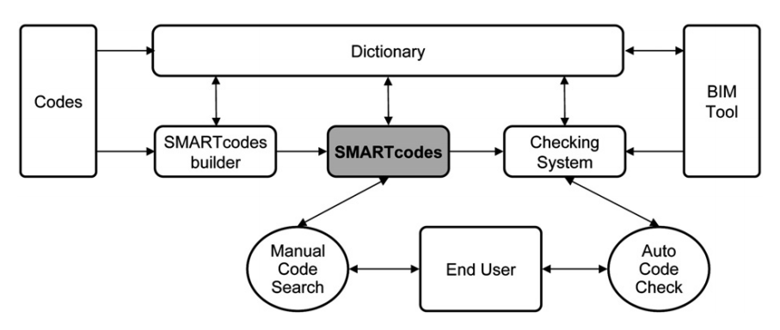

Figure 2 – BIM Framework for SMARTcodes (C. Eastman et al., 2009)

## 2.4 BUILDING INFORMATION MODELLING

Building Information Modelling (BIM) is one of the most promising developments in the architecture, engineering, and construction (AEC) industries. With BIM technology, one or more accurate virtual models of a building are constructed digitally. They support design through its phases, allowing better analysis and control than manual processes. When completed, these computer-generated models contain precise geometry and data needed to support the construction, fabrication, and procurement activities through which the building is realized. BIM also accommodates many of the functions needed to model the lifecycle of a building, providing the basis for new design and construction capabilities and changes in the roles and relationships among a project team. When adopted well, BIM facilitates more integrated design and construction process that results in better quality buildings at lower cost and reduced project duration(C. M. Eastman, 2011).

In a virtual digital environment, BIM simulates the construction process. BIM digitally / virtually constructs a 3D virtual / digital representation of the original building, which is called the BIM model. After completion, the Building Information Model has the accurate geometry and all the relevant data required for calculation, visualization, and other processes in various construction phases such as design, procurement, and manufacturing to realize the construction. It is important to note that BIM is not a specific software, making BIM models is a name of the process.

The Building Information Modelling (BIM) has recently become a current research territory in Architecture, Engineering and Construction (AEC) industry because of its emphasis on improving structure with computerized innovation, BIM stores building structure as a gathering of items with related properties (for example a divider that has a length, stature and material) and these models contain the three-dimensional geometry of the working just as the semantic data of the components and Innovative advances in BIM can help the procedure of computerizing the checking of construction regulations conformances since all the required information is available inside the BIM demonstrate (Ciribini et al., 2016).

A building data show illustrates the geometry, spatial connections, geographical data, quantities and properties of structural components, cost gages, inventories of materials and the construction sector's undertaking plan, which includes the BIM alternative construction process (Building Information Modelling), is growing rapidly all over the world as the linear projection and the building management structure could be considered as a model of a traditional construction process (Raninder Kaur Dhillon, Hardeep Singh Rai, 2017). In this model, it is conceivable to separate the projection, planning, implementation, and operation stages as shown in figure 3 and figure 4.

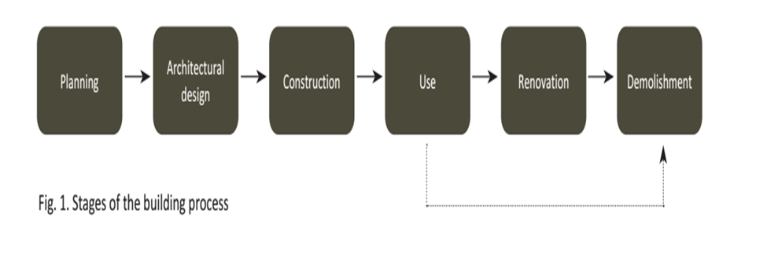

Figure 3 - Stages of Building Process (Ustinovičius et al., 2018)

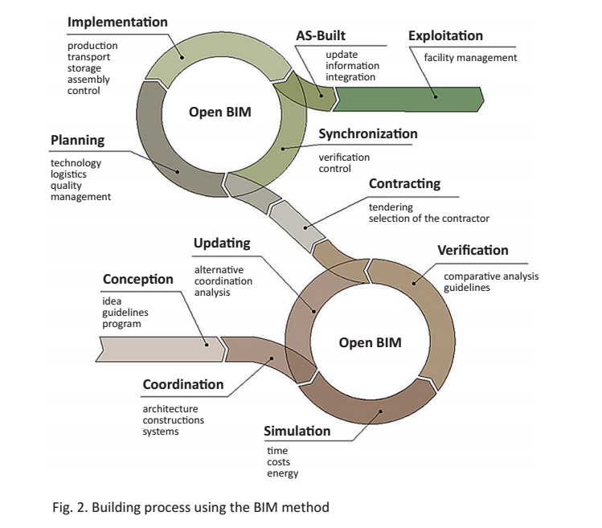

Figure 4 - Building process using the BIM method (Ustinovičius et al., 2018; Jung & Joo, 2011)

The construction process based on the BIM method is an irresistible cycle in which the locations of the construction process and the flow of evidence are prepared for a system of organizational activity at the same time (Leonas et al., 2018). It was determined that the use of BIM has obvious advantages, although it may be quite unaffordable for some users.

### **2.4.1 APPLICATIONS OF BIM**

A BIM model can be utilized for the several purposes as envisaged in a study (Azhar, 2011a). it is useful to for the visualization where 3 Dimensional renderings can be produced effectively and visualized easily. In normal model, shop drawings / models for different structure frameworks are very difficult to produce. However, once the BIM model is made, the metal sheet ventilation shop drawings can be delivered in no time. BIM model can alsobe used for audits of different structural components. Fire divisions and other building regulatory authorities may utilize these models for audit of structures. BIM is helpful in assessing costs of project. Material quantity is extracted and updated when any changes are made in the model for calculating cost. For all building components, a BIM design model can be used effectively to organize material requesting, making, and delivering plans. Since BIM data models are made to scale in 3-Dimensional space, every single real framework can be updated in a split second and consequently checked for clashes. For instance, it can check that MEP pipes does not cross with steel bars, conduits, electrical components, and dividers.

A BIM data model can be effectively adjusted to graphically clear potential disappointments, spills, clearing plans, etc. the facilities divisions can utilize it for remodels, space arranging, what's more, upkeep activities. The Information regarding every aspect of model is more effectively shared and can be updated and reused. Building recommendations can be dissected thoroughly, re-enactments can be performed efficiently and quickly, and execution can be benchmarked, empowering better and inventive arrangements. Ecological execution is progressively unsurprising, as well as better control of the cost of the lifecycle. The quality of design and documentation is better and well-integrated with the help of BIM model. In various procedures, digital item information can be reused and used to assemble auxiliary frameworks. From a client perspective, the proposals are better checked and managed by exact perception. All the information about structural, electrical, MEP components and other components is available with the model to be used throughout the usage and maintenance of Building. There are, however, several challenges in the BIM implementation in AEC industry. for instance, Umar (2022) classifies these challenges into four categories of (i) Organization, (ii) Technical”, (iii) Government and Legal, and (iv) Environment.

### 2.4.2 TECHNICAL BENEFITS

BIM offers a substantial specific development on customary CAD, which offers more control, more interoperability dimensions and knowledge. Computerized interpretation of both practical and physical qualities of an office empowers clients to share design structure information among software applications, both within the association / department and in a multidisciplinary environment more generally. Since data is stored in a BIM database, any changes in information required during the planning process can be consistently included and monitored throughout the project's life cycle. BIM was described as "the innovation in the production and management of a building's parametric model". It has additionally been referred as a developing multifaceted phenomenon with an object-oriented 3-Dimensional model of a building structure to authorize data exchange and interoperability (Ghaffarianhoseini et al., 2017). It has also been referred to as a multi-faceted development phenomenon with a 3-D object-oriented model of a building structure to allow data exchange and interoperability (Ghaffarianhoseini et al., 2017).

* **Data organization benefits**

BIM tools have empowered wide-ranging data related to the construction to be taken during the project, extending from specific construction components and spatial associations and connection between those items. BIM integrates construction data ranging from geometry, 3-D links, light examination, topographical information, material quantities and various properties of the material of the product building components, description, fire rating, furniture, textures, costs and total carbon content. These structures allow designers, engineers, and contractors to monitor connections and associations between building components and structural component maintenance details. While the designer / engineer understands the benefits of BIM, they could become apparent to other project shareholders such as owners, contractors, subcontractors, suppliers, fit-outs, assembly companies, etc. Furthermore, BIM can also be used indispensable for competence administration incorporation. If there are any changes in design, BIM tools can participate, assemble, and keep track of all changes for the capability / project with the design principles and all design layers. BIM tools offer interoperability chances in addition to the capability for appropriate integration, permitting inputs from various authorities and different BIM based software to come together to exchange information in the model.

* **Calibration benefits**

Standards for data exchange have been developed to fully allow BIM users to exchange ideas, associations, information, and models. These standards were created in the form of IFC which develops standards for data exchange for structure items was led by building SMART. It was a major step forward in the development of the BIM process. This was subsidized to allow and arrange interoperability between users of AEC BIM using different platforms by establishing standard design models that include rich semantic information and geometric component data. **Assimilation benefits**

BIM has recently gained acceptance amongst key players in Architecture construction industry for using as a substitute technique of design and construction. Similarly, BIM is expected to be operated for data integration to increase AEC teaching. BIM has formed to encourage the expanding complex nature of development projects, organized to encourage plan, development and maintenance of events through a synchronized procedure. It gives a community stage to all the partners associated with a task lifecycle in their respective field. Owners, inventors, provisional workers and development heads can use BIM to embrace development extends more effectively than any time in recent memory. BIM can also be utilized as a smart manual book for securely supervision and working the structure giving total office data, for example, physical building structure, Mechanical Electrical and piping, furniture as well as equipment. The BIM model can be utilized effectively for mated manufacture machines for pre-created steel or other constructing sections. Where a construction illustration relates to time, it is possible to rebuild the development procedure. BIM can be viewed as a key towards future of Design and Construction and upgrade of practicality housing and prudent constructions.

* **Financial ben**e**fits**

In addition, BIM has been recognized as having significant financial advantages. BIM customers have outlined the benefits of using BIM. BIM's most significant effect was to limit documentation errors. This has been tracked by using BIM as a business advertising device. Additionally, less staff turnover was observed as the current advantage of using BIM. Less legally binding cases and decreased cost of development are considered long-term benefits. Keeping up intermittent business with past customers is additionally a remarkable advantage of BIM. For structure, the 3-Dimensional BIM model will give a progressively rational observation of the plan. By improved joint efforts, a constant improvement between various plans controls can be accomplished, which essentially diminish building mistakes and errors. Any changes in the 3-Dimensional model can be produced quickly to 2-Dimensional illustrations. Financial assessments can be separated from the BIM model to keep all associated with it informed of the financial ramifications as the model develop.

### 2.4.3 BIM Model Categories

There are different kinds of models, and a few definitions are given in the script and by the standards bodies:

**Design Intent Model**

These models catch the expected plan and are utilized for task BIM execution, advanced structure mock-ups, special help, and coordination. The endorsed model is a contract description for submission to the administrator and for development. The amount, size, shape, area and outline of components are precise in this model; it contains one of a kind resource distinguishing proof numbers and integrates the Spatial Program model.

**Building Model**

Established from the Design Intent Model, these classically characterize a single structure framework made for the reasons for positioning, planning, organizing, manufacturing parts and executing development. Model components are precise and may integrate manufacture, assembly, itemizing, and non-geometric data.

**Management Model**

This is a complex model that incorporates various Design as well as Construction BIMs, enrolled spatially and utilized for the reasons for interfering checking (conflict finding), awareness and further BIM investigations within construction.

**As-Built Model**

These models catch the conditions toward the completion of development and should be dependent on the design intent model and progressively consolidate scheme data as development advances characterizes as-constructed models as "editable duplicate of the Record BIM that is continually refreshed to characterize to the current finished condition of the construction and frameworks setup (Motamedi, Iordanova, & Forgues, 2018).

### 2.4.4 CURRENT AND FUTURE TRENDS

• BIM clients spoke to all sections of the structure, development industry, and they worked all through the United States.

• The significant application zones of BIM were development archive improvement, calculated plan, support, and pre-project arranging administrations.

• The utilization of BIM brought down generally speaking danger dispersed with a comparative contract structure.

• At the term of the study, most organizations utilized BIM for 3-Dimensional and 4-Dimensional clash detection and conflict location.

• The utilization of BIM increased efficiency, better commitment of undertaking staff, and decreased possibilities.

• A deficiency was noted of capable structure data modelers in the development business, and research was started to develop in this area (Weng, Cheng, Kwong, Wang, & Chang, 2011).

## 2.5 AUTODESK REVIT

The only complete parametric Modelling software available today is Revit. It was originally created by U.S. based company PTC (Parametric Technology Corporation) which also created other popular software like FEM tool, Mathcad which are widely used in the engineering field Originally it was only built for architectural purposes, i.e., for architects it was built. Most people involved in its development are either architects or they come from a background in design and construction (Arkin & gregory, 2007).

Autodesk Revit Architecture was fabricated utilizing parametric structure demonstrating innovation, in which structures are spoken to as an incorporated database containing both graphical and non-graphical information as In impact, past graphically portraying the plan, BIM models in Autodesk Revit Architecture contains parameters that can be utilized to speak to construction regulation learning and can be consequently caught amid the structure procedure for supporting code consistence checking (Weng et al., 2011). In Revit, each building or structure segment is related with predefined parameters which are assembled into two classes: type parameters and occurrence parameters. The sort parameters control all components of the equivalent type while the case parameters control chose or made examples of the sort and occasion parameters are additionally ordered into various gatherings, so all parameter can be put away in various arrangements such as: content, whole number, number, length, territory, volume, edge, URL, material, and some new parameters speaking to the information in construction standards can be made and put away as venture parameters which can be utilized to decide the code consistence of a structure part (Weng et al., 2011).

Now Revit is used as a Building Information Modelling Software for engineers, architects, designers and contractors developed by the Autodesk. It allows user to develop a 3D model of a building and structure, annotate it using the 2D drafting components, and access the building information from the building’s model database. It can also be used to plan and track changes during various stages of construction such as planning, designing, executing, maintenance and later demolishing. It can be used for architectural, structural and MEP designing of a building.

### 2.5.1 REVIT ARCHITECTURE

The design made on the Revit architecture is only for architectural purposes. It is not applicable for structural analysis and other analysis which based on structural design. The architectural components are doors, windows, architectural columns, openings, stairs, and floors. Energy analysis can also be done on architectural design.

### 2.5.2 REVIT STRUCTURE

Revit structure is used to design the structural model for the building. Main components of structural model are beams/girders, columns, footings, and reinforcements etc. Structural analysis can be done on structural model.

### 2.5.3 REVIT MEP

MEP is an abbreviation of Mechanical, Electrical and Plumbing. It is a powerful tool of Autodesk Revit which is used in the designing of electrical/power, plumbing, drainage, and HVAC (heat ventilation and cooling) systems for the building.

## 2.6 VISUAL PROGRAMMING

The designer intents always to thrive for more sophisticated building geometries. The ongoing development in CAD (Computer Aided Design) helps the designer overcome the restrictions and use the knowledge of computer programming to its best to make the most sophisticated building designs a reality e.g., through the use of conditional statements and loops in parametric BIM. As the building designers have no substantial knowledge of the traditional programming or code writing so a visual programming languages and platforms had been introduced. Visual programming allows for a simplified and user-friendly way of replacing the traditional difficult code writing process with a visual metaphor of small blocks with different functionalities across a system or procedure. With visual programming computer programs can be manipulated graphically rather than textually code writing. Several surveys show that non-programmers or novice programmers better understand the visual programming instead of traditional programming (Bergin & Yan, 2015).

Grasshopper and Dynamo are both based on visual programming language (Python) and create numerous opportunities for designers using Rhino or Revit. In this study Autodesk Revit and Dynamo has been used having some differences form grasshopper. Some of benefits of Dynamo are (DynamoPrimer, 2016);

* **Customize Revit**

Dynamo lets user build automation routines for Revit without learning the Revit API (Application Programming Interface) which is difficult. This opens up many opportunities for Revit users to customize their workflow without learning a lot.

* **Control model Information**

The building information modelers often say that the real power of the Revit is not just geometry creation but how the model information can be tracked and controlled, and Dynamo does this job very well. It lets the user design systematic relationships for manipulating parameters and model elements that would otherwise be impossible with Revit built-in tools.

* **Design with BIM**

There is often a misconception with BIM that it is only for production, not designing. But with Dynamo this misconception is proved inaccurate. It allows the designers various iterative tools in the context of BIM.

## 2.7 DYNAMO

Dynamo is the Autodesk Revit API (Application programming interface) that allows users to create custom tools and plugins and add them to the Revit's integrated features. A number of visual programming software that includes Maya Hypergraph, LEGO MINDSTORMS NXT, which is based on National Instruments LabVIEW, influences the user interface and feel of dynamo. As a parametric modelling program, it takes inspiration from McNeel's Grass-hopper for Rhino and the Generative Components of Bentley. It is designed to take the parametric modelling capabilities of Revit to the next level by adding certain levels of associativity of data and geometry that is not available in the Revit functionalities e.g., driving parameters based on external inputs or analysis. One can map the required parameters and change its value dynamically based on input source. (Kensec, 2014)

Dynamo was used for a number of applications, including the connection between the Arduino board, a light sensor, and the information model for building. It was also used for various other applications as a general purpose interface for Revit e.g. creating/making Revit sheets and view layouts, it has also a potential use for fabrication of architectural components, making virtual automated shading devices, extracting solar radiation values and Changing Revit parametric geometry by manipulating a value slider in the Dynamo. (Kensec, 2014)

### 2.7.1 THE ANATOMY OF DYNAMO

Dynamo is a visual programming language tool, and the operations of data is executed by nodes and wires in the dynamo workspace. The nodes perform a function. The function or task which the node can execute can be very simple as adding two numbers or as complex as creating complex geometry. The language used for scripting the nodes is python. With some exceptions, majority of nodes are composed of the following five parts:

1. Name of the Node.
2. Main Body: Right clicking here presents options at the level of whole node.
3. Input and output ports: Wires are connected through these ports.
4. Data preview: Results executed from the node can be viewed.
5. Lacing Icon: Indicates lacing option specified for matching list.

Connecting two nodes is simple as clicking on the output port of one node (a connecting wire will originate) and then clicking on the input port of the other node. Make sure to connect the right input with the node otherwise feeding the wrong input or data type will generate errors. The wires connecting the nodes transfer data like the electrical cables that transfer power.

## CHALLENGES ASSOCIATED WITH EXISTING AUTOMATION TOOLS

Derived from the existing literature, the automation tools face several challenges and limitations. For instance, automation tools often require a significant learning curve to understand and use effectively. They can have complex interfaces, scripting languages, or workflows, making them challenging for non-technical users (Tsafnat et al., 2014). Likewise, some automation tools are designed for specific tasks or workflows and may not provide the flexibility to automate diverse processes. Adapting them to unique or complex scenarios can be difficult or require custom development (Vogel-Heuser et al., 2014). Many automation tools are built to work with specific software or systems, making it challenging to integrate them with other tools or legacy systems. This can create silos and hinder end-to-end automation (Christensen et al., 2021). Automation tools may be platform-dependent, meaning they only work on specific operating systems or environments. This restricts their usage and can be a barrier for organizations with diverse IT infrastructure (Gorwa et al., 2020). As technologies evolve, automation tools require ongoing maintenance and updates to stay compatible and secure. However, updating automation tools can sometimes be disruptive, requiring downtime and reconfiguration (Mäder and Gotel, 2012). Automated processes can be fragile and prone to errors, especially when unexpected situations or changes occur. Proper error handling and exception management can be challenging to implement, leading to unreliable automation (Mundada et al, 2022). Some automation tools may struggle to handle large-scale or enterprise-wide automation needs. They might have performance limitations or lack features like load balancing, resource management, or distributed processing (Bender et al., 2018). Ng et al. (2021) suggest that most automation tools are rule-based and lack cognitive abilities like natural language understanding, context awareness, or decision-making. This restricts their ability to handle complex tasks that require human-like intelligence. Almorsy et al. (2013) argued that automation tools may introduce security risks if not properly configured or monitored. Unauthorized access, data breaches, or compliance violations can occur if automation workflows are not adequately protected. Finally, as noted by Shemilt et al. (2019) some automation tools can be expensive, especially those designed for enterprise-level automation. Licensing models, such as per-user or per-transaction fees, can make them cost-prohibitive for small or medium-sized businesses. A framework developed for automated code compliance checking through BIM based visual programming should be able to address these challenges.

# 3. METHODOLOGY

The methodology adopted to develop an automated system for the compliance checking of building structures include both quantitative and qualitative approaches (Umar, 2021). The key steps involved the research approach include the review of the existing literature to find the problems in the existing code compliance and then confirmed these problems with the CDA officials through semi structured interviews (15 numbers) in the context of Pakistan (Umar, 2022). Similar research approaches were adopted by Ozarisoy and Altan, (2023) and Ozarisoy (2022) in their research related to energy effectiveness and retrofitting of high-density residential buildings. The criteria used for the selection of CDA officials was that they must have a rank of deputy director with at least 10 years of total experience after graduation and a minimum experience of 5 years after attaining the rank of deputy director. They must have a recognized degree in Civil Engineering or allied disciplines. The specific building bylaws that govern the CDA was then selected. Later codes were created through visual programming and the bylaws was translated to these codes. This was tested on several BIM models, which include report generation and web portal creation. The system was then used by a group of selected employees (10 numbers) and applicants (customers) (10 numbers). They employees for the interviews must be the one who are directly involved in the process of building plans compliance and approval with a minimum of 10 years relevant experience. the applicants (customers) where those who required the approval of their building plans from the CDA. All the participants were explained the aims and objectives of the research and their willingness were obtained before their participation in the interviews.

Relevant data was collected from Capital Development Authority about the manual code compliance checking process. As mentioned earlier, fifteen officials were interviewed to have a clearer image of the process. After understanding the process of the manual code compliance checking as shown in figure 5, the selection of the byelaws was done. The Byelaws chosen were the Islamabad Residential Sectors Zoning (Building Control) Regulations (CDA, 1993).

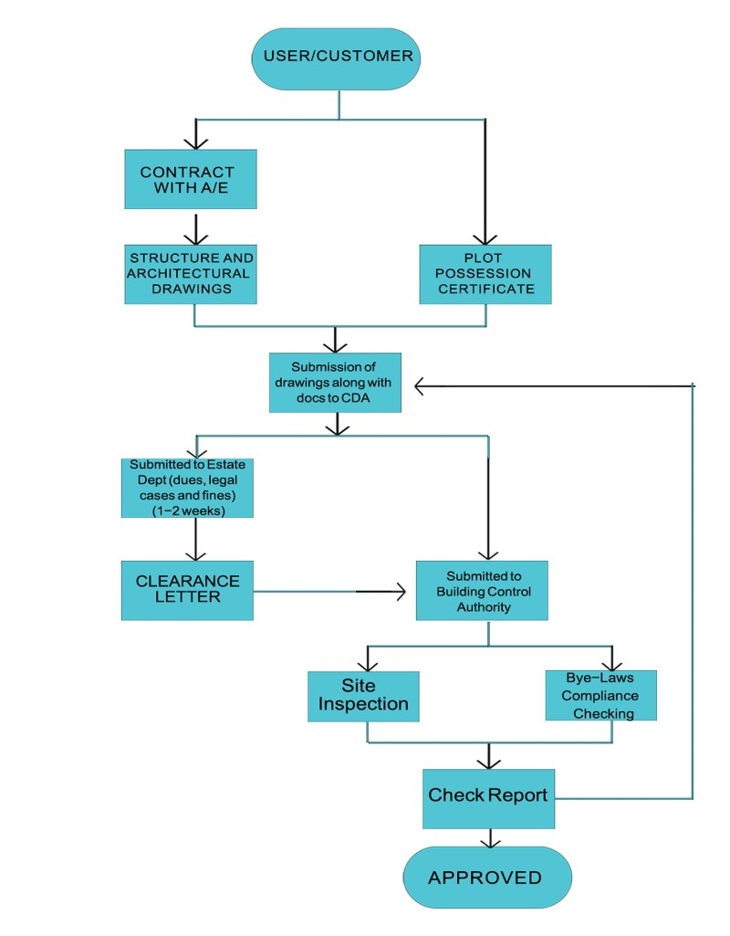

Figure 5 - Manual code compliance checking process

The first step of the automated code compliance is the BIM model. After the creation of an automated BIM code compliance process, the BIM Model open in Autodesk Revit and the Dynamo framework was run. Assuming that the 3D Model is a complete model i.e., it has defined names, areas, tags, categories, dimensions, property line and fixed boundaries etc., dynamo will extract data from the BIM model i.e., its features, specifications, and the dimensions as demonstrated in figure 6.

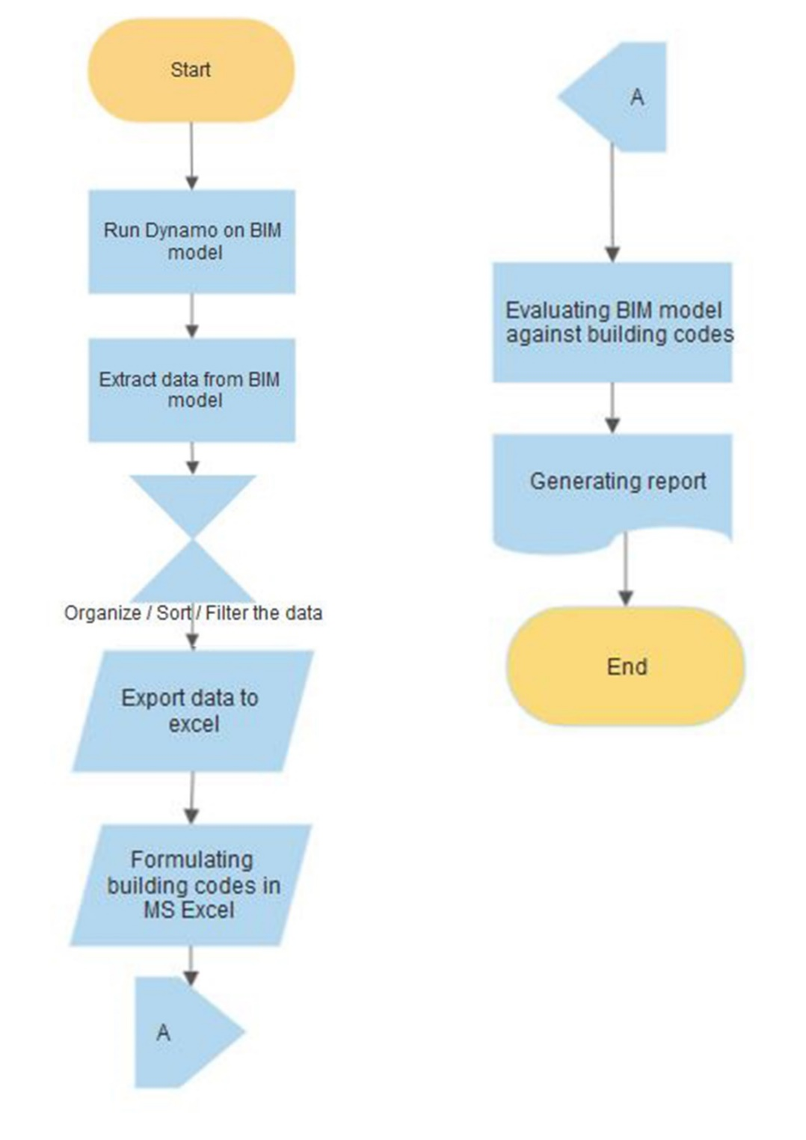

Figure 6 - Workflow of Creating code through Visual programming

Since, a typical BIM model has a lot of mixed-up data stored in it, but that jumbled up data is of no use in that form. So, the data extracted from the model is then organized, sorted and filter using nodes such as List, Transpose and Select etc. The sorted and organized data is exported to excel where the further process of compliance checking is done as shown in figure 7 (a, b, and c).

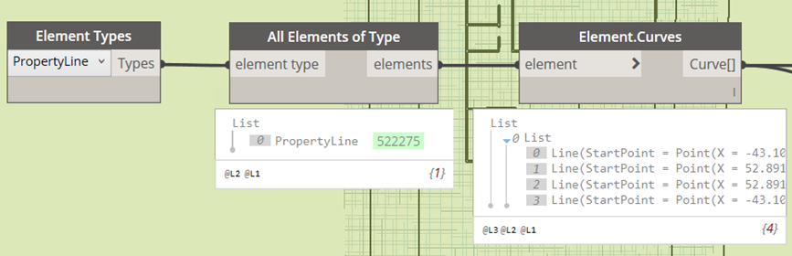

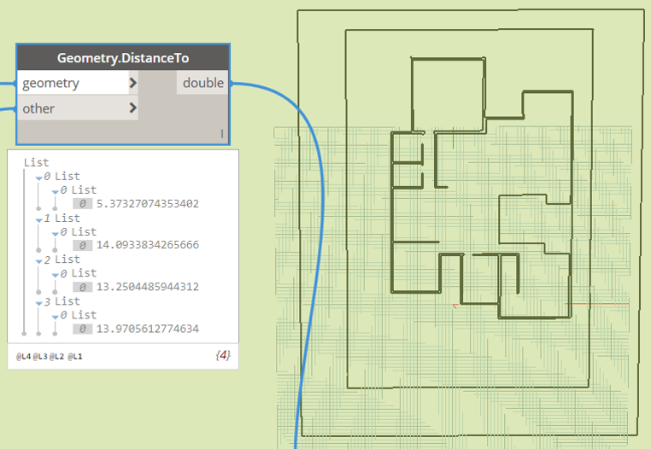

Figure 7 a: Extracting Data from BIM Model

Figure 7 b: Organizing and Filtering Data from BIM model  Figure 7c: Result after Calculations

For the process of compliance checking, formulae are made in MS excel and the Revit model specifications are checked against the CDA bylaws. Basically, the bylaws are converted into a form that is comparable with the extracted data. After the data is exported to the excel file, it is organized under the column of “Actual Values”. Another column is made under the title “Code Values” in which values from the Bylaws are added. These two columns are then compared using certain self-made formulas. The Revit model specifications are checked against the CDA bylaws. Which will tell us that what features comply with the specifications, and which do not.

After the compliance checking, whether the model is compliant or not, a report will be generated which would include all the details of the specifications and would include the dimensions or specifications which are compliant and the ones which are not. If the model is not compliant, a review report will be generated which will be sent to the user to perform the required changes. If the model is compliant then a final report will be generated consisting of the Assistant Director and Deputy Director Building Control Authority’s signature.

## 3.1 Service Delivery Management System

The proposed process as shown in figure 8, first, the user has to register himself at the CDA portal by creating an account. This will personalize the access only to the specified user and ensure the privacy. After that the user will submit the BIM model on the portal. The data from the sign-up page will be stored in the CDA database for further use. The CDA authorities will check for the specifications of the plot or model and after the concerned approval the documents will be cleared for further processing. If the model is not accepted or documents are not cleared, then the model will be handed back to the client. After the approval and clearance of the model, CDA will run compliance checker on the model to check for that the model is according to the required specifications or not. After the compliance checking, whatever the results are whether the model is compliant or not a report will be generated which would include all the details of the specifications and would include the features which are compliant and the ones which are not. The report copy will be then submitted to the client so as he can look out for the modifications.

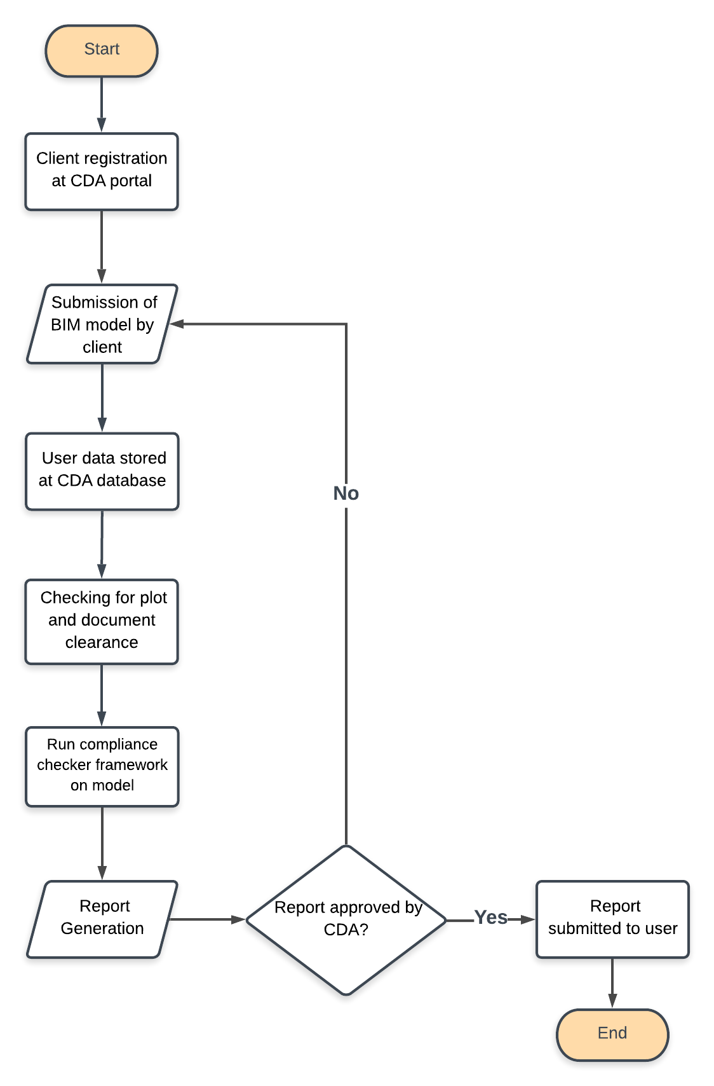

Figure 8 - Workflow of Service Delivery Management System

# 4. RESULTS AND ANALYSIS

To identify the problems, present in existing code compliance checking process, literature was studied, and a field survey was done. PRISMA guidelines are observed while doing the literature review (Umar, 2021-b). After using all the criteria and compliance, a total of 12 research papers were used that include Cornelius Preidel and Andre Borrmann, 2015; Charles S. Han et al., 1997; David Greenwood et al., 2010; Johannes Dimyadi and Robert Amore, 2013; Jonathan Reinhardt and Malachy Mathews, 2017; Cornelius Preidel et al., 2017; Sagar Malsane et al., 2014; A. Fatima et al., 2015; Tala Kasim, 2015; Tang-Hung Nguyen and Jin-Lee Kim, 2011; C. Eastman et al., 2009; and Vito Getulia et al., 2017. The key problems with current buildings codes compliance arrived from these papers include cost, delays, time consuming, error prone, laborious, inconsistencies in interpretation, iteration, ambiguous, cumbersome, uncertainties, unreliable, inconsistent, and wrong execution. The interview process with the CDA officials also confirmed these problems. For the purpose of creating Automated Code Compliance checking process several BIM models of residential buildings (an example shown in figure 9) were created using Autodesk Revit and used for testing of automated code compliance process. The final result of compliance checking process was developed spreadsheet program for which Macros were developed for easy printing the whole report (figure 10).

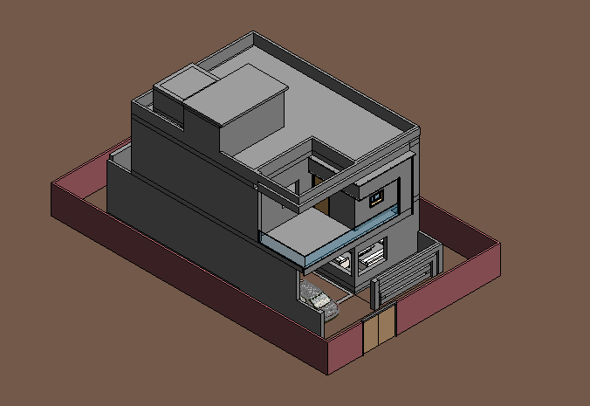

(a)



(b)

Figure 9: (a) BIM model of Residential Building (b) Result after Calculations

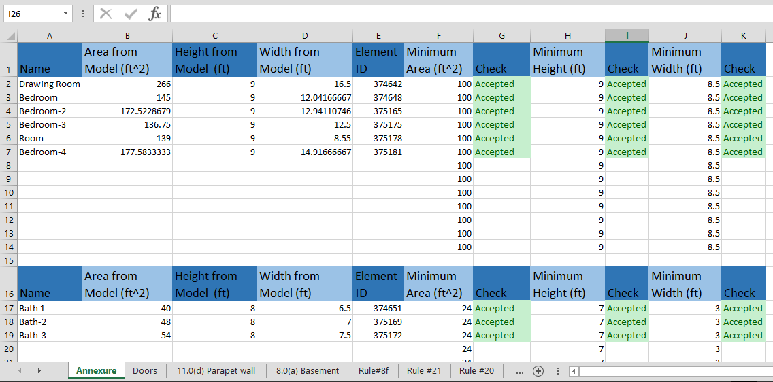

Figure 10: Report of Complete BYE-LAWS

For the purpose of efficient and time saving service delivery management system XAMPP database management and PHP programming language were used. Using this user can sign up easily on CDA website and submit his BIM model for compliance checking and receive the results on the same portal for which the notifications can be sent to their email address and mobile phone which they need to provide during the registration process. Finally, the views CDA customers (10 numbers) and the relevant staff (10 numbers) on this new system developed was obtained in the form of interviews after their experience with the system. While most of the feedback were positive, some minor modifications were made in the process considering their feedback. While majority of the participants (the CDA customers) appreciated the reduction in time to process their proposed building plans, however, they raised the concern about the additional cost the customers need to pay of development of the BIM model of their plan. With the manual system, the customers only need to submit the sets of 2D drawings which is obviously can be cheaper than the development of complete set of BIM model. The manual process normally takes a week time for code compliance, but it can be completed within a day through the new programme developed in this research. The actual checking process or in other words the code compliance process basically do not take more than 10 minutes. The remaining time which was on average 6 hours was mainly consumed in the administrative process. Overall, the automated building codes checking process help a lot in reducing the use of resources even can if it takes 6 hours compared to the manual system which take a week time. The new system of the code compliance was also demonstrated to the top officials of the CDA and Ministry of Science and Technology and was well appreciated. It is expected that such technological innovation can bring several positive changes in the developing countries like Pakistan which is currently struggling in several areas including the United Nations Sustainable Development Goals (UN SDGs, 2015) where the country is not on track to achieve these goals by 2030. There are particularly major challenges with goal 9 (industry innovation and economic growth) and the progress in progress in stagnating (Sachs et al, 2022).

# DISCUSSION AND CONCLUSION

The purpose of this research was to develop an Automated Building code compliance checking process for local authority, the CDA in Pakistan. Currently, there is a manual system in placed which has different drawback. The typical disadvantages of the manual compliance system were delivered through the extensive review of the existing literature and then confirmed by the semi-structured interviews held with 15 officials of the CDA. These disadvantages include cost, delays, time consuming, error prone, laborious, inconsistencies in interpretation, iteration, ambiguous, cumbersome, uncertainties, unreliable, inconsistent, and wrong execution. The interview process with the CDA official also helped to understand the current manual process of the building code compliance and the requirement of the requirement of building bylaws Islamabad Residential Sectors Zoning (Building Control) Regulations enforced in the Capital of Pakistan “Islamabad”. The CDA is responsible of the enforcement of building regulations in Islamabad. The first step of the automated code compliance is the creation of BIM model which should have defined names, areas, tags, categories, dimensions, property line and fixed boundaries etc. The compliance process involves the use of Autodesk Revit and the Dynamo framework which extract data from the BIM model i.e., its features, specifications, and the dimensions. For the process of compliance checking, formulae are made in MS excel and the Revit model specifications are checked against the CDA applicable bylaws. After the compliance checking, whether the model is compliant or not, a report will be generated which would include all the details of the specifications and would include the dimensions or specifications which are compliant and the ones which are not. If the model is not compliant, a review report will be generated which will be sent to the user to perform the required changes. Since, this a new system developed for the CDA concerned staff and its customers, it was validated through the interview process with the CDA concerned employees and their relevant customers. The new system of the code compliance can help to reduce the time required for a typical house plan from one week to six hours. The actual time which the programme take is just few minutes, the remining time is required for the administrative process. While the feedback from both the parties were positives, some minor changes recommended were incorporated to the system. While the customers did appreciate the new process with the main advantage of reducing the time requirement and other clerical procedure, they did raise the concern of the excessive cost the customers will need to bear in the form of development of BIM model of their proposed plan. In the manual process, the customers only required to submit the set of 2D drawings, but with the new system, they will be required to submit a complete BIM model which will incur an excessive cost. Since, the CDA overall cost in building plan compliance and checking will reduce, they can transfer that benefit to its customers by reducing the administrative fee for the building plan approval. The new system will also help to create new employment as BIM experts will be required to develop all the new building plans that require approval from the CDA. Pakistan is one of the developing countries in South Asia which has significant challenges with several goal of the United Nations Sustainable Development Goal including goal 9 (industry innovation and economic growth). Such initiative can help Pakistan to excel it performance in industry innovation and can pave the road toward economic growth. One of the key limitations of this research is that the final feedback on the framework is obtained from a limited number of the customers (10) which appears too small to arrive on a concrete conclusion. Ideally, feedback should be a continuous process and any customer using the system/ the new framework should be given a chance to provide feedback on the effectiveness of the system. While the findings of the research provide clear benefits of the new automatic building code process but since, the data used in this research was based on the small number of size and BIM models, the project is now required to be implemented on trial bases so that a large set of data can be collected, and the performance of the process can be evaluated. Since, the compliance of building regulation in a major issue in many countries particularly, in developing, world, the findings of this paper along with the proposed framework will be useful for many countries to benchmark with their own system, adopt this framework for their code compliance or make necessary changes to their own system to make it more effective.

# REFERENCES

Abbas, A., Din, Z.U. and Farooqui, R., 2016. Integration of BIM in construction management education: an overview of Pakistani Engineering universities. Procedia Engineering, 145, pp.151-157.

Abdullah, H., Haroon, Mamoon. (2013). Bim Based Analysis of a Multi-Story Building And Estimation Of Service Life Of Building Components. Retrieved from

Arkin, & gregory. (2007). The history of Revit - the future of Design.

Asim, M., Gulzar, S., Ali, M.M. and Shirwani, R.K., 2017. Study on Impediments and Success of building Byelaws Implementation in Lahore, Pakistan. Journal of Research in Architecture and Planning, 22.

Azhar, S. (2011a). Building Information Modeling (BIM): Trends, Benefits, Risks and Challenges for the AEC Industry.

Azhar, S. (2011b). Building information modeling (BIM): Trends, benefits, risks, and challenges for the AEC industry. Leadership and management in engineering, 11(3), 241-252.

Bender, M., Henke, N. and Lamarre, E., 2018. The cornerstones of large-scale technology transformation. McKinsey Quarterly, 4, pp.39-52.

Bergin, M. R. A. M., & Yan, A. M. W. (2015). BIM based Parametric Building Energy Performance Multi-Objective Optimization.

Christensen, M., Yunker, L.P., Shiri, P., Zepel, T., Prieto, P.L., Grunert, S., Bork, F. and Hein, J.E., 2021. Automation isn't automatic. Chemical Science, 12(47), pp.15473-15490.

Ciribini, A., Ventura, S. M., & Paneroni, M. (2016). Implementation of an interoperable process to optimise design and construction phases of a residential building: A BIM Pilot Project. Automation in construction, 71, 62-73.

Dimyadi, J., & Amor, R. (2013). Automated Building Code Compliance Checking - Where is it at?

DynamoPrimer. (2016). The Anatomy of Dynamo.

Eastman, C. M. (2011). BIM handbook : a guide to building information modeling for owners, managers, designers, engineers and contractors (2. ed.). Hoboken, NJ: Wiley.

Eastman, C., Lee, J.-m., Jeong, Y.-s., & Lee, J.-k. (2009). Automatic rule-based checking of building designs. Automation in construction, 18(8), 1011-1033.

Gazder, U. and Khan, R.A., 2018. Effect of organizational structures and types of construction on perceptions of factors contributing to project failure in Pakistan. Mehran University Research Journal of Engineering & Technology, 37(1), pp.127-138.

Ghaffarianhoseini, A., Tookey, J., Ghaffarianhoseini, A., Naismith, N., Azhar, S., Efimova, O., & Raahemifar, K. (2017). Building Information Modelling (BIM) uptake: Clear benefits, understanding its implementation, risks and challenges. Renewable and Sustainable Energy Reviews, 75, 1046-1053. Retrieved from http://www.sciencedirect.com/science/article/pii/S1364032116308413. doi:https://doi.org/10.1016/j.rser.2016.11.083

Gorwa, R., Binns, R. and Katzenbach, C., 2020. Algorithmic content moderation: Technical and political challenges in the automation of platform governance. Big Data & Society, 7(1), p.2053951719897945.

Harati-Mokhtari, A., Wall, A., Brooks, P. and Wang, J., 2007. Automatic Identification System (AIS): data reliability and human error implications. The Journal of Navigation, 60(3), pp.373-389.

Hardin, B., & McCool, D. (2015). BIM and construction management: proven tools, methods, and workflows: John Wiley & Sons.

Haseeb, M., Bibi, A. and Rabbani, W., 2011. Problems of projects and effects of delays in the construction industry of Pakistan. Australian journal of business and management research, 1(5), pp.41-50.

Jung, Y., & Joo, M. (2011). Building information modelling (BIM) framework for practical implementation. Automation in construction, 20(2), 126-133. Retrieved from http://www.sciencedirect.com/science/article/pii/S0926580510001391. doi:https://doi.org/10.1016/j.autcon.2010.09.010

Kensec, K. M. (2014). Integration of Environmental sensors with BIM: case studies using Arduino, Dynamo and the Revit API.

Leonas, U., Arūnas, P., Jovita, S., Mantas, V., Oksana, Č., & Robertas, K. (2018). Challenges of BIM technology application in project planning. Engineering Management in Production and Services, 10(2), 15-28. Retrieved from https://content.sciendo.com/view/journals/emj/10/2/article-p15.xml. doi:https://doi.org/10.2478/emj-2018-0008

Mäder, P. and Gotel, O., 2012. Towards automated traceability maintenance. Journal of Systems and Software, 85(10), pp.2205-2227.

Malsane, Sagar & Matthews, Jane. (2010). Automated compliance checking using building information models.

Masood, R., Kharal, M.K.N. and Nasir, A.R., 2014. Is BIM adoption advantageous for construction industry of Pakistan?. Procedia Engineering, 77, pp.229-238.

Motamedi, A., Iordanova, I., & Forgues, D. (2018). FM-BIM preparation method and quality assessment measures.

Mpofu, M. and Hlatywayo, C.K., 2015. Training and development as a tool for improving basic service delivery; the case of a selected municipality. Journal of Economics, Finance and Administrative Science, 20(39), pp.133-136.

Mundada, P.S., Barbosa, A., Maity, S., Stace, T.M., Merkh, T., Nielson, F., Carvalho, A.R., Hush, M., Biercuk, M.J. and Baum, Y., 2022. Experimental benchmarking of an automated deterministic error suppression workflow for quantum algorithms. arXiv preprint arXiv:2209.06864.

Nguyen, T.-H., & Kim, J.-L. (2011). Building code compliance checking using BIM technology. Paper presented at the Proceedings of the 2011 Winter Simulation Conference (WSC).

Ozarisoy, B. and Altan, H., 2023. Handbook of Retrofitting High Density Residential Buildings: Policy Design and Implications on Domestic Energy Use in the Eastern Mediterranean Climate of Cyprus. Springer Nature.

Ozarisoy, B., 2022. Energy effectiveness of passive cooling design strategies to reduce the impact of long-term heatwaves on occupants’ thermal comfort in Europe: Climate change and mitigation. Journal of Cleaner Production, 330, p.129675.

Reinhardt, J., & Mathews, M. (2017). The Automation of BIM for Compliance Checking: a Visual Programming Approach.

Sachs, J., Lafortune, G., Kroll, C., Fuller, G. and Woelm, F., 2022. From Crisis to Sustainable Development: the SDGs as Roadmap to 2030 and Beyond. Sustainable Development Report 2022. Cambridge: Cambridge University Press. See: https://dashboards.sdgindex.org/ (accessed 27/09/2022).

Scott, E., 2005. Managing municipal police training programs with limited resources. Police Chief, 72(10), p.40.

Shemilt, I., Arno, A., Thomas, J., Lorenc, T., Khouja, C., Raine, G., Sutcliffe, K., Preethy, D.S., Kwan, I., Wright, K. and Sowden, A., 2021. Cost-effectiveness of Microsoft Academic Graph with machine learning for automated study identification in a living map of coronavirus disease 2019 (COVID-19) research. Wellcome Open Research, 6, p.210.

Solihin, W., & Eastman, C. (2015). Classification of rules for automated BIM rule checking development. Automation in Construction, 53, 69-82. Retrieved from http://www.sciencedirect.com/science/article/pii/S0926580515000370. doi:https://doi.org/10.1016/j.autcon.2015.03.003

Stack, K.M., 2012. Interpreting regulations. Mich. L. Rev., 111, p.355.

Tan, X., Hammad, A., and Fazio, P. (2010) ‘Automated Code Compliance Checking for Building Envelope Design’, Journal of Computing in Civil Engineering, 24 (2), pp. 203-211.

Tsafnat, G., Glasziou, P., Choong, M.K., Dunn, A., Galgani, F. and Coiera, E., 2014. Systematic review automation technologies. Systematic reviews, 3, pp.1-15.

Umar, T. (2022), "Challenges of BIM implementation in GCC construction industry", Engineering, Construction and Architectural Management, Vol. 29 No. 3, pp. 1139-1168. https://doi.org/10.1108/ECAM-11-2019-0608.

Umar, T., 2021-b. Key factors influencing the implementation of three-dimensional printing in construction. Proceedings of the Institution of Civil Engineers-Management, Procurement and Law, 174(3), pp.104-117. https://doi.org/10.1680/jmapl.19.00029.

Umar, T., 2022. Challenges of BIM implementation in GCC construction industry. Engineering, Construction and Architectural Management, 29(3), pp.1139-1168.

Umar, T., 2022. The impact of COVID-19 on the GCC construction industry. International Journal of Service Science, Management, Engineering, and Technology (IJSSMET), 13(2), pp.1-17.

UN SDGs (United Nations Sustainable Development Goals), 2015. About the Sustainable Development Goals. United Nations, New York, United States. See: https://www.un.org/sustainabledevelopment/sustainable-development-goals/ (accessed 23/08/2022).

Ustinovičius, L., Puzinas, A., Starynina, J., Vaišnoras, M., Černiavskaja, O., & Kontrimovičius, R. (2018). Challenges of BIM technology application in project planning. Engineering Management in Production and Services, 10(2), 15-28.

Vogel-Heuser, B., Diedrich, C., Fay, A., Jeschke, S., Kowalewski, S. and Wollschlaeger, M., 2014. Challenges for software engineering in automation. Journal of Software Engineering and Applications, 2014.

Weng, S.-J., Cheng, B.-C., Kwong, S. T., Wang, L.-M., & Chang, C.-Y. (2011). Simulation optimization for emergency department resources allocation. Paper presented at the Proceedings of the Winter Simulation Conference.