Ten Years of I-Docs: a reflective discussion on polyphony and practice-led research
Dr. Judith Aston

Abstract
This article is based on my keynote and accompanying workshop for the inaugural StoryBits conference in April 2021. This was ten years on from the first i-Docs symposium in March 2011, with the StoryBits conference taking a similar approach in relation to bringing practice and research-based projects into productive dialogue. My reflections are based on the deeply collaborative endeavour that lies at the heart of i-Docs, in which there has always been a shared interest in the multiple, in non-linearity and in the evolving practices of documentary making. The article considers some key themes which have emerged from my work and considers how these might feed into future collaborative ventures, between i-Docs, StoryBits and beyond. In particular, I offer some insights around practice-led research, approaches to complexity, and my ongoing work with polyphonic documentary and database narrative.

Keywords
StoryBits, i-Docs, immersive, interactive, intertwingled, intra-active, polyphonic documentary, database narrative

Introduction
This article is based on my keynote and accompanying workshop for the inaugural StoryBits conference in April 2021. This was ten years on from the first i-Docs symposium in March 2011, with the StoryBits conference taking a similar approach in relation to bringing practice and research-based projects into productive dialogue. The thematic approach is similar too, placing issues relating to interactivity, immersion and evolving approaches to narrative at the heart of this dialogue. Given this, it feels like a good moment to reflect some more on key themes which have emerged from my work with i-Docs and to consider how these might feed into future collaborative ventures, between i-Docs, StoryBits and beyond.

This is in the context of i-Docs having moved into a new phase in which we are no longer convening bi-annual symposia but are instead looking to collaborate with other like-minded bodies in a more ongoing way through our i-Docs Community Conversation series and other such initiatives. Whilst I do not have the space here to include everything that I covered in my keynote and workshop, my aim is to give an overview of the key issues and themes that I raised and that were picked up in the ensuing discussions.

Figure 1
StoryBits Conference 2021, UBI/LABCOM
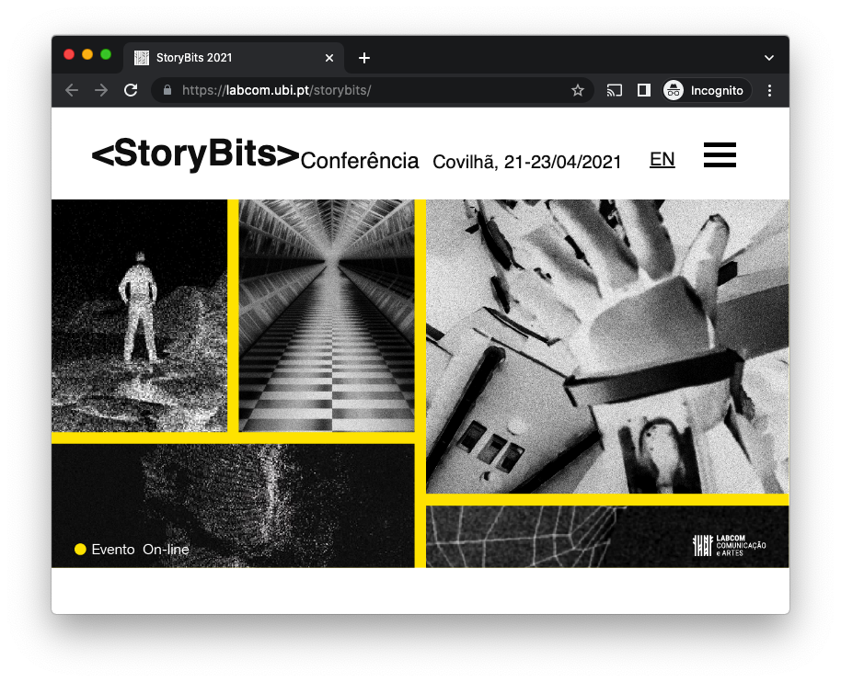
Note. StoryBits conference homepage (https://labcom.ubi.pt/storybits/)

My intention is that this will serve as a starting point for further enquiry. Whilst my reflections are based on the deeply collaborative endeavour that lies at the heart of i-Docs, in which there has always been a shared interest in the multiple, in non-linearity and in the evolving practices of documentary making, I am at the same time applying my own particular experience and analytical lens to these reflections. This builds on my multidisciplinary work as a geographer, anthropologist, documentary maker and interaction designer.

I will begin with some thoughts on the thinking about interactive documentary that led to the establishment of the i-Docs symposia. As part of this, I will discuss the core principle of theorising through practice. I will also explain why we subsequently opened up the ‘i’ in i-Docs to put interactivity into dialogue with other terms such as immersion, intervention, intra-action and Ted Nelson’s concept of intertwingularity, which addresses the complexity of interrelations in human knowledge. I will then offer my personal take on what I think is important to focus on as we go forwards across i-Docs, StoryBits and beyond. I will offer some insights around approaches to complexity and I will reflect on my ongoing work with i-docs and polyphony.

The inception of i-Docs

i-Docs is a research group based in the Digital Cultures Research Centre at the University of the West of England in Bristol, which I co-founded in 2010. Between 2011 and 2018 we ran a series of five international symposia which brought scholars, media artists and industry practitioners together to discuss the impact of emerging digital technologies on evolving forms of documentary practice. We are no longer convening these symposia, although we did have one fully planned for 2020 prior to its disruption by COVID.

Instead, we are working on collaborative ventures with like-minded colleagues on a more rolling basis. The impact of COVID has made this possible, as there is more scope now for ongoing conversations with colleagues from different continents, which involve less travel and more scope for inclusivity. We had been grappling with this anyway, in our efforts to make i-Docs 2020 a climate aware event with possibilities for greater inclusivity through remote participation, this being for us one of the more positive outcomes of the pandemic.

At their inception in 2011, the i-Docs symposia were focused on ways in which computers could be used to engage with complexity through the creation of multiple pathways through databases of curated documentary content. The symposia reflected on how this was leading to the emergence of a plethora of new forms and platforms which were challenging the hegemony of uni-sequential presentational formats of documentary film, as traditionally seen in the cinema or on television.

Figure 2
i-Docs website
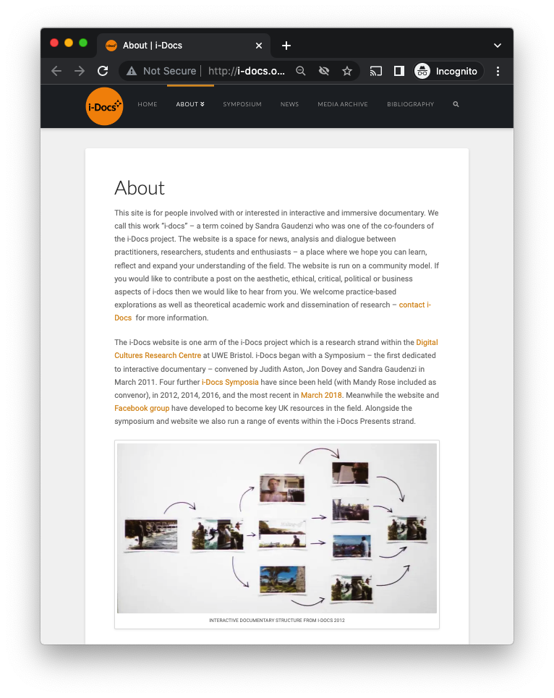
Note. I-Docs website, ABOUT I-DOCS page (http://i-docs.org/about-interactive-documentary-idocs/)

In 2011 the web-doc was very much the latest thing within the documentary film industry in relation to new platforms. There was much interest in how this might affect modes of production, leading to a desire for documentary makers to learn more this emerging form of practice. This coincided with my ongoing work on interactive multimedia and cross-cultural communication, which had been the subject of my PhD completed in 2003, and with Sandra Gaudenzi’s ongoing PhD studies on interactive documentary, which she completed in 2013.

It was this confluence of ideas and interests that led to us convening our first i-Docs symposium in 2011 and to us publishing our Setting the Field article in 2012. Given that we established the i-Docs Research Group under the stewardship of Jon Dovey, then director of the Digital Cultures Research Centre at UWE Bristol, i-Docs has always been interested in the impact of emerging technologies on everyday life, on their possibility for affecting impact and social change beyond the academy. This was consolidated when Mandy Rose joined us in this endeavour in 2014.

Researching through practice

In our article, Sandra Gaudenzi and I reflected on the first i-Docs symposium (Aston and Gaudenzi 2012). We explained that the event was set up with the explicit aim of bringing theory and practice into productive dialogue, in a way in which engaged scholars, artists and industry practitioners in interdisciplinary conversations. The i-Docs symposia were explicitly set up as a non-commercial space in which ideas and practices could be freely exchanged, as we collectively explored the impact of interactive digital technologies on approaches to documentary making.

We were very clear in this article that our work was practice-led, in that we saw discussion around the act of developing and making interactive documentary as being a necessary prerequisite to any subsequent theorising (125). We also argued that i-docs should not be seen as the uneventful evolution of documentary in the digital realm, but rather as a form of nonfiction narrative that privileges action and choice, immersion and enacted perception, as ways to construct the ‘real’ rather than represent it (125). We also articulated the relationship between author and agency within i-docs as being central to our understanding of possibilities within a rapidly evolving field of study (128).

The definition that we provided for i-docs as being any project that starts with an intention to document the ‘real’ (125-6) and that uses digital interactive technology to realise this intention, was deliberately broad. We also wanted to acknowledge that interactivity in i-docs often goes beyond a delivery mechanism to incorporate processes of production. This focus on process as well as product has been key to our development of the field, linked to the idea that i-docs is as much about constructing reality through active collaboration as it is about representing it. This can be extended to the broader context of interactive narrative as an active process of making and doing as opposed to a more passive process of consuming.

Opening up the ‘i’ in i-docs

For the first three symposia in 2011, 2012 and 2014, the focus was very much on using the term i-docs as a shorthand for ‘interactive documentary’, focusing on audience and different degrees of agency in the co-construction of meaning. Whilst we were keen from the outset not to limit this just to the web-doc, bringing live performance, locative media and installation work into the frame, the discussion and debate was orientated around the aesthetics of the database, interface design, the creation of multiple pathways through documentary content, and the non-linear possibilities for narrative design that this afforded.

However, in 2013, i-docs colleague Florian Thalhofer pointed out that web-docs were already becoming quite ‘linear’. This prompted me to write an article on The linear turn in i-docs (Aston 2013) in which I reflected on Florian’s provocation and laid down the challenge to not lose sight of the field’s roots in non-linear hypertext systems. At the time a web-doc called Alma: a tale of violence (Upian, 2012), was winning awards for its highly effective and immersive multi-linear structure. Florian’s concern was that this was an example of interactive documentary becoming influenced by the more standard conventions of uni-sequential media and dramatic narrative, thus moving the i-docs field away from its original broader intentions.

Whilst I have always been an advocate for keeping things open and for celebrating a plurality of approaches and forms, his provocation did get me thinking and has indeed stayed with me. Where Florian is very concerned about the effect that dramatic narrative has on the human psyche and has a strong aversion towards watching Hollywood films, I am more concerned to keep things in balance and for i-Docs to be a forum where these things can be debated and discussed. In 2016, however, this core set of debates about evolving approaches to narrative in response to what Lev Manovich called ‘the era of the database’ (Manovich 2001) was put into question by what we have called the ‘immersive turn’ in interactive documentary (Aston 2016, Rose 2018).

This ‘immersive turn’ reflects a shift within the industry away from interactivity and its association with agency towards immersion and its association with presence (see Murray 2011 for this distinction and Aston 2016 for discussion of this shift). Whilst this can be seen as part of a wider cultural agenda relating to breaking down the binary between body and mind, it is also linked to the emergence of immersive technologies such as virtual reality. In opening up the ‘i’ in i-Docs, I was particularly keen to keep interactivity in the frame. This I felt was essential, in order to not lose sight of the original intentions of the i-Docs symposia, which reflected my specific interest in adding new approaches to multiperspectivity into the documentary form through choice-based interaction.

We were also keen to consider other relevant terms which can come from the ‘i, such as intervention, intertwingularity and inter-action. This was in the spirit of celebrating the multiple, as opposed to focusing on one single perspective or point of view. We saw intervention as reflecting the activist aspects to i-docs, focusing in on the potential of i-docs methods and processes as catalysts for the enaction of social change by actively involving participants and audiences in the co-creation process. We wanted to look at how i-docs, alongside other media forms and processes, can be used to actively construct, as opposed to passively represent, reality.
Figure 3
Everything is Deeply Intertwingled
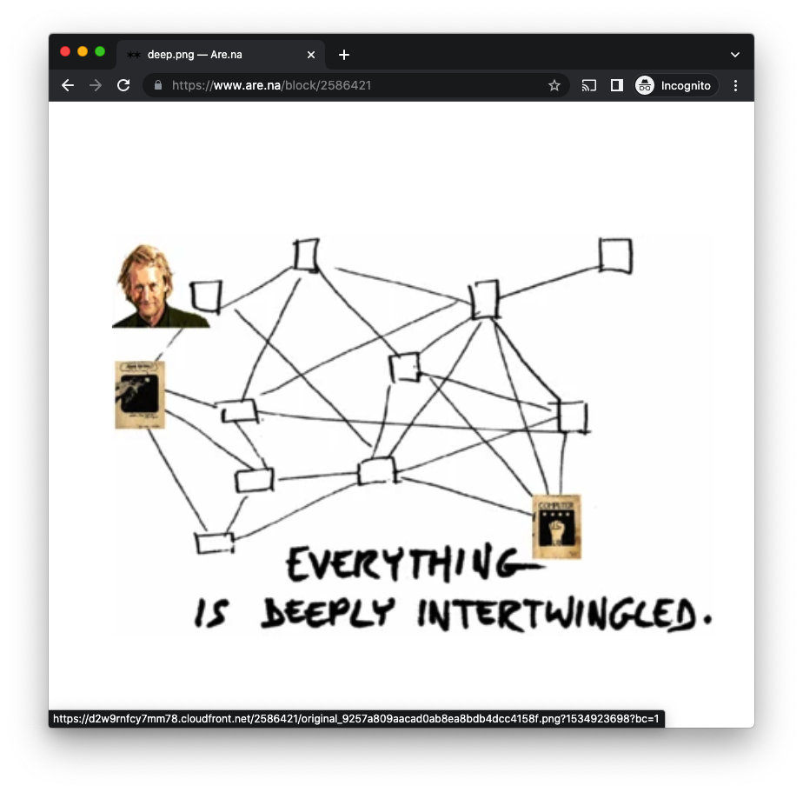

Note. Remixed image deep.png, from the original on Nelson, Computer Lib/Dream Machines), added by Nathan Pilcher to Are.na block Ted Nelson Xanadu. Retrieved from https://www.are.na/block/2586421

‘Intertwingularity’ was coined by Ted Nelson in his seminal book Computer Lib/Dream Machines (1974). He wrote that "in an important sense, there are no ‘subjects’ at all, there is only all knowledge, since the cross-connections among the myriad topics of this world simply cannot be divided up neatly” (ibid; 45). For him, computer-based ‘hypertext’ (a term which he also coined) “at last offers the possibility of representing and exploring it all without carving it up destructively” (ibid; 45). Consideration of Nelson’s idea that “everything is deeply intertwingled” (ibid; 45) and how hypertext systems might facilitate our ability to explore this, was at the heart of the inception of the i-Docs symposia and of my original interest in setting these symposia up. It has thus been very important to keep ‘intertwingularity’ firmly in the mix.

Last but not least, ‘intra-action’ comes from feminist theorist and theoretical physicist Karen Barad. She prefers this to ‘interaction,’ which she sees as necessitating pre-established bodies that participate in action with each other. Intra-action understands agency as not an inherent property of an individual or human to be exercised, but as a dynamism of forces (Barad, 2007, p. 141) in which all designated ‘things’ are constantly exchanging and diffracting, influencing and working inseparably. This offers a more dynamic way of looking at i-docs. with interaction looking at the interrelationships between fixed entities and intra-action looking at the flow between these entities.

Intra-action is closely connected to the anthropologist Tim Ingold’s concept of ‘corresponding’ (2020) and to Donna Haraway’s use of the term ‘worlding’ (2016) and has become central to much of our thinking within the i-Docs research group. Rather than replacing the term interactivity with intra-activity, however, I have chosen to incorporate this thinking into my understanding of interactivity. I have taken this approach and continued to use the term ‘interactive documentary’ as an explicit intervention to keep the agency and database aspects of i-docs in the frame. This has enabled me to continue to focus on interactivity and agency in the face of the more commercially-oriented turn towards immersive technology and presence.

In so doing, my aim has been to embrace thinking about immersion and intra-action without losing sight of the original intentions of i-docs and my own specific interests in the narrative affordances of the database as a way in to multi-perspectival thinking. I am not precious about the term ‘interactive documentary’, however, and fully acknowledge that there are other terms which can embrace ‘interactive documentary’ thinking, such as ‘open documentary’, ‘expanded documentary’, ‘docmedia’ and indeed the term ‘storybits’, with this latter term opening the way to looking at the database and evolving narrative forms in a broader context which is not exclusive to documentary.

Immersive media and sensationalism

In the novel Fahrenheit 451, Ray Bradbury (1953) warned against allowing society to drift from being an educated and literate one to being driven by experiences and sensationalism. This is something that I believe we need to be mindful of, particularly within the context of cultural wars and fake news. If everything becomes about sensations, and if we have ‘Newsspeak’ and only one way of seeing the world, then we will reduce our capacity for language. If we have no words to express thoughts that challenge and critique the dominant paradigm, then we have an authoritarian society. This is another reason why I have been so keen to keep interactivity in the frame, as a way of not losing sight of the more cognitive aspects of i-docs which come with building agency into the experiences that we create.

In an article on the historic link between immersive media and fascist propaganda, Carrie McLaren (2020), asks whether “forgetting one’s surroundings, losing track of physical reality, and escaping into a constructed world” is inherently a good thing or whether it makes people susceptible to being manipulated. She references the work of the anthropologist Margaret Mead who, along with other progressive thinkers made up the Committee for National Morale in the USA and advised President Roosevelt in the 1940s on media policy to help counteract the effects of Nazi propaganda. The Committee linked immersive media to the mass media manipulations of the Nazis and advocated for an alternative approach that would encourage Americans to make meanings for themselves.

This work built on Maslow’s concept of the ‘democratic personality’, as a counter to what the Committee saw as being the ‘authoritarian personality’ of Nazi Germany. In order to promote a more democratic and less hierarchical mindset based on principles of equality, they sought to promote forms of media which would allow participants to make active choices and to do this collectively. The Cultural Historian Fred Turner sees this work as paving the way for the rise of the 1960s counterculture movement, with Bauhaus refugees at places like the Black Mountain College building media environments that could facilitate this (Turner 2013). As Ruth Benedict has been quoted as saying: “anthropology makes the world safe for difference” (Haviland 2005, 133), a key agenda in her work with Mead being to promote this liberal approach within post-war American culture.

This resonates with my own motivations around privileging agency over presence, or at least finding an appropriate balance between the two. It is why I used the term ‘mind the gap’ in my StoryBits keynote, as a reference to the idea of creating (where appropriate) spaces or gaps in media experiences for thought and active decision making. It is also why I believe so strongly that we need to promote mindful consideration of the relative merits of interaction and immersion, in order to promote intelligent thinking around their application. Whilst interaction can be built into many different types of media experience, my argument here is that we should not lose sight of the agency which choice-based decision making can afford in database documentary in these times when immersive technology is taking up so much bandwidth.

Polyphony and database narrative

In recent years, I have been using ‘polyphonic documentary’ as a catch-all term for the aspects of i-docs that I am particularly interested in. This is because ‘polyphony’ has a longer history within documentary discourse than ‘interactivity’ or ‘immersion’ and is a concept that lends itself to focusing down on multi-perspectival thinking. Together with my colleague Stefano Odorico, I have convened a research project called Polyphonic Documentary, which is looking at the potential of interactive documentary for promoting interdisciplinary dialogue and exchange in a context of climate emergency and increasing polarization. This is a collaborative project with i-docs colleagues from around the world and is still in process.

Fig. 4 Polyphonic Documentary website

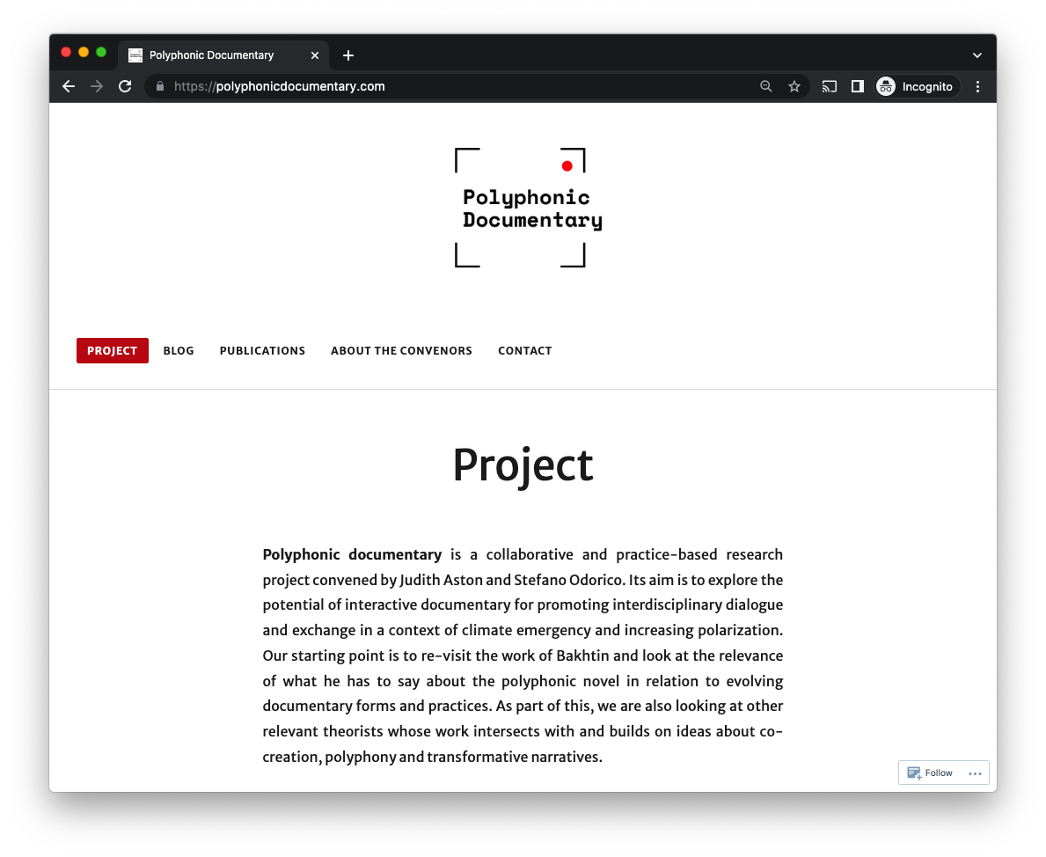
Note. Polyphonic Documentary project homepage https://polyphonicdocumentary.com/

The project acknowledges that ideas about the multiple and breaking from the presentation of a singular ‘world view’, which are central to the concept of polyphony, are not unique to interactive documentary. We are, however, focused on progressing debates around what the database and hypermedia structures that are central to interactive documentary forms and processes bring to the table. Our argument is that this is relevant to industry as well as academia because the database is indeed a major cultural form of our current time and, once the furore around immersive technology dies down, there will be a more balanced return to looking at a wider range of technologies and processes.

This strategy is already bearing fruit through our collaboration with the inventor of the Stornaway authoring tool, Ru Howe, whose work with interactive narrative is gaining traction around the world. The rise in conferences which are looking at interactivity alongside immersion is also noticeable and the internationally orientated IFM conference on Interactive Film and Media is also growing in stature. I see my collaboration with StoryBits as very much building on this momentum and am very much looking forward to bringing my own research questions within the field of interactive documentary into dialogue with more recent questions that have been thrown up by the turn towards immersive documentary.

This will, I feel, generate continuities as well as ruptures and will keep us all busy for a good few years to come. Through ongoing dialogue with Luis Frias, as one of three convenors of the StoryBits conference, we have already established much common ground. I like the fact that Luis is an interaction designer by trade and that he shares my core interest in polyphony and evolving narrative forms. We are both interested in taking a practice-led research approach towards looking at the relationship between media technology and narrative expression within a context of promoting multi-perspectival thinking and understanding. Our core question in relation to this is what new cultural perspectives might this afford whilst maintaining the foundational values of interactive design and multi-cultural ethnographic engagement.

Future plans

Luis is actively participating in the Polyphonic Documentary project and we are planning to co-convene an i-Docs Community Conversation on Polyphonic Narrative Tools prior to the next edition of StoryBits in April 2023. We are also looking at establishing some shared PhD supervisory teams and at continuing the dialogue with the IFM conference for which Stefano Odorico is now a co-convenor. Through his research, Luis has been looking at ‘optional thinking’ and ‘the cinema of choice’ (Shaul 2012). This refers to the cognitive ability to generate, perceive, compare and assess alternative hypotheses that offer explanations for events (ibid;2). Shaul notes how standard narrative movies close down thinking processes, delivering easy pleasures to the viewer. He then argues that ‘optional thinking’ techniques can be employed to present alternate narrative paths and offer a more intellectually stimulating experience.

Meanwhile, through the Polyphonic Documentary project, we have been looking at relational ways of engaging with film clips that database structures afford, which allow for varying degrees of open-ended cognitive engagement with narrative. I have recently read Olga Tocarczuk’s novel Flights (2007), in which she writes that there are two different kinds of looking: one which allows you to see objects, the other being panoramic viewing, a more general view thanks to which you notice links between objects, their network of relations (352). I firmly believe that i-docs methods and processes have much to contribute to our understanding of these different forms of engagement, which is in essence what we are looking at through the Polyphonic Documentary project in relation to ideological polarisation and climate change.

Stefano and I wrote in our 2017 article that i-docs methods and processes have as much potential as a tool for thought through which to explore complex ideas and arguments, as they have as a tool for communicating the insights gained from this exploration (83). This needs to born in mind as we go forwards, to open up potential for interdisciplinary connections to be made around the contribution interactive documentary can make to broader research on complexity. For example, climate scientists are becoming increasingly aware of the need to engage with indigenous epistemologies, in order to better understand how to manage resources across different cultural contexts. As part of my research, I am keen to explore how i-docs methods might be employed to help to put these different epistemological perspectives into dialogue.

Stefano and I have also contributed to a collection on Interactive Documentary: Decolonising Practice Based Research (Aston and Odorico, 2022) and it will be important to build on this work. Interactive documentary will need to be decoupled from its technocentric roots, for example, if we are to think about its relevance to polyphony in a genuinely cross-cultural way. I am particularly interested in how language and culture shapes our understanding of narrative, this being something that the multinational nature of the Polyphonic Documentary project is enabling us to discuss. In this sense we are moving towards considering i-docs more as being a set of practices than as being coupled to any specific technologies, building on Paolo Favero’s provocation that this is the way forwards for the field (2017).

Whilst the database is still important to this, our focus on agency is intended to provide insights that will have wider resonance in relation to approaches to narrative. We are also aware that our focus on the transformative potential of interactive documentary to help promote multi-perspectival thinking and understanding cannot be divorced from the varying socio-political contexts in which technology is used. The power structures that lie behind interactive documentary technologies are not inconsequential and this absolutely does have an impact on their use. In this sense, decoupling interactive documentary from its technocentric roots can only work if we include both low and high-tech applications and look at how they serve different purposes across different contexts, this being a work in progress.

Bibliographic references

Aston, Judith. (2013) The Linear Turn in I-docs: a provocation. Available online on i-Docs website.

Aston, Judith. (2016) Interactive Documentary: what does it mean and why does it matter? Available online on i-Docs website.

Aston, Judith and Gaudenzi, Sandra (2012) “Interactive Documentary: setting the field”, in Studies in Documentary Film, 6 (2).

Aston, Judith and Odorico, Stefano. (2018). “The Poetics and Politics of Polyphony: Towards a Research Method for Interactive Documentary”, in Alphaville Journal of Film and Screen Media, Vol 15.

Aston, Judith and Odorico, Stefano (2022) “Interactive Documentary: it’s history and future as a polyphonic form”, in Ryan, Kathleen and Staton, David (eds) Interactive Documentary: decolonizing practice-based research. Routledge.

Bradbury, Ray. (1953) Fahrenheit 451. Ballantyre Books.

Favero, Paolo (2017), “The Travelling I-doc”, in Aston et al (eds) i-Docs: the evolving practices of interactive documentary, Wallflower Press.

Haraway, Donna. (2016) Staying With the Trouble: making kin in the Chthulucene. Duke University Press.

Haviland, William (2005). Cultural Anthropology: the human challenge. 11th ed. Belmont, California: Thomson Wadsworth.

Ingold, Tim. (2020). Correspondences. Wiley.

McLaren, Carrie. (2020). “Why immersive? On the historic link between immersive media and fascist propaganda”, in Immerse: Creative Discussion of Non-fiction Storytelling, Nov 20.

Murray, Janet. (2011) Inventing the Medium: principles of interaction design as a cultural practice’. MIT Press.

Manovich, Lev. (2001). The Language of New Media. MIT Press Leonardo Book Series.

Nelson, Ted. (1974) Computer Lib/Dream Machines. Self-published. Republished in 1987 by Microsoft Press.

Rose, Mandy. (2018). “The Immersive Turn: Hype and hope in the emergence of virtual reality as a nonfiction platform”, in Studies in Documentary Film, 12(2), 132-149.

Shaul, Nitzen Ben (2012) Cinema of Choice: optional thinking and narrative movies. Berghahn Books.

Tocarczuk, Olga (2007) Flights. Fitzcaraldo Editions.

Turner, Ted (2013) The Democratic Surround: multimedia and American liberalism from WW11 to the Psychedelic Sixties. University of Chicago Press.

Online artworks

Upian (2012). Alma: a tale of violence. Interactive documentary made for web and ipad.

See polyphonicdocumentary.com for further details
See Stornaway.io for further details
See https://interactivefilm.blogspot.com/ for further details
Interactive Film and Media

