## Teaching hidden climate threats: drought in the UK

Winning the GA’s silver publishing award in 2020 for their e-book and associated teacher notes, the team behind the resource creation reflect on the impact of their work and the importance of climate discussions in the primary classroom.

Over the life course of the children in our current year six (10 – 11 year olds in 2022), they will have experienced extreme weather conditions in the UK. The Met Office (see Web Resources) have reported on winter storms of 2014; flooding resulting from storms in 2015; damaging winds of 2016 and 2017; five unseasonably strong storms in 2018 along with significant snowfalls; severe flooding and heavy rainfall through much of 2019; ten storms bringing turbulent, wet weather in 2020; and a further five in 2021. By February 2022, the shores of the UK had been battered by Storm Dudley, Eunice and Franklin in quick succession. The media reports on burst river banks, submerged streets, homes evacuated, trains cancelled, risk and loss of life. These immediate and visible threats to people and place litter our screens and fill our radio waves. With the continuation of the climate crisis, such reporting is only set to increase and as teachers of primary geography, they can provide a useful stimulus for discussions about the changing weather, the water cycle, land use impacts etc. However, they can also reinforce UK weather stereotypes and misconceptions. In this article, we would like to present the often overlooked experience within the UK, and consider why and how we can go about teaching drought.

How often have you heard - “It always rains in the UK’? Rain is immediately observable. At school, it can stop playtime, cause the cancellation of trips and sporting events and ruin a summer fete. By contrast, we tend to hear less about the dry weather. Yes, there were reports about the sunny weather of July 2013, the short heatwave in 2015, the warm summer of 2018 and the sunniest May on record in 2020. These offered glorious images of beach goers and ice creams enjoyed in the heat. What wasn’t covered in the news as spectacularly was the slow drying out of the land. We heard little of the 17 months of below average rainfall between 2004-2006, or the persistent lack of rain in Spring 2011, or the prolonged period of drought between 2010 and 2012, or how livestock farming was affected by the summer drought of 2018.

In the UK, it doesn’t rain nearly as often or as heavily as people may think. As we move deeper into the climate and ecological emergency, we believe we need to value water as ‘precious, fragile and dangerous’ (UN High Level Panel on Water). Water is both a risk (of too much; too little) and a valuable resource for people, animals and environment. We need to engage and enable learners in ways that will provide knowledge, personal expertise and community understanding about water efficiency and lifestyle adaptations for more sustainable use – without adding to levels of eco-anxiety. To this end, we have developed a research informed, free, children’s book (for use in Key Stage 2), with associated Teachers’ Notes. Here we present our ongoing evaluation of this resource and reflect on the challenges of teaching about UK drought.

The **free** e-picture book, “*DRY: the Diary of a Water Superhero”* aims to raise awareness and bring focus to positive water behaviours as a schoolgirl begins to recognise the impact of the weather when a dry summer is followed by a dry winter. The narrative highlights water as a finite resource, needing efficient use, and at the same time promotes drought awareness – preparing for UK drought. The story is presented as an 11 year old’s diary entries through a school year. The digital collages created by Luci Gorell Barnes are immediately eye catching, and in the classroom, they offer opportunities to explore the issues in different ways.

Visual Literacy and Critical Thinking:

Visual literacy is not only the skill of decoding and recognising images, but also functions on a higher level where the viewer makes sense of what is seen, thus requiring critical thinking. The viewer must identify, decode and interpret. They must use their skills of prediction, inference and deduction. As Margaret Mackintosh (2005) reminds us – we often forget that reading and interpreting images is often overlooked in favour of the same skills practiced in text based sources.

Through lesson observations, surveys and interviews with trainee and qualified teachers, we found that the layered details in *DRY: the diary of a water superhero,* allowed learners to play games such as I Spy; spotting evidence about what the weather is like from the pictures. A close interrogation of the image may show plants that are drooping and going brown in pots, desiccation cracks underfoot where the soil has become so dry it has begun to crack, and wildlife ‘talking’ about how adverts may use the weather to help sell products.

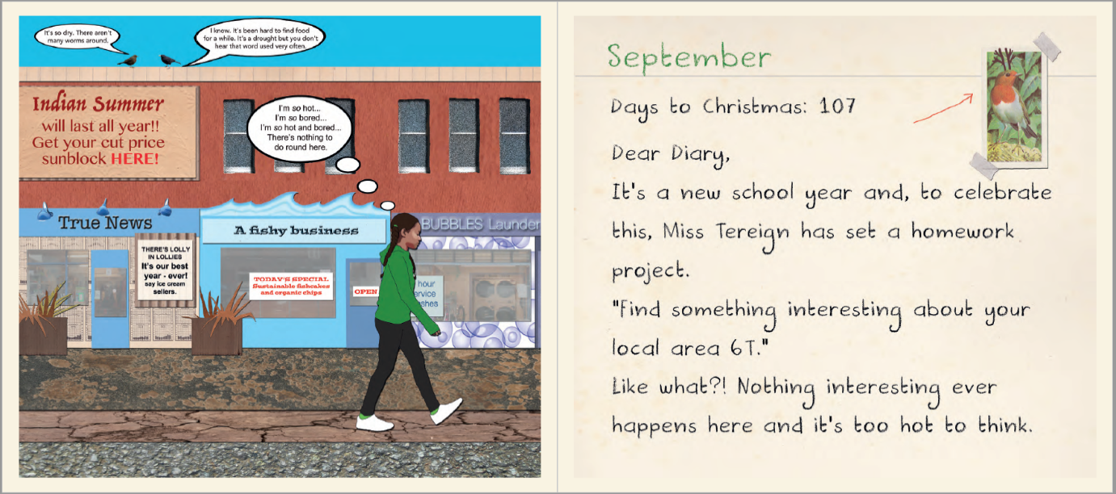

Other images can be used to play ‘Spot the Difference’ where small, but significant strategies have been made to change how the characters use their allotment space near the start and the end of the book. Will pupils spot the switch from hose to watering can, plastic water bottle to reusable bottle and the planting of more drought-resistant crops? And, upon asking why?, will they be able to think through the reasons these changes have been enacted?

Supporting abstract thinking:

All users of the book noted that their knowledge about water use increased having read/ looked at it. Of particular interest to many was the somewhat abstract idea of ‘embedded water’. Our protagonist receives metaphorical ‘water goggles’ for Christmas and the complex idea of a water footprint is introduced. Suddenly readers become aware that these goggles allowed her to see just how much water is needed in the production of her festive lunch – nearly 300litres for every 1kg of potatoes, over 4000 litres for 1kg of turkey, over 17,000 litres for 1kg of chocolate. The Teachers’ Notes then offer activities to explore these concepts to ensure that learners recognise the impact of the supply chain that links a plate of food with people and planet.

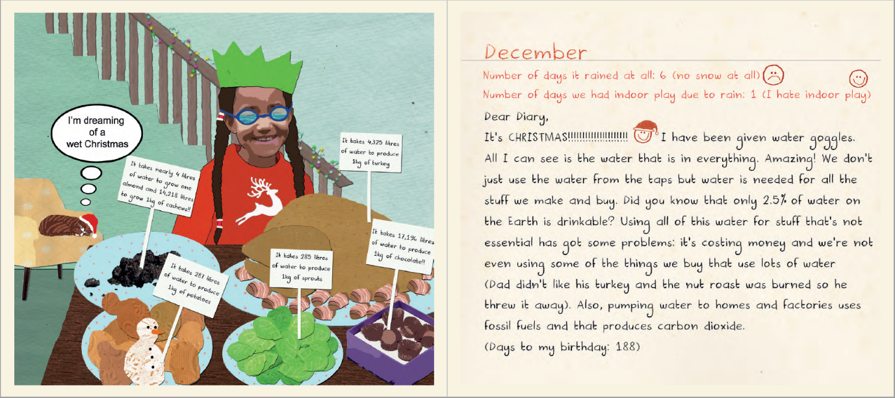

Action planning for change:

At points in the story, young people reported that they had felt anger towards those who were not listening to the girl’s plight for change. By the end of the book, young people told us that they felt more positive; they recognised that with the help of others, small changes could be made that would contribute to larger changes at ever greater scales.

Knowing about the impacts of water shortages and mitigation strategies that can be used to help ensure access to water are important for a sustainable future. However, we are also mindful that these issues can worry and upset young people. It is not appropriate to put the onus for action on the shoulders of our pupils. As such, the resource offers information about what businesses and local authorities are doing already to reduce the impact of water shortage and drought. There are lots of ideas for community and school action, as well as practices that individuals can do. The Teacher’s Notes provides a framework to support making an action plan and in conversations with pupils, we heard personal commitments being made to try not to waste food due to embedded water; to drink the water they are given at meal times rather than throwing it away and turning taps off when brushing teeth. Similarly, teachers talked about how the book made them re-consider their diet and reducing their purchasing of foods with a high-water footprint (such as avocados, meat and almonds). They spoke of how they would now fill the washing machine rather than put on half or less than half loads. There were school commitments made to purchase a washing up bowl for the staff room (which uses less water than washing up in a sink), and plans to talk to school maintenance about dripping taps.

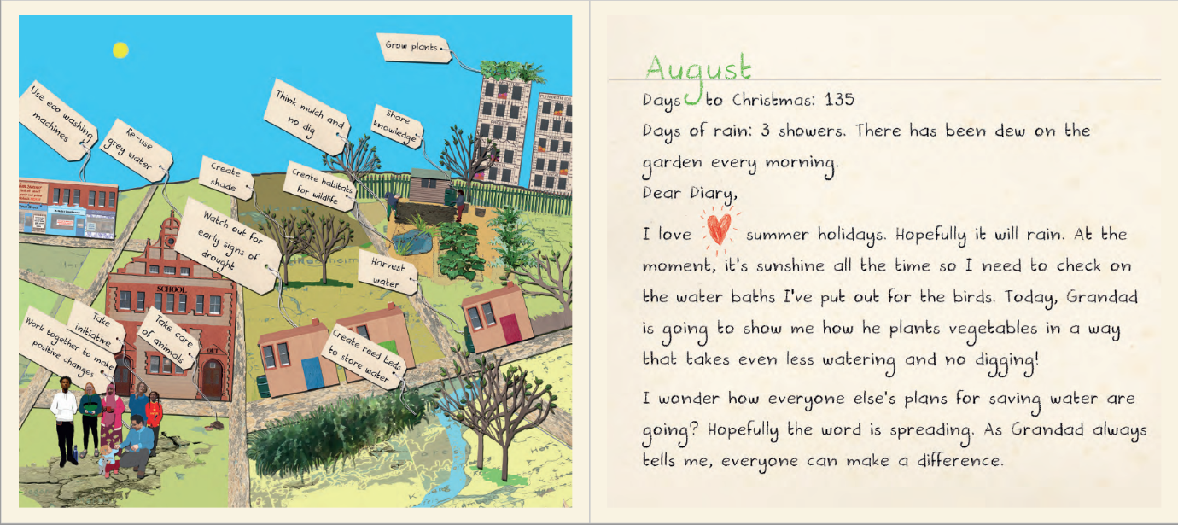

In order to support young learners in adapting to changes in climate and the increasing threat of water scarcity in the UK, we need resources that encourage conversations and thinking around these issues. We hope this book allows you to begin these conversations. The evaluation of this resource is ongoing; if you use this free e-book, please consider filling in the quick online survey!

References

Jones, V., Whitehouse, S., McEwen, L., Williams, S., & Gorell Barnes, L. (2021). Promoting Water Efficiency and Hydrocitizenship in Young People’s Learning about Drought Risk in a Temperate Maritime Country. *Water*, *13*(18), 2599. <http://dx.doi.org/10.3390/w13182599>

UN High Level Panel on Water (2016) Valuing water: preamble. <https://www.gwp.org/contentassets/7afbd79511f044989afab7bde4d4d23f/bellagio-preamble-and-principles.pdf>

Mackintosh, M (2005) Primary Geography Handbook, GA

Web Links:

Free e-book <https://issuu.com/uwebristol/docs/dry_the_diary_of_a_water_superhero>

Free teachers’ notes <https://dryutility.info/wp-content/uploads/2020/01/DRY-book-Teachers-Notes-FINAL-E-VERSION.pdf>

46 simple information cards produced by the DRY project can be found here <https://issuu.com/uwebristol/docs/water_drought_and_you> and accompanying posters at dryutility.info/learning

Link to survey evaluation for teachers / educators using the book: <https://dryutility.info/survey>

Link to the Met Office: <https://www.metoffice.gov.uk/weather/learn-about/past-uk-weather-events>

### Jones, V., Gorell Barnes, L., McEwen, L., Whitehouse, S., Williams, S. are based at the University of the West of England, Bristol.

**All images should be credited to Luci Gorell Barnes (2019).**