Clare Mackay, UWE Bristol
Aurore Julien, University of East London
Jacob Hirst, independent scholar

Sustainability and Sustainable Event Management

Abstract
Sustainability is a macro-level policy issue (Musgrave & Raj, 2009). It involves living and working in ways that do not negatively affect future generations (World Commission on Environment and Development, 1987). To operate sustainably, events organisers need to maximise positive – and mitigate negative – economic, socio-cultural, and environmental impacts and legacies (Smith-Christensen, 2009). This case provides students with the opportunity to (a) identify the impacts and legacies of a music festival, (b) identify examples of good practice in sustainable events management and evaluate the extent to which they are impactful, (c) strategically plan how they will enhance the sustainability of a festival, and (d) how they will evaluate the success of their proposed initiatives.
Subjects: Strategic Event Creation; Sustainable Events Management; Contemporary Issues and Trends; Event Evaluation

Introduction
Global warming is an emergency (United Nations, 2021). As events contribute to global warming through the carbon emissions associated with transport, waste, energy, and the supply chain (Jones, 2018), it is crucial that efforts continue to enhance the environmental sustainability of events.
The not-for-profit association A Greener Festival (AGF) was established in 2007 to help festivals become more sustainable by assessing their environmental impacts and practices (Berridge, Moore, & Ali-Knight, 2018). AGF has since widened its remit to events, arenas, and tours.
The most sustainable event/arena/tour and those that are to be commended in both the UK and overseas are announced at the International AGF Awards. This provides events/arenas/tours with added incentive to participate as the accolades can be used to appeal to today’s conscious consumers.
Events/arenas/tours that register to be assessed, complete a Self-Assessment Form outlining how they impact the community and environment, and submit this to AGF along with supporting documents. Assessors from AGF review the paperwork before conducting an on-site evaluation where they compare the information provided with their observations front and back-of-house and speak to relevant stakeholders (e.g. traders, caterers, and organisers). Post-event, further evidence in the form of data (e.g. % of waste; carbon footprint from travel; and the kW of power used) is sent to the assessors by the event organisers. The assessors use the evidence collated to grade the event/venue against the assessment criteria (e.g. social impacts, water, and energy) to generate the festival/arena/tour’s sustainability rating. Crucially, a report is produced to highlight the event/arena/tour’s good practice in sustainable events management and areas for improvement.
To become an Assessor for AGF, individuals must have an undergraduate degree or level 6 equivalent qualification or three years of relevant experience (Falmouth University, n.d.). After completing Stage 1 of the training to learn about industry best practice, Assessors can continue their training by assessing a participating event/arena/tour under the guidance of a Senior Assessor (Berridge, Moore, & Ali-Knight, 2018).
Assessors are chosen for each event based on their proximity to the site/venue and the proposed mode and cost of their travel, thus ensuring sustainability within the selection process.
This chapter presents a case study of the evaluation of a hypothetical festival called Transformation by fictional AGF Assessor Dominique and fictional Senior Assessor Alex.

Dominique and Alex’s Pre-Festival Evaluation of Transformation’s AGF Application
As an Events Management graduate, Dominique trains to become an Assessor for AGF to gain greater understanding of sustainable events management in practice, and to have the opportunity to attend more events.
Having completed the training, passed the test, and received her certificate verifying that she is now a Stage 1 Assessor, she is accepted onto Stage 2 of the training which involves conducting an evaluation with a Senior Assessor acting as a mentor. She receives a spreadsheet with a list of events that need to be evaluated. She notices that Transformation – which is staged not far from where she lives – is on the list, so she sends in her estimated travel costs and is asked to evaluate the festival. Prior to attending, she reviews the festival’s application and supporting documents (e.g. Ecological Report; Site Drainage Plan; Noise Management Plan) under the guidance of her mentor, Alex. The knowledge and understanding they gain about Transformation’s practices is outlined below:

Social Impacts
- Community consultation is undertaken, and actions are taken to mitigate the negative impacts of the festival on the community. For example, litter is picked up off site, and free tickets and a complaints hotline are provided for locals. The festival also raises money for community projects.
- A noise management plan is in place to minimise noise pollution

Equality, diversity, and inclusion
- The line-up is gender and ethnically diverse

Water
- The festival has a mains water supply and water is provided via standpipes. Two water tankers are on standby in case there are any disruptions to the mains supply. The festival plumbers check the system regularly for leaks.
- Soakaways are used for the drainage of grey water
- Social media and signage are used to educate festivalgoers on the importance of using the toilets provided

Sustainable Supply Chain Management
- The festival’s sustainability policy was produced from contributions from each department and has been approved by the board of directors.
- A sustainable procurement policy is in place and applies to crew, caterers, and traders. Non-recyclable and single-use items are banned. Sustainability requirements are integrated within the tender for caterers and the most sustainable caterers are selected. Readiness to open checks are performed and non-compliant traders are not permitted to open.
- Local preferred suppliers deliver goods to traders who need them to reduce vehicle movement.

Ecology
- The Ecological Report identifies sensitive areas containing flora and fauna. As a result, an area of the site is fenced off and the festival works with a conservation charity to contribute to the conservation of the habitat of the grey partridge.
- Spill kits are kept on site for small fuel and hydraulic spillages. A gully tanker is used to suck up any sewage spillages and if required, the ground is jet cleaned.

Travel
- As audience travel can account for around half of a festival’s total carbon emissions from transport (Vision 2025, Powerful Thinking and Julie’s Bicycle, 2020), efforts are being made to try to mitigate the travel carbon footprint of the festival. Festivalgoers are encouraged to travel to the festival via public transport and shuttle buses are provided from the local train station to try to prevent festivalgoers from taking taxis. To try to discourage festivalgoers from driving to the festival, a parking fee is charged. The money raised from this is used to subsidise return coach travel from a variety of locations to make it cheaper for festivalgoers and encourage uptake. Public transport, coach travel, and travelling in a car at full capacity are incentivised by providing festivalgoers with the opportunity to arrive on site on Friday night to have first choice of where to camp. Car sharing is incentivised with the opportunity to win free tickets to next year’s festival.
- Local artists are used where possible. Touring artists are booked and shared with other promoters. Artists are asked to use sustainable modes of transport. Artists flying have been asked to fly economy. A shuttle bus service is used to collect artists and efforts are made to ensure the vehicle is at full capacity. Artists travelling by tour bus have been asked to travel in a Euro 6 compliant bus (Ecolibrium, n.d). Artists not travelling in a tour bus are staying in local hotels. Efforts are made to ensure artist’s riders are sustainable.
- Staff and crew live on site for the build, event, and break or stay in local accommodation.
- A survey will be conducted post-festival to ascertain the environmental attitudes and behaviours of festivalgoers and assess the effectiveness of on-site environmental initiatives. The questionnaire includes a question asking festivalgoers how far they have travelled to attend the festival and by which mode of transport. This data will be used to calculate the total distance of return travel per mode of transport. As the amount of fuel used provides a more accurate figure from which to calculate the CO₂ equivalent (CO₂e – this includes non-carbon dioxide greenhouse gas emissions such as methane and nitrous oxide in addition to carbon dioxide; Jones, 2018) of audience travel, the coach and shuttle bus companies will be asked to provide receipts of the amount of fuel used. Data from the Car sharing website will also be collected to support the calculation of the average distance travelled via car sharing. The CO₂ e of audience travel will be calculated by multiplying the total audience mileage by car and motorcycle, and the total fuel used by passengers travelling via other modes of transport by the UK Government Department for Business, Energy, and Industrial Strategy Greenhouse Gas Conversion Factors (2022).

Energy
- Electricity will be provided through a combination of mains power supplied through a green tariff, hybrid power generators (Powerful Thinking, 2017), and ‘Pee Power’ (UWE, 2019). The kilovolt-ampere (kVA) of the generators provided to traders is limited (Powerful Thinking, 2017). Generators are switched off when possible.
- Electric Wheels zero emissions vehicles are used by staff to traverse the site (Ecolibrium, n.d.).
- All festoon lighting is LED, and the lighting is dimmed where and when this is possible.

Waste
- Festivalgoers are asked not to bring single-use/non-recyclable items. They are told where they can find bin bags, and they are encouraged to purchase a good quality tent/a pre-pitched tent, use the bins provided, and take their tent home with them.
- A salvaging charity will visit the site post-festival to salvage abandoned tents and camping equipment which it will distribute to charities.
- The recycling will be sorted on site.
- 8th Plate, a food salvage initiative founded by A Greener Festival and the Nationwide Caterers Association, collect leftover food from traders at the end of the festival and distribute it to local charities.
- Festivalgoers and crew are encouraged to bring a reusable water bottle with them.
- Compost toilets are used throughout the site. The urine is separated from the waste and removed by tanker. The waste is taken off site for treatment. The accessible toilets and toilets in medical areas are Polyjohns; these are serviced daily, and the brown/black water is removed by tankers (Jones, 2018).
Having reviewed the festival’s Self-Assessment Form and supporting documents with Dominique to gain a critical understanding of Transformation’s efforts to enhance the sustainability of the festival, Alex arranges on-site meetings for them with relevant festival stakeholders (e.g., Sustainability Officer; Site Manager; Waste Manager).

Evaluating Transformation
The day of the festival arrives, and Dominique is excited! Her backpack is heavy, so she is pleased that she booked a pre-pitched tent and is not having to carry a tent to the coach station too.
On the coach, Dominique checks her social media and notes that the festival is promoting its green initiatives and pro-environmental behaviour. After being stuck in gridlock for some time, her coach arrives at the festival.
While queuing to enter, she photographs signage asking that festivalgoers ‘respect our home’, however litter has already been dropped close by.
After finding her tent, she goes in search of food. She buys some falafel and sees that the catering unit is advertising Rainforest Alliance certified, organic, and Fairtrade products, and asks if she can see them. The caterer also shows her his environmentally friendly detergent (see image below) and the hybrid generator providing him with energy. He says he wishes the festival was collecting the caterers’ food waste for composting.

Image 1 (author’s own photograph).
There is so much litter in the area around the catering units that Dominique almost does not want to sit there to eat. She sees staff employed as litter pickers collecting the litter into green and black bin bags, but their efforts seem futile.
She is unsure which bin to put the compostable serveware in as the green bins are labelled ‘cans’ and ‘bottles’ and the other bin is black. She opts for the green bin.
She walks to the bar and notices on her way there that there are electronic billboards encouraging festivalgoers to adopt environmentally responsible behaviour. When she reaches the bar, she sees that the tills too are conveying environmental messaging. She sends a message in the Solo Polo Woov chat to find out if there is anyone she can meet up with. A few people meet her at the bar, and they make their way to the main stage.
It has been raining, and the ground front of stage has been covered in wood chip to try to protect it from erosion. On either side of the stage, there are screens conveying environmental messaging, e.g., information about the amount of clothing going to landfill every day. The lead singer of The 1975 speaks about the need to do what we can to protect the environment and the band end their set with ‘Time to Rebel’. Chronnix, whose set is next, tells festivalgoers that the festival is committed to reducing tent waste and that festivalgoers should take their tents home. When he sings ‘Black is Beautiful’, Dominique feels a sense of pride and belonging as the whole crowd sings along. After Chronnix, Dominique goes to her campsite to get a jumper and notices that the lights have been dimmed to save energy. She rushes back to the main stage to see Billie Eilish. She loves Billie’s environmentalism, and it was a brilliant gig! However, she realised when standing front of stage that consideration needs to be given to reducing litter in this area as people were dropping their cups and cans. She wonders if a reusable cup system would help to mitigate this.
The next morning, she goes in search of coffee. The baristas are using compostable cups and not giving out lids to try to mitigate their environmental impact.
After getting her coffee, she meets Alex who has just arrived. On their way to the Production Office to meet the Site Manager, they photograph an ashtray designed to mitigate cigarette litter by encouraging people to vote as to their preferred artist through the disposal of their cigarette butt.
During their meeting, they visit the waste facility which includes recycling belts where the waste is sorted. They check how many waste streams the recycling is being separated in to and whether the waste is being sorted correctly into each stream. They are shown the spill kits that were mentioned in the festival’s Self-Assessment Form.
On their way back to the main festival site, they go to the traders’ village to check the sustainability of the products on sale. There are traders selling vintage clothing and clothing with sustainable certification, and social enterprises proudly displaying how their businesses help people in other countries (see images below).
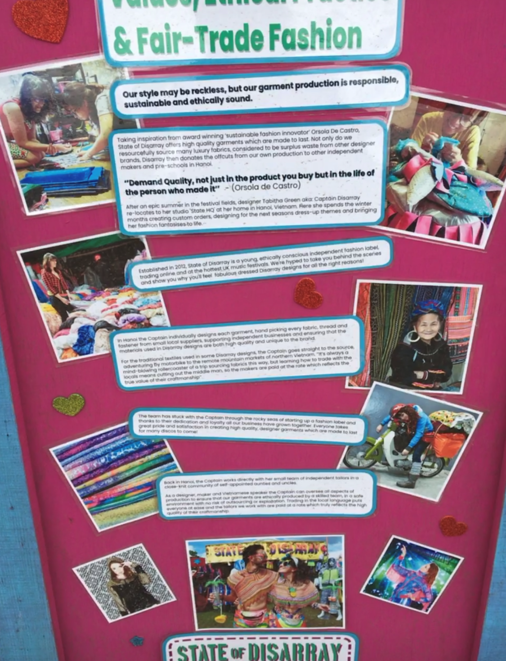
Image 2 (author’s own photograph).

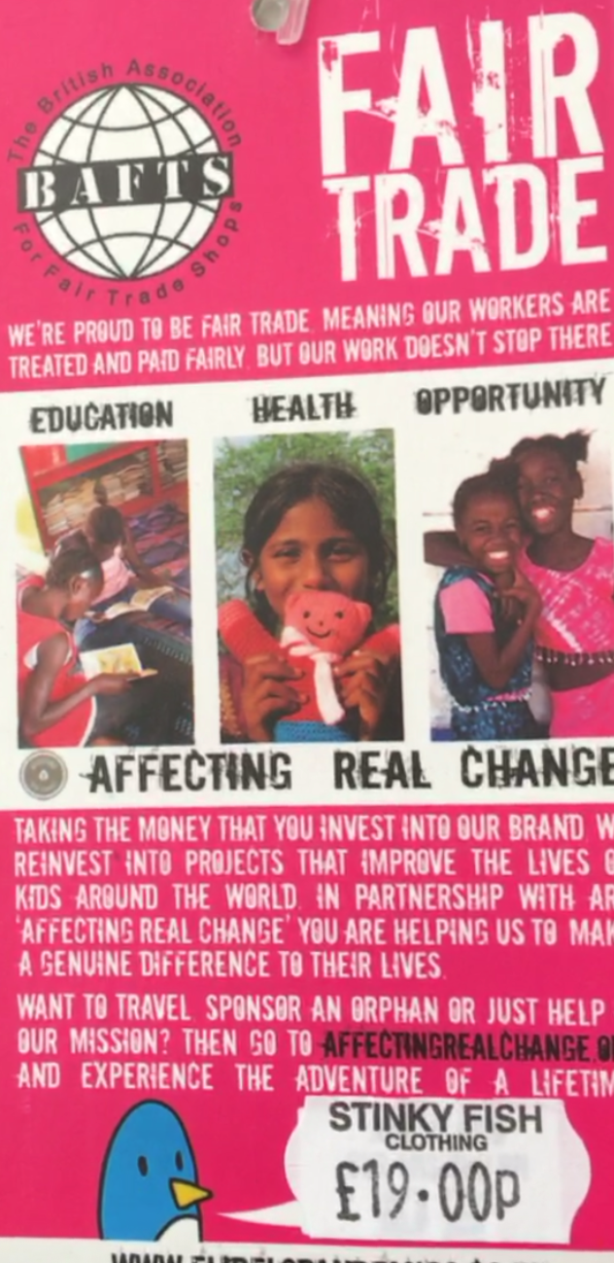
Image 3 (author’s own photograph).
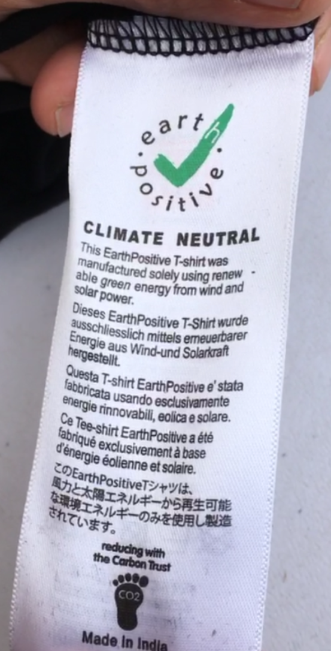
Image 4 (author’s own photograph)
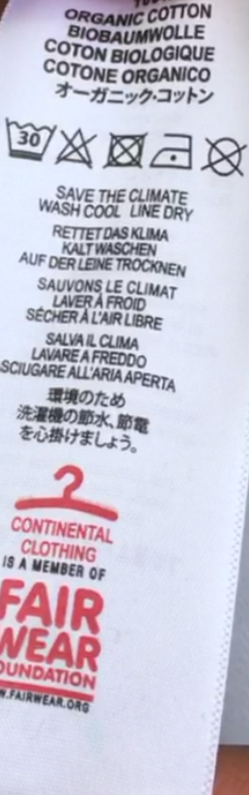
Image 5 (author’s own photograph).
Some of the traders are selling non-sustainable clothing. Dominique and Alex also observe plastic products including single-use, and products containing glitter – which is not biodegradable (pictured below).
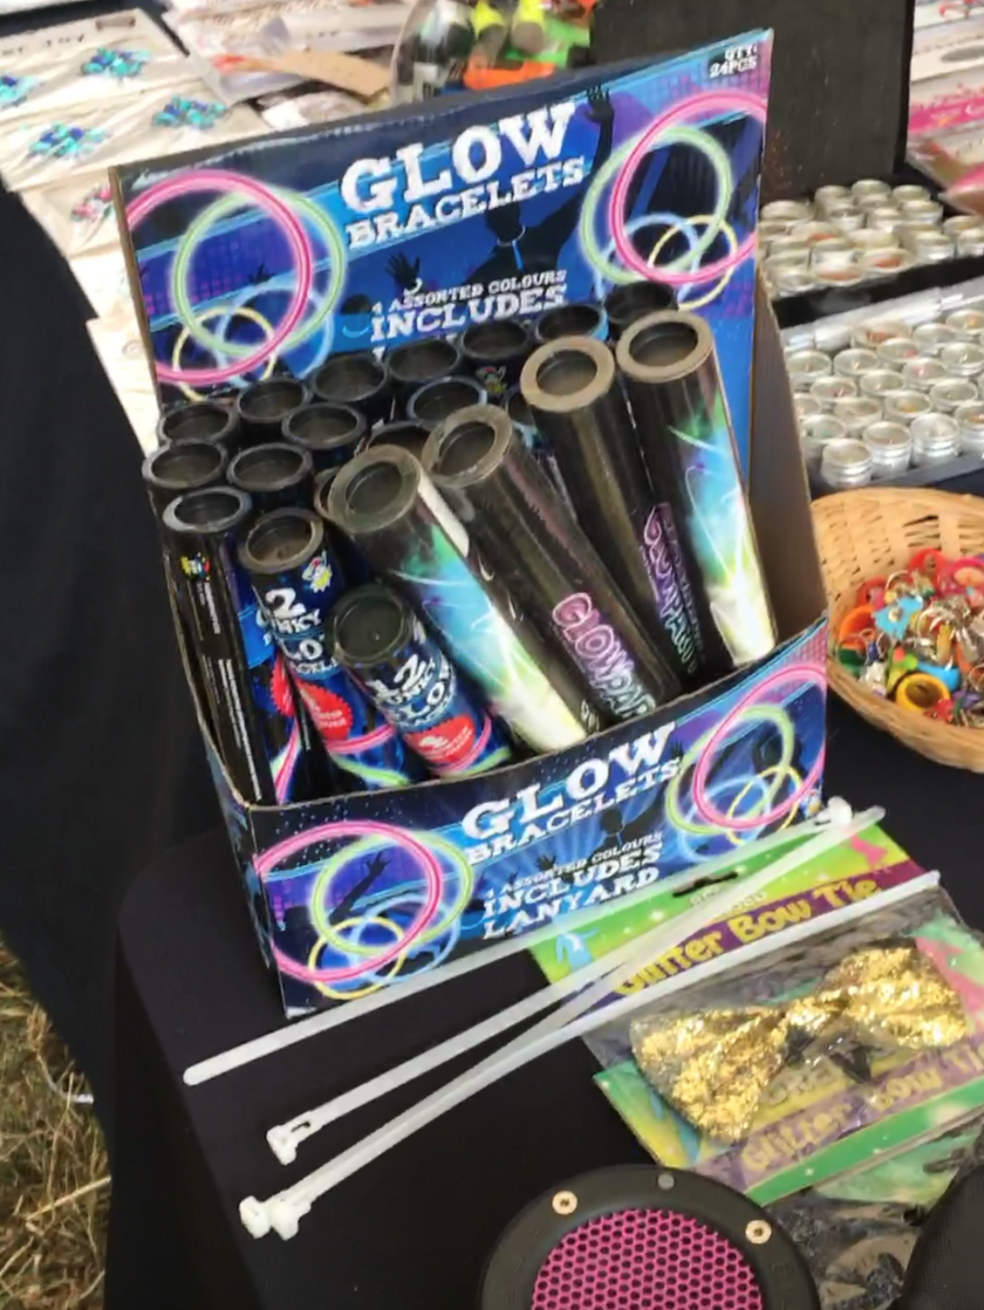
Image 6 (author’s own photograph)
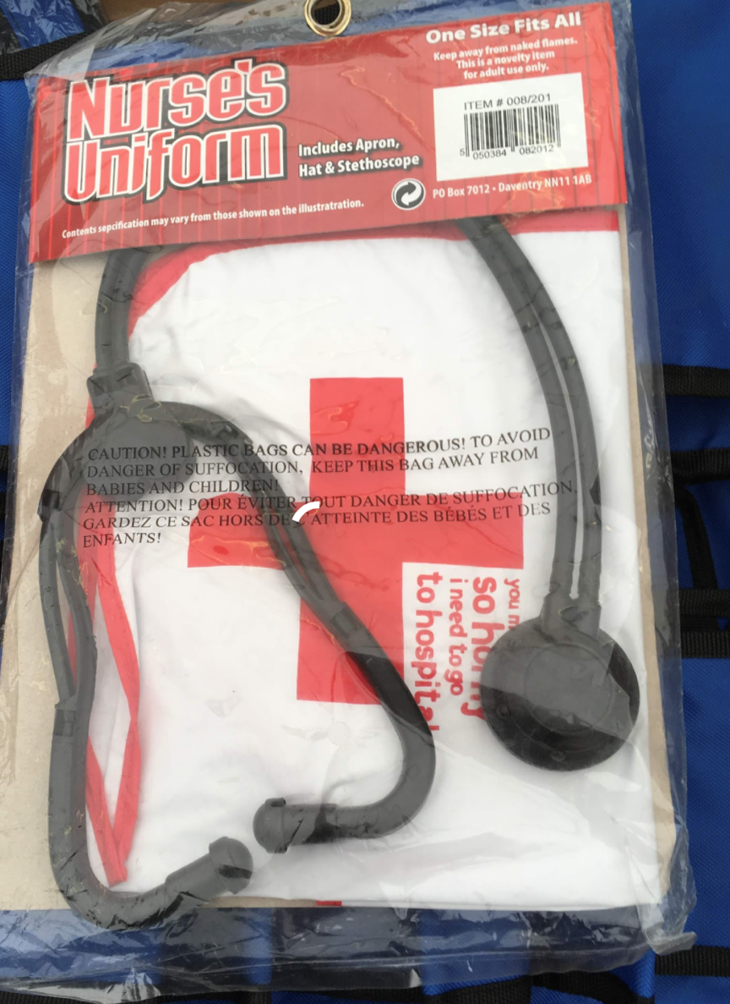
Image 7 (author’s own photograph)
They realise they are hungry and go to get a burger. The van they go to is displaying a provenance board to show that the meat used is reared locally. The caterer shows them the packets of meat to evidence this.
They sit down with their burgers and see that a can of cider has been left sitting on the table despite the table being next to some bins. A wasp bothers them as a result, and they move. As a fellow camper said to Dominique that morning, ‘you wonder why people can’t just tidy up after themselves and put their litter in the bins’.
They go to meet friends of Alex and use the toilet on their way. Thankfully, there are plenty of compost toilets around the site and they do not have to queue for long. While washing their hands, Alex points out the soakaway underneath the standpipe.
When they get to Alex’s friends’ campsite, there are volunteers encouraging people to take their tent home. After a few drinks, they gather their recycling to gain entry to the Recycling Rave. They have a brilliant night there, and it is late when they get back to their campsite. The wind has picked up, and it is raining heavily. There are tents flying away and others look ready to do so. Dominique is glad her small tent is less likely to get caught by the wind. However, it is scary being alone in a tent in such bad weather and she goes on to the Solo Polo chat in Transformation’s Woov app to talk to others who feel the same. This makes her feel better.
The next morning, they pack up and make their way to the coach park. Though there is litter lying around, Alex says it looks like less tents have been abandoned compared to when they attended the festival last year. It looks like those that have been abandoned, did not survive the weather.
Dominique’s coach back to Bristol is late so she is thankful that the coach company is handing out goody bags as there are no catering units near the coach park and she is hungry. The goody bag contains vegan snacks and a protein drink. Unfortunately, the bags are plastic and contain flyers, and many people are dropping these on the ground.
Post-festival, Dominique and Alex will complete their evaluation using the data they receive from the festival and their photographs and notes. First however, Dominique is looking forward to going home for a nice bath and an early night. Attending festivals always makes her appreciate water, and she plans to donate to Water Aid tomorrow.

Acknowledgements
The authors would like to express their gratitude to Claire O’Neill and Teresa Moore of A Greener Festival, and to Vassilios Ziakas, for their time, support, and feedback. Thanks also to Christopher Johnson of Shambala festival and Emily Ford and Martin Coat of Boomtown Fair for the insight provided by them on the strategic design and sustainable practices of the festivals. However, it should be noted that the case study above is entirely hypothetical and draws on the authors’ experience within, knowledge of, and independent research on the sector and industry more broadly.

Discussion questions
1a. Identify the positive and negative impacts and legacies of the festival that are evident within the case above.
1b. Can you identify any other impacts or legacies that can be associated with festivals?
2a. Identify the examples of good practice implemented to enhance the sustainability of the festival.
2b. Reflecting on festivals/events/venues, are you aware of other examples of good practice that are implemented to enhance sustainability?
2c. To what extent do you think the examples you have identified help to mitigate negative impacts/legacies?
3. Imagine you are Transformation’s Sustainability Officer, and you need to set objectives for next year’s festival.
- With reference to the case above, what are the core issues you would tackle?
- How will you tackle these?
- Are your plans feasible or are there implications and impacts associated with them that you need to consider before implementing your proposed changes? Consider the following:
- Will the changes you want to make have financial implications?
- How can you save or raise money to offset the financial implications associated with your plans? Do the financial implications of your proposed changes make it difficult to implement the changes you want to make?
- Are any of your proposed changes likely to lead to dissatisfaction? If so, how can this be mitigated?
- Will there be barriers to making your desired changes? How can you overcome these barriers?
- Given your consideration of the questions above, what can you feasibly implement to try to enhance the environmental sustainability of the festival while mitigating dissatisfaction amongst stakeholders and ensuring the festival’s economic sustainability?
Your responses to these questions should consider the following stakeholders:
- Festivalgoers
- Traders
- Caterers and their staff
- The festival organisers
- The festival’s crew and volunteers
- Festival suppliers and contractors
- Artists and their management companies
- Retailers
- The government
- The media
- After deciding on the issues that are feasible to address, write SMART objectives for next year.
- Write performance indicators that can be used to measure the festival’s performance against the objectives set.
- What data will be required to measure the festival’s performance against the objectives set? Who can the data be obtained from? If data will need to be collected, how – and by whom – will this be done?

References/Further reading
Berridge, G., Moore, T., & Ali-Knight, J. (2018). Promoting and assessing sustainability at festivals: A case study of the ‘A Greener Festival’ initiative. In H. Sèraphin & E. Nolan (Eds.), Green events and green tourism: An international guide to good practice (pp. 18-30). Abingdon: Routledge.
Department for Business, Energy, and Industrial Strategy (2022). 2022 Government Greenhouse Gas Conversion Factors for Company Reporting: Methodology Paper for Conversion Factors Draft Report. https://assets.publishing.service.gov.uk/government/uploads/system/uploads/attachment_data/file/1083857/2022-ghg-cf-methodology-paper.pdf
Ecolibrium (n.d.). Sustainable Travel Guide for Artists and the Music Industry. https://ecolibrium.earth/sustainable-travel-guide-for-artists-and-the-music-industry/
Falmouth University (n.d.). A Greener Festival Assessor Training. https://flexible.falmouth.ac.uk/courses/short/a-greener-festival-assessor-training?fbclid=IwAR3rg2fVw7lRTdl_CUQ4vE9MKIPpJArzm8HaslWotGfdHKl3Bg2F3sQSxlI#graduates
Jones, M. (2018). Sustainable events management: A practical guide (3rd Edition). Abingdon: Routledge.
Musgrave, J. & Raj, R. (2009). Introduction to a conceptual framework for sustainable events. In R. Raj & J. Musgrave (Eds.), Event management and sustainability (pp. 1-12). Wallingford: CABI.
Smith-Christensen, C. (2009) Sustainability as a Concept within Events. In: R. Raj & J. Musgrave. Events management and sustainability (pp. 22 – 31). Wallingford: CABI.
Vision 2025, Powerful Thinking and Julie’s Bicycle (2020). The Show Must Go On Environmental impact report for the UK festival and outdoor events industry 2020 Update. https://www.vision2025.org.uk/the-show-must-go-on/
Powerful Thinking (2017). The Powerful Thinking Guide: Smart Energy for Festivals and Events. https://www.powerful-thinking.org.uk/resources/powerful-thinking-guide-2017/
United Nations (2021, August 9). IPCC Report: ‘Code Red’ for human driven global heating, warns UN chief. UN News: Global perspective human stories. https://news.un.org/en/story/2021/08/1097362
UWE Bristol (2019). Pee power technology returns to Glastonbury for fourth year. https://info.uwe.ac.uk/news/uwenews/news.aspx?id=3953#:~:text=The%20PEE%20POWER%20urinals%20%2D%20among,phones%20and%20provide%20urinal%20lighting.
World Commission on Environment and Development (1987) Report of the World Commission on Environment and Development: Our Common Future. https://sustainabledevelopment.un.org/content/documents/5987our-common-future.pdf

Teaching note
Clare Mackay, UWE Bristol
Aurore Julien, University of East London
Jacob Hirst, independent scholar

Learning objectives
Students will be able to:
- evaluate how, and the extent to which, events contribute to positive and negative impacts and legacies
- recommend how they will enhance the sustainability of an event considering the feasibility of their recommendations
- plan how they will evaluate the performance of an event against SMART objectives to assess the success of their recommendations in enhancing the sustainability of the event as part of a cycle of continuous improvement

Target audience
Events professionals seeking to learn how to enhance the sustainability of an event and undergraduate or postgraduate students studying sustainable development or festival/events/sports/tourism management, particularly those undertaking modules on:
- Strategic Event Creation
- Events and Sustainability
- Events Management
- Event Evaluation
- Research Methods

Theoretical background
The theoretical underpinning of the case lies in the macro-level policy agenda of sustainable development (Musgrave & Raj, 2009).
To gain experience of strategically planning an event to enhance its sustainability, the case provides students with an opportunity to adopt the role of the Sustainability Officer for a hypothetical festival. The students are tasked with identifying the impacts and/or legacies from the case that they want to try to mitigate/leverage as well as with considering how they will do so (Case, 2013; Holmes, Hughes, Mair, & Carlsen, 2015; Jones, 2017; Julien & Mackay, 2020; Raj & Musgrave, 2009).
To draw attention to the difficulties that events professionals may encounter when trying to create sustainable events (Dodds, Holmes, & Novotny, 2020; Henderson & McIlwraith, 2012; Mair & Laing, 2012; Jones, 2017), while highlighting the ‘stakeholder-centric’ approach that strategic event creation requires (Crowther, 2014, p. 12), the case requires the students to consider the feasibility of their ideas. The students should be encouraged to identify any implications or impacts associated with their ideas considering different stakeholders and barriers they may face so that they can determine how they will strike a balance between the three spheres of sustainability (Dodds et al., 2020; Henderson & McIlwraith, 2012; Jones, 2017; Mair & Laing, 2012).
Having decided on the issues that are feasible to address and how they will address them, the case provides the students with an opportunity to gain experience of developing SMART objectives, and performance indicators that can be used to measure the festival’s performance against their objectives (Case, 2013; Getz, 2018; Jones, 2017; Julien & Mackay, 2020). Setting SMART objectives and performance indicators allows the students to identify the data they need to measure their performance against their objectives, who they will need to obtain it from, and whether – and how – any additional data required will be collected (Getz, 2018).
Having learnt how to develop SMART objectives and performance indicators in the context of the case, the students can apply their learning to their own events or event evaluation plans. Of benefit for their career within the events industry, the case study takes the students through the process of sustainable events management from the identification of event impacts and legacies through to the evaluation of the event to assess their performance against their objectives in a cycle of continuous improvement. The case thus helps to produce events professionals who are strategic, ‘outcome obsessed’, and reflective (Crowther, 2014, p. 12).

Recommended readings to prepare for the case
Dodds, R., Holmes, M., & Novotny, M. (2020). Because I believe in it: Examining intrinsic and extrinsic motivations for sustainability in festivals through self-determination theory. Tourism Recreation Research, 47(2), 111-129. https://www.tandfonline.com/doi/abs/10.1080/02508281.2020.1841375
Gao, Y., Ma, Y., Bai, K., Li, Y., & Liu, X. (2021). What factors influence individual pro-environmental behaviour in the tourism context: Rationality, affect or morality? Asia Pacific Journal of Tourism Research, 26(5), 516-538. https://doi.org/10.1080/10941665.2021.1876117
Johnson, C. (2019, November 19). Exploring the environmental footprint of festival food. Stand Out: Live Events Magazine. https://www.standoutmagazine.co.uk/exploring-the-environmental-footprint-of-festival-food/
Julien, A. & Mackay, C. (2020). Environmentally Sustainable Event Design. In V. Antchak & O. Ramsbottom (Eds.), The fundamentals of event design (pp. 177-194). Abingdon: Routledge.
Skinner, T. (2019, May 8). Festivals urge shops to stop selling ‘single-use tents’. NME. https://www.nme.com/news/music/festivals-urge-shops-to-stop-selling-festival-tents2485563-2485563

Teaching methods
Lecturing and a small group activity and simulated learning activities.

Teaching instruction and lesson plan

Lecture
Introduce the students to the concept of sustainability and develop their critical understanding of the three spheres of sustainability as they relate to events through a 40min lecture.

Small group activity (15mins)
Ask the students to answer question 1a in small groups.

Small group simulated learning activity (20mins)
Ask the students to discuss questions 3a, b, and c in their small groups and to each note their answers.

Lecture (15mins)
Explain how to develop SMART objectives and performance indicators, and table 2 (see questions and answers section below) so that the students can complete questions 3d, e, and f.

Small group simulated learning activity (30mins)
Ask the students to work together to complete questions 3d, e, and f on Microsoft Word ensuring that the final version is shared between all group members so that they can retain it for reference.

Authentic assignment
This authentic assessment provides students with the opportunity to simulate the role of an assessor for AGF to evaluate an event of their choice, thus simultaneously designing out the potential for an assessment offence (Sviniki, Piccinin, Sharpe, and Alexander, 2011).
Given academic and industry time constraints and the operational requirements of events professionals, the AGF process is condensed to make the assignment more feasible for the students to conduct while still providing them with as authentic an assessment as possible. To this end, it is suggested that students only interview their relevant industry contact post-event rather than during the event.
The assignment can be conducted by individual students or in pairs or groups depending on the preference of the educator and the level of the students. For example, it would perhaps be best as a group assignment or conducted in pairs by first or second-year students, and as an individual assignment by final year undergraduates or Masters students.
To prepare the students for their assignment, you will need to provide them with your institution’s ethics form, guidance on how to develop a Participant Information Sheet and consent form, and guidance on report writing.
The suggested assessment brief to provide to the students is outlined below and includes a suggested schedule based on an 11-week semester. This is outlined within the assessment brief to keep the students on track but can be used as a guide for the teaching team. It can be adapted as necessary by educators following a different delivery pattern.

Assignment Brief
Focusing on an event of your choice that you can gain access to; you are required to conduct an event evaluation akin to that carried out by AGF assessors. You should then use your evaluation and the data/evidence you have gathered to write a 3000-word report for the event organisers highlighting areas of good practice and areas for development, making recommendations as to how the sustainability of the event can be enhanced as part of a process of continuous improvement. Your report should follow standard academic report writing conventions and the information provided should be as engaging and accessible as possible for your reader (i.e. you should make use of tables, bullet points, and diagrams as appropriate).
The assessment form provided below is an adaptation of the AGF Award Self-Assessment Form that is completed by events professionals who want their event/arena/tour to be assessed by AGF. At the event, the assessors use the form and their evaluation of the documents they receive from the event organisers in support of their application as an interview guide to obtain any further information they require from relevant stakeholders (e.g., the Site Manager, Sustainability Officer, and Waste Manager). Assessors also use the form to guide their observations on site, looking for – and taking photographs of – good practice and areas for development. The events professional responsible then sends any outstanding data to the assessors post-festival for the assessors to complete their scoring on the form. To condense this process somewhat for the sake of your assessment and to make the contribution of busy events professionals more feasible while still providing you with as authentic an assessment as possible, you should seek to interview your relevant industry contact post-event rather than during their event.

Instructions
Choose a forthcoming event that you will be able to attend to focus on. As events organisers become increasingly busy in the lead-up to an event, you should choose an event that is reasonably far in advance to give the events professional within the organisation time to complete the Assessment Form for you pre-event. It is recommended that you consider the suggested timeframe outlined in table 1 below and try to choose an event that is staged around the end of term/week 12 depending on your academic calendar.
Week | Task
Week 1 | Assessment brief launched
Week 2 | Ethics form filled in, Participant Information Sheet created, and Consent Form created
Week 3 | Ethics form signed off/edits requested by Lecturer
Week 4 | Students contact events professional attaching Participant Information Sheet, Consent Form, and Evaluation Form to email/Edited documents signed off by lecturer if not signed off in week 3
Week 5 | If not done in week 4, students contact events professional attaching Participant Information Sheet, Consent Form, and Evaluation Form to email
Week 6 | Students are granted access/send follow-up email to events organisation/approach another events professional
Week 7 | All students have gained access to an event
Week 8 | All students have gained access to an event
Week 9 | n/a
Week 10 | Students receive completed form and accreditation from events professional
Week 11 | Students review form and supporting documents and identify what to look out for at the event
One week after the end of term | Students attend event to conduct evaluation
Two weeks after the end of term | Students interview relevant events professional and obtain post-event data  Students complete assessment form
Three – four weeks after the end of term | Students use assessment form and evidence collected to write a report for the events professional and for assessment submission
Four weeks after the end of term | Assessment submission
Table 1. Suggested Timeframe
Before seeking permission from the event organisation, you will need to obtain ethical clearance from your university. You should create a Participant Information Sheet and a Consent Form that you can send to the event organisation to help you to gain their informed consent and to provide them with assurance that you will be providing them with confidentiality and not divulging any of the sensitive information they provide you with. You should email the Events Manager/Site Manager/Sustainability Officer attaching your Participant Information Sheet, Consent Form, and a copy of the Assessment Form below to your email and ask if you can complete an environmental assessment of their event, explaining that you will provide them with a report outlining your findings to help you to gain access. Your email should explain that the assessment will involve the relevant contact within the organisation completing the Assessment Form for you and providing you with relevant supporting documents and/or evidence; an event evaluation conducted by yourself at the event, for which, you will require accreditation to be mailed to you; and an interview two weeks post-event along with the provision of relevant data (this gives the event organiser time to obtain data from different contractors post-event to make the evaluation as thorough as possible).
After obtaining consent, you should ask the events professional you are liaising with to have the relevant person within the organisation complete the section of the Assessment Form titled ‘Event Information/Findings’ using the criteria provided as a guide and return it to you along with any relevant supporting documents and/or evidence providing them with a deadline of two weeks.
When you receive the completed form, you should review the information and documents they have provided you with and identify what evidence you need to look for at the event. You should then attend the event and look for examples of good practice and issues relating to environmental sustainability paying particular attention to whether there are any discrepancies between what you have been told and what you are observing. Use your mobile phone to take photographs of what you are observing and use the ‘Event Information/Findings’ section of the Assessment Form/a notepad/your phone/tablet to take notes on your findings.
Two-weeks post-event, having obtained informed consent, interview the relevant events professional from your chosen events organisation and ask them about any areas where you have identified a mismatch between their claims and your observations and about any unsustainable practices you observed at the event. Obtain their permission to record the interview so that you can play it back later to help you to complete your assessment. You should also ask them to provide you with relevant data that was gathered at the event and any further evidence/documents you require from them to help you to complete your assessment.
After your interview, you can complete the ‘Event Information/Findings’ section of the Assessment Form and add your corresponding recommendations.
Having completed the event evaluation, you should use your findings and recommendations along with the evidence you have gathered to write a report for your industry contact outlining the event’s good practice in sustainable events management, areas for development, and your recommendations for enhancing the sustainability of the event.
As a student, it is recognised that you may not be able to conduct as thorough an evaluation as suggested here; it is suggested that you do the best you can given the access, information, data, and time available to you.

Assessment Form
Name of event:
Capacity:
Total number of event days:
Total audience per day:
Total number of crew (including artists):
Category | Assessment criteria | Event information/findings | Recommendations
Social impacts and legacies | What, if anything, does the event do to minimise negative impacts on the local community?  Does the event raise funds for community initiatives, contribute to positive socio-cultural impacts for the local community or to local environmental initiatives beyond the event site/venue?  Is there any evidence that the event generates positive social impacts that are sustained in the long-term?
Equality, diversity, and inclusion | What, if anything, does the event do to promote equality, diversity, and inclusion within the workforce, line-up, and front of house?
Water | Does the event use the mains water supply or is water brought to the event in tankers increasing the event’s carbon footprint?  Is water saving equipment used? (e.g. time limited taps and low flush toilets).  Is water use monitored and the total amount used calculated in cubic metres with a view to annual reduction?
Wastewater and sewage | Does the event have a site drainage plan?  Are sustainable drainage systems (e.g. soakaways) used?  Does the event connect to mains sewerage for water disposal or is wastewater driven by tanker to a wastewater treatment plant increasing the environmental impact of the water usage?  Are waste liquids separated (e.g. grey water, black water, and oil) and is urine separated from sewage? Is grey water reused?  Does the event measure the volume of wastewater and sewage produced during the event with a view to annual reduction?
Procurement | Does the event have a sustainable procurement policy that follows the waste hierarchy (i.e. prevention, reuse, recycling, recovery, and disposal) and is this implemented throughout the organisation? Is this extended to contractors, caterers, and sponsors?
Ecology | Has a biodiversity assessment been undertaken by an ecologist prior to the event to identify rare or protected areas of the site that need to be protected due to their value or to protect the habitat of protected species? What measures are taken to protect these areas and/or habitats during the event?  Does the event actively engage in conservation work?  Is there a plan in place for dealing with spillages that could contaminate the land or waterways?  Does the event have a pollution incident response plan?  If the event is held on a greenfield site, what, if anything, is done to prevent the compaction and/or erosion of the soil?  Are steps taken to prevent eutrophication of the waterways in or next to the event site?
Transport | Is the event easily accessible by public transport mitigating the need for driving/taxis?  What efforts, if any, are made to reduce the travel carbon footprint of attendees, artists, and crew?
Energy | Does the event obtain all its energy from the national grid/mains power connection? If so, is this on a green tariff and if it is, what percentage of the power supplied is from renewable sources?  Are renewable energy sources such as wind, solar, hydro, or pedal power or sustainable biofuels used on site? If so, and the site is owned by the organisers, does the event generate energy all year round from a permanent installation?  Are hybrid generators used to store energy and reduce generator use?  If diesel or biodiesel generators are used, is the amount of fuel used monitored?  What efforts, if any, are made to reduce the power requirements, fuel, and energy use of the event? (For example, effective measurement of power requirements, fuel and power efficiency, and energy saving equipment).  Is the total amount of fuel used monitored?
Waste | Does the event have a waste management plan that applies the waste hierarchy to both back and front of house activity, and includes consideration of where the waste goes after it leaves the site?  What steps, if any, are taken to help contractors, caterers, traders, and attendees to mitigate their waste?  Is food waste separated for composting? Are the caterers and audience provided with separate bins for food waste?  Is toilet waste composted?
Legal compliance and management | Does the event have a Sustainability Policy that is endorsed at board level and extends to all areas of operation and to all staff and contractors? What evidence is there that this is implemented in all areas and by all staff and contractors?  Does the event have a Sustainability Officer or designated employee responsible for sustainability? Do they have authority to ensure the implementation of the sustainability policy?  What is done to ensure that individuals responsible for activities that could affect the environment are trained, competent and aware of best practice?  Are staff paid a living wage/a wage that reflects the cost of living?  Is there a budget for sustainability initiatives?  Is there evidence that checks are conducted to ensure that refrigeration and air-conditioning systems are properly maintained?  Do the event risk assessment, Event Safety Management Plan, and emergency plans include consideration of the environment?
External reach, education, and behaviour change | Does the event attempt to raise social awareness or influence pro-environmental behaviour through its website, social media or on site via communications or programming? Is research conducted to assess the effectiveness of initiatives?  Are environmental charities involved in the event?  Are there thought leaders within the organisation that raise awareness and lead action within the sector?  Does the event offset any unavoidable negative environmental impacts?
Carbon analysis | Does the event measure the travel carbon footprint of attendees, artists, and production with a view to annual reduction?  Is the total carbon footprint of the event calculated with a view to annual reduction?  Are the national government conversation factors used to calculate the carbon footprints of the event?
Further comments | Is there anything additional that is not covered above that can be a potential environmental impact of the event or an action for improvement not captured above?
Table 2. Assessment Form adapted from AGF’s Self-Assessment Form

Questions and answers for analysis
- Identify the positive and negative impacts and legacies of the festival that are evident within the case study.

Answers

Positive impacts/legacies within the case study
- Conservation
- The festival line-up is gender and ethnically diverse and the artists are celebrating diversity and promoting environmentalism
- The festival has a Solo Polo community for lone festivalgoers and festivalgoers can form communities within the smartphone application Woov. The communitas generated helps to foster inclusion and alleviate loneliness. This may be an impact or legacy depending on whether the connections made are episodic or maintained.
- Fundraising for the local community
- Local businesses and people in other countries are benefiting from the festival through the supply chain
- Dominique feels a sense of pride and belonging during Chronnix’s set. The festival is therefore fostering inclusion and social cohesion, albeit transitory.
- Abandoned tents and leftover food are distributed to charities and those in need.
- The festival generates pro-environmental intentions as Dominique plans to donate to Water Aid when she gets home. However, there is often a gap between attitude and behaviour therefore she may not actually donate (Mascarenhas, Pereira, Rosado, and Martins, 2021). There is a need for longitudinal research that assesses whether festivals influence festivalgoers to adopt pro-environmental behaviours.

Negative impacts and legacies within the case study
- Litter has been dropped which is unsightly and could be trampled into the ground and release toxins into the soil.
- The case suggests that there is evidence of soil erosion (Case, 2013).
- Tent abandonment exacerbates global warming through the carbon emissions generated through the production of ‘single-use’ tents which contribute to plastic waste (Skinner, 2019).
- There are traders selling cheap plastic products. Fossil fuels are used to make such products therefore they contribute to climate change via carbon emissions.
- Local level air pollution through the carbon emissions emitted by the coach.
- The carbon emissions generated by the festival contribute to climate change, and acid rain, and the latter can damage and kill plants, trees, and fish, and damage buildings through erosion. However, acid rain can be beneficial for vegetation, and it can also act as a combatant of global warming by helping to deflect solar radiation (Case, 2013).

- Imagine you are the festival’s Sustainability Officer, and you need to set objectives for next year’s festival.

- With reference to the case, what are the core issues you would like to tackle?
- How will you tackle these?
- Are your plans feasible or are there implications and impacts associated with them that you need to consider before implementing your proposed changes? Consider the following:
- Will the changes you want to make have financial implications?
- How can you save or raise money to offset the financial implications associated with your plans? Do the financial implications of your proposed changes make it difficult to implement the changes you want to make?
- Are there any negative social impacts associated with the changes you want to make?
- Will there be barriers to making your desired changes?
- How will you ensure you strike a balance between the three spheres of sustainability?
Your responses to these questions should consider different stakeholders.
- After deciding on the issues that are feasible to address, write SMART objectives for next year.
- Write performance indicators that can be used to measure the festival’s performance against the objectives set.
- What data will be required to measure the festival’s performance against the objectives set? Who can the data be obtained from? If data will need to be collected, how – and by whom – will this be done?

Indicative Answers
3a. The students might consider trying to:
- reduce the amount of litter dropped
- reduce the number of tents abandoned
- reduce the carbon footprint of the food sold by the festival’s caterers
- reduce food waste
- reduce the festival’s carbon footprint from travel
- reduce the environmental impact of the festival’s energy use
- ban cheap plastic products and non-sustainable clothing from being sold on site
- ensure traders are adhering to the festival’s sustainability policy
- ask their coach company to provide sustainable goody bags for festivalgoers
- measure the festival’s total carbon footprint with a view to reducing it
3b.

Reducing the amount of litter dropped
- More litter pickers could be deployed
- The students might consider other ways in which the festival can encourage pro-environmental behaviour

Reducing tent abandonment
The festival could:
- encourage festivalgoers to buy a good quality tent/hire a pre-purchased tent, and/or make more pre-purchased tents or other types of pre-pitched accommodation available for hire/sale
- work together with the sector to place pressure on companies producing and selling cheap ‘throwaway tents’ (Henderson & Musgrave, 2014) to try to end the consumerist mentality of purchasing a cheap tent that will not last beyond one festival or that can be abandoned if a festivalgoer cannot be bothered packing it up to take it home for future use or does not know how to (Skinner, 2019).
- Use engaging methods such as street theatre, storytelling, and alternate reality gaming to educate festivalgoers on the impact of tent abandonment like the UK festival Boomtown Fair

Reducing food waste
- The festival could provide composting bins to the caterers to reduce food waste and the festival’s overall waste
- Separate bins to collect food waste could also be provided front of house and in crew catering

Reducing the footprint of the food sold
- The festival could opt to go meat and fish free (Julien & Mackay, 2020) with immediate effect or do this gradually by reducing the fish and meat sold or by going meat free in the first instance before later phasing out fish. The urgency of the climate crisis should inform this decision.
- The festival and its caterers could work with Nommm or a similar organisation to create ‘One Planet Plates’ of 0.5kg CO₂ e per main meal to contribute to limiting global warming to 1.5 degrees Celsius above pre-Industrial levels as per the Paris Agreement and label their menu boards so that festivalgoers can make informed choices to reduce their environmental impact and in turn, the carbon footprint of the festival. The same approach could be applied to crew catering (Johnson, 2019; Shambala, n.d.).

Reducing the carbon footprint of travel to the festival
- The festival could work with the sector to try to place pressure on coach companies and the government to try to phase out coaches that run on fossil fuel in favour of electric coaches.
- To try to encourage stakeholders to take responsibility for and try to reduce their travel carbon footprint, festivalgoers, artists, crew and contractors could be asked to calculate their travel carbon footprint using Ecolibrium’s (n.d) travel carbon calculator (which has been developed using the UK Government Department for Business, Energy, and Industrial Strategy (2022) Greenhouse Gas Conversion Factors which reflect the International Panel on Climate Change’s Fourth Assessment Report and are consistent with greenhouse gas reporting under the United Nations Framework Convention on Climate Change).
- The festival could remove car parking to eradicate travel to the festival by car. However, this would require ensuring that public transport and coach companies can cope with the excess number of festivalgoers travelling via these modes of transport.
- The festival report in their application that they are measuring the carbon footprint of festivalgoers. However, there is no mention of measuring the carbon footprint of artists or production. Measuring these would help the festival to reduce the overall travel carbon footprint of the festival. They could do this by gathering the receipts for the fuel used by the artist shuttle buses and plant vehicles.

Reducing the festival’s energy use
- The festival could try to increase the amount of energy they are able to obtain from the national grid on a green tariff or try to replace some/all of the hybrid generators with (sustainable) biofuel generators (Powerful Thinking, 2017).

Sustainable Supply Chain Management
- The sale of cheap plastic/non-sustainable products could be banned, and this could be added to the festival’s sustainability policy and communicated to all stakeholders (Jones, 2018).
- The festival needs to ensure that an audit is being undertaken by mystery shoppers and that there are repercussions for traders who are not compliant. For example, traders could be forced to close/blacklisted (Julien & Mackay, 2020).
- The festival should work with stakeholders such as the coach company to encourage them to be sustainable to ensure sustainability throughout the supply chain.

Measuring the festival’s total carbon footprint with a view to reduction
- Meters can be used to gather data on the amount of water used in different areas, the peak and average power used in different areas can be monitored, and data on the amount of waste, recycling, and wastewater taken off site for treatment can be obtained from the waste contractor and toilet supplier. This data can be used in conjunction with the total travel carbon footprint of the festival to calculate the festival’s total greenhouse gas emissions as CO₂ equivalent (CO₂e; this includes non-carbon dioxide greenhouse gas emissions such as methane and nitrous oxide in addition to carbon dioxide; Jones, 2018). This will aid the festival in strategizing to make targeted reductions moving forward.
3c. The students should be encouraged to consider the impacts, affordability, resourcing, and communications implications of their proposals in relation to the festival and other stakeholders including:
  - the potential politics involved
  - the need to balance the three spheres of sustainability
  - the potential to influence stakeholders within the supply chain
  - how any potential dissatisfaction could be mitigated
  - the urgency of the climate crisis
  - the extent to which their proposals are likely to be effective
For example, going meat and fish free could reduce the amount of revenue the festival generates from selling pitches to caterers. Banning the sale of some products could similarly reduce the number of traders purchasing pitches. Removing parking facilities would also reduce the festival’s revenue. Other potential initiatives suggested above will incur costs.
Is there anything that the students plan to implement that they can use to raise money to pay for their proposed initiatives? Perhaps they could invest in a stock of tents that they can sell themselves as pre-pitched tents for revenue in addition to also outsourcing this to provide a greater supply of pre-pitched accommodation for festivalgoers to hire. This could be used to cover costs and generate future profit while also reducing tent abandonment and waste.
Going meat and/or fish free and banning parking could result in dissatisfaction amongst festivalgoers (Julien & Mackay, 2020) and removing parking facilities could also have logistical issues.
The students may encounter barriers to their proposals from stakeholders within their organisation who are not willing to provide managerial or financial support (Mair & Jago, 2012) or who are not responsive, apathetic, lack relevant knowledge or skills (Henderson & McIlwraith, 2012), or are more interested in pursuing their own agendas. For example, if the Head of Communications is not on board, it will be difficult to promote sustainable initiatives. It will also be important to have contractors on board (Julien & Mackay, 2020). The inability to source appropriate suppliers or resources could be a barrier to implementing the proposed plans (Mair & Jago, 2012). The apathy and/or dissatisfaction of festivalgoers could also be a barrier.
The students will need to weigh up the costs and benefits and strike a balance between the three spheres of sustainability.
3d, e, and f. Students should be encouraged to write their SMART objectives, performance indicators, the data required and who it will be obtained from and/or gathered by in a table as per the exemplar below (Getz, 2018). This will help them to ensure that their performance indicators reflect their objectives and so forth for each of the criteria along the top of the table.
SMART objectives | Performance indicators | Data required | Data to be obtained from/gathered by
To reduce the amount of litter dropped on site by increasing the number of litter pickers in each area by 50% | Number of litter pickers deployed to each area should demonstrate an increase by 50% compared to the previous year | Number of litter pickers deployed in each area of the site at last year’s festival and the forthcoming festival. | Recruitment company
To campaign for manufacturers and shops to stop producing and selling cheap ‘throwaway tents’. | No. of column inches and/or minutes of media coverage calling on the manufacturers and retailers who produce and sell cheap ‘throwaway’ tents to put an end to the practice. | The media coverage generated | Marketing team
To reduce the amount of traders selling cheap plastic products on site by 100% | No cheap plastic products for sale on site | - Trader application forms  - Evidence that no cheap plastic products have been brought on to the site for sale | Concessions Manager  Sustainability Auditing Team

List of References
Case, R. (2013). Events and the environment. Abingdon: Routledge.
Crowther, P. (2014). Strategic event creation. In L. Sharples, P. Crowther, D. May, & C. Orefice (Eds.), Strategic event creation (pp. 3-20). Oxford: Goodfellow Publishers.
Department for Business, Energy, and Industrial Strategy (2022). 2022 Government Greenhouse Gas Conversion Factors for Company Reporting: Methodology Paper for Conversion Factors Draft Report. https://assets.publishing.service.gov.uk/government/uploads/system/uploads/attachment_data/file/1083857/2022-ghg-cf-methodology-paper.pdf
Dodds, R., Holmes, M., & Novotny, M. (2020). Because I believe in it: Examining intrinsic and extrinsic motivations for sustainability in festivals through self-determination theory. Tourism Recreation Research, 47(2) 111-129. https://www.tandfonline.com/doi/abs/10.1080/02508281.2020.1841375
Ecolibrium (n.d.b). Travel Carbon Calculator. https://ecolibrium.earth/travel-carbon-calculator/
Getz, D. (2018). Event evaluation: Theory and methods for event management and tourism. Oxford: Goodfellow Publishers.
Henderson, E., & McIlwraith, M. (2012). Ethics and corporate social Responsibility in the meetings and events Industry. New York: John Wiley & Sons.
Henderson, S., & Musgrave, J. (2014). Changing audience behaviour: Festivalgoers and throwaway tents. International Journal of Event and Festival Management. 5(3) 247-262.
Holmes, K., Hughes, M., Mair, J., & Carlsen, J. (2015). Events and sustainability. Abingdon: Routledge.
Julien, A., & Mackay, C. (2020). Environmentally sustainable event design. In V. Antchak & O. Ramsbottom (Eds.), The fundamentals of event design. Abingdon: Routledge.
Johnson, C. (2019, November 19). Exploring the environmental footprint of festival food. Stand Out: Live Events Magazine. https://www.standoutmagazine.co.uk/exploring-the-environmental-footprint-of-festival-food/
Jones, M. (2018). Sustainable events Management: A practical guide (3rd Edition). Abingdon: Routledge.
Mair, J. & Lang, J. (2012). The greening of music festivals: Motivations, barriers, and outcomes. Journal of Sustainable Tourism, 20(5) 683-700.
Mascarenhas, M., Pereira, E., Rosado, A., & Martins, R. (2021). How has science highlighted sports tourism in recent investigation on sports’ environmental sustainability? A systematic review. Journal of Sport & Tourism, 25(1), 42-65.
Musgrave, J. & Raj, R. (2009). Introduction to a conceptual framework for sustainable events. In R. Raj & J. Musgrave (Eds.), Event management and sustainability (pp. 1-12). Wallingford: CABI.
Powerful Thinking (2017). The Powerful Thinking Guide 2017: Smart Energy for Festivals and Events. https://www.powerful-thinking.org.uk/
Raj, R., & Musgrave, J. (Eds.) (2009). Event management and sustainability. Wallingford: CABI.
Shambala (n.d). Food & Drink. Retrieved August 24, 2022, from https://www.shambalafestival.org/essential-info/sustainability/food-drink/
Skinner, T. (2019, May 8). Festivals urge shops to stop selling ‘single-use tents’. NME. https://www.nme.com/news/music/festivals-urge-shops-to-stop-selling-festival-tents2485563-2485563
Sviniki, M., Piccinin, S., Sharpe, R., and Alexander, W. (2011) Dealing with plagiarism. Epigeum. https://www.epigeum.com

Online Resources
ISO 20121 is the international standard for sustainable events management. A free brochure providing an overview of the standard can be downloaded from the website: https://www.iso.org/publication/PUB100302.html
The Global Reporting Index Event Organisers Sector Supplement contains useful performance indicators for measuring the sustainability of events: http://www.reloaderitalia.it/wp-content/uploads/2013/01/event_organizers_sector_supplement.pdf
www.eventimpacts.com is a website with guidance on evaluating event impacts. It was developed with a view to standardising the process for comparative evaluation.
To calculate the carbon footprint of an event or the total greenhouse gas equivalent of activities, you need to multiply the data you have (e.g. litres of diesel) by a conversion factor. Different governments will publish their own conversion factors. In the UK, the Department for Business, Energy, and Industrial Strategy ‘conversion factors for the reporting of greenhouse gas emissions’ are updated annually and used by festival organisers to calculate the CO₂ equivalent (CO₂ e) of activities (e.g. transport emissions). This methodology reflects reporting within the United Nations Framework Convention on Climate Change: https://www.gov.uk/government/collections/government-conversion-factors-for-company-reporting
Ecolibrium’s travel carbon calculator was developed using the UK Government’s Department for Business, Energy, and Industrial Strategy’s Greenhouse Gas Conversion Factors, and can be used to measure the travel emissions of artists, crew, contractors, visitors and participants and can be made available to these stakeholders to encourage them to calculate their footprint and try to reduce it: https://ecolibrium.earth/travel-carbon-calculator/
Julie’s Bicycle is a not-for-profit organisation that encourages sustainability within the arts and culture. The website contains useful resources including their Green Rider Guide, and Creative Green Tools which can be accessed free of charge and used to calculate the carbon footprint and environmental impacts of an event by inputting the total amount of waste and sewage generated, different sources of energy used, water usage, and audience travel figures: https://juliesbicycle.com/
Powerful Thinking is a festival sector think tank. The website includes useful resources including their energy guide: https://www.powerful-thinking.org.uk/
Plastic Free Festivals and Events Guide: http://rawfoundation.org/making-waves/2018/03/06/plastic-free-festival-guide-launches/
Sustainable Travel Guide for Artists and the Music Industry: https://ecolibrium.earth/sustainable-travel-guide-for-artists-and-the-music-industry/
Circular Festivals Toolbox: https://www.circularfestivals.nl/toolbox/default.aspx
City to Sea have produced a guide to introducing a reusable cup scheme at events: https://www.refill.org.uk/refill-guide-for-events/

