EXPLORING THE IMPACTS THAT VIRTUAL NATURE EXPOSURE CAN HAVE ON HEALTH AND WELL-BEING AND THE MECHANISMS INVOLVED: A SYSTEMATIC REVIEW

ABSTRACT

Exposure to nature can improve health and well-being. However, numerous populations have restricted access to outdoor environments. Reviews show virtual nature exposure can provide benefits for a range of health and well-being outcomes. There is space for a systematic review that provides an overview of all outcomes impacted by virtual nature exposure, as well as underlying mechanisms. This systematic review searched databases; PsycINFO, MEDLINE, SCOPUS, Web of Science, and Google Scholar. Searches results in 9948 articles, with 66 studies included in the review. Findings showed virtual nature exposure can increase levels of mood, motivation, restorativeness, and cognitive functioning, whilst reducing anxiety, depressive symptoms, stress, and perceived pain. Presence and perceived restorativeness mediated improved positive affect after exposure, whilst connectedness to nature mediated improved positive affect and ability to reflect after exposure, and perceptions of safety mediated the extent to which enclosure of an environment predicted perceived restorativeness. There is support for virtual nature to be used in general and clinical settings for improving health and well-being, in addition as a tool for populations with limited mobility. Future studies should investigate long-term virtual exposure and conduct statistical analyses to understand the mechanisms linking virtual nature exposure with health and well-being outcomes.

I. INTRODUCTION

A. Natural environments

Exposure to natural environments can have numerous benefits for health and well-being, including reduced stress, increased positive affect (experiencing positive moods), and improved cognitive development (van den Berg et al., 2018; McMahan & Estes, 2014; Maes et al., 2021). Two theoretical frameworks underpin these impacts: Attention Restoration Theory (ART) (Kaplan & Kaplan, 1989), and Stress Recovery Theory (SRT) (Ulrich et al., 1991). ART posits that exposure to a natural environment can be restorative, allowing directed attention to rest and recover, and restore from mental fatigue (Kaplan, 1995). Moreover, SRT states that exposure to natural elements can aid in recovery from stressful situations (Ulrich, 1981). Being in an unthreatening environment can activate a positive emotional response and sustain attention which in turn impedes negative emotions. These frameworks are well-known and have informed policies and practice.

There are policies with the aim to improve green space access, including considering local natural spaces as essential ways to maintain health and well-being, ensuring local policies are informed by evidence of the need for access, and prioritising access to green spaces for communities where access is deprived or unequal (Public Health England, 2020). However, many populations cannot access the outdoors. Roughly 56.2% of the global population live in cities and have fewer options for visiting local natural environments (Buchholz, 2020). Additionally, people may have access but avoid visiting due to lack of time, poor weather, or avoidance of unattractive features. Further, the COVID-19 pandemic has impacted the ability to go outdoors with enforced stay-at-home orders.

B. Immersive virtual environments

People can be exposed to natural environments without going outdoors, by using simulated alternatives such as images, videos, 360° videos, augmented and virtual reality (VR). VR environments, otherwise known as Immersive Virtual Environments (IVEs), are commonly shown through head-mounted displays (HMDs) which block the vision of external reality and project a 360° virtual world. Virtual HMDs are more affordable and accessible for the public which allows IVEs to be viewed from home. Conversely, some argue that they require a fairly high level of computer proficiency which may instead make the technology less accessible (White et al., 2018). One of the main downfalls of using IVEs is cybersickness. Consideration still needs to be taken regarding cybersickness and how this may hinder health outcomes.

C. Current literature reviews

The impact of virtual nature on attention restoration and affect have been explored in recent systematic reviews. One review and meta-analysis focused on attention restoration after exposure to real and simulated natural environments (Ohly et al., 2016). Although informative through the synthesis of many study designs, it was difficult to conclude which types of simulations and populations benefited from attention restoration. Another systematic review by Browning et al. (2021) focused on the methodological choices made by studies measuring health and cognitive outcomes after simulated nature, which included simulation methods, landscape features and controlled human factors. The review included all types of simulations. Furthermore, Browning et al. (2020a) compared the impacts of simulated nature and real nature on affect. They demonstrated that being outdoors in real natural settings is more beneficial for mood than viewing simulated natural environments, and that going outdoors should be favoured over being indoors. Overall, it is mostly agreed that the best form of exposure to nature is through real settings, however VR can be used as an effective alternative if going outdoors is not feasible.

It is imperative to understand the pathways that explain the links. Pathways linking health outcomes and being in urban green spaces have been outlined by the World Health Organisation (2016). These include improved relaxation and restoration; improved social capital; improved functioning of the immune system; enhanced physical activity, improved fitness, and reduced obesity; anthropogenic noise buffering and production of natural sounds; reduced exposure to air pollution; reduction of the urban heat island effect; enhanced pro-environmental behaviour; optimized exposure to sunlight; and improved sleep. However, the mechanisms linking outcomes and exposure to virtual nature are less understood.

D. Impact

A systematic review outlining how virtual nature has been used to impact health and well-being outcomes would be beneficial for all fields using virtual technologies and exposure to environments. A review outlining the mediators underlying virtual nature effects would be beneficial for informing practice and therapeutic interventions. Beneficial outcomes could encourage a new form of social prescribing, similar to ‘green social prescribing’ and prescriptions for nature exposure. It is also important to outline results which have shown negative effects and the underlying mediators. One can then advise individuals to avoid certain exposures or technology that may be detrimental to their health. Outcomes of exposure to simulations have been reported, however, they have been focused on individual outcomes, rather than broad overviews. Furthermore, reviews are predominantly quantitative including experimental designed studies (Ohly et al., 2016; Browning et al., 2020a). This leaves a gap for a review that encompasses both quantitative and qualitative, as well as all study designs. There is a need for the health and well-being outcomes from current studies to be presented in one paper. This reference paper is an up-to-date overview of the field and provides a clear trajectory for how future research should be conducted.

E. Objectives

In this review, the health and well-being outcomes associated with virtual nature exposure are synthesized. There are two aims: firstly, to investigate which health and well-being outcomes can be affected by exposure to virtual nature, and to synthesis the mechanisms that explain why, and how, virtual nature can impact health and well-being. An overriding objective of this review is to bring together the vast literature surrounding the effects that virtual nature can have. Literature from the previous 21 years needs to be concisely displayed, alongside explanation of the mediators which underlie the published effects. These aims led to the following research questions:

RQ1: “What are the impacts of virtual nature exposure on health and well-being?”

RQ2: “What are the mechanisms involved that underlie the effects on health and well-being gained from virtual nature exposure?”

II. METHODS

This systematic review followed the guidelines for the Preferred Reporting Items for Systematic Reviews and Meta-Analyses (PRISMA) (Moher et al., 2009; Page et al., 2021). Ethical approval was received from the University of Bath.

- Eligibility criteria

Criteria for inclusion was any study whereby participants had exposure to virtual nature/natural environment. This included simulations such as 360° videos, VR, or augmented reality. Still photographs, images, or pictures of natural environments were not included. Natural environments were any type of green or blue space and included biophilic elements. Studies using urban environments, or real environments, were included if a comparator condition to a natural virtual environment was used. The studies also needed to include at least one health or well-being outcome. The outcomes were kept broad (memory, attention, executive functioning, creativity, cognitive functioning). The most recent literature was searched from January 2000-July 2021. Sources needed to be written in English. Country of publication was not restricted. There was no restriction to populations studied; general or clinical. Quantitative and qualitative studies were included.

- Information sources and search strategy

The databases searched were; PsycINFO, MEDLINE, SCOPUS, and Web of Science. All databases were last searched 27th July 2021. Grey literature was searched through the first 40 pages of Google Scholar. The first 40 pages were only searched due to the extensive results, lack of time available, and the lack of relevance in titles after the first 40 pages. Searches were conducted using three concepts: simulation strategies (e.g. simulation OR VR OR virtual etc), nature and natural environments as the exposure (e.g. green OR natur* OR “blue space” etc), and health and well-being measured outcomes (e.g. health OR well-being OR “mental health” etc). Search terms regarding mechanisms, pathways, and mediators were also included in the search strategy. Trial searches were conducted to identify if search terms were suitable and inform NOT terms.

- Selection process

After database searches, results were exported into Mendeley reference manager and duplicates were removed. Title screening was then carried out by one researcher. If it was not apparent by the title whether the source was relevant, the abstract was screened, and a decision was made. After title screening, the full texts of relevant sources were screened. Relevant sources were included as the final studies in this review. A detailed data extraction form was populated for each study, and variables of importance were extracted, including; population, sample size, study design and comparators used, technology/type of simulation used, exposure/environment used, outcomes, main results, and information regarding mediators or causal pathways.

- Quality assessment

The Effective Public Health Practice Project’s (EPHPP) Quality Assessment tool for Quantitative Studies (Thomas et al., 2004) was used to assess the quality of the studies. The EPHPP rates studies on six components: selection bias, study design, controlling for confounders, blinding methods, data collection method, and withdrawals/dropouts. Each individual component section is rated as ‘Strong’, ‘Moderate’, or ‘Weak’, and a global rating is calculated. The quality assessments of studies were not used to exclude studies from this review, however, the quality assessment ratings given for each study were cautiously interpreted in the synthesis of results. The decision to not remove weakly rated studies was made so to capture results from a broad range of study designs.

III. RESULTS

- Study selection

A total of 9948 records were sourced (Figure 1). After deduplication, a final 6819 sources went through title screening. 177 sources were eligible for full text screening which resulted in 66 individual studies included in this review. Reasons for exclusion when screening included: no access to full text, exposure was not simulated, exposure was not nature, outcome not in scope, or the source was a proposal or protocol. Literature reviews were excluded but are recognised in discussion with the results.

Figure 1. Flow-diagram based on Preferred Reporting Items for Systematic Reviews and Meta-Analyses (PRISMA) guidelines.

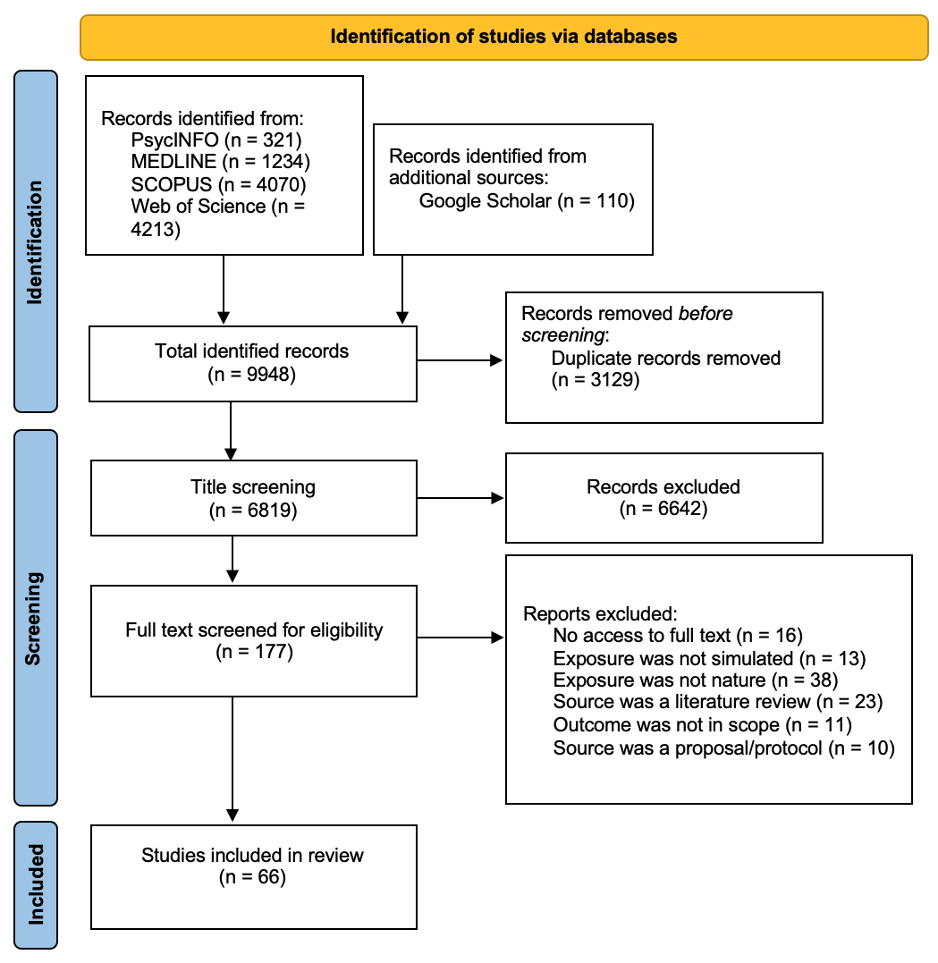

- General characteristics of sources

1.Locations and quality

No included studies had been conducted in low-middle income countries. Studies were predominantly conducted in the Global North, with the majority in Europe (Figure 2).

The studies included were assessed for quality using the EPHPP. Most studies included in this review were assessed as being weak (Figure 2). Only some studies were considered as strong quality (6%). In sum, the general quality of the studies included was poor and therefore the results should be interpreted with caution.

Figure 2. Pie charts showing the distribution of publication locations (left) and the quality of included studies (right).

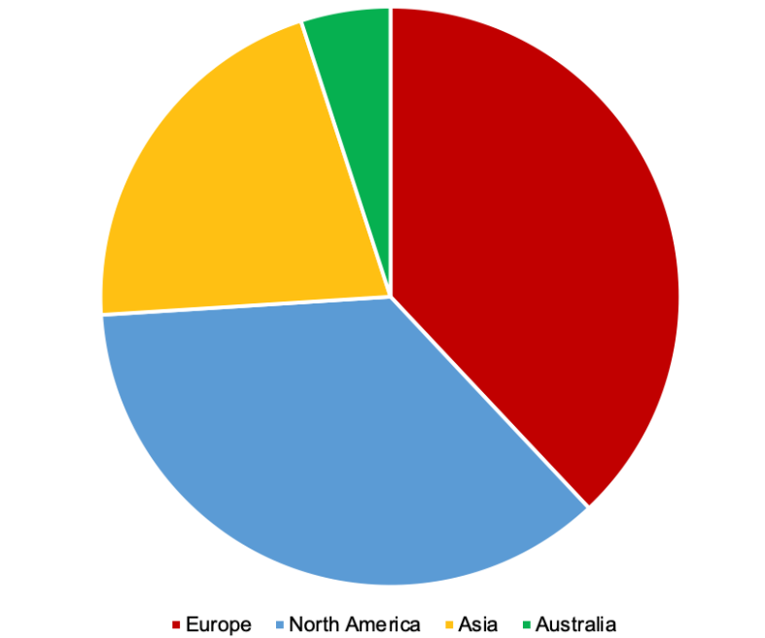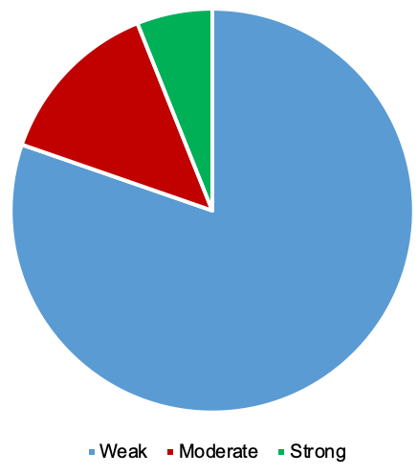
6%
14%
80%
5%
21%
38%
36%

2.Source type

Included studies were predominantly represented by between subject’s designs and RCTs (Figure 3). No study used solely qualitative methods.

Figure 3. Bar chart representing the study designs of included studies.

3.Samples

A broad range of populations and sample sizes were represented. The smallest sample size was 4 participants, and the largest was 444. The median sample size was 60. The studies broadly varied in ages of participants. Almost half of studies used an entirely adult (18+ yrs), non-student population or had a majority. Twenty-four studies consisted of university students, and five involved both university students and staff. One study involved a child population and five studies involved older adults or a sample where older adults (65+ years) were the majority.

4.Simulation

Thirty-five of the studies used VR HMDs as the simulation method. Five studies used VR glasses, one used VR goggles, and one used a VR viewer not requiring HMD. After VR HMDs, the second most commonly used simulation method was videos (excluding 360°) displayed as videotapes, on televisions, and on desktop computer screens. Two studies used 360° videos. Eight studies used projector screens. Two studies used a combination of methods (videos and VR HMDs). Duration of simulation varied. Most studies reported a simulation duration of 5 minutes or less. Twenty-two studies reported exposure length 6-10 minutes. Six studies reported 11-15 minutes, and three studies reported 16-20 minutes. Some studies had longer duration lengths; ten studies reported over 20 minutes. One study did not report duration length, and one study reported that participants were self-paced.

5.Nature exposure

A broad range of natural environments were represented. Most reported exposure to nature through scenes of forests, including woods, and bamboo forests. Seven studies used natural elements in or outside buildings. Other environments included views of coastal paths/scenes, arboretums, gardens, parks, underwater scenes, and beaches. Most studies used several environment exposures. Five studies used a combination of scenes of beaches and greenspaces. Eleven studies used scenes of multiple green spaces. These included open green spaces, gardens, walkways, nature reserves, meadows, hillsides, forests, mountains, parks, roadside vegetation, valleys, and tree canopies. Sixteen studies reported using ‘nature scenes’ which varied in green (forests, mountains, parks, trees, fields, nature island) and blue spaces (bodies of water, riversides, streams, brooks).

- Narrative synthesis - outcomes

Eight studies measured mood as an outcome and seven found beneficial impacts. Some examples are now described. One study investigated exposure to 360° videos and mood (Mostajeran et al., 2021). Viewing a forest helped decrease feelings of fatigue, and mood was more disturbed by urban environment exposure. Gao et al. (2019) measured mood before and after virtual nature exposure. They found an alleviation in negative mood after exposure, but positive mood did not significantly improve. Wang et al. (2020a) exposed a positive association between positive mood scores and a neat undergrowth landscape of the forest. Additionally, positive mood effects have been found after exposure to indoor environments with biophilic elements (Yin et al., 2018). Positive effects have also been found in prison populations (Nadkarni et al., 2021). Incarcerated men felt less anxious and depressed, and calmer after viewing nature videos. Similarly, chemotherapy patients have been found to feel more relaxed, calmer, and more content after viewing VR nature scenes (Wilson & Scorsone, 2021).

Affect after virtual nature exposure was also measured. For example, positive affective states increased after viewing a virtual natural landscape (Reese et al., 2021). Valtchanov et al. (2010) found increased positive affect after using VR. Two studies also found increases in positive affect after participants viewed videotapes of an arboretum, compared to an urban environment (Mayer et al., 2009). However, this positive impact was more substantial after exposure to a real natural environment. Some studies measured levels of affect in participants with depressive symptoms after viewing a forest and a built environment video on a computer (Meuwese et al., 2021). Viewing the forest video reduced negative affect for participants with depressive symptoms, compared to viewing the built environment. McAllister et al. (2017) found increased positive affect and decreased negative affect after viewing a nature video compared to no nature. Calogiuri et al. (2018) measured affect after participants experienced a real nature walk and a virtual comparison. Increased affect was associated with the nature walk, whereas poorer affect was associated with the virtual environment. Calogiuri et al. (2018) attributed this to cyber sickness.

Other studies measured self-reported and physiologically measured anxiety. Wang et al. (2020) found that patients with generalized anxiety disorder (GAD) showed lower galvanic skin responses (a physiological indicator of stress), after exposure to a virtual nature environment compared to a control. Further, Zabini et al. (2020) measured perceived anxiety after exposure to a virtual forest compared to an urban environment. Short term effects for reduced anxiety were seen for those exposed to the virtual forest environment.

Several studies measured multiple outcomes. For example, depressive symptoms of older women were lowered after participation in a group-based programme involving viewing a virtual therapeutic garden (Szczepanska-Gieracha et al., 2021). Browning et al. (2020) found being outdoors in a natural environment and viewing a 360° VR video of nature proved beneficial for increasing arousal and positive moods compared to an indoor environment without nature. One study focused on state social motivation (Castelblanco, 2019). Participants experiencing virtual nature exposure, compared to controls, reported higher levels of state social motivation. Anderson et al. (2017) found reductions in negative affect after VR exposure to natural settings. When comparing 2D nature to VR simulated, participants reported greater levels of positive affect and satisfaction when viewing VR nature (Frewen et al., 2020). Also, when viewing an underwater environment on a computer screen compared to VR, lower levels of anxiety are observed for VR, whereas there is a decline in positive affect for computer screen (Liszio et al., 2018). Moreover, one study measured affect and boredom of participants during exposure to nature through three simulations: 2D video on HD TV, 360-degree VR HMD, or computer-generated VR (Yeo et al., 2020). Negative affect and boredom levels reduced, and positive affect increased across all conditions.

Some studies measured stress and/or relaxation. One study found that virtual nature stimuli evoked a decrease in stress levels in incarcerated individuals (Nadkarni et al., 2021). Further, participants reported lower levels of self-reported stress after a VR nature experience (Reese et al., 2021). Another found that viewing VR nature can also be a distraction at work and significantly reduce GSR and heart rate (Ahmaniemi et al., 2017). Kim et al. (2017) found that higher levels of perceived tranquillity were shown after exposure to environments with more pastoral (quiet, not urban) features. Further, Kim and Lee (2018) reported higher levels of calmness after exposure to a virtual nature environment, compared to an urban or indoor environment. In addition to these studies, other research focuses on restoration from stress (Yin et al., 2020; Yin, 2019; Valtchanov et al., 2010; Schebella et al., 2020; Meuwese et al., 2021; Wang et al., 2019a; Hedblom et al., 2019; Li et al., 2020; Liszio et al., 2018; De Kort et al., 2006).

Two studies found virtual nature to act as a buffer against stress. Chan et al. (2021) investigated exposure to virtual vertical greenery and found that exposure prevented stress, whereas Blum et al. (2019) found that viewing virtual nature to implement immersive heart rate variability biofeedback acted as a buffer to stress compared to a non-VR condition. But some studies found different results. Snell et al. (2019) measured recovery from stress after viewing a perceived live video of nature, a recorded video or control. The results showed stress recovery was similar for the perceived live and recorded video conditions. Further, when compared to 360° videos, photos of urban and forest environments were more effective in reducing stress (Mostajeran et al., 2021).

Further, six studies focused on attention capabilities after virtual nature. Crosson and Salmoni (2021) found significant improvements in directed attention performance after viewing a forest on a 180° projector screen whilst walking on a treadmill. Another study found positive restorative effects on attentional fatigue when viewing natural spaces with VR glasses (Gao et al., 2019). A further two studies showed attentional capacity and the ability to reflect increased for participants viewing a natural environment (Mayer et al., 2009). Snell et al. (2019) measured attention recovery and reported improvements on the Necker Cube Pattern Control task after watching a perceived live video of nature compared to a recorded and control video. One study found significant results with cognitive performance (Mostajeran et al., 2021). Participants made fewer errors on a cognitive task after viewing a virtual forest compared to an urban area. Three studies measured creativity as an outcome; scores on a creativity test improved after viewing virtual indoor office environments with biophilic features environments (Yin et al., 2019).

Self-reported restorativeness was a common outcome. One study involved looking at levels of self-reported presence after viewing virtual nature (Chung, 2018). Participants scoring higher in self-reported presence perceived the environment as more restorative. Further, Chung et al. (2018) showed a negative association between restorativeness scores and fronto-central region P3a amplitudes, a biomarker of attention, after virtual nature exposure. Three studies compared perceived restoration after virtual nature exposure. Virtual nature was rated as more restorative than virtual urban environments (Yu et al., 2020), and this was similar for adults on an ICU (Gerber et al., 2019). Similarly, McAllister et al. (2017) found greater perceived restorativeness after viewing wild nature and urban nature videos. Two studies compared exposure to virtual and real forests (Mattila et al., 2020; Browning et al., 2020). In Mattila et al.’s (2020) study, levels of perceived restorativeness was the same after viewing a virtual forest and being in a physical forest. Similarly, Browning et al. (2020) found that participants rated virtual and physical nature exposure as both being restorative, compared to an indoor control. Finally, Wang et al. (2020) reported increased levels of restorative quality when viewing virtual nature, whereas Tabrizian et al. (2018) found that restorativeness was inversely affected by the spatial arrangement and permeability of the park setting.

Finally, some studies measured walking function in clinical populations after exposure to VR natural environments. Walking ability improved after VR nature exposure (Biffi et al., 2015; Cho et al., 2015). Additionally, pain and exertion were outcomes of some studies. Perceived and experienced levels of pain improved after virtual nature exposure (Gromala et al., 2015; Tanja-Dijkstra et al., 2018), and higher levels of exertion after a virtual nature experience were recorded (Calogiuri et al., 2018).

- Mediators

Overall, five mediators and one moderator were statistically analysed and found to be significant. These included:

- Presence as a mediator for improved positive affect after virtual nature exposure (p < 0.01) (Yeo et al., 2020).
- Presence as a mediator for virtual experiences and emotions (p < 0.05) (Riva et al., 2007).
- Perceived restorativeness as a mediator for improved positive affect after virtual nature exposure (p < 0.001) (McAllister et al., 2017).
- Connectedness to nature as a mediator for improved positive affect and ability to reflect after virtual nature exposure (p < 0.001) (Mayer et al., 2009).
- Perceptions of safety as a mediator for the extent to which enclosure of environment predicts perceived restorativeness (p < 0.001) (Tabrizian et al., 2018).
- Depressive symptoms as a moderator for increased stress reduction after virtual nature exposure (p < 0.001) (Meuwese et al., 2021).

IV. DISCUSSION

- Summary and interpretation

This paper systematically reviewed the literature on the impacts that exposure to virtual nature can have on health and well-being, and aimed to answer two research questions: “What are the impacts of virtual nature exposure on health and well-being?”, and “What are the mechanisms involved that underlie the effects on health and well-being gained from virtual nature exposure?”

The results support that virtual exposure to natural environments could be particularly useful for improving health and well-being for people who cannot access outdoor environments, which supports White et al.’s hypothesis (2018). Virtual nature can act as a practical way to deliver a therapeutic intervention without over-exerting patients or exposing them to the risk of allergic reactions or accidental injuries (Jennings et al., 2019). Prison populations were also highlighted in this review, showing that virtual nature can be an alternative for those in long-term confinement. Afterall, the environment and experience of prison is very influential on prisoner’s ability to rehabilitate afterwards (Söderlund & Newman, 2017). However, physical biophilic elements, such as indoor potted plants, can also be beneficial for health (Nieuwenhuis et al., 2014) and this would be a more cost-effective option to implement in prisons and health care facilities. The results of this review are not consistent with Browning et al.’s (2020a) meta-analyses, which showed that being outdoors in a real setting provides more benefits to mood than viewing a simulated virtual setting. Meta-analyses are a strong analysis method which provide objective and generalisable results, however Browning et al.(2020a) only included experimental data in their review. This may be why the results are inconsistent.

This review also briefly identified five mediators and one moderator that were statistically analysed by some included studies, answering research question 2. Presence was found to be a mediator of improved positive affect after virtual nature exposure, as well as for general virtual experiences and emotions. Presence refers to the feeling of experiencing an illusion of being in a virtual environment without knowing for sure whether you are there (Slater, 2018). Feeling present and in the illusion of the virtual environment can lead to improved positive affect. Perceived restorativeness was also found to be a mediator for improved positive affect. This finding was in line with ART (Kaplan & Kaplan, 1989) and supports a link between restoration and virtual nature. When viewing a natural environment, the extent to which enclosure and feelings of being enclosed predicted perceived restorativeness was mediated by perceptions of safety. Previous literature shows that open space is key as to whether an environment is perceived as safe (Loewen et al., 1993).

The mechanisms described by WHO (2016) are mostly different to the mechanisms regarding virtual nature and health and well-being outcomes presented here. Although one similar mechanism refers to increased restoration and restorativeness can mediate the increases seen in positive affect after exposure to real and virtual natural environments. There are some suggestions for the differences. Firstly, several mechanisms reported by WHO (2016) relate to being physically outdoors. It is likely that these were not found as mechanisms specific to virtual nature due to them not being recognised outcomes with being indoors. Some studies in this review did combine physical activity on treadmills whilst viewing virtual nature (Biffi et al., 2015; Cho et al., 2015), however they did not conduct mediation analyses.

- Limitations

One limitation was that no studies were conducted in low-middle income countries. This may be due to the development of immersive technologies in predominantly high-income countries, but it is essential to know whether virtual nature can have an impact in low-middle income countries, especially as these countries have limited mental health services (Saxena & Maulik, 2003). Another limitation is that only short-term effects of virtual nature exposure were investigated. Many of the studies only used one short dose of virtual exposure. While it is important to understand the short-term impact, if health care practices and therapeutic interventions are going to use virtual exposure as a tool, it is essential to investigate long-term exposure. Furthermore, limited studies conducted mediation or moderation analyses. This highlights the lack of research that has provided an explanation through a mechanism/pathway and provides no structure for practice/policies to use.

The methodology of this review also has limitations. The majority of studies were rated as ‘weak’ in quality, and so should be interpreted with caution. Although the aim was to provide an overview of the various study designs that have been used, this means that the methods used are not reliable. In addition, while qualitative studies were searched for, none were eligible for this review. There is a gap to investigate qualitatively how different populations experience virtual nature exposure.

- Implications

It is imperative that future research incorporates mediation analyses into their methodologies so to explain the links between health and well-being outcomes and virtual nature exposure. There may be more mechanisms that explain outcomes which are known due to the lack of analyses conducted. Also, future research needs to qualitatively investigate the same field. Researchers could understand more about how participants think/feel whilst experiencing virtual nature. This review can be improved by following a more rigorous methodology and presenting a statistical synthesis of results and formally assess trustworthiness of results reported in included studies. Furthermore, there are new methods in health care practices that involve ‘green social prescribing’ (NHS, 2021). This is a prescription for patients to go outdoors and have physical engagement with nature for physical and mental health benefits. Virtual nature could follow a similar trajectory, and if consistently found to be beneficial for patients with limited mobility, it has potential to become a prescription for mental health. This research has further importance especially in relation to the recent COVID-19 pandemic when stay-at-home orders were enforced. Virtual nature exposure could be especially helpful in these situations, and similar, when access to real environments is limited.

V. CONCLUSION

There is extensive support for exposure to nature being beneficial for health and well-being, and some studies advocate real nature as irreplaceable exposure. However, literature is showing virtual nature exposure to be a beneficial alternative exposure for populations with limited mobility. This review presented studies which have shown beneficial impacts on a broad range of outcomes. This synthesis has shown potential to use virtual nature exposure in general settings, as well as clinical and therapeutic interventions. Immersive technologies can be integrated into a range of settings where they can be used to benefit physical and mental health. But some studies have shown no impact or negative impacts of virtual exposure namely due to the risks of technology usage (e.g. cybersickness) which should be taken into consideration. Furthermore, caution should be taken with extensive use of these technologies as long-term impact is unknown.

This review provides a beginning for future studies to investigate the long-term effects of exposure, and the underlying mechanisms. This could inform policy and allow for these technological methods to be used to their optimum in improving health and well-being.

REFERENCES

Ahmaniemi, T., Lindholm, H., Muller, K., & Taipalus, T. (2017). Virtual Reality Experience as a Stress Recovery Solution in Workplace. IEEE Life Sciences Conference (LSC). 2017-January, 206-209.

Anderson, A., Fellows, A.M., Cowan, D.R., & Buckley, J.C. (2017). Relaxation with Immersive Natural Scenes Presented Using Virtual Reality. Aerospace Medicine and Human Performance. 88(6), 520-526.

Biffi, E., Beretta, E., Diella, E., Panzeri, D., Turconi, A.C., Strazzer, S., et al (2015). Gait rehabilitation with a high tech platform based on virtual reality conveys improvements in walking ability of children suffering from acquired brain injury. Annu Int Conf IEEE Eng Med Biol Soc. 7406-9.

Blum, J., Rockstroh, C., & Göritz, A. S. (2019). Heart rate variability biofeedback based on slow-paced breathing with immersive virtual reality nature scenery. Frontiers in Psychology, 10, 2172.

Browning, M.H., Saeidi-Rizi, F., McAnirlin, O., Yoon, H., & Pei, Y. (2021). The Role of Methodological Choices in the Effects of Experimental Exposure to Simulated Natural Landscapes on Human Health and Cognitive Performances: A Systematic Review. Environment and Behavior. 53(7), 687-731.

Browning, M.H., Mimnaugh, K. J., van Riper, C. J., Laurent, H. K., & LaValle, S. M. (2020). Can simulated nature support mental health? Comparing short, single-doses of 360-degree nature videos in virtual reality with the outdoors. Frontiers in psychology, 10, 2667.

Browning, M.H., Shipley, N., McAnirlin, O., Becker, D., Yu, C.P., Hartig, T., et al. (2020a). An actual natural setting improves mood better than its virtual counterpart: A meta-analysis of experimental data. Frontiers in psychology. 11, 2200.

Buchholz, K. (2020). How has the world’s urban population changed from 1950 to today? World Economic Forum. Retrieved from: https://www.weforum.org/agenda/2020/11/global-continent-urban-population-urbanisation-percent/ [Accessed 10 September 2021].

Calogiuri, G., Litleskare, S., Fagerheim, K. A., Rydgren, T. L., Brambilla, E., & Thurston, M. (2018). Experiencing nature through immersive virtual environments: Environmental perceptions, physical engagement, and affective responses during a simulated nature walk. Frontiers in psychology, 8, 2321.

Castelblanco, S. A. (2021). The Effects of Virtual Nature Exposure on State Social Motivation. Electronic Theses and Dissertations. Paper 3860.

Chan, S.H.M., Qiu, L., Esposito, G., & Mai, K.P. (2021). Vertical greenery buffers against stress: Evidence from psychophysiological responses in virtual reality. Landscape and Urban Planning. 213(104127).
Cho, K.H., Kim, M.K., Lee, H-J., & Lee, W.H. (2015). Virtual Reality Training with Cognitive Load Improves Walking Function in Chronic Stroke Patients. Tohoku J. Exp. Med. 236, 273-280.
Chung, K. (2018). MMN/P3a complex: A distinct event-related potential (ERP) biomarker of involuntary attention restoration during exposure to virtual nature in healthy adults. Available from: Research Gate.

Crossan, C., & Salmoni, A. (2021). A Simulated Walk in Nature: Testing Predictions From the Attention Restoration Theory. Environment and Behaviour. 53(3), 277-295.

De Kort, Y.A.W., Meijnders, A.L., Sponselee, A.A.G., & IJsselsteijn, W.A. (2006). What’s wrong with virtual trees? Restoring from stress in a mediated environment. Journal of Environmental Psychology. 26, 309-320.

Frewen, P., Mistry, D., Zhu, J., Kielt, T., Wekerle, C., Lanius, R. A., et al (2020). Proof of concept of an eclectic, integrative therapeutic approach to mental health and well-being through virtual reality technology. Frontiers in Psychology. 11, 858.

Gao, T., Zhang, T., Zhu, L., Gao, Y., & Qiu, L. (2019). Exploring Psychophysiological Restoration and Individual Preference in the Different Environments Based on Virtual Reality. International Journal of Environmental Research and Public Health. 16, 3102.

Gerber, S. M., Jeitziner, M. M., Sänger, S. D., Knobel, S. E., Marchal-Crespo, L., Müri, R. M., et al. (2019). Comparing the relaxing effects of different virtual reality environments in the intensive care unit: observational study. JMIR perioperative medicine. 2(2), e15579.

Gromala, D., Tong, X., Choo, A., Karamnejad, M., & Shaw, C. D. (2015, April). The virtual meditative walk: virtual reality therapy for chronic pain management. In Proceedings of the 33rd Annual ACM Conference on Human Factors in Computing Systems (pp. 521-524).

Hedblom, M., Gunnarsson, B., Iravani, B., Knez, I., Schaefer, M., Thorsson, P., & Lundström, J. N. (2019). Reduction of physiological stress by urban green space in a multisensory virtual experiment. Scientific reports. 9(1), 1-11.

Jennings, V., Browning, M.H.E.M., & Rigolon, A. (2019). Friend or Foe? An Overview of the Services and Disservices from Urban Green Spaces. In: Urban Green Spaces. SpringerBriefs in Geography. Springer Cham.

Jiang, B., He, J., Chen, J., Larsen, L., & Wang, H. (2021). Perceived Green at Speed: A Simulated Driving Experiment Raises New Questions for Attention Restoration Theory and Stress Reduction Theory. Environment and Behavior. 53(3), 296-335.

Kaplan, S. (1995). The restorative benefits of nature: Toward an integrative framework. Journal of Environmental Psychology. 15 169-182.

Kaplan, R., & Kaplan, S. (1989). The experience of nature: A psychological perspective. Cambridge University Press, New York.

Kim, J., Kil, N., Holland, S., & Middleton, W. K. (2017). The effect of visual and auditory coherence on perceptions of tranquility after simulated nature experiences. Ecopsychology. 9(3), 182-189.

Kim, T., & Lee, S. (2018, February). Restorative Effects of Exercise in Virtual Environments. In Proceedings of the 9th Augmented Human International Conference (pp. 1-3).

Li, C., Sun, C., Sun, M., Yuan, Y., & Li, P. (2020). Effects of brightness levels on stress recovery when viewing a virtual reality forest with simulated natural light. Urban Forestry & Urban Greening. 56. 126865.

Liszio, S., Graf, L., & Masuch, M. (2018). The Relaxing Effect of Virtual Nature: Immersive Technology Provides Relief in Acute Stress Situations. In B.K. Wiederhold, G. Riva, and S. Bouchard (Eds.), Annual Review of Cyber Therapy and Telemedicine (pp. 87-93). USA: Interactive Media Institute.

Loewen, L.J., Steel, G.D., & Suedfeld, P. (1993). Perceived safety from crime in the urban environment. Journal of Environmental Psychology. 13(4), 323-331.

Maes, M.J., Pirani, M., Booth, E.R., Shen, C., Milligan, B., Jones, K.E., et al. (2021). Benefit of woodland and other natural environments for adolescents’ cognition and mental health. Nature Sustainability. 1-8.

Mattila, O., Korhonen, A., Pöyry, E., Hauru, K., Holopainen, J., & Parvinen, P. (2020). Restoration in a virtual reality forest environment. Computers in Human Behavior. 107, 106295.

Mayer, F.S., McPherson Frantz, C., Bruehlman-Senecal, E., & Dolliver, K. (2009). Why is Nature Beneficial? The Role of Connectedness to Nature. Environment and Behavior. 41(5), 607-643.

McAllister, E., Bhullar, N., & Schutte, N.S. (2017). Into the Woods or a Stroll in the Park: How Virtual Contact with Nature Impacts Positive and Negative Affect. International Journal of Environmental Research and Public Health. 14, 786.

Meuwese, D., Dijkstra, K., Maas, J., & Koole, S.L. (2021). Beating the blues by viewing Green: Depressive symptoms predict greater restoration from stress and negative affect after viewing a nature video. Journal of Environmental Psychology. 75, 101594.

Moher, D., Liberati, A., Tetzlaff, J., & Altman, D.G. (2009). Preferred reporting items for systematic reviews and meta-analyses: the PRISMA statement. British Medical Journal. 339, b2535.

Mostajeran, F., Krzikawski, J., Steinicke, F., & Kühn, S. (2021). Effects of exposure to immersive videos and photo slideshows of forest and urban environments. Scientific Reports. 11(1), 1-14.

Nadkarni, N.M., Thys, T.M., Ruff, J.S., Anholt, A., Treviño, J., & Yeo, S.K. (2021). Providing Virtual Nature Experiences to Incarcerated Men Reduces Stress and Increases Interest in the Environment. Ecopsychology. 13(2), 71-83.

National Health Service (NHS). (2021). Green social prescribing. Retrieved from: https://www.england.nhs.uk/personalisedcare/social-prescribing/green-social-prescribing/ [Accessed 10 September 2021].

Nieuwenhuis, M., Knight, C., Postmes, T., & Haslam, S.A. (2014). The relative benefits of green versus lean office space: Three field experiments. Journal of Experimental Psychology: Applied. 20, 199-214.

Ohly, H., White, M.P., Wheeler, B.W., Bethel, A., Ukoumunne, O.C., Nikolaou, V., et al. (2016). Attention Restoration Theory: A systematic review of the attention restoration potential of exposure to natural environments. Journal of Toxicology and Environmental Health. Part B, 19(7), 305-343.

Page, M.J., McKenzie, J.E., Bossuyt, P.M., Boutron, I., Hoffmann, T.C., Mulrow, C.D., et al. (2021). The PRISMA statement: an updated guideline for reporting systematic reviews. BMJ. 372(71).

Public Health England (2020). Improving access to greenspace. A new review for 2020. Public Health England. Retrieved from: https://assets.publishing.service.gov.uk/government/uploads/system/uploads/attachment_data/file/904439/Improving_access_to_greenspace_2020_review.pdf [Accessed 23 August 2021].

Reese, G., Kohler, E., & Menzel, C. (2021). Restore or Get Restored: The Effect of Control on Stress Reduction and Restoration in Virtual Nature Settings. Sustainability. 13, 1995.

Reynolds, L., Rogers, O., Benford, A., Ingwaldson, A., Vu, B., Holstege, T., et al. (2020). Virtual Nature as an Intervention for Reducing Stress and Improving Mood in People with Substance Use Disorder. Journal of Addiction. 2020, 1892390.

Riva, G., Mantovani, F., Capideville, C. S., Preziosa, A., Morganti, F., Villani, D., et al. (2007). Affective interactions using virtual reality: the link between presence and emotions. Cyberpsychology & behavior. 10(1), 45-56.

Saxena, S., & Maulik, P.K. (2003). Mental health services in low- and middle-income countries: an overview. Current Opinion in Psychiatry. 16(4), 437-442.

Scates, D., Dickinson, J.I., Sullivan, K., Cline, H., & Balaraman, R. (2020). Using Nature-Inspired Virtual Reality as a Distraction to Reduce Stress and Pain Among Cancer Patients. Environment and Behaviour. 52(8), 895-918.

Schebella, M.F., Weber, D., Schultz, L., & Weinstein, P. (2019). The Nature of Reality: Human Stress Recovery during Exposure to Biodiverse, Multisensory Virtual Environments. International Journal of Environmental Research and Public Health. 17, 56.

Sjölander, A., Ung, E.J., Theorell, T., Nilsson, A., & Ung, K-A. (2019). Hospital Design with Nature Films Reduces Stress-Related Variables in Patients Undergoing Colonoscopy. Health Environments Research & Design Journal. 12(4), 186-196.

Slater, M. (2018). Immersion and the illusion of presence in virtual reality. British Journal of Psychology. 109, 431-433.

Snell, T.L., McLean, L.A., McAsey, F., Zhang, M., & Maggs, D. (2019). Nature Streaming: Contrasting the Effectiveness of Perceived Live and Recorded Videos of Nature for Restoration. Environment and Behavior. 51(9-10), 1082-1105.

Söderlund, J., & Newman, P. (2017). Improving Mental Health in Prisons Through Biophilic Design. The Prison Journal. 97(6), 750-772.

Szczepánska-Gieracha, J., Cieślik, B., Serweta, A., & Klajs, K. (2021). Virtual Therapeutic Garden: A Promising Method Supporting the Treatment of Depressive Symptoms in Late-Life: A Randomized Pilot Study. Journal of Clinical Medicine. 10, 1942.

Tabrizian, P., Baran, P.K., Smith, W.R., & Meentemeyer, R.K. (2018). Exploring perceived restoration potential of urban green enclosure through immersive virtual environments. Journal of Environmental Psychology. 55, 99-109.

Tanja-Dijkstra, K., Pahl, S., White, M.P., Auvray, M., Stone, R.J., Andrade, J., et al. (2018). The Soothing Sea: A Virtual Coastal Walk Can Reduce Experienced and Recollected Pain. Environment and Behavior. 50(6), 599-625.

Thomas, B.H., Ciliska, D., Dobbins, M., & Micucci, S. (2004). A process for systematically reviewing the literature: Providing the research evidence for public health nursing interventions. Worldviews on Evid Based Nurs. 1(3), 176-184.

Ulrich, R.S. (1981). Natural versus urban scenes: Some psychophysiological effects. Environment and Behavior. 13, 523-556.

Van den Berg, A.E., Joye, Y., & de Vries, S. (2018). Health benefits of Nature. In: Steg, L., de Groot, J.I.M. (Eds) Environmental Psychology: An Introduction. (pp. 55-64) Wiley.

Valtchanov, D., Barton, K.R., & Ellard, C. (2010). Restorative Effects of Virtual Nature Settings. Cyberpsychology, Behaviour, and Social Networking. 13(5).

Wang, X., Shi, Y., Zhang, B., & Chiang, Y. (2019a). The Influence of Forest Resting Environments on Stress Using Virtual Reality. International Journal of Environmental Research and Public Health. 16, 3263.

Wang, T-C., Sit, C. H-P., Tang, T-W., & Tsai, C-L. (2020). Psychological and Physiological Responses in Patients with Generalized Anxiety Disorder: The Use of Acute Exercise and Virtual Reality Environment. International Journal of Environmental Research and Public Health. 17, 4855.

Wang, Y., Jiang, M., Huang, Y., Sheng, Z., Huang, X., Lin, W., et al. (2020a). Physiological and Psychological Effects of Watching Videos of Different Durations Showing Urban Bamboo Forests with Varied Structures. International Journal of Environmental Research and Public Health. 17, 3434.

White, M.P., Yeo, N.L., Vassilijev, P., Lundstedt, R., Wallergård, M., Albin, M., & Lõhmus, M. (2018). A prescription for “nature” – the potential of using virtual nature in therapeutics. Neuropsychiatric disease and treatment. 14, 3001-3013.

Wilson, K., & Scorsone, G. (2021). The Use of Virtual Reality Technologies to Reduce Anxiety and Improve Experience in Chemotherapy Patients During Treatment. Frontiers in Virtual Reality. 2, 88.

World Health Organization. (2016). Urban green spaces and health. A review of evidence. Copenhagen: WHO European Regional office. Available from: https://www.euro.who.int/__data/assets/pdf_file/0005/321971/Urban-green-spaces-and-health-review-evidence.pdf [Accessed 11 August 2021].

Yeo, N.L., White, M.P., Alcock, I., Garside, R., Dean, S.G., Smalley, A.J., et al. (2020). What is the best way of delivering virtual nature for improving mood? An experimental comparison of high definition TV, 360 video, and computer generated virtual reality. Journal of Environmental Psychology. 72, 101500.

Yin, J. (2019). Bringing Nature Indoors with Virtual Reality: Human Reponses to Biophilic Design in Buildings (Doctoral dissertation, Harvard University).

Yin, J., Zhu, S., MacNaughton, P., Allen, J.G., & Spengler, J.D. (2018). Physiological and cognitive performance of exposure to biophilic indoor environment. Building and Environment. 132, 255-262.

Yin, J., Arfaei, N., MacNaughton, P., Catalano, P. J., Allen, J. G., & Spengler, J. D. (2019). Effects of biophilic interventions in office on stress reaction and cognitive function: A randomized crossover study in virtual reality. Indoor Air. 29(6), 1028-1039.

Yin, J., Yuan, J., Arfarei, N., Catalano, P.J., Allen, J.G., & Spengler, J.D. (2020). Effects of biophilic indoor environment on stress and anxiety recovery: A between-subjects experiment in virtual reality. Environment International. 136, 105427.

Yu, C-P., Lee, H-Y., Lu, W-H., Huang, Y-C., & Browning, M.H.E.M. (2020). Restorative effects of virtual natural settings on middle-aged and elderly adults. Urban Forestry & Urban Greening. 56, 126863.

Zabini, F., Albanese, L., Becheri, F.R., Gavazzi, G., Giganti, F., Giovanelli, F., et al. (2020). Comparative Study of the Restorative Effects of Forest and Urban Videos during COVID-19 Lockdown: Intrinsic and Benchmark Values. International Journal of Environmental Research and Public Health. 17, 8011.

