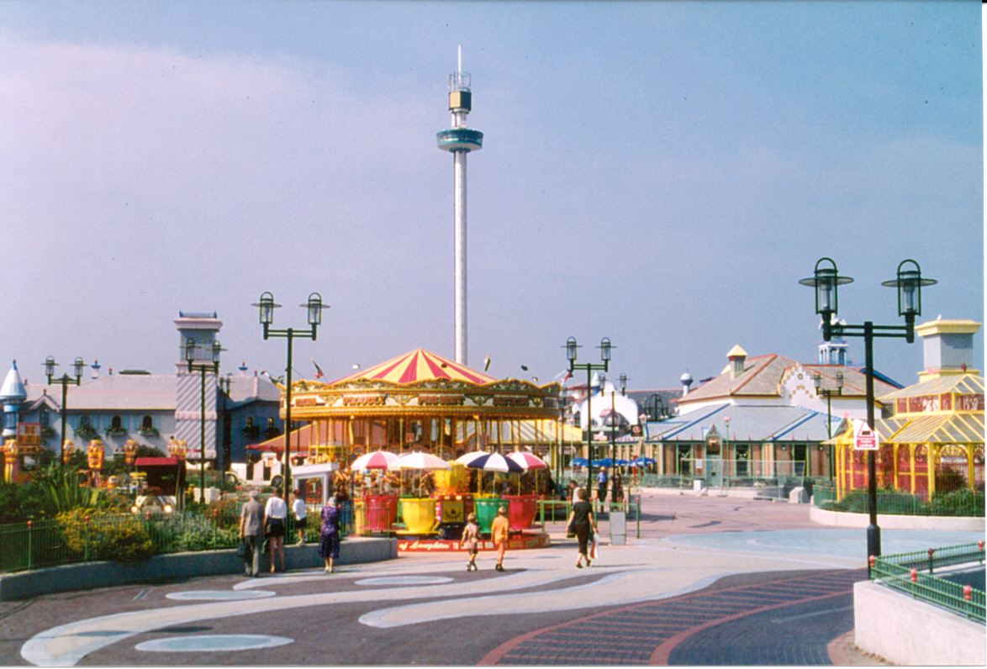
Figure 3 Children’s Village, Rhyl (photograph by author)

