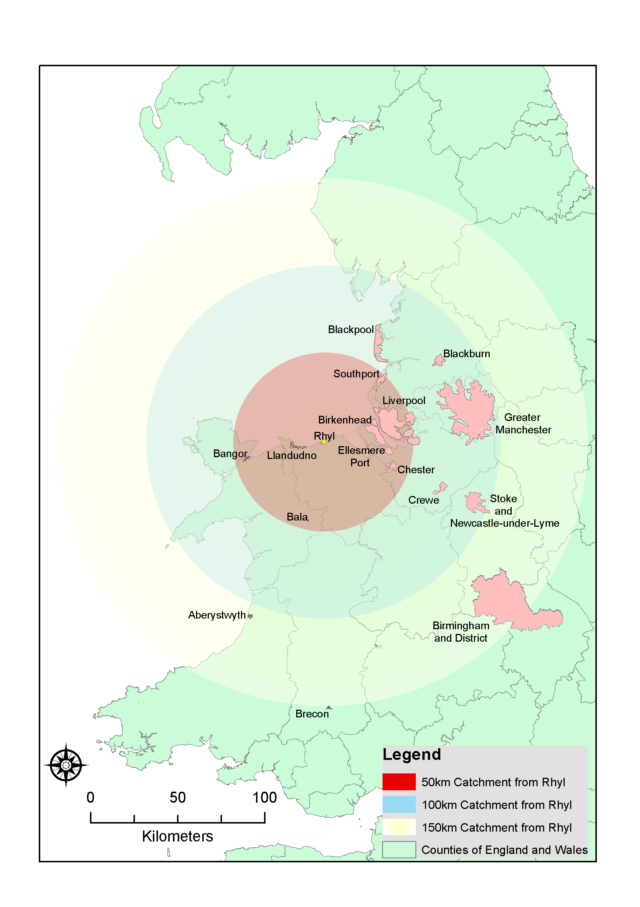
Figure 1 Map of Wales and the west of England, showing location of Rhyl in relation to selected source markets and competitor destinations

