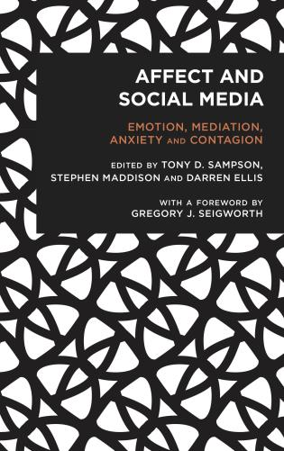

[https://rowman.com/ISBN/9781786604385/Affect-and-Social-Media-Emotion-Mediation-Anxiety-and-Contagion#](https://rowman.com/ISBN/9781786604385/Affect-and-Social-Media-Emotion-Mediation-Anxiety-and-Contagion)

See Reviews:

Social media play an outsized role in our emotional lives. They continually modulate our moods and feelings. They transmit vague sensations that run through us like an infection or contagion. In order to take the measure of social media today, the essays in this volume combine empirical research with far-ranging speculation, offering us analyses that are at once surprising and disturbingly familiar.  
**— Steven Shaviro, DeRoy Professor of English, Wayne State University**  
  
  
Sampson, Ellis and Maddison’s collection is crucial to any understanding of contemporary digital culture. Bringing together many directions of affect theory, theorising across a radical plurality of sites, they skilfully hold on to a vital coherence through critical affect studies inspired by feminist and queer theory and by core contributors in the field (e.g. Clough, Gregg, Seigworth, Paasonen).  
**— Kate O'Riordan, Professor of Digital Culture at the University of Sussex**  
  
  
This is a thought-provoking, occasionally scary, and thoroughly fascinating exploration into the complex networked intensities within which we operate. Spanning from pedagogy to pornography, and beyond, it comes with an international focus and a profoundly interdisciplinary analytical range that make it recommended reading for all interested in understanding the key role that social media plays is contemporary culture.​  
**— Susanna Paasonen, Professor of Media Studies at the University of Turku**