A health map for the local human habitat
Hugh Barton and Marcus Grant
WHO Collaborating Centre for Health Cities and Urban Policy, University of the West of England, Bristol.

Published as: Barton, H. and Grant, M., (2006) A health map for the local human habitat, Journal of the Royal Society for the Promotion of Public Health, 126 (6) pp252-261.

At the 2006 UK Public Health Association Conference, held in Telford in March, and the International HIA conference in Cardiff in the same month, there was much interest in a new model of health determinants applied to the planning of human settlements. This ‘health map’ is presented here in its current form for the first time. The authors explain its purpose.

The environment in which we live is a major determinant of health and well-being. Modern town planning originated in the nineteenth century in response to basic health problems, but in the intervening years has become largely divorced from health. We have been literally building unhealthy conditions into our local human habitat. Recent concerns about levels of physical activity, obesity, asthma and increasing environmental inequality have put planning back on the health agenda. It is widely recognised that public health is being compromised by both the manner of human intervention in the natural world and the manner of development activity in our built environment (Larkin, 2003). However, taking action is not necessarily simple. The links between health and settlements are often indirect and complex. A tool to improve understanding and foster collaboration between planning and health decision-makers is badly needed.

The good news is that the impact of the natural and built environments on health is receiving increasing focus from both public health professionals and spatial planners. On the one hand, for example, the UK Public Health Association (UKPHA) has set up a Strategic Interest Group (StIG) for natural and built environment. This group devised a well-attended themed strand of some nine papers and a workshop at the recent UKHPA Annual Forum. In the spatial planning fraternity indications of interest can be seen in the recent Royal Town Planning Institute conference on Spatial Planning and Health (16th February, Birmingham). To some extent this is being supported by legislative changes such as the introduction of Community Strategies and the new planning act (Planning and Compulsory Purchase Act 2004), which gives more emphasis on cross-sectoral work.

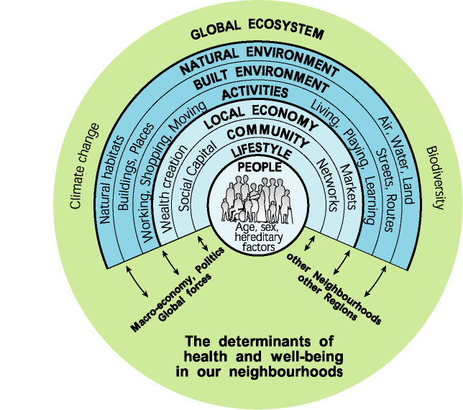

Figure 1: The health map

The new health map presented in Figure 1 has obvious and intentional antecedents in the health literature - Whitehead and Dahlgren’s much-quoted 1991 diagram that shows the relationship between health and the physical/social/ economic environment. The other inspiration came from eco-system theories and the principle of sustainable development (see Barton et al 1995). Working as spatial planners advising the WHO Healthy Cities movement, the authors have tested, developed and re-tested a visual tool for both communicating and analysing the health / settlement relationship (Barton, Grant and Guise, 2003; Barton, 2005). This version of the health map consolidates previous work. It has been refined through comments from members of the UKPHA StIG (including the Commission for Architecture in the Built Environment, English Nature, Countryside Council for Wales and Groundwork Trust), as well as WHO Healthy Cities and many individuals . The health map has been designed as a dynamic tool that provides a basis for dialogue and provokes enquiry. It has been deliberately composed to provide a focus for collaboration across practitioner professions – such as planners, public health, service providers, ecologists, urban designers and across topics transport, air quality, community development, economic development.

People are at the heart of the map, reflecting not only the focus on health, but also the anthropogenic definition of sustainable development (Brundtland, 1987). All the different facets of a human settlement are reflected in the series of spheres which move through social, economic and environmental variables. The settlement is set within its bioregion and the global ecosystem on which it ultimately depends. Broader cultural, economic and political forces which impact on well-being are represented. Thus all the elements of the original Whitehead and Dahlgren diagram of the determinants of health are included, spread out to reflect the ecosystem of the local human habitat.

The urban development process, and more particularly the design and planning of settlements, reside in one sphere – the built environment. Thus planners can see their place in determining health. In direct terms, they can affect the quality of that environment, for example, housing. But the importance of the model is that it can be used to analyse the knock-on effects which are often much more significant in terms of health. Take a new road, for example, : the pattern of human activity – travel behaviour and destinations – is changed. Activity in turn impacts on the local natural environment (e.g. air pollution) and the global ecosystem (greenhouse emissions). It also affects local economic efficiency and people’s lifestyle choices (the likelihood of walking or driving). Lifestyle changes may well impact on the pattern of social networks. It is apparent that every sphere representing health determinants – except the inherited characteristics - is impacted to a certain extent. The model can help distinguish these processes and contribute to sustainability and health impact assessment.

A fuller presentation of the health map from the health perspective will appear in a later edition of this Journal. For an explanation from the perspective of planning theory, a recent paper in Built Environment 31,4 (Barton 2005), outlines some important developmental steps.. Further comments on the diagram and its potential use are welcome.

References
Barton, H. 2005, A health map for human settlements, Built Environment, 31, 4, pp339-355
Larkin, M., 2003, Can cities be designed to fight obesity, The Lancet, 362, pp1046-7
Barton, H., Grant, M. and Guise, R. (2003) Shaping Neighbourhoods. Spon, London
Whitehead, M. and Dahlgren, C. (1991) "What can we do about inequalities in health". The Lancet. 338: 1059-1063
Barton H, Davis G and Guise R (1995) Sustainable Settlements – a guide for planners, designers and developers LGMB and UWE, Bristol
Brundtland G (1987) Our Common Future, World Commission on Environment and development, Oxford University Press, Oxford

