TEN YEARS OF LOCAL AIR QUALITY MANAGEMENT EXPERIENCE IN THE UK: AN ANALYSIS OF THE PROCESS
T.J. Chatterton, J.W.S. Longhurst, N.S. Leksmono, E.T. Hayes and J.K. Symons

Air Quality Management Resource Centre, University of the West of England, Frenchay Campus, Coldharbour Lane, Bristol, BS16 1QY, United Kingdom.
Tel: +44-117-328-3825. Fax: +44-117-328-2132
Email address: aqmrc@uwe.ac.uk http://www.uwe.ac.uk/aqm/

Abstract

For over ten years the UK has operated a Local Air Quality Management process to determine the relationship between air quality work carried out by local and national governments. LAQM in the UK is a dynamic process subject to continuing review that allows it to reflect developments in European legislation, technological and scientific advances, improved dispersion modelling techniques and an increasingly better understanding of the socio-economic issues involved in reducing air pollution. LAQM is an outcome based activity, it guides Local Authorities to determine the likelihood of exceedences of Air Quality Objectives, and, where these are considered likely, it forces the authority to develop an Action Plan to deal with the problem. This is in contrast to processes such as Environmental Impact Assessment which can be seen as process orientated and do not guide the process towards a specific decision, action or judgement. LAQM should be considered as much more than the simple legal framework controlling this process and should be seen as a complete package including all the support tools and other activities that ensure the effectiveness and efficiency of the regieme. Whilst the process of LAQM, described here, has been developed for the UK, the generic elements of the process are applicable to other countries challenged by air pollution problems which require both national and local action to resolve them.

Introduction
At the start of the 21st Century there is a wide range of both social and environmental threats that need to be managed in order to protect public health in the United Kingdom. There are many synergies (often both subtle and complex) between all of these threats and so public health strategies must seek to regulate and manage these synergies in an effective and efficient manner.
Traditionally environmental threats have been separated into the three core media of Air, Land and Water. Each of these can be broken down into sub-groupings e.g. for Air these might include not only conventional air pollution but also noise, light and greenhouse gas emissions.

Multi-threat Assessment
There are various tools, statutory and non-statutory, used within regulatory or planning processes that help to evaluate the effects of individual developments or of Plans, Polices and Programmes on public health and other areas such as eco-systems. These include: Environmental Impact Assessment, Strategic Environmental Assessment, Sustainability Appraisal and Health Impact Appraisal.
However, with many of these tools, assessments of effects can be made that will indicate the likely existence of negative impacts, but the outcomes may not necessarily carry sufficient weight to prevent the actions going ahead or force mitigation of the negative effects. One of the key reasons for this is that these assessments tend to focus on process rather than decision based outcomes (Cashmore 2004) . They are not designed to produce a qualitative outcome indicating whether effects can be considered ‘acceptable’ or ‘non-acceptable’ and often simply catalogue the extent of impacts that will be endured if the decision making process doesn’t ensure that mitigation measures are covered by compulsory conditions.

Local Air Quality Management as the focussed tackling of a ‘single’ threat
The 1995 Environment Act (HM Government 1995) introduce a system for managing ambient air quality in the UK based on Standards and Objectives (described in more detail below and illustrated in Table 1Table 1 , Local Authorities in the UK have been required to identify those areas in which air quality objectives will be exceeded and to declare these locations as Air Quality Management Areas (AQMA). Following this a Local Authority must develop an Air Quality Action Plan in order to achieve the objectives through mitigation and management measures. This process is currently overseen and managed by the Department for Environment, Food and Rural Affairs (Defra) in England and the Devolved Administrations in other parts of the UK (the Welsh Assembly Government, the Scottish Government, and the Department of Environment, Northern Ireland).
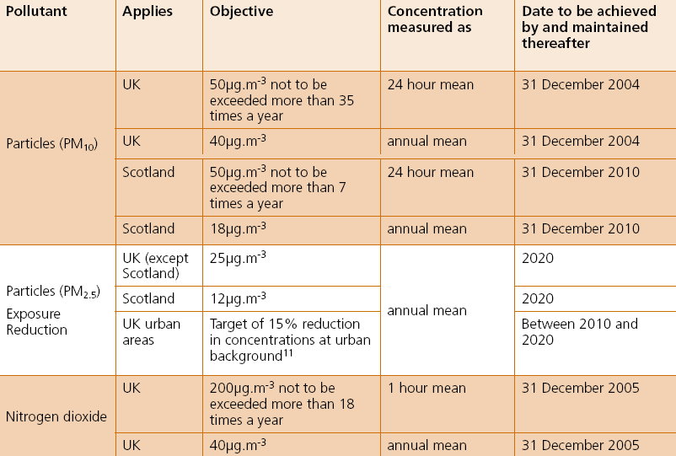Table 1: UK Air Quality Standards and Objectives for Particles and Nitrogen Dioxide (Defra 2007)
The first round of the review and assessment process concluded in 2001 with some 119 Local Authorities declaring AQMAs. At the end of Round 2 (2004), some 192 Local Authorities had declared AQMAs and by December 2006, several months into Round 3 the total had risen to over 200 and is expected to rise yet further still (see Figure 1). These AQMAs have principally been declared with regard to annual mean nitrogen dioxide concentrations. A significant number have also been declared for particulate matter and sulphur dioxide, and just one Local Authority has declared an AQMA for benzene.

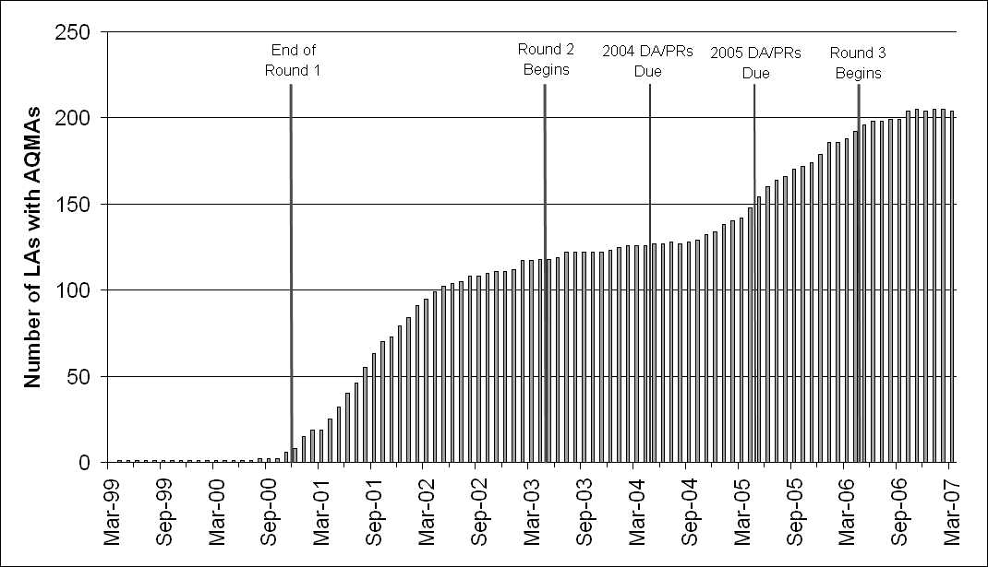
Figure 1: Number of Local Authorities with Air Quality Management Areas March 1999-2007
The current UK Local Air Quality Management process can be seen as a strong example of good public health orientated environmental management, setting out a risk-based framework, leading to targeted, proportionate and cost effective actions focussed on a single area of the environment. The system is independent of the European Union’s legislation, as the EU only has the ability to interact with national (Member State) governments. However, the LAQM system is one of the means by which the UK governments seek to ensure their compliance with European regulation.

The Strengths of the Process
Within the UK LAQM system, there are a number of key features of the process that can be identified.

Clear health-based standards. These standards are established within the UK’s Air Quality Strategy and are defined as “the concentrations of pollutants in the atmosphere which can broadly be taken to achieve a certain level of environmental quality….based on assessment of the effects of each pollutant on human health including the effects on sensitive subgroups or on ecosystems” (Defra 2007c). The standards were established on the basis of scientific evidence assessed by the Expert Panel on Air Quality Standards (EPAQS) under the auspices of Defra (or the previous environment ministries). This group has now been subsumed into the Committee on the Medical Effects of Air Pollutants (COMEAP), under the Department of Health as there is less perceived need to establish independent UK standards due to “the rise in the importance of the European air quality management process”. These standards can potentially be interpreted as indicating what the government would consider ‘acceptable’ and ‘unacceptable’ levels of air pollution in an ideal world. For example, the short-term air quality standard for PM₁₀ is set at 50µg/m³ as a 24-hour running mean. Although it is accepted that the non-threshold nature of PM pollution means that it is not possible to set a cut-off point below which there are no effects, this level has been set by EPAQS at a concentration “which, in its judgement, would minimise the health impacts on the [UK] population” (DoE 1997).

Pragmatic Objectives are also laid out within the UK Air Quality Strategy. These are based on the standards described above, but they take into account technical and economic considerations. They are defined as “policy targets often expressed as a maximum ambient concentration not to be exceeded, either without exception or with a permitted number of exceedences, within a specified timescale” (Defra 2007). Currently the UK has a short-term PM₁₀ objective for achievement by 2004 set at a daily (24-hour midnight to midnight) concentration of 50µg/m³ with an allowance of 35 exceedences per year (the 99th percentile). Due to lower exposure to transboundary (especially secondary) particles, Scotland has chosen to implement a more stringent set of objectives for achievement by 2010. This sets the daily PM₁₀ target at 50µg/m³ with only 7 exceedences per year. The UK has also established an annual mean objective for PM₁₀. This has been based on the European Limit Value rather than work by EPAQS, and this is currently set at an annual mean of 40µg/m³ for achievement by 2004. Similar to the short-term mean, Scotland has also set a more stringent annual objective for achievement by 2010 of 18µg/m³.

Sound science to assess risk and promote cost-effective action. The original UK Air Quality Strategy (DoE 1997) set out 9 key principles for UK air quality policy. These were: Sustainability, Effects-based approach, Risk assessment, Sound science, Proportionality, Polluter pays principle, Precautionary principle, Subsidiarity and Effective international monitoring and enforcement. These principles have allowed the development of a system in the UK that steers Local Authorities through a staged ‘Review and Assessment’ process, only undertaking work proportional to the risk of exceedences of the air quality objectives occurring. The process was initially established as a three stage process, but currently trimmed down to two stages: a regular Updating and Screening Assessment and a Detailed Assessment. The first stage is a primarily desk based study that requires the Local Authority to examine local monitoring data (often from passive diffusion tubes) and to assess local road and industrial sources against a checklist and with simple screening tools to see if they exceed certain criteria. If they do, then the authority has to progress to the Detailed Assessment which (ideally) will result in the collection of automatic monitoring data and carrying out of dispersion modelling. If the result of this study concludes that exceedences of objectives can be considered “likely” then the authority is required to declare an Air Quality Management Area. Once this has been declared the authority is then required to carryout a Further Assessment of the problem – undertaking source apportionment studies and calculations of what reductions in emission would be necessary to meet the objective concentrations. The findings of this are then used to inform the development of an Action Plan aimed at bringing about the achievement of the objectives.

A strong framework for assessing the problems at both local and national levels. The LAQM system allows the UK national government and Devolved Administrations to co-ordinate the air quality activities of Local Authorities. The unexpected number of Air Quality Management Areas that have been declared (see below) has shown that it is vital that air quality work is undertaken at a local level so that local knowledge of sources and issues can be used to identify problems that are invisible to a national government. However, in the way that it has delegated air quality responsibilities to Local Authorities the UK LAQM process has been designed to avoid a number of potential pitfalls. Firstly, the process requires and monitors the involvement of all Local Authorities under the same basic set of guidance. As described above, the process undergone is a staged process that only requires proportional actions to be undertaken, however the universal process and guidance allows national government to ensure that there is consistency and comparability in the local work. The universal nature of the process also allows national government to efficiently provide tools such as modelled background concentrations (see below) for assisting Local Authorities in carrying out their LAQM responsibilities without authorities having to each carry out unnecessary work and duplicating effort.

A repetitive assessment process that allows developments in the science and understanding of air pollution to be incorporated into guidance. The LAQM process is currently based on a rolling three year cycle. With Local Authorities undertaking an initial Updating and Screening Assessment (USA) and then a Detailed Assessment or more simple Progress Report in the following 2 years. Every third year the authorities go back to carrying out a ‘USA’ report. This rolling process has been designed for a number of reasons. Firstly, it ensures that all Local Authorities are paying some attention to air pollution issues, and even very basic annual reporting ensures that the issue is kept on their local agendas. More importantly though, the repetitive process allows the guidance to be updated to reflect developments in the science and policy of air pollution and for these to be smoothly incorporated into an ongoing process. Some key changes in the process have included:
- Redirection of attention from large roads with high flows, to much smaller roads/flows in small towns;
- Updating of objectives, in line with EU legislation and policy aspirations;
- Treatment of monitoring data from TEOM monitors in order to compare it to the European Gravimetric reference method;
- Treatment of data from passive nitrogen dioxide diffusion tubes to account for laboratory bias;
- Highlighting of potential new sources such as heritage steam railways, shipping and poultry houses.

Some other issues, such as the impact of increasing direct nitrogen dioxide emissions from motor vehicles, have been identified at least partly due to the widespread scrutiny of air pollution brought about by LAQM, but are still to filter into the process.

A requirement for relevant public exposure. One of the key elements of the assessment process has been the focus on calculating air pollution concentrations where there is relevant public exposure. The UK Regulations (secondary legislation which sets out the air quality objectives) states that the objectives apply to “the quality of the air at locations which are situated outside of buildings or other natural or man-made structures, above or below ground, and where
members of the public are regularly present”(HMSO 2000). The latest technical guidance for LAQM (Defra 2003) elaborates on this to make it clear that the public exposure must be relevant to the objectives averaging time. Therefore for objectives with annual or daily averaging times, the relevant exposure is considered to be locations where there is residential or other long-term exposure such as homes, schools and hospitals. For short-term objectives such as the UK’s 15-minute sulphur dioxide objective, any location where a member of the public would be exposed for 15 minutes would count, including footpaths, parks etc. These requirements for exposure relate solely to members of the public in outdoor (ambient) locations, with exposure of workers and in indoor locations being governed by Occupational Health, and other Health and Safety legislation. This focus on public exposure is not present in some other systems such as the European Framework Directive. It has raised some interesting debates within the UK, particularly with regard to the definition of ‘outside locations’ with regard to when a railway station with covered platforms qualifies in this category or not.

The Results and Improvements in Air Quality

In the mid-1990s, when the UK National Air Quality Strategy was developed, the general view of air quality in the UK was that, with the exception of ozone, air quality in the UK was generally good and that problems were predominantly limited to “occasional episodes of poor air quality which tend to occur with greater frequency and severity in heavily populated urban and industrial zones” (Longhurst et al. 1996). When the process was launched in 1997, expectations were that few Local Authorities would proceed past the initial stage of the LAQM Review and Assessment process and that only the largest metropolitan areas would require the declaration of AQMAs (Bartlett et al. 1997).

More Problems?

Since 1998 the process has now led to over 200 Local Authorities in the UK (approximately 50%) identifying AQMAs where the air quality objectives are likely to be exceeded. The large amount of work carried out both by Local Authorities in their assessment work and the national governments in their supporting roles, has led to the process guidance helping identify pollution problems that were previously being overlooked. As a consequence each round of assessment is leading to the declaration of more AQMAs. The process has been very successful in identifying those areas where poor air quality coincides with public exposure, particularly in those areas where air quality hotspots are so small that it would have been impracticable for them to have been identified from a national level. Statistically, this approach to assessing the process potentially makes it appear as though air quality in the UK is worsening. However, is there any evidence that, despite the strengths of the process outlined above, that LAQM in the UK is failing?

National Improvements in Air Quality?

Despite the successful identification of these numerous air quality problems, there is little evidence of any significant improvements to general air quality in the UK since the LAQM process began in 1998. Figures 2 and 3 are derived from the government’s Headline Sustainability Indicator for Air Quality (Defra 2007d). This is essentially the figure that the government has chosen to be judged by in terms of air quality improvements. Interestingly, the graphs fail to indicate any obvious improvement in air quality since around 1997 when the National Air Quality Strategy was launched. One of the reasons for the improvements in the early 1990s at urban sites shown in Figure 4 may well be the introduction of the Euro I exhaust standard in 1993, and then Euro II in 1996. Following these first two considerable leaps in controlling vehicle emissions, subsequent improvements through Euro standard exhaust controls, though potentially as impressive relative to the previous standards in percentage improvements, are unable to reduce the total mass of emissions as successfully.

The Headline Indicator statistics are not entirely relevant to assessing the success of LAQM though. Figure 2 focuses solely on Ozone and PM₁₀, and most of the polluted days shown in Figure 3 are attributable to these pollutants. What is characteristic about these two pollutants is that they have a very strong regional/transboundary component. In the case of ozone this is such that it is not actually regulated under LAQM. Therefore, when taking into account the fact that most AQMAs have been declared with regard to annual mean concentrations of nitrogen dioxide, it is hard to judge the LAQM system solely on the basis of these statistics. However, this issue does highlight differences in the local and national air pollution pictures that suggest that there is a strong need for a local perspective on air pollution.

Successful Action Plans?

Although some of the Action Plans may have led to local reductions in air quality there is only one Action Plan recognised to date that has resulted in the successful revocation of an AQMA. This however, was for an isolated ship loading/unloading activity (KL&WN DC 2003) that was easier to control than the road transport problems that have led to over 95% of AQMA declarations.

Other Weaknesses

No legal obligation to meet objectives. Although the Air Quality Objectives may appear to be binding targets for either Local Authorities or national governments to meet, they are not. The Air Quality Objectives are no more than “policy intentions” (Defra 2007), with no requirement placed on Local Authorities other than to be seen to be acting “in pursuit of the air quality standards and objectives” (Defra 2007). This was ostensibly the case to prevent penalties occurring due to exceedences of the air quality objectives that occurred due to circumstances beyond the control of local or national government such as transboundary pollution or extreme meteorological events. However, in the case of Local Authorities, it can be considered fortunate because although they have firm and detailed responsibilities to undertake the assessment of air quality, they often have very little ability to do something about improving it.

No ability to restrict development. Although air quality is recognised as a material consideration within the UK planning process (ODPM 2004) air quality legislation gives no de facto ability to Local Authorities to prevent any development proceeding – even if the development is clearly shown to be likely to worsen air quality within an existing AQMA. In fact the LAQM policy guidance (Defra 2003) expressly states in paragraph 7.35 that “It is not the case that all planning applications for developments within or adjacent to AQMAs should be refused [even] if the developments result in a deterioration of local air quality”.

Whilst air quality does appear to have been used a number of times in turning down applications for residential developments often focussing on the increased exposure rather than increased emissions, there are relatively few cases where it has been used to limit commercial developments – however air quality issues have become a major issue in setting potential limits and constraints on further development of London’s Heathrow Airport unless EU Limit Values can be met (DfT 2006) and this is setting a very high profile exception to the general trend.

Little relationship between assessment and the control of sources. The LAQM process is administrated by Defra and the Devolved Administrations through Environmental Health or other Environmental Service departments. In practice, most of the sources of air pollution can be related to the remit of transport, land-use planning or economic development related areas of the Local Authorities or are administered and managed by national or regional agencies that will consult with but are not answerable to Local Authorities. Therefore there is limited opportunity within the LAQM process for a Local Authority working in pursuit of the air quality standards and objectives to have the final decision on the control of a new or an existing source of emission within the area of their jurisdiction. Possibly the clearest example of the causes of problems being beyond the control of the local authority is with regard to road transport. Whilst over 90% of AQMAs are related to road transport emissions, the ability of Local Authorities to control the number of vehicles on their roads is severely constrained by national policies that cater for large future increases in road traffic. Figure 2 shows the historic growth in annual vehicle kilometres in the UK, extended out to 2025 on the basis of current Department for Transport predictions (DfT 2005). In the light of a national transport framework based around providing for a 40% increase in vehicle traffic between 2000 and 2025, it is hard to see how Local Authorities might find the ability to control the growth of traffic in their areas.

A failure to fully develop local authority in-house skills. Although guidance on policy and technical aspects of the LAQM process have been provided along with frequent training events to help guide non-expert environmental health officers through the LAQM process, lack of resources along with idiosyncrasies in the funding system for local authorities have meant that it is easier for authorities to acquire capital funding to pay consultants to carry out air quality work than it is to obtain increased revenue to allow the employment of an expert air quality officer. This tendency for air quality work to be carried out externally can lead to issues regarding the authority’s ownership of the process and its consequent ability to push for air quality improvements against other political demands such as economic development.

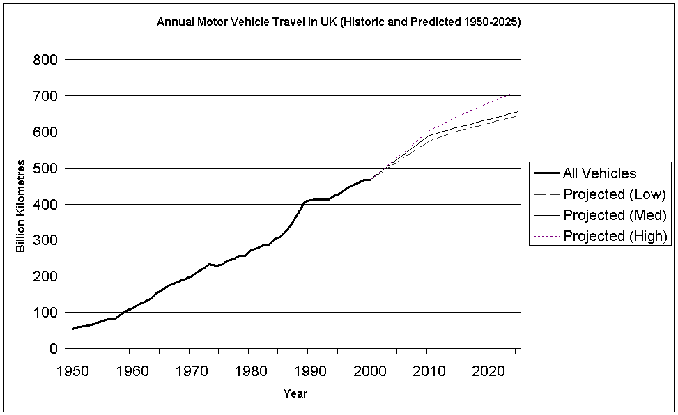
Figure 2: Historic and Predicted UK Traffic Growth (Historic Data from DfT 2005a, Projections DfT 2005b and DfT 2005c)

Figure 3: UK Air Quality Indicator for Sustainable Development A (Defra 2007d)

Notes:
- Ozone is not managed by Local Authorities under the LAQM process due to its regional/transboundary nature.
- 2006(p) indicates figures based on provisional monitoring data

Figure 4: UK Air Quality Indicator for Sustainable Development B (Defra 2007d)

The Future for LAQM

Integrated Management

One of the key areas for improving LAQM is the integration of the LAQM assessment process with other council departments linked to the sources of air pollution. Significant benefits have been seen with the incorporation of statutory air quality aspects within Local Transport Plans (Beattie et al 2005), however, there is still a relatively under developed relationship between environmental health and land-use planning despite strong policy guidance from government to encourage its development (Defra 2003). In addition to this there is the growing problem that the issue of global climate change is beginning to obscure many local environmental issues, and local air quality is not immune to this. One example is the move to install biomass fuelled boilers to reduce carbon emissions, but at the risk of increasing conventional pollution through local combustion and increased traffic related to fuel delivery. Conversely, bypasses are often seen as a means of reducing vehicle related air pollution in urban centres, however without other demand management measures they lead to longer trips for vehicles and therefore potential increases in carbon dioxide and other greenhouse gas emissions. The government commissioned an in depth analysis of the interaction between Climate Change and Air Quality by its Air Quality Expert Group (AQEG 2007)

Exposure Reduction

The other area where major changes may soon affect the LAQM process is the introduction of the ‘exposure reduction’ concept – a move away from focussing solely on pollution hotspots and instead regulating at a wider spatial scale in order to deliver improvements in air quality that will affect large numbers of the population, thereby maximising public health benefits. Figure 5 (modified from Figure 4.1 in Defra (2006)) shows how, for a non-threshold pollutant such as PM, where equivalent reductions in terms of µg/m³ achieve similar health improvements whatever the baseline concentration, much greater public health benefits can be gained by reducing the average concentration that the population are exposed to rather than solely targeting the hotspots where very few people are exposed. Area A represents the health benefit that would be achieved from the limit value/hotspot approach, whilst Area B represents the benefit from the proposed ‘Exposure Reduction’ technique. This technique has been proposed for managing PM_{2.5} in both the consultation report for the new UK Air Quality Strategy (Defra 2007b - where it is described in detail) and the European Union’s Thematic Strategy on Air Pollution (EC 2005). This method is intended to form an additional means of securing public health benefits through AQM. As such the exposure reduction system, while demanding reductions in overall mean background pollution concentrations, also incorporates a fixed ‘backstop’ limit or ‘Concentration Cap’ that ensures the worst of the hotspot locations will also be managed.
Figure 5: Annual Number of People Exposed vs Concentration of Pollutant (Defra 2007)

5. Conclusions

The UK approach to Local Air Quality Management can be judged on the basis of its efficiency as a process and its effectiveness in improving air quality at the local level in areas of public exposure to high pollution. The LAQM process has been refined over a series of rounds of activity dating back to 1998 and has become a routine activity for those Local Authorities who have become capable and competent in discharging their responsibility. The outcome of their efforts is an efficient process for the identification of areas of poor air quality and the quantification of the temporal and spatial domain of such areas. Thus the LAQM process can be considered as efficient.

If effectiveness is taken solely as an improvement in air quality resulting from the application of the LAQM process, then the process might, erroneously, be considered as ineffective. This would not be a fair assessment. The development and implementation of Air Quality Action Plans has not as yet had the anticipated effect on local air quality. This outcome is not unexpected if one considers the nature of the countervailing forces of development in road traffic commerce and industry that often lie wholly or in part outside of Local Authority control. Where the Local Authority has control and has been able to establish effective internal and/or external coordination and communication systems between different functions, then significant air quality improvements can be seen at the local level even if the actions do not always remove the objective exceedence problem.

One of the key elements of the LAQM process is its dynamic nature of allowing continual adaptation to changes in knowledge and understanding. In the 10 years since the first National Air Quality Strategy for the UK (DETR 1997) there are many examples of process improvement and enhancement of the overall effectiveness of the application of LAQM. These include:
- Providing air quality with a seat at the local and national decision making table. The considerable amount of work done through the LAQM process has shown that air quality is still an issue for many places in the United Kingdom. On the basis of the existing knowledge and understanding of air pollution in 1997 many of the problem areas now identified would have been overlooked were it not for the thorough, uniform assessment process instigated by LAQM.

- Dealing with uncertain science. The principles of risk assessment, and proportionality have helped much of the air quality work carried out by local authorities to be done within the traditionally slim resources available to local authorities. The LAQM system has helped to quantify and manage some of the uncertainties that arise from the use of basic methods such as screening models and passive sampling and provide frameworks for working with these outputs.

- Public consultation. Part of the LAQM process, particularly when it comes to action planning, involves the consultation and participation of the public. This has provided a wealth of knowledge about public consultation as an act of science communication (AQMRC 2007).

- Integration with other disciplines. Although progress has been slow and is very much still on going, the LAQM process has forced the interaction of transport and land-use planners with environmental departments. This has helped open up these disciplines to a range of environmental concerns which they also now have to deal with such as noise and climate change.

- Promoting proportionate and cost-effective action in a low-resource environment. The provision of universal guidance and support tools has allowed credible, comparable and consistent air quality screening work to be carried out by all local authorities whether or not they are able to employ an expert air quality officer or not.

- Reducing the duplication of activity at a local level through the provision of suitable national support services. The provision of a uniform set of tools and datasets for the use of all local authorities has not only allowed consistent and comparable work to be carried out, but in the case of data such as the background pollution concentration data (AEA 2007) it has prevented the need for local authorities to all monitor their own regional background levels.

- Producing frequently updated, prescriptive official guidance whilst supporting non-governmental supplemental guidance where suitable and encouraging the uptake and use of this non-statutory guidance.

- Setting a strong emphasis on staff development to ensure an institutional capacity and capability for LAQM not initially present within the Environmental Health field.

- The creation of the Institute of Air Quality Management (see http://www.iaqm.co.uk/), a new professional body to encourage and maintain individual levels of standards and competency within the air quality management profession.

The net effect of these achievements is a system through which patterns of air pollution across the UK at a local level can be followed by national government, safe in the knowledge that the information is both consistent and comparable, and most importantly of sufficient quality to be certain that potential problems are identified. This means that the national government can inform its own actions in relation to its obligations to the European Union, safe in the knowledge that it has thorough understanding or air pollution issues across the country. For Local Authorities, the system provides a solid framework in which they are supported in carrying out rigorous but proportionate analyses of their air quality that can be used to inform local policies and actions that may have an impact on pollution. Whilst not all countries may have the same relationships and structures between national and local government, the UK Local Air Quality Management system provides a tried and tested model that can provide valuable lessons for anybody seeking to establish an air quality management system.

6. References
AEA 2007, LAQM Tools webpage http://www.airquality.co.uk/archive/laqm/tools.php?tool=background04 (accessed 10/10/07).
AQEG 2007, Air Quality Expert Group report - Air quality and climate change: a UK perspective, Department for Environment, Food and Rural Affairs, April 2007.
AQMRC 2007, http://www.uwe.ac.uk/aqm/esrc/ (accessed 10/10/07).
Beattie C.I., Chatterton T.J., Hayes E.T., Leksmono N.S., Longhurst J.W.S. & Woodfield N.K. 2006, ‘Air quality action plans in the UK: an overview and evaluation of process and practice’, Air Pollution XIV, WIT Press, Southampton, pp. 503-512.
Cashmore M., 2004, ’The role of science in environmental impact assessment: process and procedure versus purpose in the development of theory’, Environmental Impact Assessment Review 24(4):403-426.
Defra (Department for Environment, Food and Rural Affairs) 2003, Welsh Assembly Government, Scottish Executive, and Department of the Environment for Northern Ireland 2003, Policy Guidance LAQM.PG(03), Defra, London.
Defra 2006, The Air Quality Strategy for England, Scotland, Wales and Northern Ireland: a consultation document on options for further improvements in air quality Volume 1, Defra, London.
Defra 2007b, The Air Quality Strategy for England, Scotland, Wales and Northern Ireland, Volume 2, Defra, London. http://www.defra.gov.uk/environment/airquality/strategy/index.htm
Defra 2007, The Air Quality Strategy for England, Scotland, Wales and Northern Ireland, Volume 2, Defra, London. http://www.defra.gov.uk/environment/airquality/strategy/index.htm

Defra 2007c, ‘Air quality scientific advisory expert groups merged’ Joint Information note with Department of Health Defra News Release Ref: 102/07 Date: 30 March 2007 http://www.defra.gov.uk/news/2007/070330b.htm (accessed 10/10/2007).
Defra 2007d, Statistical Release Ref: 15/07, 23rd January 2007, www.defra.gov.uk/news/2007/070123a.htm (accessed 10/10/07).
DETR (Department of the Environment, Transport and the Regions) 1997, The United Kingdom National Air Quality Strategy, The Stationery Office, London.

DETR, National Assembly for Wales, Scottish Executive, and Department of the Environment for Northern Ireland 2000, The Air Quality Strategy for England, Scotland, Wales and Northern Ireland: working together for clean air, The Stationery Office, London.
DfT 2005a, Transport Statistics for Great Britain 2005, (Table 7.1) Department for Transport, 2005.
DfT 2005b, The Freedom of Information request on the Future of Transport White Paper, Department for Transport, http://www.dft.gov.uk/foi/responses/2005/mar/trafficgrowthforecasts/futureoftransporttrafficsummary (accessed 12/10/07).
DfT 2005c, The Future of Transport: Modelling and Analysis, Department for Transport, http://www.dft.gov.uk/about/strategy/whitepapers/previous/coll_sustainabledevelopmentappra/thefutureoftransportmodellin5485 (accessed 12/10/07)
DfT 2006, Project for the Sustainable Development of Heathrow, Department for Transport, http://www.dft.gov.uk/pgr/aviation/environmentalissues/secheatrowsustain/ (accessed 11/10/07).
DoE 1997, The United Kingdom Air Quality Strategy, Department for the Environment and the Scottish Office, March 1997.
EC (European Commission) 2005, Thematic Strategy on Air Pollution, Communication from the Commission to the Council and the European Parliament, COM(2005) 446 final.
HM Government 1995, Environment Act 1995, Part IV, Chapter 25, The Stationery Office, London.
Longhurst J.W.S., Beattie C.I., Chatterton T.J., Hayes E.T., Leksmono N.S., Woodfield N.K. 2006, ‘Local Air Quality Management as a risk management process: assessing, managing and remediating the risk of exceeding an air quality objective in Great Britain’, Environment International, 32:934-947.
ODPM 2004, Planning Policy Statement 23: Planning and Pollution Control, TSO (The Stationery Office), Norwich, 2004.
HMSO 2000, Air Quality (England) Regulations No. 928, 30th March 2000.
KL&WN DC 2003, Action Plan for Air Quality Management Area (South Quay), Kings Lynn and West Norfolk Environmental Protection Service, September 2003.

