Bluebell, Short Film and Feminist Film Practice as Research: Strategies for Dissemination and Peer Review

Bluebell (2003) is a six-minute narrative short which was shot on Super 16mm film. A young woman, Juliette (Natasha Nicholl), plays hide-and-seek with her five-year old daughter (Matilda Bowes) in the bluebell woods. ‘Mummy, why am I called Bluebell?’, the small child’s innocent question triggers a chain of flashbacks which force her mother to confront disturbing events from the past. Juliette’s daughter was conceived when she was raped walking home from school through the woods. During the assault Juliette focuses on a single bluebell, which magically draws her attention to a rock with which she fights back, striking her assailant dead. Finding herself pregnant, Juliette seeks medical support, but finding gynaecological examination as traumatic as the original assault, decides to keep the baby. Returning to the woods five years later is a kind of exorcism of the past and a celebration of the inner strength that allowed her to be a survivor, rather than a victim of rape. For this reason she has named her child after the bluebell that saved her. Whilst the above brief description offers an overview “what happens”, it does not give any sense of the film’s structure or of the narrative strategies employed in the film, which plays with audience expectation of rape narrative by using cliché, flashback and revelation - strategies that I explore further below.

The idea for Bluebell developed out of my published research on Angela Carter’s feminist reappropriation of Red Riding Hood in the short story (1979), radio (1980) and film adaptations (1984) of ‘The Company of Wolves’ and their reception by the feminist sisterhood (Crofts 1999, 2003). Jack Zipes (1983) suggests that Red Riding Hood is one of many rape narratives that have traditionally functioned to acculturate young girls to their expected gender roles. However, some feminist academics argue that Carter simply reproduces the patriarchal power relations of the original fairy tale (see Andrea Dworkin 1982, Patricia Dunker 1984, Avis Lewallen 1988). According to Maggie Anwell (1988), this is even more the case when her work is translated to film, reflecting a wider concern with whether feminist politics in general can survive the transposition to the screen without being ‘reduced, manipulated - even travestied - by the underlying market forces’ (p.72). This prompted me to ask whether it is possible, as a feminist filmmaker, to deconstruct the dominant narrative of stranger rape without reproducing patriarchal power relations.

Reappropriation of patriarchal narrative structures is a well-documented feminist strategy. In the chapter entitled ‘Desire in Narrative’, de Lauretis argues that:

narrative is a major issue in women’s cinema; a feminist strategy should combine, rather than oppose, the notions of film as a political tool and entertainment … For feminist theory in particular, the interest in narrativity amounts to a theoretical return [original emphasis] to narrative … that return amounts, as is often the case with any radical critique, to a rereading of the sacred texts against the passionate urging of a different question, a different practice, and a different desire.’ (de Lauretis 1984: 107)

As Janice Haaken asserts ‘a feminist mode of storytelling does alter the transmission of tales in its opposition to “received wisdom” about women under patriarchy … ideally it is an antihypnotic project, one of dispelling illusions and waking up from the slumber induced by patriarchal authority’ (Haaken 1998: 115). Yet, feminist reappropriation is a risky strategy. According to Janice Haaken ‘feminist storytelling by simultaneously fortify and destroy conventional wisdom. Consequently, feminist storytelling faces a range of strategic dilemmas, both in how to present women’s experiences within available, preesxisting traditions and in how to create new stories, less encumbered by inhibitions and constraints’ (Haaken 1998: 115). The mixed feminist response to Carter’s reappropriation of fairy can be read in this context.

Tanya Horeck asserts that ‘The representation of rape continues to be one of the most highly charged issues in contemporary cinema’ (2004: 115). Whilst, Horeck’s book explores what it means to watch a rape, focusing on the act of viewing, in reflecting on my own film practice I have had to examine what it means, as a feminist filmmaker, to depict a rape. With the politics of rape and representation being so loaded, particularly when translated into film, it has been illuminating to shift my focus from film theory to film practice situated in a research context. Resituating these arguments in my own practice has enabled me to gain a new perspective on and contribute to ongoing debates around gender, female subjectivity and visual representation.

Stranger Rape
The film is structured in order to suggest to the viewer from the outset that Bluebell’s conception is the result of a rape. Immediately after Bluebell asks about her name, we cut to a medium close shot of Juliette which signals the series flashbacks which follow, starting with a rapid montage of images of Bluebell getting younger and younger in age, until she is an embryo in the womb. Descending arpeggios, are joined by a swelling heartbeat and school bell, which end abruptly with the sound of retching, as we cut to the young Juliette being sick in the school toilet: morning sickness. As Juliette wipes the sick away from her mouth, we hear schoolgirls laughing and gossiping in the background. We cut back briefly to a closer shot of Juliette’s face in the present-day, resituating the following flashbacks as being from her perspective. The young Juliette in uniform walks home from school listening to her earphones. We cut back to the close-up of Juliette in the present before flashing back to a two-second shot of the young Juliette, uniform dishevelled, running away (see Figure 10). This is the first of three times that we see this image, a point I shall return to later on.

At this point in the film, the viewer can gather that something “bad” has happened in the bluebell woods: a young girl walking alone in a public space; all the ingredients for stranger rape, which is the dominant strand of rape narrative in Western culture, from Dinah walking out alone to see the women of the field and being “defiled” by Shechem (Genesis 34) to Little Red Riding Hood straying from the path on her way to see Granny and meeting the Big Bad Wolf in the Perrault and the Brothers Grimm versions of the well-known fairy tale. When I was developing the script I was conscious of the fact that the narrative of rape affects the daily lives of both men and women (my male friends making sure I get a cab home, my mother telling me to “walk with a purpose”, etc.) and that both women and men’s behaviour is influenced by the very public, but at the same time taboo, cultural discourse of rape. Cultural geographer Rachel Pain acknowledges ‘fear of crime has tangible and serious effects on social interaction, use of space and quality of life’ (Pain 2001: 909). Artist Banksy comments on the way in which the English pastoral has come to evoke a crime scene, ‘our nation has been vandalised by its obsession with crime and paedophilia where any visit to a secluded beauty spot now feels like it may result in being molested or finding discarded body parts’ (Banksy 2005: 137). However, the narrative of stranger rape belies the fact that statistically most sexual violence occurs in the domestic or private sphere, in the context of family abuse or acquaintance rape. As Pain asserts:

women’s fear of physical and sexual violence is widespread and … its effects are pervasive. Perceptions of safety and danger are strongly bound up with the ideological division between public and private space. … women’s fear of male violence is still usually manifested in fear of public places. … Violent crime remains a major constraint on the spatial behaviour and activities of women in all social groups … sexual violence and fear of it continue to exert the same controls over women’s lives. Ideologies about safe and dangerous spaces remain firmly in place. … The threat of violent crime is externalised as being outside the family. (Pain: 1997: 239-40)

However, in attempting to demythologise stranger rape, there is always the danger of reinscribing the power of the myth. Indeed, media reporting of rape tends to amplify the danger of “stranger rape”, rather than acknowledging the domestic context for much sexual violence. There is a predominance of imagery of men killing women in mainstream film and television, and the fact that Juliette defends herself is partially a desire to redress the balance. My desire to counteract the representation of women as victims, rather than survivors of rape, is clearly influenced my earlier research on novelist Angela carter. Discussing ‘The Company of Wolves’, her feminist reworking of Red Riding Hood, in interview with John Haffenden, Carter states ‘she eats the wolf, in effect’ (Haffenden 1985: 83). In Heroes and Villains (1969) Marianne’s reaction to her rape by Jewel is one of anger, not victimhood. In Nights at the Circus (1984) the winged aerialiste, Fevvers demands ‘wherein does a woman’s honour reside, old chap? In her vagina or in her spirit? … I do think, myself ... that a girl should shoot her own rapists’ (Carter, 1984: 230-31).

Sequence Analysis
In order to demonstrate how the film goes on to play with the narrative expectations set up in the opening montage, it is necessary to provide further detailed description of both the film’s formal construction, and its narrative content. At the close of the opening montage we return to the present with a close up of Juliette, followed by a reverse angle extreme close-up of Bluebell looking expectantly up at her. Juliette snaps out of her memories and chases after Bluebell, arms outstretched to tickle her, exclaiming ‘Come here you little monkey’. Bluebell screams with delight at being grabbed. Responding to the director’s cut, Supervising Editor Chris Wade felt that in the opening shots of Juliette and Bluebell, there needed to be a greater sense of enjoyment between them and more sense of time passing to ‘give greater prominence to the girl’s question’. I had filmed an over-the-shoulder shot / reverse shot dialogue sequence between Juliette and Bluebell that was not working. Having trained and worked in the industry as an editor, I planned to cut the film myself, but having arrived at my “fine cut”, was not satisfied with the results. I sought feedback from two Supervising Editors whose opinions I trusted, Katie Mack (University of Bristol) and Chris Wade. Wade’s main criticism of my cut was the (lack of) timing and the rhythm in what he calls ‘the poetic moments’ whenever there is little action. Wade suggested that I ask Lizzie Minnion to come on board as Editor. Having just had a child, and wishing to break in her new Final Cut Pro suite, she was willing to offer her services for free. Her recent motherhood proved to be instrumental in bringing another perspective to this film about, among other things, maternity and (re)birth. Lizzie and I watched the opening sequence of Nicolas Roeg’s Don’t Look Now (1973) and had an epiphany with regard to the opening. We decided to focus initially on the lone figure of Bluebell alone in the woods in order to emphasise the visual allusion to Red Riding Hood and suggest a sense of impending danger, before introducing the character of Juliette. Ditching the awkward scripted dialogue sequence, a game of hide and seek was constructed in the edit which serves to bring out the relationship between mother and child.

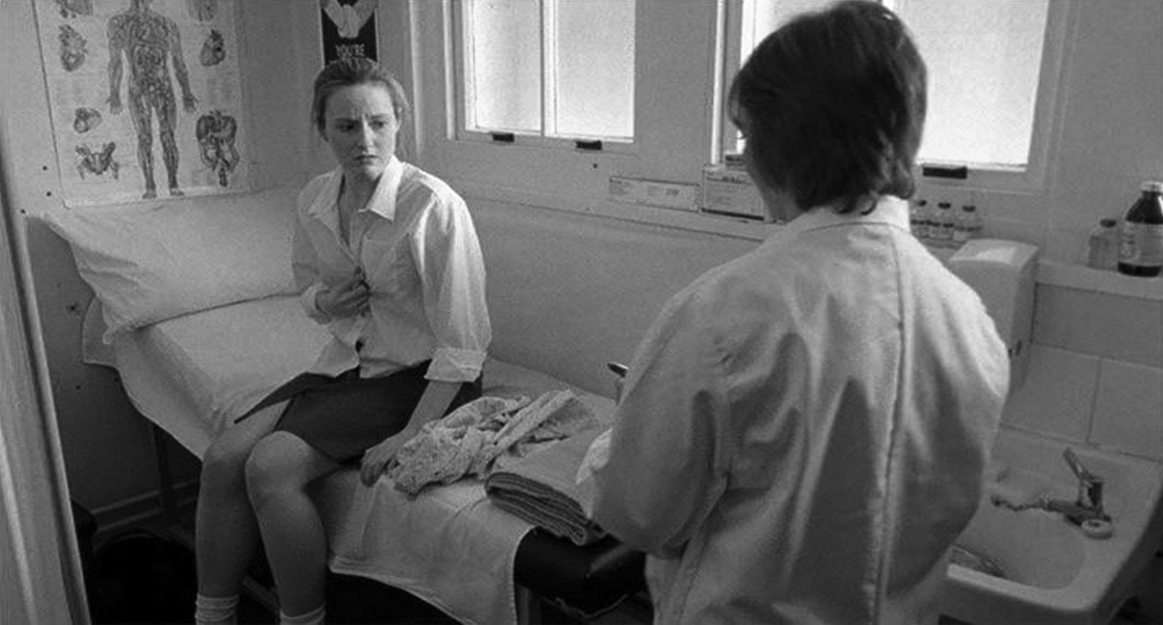
Figure 1: Natasha Nicholl and Catherine Swingler in the Doctor’s office (Copyright with the artist).

In the next scene we cut to a wide shot of the Doctor’s surgery (Figure 1). Juliette is sitting uncomfortably on the hospital bed as the Doctor (Catherine Swingler) breezes in and draws the screen across ‘If you’d like to pop the gown on and lie back for me, ok?’. Around the edge of the screen, we see the Doctor washing her hands over Juliette’s shoulder and then cut to a high angle shot over the top of the screen, which makes Juliette look small, isolated and alone as she begins to unbutton her school blouse. We can hear the Doctor moving around and cut to Juliette’s point of view of the screen as we hear metallic scraping noises. We cut to a shot of the Doctor preparing the speculum; this is a mid-shot which cuts the Doctor’s head off, dehumanising her. We return to the high angle of Juliette over the screen starting to cry. ‘It’s ok, just try to relax, it won’t take long’, the Doctor’s voice sounds very far away. When the Doctor whips back the screen she finds that Juliette, clutching her blouse together, has failed to disrobe. We cut from a wide shot over the Doctor’s shoulder to Juliette’s point of view of the Doctor picking up the speculum, to a close shot of Juliette looking perturbed, back to the wide as Juliette grabs her bag. We cut in close to Juliette’s face, then back to the wide as she storms off leaving the Doctor holding the speculum in disbelief (Figures 2 & 3).

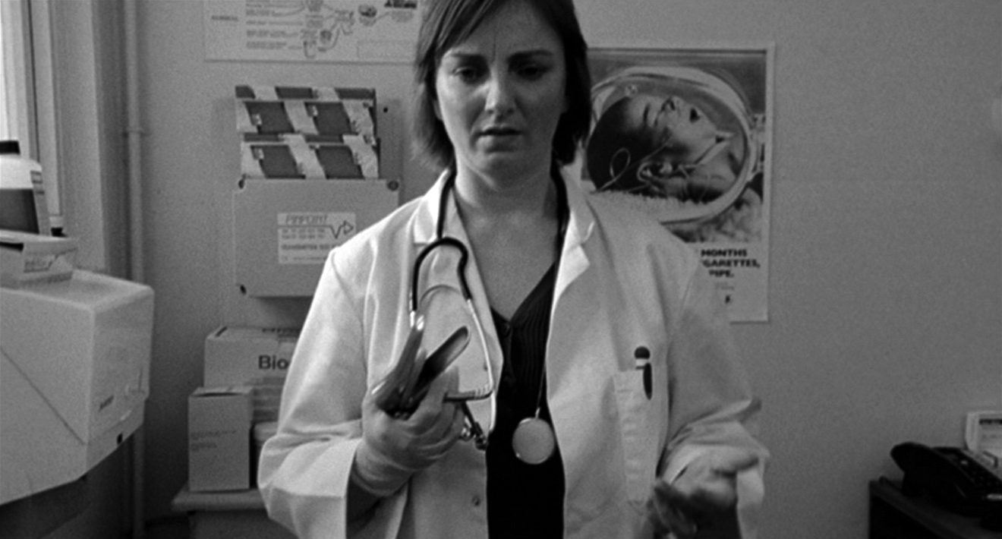
Figure 2: Catherine Swingler holding speculum in the Doctor’s office (Copyright with the artist).

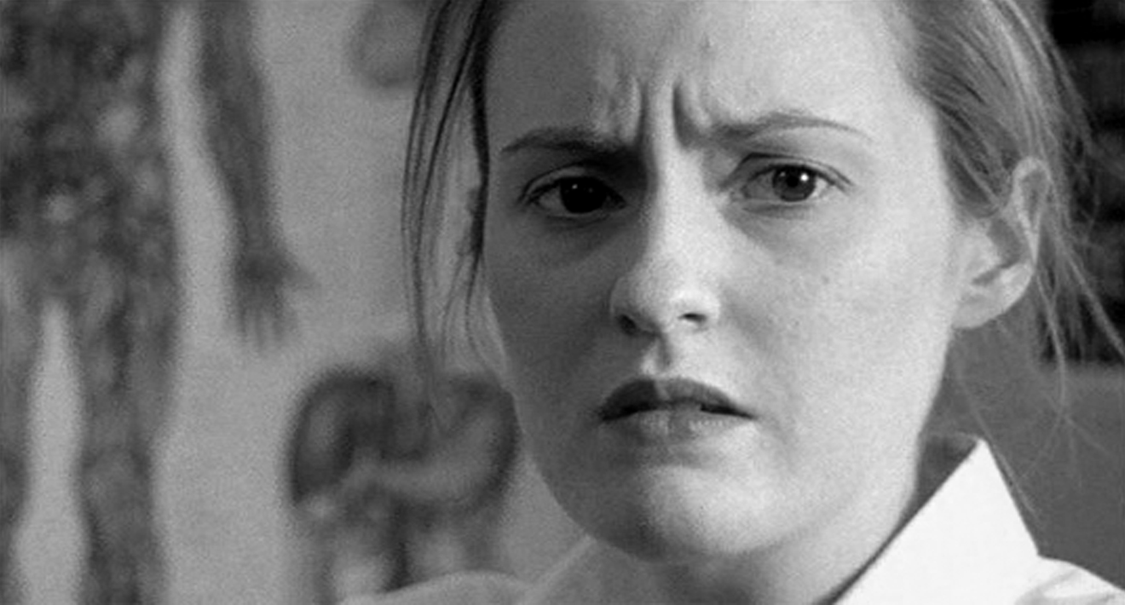
Figure 3: Close-up of Natasha Nicholl in the Doctor’s office (Copyright with the artist).

The use of shot, reverse shot and the close up here emphasises Juliette’s point of view and her unwillingness to accept help from the medical establishment. In her critique of Freud’s writings about femininity, de Lauretis (1984) notes that for Freud ‘the difficult journey of the female child to womanhood … leads to the fulfilment of her biological destiny, to reproduction’ which is (quoting Freud), ‘“to some extent independent of women’s consent”:

Thus the itinerary of the female’s journey, mapped from the very start on the territory of her own body … is guided by a compass pointing not to reproduction as the fulfilment of her biological destiny, but more exactly to the fulfilment of … his biological and affective destiny - and to the fulfilment of his desire (132-33).

In this way female reproduction can be linked to a kind of rape. Christine Northrup has suggested for some women “pelvic check-up feels like a rape,” gynaecology is experienced as sexual assault (1995: 613). Other women filmmakers have explored concerns about femininity, reproduction and the medical establishment. For example Catherine Breillat uses fantasy and body horror to explore anxieties about sexuality, childbirth and motherhood in her feature Romance (1999). She takes the virgin/whore dichotomy literally in one scene in which the central character is in labour, her body split by a wall between the cool, white, sanitised hospital above the waist and a hellish, red, pornographic mise-en-scene (like something from Dante’s Inferno or Hieronymus Bosch) below the waist.

Whilst the Doctor’s scene in Bluebell does not use fantasy, there are elements of body horror and concerns about fertility and childbirth, which whilst not the primary focus of this article, are nevertheless worth alluding to briefly here. In the opening montage we see Bluebell regressing in age until she is a foetus and then an embryo in the womb. The Doctor’s office is dressed with graphic posters of the human body and a public awareness poster of a baby smoking (see mise-en-scene of Figures 2 & 3). Juliette’s horrified reaction to the speculum situates it as an object of horror, enhanced by the sound design of scrapping metal. Commenting on the director’s cut, supervising Editor Wade comments that ‘the use of the sound over the shot of the hospital screen is outstanding. The shot and the accompanying sound tell us more about what is in her head than watching her undo a button’, suggesting that ‘the shot could be longer’. It is very interesting, perhaps reflecting the inexperience of a first-time director, that the coverage of this scene far exceeded that amount of footage that made it into the final cut.

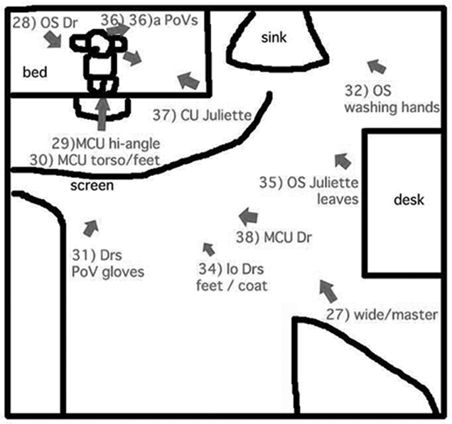
Figure 4: Diagram of camera placement in Doctor’s office (Copyright with the artist).

In my cut, I attempted to cover the scene from all eleven angles I had shot because I was attached to the work that went in to creating them (see Figure 4). With Minnion’s help this scene was honed to crystallise Juliette’s isolated perspective. McIntyre’s sound design is also important here, the attenuated audio brings us more firmly into Juliette’s point of view.

The Big Bad Wolf
Back in the present, we cut directly to a medium long shot of Bluebell stomping through the bluebells in her red Wellington boots, the sound of the heartbeat symbolising a life not terminated. Using associative editing, we cut from Bluebell’s legs to a close shot of the young Juliette’s legs walking towards us from screen left. We then cut out to an extreme wide shot of Juliette walking screen left to right, her tiny figure dwarfed by the trunks of the slim silver birches, framed by a canopy of green and a carpet of blue. We cut in to a medium close shot of Juliette entering from frame left. She pauses, as if she hears something and she turns around, removing her earphones, to see if there is anything there. In the build up to the initial encounter between Juliette and the Man, Wade felt that not enough time was allowed to develop an expectation that something was about to happen and that ‘our senses haven’t been sharpened by anticipation’, suggesting cutting to ‘an additional shot of the empty wood … to give a greater sense that the woman is wary, nervous’. In the final cut, Minnion cuts to a series of lingering shots of the woods and close-ups of the bluebells, and the timing of the sequence, together with Gary McIntyre’s sound design, lend a much needed aura of suspense just before Juliette encounters the Man. We cut to a series of long-held shots of the woods, details of the bluebells, tree trunks, returning to the medium close up of Juliette to situate these as point of view shots. We hear the birds and wind in the trees. But, there is nobody there.

As Juliette turns around, readjusting her earphones, we see the Man (Mark Wilson) slip out from behind a tree. We cut to a mid-shot of Juliette over the Man’s left shoulder. In the reverse angle he moves towards her. In close up Juliette hesitates, unsure of his intentions, cutting back to the wide over Juliette’s shoulder as he lunges towards her. One of the frequent comments I receive is that the Man is a cipher and his character is not sufficiently developed. With its roots in the feminist reappropriation of fairy tale, I wanted the characters to be archetypal and for the film to be female-centred, told primarily from the perspective of Juliette (the Mother and the Doctor could equally be said to be sketches, rather than fully fleshed out characters). Another frequent comment, usually from male spectators, is that the Man is too good looking, as if all rapists are disfigured hunchbacks with buckteeth like Harry Connick Junior in Copycat (1995). The “othering” of the rapist supports the myth of stranger rape whereas, as we have seen, women are much more likely to be sexually assaulted by somebody they know. The casting leaves the uncomfortable possibility of the male spectators identifying with the Man, and female spectators finding him attractive. I wanted there to be a moment or glance that would pass between Juliette and the Man so that, like Juliette, the viewer is initially unsure of his intentions. We cut back to the reverse angle as Juliette, realising his purpose, runs away. The Man catches her and pulls her to the ground (Figure 5). At this point we cut on action to a matching action shot in the present day as Bluebell pushes the laughing Juliette to the ground (Figure 6).

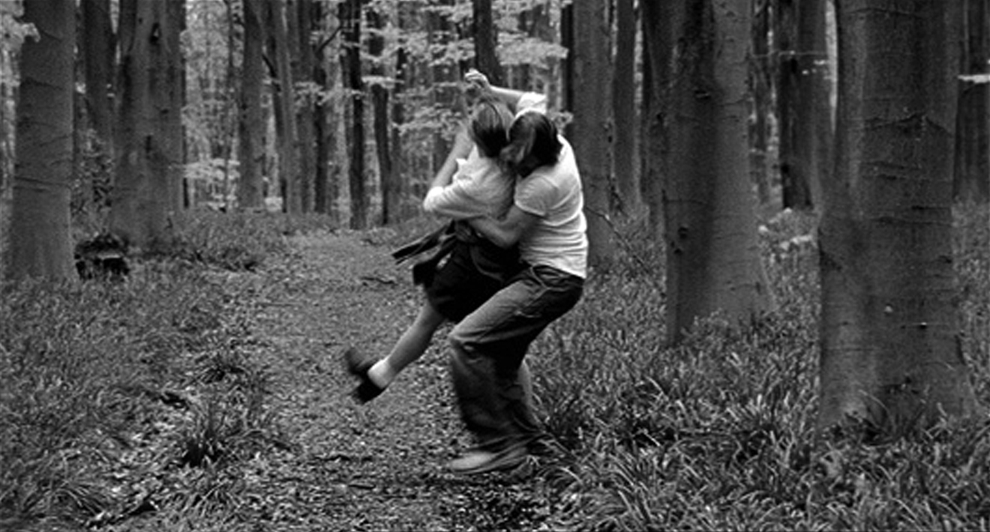
Figure 5: Natasha Nicholl and Mark Wilson in the rape scene flashback (Copyright with the artist).

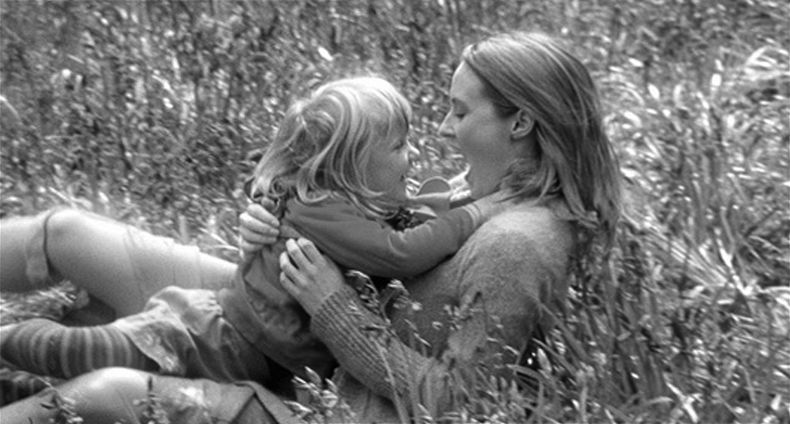
Figure 6: Matilda Bowes and Natasha Nicholl in the narrative present (Copyright with the artist).

Intercutting between past and present, the Man pins the young Juliette down, whilst the present-day Juliette tickles Bluebell, who screams with delight. In the past the Man fumbles with Juliette’s skirt; in the present Juliette tickles Bluebell in a medium two-shot. We then cut in to a close of Bluebell laughing and squealing ‘Stop!’ as Juliette tickles her. This sequence was partially inspired by the knowledge that, according to Carter (1977), in Perrault’s version of Little Red Riding Hood, there was an instruction for the story-teller to jump on the child, pretending to be the wolf (see also Haffenden 1985: 84). I was interested in exploring a child’s paradoxical desire to be “tickled to death”.

The intercutting between the rape flashback and Juliette tickling Bluebell in the present was one of the most contentious scenes for Editor Lizzie Minnion who felt that this sequence was too disturbing and, for some viewers, could suggest undertones of child abuse. This scene was one which caused a great deal of discussion during the edit. The dialectical montage between past and present was written into the script, so I was quite attached to it:

15. EXT. BLUEBELL WOODS - PRESENT-DAY

In a light suffused with gold, we see BLUEBELL’S tiny, perfect teeth as she laughs silently at the pleasure of being tickled by her mother. She kicks out her legs, wriggling to get free.

16. EXT. BLUEBELL WOODS - FLASHBACK - DAY - COLD

In the cold blue light, YOUNG JULIETTE kicks and thrashes about, but to no avail: he’s got her pinned. His hand pinching the skin on her wrist. He’s pushing up her skirt.

YOUNG JULIETTE
(reverberating over the cut)

No!

After much discussion, Minnion and I agreed to include the sequence. In the event it is Bluebell’s ‘Stop!’ that reverberates over the cut. The use of parallel editing serves to juxtapose the temporal location of the bluebell woods in the past and present and invites comparison between the trusting relationship between mother and daughter and the rape. I wanted to create a tension between the beauty of their present relationship and the horror of the child’s conception and also emphasise the contrast between the mise-en-scene of the bluebell woods in past and present. In terms of the online, I had been keen, from the script stage, to use the colour temperature of the images to create a differentiation between past and present scenes in the bluebell woods. This is particularly pronounced in the tickling scene described above, where Colourist Christian Short put a glow on the “present” tickling scene and made the blue of the bluebells warmer, whilst extenuating the blacks and cooling the blues in the “past” rape scene. This was important to emphasise the juxtaposition between the horror of Bluebell’s conception, with the joy of the current relationship between mother and child.

In the following scene, Bluebell’s ‘Stop!’ ends abruptly with the noise of gurgling water; we cut to Juliette’s point of view of a plughole. From between the taps, we see Juliette sitting paralysed in the bath staring at the vortex of her bathwater disappearing down the drain. This is a cliché of rape narrative, the washing away of the transgression. A knock on the door and the Mother (Patsy Hayden) remonstrates her, off screen, for staying in the bath too long and getting wrinkly. We cut to a precise reverse angle of Juliette’s back as she glances towards her mother’s voice. The tap drips ominously.

As she turns back we cut in to a close-up of her face remembering; flashing back briefly to the same image of the young Juliette running away that we saw in the opening montage (Figure 10). We return to the close up of Juliette in the bath as we hear her mother knocking again at the door. This close shot is superimposed over an extreme low angle shot of swaying branches, making an intricate lace pattern on her face (Figure 7).

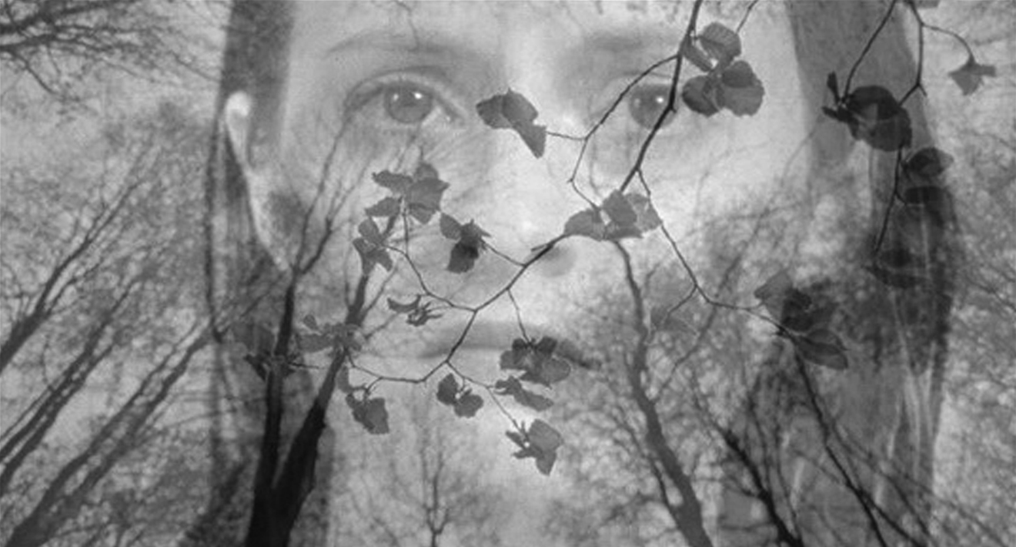
Figure 7: Superimposition of trees over Natasha Nicholl’s face (Copyright with the artist).
This is revealed as the young Juliette’s point of view in the next shot, as she lies on her back looking up at the forest roof, a high angle over the Man’s shoulder as the he rapes her. This shot utilises two key techniques for foregrounding female subjectivity, the close-up and the point of view shot, superimposed one on top of the other. The shot of Juliette looking up at the swaying trees emphasises the way in which she focuses on her external environment in order to cope with her ordeal. Christine Northrop claims that ‘many women who have been sexually abused as children relate that they “left their bodies” during the abuse’ (Northrup 1995: 66). A strange tinkling noise draws Juliette’s attention and as she turns her head screen left, we cut on action to a side angle and pull focus from her face to a lone bluebell, then cutting to a reverse angle of Juliette’s point of view of the bluebell, which sparkles mysteriously (Figure 8).

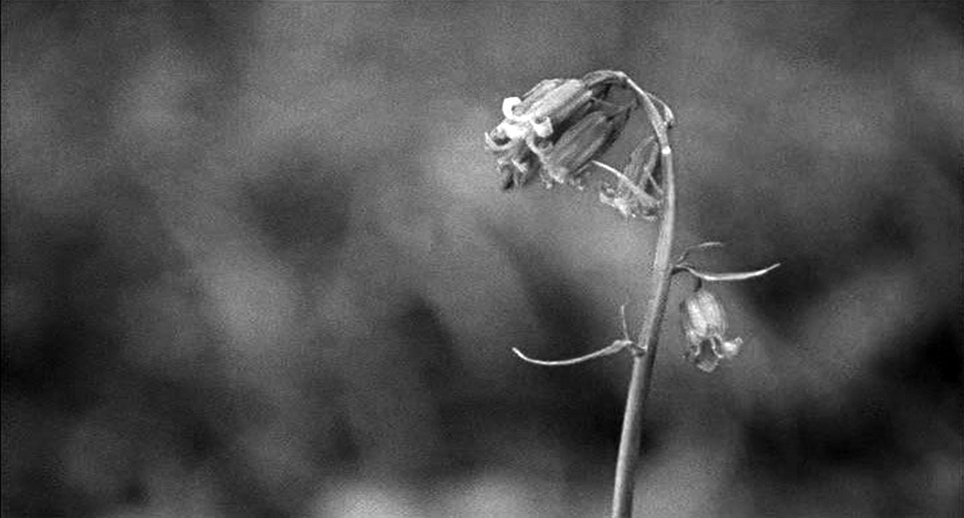
Figure 8: Close-up of bluebell (Copyright with the artist).

When we came to rehearse the rape scene, I wanted Nicholl and Wilson to feel safe and to develop a rapport with each other and I was also keen to have their input on character development and the physical blocking of the rape. I used games and warm up exercises (participating fully in both) in order to gain their trust and create a safe environment from within which we could all explore the rape scene (see Keith Johnstone 1979 and Augusto Boal 1992). Physically blocking the encounter and subsequent assault enabled me to test out my script, rejecting the shots of Juliette’s constrained wrists, as that position was not intuitive to the actors. All this work paid off on the first day of the shoot so I could concentrate of directing the camera and the actors knew exactly what was required of them in terms of the action.

It is interesting to contrast my instinctive, inclusive method of working with the actors in developing this scene, with Sam Peckinpah’s notorious approach in Straw Dogs. Peckinpah apparently intended to withhold the full details of the rape scene from actor, Susan George, who plays Amy (see Barker 2006 and Weddle 1996). According to Mark Kermode, ‘when Peckinpah finally and reluctantly agreed to discuss the scene, he announced bluntly: “I don’t intend to tell you how I’m going to shoot it, but I will tell you that you are going to be naked; two men are going to attack you; one is going have sex with you; and the other man is going to bugger you”’. Appalled, George threatened to walk off set, refusing to continue unless he took her suggestions on board, including the use of close ups on her face to align the spectator more closely with Amy’s subjectivity. As Kermode asserts, ‘the usually implacable Peckinpah caved in and agreed to let George try to depict Amy’s trauma by concentrating on her eyes and face, rather than her body. The resulting scene, a strange mixture of the explicit and the oblique, has since become the focus of heated controversy’ (Kermode 2003).

Feeding back on the director’s cut, Chris Wade enabled me to realise that ‘less is more’ of the rape scene when we cut to the final denouement: ‘a facial expression and clenched fist could be more horrific than the full blow-by-blow description. The more you reveal, the less credible it may appear’. I had covered the entire sequence from a number of different angles, including a full-length long shot of their bodies from the side (which is used only briefly in the final cut, when he initially gets her on the floor), a wide high angle, and a mid-shot from the side. In the final cut much of this footage was omitted and most of the rape scene is cut in close, over the Man’s shoulder and the emphasis is on Juliette’s face, with extensive use of point of view shots and reverse shots, both showing her looking and the object of her gaze.

It is useful to reflect on my choice of continuity editing and the way in which I chose to block scenes with the camera in contrast to the use of the controversial single take in Gasper Noé’s Irréversible (2001) which some critics have argued prevents the nine-minute rape scene from becoming gratuitous by forcing the viewer to acknowledge the horror of violence (Ebert 2003). Does this mean that editing (specifically continuity editing) is inherently gratuitous? Whilst it has long been argued that editing sutures the spectator into the narrative (see Heath 1976), in its refusal to cut in close to Alex’s (Monica Bellucci’s) face or use point of view shots from her perspective, Noé’s unflinching long shot could be argued to deny female subjectivity. Echoing Peckinpah’s ambition to film the ‘best rape scene ever filmed’ (Barker 2006), Noé’s ambition was ‘to make a film more violent than Sam Peckinpah's Straw Dogs’ (O’Hehir 2003), a film from which he claims to have walked out when he saw it for the first time (Jonathan Carter 2003). Both Straw Dogs and Irréversible are narratives about masculinity and the effect the rape of a woman has on the male protagonists. But unlike Straw Dogs, with Susan George’s insistence on the use of subjective close-ups, Irréversible offers no such space for female subjectivity, situating the rape as an issue of male revenge, reinforcing the ideology of women as victims, rather than survivors of rape. As Peter Bradshaw has pointed out, ‘Noé’s movie is not the smallest bit interested in the woman’s experience, but in male rage’ (2003).

In Bluebell it is Juliette’s rage that is the focus of the rape scene. We return to the shot of Juliette over the Man’s shoulder. She looks directly at him with pure hatred. We cut back to the close-up of Juliette in the bath. Her face takes on a determined look situating what happens next as a deeper level of flashback, returning us to the scene of the original trauma. The same magical noise that drew her attention to the bluebell brings Juliette’s attention to a large rock. We pull focus as Juliette’s hand reaches out for the rock, cutting to a close up of the rock from Juliette’s point of view as she grips it tightly. Juliette screws up her face with effort, and utters a primordial roar as she lashes out (see Shot 76, Figure 9).
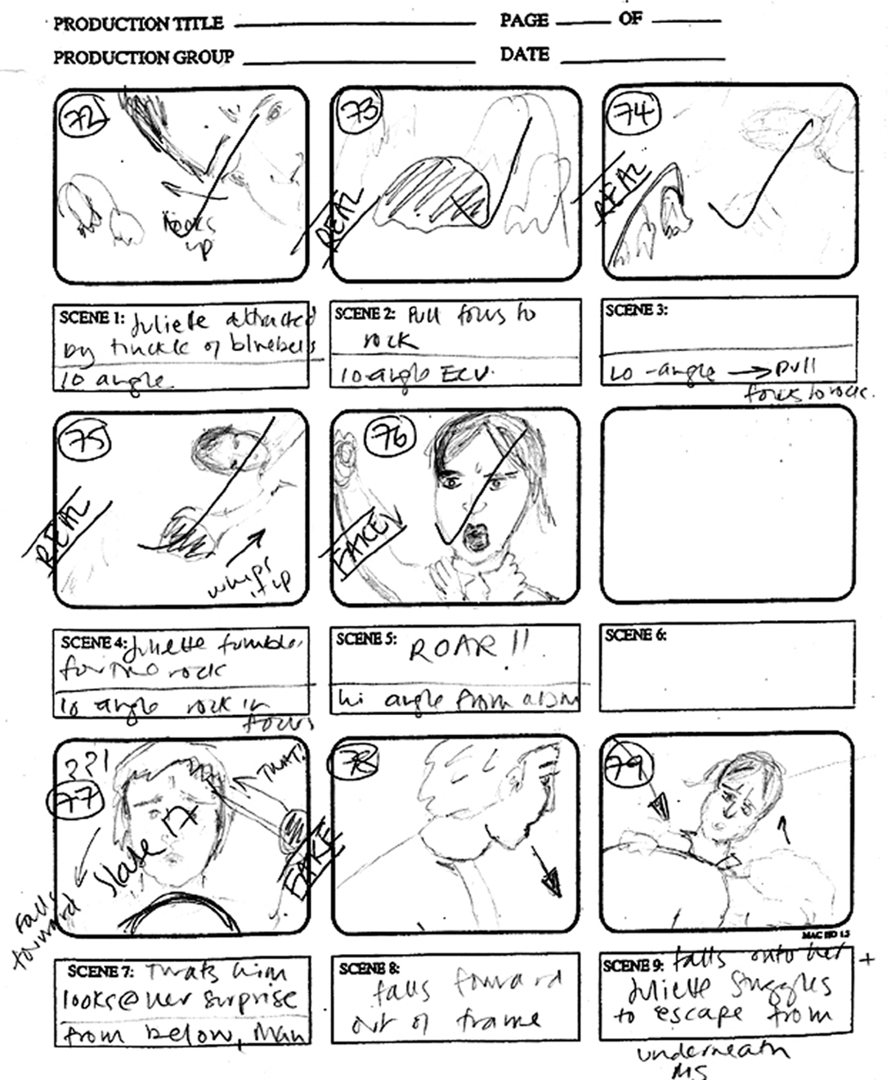
Figure 9: Bluebell (2003) Annotated shooting copy of storyboard (Copyright with the artist).

We cut to a close up of the Man from Juliette’s point of view as she strikes his head. He looks momentarily surprised, and we cut to a high angle shot from above as he slumps down on top of Juliette who struggles to free herself from under his weight. As she attempts to push him off, we cut to a side angle as she rolls him over to reveal a fatal wound to his head. Juliette scrambles to her knees, still clutching the rock. We cut to an objective third person perspective of the Man lying lifeless, then back to Juliette looking on in horror. Noticing the rock, she throws it down as if it is a burning hot coal. She pushes herself up from her knees and runs, barefoot, into the woods (Figure 10). Juliette’s fleeing figure dissolves into the lone bluebell that saved her, which in turn dissolves into a long shot of Bluebell, saying ‘Mummy?’ questioningly from behind a tree. We cut to an enigmatic shot of Juliette half-smiling, ending on a long shot of Juliette and Bluebell walking away from us hand-in-hand into the woods. Fade to black, credits roll.

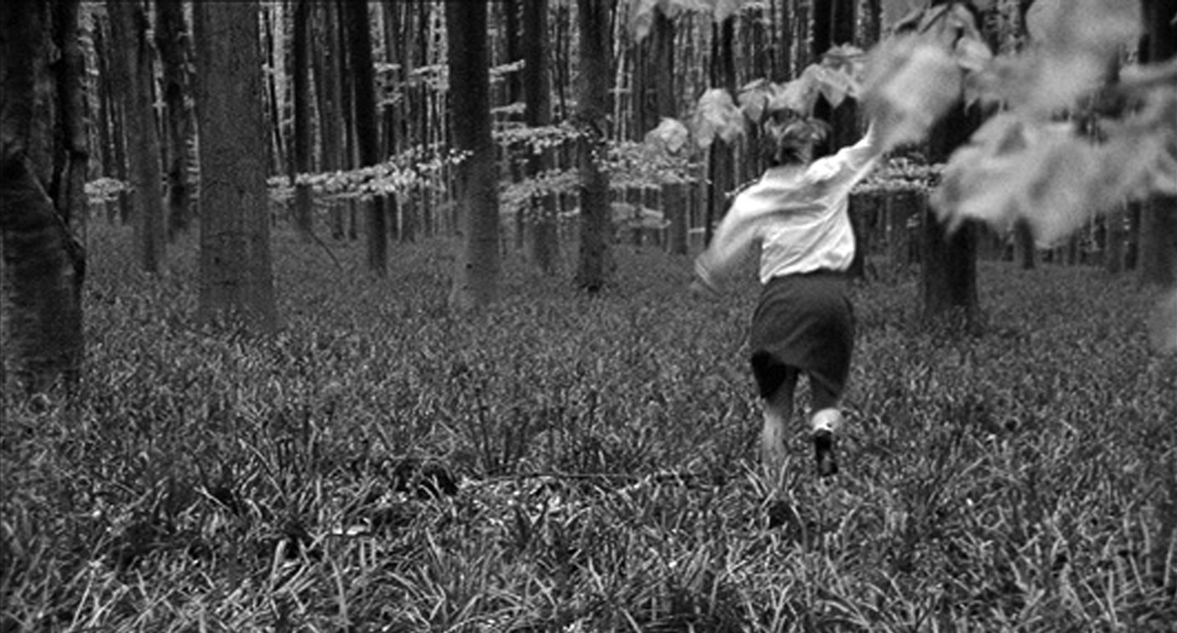
Figure 10: Natasha Nicholl running away (Copyright with the artist).

Thrice Upon a Time: Short Film, “Horizontal” Storytelling and “Vertical” Narrative Axes
I’d like to focus further on the narrative strategies of flashback and repetition by exploring the multiple use of the shot of Juliette running away from the scene of the crime (see Figure 10). The first time we see it is in the montage immediately after Bluebell asks about the origin of her name, this time signalling to the viewer that “something” has happened in the woods and setting up the audience expectations of a rape narrative. The second time we see it is at the beginning of a subjective flashback in the Bathroom scene, after we’ve already witnessed the initial assault and the Doctor’s scene. The third and final time it functions to establish the proceeding flashback. At this point the spectator has had the opportunity to make the connection between the rape and the child, before flashing back further to reveal the fact that Juliette defends herself from the rape. The third and final time we see this shot is at the end of the final flashback. This time it occurs in chronological sequence after Juliette disentangles herself from beneath the Man’s body, so that we now know the full import of the memory: that she is running away from a murder as well as a rape. Each time the image is seen it accrues a slightly different resonance. Whilst not suggesting that Bluebell is an avant-garde or experimental film (it is a feminist strategy to engage with the mainstream realist mode, although there is an element of magical realism in the treatment of the bluebell), this can be compared to the use of repetition in Maya Deren’s Meshes of the Afternoon (1943). Malcom le Grice quotes Deren’s contribution to a 1963 Symposium, in which she ‘introduces the concept of “verticality”, an exploration at right angles to the “horizontal” development of the narrative’ (2002: 318), suggesting that the film:

explores a complex form of a repeated, dreamlike, symbolic event. At each repetition, small changes expand the spectator’s imaginary construction of the symbolic space rather like a spiral through a matrix of action images. The spectator’s passage through the film requires each previous “version” of the action to be reviewed by the next - not replacing it by a more definitive version but deepening the experiential reference in a cumulative transformation. The inevitable linearity of the film is used to explore symbolic space which is not resolved as a causal narrative. (le Grice 2002: 318)

Deren refers to Shakespeare, contrasting the horizontal development of the narrative with the “pyramid” or vertical exploration of the present moment. Le Grice cites Deren’s contention that short films ‘(and they are short because it is difficult to maintain such intensity for a long period of time), are comparable to lyric poems, and they are completely a “vertical” or what I would call a poetic construct, and they are complete as such’ (le Grice 2002: 319). In Bluebell each time we see the image of the young Juliette running away into the bluebell woods it accumulates additional layers of meaning in relation to the narrative. The “horizontal” or narrative time occupies the afternoon that Juliette and Bluebell visit the woods, the “vertical” story time weaves back and forth, like the editor’s shuttle, past this defining moment (see circled points in Figure 11).

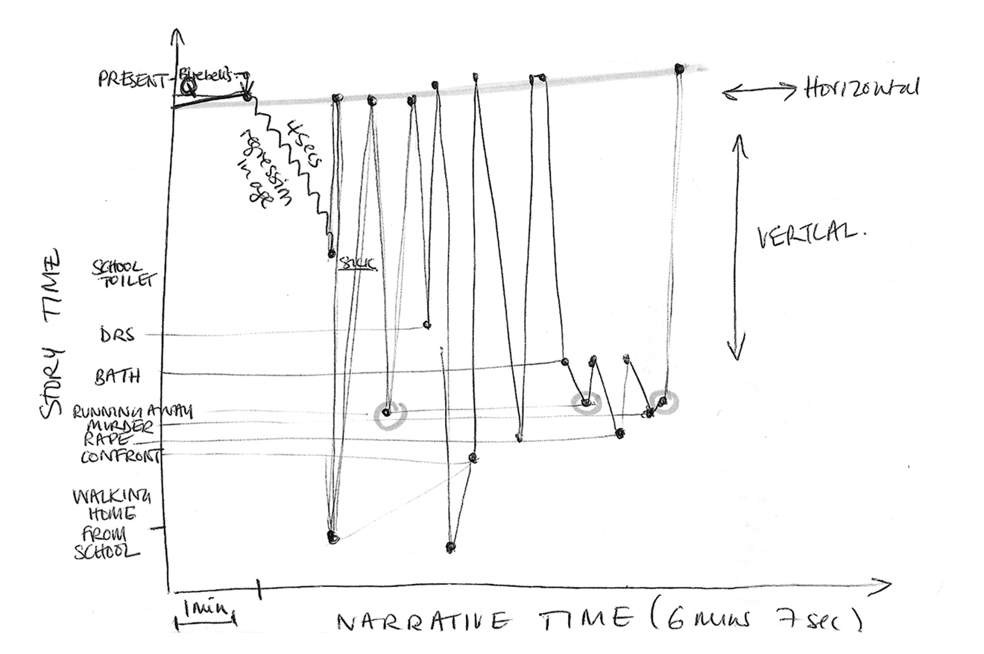
Figure 11: Sketch of Narrative Structure (Copyright with the artist).

It is interesting to explore how my formal, aesthetic and technical choices as a filmmaker have been influenced by the fact that I am operating within the medium of short film. As Gareth Evans asserts, “because there is less distance to travel between form and content, image and intention, opening and closure, an attention to frame and exposition […] becomes crucial” (Elsey and Kelly 2002: xiii). Writing specifically about the short story, Clare Hanson suggests that the elisions and gaps in short narrative forms leave space for the reader’s imagination. In the ‘Afterword’ (1974) to her first short story collection, Fireworks, Angela Carter comments that ‘the limited trajectory of the short narrative concentrates its meaning’. Similarly, in the preface to her collected radio plays, Carter describes radio as ‘a kind of three-dimensional story-telling’ that invokes ‘the listener’s imagination’ (Carter 1985: 7, 11). Carter’s attraction to both the short story and the radio play correlates with what Merja Makinen has described as her insistence that her texts were ‘open-ended, written with a space for the reader’s activity in mind’ (1992: 6). This ‘open-endedness’ mirrors the elliptical structure of other short narrative forms that, as Hanson has argued, can often stir the imagination of the reader in a particular way. ‘Ellisions [sic] and gaps within a text offer a special space for the workings of the reader’s imagination, offer a space for the work of the image-making faculty which would otherwise lie dormant’ (Hanson (ed.) 1989: 23).

It is productive to take this formal comparison between the radio play and the short story further, and to extend the comparison to the short film. As Elsey and Kelly point out, the limitations not only of space/time, but also of budget, often allow the short film maker greater freedom, ‘shorts allow a lighter, faster, more exploratory approach’ providing ‘a necessary creative space’ (2002: 121). These short forms paradoxically contain more imaginative space precisely because of their “lack”. The “blindness” of radio, the absence of visual stimuli, necessitates the stimulation of the listener’s imagination (in Hanson’s terms, activating the ‘image-making faculty’), creating space for their active involvement in the process of meaning production (inviting the listener’s ‘desire’ into the text). The lack of narrative space in short film also contributes to its open-endedness as a medium, demanding a similarly active spectatorship. Malcolm le Grice argues that ‘various oppositional devices have been developed together with an attempt to permit, encourage, or initiate the spectator’s own symbolic activity as the basis for appropriation of the film experience’ (61). These strategies can clearly be utilised in longer forms, and not all shorts use them, but the limited space of the short film does invite the imagination of the spectator into the text: as Gareth Evans asserts “the shorter the evidence the more imagination plays the detective” (Elsey and Kelly 2002: xi). Thus the short form could be said to be potentially radical in its tendency to encourage the imaginative activity of the spectator. As le Grice suggests one way to resist ‘dominant cinema’ is by ‘demanding or encouraging a more “conscious” or self-aware spectator’ (le Grice 1983: 53). In Bluebell, I aimed to encourage just such an active spectatorship, formally experimenting with non-linear narrative, disrupting the Aristotelian unities of time, place and character that normally uphold hegemonic discourse (see Rosemary Jackson 1981), using the “shorthand” of cliché, flashback, repetition and revelation to trouble audience expectation of rape narrative.

Furthermore, short forms are also formally suited to dealing with those elements normally excluded from, or marginalised within, the dominant realist mode. As Hanson argues ‘the formal properties of the short story - disjunction, inconclusiveness, obliquity - connect with its ideological marginality and with the fact that the form may be used to express something suppressed / repressed in mainstream literature’ (1989: 6). Elsey and Kelly suggest that the short offers a useful ‘opportunity for play and innovation’; as a ‘condensed, elliptical, poetic’ form, they argue, the short film ‘may be the site of concentrated communication between filmmaker and audience, where a strong voice or individual vision is possible’ (128). For this reason, the short film offers a productive space for the emergent feminist filmmaker.

Straying from the Academic Path: Strategies for Dissemination and Peer Review
In terms of outputs and dissemination I have used a broad strategy in an attempt to address the RAE 2008 criteria of “Significance”, beginning with exhibition at film festivals and industry networks and following through with academic dissemination. LSBU Faculty funding was awarded for a 35mm transfer (necessary in order to be eligible for “Oscar nominating” festivals - the winners of these festivals form the shortlist for the Academy Awards category for Best Short). The film was originally mastered on Digital Betacam and then transferred to film by DVFilm in Texas. The film was also mastered on Betacam SP (PAL & NTSC) in order to broaden the potential for international exhibition and distribution. The Faculty grant also covered PAL and NTSC VHS preview tapes for submission to international film festivals. After some success at national and international film festivals (eleven so far, including three “Oscar nominating” ones, Palm Springs, LA Shorts and Seagate Foyle International Film Festival), it seemed imperative to situate the film within an academic context and disseminate my research via conference papers that would enable me to reflect on my own practice and trace a route map of my research process. This began with a departmental research seminar at LSBU (2004), followed by a presentation at the AMPE / MeCCSA joint annual conference (2005), the JMP Symposium on ‘Dissemination and Peer Review of Media Practice Research’, University of Salford (2006), ‘Narrative, Anti-Narrative, Non-Narrative’ conference, University of the West of England (2006). It seemed important to seek a broader audience for the research, so international and interdisciplinary conferences were also targeted (Third International Language Communication Culture Conference, Evora Portugal (Nov 2005), Second Emotional Geographies International and Interdisciplinary Conference, Queens, Kingston Ontario (2006). This strategy has lead to an invited research seminar presentation at the Centre for Media Research, Ulster (2006).

Another issue that was raised at the Salford symposium was that of Peer Review of practice research. Rather than attempt to replicate the existing scientific model that published research in the humanities is currently subject to, the practice research community has an opportunity to invent new ways in which to validate practice research within the academy. In my own approach to peer review I have sought both industry and academic engagement. The film was reviewed in Showreel Magazine (April 2005), a leading-edge publication for the independent filmmaking industry and screened at the Women in Independent Film Network (2004), as well as at ‘Showcasing Women’, Women in Media Studies Network screening (2005). The film is currently under consideration by JMP’s sister publication ScreenWork - a peer-reviewed DVD of academic screen media practice. I have also been inviting academics to review the film at conferences and presentations and intend to publish these on a supporting website (for which LSBU faculty funding has been won). Whilst this does not replicate anonymous peer review in the traditional sense, I am nevertheless keen to create a dialogue within the academic community about the film and see the web as a useful resource for this.

I have been exploring ways of evidencing the academic context of my research within the actual output itself, through web and DVD interfaces. At the Salford symposium I presented a prototype DVD that uses a simple menu structure to provide Supporting Materials (including Production Details, Cast and Crew Credits, Acknowledgements, Festival History, Director’s Biography, Film and Production Stills and a “Making of” documentary) and a section on Academic Context (with a brief note on content, form and process, a list of peer review and conference presentations). A supporting website is currently under development. This dual approach is desirable for a number of reasons, primarily, because it is easier to update a website with new reviews, festivals or conferences as they occur, rather than to remaster a DVD. The Internet could also be argued to be more accessible, provide a broader reach and be more “future proof” (i.e. DVD technology is already being superseded by HD DVD, whereas the Internet is generally back-compatible). It could also provide a useful teaching resource for short film. However, I am reluctant to have the whole film streamed on the Internet so I am considering limiting the website to a trailer and providing a means of obtaining a review copy of the DVD (say via PayPal). Other tools with which to evidence and provide academic context could include podcasts of conference papers, exporting PowerPoint presentations for the web, providing a director’s commentary on the DVD. In this way DVD and Internet technologies could work in tandem to provide a research context and a broader means of dissemination and peer review for practice research.

Conclusion
Since the 1980s feminist film culture seems to have moved away from practice / praxis and become more theorised with regard to psychoanalytic formations of gender, subjectivity and spectator identification, and more recently media, cultural and communication studies’ emphases on audience response. Writing in 1987 Teresa De Lauretis points out a ‘rift, a division, an ideological split within feminist film culture between theory and practice’ (135). In a chapter entitled ‘Practicing Feminist Theory’, Maggie Humm similarly suggests that ‘although there is a large body of feminist film theory’, citing Mulvey’s well-known essay, ‘practices of transformation have been under theorised’ noting ‘the dropping out of sight in feminist film theory of community feminist film practice’ (1997: 184). Female film directors, both within and outside of the academy, remain scarce. According to Rachel Millward, founder of the Birds Eye View Film Festival, ‘only 7% of film directors are women’ (2006). It seems, then, that a return to feminist film theory through practice offers a useful avenue for research. Feminist film practice clearly needs to be reintegrated both into the academy and the mainstream. It may well be the case that this practice research is happening, but that it needs be disseminated more widely and incorporated more thoroughly into a system of peer review if there is to be a productive dialogue between feminist film theorists and practitioners that can enrich the subject field and contribute to knowledge and understanding.

References

Maggie Anwell (1988) , ‘Lolita Meets the Werewolf: The Company of Wolves’ in Lorraine Gamman and Margaret Marshment (eds), The Female Gaze: Women as Viewers of Popular Culture, London: Women’s Press, 76-85.

Banksy (2005), Wall and Piece, London: Century.

Martin Barker (2005), ‘Loving and Hating Straw Dogs: The Meanings of Audience Responses to a Controversial Film: Part 1’ Particip@tions, 2:2, December (http://www.participations.org/volume%202/issue%202/2_02_barker.htm). Accessed 20 Jan 2007.

Martin Barker (2006) ‘Loving and Hating Straw Dogs: The Meanings of Audience Responses to a Controversial Film: Part 2 - Rethinking Straw Dogs as a Film’, Particip@tions, 3:1, May (http://www.participations.org/volume%203/issue%201/3_01_barker.htm). Accessed 20 Jan 2007.

Birds Eye View Film Festival (http://www.birds-eye-view.co.uk). Accessed 20 Jan 2007.

Augusto Boal (1992), Games for Actors and Non-Actors, London and New York: Routledge.

Peter Bradshaw (2003), Review of Irréversible, The Guardian, Friday 31 January (http://film.guardian.co.uk/News_Story/Critic_Review/Guardian_Film_of_the_week/0,,885577,00.html). Accessed 20 Jan 2007.

Angela Carter (1969), Heroes and Villains, Harmondsworth: Penguin.

Angela Carter (1972), The Infernal Desire Machines of Doctor Hoffman, Harmondsworth: Penguin.

Angela Carter (1974), Fireworks: Nine Profane Pieces, London: Virago.

Angela Carter (ed. and trans.) (1977), The Fairy Tales of Charles Perrault, London: Gollancz.

Angela Carter (1979), The Bloody Chamber, Harmondsworth: Penguin.

Angela Carter (1984), Nights at the Circus, London: Pan.

Jonathan Carter (2003), Collective: the Interactive Culture Magazine, Issue 235, 30 January (http://www.bbc.co.uk/dna/collective/A939666). Accessed 20 Jan 2007.

Charlotte Crofts (1999), ‘Curiously Downbeat Hybrid or Radical Retelling?: Neil Jordan’s and Angela Carter’s The Company of Wolves’ in Cartmell, Hunter, Kaye and Whelehan (eds), Sisterhoods Across the Literature / Media Divide, London and Sterling, Virginia: Pluto Press, 48-63.

Charlotte Crofts (2003), Anagrams of Desire: Angela Carter’s Writing for Radio, Film and Television, Manchester University Press.

Michelel L. Crossley (2000), Introducing Narrative Psychology: Self, Trauma and the Construction of Meaning, Buckingham: OU Press.

Teresa de Lauretis (1984), Alice Doesn’t: Feminism, Semiotics, Cinema, Bloomington: Indiana University Press.

Teresa de Lauretis (1987), Technologies of Gender: Essays of Theory, Film and Fiction Bloomington: Indiana University Press.

Maya Deren (1963), ‘Poetry and Film Symposium, 1953’, Film Culture, 29, Summer.

Mary Ann Doane, Patricia Mellencamp and Linda Williams (eds) (1984), Re-Vision: Essays in Feminist Film Criticism, Frederick, Md: University Publications of America and The American Film Institute.

Mary Ann Doane (1986), ‘The Voice in Cinema: The Articulation of Body and Space’, in Philip Rosen (ed.), Narrative, Apparatus, Ideology, New York & Chichester: Columbia University Press, 335-48.

Mary Ann Doane (1991), Femmes Fatales: Feminism, Film Theory, Psychoanalysis. London: Routledge.

Patricia Duncker (1984), ‘Re-imagining the Fairy Tales: Angela Carter’s Bloody Chambers’, Literature and History, 10:1, Spring, 3-14.

Andrea Dworkin (1974), Women Hating, New York: Dutton.

Andrea Dworkin (1982), Pornography: Men Possessing Women, London: Women’s Press.

Robert Ebert (2003), Review of Irréversible, SunTimes, 14 March
(http://rogerebert.suntimes.com/apps/pbcs.dll/article?AID=/20030314/REVIEWS/303140303/1023) Accessed 20 Jan 2007.

Eileen Elsey and Andrew Kelly (2002) In Short: A Guide to Short Film-Making in the Digital Age, London: BFI.

Mary Gergen (2001), Feminist Reconstructions in Psychology: Narrative, Gender and Performance (Thousand Oaks, CA, London and New Delhi: Sage.

Janice Haaken (1998), Pillar of Salt: Gender, Memory, and the Perils of Looking Back, London: Free Association Books.

John Haffenden (1985), Novelists in Interview, London: Methuen, 76-96.

Clare Hanson (ed.) (1989), Re-reading the Short Story, London:Macmillan.

Molly Haskell (1987), From Reverence to Rape: The Treatment of Women in the Movies (2nd Edition), Chicago: University of Chicago Press.

Stephen Heath (1976), ‘Narrative Space’ in Screen, 17:3 Autumn, 68-112.

John Higginson (2005), ‘Flirting Women “Asking for Rape”’, Metro, Nov 21.

Leah Alexandra Huff (2006), ‘Sacred Sustenance: Maize, Storytelling and a Maya Sense of Place, Journal of Latin American Geography 5:1.

Maggie Humm (1997), Feminism and Film, Edinburgh University Press.

Stephen Green (2004), ‘Dinah Rides Out’, Christian Voice, January (http://www.christianvoice.org.uk/Articles/Dinah.html). Accessed 20 Jan 2007.
.
Rosemary Jackson (1981), Fantasy: The Literature of Subversion, London: Routeledge.

Keith Johnstone (1979), Impro: Improvisation and the Theatre, London: Methuen.

Mark Kermode (2003) ‘A wild bunch in Cornwall’, Observer, 3 August.

Malcom Le Grice (1983), ‘Problematizing the Spectator’s Placement in Film’ in Cinema and Language Los Angeles: University Publications of America and The American Film Institute.

Malcolm Le Grice (2001) Experimental Cinema in the Digital Age, London: BFI.

Avis Lewallen (1988), ‘Wayward Girls But Wicked Women?: Female Sexuality in Angela Carter’s The Bloody Chamber’ in Gary Day and Clive Bloom (eds), Perspectives on Pornography: Sexuality in Film and Literature, New York: St Martain’s Press, 144-58.

Alan Lovell and Gianluca Sergi (2005), Making Films in Contemporary Hollywood, London: Hodder Arnold.

Rachel Millward (2006), ‘The Seven Percent Solution’, The Film Network, 1 June (http://www.bbc.co.uk/dna/filmnetwork/A12191492). Accessed 20 Jan 2007.

Mica Nava (1992), Changing Cultures: Feminism, Youth and Consumerism, London: Sage

Christine Northrup (1995), Women’s Bodies, Women’s Wisdom, London: Piatkus Books.

Rachel Pain (2001), ‘Gender, Race, Age and Fear in the City’, Urban Studies 38, 899-913.

Rachel Pain (1997), ‘Social Geographies of Women’s Fear of Crime’, Transactions of the Institute of British Geographers 22, 231-44.

Andrew O'Hehir (2003) Review of Irréversible, Salon.com, 12 March (http://archive.salon.com/ent/movies/review/2003/03/12/irreversible/index.html). Accessed 20 Jan 2007.

Kaja Silverman (1990), ‘Dis-Embodying the Female Voice’, in Patricia Erens (ed.), Issues in Feminist Film Criticism, Bloomington & Indianapolis: Indiana University Press, 309-27.

Chris Wade (2003), personal email.

David Weddle (1996), Sam Peckinpah: If They Move… Kill ’Em!, London: Faber and Faber.

Websites
DVFilm (http://www.dvfilm.com) Accessed 20 Jan 2007.
Showreel Magazine (http://www.showreel.org) Accessed 20 Jan 2007.
Shooting People (http://www.shootingpeople.org) Accessed 20 Jan 2007.
Banksy’s website (http://www.banksy.co.uk/indoors/02_3.html) Accessed 20 Jan 2007.

Filmography
The Accused (dir. Jonathan Kaplan, 1988)
Blight (dir. John Smith, 1996)
Bluebell (dir. Charlotte Crofts, 2003)
Copycat (dir. Jon Amiel, 1995)
Don’t Look Now (dir. Nicolas Roeg, 1973)
Early Bird (dir. Inga Burrows, 2006)
Irréversible (dir. Gaspar Noé, 2002)
Ladies (dir. Carol Stevens, 2004)
Romance (dir. Catherine Breillat, 1999)
The Sopranos, Season 2: Episode 11 (dir. Alan Coulter, 2000)
Straw Dogs (dir. Sam Peckinpah, 1971)
Thelma and Louise (dir. Ridley Scott, 1991)
Volver (dir. Pedro Almodóvar, 2006)

In terms of casting, it was important to get an actor who could pull off both the young school-aged Juliette and the slightly older character, and physically resemble Matilda (Tilly) Bowes, who plays the child (as she was secured first). Natasha Nicholl had a quality of determination around the mouth that made her stand out. I wanted Juliette to look young, and innocent, but also to have a hardness and inner resilience to her.
In a front page article entitled, ‘Flirting Women “Asking for Rape”’ published in Metro, a free London newspaper, it was reported that ‘a third of Britons believe women who act flirtatiously are partly to blame if they get raped … five percent of women, compared with three per cent of men, thought a woman was “totally responsible” for being raped if she was drunk’ (Higginson 2005: 1).
There is a growing body of work in which women fight back from male aggression. In Thelma & Louise (1991) the two eponymous heroines kill the rapist, and whilst they both have to die at the end, that moment of agency resonates beyond the end of the film. Recently, more female characters are fighting back against domestic violence: Janice Soprano shoots her fiancé Richie Aprile in The Sopranos (2000) and Raimunda’s daughter stabs her abusive stepfather in Almodóvar’s Volver (2006).
Mica Nava (1992) describes a similarly angry reaction to a rape which she puts down to experience.
Carter also acknowledges that rape is not straightforwardly an issue of male violence against women: Walser receives a ‘sharp dose of buggery’ in Nights at the Circus, and Desiderio is similarly buggered by ‘the acrobats of desire’ in The Infernal Desires of Dr Hoffman (1972). (8,500 words)

