Channel 4 at 40 in Bristol: The TV Revolution
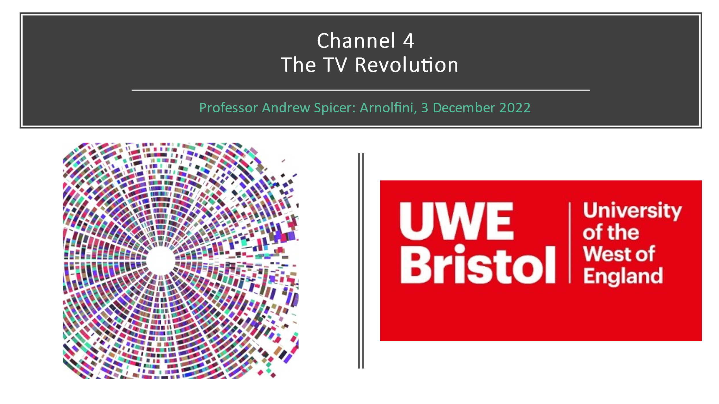
Introduction
Welcome everyone to what I hope will be a stimulating and enjoyable event that is a comradely but not uncritical celebration of Channel 4 and its connections with Bristol.
I’m Andrew Spicer, Professor of Cultural Production at the University of the West of England and I’d like in this opening talk to provide a brief introduction to Channel 4, focusing on how a particular set of interconnected aims and values have guided the role that this unique public service broadcaster has played in British social and cultural life over the last 40 years. I’ll be trying to define in what senses was Channel 4 a ‘TV Revolution’? As you’ll see from the schedule, this will be followed by a series of illustrated talks that focus on particular programmes as we explore the broadcaster’s longstanding and multifaceted relationship with Bristol.
But I must begin with some thanks. First to our partners, the Arnolfini International Centre for Contemporary Arts that has been part of the fabric of Bristol’s cultural life since 1961 which is hosting this event. Second to my co-organisers: Professor Rod Stoneman with whom I’ve talked off and on about what kind of event this might be for quite some time and who organised major critical celebrations of Channel 4 in London – specifically the BFI Southbank Season in September; and Christo Wallers who has done most of the organisational heavy lifting. Thank you both so, so much. I’d like to thank the Moving Image Research Group at UWE for some financial support and the Digital Cultures Research Centre, including Amy Densley who’s helped with the organisation.
A warm thanks too, to all who are presenting today without whom, of course, there would be no event. It’s been a collective effort, with presenters suggesting others whom I could contact and always ready with suggestions and advice. Thank you all.
I realise this is a long day and you may not all be able to attend all of it, but I hope many of you will stay for the drinks and nibbles and the screening of The Falklands War: The Untold Story this evening.
The TV Revolution
Channel 4 first broadcast on 2 November 1982. Where did it come from, why did it emerge when it did, what does it stand for – what is its mission? – and what might be its future?
The nature and function of public service broadcasting in the UK has always been a highly political affair because of its perceived importance in social and cultural life. In the words of John Reith, the BBC’s founding figure, television should inform and educate as well as entertain and thus play an active role in democratic and cultural processes.
Channel 4 emerged from protracted debates about what should be the UK’s fourth terrestrial channel during the 1970s. I’m asking younger members of the audience to imagine a dark and distant world when television sets had just four buttons! No menu of 300+ television channels, no internet, personal computers, smart phones, no YouTube, Netflix & other streaming platforms, no social media and so on. A vastly different world where scheduled television viewing played a much more significant role than it does today. So: it was a big deal, a very big deal as to what this fourth channel should be. What would you see when you pressed that fourth button?
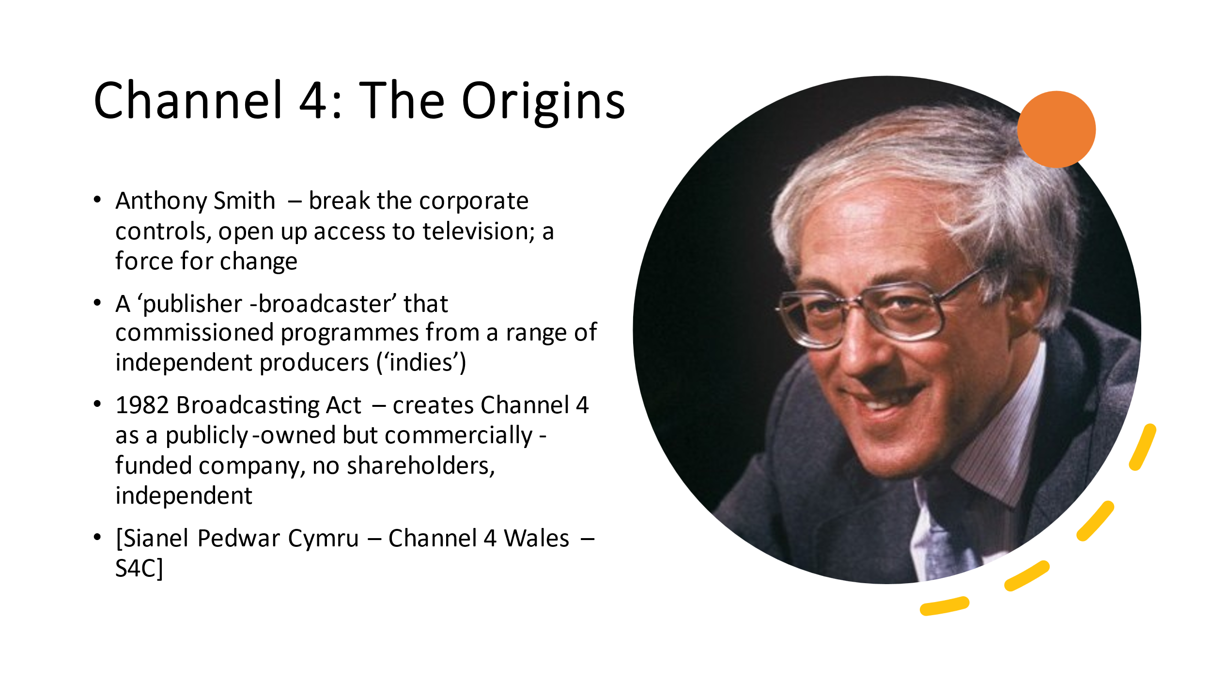For a long time it was going to be a second, straightforwardly commercial channel, ITV2. But a countervailing conception gathered force that was not so much anti-commercial as anti-corporate. The most influential voice, Anthony Smith, ex-BBC current affairs producer and BFI Director, thought UK broadcasters had become closed, inaccessible and largely unaccountable corporations exacting rigid institutional controls over their contracted staff. Smith wanted to open out broadcasting to fresh voices, a more diverse creative community, with different ideas for programmes, a new type of broadcaster that could ‘aspire to the pluralism of publishing’ as he put it. His views gained currency and the 1977 Annan Report on Broadcasting advocated that the fourth channel should serve as a force for change and commission rather than produce programmes.
William Whitelaw, the Home Secretary in the Conservative government under Margaret Thatcher that came to power in 1979, understood the need for change and backed the proposals. Commissioning from small companies fitted Tory ideas about entrepreneurship, companies competing in the free market, but it’s an oft-repeated irony that it was a right-wing Tory government that oversaw the birth of Channel 4. The 1982 Broadcasting Act established Channel 4 as a publicly owned not-for-profit company, alongside, in a late change, a separate Welsh Channel, Sianel Pedwar Cymru – Channel 4 Wales: S4C.
Channel 4 was not ITV2. Although it sold advertising space, it was to be paid for by the other ITV companies, but they could not determine content nor exert editorial control. Unlike the existing ITV companies, it had no shareholders and therefore was free to invest all its revenue (minus running costs = 10%) in commissioning programmes. And, unlike the BBC, it is not dependent on government funding through a licence fee and therefore arguably more independent of political interference, a point I’ll come back to. It is a unique model – publicly owned but commercially funded. 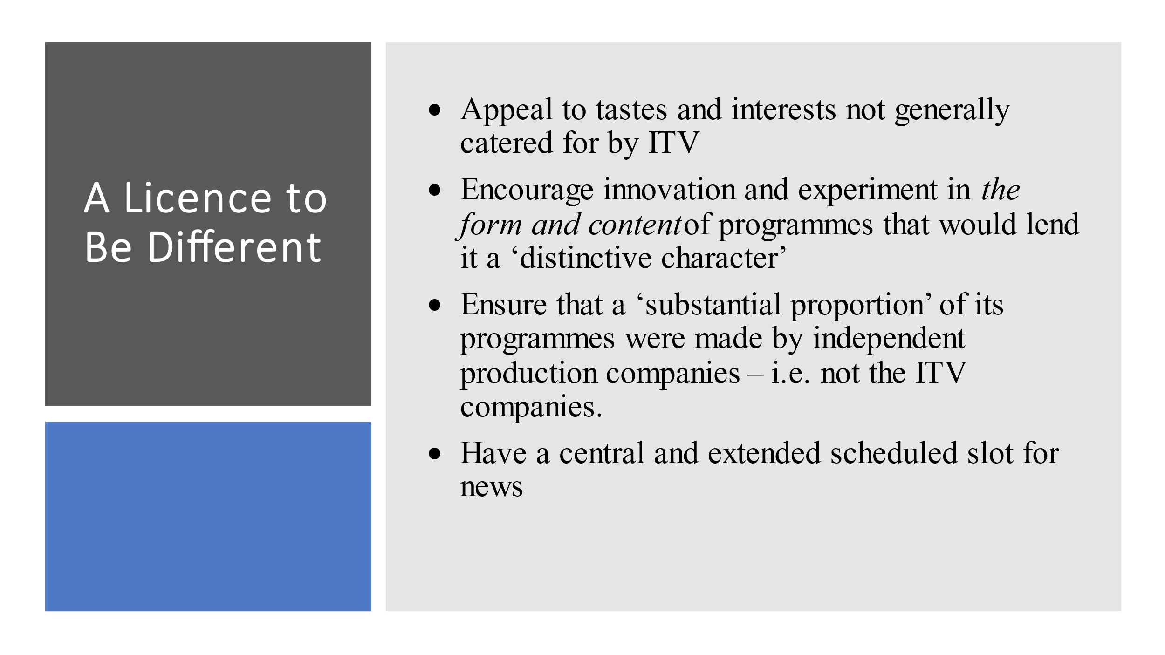Channel 4 had licence to be different as the phrase went. Its statutory remit required Channel 4 to:
- Appeal to tastes and interests not generally catered for by ITV
- Encourage innovation and experiment in the form and content of programmes that would lend it a ‘distinctive character’
- Ensure that a ‘substantial proportion’ of its programmes were made by independent production companies – i.e., not the ITV companies.
- Have a central and extended scheduled slot for news
This was the birth of the ‘TV Revolution’, a broadcaster constituted to be radical, subversive, challenging, reaching out to an increasing diverse, multicultural UK society. Its core demographic was and remains 16–35-year-olds who might wish to see something different on their television screens. And, as a publisher-broadcaster, Channel 4 would not produce its own programmes but commission them from other companies, which encouraged numerous small, independent companies to make television programmes with fresh, diverse and innovative content: we’ll hear from some of them during the course of today. And in its first year of operation, these new indies took 61% of the initial commissions, four times what had been anticipated (MB: 51).
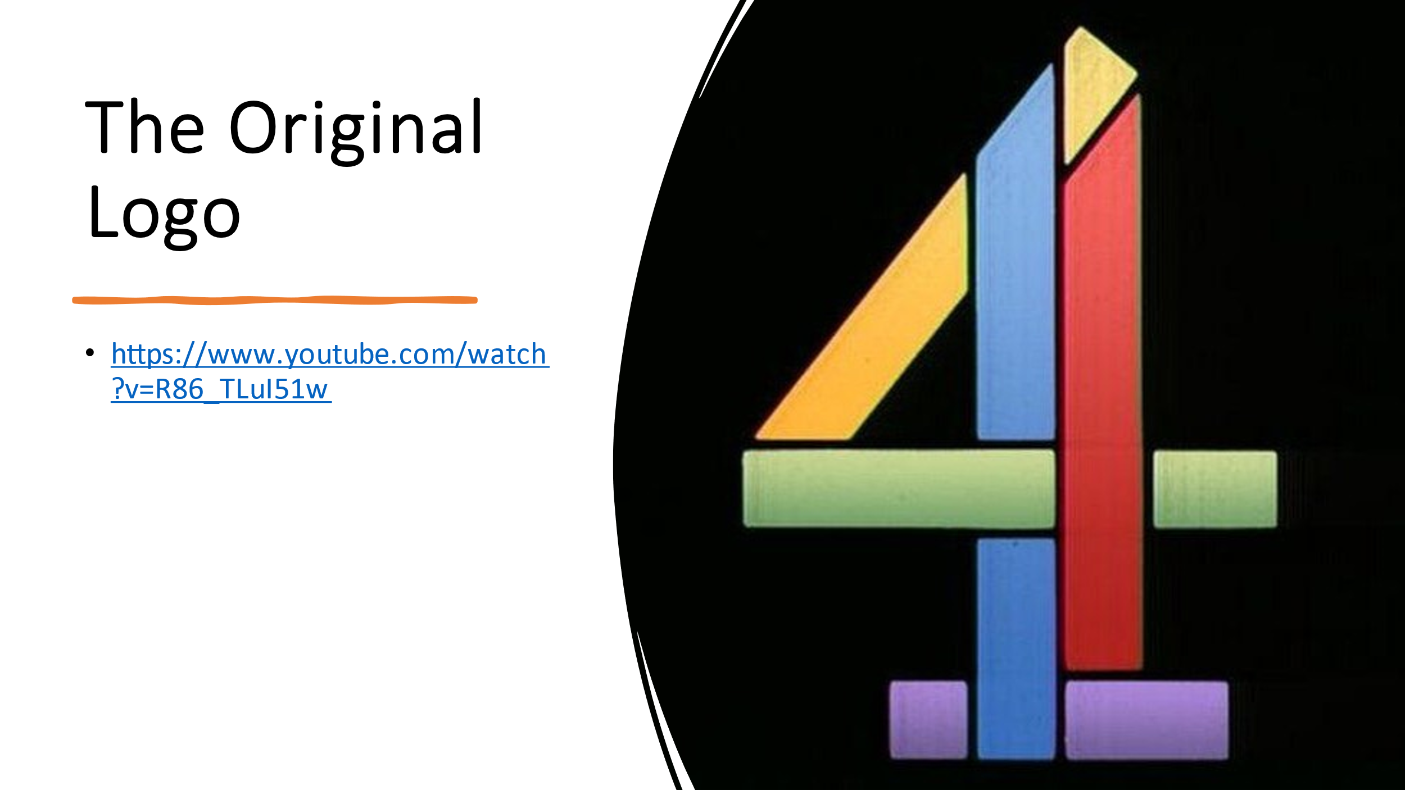Channel 4’s first ident was created by a young designer, Martin Lambie-Nairn, who came up with the concept of flying blue, green, purple, red and yellow matchsticks coming together, which he thought symbolised diversity – a publisher-broadcaster that brought those rainbow elements together (MB: 50).
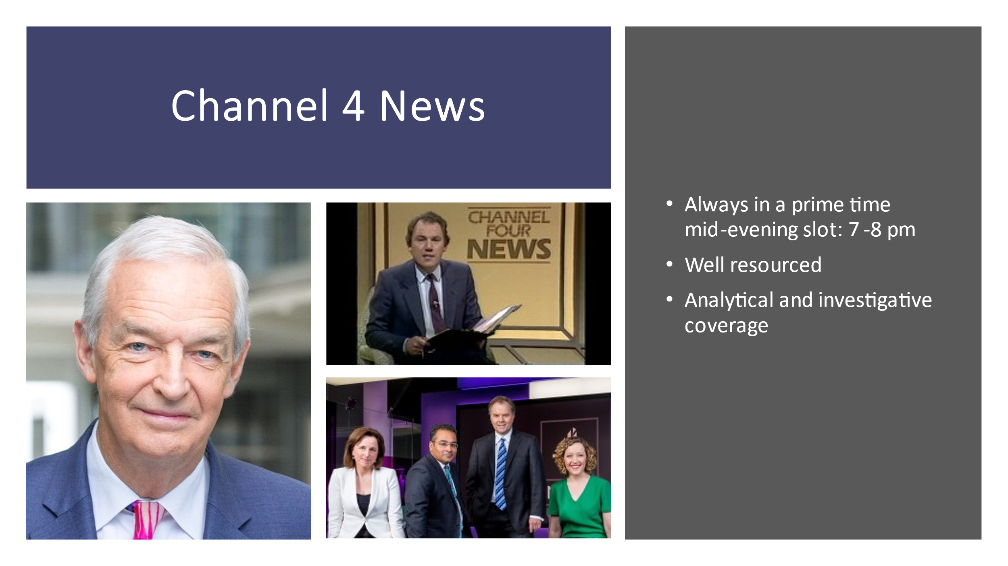TV News Revolution
In the light of what other presenters will discuss, I’d like to focus on Channel 4’s news programme, which has from the outset been slap bang in the middle of the evening and a full hour in length, which afforded the opportunity for greater range and depth of coverage, especially foreign events. Its investigative approach resembled that of a broadsheet such as the Guardian. It’s come to stand for core Channel 4 values: fearless, hard-hitting, taking no prisoners, irreverent and anti-Establishment.
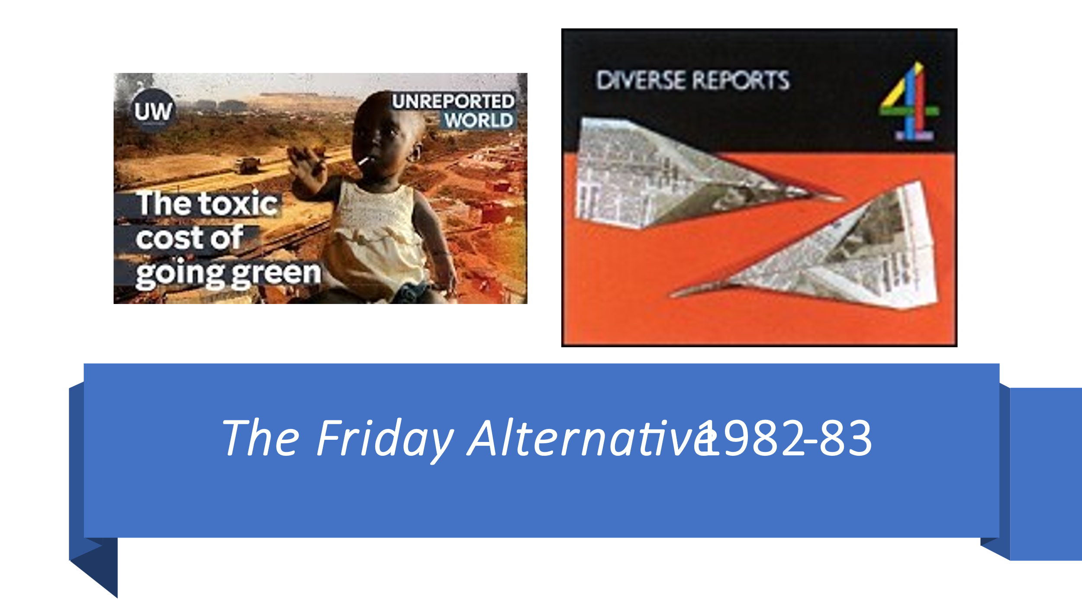For a year or so it had an anarchic supplement, The Friday Alternative made by David
Graham, who’d worked for the BBC flagship Panorama, but become increasingly
dissatisfied with how it presented current affairs. Graham set up a small company, Diverse Productions, recruiting a varied cross-section of personnel to make radical news. The programmes were low budget, often a bit ramshackle but always looking for what goes unreported or is deliberately suppressed. The Friday Alternative openly acknowledged the political position of the reporter, breaking the established conventions of objectivity and ‘due impartiality’. One example broadcast on 7 January 1983 – chosen in the light of this evening’s documentary – focused on the Falklands War, using leaked BBC internal minutes to show how local radio stations were prevented from using interviews with Falklands widows and how the infamous sinking of the Belgrano, an Argentine warship that was sailing away from the exclusion zone when it was sunk, was reported. Always controversial, pressure from various sources including ministers, caused The Friday Alternative to be closed in 1983, succeeded by the documentary series Diverse Reports, 1983-87. Its legacy is Unreported World, which has some of the most fearless journalism on current television.
Aspects of the Revolution
I think we can claim a different approach to reporting the news as an important aspect of Channel 4’s TV Revolution. The other presenters may make different claims, but I’d like to mention two others.
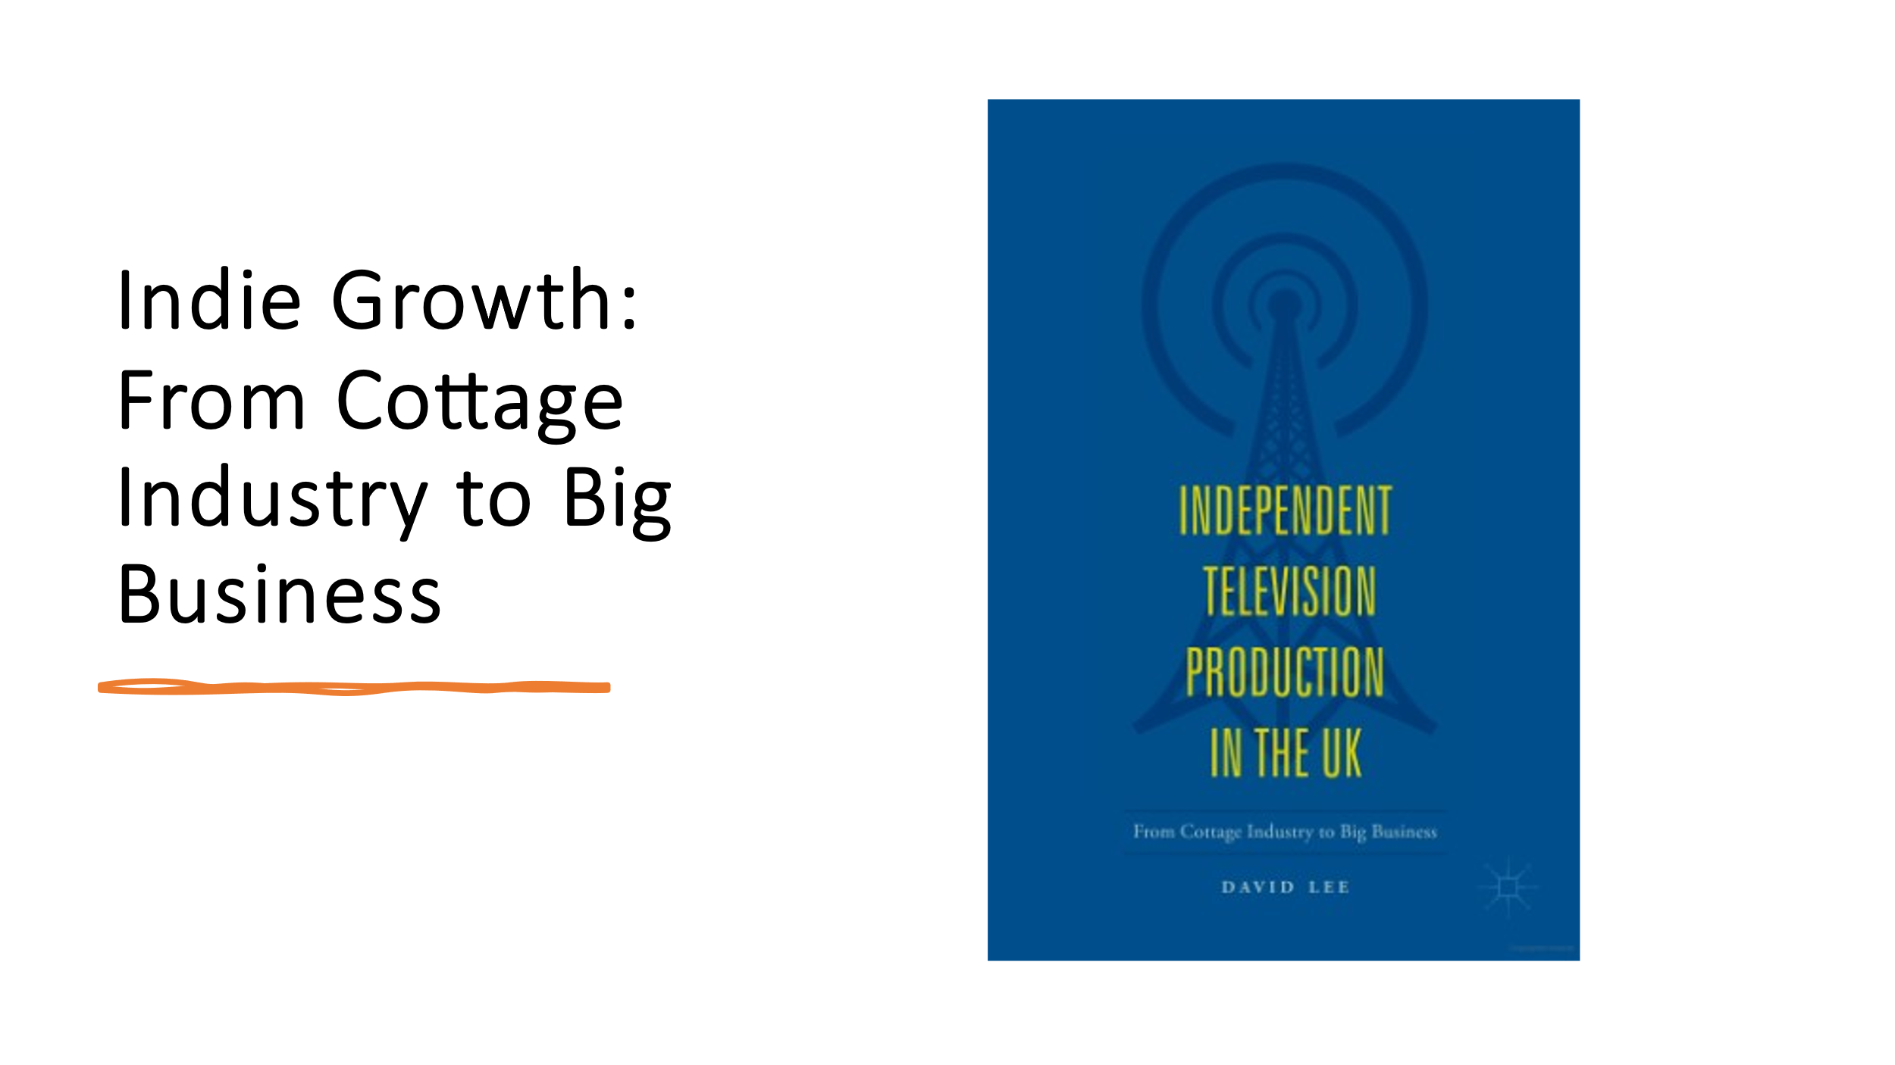
- Growth of the independent sector
Channel 4’s constitution as a publisher-broadcaster that relied on independents to produce its programming inaugurated the huge growth of the UK’s independent production sector, which changed from cottage industry to big business. According to current estimates, the sector is now worth around £3.5 billion. With the development of ITV and BBC Studios, commissioning independent production has become the norm for the UK and globally. There are regressive aspects to this growth – the sector is characterised by churn, instability and precariousness and the development of conglomerates (‘super indies’) – that shoulder out smaller competitors – but Channel 4 was the pathbreaker in this TV revolution.
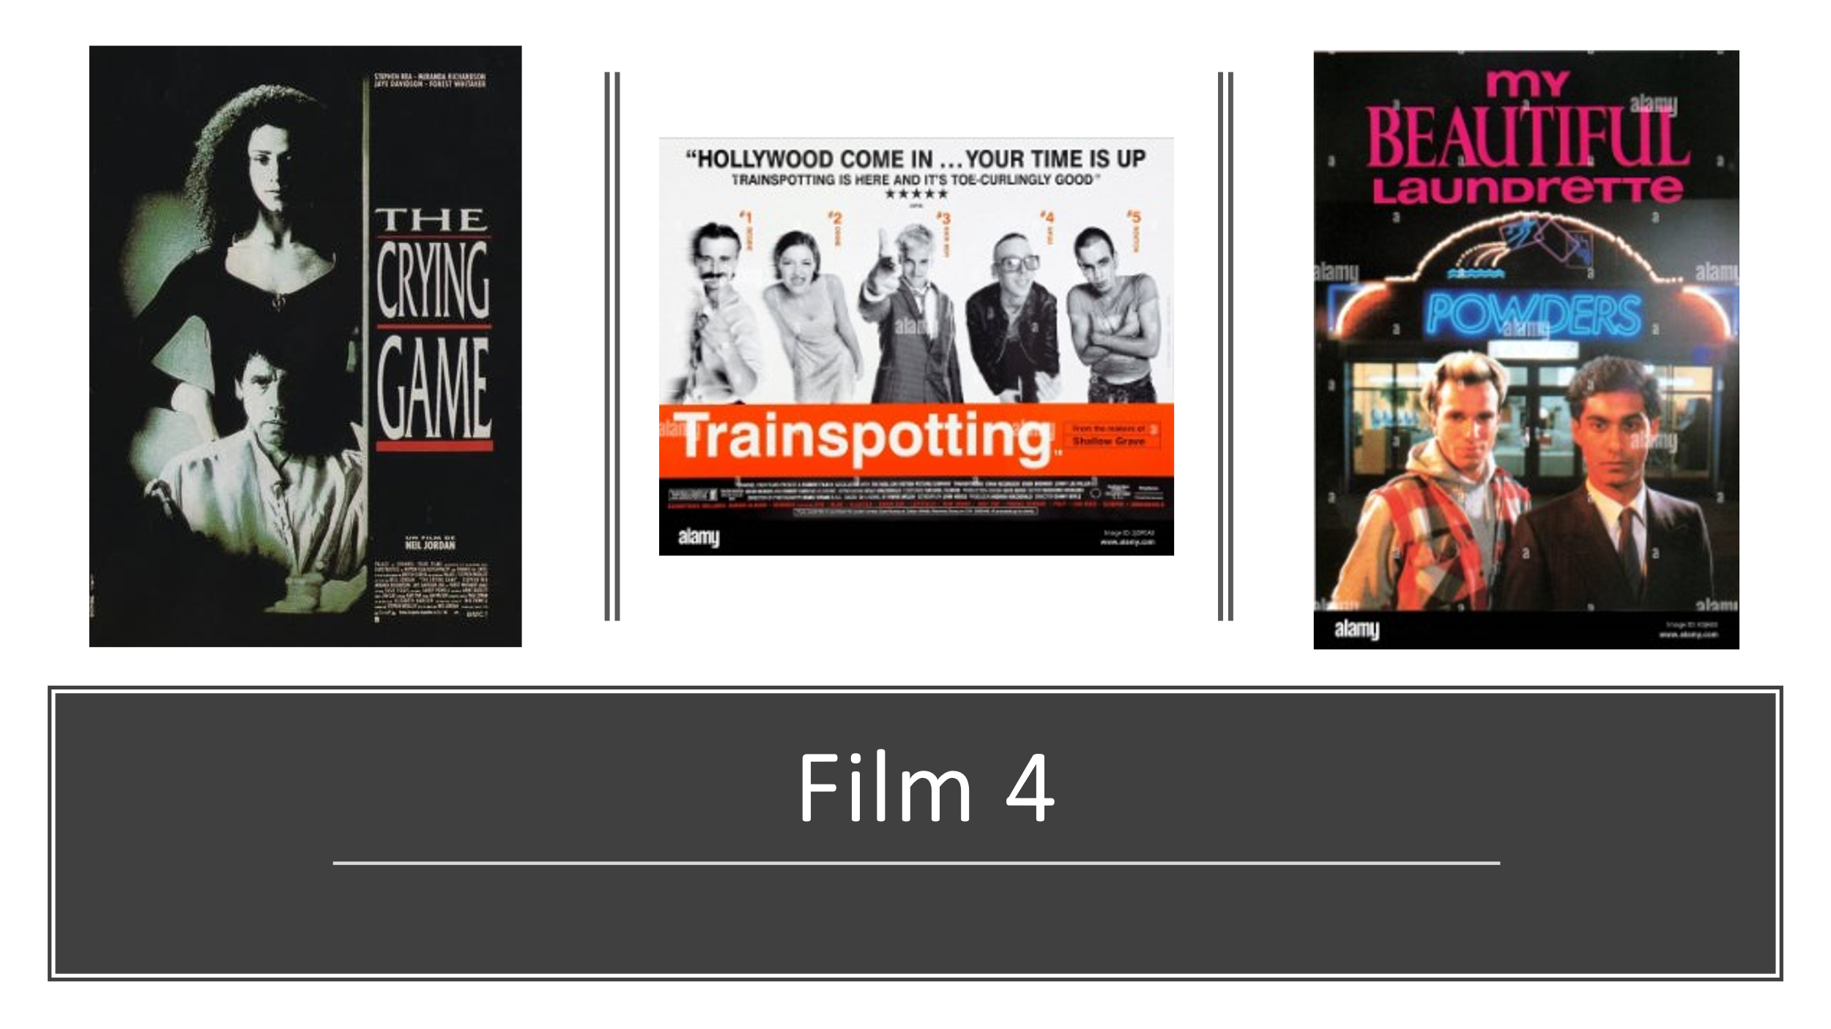
- Film4 & a rejuvenated UK film industry
Rod will talk next about the innovative work of the Independent Film and Video Department, so I’ll mention Film4. Jeremy Isaacs, Channel 4’s first CEO, was adamant that it should support the UK’s indigenous feature film industry, an unprecedented move by a UK broadcaster though based on a West German model. Its first fiction commissioner, David Rose, encouraged innovative productions, soliciting films, often by debuting writers or directors, such as My Beautiful Laundrette (1985), Comrades (1986) and Distant Voices, Still Lives (1988), Although there have been ups and downs, by common consent, Film4 injected fresh life into what was a moribund British film industry, helping to create a rejuvenated national cinema, producing or co-producing some of the UK’s most celebrated films since the 1980s, including The Crying Game (1992), Trainspotting (1995) and 12 Years a Slave (2013). Will hear from Martin Kisko about Zastrozzi.

Channel 4 over time

You’ll be pleased to know I’m not going to attempt to describe Channel 4’s subsequent history: that’s for today as a whole and I don’t want to pre-empt debate about whether Channel 4 has become more conformist and less radical. What I’d observe, in a professorial way, is that it’s always important to try to be clear about what are the economic conditions within which Channel 4 operates. And, as a commercial as well as cultural entity Channel 4 must make ‘successful’ programmes that attract audiences and hence the advertising revenue on which it is almost entirely dependent. In David Parker’s four-part series, What’s this Channel 4? broadcast in June 2003, the then CEO Mark Thompson tells his staff that the broadcaster ‘needs commercial ambition to fulfil its cultural ambition’, so culture and commerce are inextricably intertwined.
I want to finish by touching on two further elements of Channel 4’s subsequent history: Relocation and Privatisation. 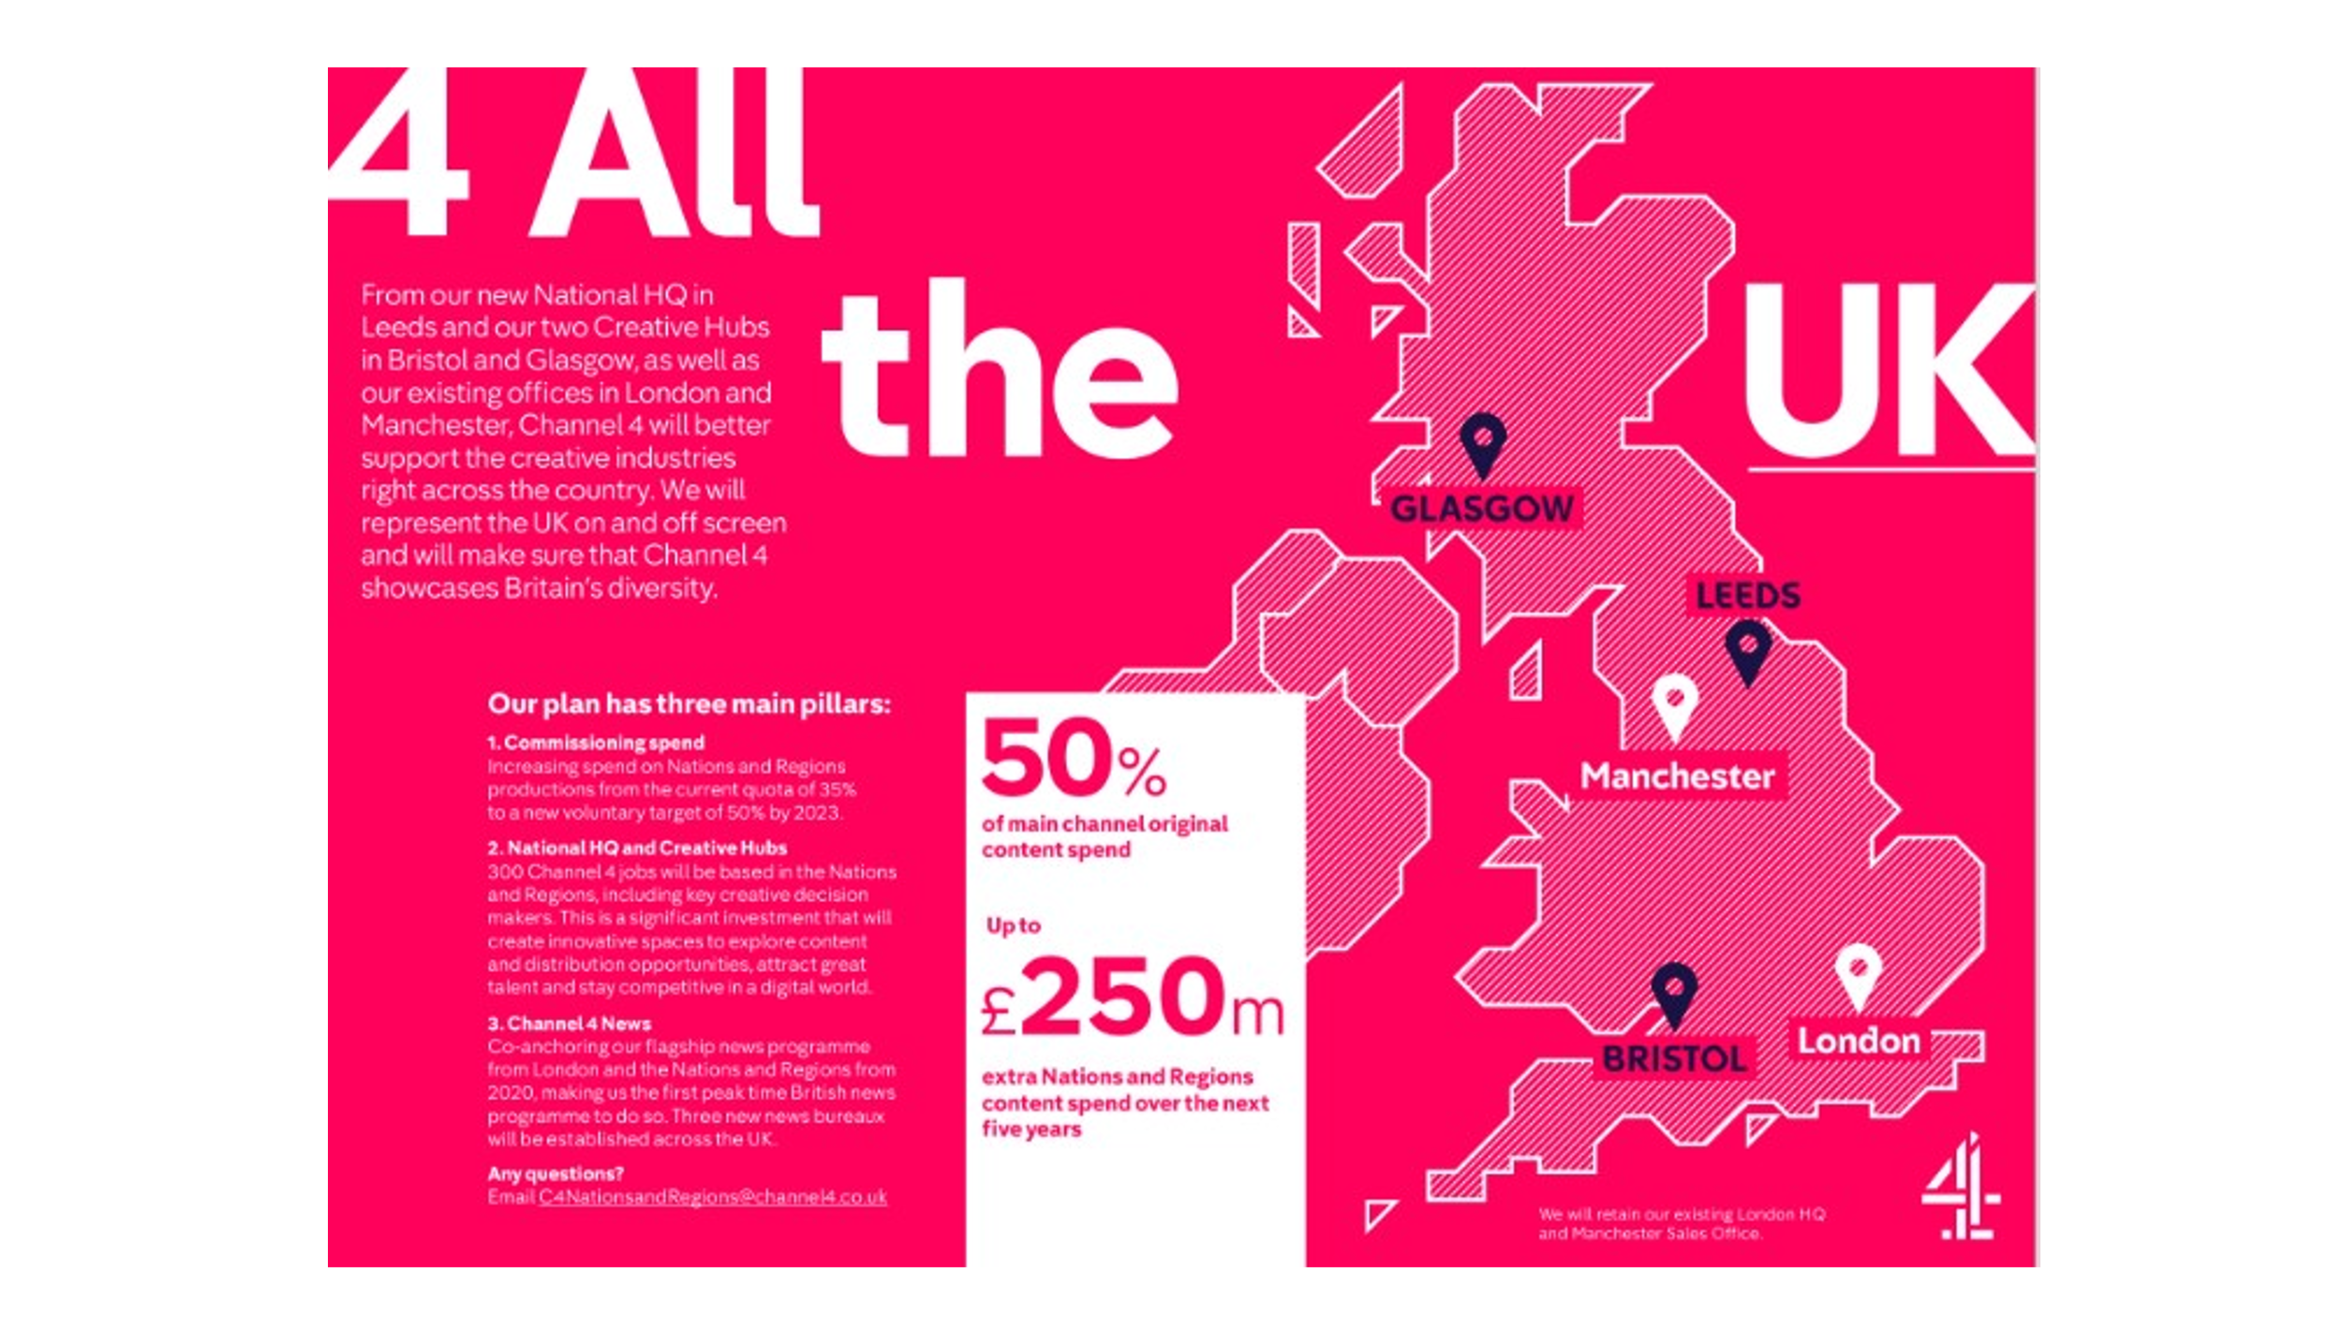Relocation
The Broadcasting Regulator, Ofcom, established in 2003, sets quotas for out-of-London primary spending as a mechanism to encourage the PSMs to produce ‘regional stories, characters, places and issues’ to ensure that television ‘reflects and responds to all the identities and communities of the UK’s increasingly diverse society’. Channel 4 always claimed this obligation was discharged by working with ‘embedded’ regionally-based indies. However, its commissioners remained in London, leaving those indies frustrated at having to travel there to pitch ideas to the Channel 4’s metropolitan commissioners, the ‘£125 cappuccino’ as it became known. Under pressure from the government, in 2017-18, Channel 4 completed a much-publicised relocation out of London – ‘4 All the UK’ – opening a new headquarters in Leeds and two ‘creative hubs’ in Bristol and Glasgow. Channel 4’s CEO, Alex Mahon, heralded the move as ‘the largest structural shake-up in Channel 4’s history’, claiming that these regional centres made the broadcaster ‘more connected to – and rooted in – the lives of the communities that make up Britain’. Channel 4 now commissions around 60 per cent of its programmes from outside the M25. Sacha Mirzoeff, who heads the Bristol Hub, will talk later about the changes this has made for Channel 4 itself and for regional screen centres such as Bristol. This is a long-term shift rather than a revolution, designed to lessen London’s dominance and champion a plurality of voices by being regionally based.
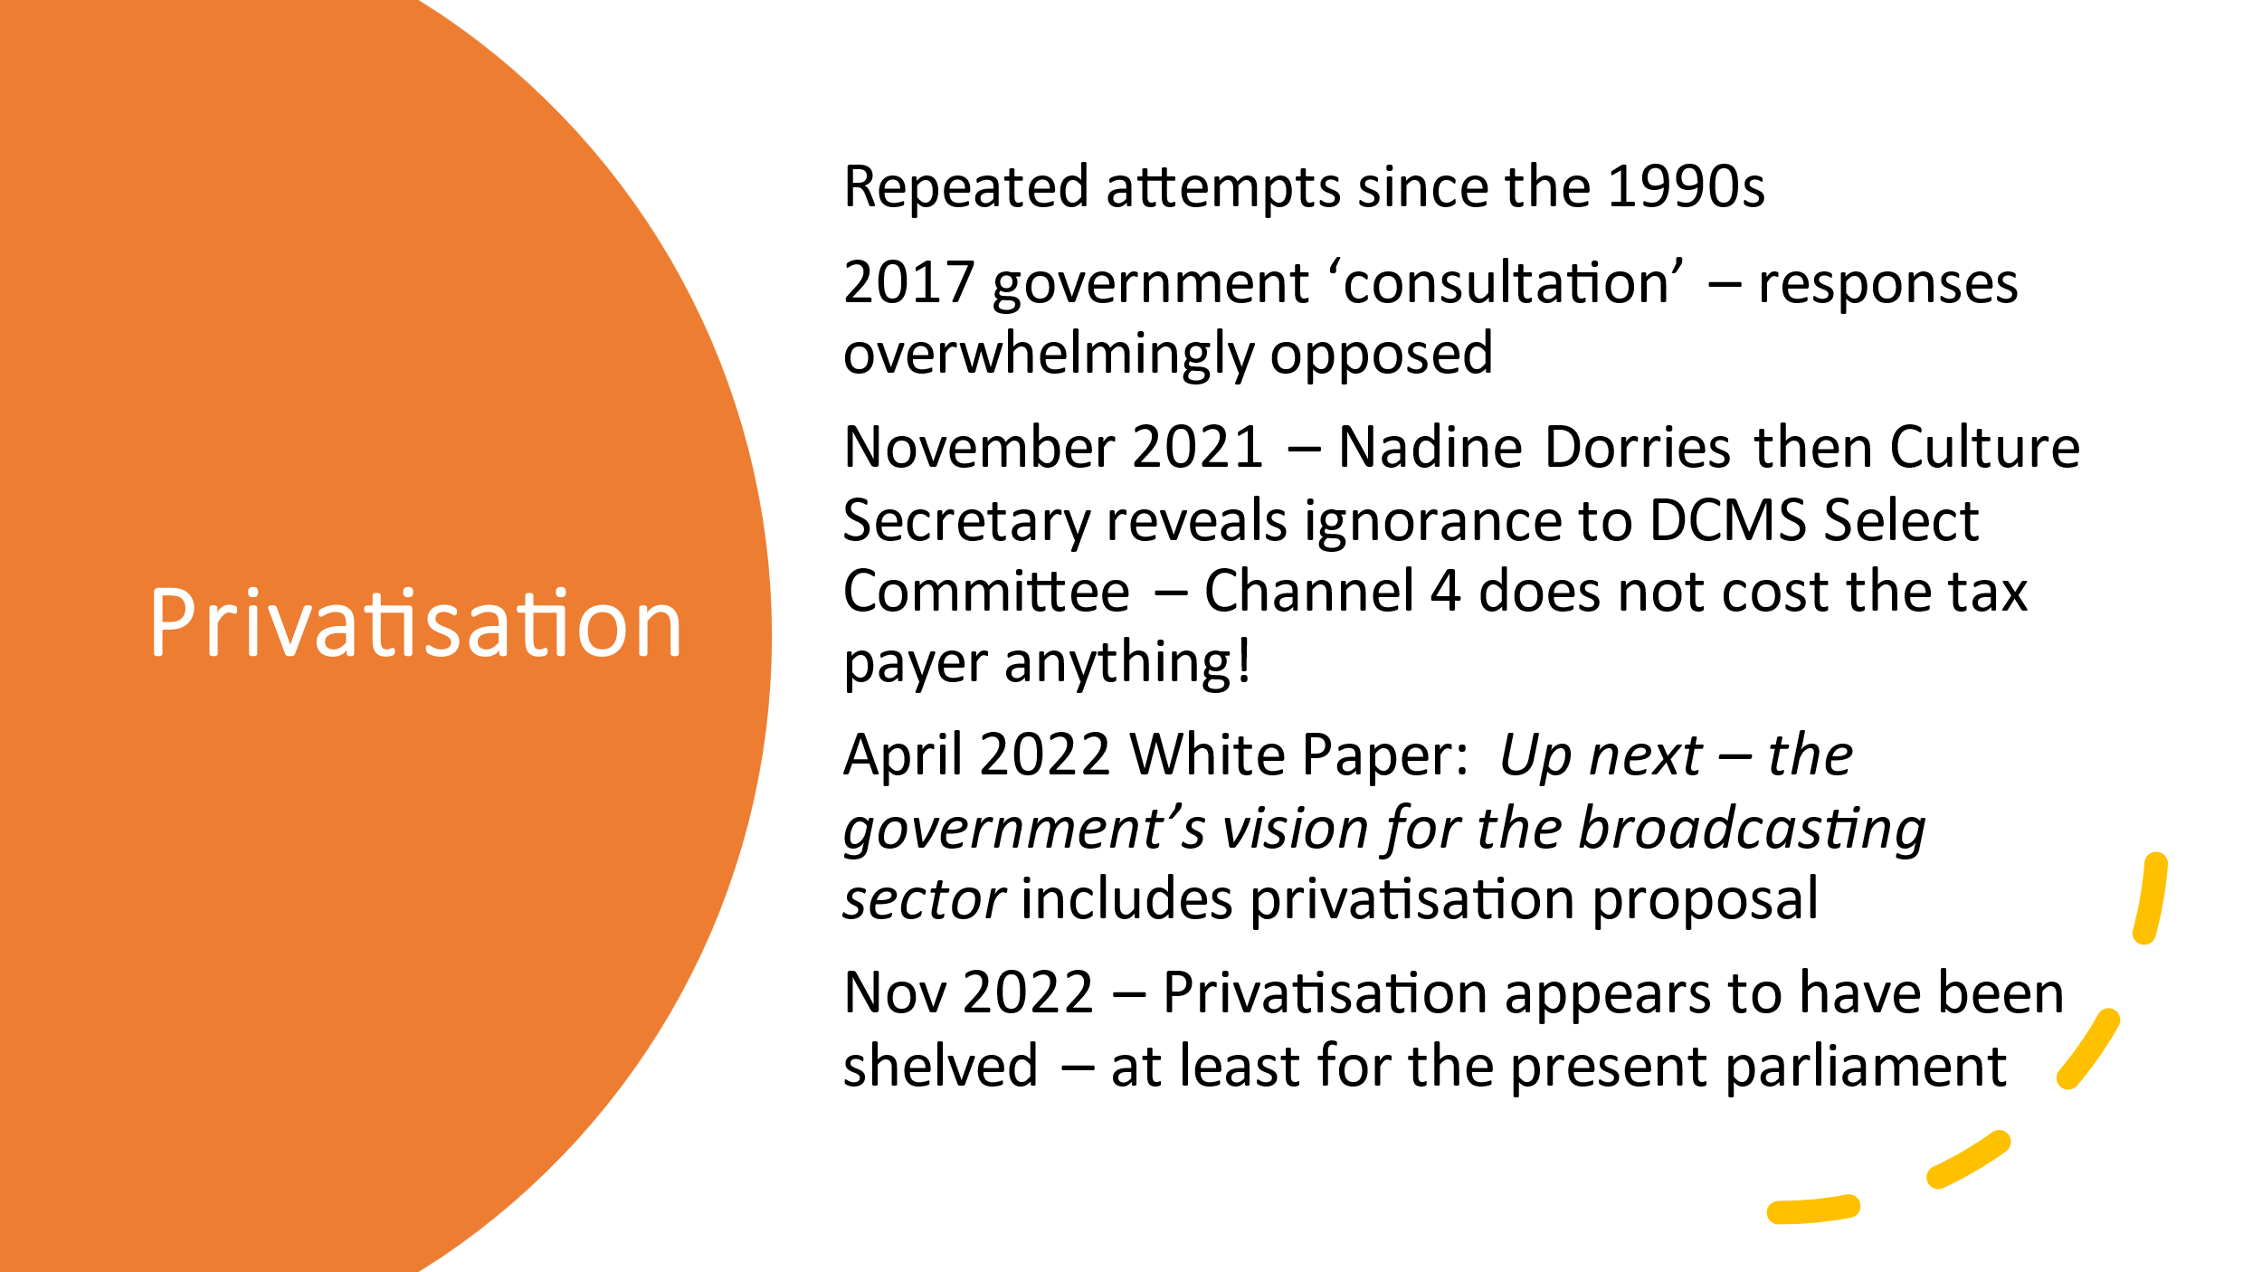Privatisation

I mentioned that Channel 4 is more independent that the BBC, ever watchful about the government renewing its licence. However, Channel 4 is a publicly owned company that can be sold by the government. Despite overseeing its birth, the Tories have never liked Channel 4: too independent, too critical and far too, in their mind, left-wing. There have been active steps to privatise the broadcaster since at least 1996 and in 2017 there was a ‘consultation’. The overwhelming response from academia, the industry and institutions was that privatisation would seriously erode if not obliterate, Channel 4’s ability to fulfil its founding remit, jeopardise its relocation initiatives and inflict lasting damage on the UK’s independent production sector. Undaunted by evidence or rational argument and signally ignorant – in November 2021 in front of the DCMS Select Committee the then Culture Secretary Nadine Dorries erroneously stated that Channel 4 received public money – the Government pressed on. Its April 2022 White Paper: Up next - the government’s vision for the broadcasting sector advocated privatisation. However, the tsunami of larger problems has meant that privatisation has been shelved for the life of the present parliament. None of the other political parties see any merit in this policy. But this entire process demonstrates not only how deeply political broadcasting ownership and regulation is, but also how vulnerable Channel 4 is as a public service broadcaster despite various credible analyses that showed it is in robust financial health as well as fulfilling its remit.

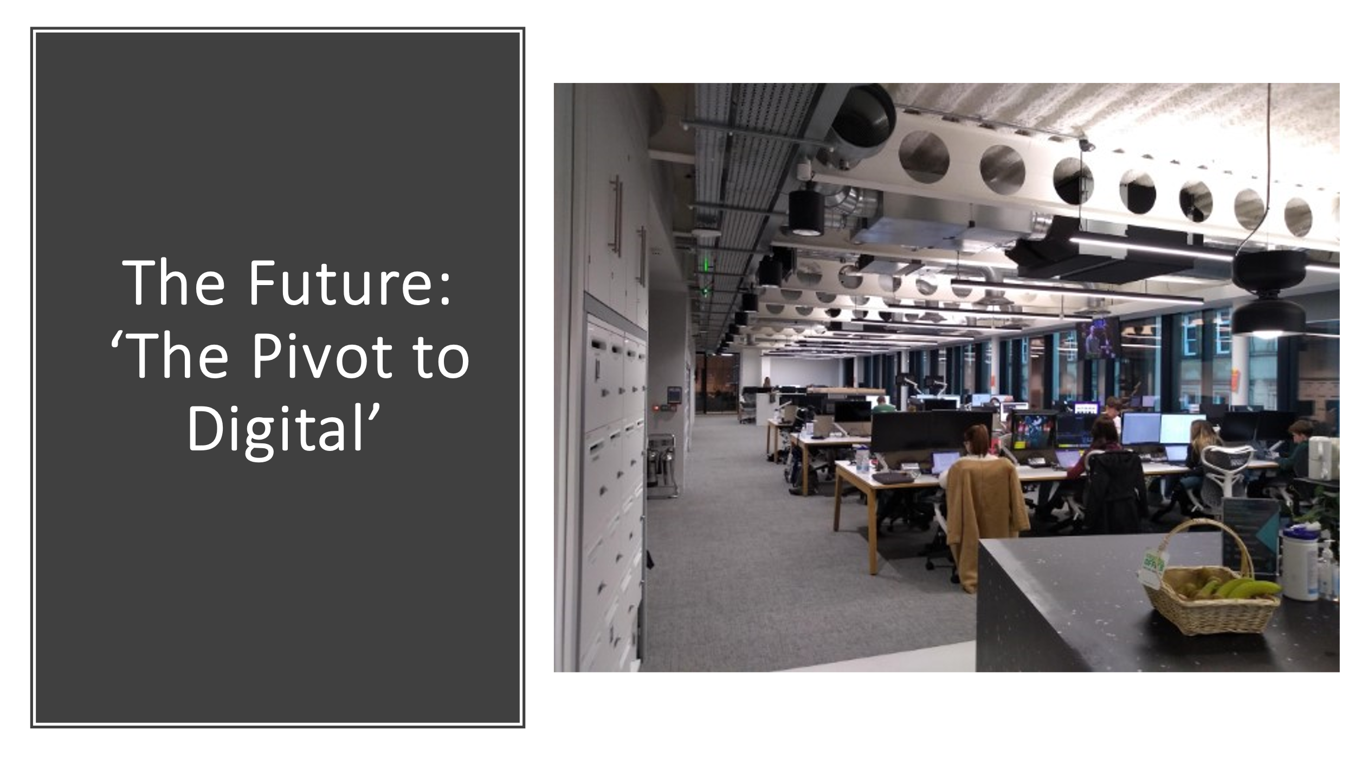Future – pivot to digital

Assuming it’s not privatised, what is Channel 4’s future? It now operates in a media landscape has been transformed since the 1980s. We live in a very different broadcasting era in which the production, distribution and consumption of television has changed radically. Channel 4 now competes with a far wider range of competitors – all those digital providers I mentioned – that are not freely accessible, nor required to provide a broad range of programming.
In response, Channel 4 is basing its Future Four strategy on accelerating its ‘pivot to digital’. Channel 4 won’t disappear as a linear broadcaster, but its priority is digital growth. When I visited the Leeds headquarters in November, I saw many of its 150 4Studio staff – the biggest department outside London – beavering away, either on new ways of packaging existing programmes or original content development for Snap Chat, Tik Tok, Facebook, YouTube etc. However, what was made clear was that 4Studio’s monetising potential would adhere to Channel 4’s core publisher-broadcaster strategy – 90 per cent of its output was being made by small, independent companies and its core remit. Ian Katz, Channel 4’s Chief Content Officer, has reaffirmed its commitment to challenge and provoke, what he calls a ‘deep strand of mischief-making and disruptiveness’.
We might want to come back to that phrase in our discussions.
It’s my pleasure now to hand over to Rod Stoneman who will discuss early independent film initiatives in Bristol and their relationship to Channel 4.

