Research event UWE July 2022

5 minutes of drawing: University of Lisbon

Name:
Gary Embury
Bio:

Gary Embury is a senior lecturer at the University of the West of England. He is currently involved in a number of reportage drawing related projects nationally and internationally including an artist’s residency collaboration with UWE Drawing Research Group and Chelsea and Westminster hospital in London. He is editor in chief of Reportager.org an online journal showcasing and initiating reportage drawing.
Gary co-founded the Chronical Residency Programme based at the Topolski studio in London and has given talks and presented papers at conferences and symposia internationally, chairing ‘Witness’ Reportage and Documentary forum at Falmouth University. He also conceived and curated the International Reportager Drawing Award​ sponsored by Moleskine and is co-author with Prof. Mario Minichiello of Reportage Illustration Visual Journalism. Gary is currently researching a new book for Bloomsbury publishing on the future of reportage and documentary drawing.

profile picture:

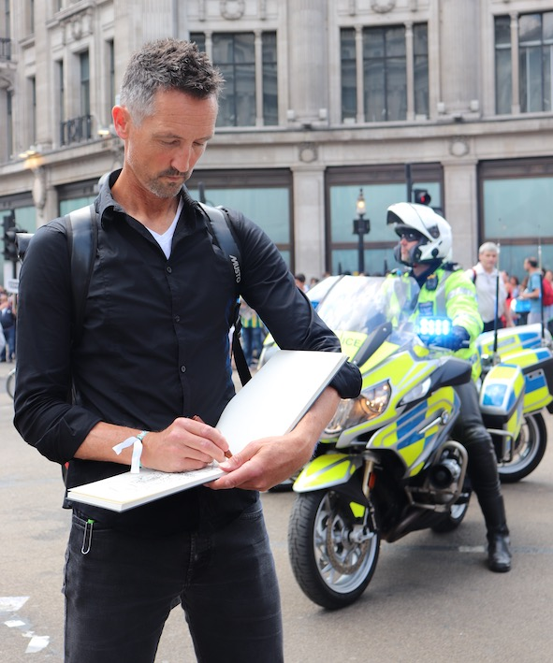
Drawing at the Trump demo. London

Title of Video:

Reimagining reportage drawing through Immersive technology.

Abstract:

Reportage drawing by its very nature is primarily a first hand or as Bonnard said, ‘First sight’ expression, often drawn from reality, experienced in the moment and on the spot. However, I am comfortable with the idea that it can also be an interpretive more constructed medium, and subscribe to the description John Grierson gave to documentary as 'The creative treatment of actuality'

On the spot drawings when taken and developed in the studio can become much more than the sum of their constituent parts. Can a purely observational sketch really express the nuances of an experience especially in situations which may need cultural, political or historical context?
If reportage drawing is to be considered a serious discipline rather than purely a passive observed version of reality, which doesn’t comment, inform, illuminate, or initiate debate, then it really needs to align itself with documentary film and photography.

As documentary artists or visual journalists how and what are we adding to a subject, location or event. Can we as visual journalists mediate, and augment our drawing in the studio to create rich multidisciplinary experiences which take advantage of the new immersive technologies now available to us in the digital and virtual worlds.

Reportage drawing as documentary practice can become richer in subject, and content and not just exist as an aesthetic response to an ‘on the spot experience.’ Work made as primary resource and reference material can be augmented and developed post event to create visually rich multi modal visual essays. This has much more in common with documentary film practice and has greater mileage and usage for the future. News isn’t documentary!

With this in mind I am now experimenting with immersive technologies such as virtual and augmented reality. As an initial early experiment, I am utilising my existing reportage drawings made in the real world, but reimagining them in virtual reality facilitated by ‘Oculus Quest and ‘Tilt brush.’ Ideally augmented reality could be more useful as it’s not as dislocating from reality as virtual reality due to the all-encompassing headset. However, for this experiment I am moving between the real and virtual world but making the work only in the virtual.

In virtual reality, the drawings take on a monumental 3 dimensionalities becoming much more like architectural objects which one can step into, rotate and scale up, even to a staggering 1: 1 scale. New spaces can be reimagined inside the drawings themselves in order to create hidden spaces and antechambers for exploration. The initial drawings remind me of architectural sketched visuals reminiscent of Daniel Libeskinds early sketches for IWMN and those of Edourdo Souto de Moura for Casa des Historias Paula Rego in Cascais

The immersive qualities of this medium are initially disembodied but fantastical and addictive. Working in a completely white trackless space devoid of floor, ceiling, or horizon can be initially disconcerting. It encourages large gestural movements creating 3 dimensional concaved marks. It’s an infinite slippy space rather than one page of a sketchbook. Many objects can be created scaled down and placed to one side in this virtual infinite studio creating a library of artefacts.

These are definitely early first step experiments for reportage drawing as documentary. However, the medium does enable five of the modes often associated with documentary practice. Observational, Participatory, Poetic, Reflexive and Performative. The expository is something I now want to explore and how might an audience participate in this experience of the real world and its narratives.
This is an early work in progress and one which could be an exciting and engaging way to develop reportage drawing as an immersive non-fiction storytelling medium or genre.

____________________________

Instagram:
@gary_embury

