Postactivation performance enhancement (PAPE) in healthy adults using a bodyweight conditioning activity: a systematic review and meta-analysis.

Nicholas J Brink¹
Demitri Constantinou¹
Georgia Torres¹

- Centre for Exercise Science and Sports Medicine, Faculty of Health Sciences,
University of the Witwatersrand, Johannesburg, RSA; FIMS Collaborating Centre of Sports Medicine.

Corresponding author:
Nicholas Brink,
+44(0)7564388177
nicjbrink@gmail.com

ABSTRACT
A systematic review and meta-analysis were conducted to review the available evidence on whether a bodyweight conditioning activity can acutely improve the outcome of a subsequent task through postactivation performance enhancement. Data sources included PubMed (National Library of Medicine), Web of Science (Clarivate Analytics), Google Scholar, SPORTDiscuss (EBSCO), Embase (Elsevier) and Thesis Global. Participants were healthy, active adults who performed either a vertical jump or a linear sprint outcome measurement. All studies were randomized control trials where the effects of a bodyweight conditioning activity were compared to a control condition. The control group followed the same course as the experimental group excluding the intervention with the intervention and outcome measurement carried out in the same session. The intervention was completed prior to the initiation of the outcome measure testing. Nineteen studies fulfilled the eligibility criteria and were included. There was a small overall effect of 0.30 (95% CI 0.14 to 0.46, p=0.0003) in favour of using a bodyweight conditioning activity to improve the outcome of a subsequent vertical jump or linear sprint. Secondary analysis indicated that there was no difference between the vertical jump and sprint sub-group, the < 5 minutes, or 5 minutes and greater between intervention and outcome measurement sub-group or whether an intervention with the same movements or different movements was used before the outcome task sub-group. Using bodyweight conditioning activities prior to performing a maximal vertical jump or sprint may provide a small benefit in performance outcome.

Systematic review registration number: PROSPERO CRD42020152006
Keywords: Postactivation performance enhancement; warm-up; plyometrics; jump; sprint.
Abstract word count: 244
Total manuscript word count: 3507

INTRODUCTION
Postactivation performance enhancement (PAPE) is a physical training principle which proposes that a muscle can be acutely optimized by its contractile history, which in turn affects the outcome of a subsequent task. This enhanced task is commonly associated with power-based activities which require high force production and a high rate of force development like sprinting and jumping (21). Postactivation performance enhancement has been tested in a multitude of sporting environments and different movement patterns with varying degrees of success (5). Typically, the conditioning activity for PAPE was thought to require a heavy resistance, isotonic preload stimulus (75-90% 1RM) to achieve this enhanced state (21). This required athletes to lift, push or pull heavy weights over a varying range of sets and repetitions to develop a combined effect of heightened muscle activity and consequential fatigue. Theoretically, the fatigue dispelled first, leaving the muscle in a state of acute enhancement (33).

Current literature has discussed the association between postactivation potentiation (PAP) and PAPE (39). Conventional models suggested that PAP is any acute enhancement lasting up to 20 minutes following heavy resistance training or a high intensity ballistic activity (3, 27). It is proposed that an initial contraction increases the myosin regulatory light chain (RLC) phosphorylation that supports the effects observed in PAP, including an enhancement in voluntary contractile force (47). Although part of this may be true, PAP only refers to an enhancement of an evoked twitch response, which is relatively short lived and rapidly decreases after ~1 minute (48). Postactivation performance enhancement is associated with among other things; voluntary contractions, increases in muscle temperature and several neural mechanisms unrelated to RLC phosphorylation where a muscle twitch has not been directly assessed (11, 32). This study did not intend to explore these terms in detail, except to apply the correct terminology. In this study PAP will refer to reported changes in muscle twitch response while, PAPE will refer to an acute bout of high intensity voluntary exercise followed by an improvement in power, speed, and strength production (3, 51).

There is a growing interest in the PAPE effects elicited by ballistic conditioning activities including plyometrics (27). The Henneman size principle suggests that motor units are activated from the smallest, type I, fatigue resistant fibers to the larger, most powerful type IIx fibers. Selective recruitment is an exception to this principle (30, 31). By utilizing high velocity, high power movements, the smaller, type I fibers can be surpassed, activating exclusively the larger type IIa and IIx fibers extremely quickly. This form of recruitment may underpin the success seen in ballistic conditioning activities and PAPE. Seitz et al. (35) demonstrated that plyometric interventions had a greater effect on the outcome measurement compared to traditional high intensity tasks, suggesting that plyometrics may play a superior role in acutely enhancing muscle tissue, a concept reiterated by Creekmur et al. and Sharma et al. (10, 36) However Seitz et al. (35) also notes that studies investigating plyometrics are limited. Further studies have since been published and as ballistic conditioning activities including plyometrics have shown potential to induce a superior PAPE response, additional investigation is warranted.

There is a positive performance correlation between a sport and the specificity of the warm-up processes (34). Similarly, a common theme exists relating to the effectiveness of PAPE - how closely the conditioning activity relates to the subsequent task (32). Van den Tillaar et al. (46) demonstrated that specificity is an important constituent in the development of an enhanced outcome. A warm-up with activities like the subsequent task were used with significant benefit compared to an alternate non-specific warm-up. Suchomel et al. (41) propose that the intensity and velocity of the conditioning activity needs to closely mimic the levels achieved during competition or training as it is highly suggestive that this is an important component in achieving a PAPE effect. It is not uncommon for sprinters and jumpers to engage in some form of sprinting or jumping prior to competitive involvement. Research has provided an indication that using a conditioning activity very similar to the subsequent task can enhance performances within specific populations (38). In a practical example Karampatsos et al. (23, 24) observed that field event athletes achieved significantly greater throw distances after three countermovement jumps or a 20-meter sprint at maximal effort. Research also suggests that jump performance improves by using different variations of jumping as the conditioning activity (8, 20).

An initial search of PROSPERO, PubMed, JBI Evidence Synthesis, Google scholar, Web of Knowledge and SPORTDiscus was undertaken in January 2021, revealing that no comprehensive systematic review had been done on this subject. This systematic review intended to investigate whether PAPE can be achieved using a bodyweight conditioning activity in a healthy adult population. It aims to provide insight for coaches, rehabilitation specialists, and medical practitioners into the effect of bodyweight conditioning activities to enhance subsequent tasks which could improve rehabilitation outcomes, training impulses and competition performances.

METHODS
Search strategy and study selection
The proposed systematic review was formatted in accordance with the Preferred Reporting Items for Systematic Reviews and Meta-analyses (PRISMA) statement checklist (29). The title of the review was registered in PROSPERO, registration number CRD42020152006. A full search strategy was developed for PubMed; National Library of Medicine (table 1) using text words within the titles and abstracts of relevant articles and the index terms used to describe the articles. The search strategy, including the identified keywords and index terms, was adapted for each information source. The reference list for each study selected for critical appraisal was screened for additional studies. An electronic literature search was conducted via PubMed (National Library of Medicine), Web of Science (Clarivate Analytics), Google Scholar, SPORTDiscuss (EBSCO) and Embase (Elsevier). The search strategies incorporated natural language and PubMed’s controlled vocabulary: Medical Subject Headings (MeSH). Unpublished studies included Thesis Global and contacting authors. Following on from the search strategy, all found citations were compiled and uploaded into EndNote X9/2019 (Clarivate Analytics, PA, USA) and the duplicates removed. Two independent reviewers screened the titles and abstracts for assessment against the inclusion criteria for the review. Possible relevant studies were recovered in full, and their citation details captured. Two independent reviewers assessed the full text of the selected studies in detail against the inclusion criteria. Full text studies that did not meet the inclusion criteria were recorded and reasons reported in the systematic review. At each stage of the review, disagreements were resolved through discussion. The search results were reported in full in the final systematic review and presented in a PRISMA flow diagram in figure 1 (29).

Eligibility criteria
This systematic review examined studies that included a healthy, active adult population where their level of participation, type of activity and training experience had been reported. This review assessed original research focusing on any bodyweight conditioning activity which attempted to elicit PAPE or to achieve an enhanced effect during a subsequent task. Types of conditioning activities included, but were not limited to, variations of the vertical jump, variations of the horizontal jump and linear sprints over different distances. The intervention needed to be completed prior to the initiation of the outcome measurement. The volume and intensity of the intervention as well as the duration between the intervention and the outcome measurement was captured when the studies were assessed. This review evaluated studies that included a control condition which was treated identically to the experimental group excluding the intervention. Both the control group and experimental groups used a reliable measurable performance outcome. This review assessed studies with the primary outcome measures being a measurable change in the score between the control group and the experimental group. Only a single outcome measurement was included per study. When multiple outcomes were measured during the same session, only to first measurement was recorded. Where available, secondary outcome measures like type, volume and intensity of the subsequent task were captured. This systematic review considered randomized controlled trials (RCT), crossover and parallel studies which were published or unpublished. These investigated the PAPE effects of a bodyweight conditioning activity on a subsequent task. Only studies published over the last 20 years were included in this systematic review due to the recent modern scientific developments within this topic and the lack of availability of studies prior to this (14). Studies which did not provide enough information to extract an effect size and were not published in English were excluded.

Assessment of methodological quality and risk of bias
Two independent reviewers critically appraised the eligible studies for methodological quality in the review using standardized critical appraisal instruments according to the Cochrane risk of bias tool (19). Disagreements were resolved through discussion. A value of low, high, or unknown risk of bias was provided for five domains of bias: selection bias, performance bias, detection bias, attrition bias, and reporting bias.

Data extraction
Data was extracted from studies included in the review by two independent reviewers. Specific details extracted included population groups, interventions, outcomes measurements, and study methods significant to the review objective with any disagreements resolved through discussion. Authors were contacted to request missing or additional data for clarification.

Data synthesis
The findings from the studies included were assessed, and a meta-analysis was carried out using Review Manager (RevMan) V.5.3 (Copenhagen, Denmark: The Nordic Cochrane Centre, The Cochrane Collaboration, 2014). Effect sizes was expressed as a standardized mean difference, their 95% confidence intervals were calculated and presented as a forest plot. The standard chi squared and I2 tests were used to test heterogeneity. Statistical analyses were performed using a fixed effects model as the heterogeneity between studies was low (44). Sub-group analysis was conducted to compare the impact of different aspects of the systematic review. Publication bias was presented for visual analysis through funnel plots.

RESULTS
Identification of studies
Following the initial database search, 1168 individual links were retrieved. After duplicates were removed, titles and abstracts screened, and full texts assessed for eligibility, 19 studies were identified for qualitative and quantitative analysis.

Characteristics of the included studies
The 19 studies identified for analysis have been summarized in table 2. All studies used a randomized controlled crossover (n=17) or parallel (n=2) design. The studies included 303 (male: n=278; female: n=25), physically active (recreational: n=5; competitive: n=14) individuals (21.3±2.6 years) from Europe (n=14), South America (n=2), Africa (n=2), and North America (n=1). All the studies included a controlled condition that was the same as the experimental condition excluding the intervention. In each study the intervention was a bodyweight conditioning activity and was concluded prior to the initiation of the outcome measurement. All the outcome measurements were either a vertical jump or a linear sprint (table 3).

Methodological quality and risk of bias
The authors’ judgement of risk of bias has been reported for each study in figure 2. Selection, reporting, and attrition bias was low across all the studies with performance and detection bias being very high. The risk of publication bias was not detected on visual examination of the funnel plot (figure 3).

Meta-analysis
From the 19 studies, 606 individual events were analyzed using standardized mean difference. The pooled results showed a small effect of 0.30 (95% CI 0.14 to 0.46, p=0.0003) in favor of using a bodyweight conditioning activity compared to the control condition. The heterogeneity was small between the studies (I2=1%) (figure 2). Sub-group analysis indicated that there were no significant differences when comparing a vertical jump 0.30 (95% CI 0.05 to 0.53) or linear sprint 0.29 (95% CI 0.07 to 0.51) outcome task (p=1.00), the time between the intervention and the outcome measurement being less than 5 minutes 0.33 (95% CI 0.10 to 0.57) or 5 minutes and greater 0.25 (95% CI 0.03 to 0.47) (p=0.60), and using a similar intervention 0.35 (95% CI 0.14 to 0.56) or different intervention 0.19 (95% CI -0.11 to 0.49) to the outcome task (p=0.40).

DISCUSSION
This systematic review and meta-analysis included 303 participants and 606 individual events which compared the effect of a bodyweight conditioning activity against a control condition on the outcome of a vertical jump or linear sprint. The pooled results suggested a significant, though small magnitude of change occurred in favor of the experimental group indicating that a bodyweight conditioning activity may improve the outcome in both these subsequent tasks.

When analyzing the results of a systematic review it is important to compare the outcomes to similar studies. Seitz et al. (35) reported in a systematic review and meta-analysis that investigated the outcome of jumps and sprints an effect size of 0.31 and 0.50, respectively while Wilson et al. (50) reported a similar pooled effect size of 0.38 for the outcome of ‘power tasks’ which likely included vertical jumps but was not clearly defined. Dobbs et al. (14) found a trivial effect of 0.08 on the outcome of vertical jumps following a variety of conditioning activities however, they pooled multiple intra-study results questioning this study’s methodology. Only Seitz et al. (35) looked at a plyometric conditioning activity in a sub-group analysis indicating an effect size of 0.47 and although this was superior to a high and moderate intensity conditioning activity, the authors report limited studies available investigating plyometrics as a conditioning activity. None of these systematic reviews included characteristics or training protocols of the included studies creating challenges analyzing the different effects. Nevertheless, it seems likely that the effect of power based conditioning activities does have a small to moderate effect on a power-based outcome measurement. This is reiterated in this current study where a small but significant effect was found when using a power-based conditioning activity to enhance a power-based outcome measurement.

Previous systematic reviews and meta-analyses all looked at the outcome of power related tasks namely, jumps, sprints, change of direction, and ballistic conditioning activities including plyometric outcomes while investigating a variety of different interventions with a strong focus on resistance tasks (14, 35, 50). All these studies used a test-retest design and neglected to include any form of within study bias assessment. Our study differed in its methodological approach by using very strict inclusion criteria. Each study needed to have a controlled condition which undertook the same processes as the experimental group excluding the intervention. This was vital in mitigating any risk of the baseline testing interfering with the intervention and the outcome measurement. Only recently have studies questioned the methodology of what effect and to what extent the previous baseline testing may have on the interventions or the subsequent outcomes (3, 11, 32).

In numerous studies authors have interspaced the intervention in between the outcome measurements (2, 4, 25). Although this may be a specific study objective, it also potentially skews the results as the later outcome measurements are also affected by previous outcome testing prior to the intervention. This could be highlighted as fatigue or enhancement. Therefore, each intervention was required to be performed and concluded prior to the initiation of the outcome measurement. This was to ensure that the effect was due to the intervention and could not be attributed to earlier outcome testing influencing the later outcome testing. Many of the studies investigated the effects of multiple different tasks as the outcome measurement (1, 12, 16, 22) and while multiple attempts at the same task were included, these authors felt that specificity was an integral aspect in measurement of a PAPE response. Where multiple different outcomes were measured, only the first measurement was considered due to the potential positive or negative feed-forward effect that one outcome measurement may have on the following measurement. Studies were excluded where the order of the outcome testing could not be determined. Where the outcome was measured over multiple time points only the first time point after the intervention was included (45). This was to avoid any feed-forward effects from the initial outcome testing to the latter outcome testing.

The effect of a bodyweight conditioning activity on either a vertical bias outcome measurement (ES=0.30) or on a horizontal bias outcome measurement (ES = 0.29) was almost identical. This does suggest that the outcome of a maximal power-based task regardless of type of action can be improved using a bodyweight conditioning activity. Although this effect is small, it is significant in both cases which has been reiterated in other studies (1, 12, ,26 36) which have all reported trivial to moderate effect sizes when comparing different power-based outcome tasks following a bodyweight conditioning activity. This would suggest athletes undertaking a bodyweight conditioning activity with either a vertical or horizontal bias would provide similar benefits in the enhancement of a subsequent power-based task. The effect of time between the bodyweight conditioning activity and the outcome measure was similar with less than 5 minutes (ES=0.33) showing a slightly greater magnitude of change compared to more than 5 minutes (ES = 0.25) though in both cases the effect size was significant. This contrasts with other studies which have indicated that ballistic condition activities including plyometrics tended to show quicker enhancements after the intervention compared to other weighted conditioning activities (35, 43). This information is slightly misleading as although most of the studies included in this meta-analysis investigated an individual time-point, three studies tested multiple time-points post intervention. As a specific study objective, only the initial outcome testing data were included to prevent any feed-forward through previous outcome testing. This may skew the outcome marginally but at least between 5 minutes and 10 minutes post intervention a small significant effect was still evident. Our study highlighted that specificity is an influential element in a PAPE outcome. Studies which compared a vertical movement or horizontal movement to a similar outcome measurement had an ES=0.35 while using an intervention different to the outcome measurement had an ES=0.19 and although not significantly different from each other the similar sub-group had a significant benefit compared to the control group while the different sub-group did not. This has been reiterated in previous studies investigating the effects of PAPE, athlete preparation and warm-up optimization. (8, 34, 46)

Study biases and limitations
A moderate selection bias was present as all studies reported randomization of subjects and random allocation of group order but limited details of how this was implemented. In these studies, performance and detection bias was high and blinding the participants and the assessors would have reduced these biases however, this can be challenging in a crossover study. Three studies reported blinding of the participants and the assessor, and two studies reported blinding during the outcome measurements (6, 7, 20).

This study did not differentiate between the type of movement, including multiple variations of the vertical jump and linear horizontal movements, and volume of the bodyweight conditioning activities that were administered. If the intervention had a vertical or horizontal bias without change in direction, the study was included if it met the other inclusion criteria. This was to maintain the focus on whether a bodyweight conditioning activity could induce a PAPE regardless of the type of activity used. Another limitation was that only the initial time-point post intervention was included. As certain studies included multiple time-points and in some cases the significant effect was reported after the initial outcome measurement, the authors felt strongly that feed-forward may have either a positive or negative effect on the later outcome measurement. Where studies continued to employ the intervention while testing the outcome, the authors only included the initial outcome measurement. This was also an attempt to control the feed-forward fatigue or enhancement effect potentially created by the outcome testing and repeated intervention administration. Only nineteen eligible studies were identified for inclusion in the meta-analysis.

PRACTICAL APPLICATIONS
There is substantial evidence that using a bodyweight ballistic or power-based conditioning activity including plyometrics has a small but significant benefit on the outcome of a power-based task. As these bodyweight tasks do not require any equipment or complex instruction and the enhancement effects have been reported as quickly as one minute post intervention, there seems little reason why athletes, coaches and rehabilitation specialist would not include both a maximal vertical jump or maximal linear sprints in athlete preparation for training or competition. As a recommendation, the final preparation phase should maximal vertical jumps and maximal linear sprints up to five minutes before participation.

CONCLUSION
This systematic review and meta-analysis demonstrated that a PAPE response can be induced by a bodyweight conditioning activity prior to undertaking a subsequent task. There was no significant difference between doing a vertical jump or a linear sprint as an outcome measure or doing the outcome measurement less than 5 minutes or more than 5 minutes after the intervention. There was no difference whether the outcome was the same or different to the conditioning activity although it was moderately more beneficial to use a vertical bias conditioning activity to enhance a vertical power-based activity and similarly for horizontal condition activities and linear sprints. Due to the simplistic nature of using a bodyweight intervention, coaches and athletes are encouraged to employ these before undertaking maximal vertical jumps or linear sprints.

ACKNOWLEDGMENTS
Funding
No external funding was sourced for this study

Conflicts of interest
The authors declare no conflict of interest

REFERENCES
- Abade, EJ, Sampaio, B, Goncalves, JB, et al. Effects of different re-warm up activities in football players' performance. Plos One 12: 2017.
- Bergmann, J, Kramer, A, Gruber, M. Repetitive hops induce postactivation potentiation in triceps surae as well as an increase in the jump height of subsequent maximal drop jumps. PLoS One 8: 2013.
- Blazevich, AJ, Babault, N. Post-activation potentiation (PAP) versus Post-activation performance enhancement (PAPE) in humans: historical perspective, underlying mechanisms, and current issues. Front Physiol 10: 1359, 2019.
- Bogdanis, GC, Tsoukos, A, Veligekas, P. Improvement of long-jump performance during competition using a plyometric exercise. Int J Sports Physiol Perform 12: 235-240, 2017
- Borba, DA, Ferreira-Júnior, JB, Santos, LA, et al. (2017) Effect of post-activation potentiation in athletics: a systematic review. Revista Brasileira de Cineantropometria & Desempenho Humano 19: 128-138, 2017.
- Brink, NJ, Constantinou, D, Torres, G. Postactivation performance enhancement (PAPE) of vertical jump performance. Unpublished, 2020
- Brink, NJ, Constantinou, D, Torres, G. Postactivation performance enhancement (PAPE) of sprint acceleration performance. Eur J Sport Sci 1-7: 2021.
- Burkett, LN, Phillips, WT, Ziuraitis, J. The best warm-up for the vertical jump in college-age athletic men. J Strength Cond Res 19: 673-676, 2005.
- Byrne, PJ, Kenny, J, O' Rourke, B. Acute potentiating effect of depth jumps on sprint performance. J Strength Cond Res 28: 610-615, 2014
- Creekmur, CC. Effects of plyometrics performed during warm-up on 20 and 40 meter sprint performance. Miami University, 2011.
- Cuenca-Fernandez, F, Smith, IC, Jordan, MJ, et al. Nonlocalized postactivation performance enhancement (PAPE) effects in trained athletes: a pilot study. Appl Physiol Nutr Metab 42: 1122-1125, 2017.
- De Sousa Fortes, L, Paes, PP, Mortatti, AL, et al. Effect of different warm-up strategies on countermovement jump and sprint performance in basketball players. Isokinet Exerc Sci 26: 219-225, 2018.
- de Villarreal, ESS, Gonzalez-Badillo, JJ, Izquierdo, M. Optimal warm-up stimuli of muscle activation to enhance short and long-term acute jumping performance. Eur J Appl Physiol 100: 393-401, 2007.
- Dobbs, WC, Tolusso, DV, Fedewa, MV, et al. Effect of postactivation potentiation on explosive vertical jump: A systematic review and meta-analysis. J Strength Cond Res 33: 2009-2018, 2019.
- Esformes, JI, Cameron, N, Bampouras, TM. Postactivation potentiation following different modes of exercise. J Strength Cond Res 24: 1911-1916, 2010.
- Fashioni, E, Langley, B, Page, RM. The effectiveness of a practical half-time re-warm-up strategy on performance and the physical response to soccer-specific activity. Journal of Sports Sciences 38: 140-149, 2019.
- Gil, MH, Neiva, HP, Alves, AR, et al. Does the inclusion of ballistic exercises during warm-up enhance short distance running performance? J Sports Med Phys Fitness 60: 501-509, 2020.
- Gil, MH, Neiva, HP, Garrido, ND, et al. The effect of ballistic exercise as pre-activation for 100 m sprints. Int J Environ Res Public Health, 16, 2019.
- Higgins, JP, Thomas, J, Chandler, J. Cochrane handbook for systematic reviews of interventions. John Wiley & Sons, 2019.
- Hilfiker, R, Hübner, K, Lorenz, T, et al. Effects of drop jumps added to the warm-up of elite sport athletes with a high capacity for explosive force development. J Strength Cond Res 21: 550, 2019.
- Hodgson, M, Docherty, D, Robbins, D. Post-activation potentiation. Sports med 35: 585-595, 2005.
- Howe, L, Coward, M, Price, P. The postactivation potentiation effect of either plyometrics or speed, agility and quickness exercises on linear sprint performance. University of Cumbria. 2017.
- Karampatsos, G, Terzis, G, Polychroniou, C, et al. Acute effects of jumping and sprinting on hammer throwing performance. J Phys Edu Sport 13: 3, 2013.
- Karampatsos, GP, Korfiatis, PG, Zaras, ND, et al. Acute effect of countermovement jumping on throwing performance in track and field athletes during competition. J Strength Cond Res 31: 359-364, 2017.
- Kummel, J, Bergmann, J, Prieske, O. Effects of conditioning hops on drop jump and sprint performance: a randomized crossover pilot study in elite athletes. BMC Sports Sci Med Rehabil 8: 2016.
- Lima, JCB, Marin, DP, Barquilha, G, et al. Acute effects of drop jump potentiation protocol on sprint and counter movment vertical jump performance. Hum Mov 12: 324-330, 2011.
- Maloney, SJ, Turner, AN, Fletcher IM. Ballistic exercise as a pre-activation stimulus: A review of the literature and practical applications. Sports med 44: 1347-1359, 2014.
- Margaritopoulos, S, Theodorou, A, Methenitis, S, et al. The effect of plyometric exercises on repeated strength and power performance in elite karate athletes. J Phys Edu Sport 15: 310-318, 2015.
- Moher, D, Liberati, A, Tetzlaff, J, et al. Preferred reporting items for systematic reviews and meta-analyses: the PRISMA statement. J Clin Epidemiol 62: 1006-12, 2009.
- Nardone, A, Romano, C, Schieppati, M. Selective recruitment of high‐threshold human motor units during voluntary isotonic lengthening of active muscles. J physiol 409: 451-471, 1989.
- Nardone, A, Schieppati, M. Shift of activity from slow to fast muscle during voluntary lengthening contractions of the triceps surae muscles in humans. J phyol 395: 363-381, 1988.
- Prieske, O, Behrens, M, Chaabene, H, et al. Time to differentiate postactivation “potentiation” from “performance enhancement” in the strength and conditioning community. Sports Med 50: 1559-1565, 2020.
- Rassier, D, Macintosh, B. Coexistence of potentiation and fatigue in skeletal muscle. Braz J Med Biol Res 33: 499-508, 2000.
- Russell, M, West, DJ, Harper, LD, et al. Half-Time Strategies to Enhance Second-Half Performance in Team-Sports Players: A Review and Recommendations. Sports Med 45: 53-364, 2015.
- Seitz, LB, Haff, GG. Factors Modulating Post-Activation Potentiation of Jump, Sprint, Throw, and Upper-Body Ballistic Performances: A Systematic Review with Meta-Analysis. Sports Med 46: 231-40, 2016.
- Sharma, SK, Raza, S, Moiz, JA, et al. Postactivation potentiation following acute bouts of plyometric versus heavy-resistance exercise in collegiate soccer players. Biomed Res Int, 2018.
- Sims, L. Isometric mid-thigh pull vs. plyometric post activation potentiation and their effects on maximum velocity in athletic males. Cardiff Metropolitan University. 2016.
- Smith, CE, Hannon, JC, McGladrey, B, et al. The effects of a postactivation potentiation warm-up on subsequent sprint performance. Hum Mov 15: 36-44, 2014.
- Smith, IC, MacIntosh, BR. A Comment on “A New Taxonomy for Postactivation Potentiation in Sport”. Int J Sports Physiol Perform 16: 163-163, 2021.
- Stieg, JL, Faulkinbury, KJ, Tran, TT, et al. Acute effects of depth jump volume on vertical jump performance in collegiate women soccer players. Kinesiol, 43, 25-30, 2011.
- Suchomel, TJ, Sato, K, DeWeese, BH, et al. Potentiation effects of half-squats performed in a ballistic or nonballistic manner. J Strength Cond Res 30: 1652-1660, 2016.
- Till, K, Cooke, C.The effects of postactivation potentiation on sprint and jump performance of male academy soccer players. J Strength Cond Res 23: 1960-7, 2009.
- Tobin, DP, Delahunt, E. The acute effect of a plyometric stimulus on jump performance in professional rugby players. J Strength Cond Res 28: 367-372, 2014.
- Tufanaru, C, Munn, Z, Stephenson, M, et al. Fixed or random effects meta-analysis? Common methodological issues in systematic reviews of effectiveness. Int J Evid Based Healthc 13: 196-207, 2015.
- Turner, AP, Bellhouse, S, Kilduff, LP. Postactivation potentiation of sprint acceleration performance using plyometric exercise. J Strength Cond Res 29: 343-50, 2015.
- Van den Tillaar, R, Lerberg, E, Von Heimburg, E. Comparison of three types of warm-up upon sprint ability in experienced soccer players. Sports Med Health Sci 8: 574-578, 2019.
- Vandenboom, R. Modulation of skeletal muscle contraction by myosin phosphorylation. Comprehensive Physiol 7: 171-212, 2011.
- Vandervoort, A, Quinlan, J, McComas, A. Twitch potentiation after voluntary contraction. J Exp Neurol 81: 141-152, 1983.
- Watterdal, Ø. 2013. The impact of warm up intensity and duration on sprint performance. The Swedish school of sport and health sciences. 2013.
- Wilson, JM, Duncan, NM, Marin, PJ, et al. Meta-analysis of postactivation potentiation and power: effects of conditioning activity, volume, gender, rest periods, and training status. J Strength Cond Res, 27, 854-859, 2013.
- Zimmermann, HB, MacIntosh, BR, Dal Pupo, J. Does postactivation potentiation (PAP) increase voluntary performance? Appl Physiol Nutr Metab 45: 349-356, 2020.

Appendix
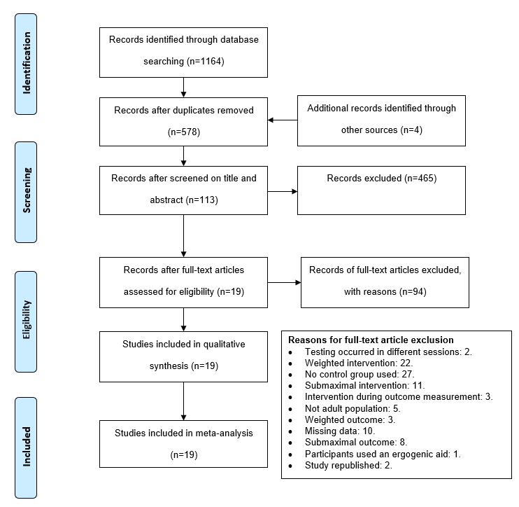
Figure 1: Flow chart of study selection for the analysis on whether a bodyweight conditioning activity can acutely improve the outcome of a subsequent task through postactivation potentiation.

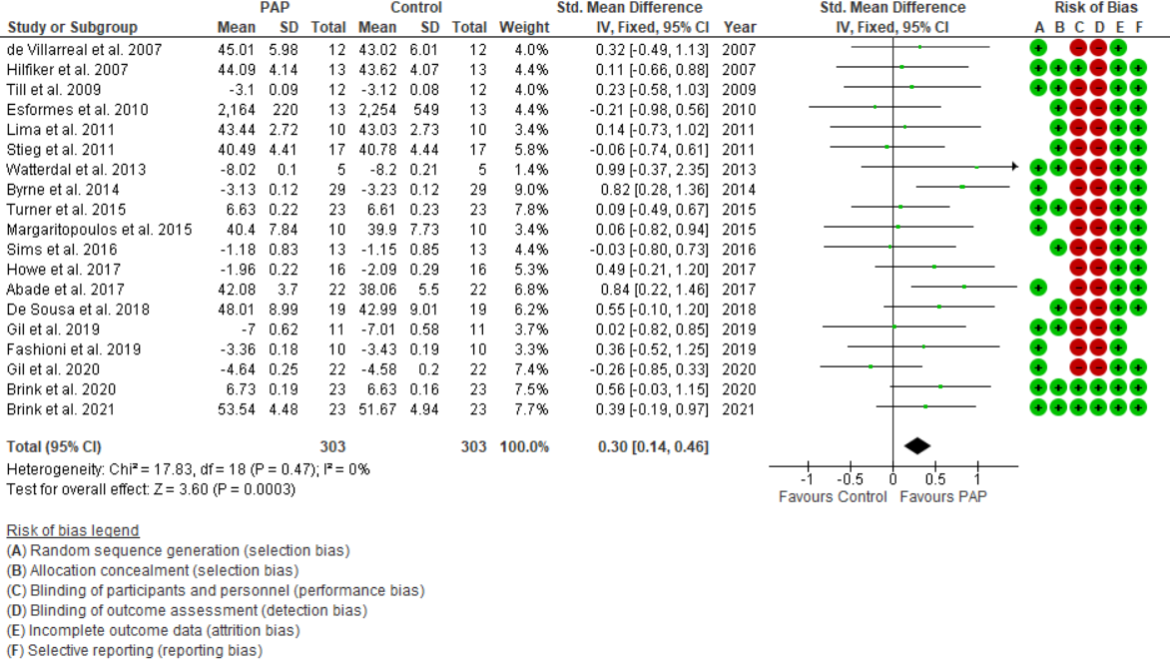
Figure 2: Primary analysis of studies measuring a bodyweight conditioning activity against a control
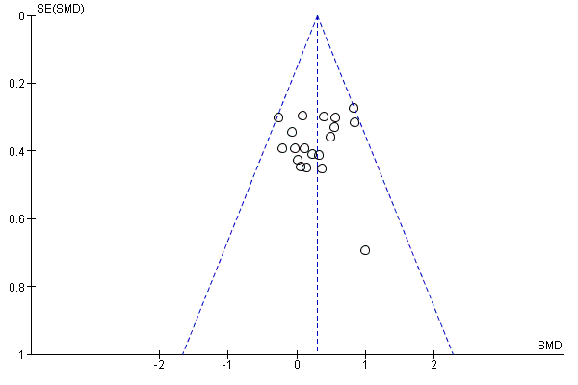
Figure 3: Funnel plot for assessing publication bias in studies measuring a bodyweight conditioning activity against a control

Table 1: Search strategy: Search of Medline PubMed
Search | Query | Records retrieved
#1 | "postactivation"[Text Word] OR "post-activation"[Text Word] | 984
#2 | "warmup"[Text Word] OR "warm-up"[Title/Abstract] OR "warm-up"[Text Word] | 2853
#3 | "jump*"[Text Word] OR "sprint*"[Text Word] | 33654
#4 | "plyo*"[Text Word] | 873
#5 | Search: #2 OR #3 OR #4 | 36209
#6 | Search: #1 AND #5 | 215
#7 | Search: #6 Filters: English | 214
#8 | Search: #7 Filters: Humans | 141

Table 2: Characteristics of the included studies
Study | Location | Sex | Age | Study designs | Level of competition | Sport | Warm up
Abade et al. (1) | Portugal | M22 | 18±1 | RCT crossover | Competitive | Soccer | Maximal
Brink et al. (7) | South Africa | M23 | 24±5 | RCT parallel | Competitive | Soccer | Submaximal
Brink et al. (6) | South Africa | M23 | 24±5 | RCT parallel | Competitive | Soccer | Submaximal
Byrne et al. (9) | Ireland | M29 | 20±4 | RCT crossover | Competitive | Variety | Submaximal
De Sousa et al. (12) | Brazil | M19 | 24±1 | RCT crossover | Competitive | Basketball | Submaximal
de Villarreal et al. (13) | Spain | M12 | 23±3 | RCT crossover | Competitive | Volleyball | Submaximal
Esformes et al. (15) | Wales | M13 | 22±3 | RCT crossover | Competitive | Variety | Submaximal
Fashioni et al. (16) | UK | M10 | 23±4 | RCT crossover | Recreational | Soccer | Submaximal
Gil et al. (17) | Portugal | M22 | 19±2 | RCT crossover | Recreational | PA | Submaximal
Gil et al. (18) | Portugal | M11 | 25±6 | RCT crossover | Recreational | PA | Submaximal
Hilfiker et al. (20) | Switzerland | M13 | 22±4 | RCT crossover | Competitive | Snow sport | Submaximal
Howe et al. (22) | UK | M13 F3 | 19±2 | RCT crossover | Recreational | PA | Submaximal
Lima et al. (26) | Brazil | M10 | 21±3 | RCT crossover | Competitive | Sprinting | Submaximal
Margaritopoulos et al. (28) | Greece | M5 F5 | 19±1 | RCT crossover | Competitive | Karate | Submaximal
Sims et al. (37) | UK | M13 | 19±1 | RCT crossover | Recreational | PA | Submaximal
Stieg et al. (40) | USA | F17 | 19±1 | RCT crossover | Competitive | Soccer | Submaximal
Till et al. (42) | UK | M12 | 18±1 | RCT crossover | Competitive | Soccer | Submaximal
Turner et al. (45) | UK | M23 | 21±1 | RCT crossover | Recreational | PA | Maximal
Watterdal et al. (51) | Sweden | M5 | 24±2 | RCT crossover | Competitive | MD running | Submaximal
RCT, randomized controlled trial; M, male; F, female; PA, physically active; MD, middle distance.

Table 3: The intervention and outcome protocols of the included studies
Study | Intervention | Outcome  measurement | Time between intervention and outcome measurement
Abade et al. (1) | Maximal Vertical and horizontal movement - 4 sets of 5 jumps over 40 cm barriers followed by agility ladder 10 steps | Vertical jump height - 2 maximal attempts | 6 min
Brink et al. (7) | Maximal vertical jumps - 2 maximal CMJ (2min) | Vertical jump height – 2 maximal attempts | 2 min
Brink et al. (6) | Maximal sprint - 2 maximal 20m sprint (2min) | Linear sprint – 2 maximal attempts (20m) | 2 min
Byrne et al. (9) | Maximal vertical movement - 3 maximal depth jumps | Linear sprint – 1 maximal attempt (20m) | 1 min
De Sousa et al. (12) | Maximal vertical jump - 6 sets of 6 CMJ 10s between reps 2 min between sets | Vertical jump height - 1 maximal attempt | 5 min
de Villarreal et al. (13) | Maximal vertical jump - 3 x 5 drop jumps | Vertical jump height - 1 maximal attempt | 5 min
Esformes et al. (15) | Maximal horizontal & vertical jumps - performed 6 alternate bounds, 6 right speed hops, 6 left speed hops, 6 vertical bounds | Vertical jump power output (W) – 3 maximal attempts | 5 min
Fashioni et al. (16) | Maximal sprints & vertical jumps - 2 straight sprinting, 2 tuck jumps into sprints, 2 reaction sprints | Linear sprint – 1 maximal attempt (20m) | 5 min
Gil et al. (17) | Maximal vertical jumps - 2x5 depth jumps (70cm) | Linear sprint – 1 maximal attempt (30m) | 10min
Gil et al. (18) | Maximal vertical jumps - 2x5 depth jumps (70cm) | Linear sprint – 1 maximal attempt (50m) | 5min
Hilfiker et al. (20) | Modified vertical jumps - 5 modified drop jumps (60cm) | Vertical jump height – 3 maximal attempts | 1 min
Howe et al. (22) | Maximal vertical & horizontal jumps - Hurdle hops x6, Lateral hurdle hops x10, CMJ x 5, depth jump x10 (20cm), Broad jump x 5 | Linear sprint – 3 maximal attempts (10m) | 4 min
Lima et al. (26) | Maximal vertical jumps - 2x5 depth jumps (75cm) | Vertical jump height – 1 maximal attempt | 5 min
Margaritopoulos et al. (28) | Maximal vertical jumps - 3x5 tuck jumps (30sec) | Vertical jump height – 1 maximal attempt | 5 min
Sims et al. (33) | Maximal vertical jumps- 3x20 pogo jumps | Linear sprint – 3 maximal attempts (10m: 30-40m) | 8min
Stieg et al. (40) | Maximal vertical jumps - 6 depth jumps | Vertical jump height – 3 maximal attempts | 10min
Till et al. (42) | Maximal vertical jumps - 5 Tuck jumps | Linear sprint – 3 maximal attempts (20m) | 4 min
Turner et al. (45) | Maximal horizontal jumps - 3 x 10 alt leg bounds | Linear sprint velocity – 1 maximal attempt (20m) | 2min
Watterdal et al. (51) | Maximal horizontal sprint - 1 x 50m sprint | Linear sprint - 1 maximal attempt (60m) | 10 min
CMJ, countermovement jump.

