Title:
‘But What Are They?’: Zine-making and invitational creative practice in an undergraduate Creative Writing class inspired by the work of Lynda Barry.

Abstract:
This illustrated article offers a record of work done for a third-year undergraduate module called Creative Writing & the Self, as part of the Creative & Professional Writing programme at the University of the West of England, Bristol in the autumn term of 2021, where students created zines as a record of their student experiences, which corresponded to the years of the pandemic. The article considers the students’ creative process and what is communicated in the zines, pages from which illustrate the article, informed by the methodology of Lynda Barry. The module offered the opportunity for staff and students to use a more invitational rhetoric (Kirtley, 2014) than elsewhere on their course(s) and the article considers this alongside the pedagogical implications of a hybrid and multimodal form and approach, of ‘sharing narratives and inviting others to join in a continuing dialogue’ (Ibid, 2014).

Keywords: creative practice, zines, invitational rhetoric, text-image

Main text:
This article offers a record of work done for a third-year undergraduate module called Creative Writing & the Self, as part of the Creative & Professional Writing programme at the University of the West of England, Bristol in the autumn term of 2021, taught by Harriet Castor Jeffery, Anthony Cartwright and assisted by Miranda Harris. This elective module includes both students from our Creative & Professional Writing degree and from English Language & Linguistics, meaning students came to the module with different experiences of academic writing and a range of ideas about what creativity is and how it works.

The creative work in the first semester involved students making a zine, intended to offer a guide to student life at UWE and Bristol through a reflection on the individual’s own university experience. These students are the 2019-2022 cohort – so their student careers have coincided with the years of the global pandemic.
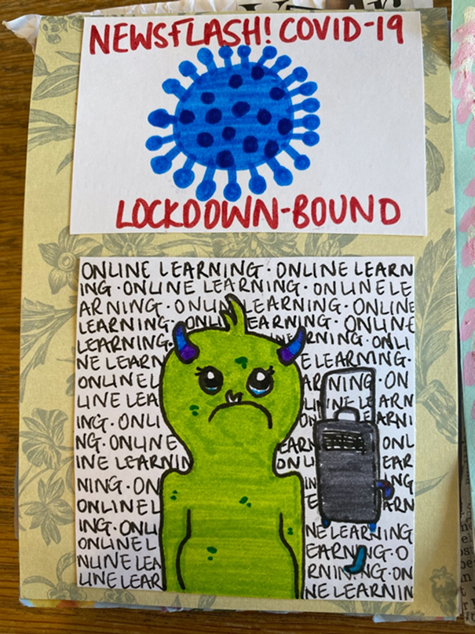
Figure 1: Amy Webber
Using approaches from the work of Lynda Barry, cartoonist, teacher and author, currently Associate Professor of Interdisciplinary Creativity at the University of Wisconsin-Madison, the work created used hybrid writing and visual forms – ranging from instructional copy to life-writing to poetry and from cartooning to collage to book art – in order to make sense of individual experiences of student life and potentially offer some insight to new students.

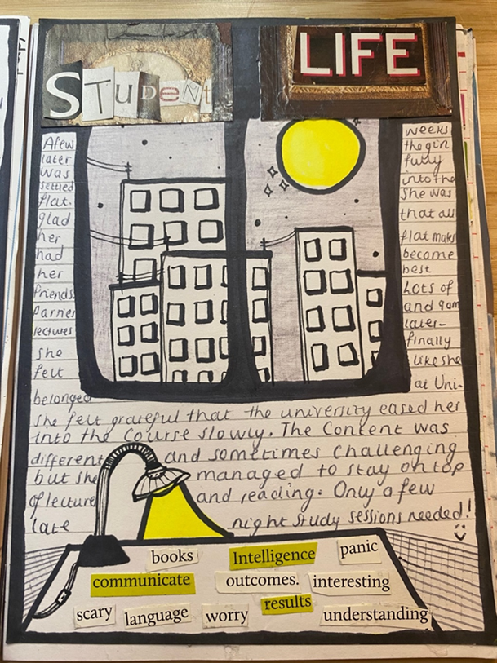
Figure 2: Eve Filiatrault
This article maps the project, considering how the students’ creative process and what is communicated in the zines, informed by Lynda Barry’s methodology (laid out in her books What it Is, 2008, Syllabus, 2014, and One! Hundred! Demons!, 2017), and how, inspired by Barry, the module tentatively introduced a more invitational rhetoric (Kirtley, 2014) to students than they might have previously experienced. The article then considers the pedagogical implications of this multimodal approach, ‘sharing narratives and inviting others to join in a continuing dialogue’ (Ibid, 2014).

‘But what are they? That’s the first question I’m usually asked when I start to talk about zines,’ (Duncombe, 1997) are the opening sentences of Stephen Duncombe’s study of zine culture, Notes From the Underground: Zines and the Politics of Alternative Culture (Duncombe, 1997) and this initial response was a common one with our students, who had spent the previous two years for the most part writing in strictly delineated forms of fiction, non-fiction, poetry and script (for the creative writers) and academic essay, often, because of lockdown restrictions, shut in their room to do so.
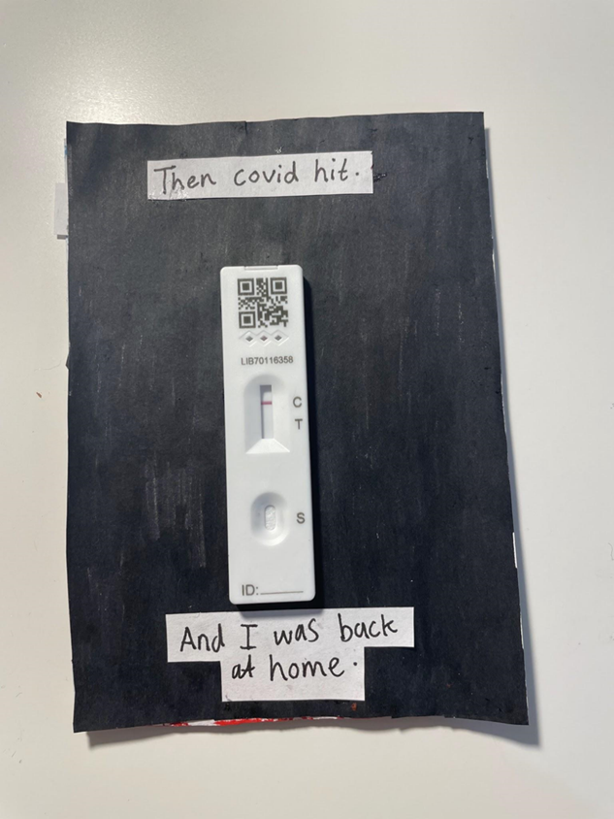
Figure 3: Tegan Leonard
‘The form of the zine lies somewhere between a personal letter and a magazine,’ Duncombe suggests, acknowledging that ‘what is ‘typical’ is a problematic term in this context,’ (Duncombe, 1997) and this was the way we approached the form initially, given the brief of writing a guide to university life for an audience of potential students. There is a way that this task could have fitted into one of our commercial and copywriting modules, even appropriating the zine form, if the potential audience of pre-university or first year university students is considered. The Creative Writing students are in the process of completing a Creative & Professional Writing degree (my italics) and, although there is possible tension between the idea of ‘professional’ writing with the ethos of zine-making, ‘zines are put together by hand using common materials and technology (do-it-yourself is the prime directive of the zine world)’ (Duncombe, 1997), with some modification, this could become a brief to write promotional content about the student experience at UWE and in Bristol. In some ways, what many students produced did meet this brief, albeit in a more personal and idiosyncratic way than might have been achieved with a copy task. We plan to sort of square this circle by – with the students’ permission – making extracts of the zines available to course offer-holders.
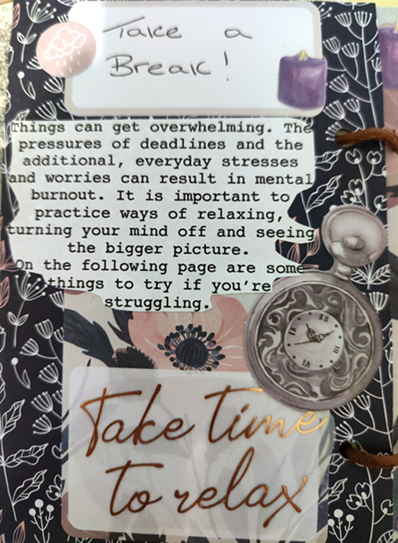 Figure 4: Chloe Dornbrack

‘What it Is’ (Barry, 2008) is the title of Lynda Barry’s autobiofictionographical work (a term she first uses to describe her 2002 book One! Hundred! Demons!), this work became a guide to what we were trying to achieve with our multimodal approach in this project. As for what zines are, ‘hand over a stack of zines and let the person asking the question decide,’ (Duncombe, 1997) was an approach we took, which was potentially liberating and daunting for students more accustomed to generic convention and academic rhetoric.

More accustomed too, were the students to traditional university classrooms and/or the even more sterile environment of the online classroom and Teams tutorial. Although we were seeking to incorporate approaches from visual culture and art practice itself (albeit in a DIY sense), the teaching of this module took part mainly at UWE’s Frenchay Campus, the home of both degree courses, and not at UWE’s City Campus at Bower Ashton, home to its art school, zine archive and new Publishing Space, where Miranda Harris was able to run various workshops in zine craft and book arts, incorporating her own book art practice, including teaching pamphlet stitch, which many students then used in creating their zines, embracing the creative potentialities of materiality. This possible tension, between the perceived greater creativity of Bower Ashton, with its studios and vitrines and primary coloured filing cabinets, compared with the potentially more academically imposing atmosphere of Frenchay, with its Law and Business and Engineering schools, embodied in a physical sense, some of the tensions and juxtapositions inherent in the project, a kind of geographical multimodality. A further juxtaposition of outdoor space and the freedom that implies with the interiority (actual and metaphorical) of lockdown came through in much of the aesthetic of the zines.
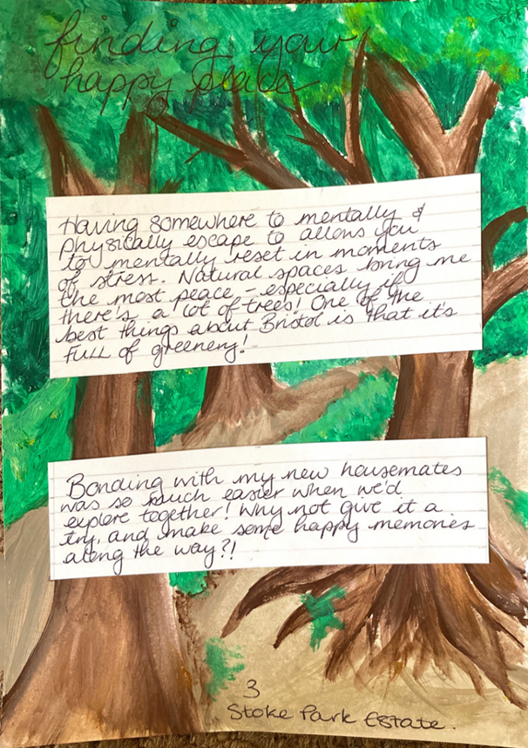
Figure 5: Charlotte Anderson
Creating the zines seemed to offer the potential for a conceptual space in which to consider a response to discontinuity and life-changes brought about both by choice, for many of the students that of embarking on a university degree and moving home and city to do so, and the life-changes imposed on all of us by the pandemic. This space provided an opportunity to reflect creatively, but also perhaps to simply observe.

Within the conceptual space of the zine, the container, in the way of Ursula K. Le Guin’s carrier bag metaphor (Le Guin, 1988) was another space. Le Guin’s metaphor, like those of Lynda Barry, offers the potential for invitational rhetoric (Kirtley, 2014). The zines as:

…a human thing to do to put something you want, because its useful, edible or beautiful, into a bag, or a basket, or a bit of rolled bark or leaf, or a net woven of your own hair, or what have you, and then take it home with you, home being another, larger kind of pouch or bag, a container for people… (Le Guin, 1988).

The zines as ‘ a sack, a bag’(Ibid.) and a book. ‘A book holds words [and images]. Words [and images] hold things. They bear meanings.’ (Ibid.)

For students more familiar with writing done for page or screen in a linear, sequential form, and in the case of the English Language & Linguistics students, much more familiar with writing as argument, the focus on the relationship between text and image, the ‘exploration of the liminal zone between the drawn and the written’ (Squier, 2021), in reference to Lynda Barry’s work), the removal of the necessity for linear progression, the removal of the necessity for argument, moving ‘not from fact to fact but from image to image’ (Barry 2019, cited by Squier, 2021), and even of narrative (although many students presented their experiences as story and read as a whole the zines seem to offer a kind of collective narrative which moved through the crises of, for some, moving home and job and family to go to university, followed by the existentsial crisis of global pandemic, followed by an opening out, finding a new sense of self post-lockdown and pre-graduation) seemed to create a conceptual space to observe the self, to hold ideas about the self and society (after both Le Guin and Barry), rather than draw conclusions or offer any definitive answers.
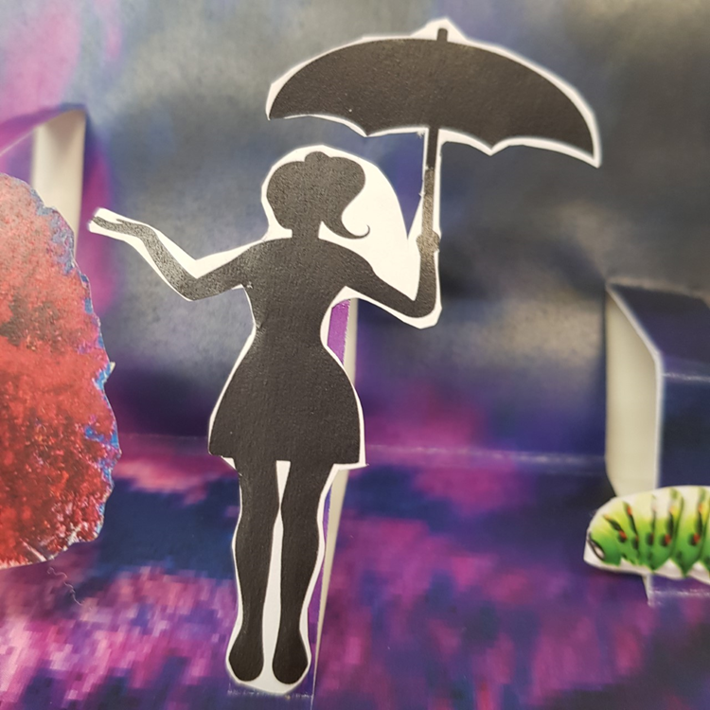
Figure 6: Katie Cookson
Lynda Barry’s invitational rhetoric as described by Susan Kirtley, citing the work of Sonja Foss and Cindy Griffin (1995), ‘marked by the “openness with which the rhetors are able to approach their audiences’’’ (Kirtley, 2014) and the presentation of ‘an extremely unguarded point of view’ (ibid) along with the way that the zine as a form, potentially, as Kirtley suggests of the comic genre ‘redistributes authority and agency to the audience’ (ibid) opens up questions about the language of compositional pedagogy, and of appraisal and argument, we apply even to marking creative assignments such as fiction and narrative non-fiction elsewhere. We describe characters or situations or plot points as ‘compelling’ or ‘plausible’ or ‘convincing’ as if in one of the classrooms of the smart Law school building, or rather, as if appraising an argument. So ingrained is this language, I wonder how consciously as teachers we do this.

As well as the visual culture being informed by Lynda Barry’s approaches, so too was the writing. In fact, I wonder if separating the written and visual texts out is a mistake in the way of conceiving all writing as persuasion. We used several exercises from the ‘Writing the Unthinkable’ section of What It Is (Barry, 2008) along with freewriting exercises in the spirit of Peter Elbow and Natalie Goldberg. Freewriting was a discipline much more familiar to the Creative Writing students than the Linguists, one used throughout the degree, and the zine creator, Vicky Stevenson’s instruction ‘Don’t take your pen off the page,’ (Stevenson, 2019) echoing Natalie Goldberg’s mantra ‘Keep the hand moving,’ (Goldberg, 1986) provided a link back to fiction, non-fiction and copy classrooms.

What freewriting shares with invitational rhetoric is the same kind of potential ‘affective flow’ (Gilbert and Matthews, 2021:2), something observed in a study of online writing and drawing, where ‘freewriting can bring the loneliness of online learning sharply into focus’. Fears of loneliness and isolation – both in the act of starting university and during the Covid crisis, lockdown specifically – were recurring themes and images in the zines.
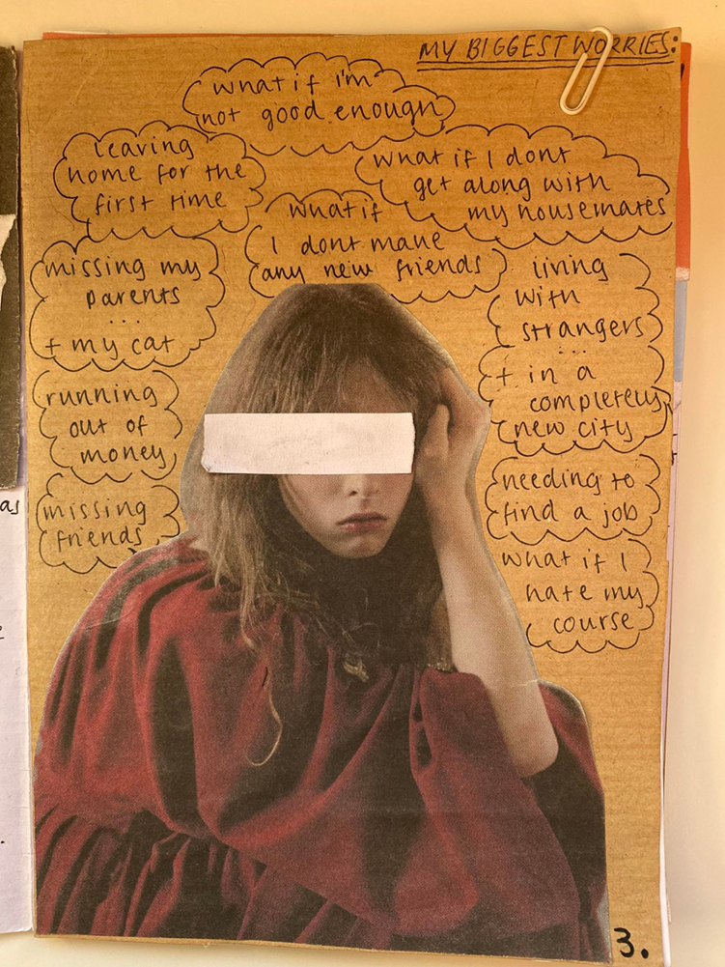
Figure 7: Amelia-Rose Rainbow

Students included some of this freewriting – sometimes unedited, exemplifying the spirit of ‘the unguarded point of view’ (Kirtley, 2014) – as text in the zines, alongside a multiplicity of other, more structured forms: instructional text, poetry, diary entries, letters, script.

This work raises questions for us as a Creative Writing team about the type of writing we set for assessment. It offers a challenge to generic form and although students are increasingly familiar with hybrid forms, intertextuality and multimodality as readers; as creative practitioners we still often refer to ourselves as ‘novelist’ or ‘playwright’ or ‘non-fiction writer’ or ‘poet’ and so on and elsewhere on the course, the stipulations of form are built into module submission criteria. Perhaps, more importantly, it asks questions about the language we are using to define work, both regarding form, and subsequently regarding feedback. ‘What is an Image?’, ‘What is and where is your imagination?’, ‘What is an experience?’ asks Lynda Barry in What It Is (Barry, 2008), all questions we asked on this module as well as those about form and feedback. ‘PS. We do not know the answers,’ she offers, kindly (ibid).
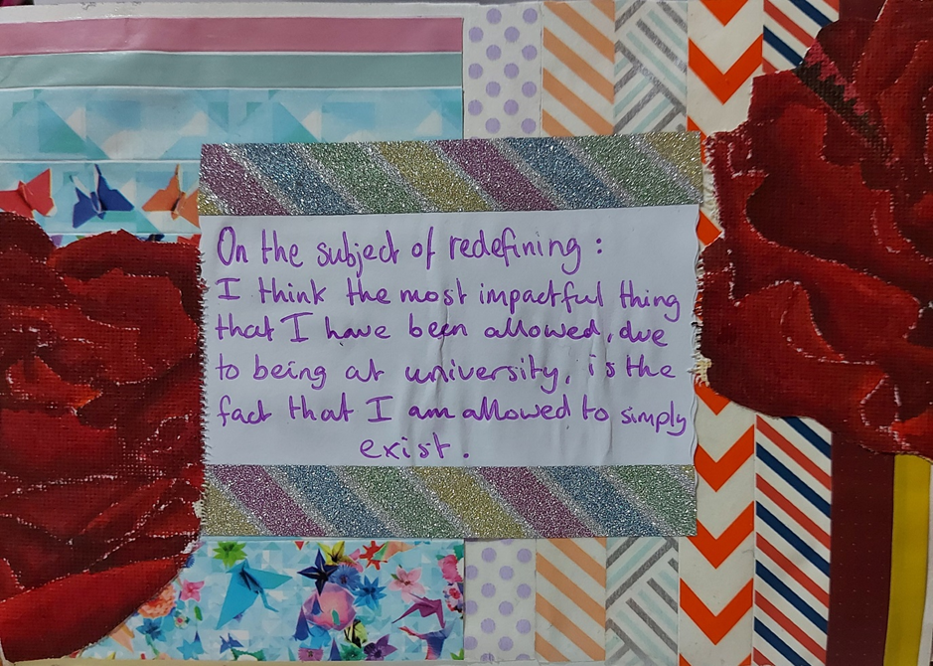
Figure 8: Jnyx Ali
The marking criteria for the zines was developed collaboratively between Harriet Castor Jeffery and the students during class time. What this process allowed was space for students and staff to consider what we value in this work. Effort and personal engagement became a theme throughout, and valuing ideas over technical execution in the case of the artwork (I wonder how much this, counter-intuitively, meant we got a high-level of craft proficiency with techniques like pamphlet stitch and experiments with collage and materiality because of the high levels of personal engagement and effort). The relationship between text and image was also a key concept for the criteria and important – for students on a writing degree – in not considering images as simply illustration of the text.
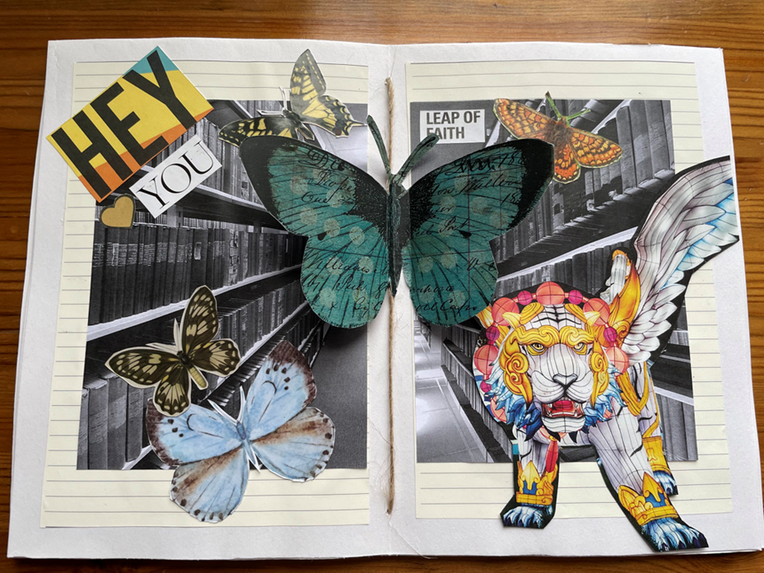
Figure 9: Stephanie Williams
So perhaps ‘But what are they?’ (Duncombe, 1997) remains a particularly valid question with regard to the zines created as part of this module and more widely. What are they, these zines? A set of responses to crises (both sought and unlooked for)? A set of illuminations on time, place and experience? Illuminations both in the sense of creative practice and as physical artefacts. Later in the module, we came to consider illuminated manuscripts in different forms, in the way of Olga Michael’s reflection on Lynda Barry’s practice and its relation to the work of Caravaggio (and their respective images of the gorgon) and the image-texts of William Blake (Michael, 2002), alongside a recognition of zines, like comics, as ‘in between categories’ (Michael, 2002, citing Carrier), erasing boundaries between text and image, archaic conceptions of ‘high’ and ‘low’ art and suggesting the potential to ‘undermine the master/official’ dynamic (Michael, 2002) as well as various gender boundaries and hierarchies. This was most clearly expressed in our looking at the pages of the manuscript known as the St. Chad Gospels, a ninth century manuscript held in Lichfield cathedral, where marginalia and drypoint of women’s names and prayers written in Old Welsh interweave with the Latin of the gospels themselves, creating what we might consider today an art intervention, certainly hybrid or interventionist writing familiar to zine practice.
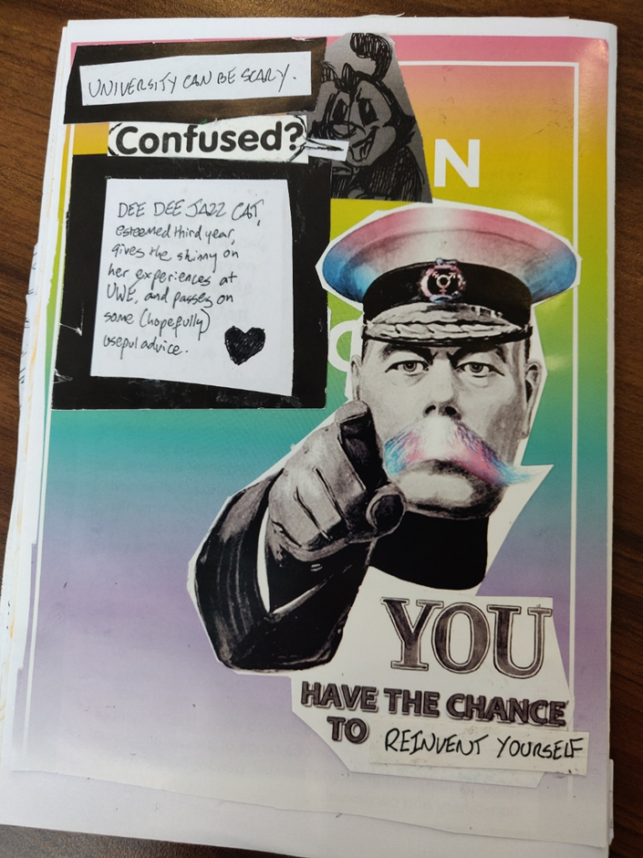
Figure 10: Raina Lilith
What are they? Perhaps ‘PS We don’t know the answers’ - certainly not a definitive answer - is the most valid response. What we did find through the module was that we, staff and students, moved away tentatively from a language of appraisal and categorisation (whether of the various life experiences of going to university and the pandemic or of the writing itself), towards one of observation, openness and provisionality: towards an invitational rhetoric and invitational creative practice.

Acknowledgments:
With thanks to all the students who took the Creative Writing & the Self module 2021/22 and to Miranda Harris and Harriet Castor Jeffery.

References:
Barry, L (2008): What It Is. Drawn & Quarterly, Toronto.
Barry, L (2017): One! Hundred! Demons! Drawn & Quarterly, Toronto.
Barry, L (2014): Syllabus: Notes From an Accidental Professor, Drawn & Quarterly, Toronto.

Duncombe, S (2017, first published 1997, Verso, London): Notes From Underground: Zines & The Politics of Alternative Culture, Microcosm Publishing, Portland.

Elbow, Peter (1973): Writing Without Teachers, Oxford University Press, Oxford.

Goldberg, Natalie (2016, first published 1986): Writing Down the Bones: Freeing the Writer Within, Shambhala, Boulder, Colorado.

Foss, Sonja K., and Griffin, Cindy L. (1995): Beyond Persuasion: A Proposal for Invitational Rhetoric, Communication Monographs 62:1.

Gilbert, Francis and Matthews, Miranda (2021): ‘Affective Digital Presence: How to free online writing and drawing?’, Journal of Writing in Creative Practice, 14:2, pp 209-37.
https://www.ingentaconnect.com/content/intellect/jwcp/2021/00000014/00000002/art00007;jsessionid=6ogt282jcbn6j.x-ic-live-02

Le Guin, U. (2019, first published 1986): The Carrier Bag Theory of Fiction, Ignota, London.
Michael, Olga (2022): Scrapbooking Caravaggio’s Medusa, Reconfiguring Blake: What It Is, One! Hundred! Demons! and Lynda Barry’s Feminist Intervention in the (Male) Artistic Canon, ImageText, 9:2 Mixing Visual Media in Comics.
https://imagetextjournal.com/scrapbooking-caravaggios-medusa-reconfiguring-blake-what-it-is-one-hundred-demons-and-lynda-barrys-feminist-intervention-in-the-male-artistic-canon/

Squier, Susan M. (2021): Drawing Monsters with Emil Ferris and Lynda Barry: An Exploration of the Drawing Process as Part of Graphic Medicine, Rupkatha Journal on Interdisciplinary Studies in Humanities, 13:2.
http://rupkatha.com/V13?n2/v13n201.pdf

Kirtley, Susan (2014): Considering the Alternative in Composition Pedagogy: Teaching Invitational Rhetoric With Lynda Barry’s What It Is, Women’s Studies in Communication, 37: 339-359.

Stevenson, V. (2019): Find Joy in Terrible Times: prompts for zine making, penfightdistro.com.

