The Duck and the Philosopher:
Rhythms of Editing and Thinking
between Bernard Stiegler and The Ister

Patrick Crogan
teaches film and media at the University of the West of England, Bristol. He has published work on film, videogames, and critical theories of technology in journals and anthologies, including essays on Stiegler.

Abstract
The Ister (Ross and Barison, 2003)—part documentary, travelogue and philosophical meditation supplementing Heidegger’s meditation on Holderlin’s poem about the Danube—opens and closes with sequences of a duck waddling along the bank of the river. The intervening film, all 3 hours of it, is in effect a large insert edit between these two sequences, or rather, this single sequence. Seen in this way, and given the significant involvement in and engagement with Bernard Stiegler’s thinking of technology that The Ister evinces (interviews with Stiegler, among others, take up much of the time of this insert), the film invites consideration in terms of his theorisation of cinema as key representational technology of the Twentieth century. His published work on cinema postdates the film but it nonetheless represents an intriguing anticipation of and in some ways response to his both theoretical and polemical approach to cinema. This paper will outline and examine some major tenets of Stiegler’s account of cinema by trying to time the momentary duck’s walk that is the extended duration of The Ister. This will involve an editing project of its own that cuts between analysis of the film, theories and practices of editing and Stiegler’s post-phenomenological account of consciousness.

Introduction
This paper seeks to broach the theme of what Bernard Stiegler calls the “cinemato-graphic carto-graphy” of montage (Technics and Time 2 254). This theme, introduced in the second volume of the Technics and Time series becomes a central concern of the third volume, subtitled The Time of Cinema and the Question of Ill-being. The comparison being made here is between mapping and the way filmic editing orients one, and indeed the collective of ones sharing the experience of the film, in the temporal realm. It is a key claim of the second volume, subtitled Disorientation, that orientational technics such as maps and films are much more than instrumental aids to the individual who is constituted culturally and psychically in some manner independent of such technics. These are the factical conditions upon which what paleontologist and evolutionary anthropologist André Leroi-Gourhan called the ethnic or cultural program is carried forward, reviewed, challenged, reinvented, revived, and so on. Such a program amounts to a spatial and temporal orientation to existence, providing the framework for one’s individuation vis-à-vis the collective formed around the inheritance and adoption of the program. In this perspective, questions of culture, identity, history and politics all pass through and interact with questions of the technical conditions of the program’s orientations and their becoming.

David Barison and Daniel Ross’ 2003 film, The Ister, concerns itself with these questions in their co-implication. In significant ways it anticipates and explores key elements of Stiegler’s questioning in its staging of philosophical thinking—a staging which is also a philosophy of human thinking in general—as “essentially” technically conditioned. This is a central and abiding theme in Stiegler’s work, from his insistence on the essential lack of an essence of human being, a being in default of an origin, whose origin is default, that is necessarily always already supplemented by technical prosthesis (Technics and Time 1, 188) to his analysis of the cinematic character of human phenomenal experience in Technics and Time 3. It is this analysis that is prepared for in the discussion of “cinemato-graphic carto-graphy” in the second volume.

Given the importance of montage or editing for both Stiegler’s consideration of and The Ister’s performative encounter with these themes, I will venture a somewhat unconventional “mix” in this paper between engagement with the film, the philosopher and the theory and practice of editing. The goal is to explore the theme of the technical conditioning of the cultural program. The question of the conventional is consequently at the centre of our concern here. Both the film and Stiegler’s work are motivated by a desire to respond to a perception of the failing of traditional cultural, social and political frameworks in the globalised information age, a perception that is not at all restricted to them. The crisis of these frameworks is one of their perceived relevance, of agreement as to their viability for orienting practices, policies, actions going forward in a changed and rapidly changing milieu—a crisis of convening, that is, of coming together. Understanding the irreducibly technical conditions and character of this coming together is critical today. Editing is an important place to start.

Working on the Timeline
I begin by making a rather outlandish claim that it is possible to consider the body of the film The Ister as a giant-sized insert edit that unrolls between the opening shot of a duck walking by a riverside (appearing before even the film’s prologue or title) and the concluding sequence of the same duck continuing its waddle. The claim is that the shots of the duck are one shot that constitutes what could be called the primary timeline of the film. The long sequence of sequences that comprise what comes after the prologue right up to the last shot of the film (of the duck walking) before the end credits is an insert into the primacy of this shot-sequence. This is clearly a wilful counter-reading of the film’s more evident principal subject, running contrary to the conventions it mobilises to construct its presentation, such as the film’s title and the intertitles, its arrangement into sequences, and so on. These orientational techniques operate—on the basis of their having-been-established, that is, their con-ventionality—to ensure that such a “mis-reading” of the film cannot be legitimate. To ensure is not so far from to insure, however, and with insurance, there is always a risk. I am risking a mis-reading of the film because in an unconventionally apposite way it takes us toward the film’s thematic and stylistic questioning of conventionality as orientation.

This outlandish claim about the film’s primary timeline also misapplies the generally accepted significance of the term “insert edit.” Or at least, and this is precisely why I begin in this manner, it reads “insert edit” against the spirit if not the technical letter of the law. What is an insert edit? Let us approach this question technically, theoretically and practically, using our dubious, if technically legitimate instance in exploring this question. In doing so we will find ourselves tracing some important changes from analog to digital editing technics and techniques:

Figure 1
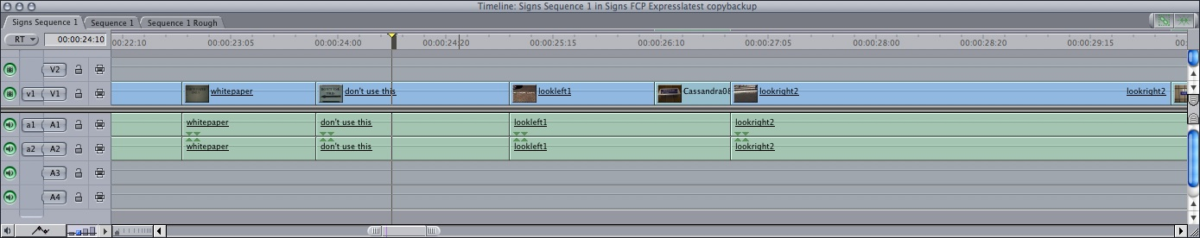

Figure 1 shows the “Timeline” window from Final Cut Express HD. The Ister was edited with Final Cut Pro, an industry standard editing system for the last decade or so and typical of nonlinear editing software in its configuration of windows, menu options and operations. Final Cut Express HD is a “lite” version made for domestic, consumer market. What is shown here is an assembling of a sequence of clips into a chronological timeline of projected time. “Assemble” is not a Final Cut edit menu command. It refers to the initial stages in the film or video editing process leading to the “rough cut” where clips are arranged in a roughly coherent structure to give a first shaping to the overall timeline of the film. Assemble versus insert edit is the opposition still active here, one drawn from earlier analog video editing systems. In this regime of practice the timeline was not a pre-existing technical frame, but a virtual one anticipated out of the experience of past edits (and the formulation of technical procedures abstracted from these). In analog editing the timeline of the film is only first instantiated by the assembly and does not pre-exist it as the Timeline window of the digital software interface. As the process constitutive of the timeline as such, assembly is made redundant by the latter. “Adding clips to the timeline” becomes the conventional terminology.

Figure 2
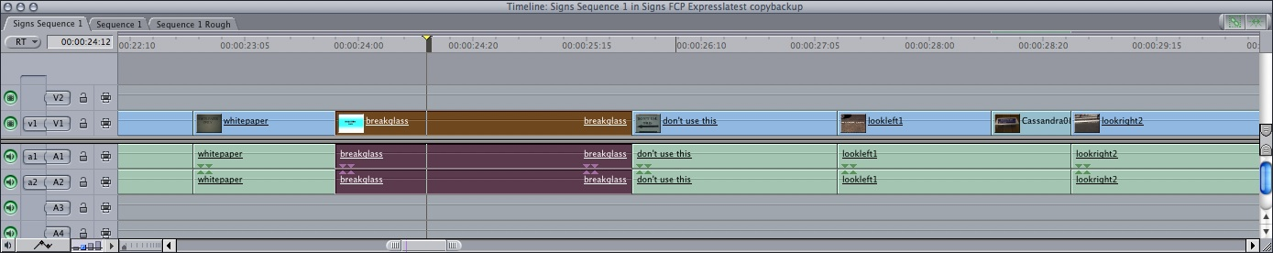

Figure 2 shows an “Insert” edit in Final Cut. The inserted clip (darkened) enters at a designated point in the timeline, pushing subsequent clips to the right, further along the timeline, to occur after it, making the film longer. In this sense, as a technical procedure, my claim about the duckwalk shot could be valid. Examination shows that it is indeed one shot split into two, in fact in an overlapping edit—a conventional strategy for providing temporal continuity in a segment cut in a parallel montage structure. The assumed parallel here would be

Line A: Duckwalk
Line B: Commentary on Holderlin, Heidegger, philosophy, technology, European history, politics, etc.

Following this “logic” further, the final shot of the duck is also the point of convergence of the two parallel lines of “action” inasmuch as it is also an image-sound montage of the duckwalk with the completion of the audio of Heidegger reading Holderlin’s poem Der Ister. Considered in its immediate context in the film, this reappearance of the duck shot amounts to the last shot of an associational and summative montage of “video clips” already seen in the film that have gone “over” this reading out of Holderlin, which reading itself summarises the film’s sustained dwelling on the enigmatic text of the poem.

The film could be cut in this way, and this would be one of the many ways the film could have filled up its Timeline window using a non-linear digital editing program.

Figure 3
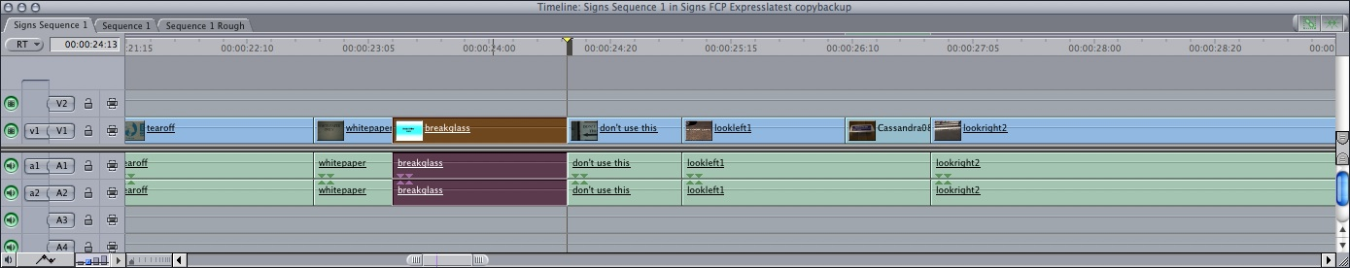

Figure 3 shows the other main alternative to the insert edit in Final Cut: an “overwrite” edit. The inserted clip (darkened) overwrites (obliterates) what was there on the timeline, replacing it but not making the film longer. The timeline is the same length but now has a different configuration of clips. The nonlinear, “nondestructive” editing regime replaces the assembly versus insert opposition with an insert versus overwrite alternative. This is different because assembly versus insert speaks more of the process of editing as a gradual crystallisation, in time, of a work made up of time. Inserting and overwriting are alternative operations for adding to and completing the pre-existing timeline frame or window. (1)

To defend, then, my provocation to read the film as one about a duckwalk belaboured with a 3 hour reflection on technology, nature, history and time, I would propose that it allows us to glimpse the contingency of the conventionality of editing that so conditions our experience of cinema. This is no small thing given the influence of the cinematic medium on the development of mainstream media and, in turn, on the course of global culture, economy and politics. In other words, our experience of cinema has been a powerful influence on our experience of experience. Stiegler will identify cinema as the Twentieth century’s programmatic “industrial temporal object,” citing accounts of its importance to the spread of American cultural and economic influence last century (Technics and Time 3, 138-143). For Stiegler what is decisive here is the manner in which Hollywood projected a narrative trajectory of adoption. American identity was adoptable, the new way ahead out of sclerotic European cultural and political systems. This adoptibility is first projected toward the masses of European and colonial immigrants, and then exported as a vehicle of US entry into global capitalist competition.

As a time-based form, cinema is constituted as a coherent experience in the unfolding of its duration. The timeline which is “laid down” in the editing achieves this coherence through a process of assembling shots which assembly is then coloured through iterative modification—from rough to fine to final cut. Typically, the film work presents a mainline with colouring complications. This line, concretised in nonlinear digital editing programs as a pre-existent, linear chronology waiting to be filled up, is fixed according to conventional schemas of linearity and its exceptions (repetitions, recourses, flashbacks, caesuras, summarisations and expansions of duration, and so on). What Gilles Deleuze calls the “indirect image of time” is composed in the edit (Cinema 1 30). For Stiegler, there is no other image of time than one that is “indirectly,” that is, technically, factically, concretised. (2)

This fixing of filmic experience is durable, as the predominant conventions of filmmaking demonstrate. The mainline may be narrative, expository, investigative, discursive, propositional, propagandistic, speculative, reflexive, or experimental. Arguably, narrative feature-length cinema still amounts to the most widespread set of techniques and formats for constructing what is commonly called cinema. In their variety, however, and across the spectrum of audiovisual time-based forms that have come in the wake of cinema, the range of conventional formats perform their programmatic function on the basis of the memory support provided by the films and technical systems with which films and other audiovisual programs are made. Stiegler calls this tertiary memory, which all technical forms and objects support, from the first cutting edges to the latest carbon fibres. Every technical obect is also a memory of the experiences conditioning its invention, and the gestures and processes leading to its creation. The “mnemotechnical” forms—of which cinema is one of the most important innovations since photography and writing—have developed the specific function of recording experience, that is, of producing artefacts that preserve past lived experience via this “exterior” tertiary memorisation (Technics and Time 1 257). The “interior” forms of human memory—genetic memory and the individual’s recall of lived experience—are conditioned “essentially” by tertiary memory in their co-constitution of human cultural existence as a process of inheritance and becoming.

Stiegler develops this account of the crucial prosthetic role technical forms play in human development by supplementing Husserl’s phenomenological account of the consciousness of temporal objects, that is, objects of attention (like film, which Stiegler designates an industrial temporal object) that unfold in time and which can only be constituted as objects through that unfolding (Technics and Time 3, 36). Husserl analyses these objects—his example is a melody—in order to clarify the phenomenon of temporality which can only be studied in phenomenological terms by analysing the consciousness of something constitutively temporal. Husserl identifies and distinguishes between primary and secondary retention, or memory. Both are “interior” forms of retention. Primary or perceptual retention is part of the present reception of the melody and allows it to be constituted as a complete object of intentional consciousness. This complete object then passes into the retained past of consciousness from which it can be recalled as a secondary recollection at a later moment. Stiegler argues that in wishing to hold onto the core of phenomenological analysis—the living present of conscious attention—Husserl excludes the co-constitutive role that external, factical remains of past consciousness play in conditioning present experience (Technics and Time 2, 231). These provide consciousness experiences it has not itself lived in the form of mnemotechnical artefacts (books, artworks, photos, film, audio recordings).

The Ister: Working with the Program
By reversing, on a “technicality,” the “figure” and “background” of The Ister between duckwalk and philosophical meditation, I set out to push into view the productive contingency of the editing “program.” The contingency is apparent in the construction of timelines on the basis of standard expectations that themselves have a technical and aesthetic history. In fact, this contingency is always on show, even in the most conventional film, and precisely as its conventionality. The schematising of temporal duration in such devices as parallel editing, summative montages, selective expansion and intensification of moments, and so forth, is commonplace as the classic analyses of narrative and documentary structure have shown. The (extra)ordinary force of convention is precisely that it provides what Stiegler calls, citing Jacques Derrida and Paul Ricoeur, a “passive synthesis” for understanding experience and for being oriented in the world (Technics and Time 2 230). Technical and especially mnemotechnical forms make this possible. On the basis of what Stiegler calls a cinemato-graphic carto-graphy, a mapping of experience in time is inscribed in the graphing of the analog illusions of temporal experience recorded on film and assembled for collective recollection. The predominant forms of this mapping of the course of experience are a central proponent of what Stiegler characterises, after André Leroi-Gourhan, as the cultural or ethnic program (Technics and Time 2 113-114). A pro-gram “writes forward” on the basis of its shaping of the sense of the experience of existence and the direction of its becoming. The “domestication” of space and time is central to this process (Leroi-Gourhan, Gesture and Speech 314).

This brings us close to the central themes of The Ister. Designating itself as a further commentary on the chain begun by Martin Heidegger on the subject of mad German romantic poet Heinrich Holderlin’s river ‘hymn,’ Der Ister, Ross and Barison’s film explores questions of human culture, technology and their temporal conjunctions. The film’s meditation on these questions—what is the nature of human being and how or where is technology placed in relation to it? What is culture, history, destiny, modernity, Europe, Germany, etc. and how or where is technology placed in relation to these?—proceeds via an experimental adoption of more than one conventional film timeline. It is part documentary (interviews, expositional intertitles, shots and sequences as illustration of “text-over” captions), part travelogue (a geographical journey is commenced, continued and completed that dwells on places and people and events experienced along the way). There are also structures that draw upon avant-garde film traditions of associational, “poetic” montage related to neither the linear causality of mainstream fiction nor discursive nonfiction forms. Of course, poetic or symbolic montage are not unknown in either of these forms. All conventions are always already composed of others, and always in dynamic play precisely through the arrival of the individual work that, while never avoiding conventionality, always innovates on the basis of it.

The film contains lengthy commentaries drawn from interviews with different personages as well as citations both from Holderlin’s poem and Heidegger’s commentary. Its project could be characterised as an ambitious effort to open up and sustain a questioning of conventional orientations to these “large” questions of human existence and becoming. It does so through a philosophically conditioned interrogation, addressing the significance of Heidegger’s philosophy and politics at the limits of Western European philosophical and political developments for the “we” who live in their wake. It works toward this end along its 3 hour length, paced principally via an alternation between philosophical commentary, reflection and a long journey. This journey is both geographical, across Europe from its margins to its traditional centre, and historical, back in time to archaeological pre-history, to ancient Greek mythology and then back to the anticipated future (of Romania, for instance, as it is accepted into NATO).

Approached from the perspective of this more orthodox description of the primary timeline of The Ister, the duckwalk that brackets the film announces a persistent thematic counterpoint to the film’s questions of human existence, namely the nature of the animal, and of the natural world, in relation to which philosophy has always posed these questions of the human. When at a screening of the film at the Adelaide Film Festival I asked the filmmakers about the significance of framing the film with the duckwalk, Dan Ross replied that it was there as a reminder that nature still has something to show us. An evasive answer perhaps, but in keeping with the way the film leads less to determinate knowledge or answers and more to doubt or openness: Is there a source of the Danube in Germany? Does Holderlin’s or Heidegger’s “Germany” exist anymore? What is the current life expectancy of philosophical thought? These questions are beyond the scope of this paper; I leave them for you to ponder once you have seen the film, or seen it again. For now, I want to venture a few propositions about what the film’s editing can show us about the technical temporal programming of thinking with which Stiegler concerns himself.

Bio-rhythms
The duckwalk could be read as a figure of the film’s slow, meandering journey along a river. The conventional, privileged positioning of the shot as framing gesture demands to be read with especial, summative significance of some kind. Anthropomorphic associations coming from other factical precedents (pictures, graphic cartoons, animated films) add some weight to taking the duck’s walk as a comic-ironic doubling of the filmmakers’ journey into history, culture and technology.

This reflexive gesture is only completed, however, at the film’s end, by which time it has been conditioned by a number of other repetitions and modifications of the first duck shot: there is another shot of an identical duck (in fact, the same duck) at the Ravensberg segment of the journey well into the second half of the film. Before this reappearance, as an image representing “animality” the duck will have inaugurated a series of shots, of pelicans, geese, but also a slug, beetles, and other creatures. The animal is thematised in Stiegler’s commentary in Part One of the film as that against which the human can be defined as the living creature who is “essentially” a technical, prosthetic being. He goes on to complicate this essentialising—indeed, for Stiegler it is originarily complicated by technicity—by explaining that his own dog is human (he talks, he has a name to which he responds, and so on…).

Stiegler’s point is that human being is always a question of adoption, (re)naming, and that it is necessarily so due to the constitutive lack of a self-evident human essence. The non-human is always and inevitably caught up in this process in one way or another. The Ister’s duck is no exception here. It raises themes concerning animality vis-à-vis humanity, nature vis-à-vis culture, and the biological vis-à-vis the technological. The recording of the duck’s individual journey along the river is split into two and dispersed to the far ends of a 3 hour duration. To take it as the primary timeline as we entertained here for a time can only be a rhetorical move. As framing gesture, counterpoint or ironic double of documentary’s journey, it treats the living duck’s movement as material in and for another experience.

This treatment interrogates those accounts of montage that envisage it as a development of aesthetic practice built on the basis of biological rhythmings of experience. For example, Eisenstein’s dialectical materialist underpinnings led him at a certain stage of his investigations to posit the dynamics of “intellectual montage” as a dialectical aufhebung of the more elementary, “physiological” rhythmings of metric montage—that is, montage according to shot lengths, where the “beat” is produced out of “physiological effects” (Film Form 82). The general principles of the Hegelian dialectic underwriting all of this are cited from Lenin: “13) recurrence, on the highest level, of known traits, attributes, etc. of the lowest, and 14) return, so to say, to the old (negation of the negation)” (Film Form, 81).

In a recent book on editing principles and practice Karen Pearlman describes the editor’s task as involving the shaping of “pulses” into a rhythm, working the biological dimension of the analogy hard: as in a “living body,” she writes, the pulse is “ever present,” tends to be homeostatic, “organizes the perception of fast and slow” and ultimately “keeps the film alive” (Cutting Rhythms ???). One could think here also of Walter Murch’s discussion of the rhythm of actor blinking that he experimented with as a way of timing cuts (In the Blink of an Eye 62).

The considerations of editing in none of these writers is as simplistic as to propose that editing a film is simply a question of discovering and duplicating a natural timing that is biologically “laid down.” Nonetheless the biological does tend to anchor these formulations one way or another, although it would be necessary to dedicate considerable time to unpacking the differences between accounts of rhythm as a cultural phenomena emerging from natural and embodied conditions. Of course, I am not suggesting that the biological has nothing to do with human time and timing—it is one of the component elements of the dynamic ensemble of human technocultural becoming. If the coordination of the physiological time signatures of the filmed and the filmmaker, projected prospectively toward the film spectator, is a central concern in understanding or practicing editing, however, then the physiological must be thought beyond, or before the natural/artificial opposition. A key consequence of Stiegler’s thought of the prosthetic “essence” of human being would be that the body is com-posed of the biological and the technical, that is, it is transductively determined out of their ongoing, dynamic interrelation. Insofar as the technical is what constitutes an always particular milieu, then the body would always be in step (or out of step) vis-à-vis the cultural programming of this milieu. In its rhythming of existence a collective exists, or rather, consists in always becoming particular vis-à-vis other rhythms (including its own past rhythms). The “physiological” consists in a permanent continuation of the technical becoming of the biological: its trajectory is “epi-phylogenetic” rather than phylogenetic (Technics and Time 1 159). The “what” invents the “who” just as much as the converse is so.

This thought of a cultural programming is what would rescue from its metaphysical vagueness Andrei Tarkovsky’s intriguing account of editing as managing the “time pressure” of recorded shots (Sculpting in Time 45). In his analogy, the pressure flows through the shot-pipes which the filmmaker has captured or created, or more precisely, the shots s/he has created in order to capture and configure the time-pressure they convey. But Tarkovsky does not elaborate on the cause of this pressure, allowing it to remain the enigma of temporality pure and simple. I would propose that it is best understood as the pressure of the cultural program, the pressure of expectations which condition a milieu of significance in which the individual is oriented to live in certain ways, the expectations in relation to which one individuates one’s particular timeline. (3)

The Ister: Rhythms of Thought
The Ister elaborates a sustained questioning of the relation between this technical, cultural conditioning of expectation and individual perception. It proposes a technically conditioned rhythming of experience. Rhythm is always built on the arrangement of repeated elements. This begins in the film with the repetition and modification of the appearances of the duck. This re-appearing of shots becomes a key technique of the assembly of the film’s timeline and gradually it becomes apparent to the viewer. At first it seems as one travels the journey from the river’s mouth back toward its source that shots have reappeared from previous sequences at previous stops on the journey. I first noticed it with the repetition of the ferryboat ride sequence which initiates the journey back up the river from close to its mouth in the Black Sea. This would be a more conventional structure of temporal cartography, namely, of the repetition and recall of previous experience or perception on the basis of present concerns. For example, the flashback structure is not unexpected in fiction film, while in documentary the use of stock footage and discursive constructions citing existing evidence are common. What the duck shot at the outset inaugurates, however, is the prior appearance of shots in earlier locations and moments from points where they are subsequently situated on the journey. The first time I noticed this (retroactively) was with the use of a shot of soldiers lined up for parade, sourced subsequently as Croatian soldiers at a ceremony in Vukovar commemorating the massacre of Croatians upon the fall of the city to Serbian forces during the wars of the breakup of the former Yugoslavia. It first appears in the film during the Histria excavations segment of the journey in Romania. (4)

These “anticipatory” edits arise at the intersection of the two main timeline structures composing the film: the travelogue and the documentary of commentators on the film’s philosophical themes. The former structure typically proceeds on the basis of a chronological arrangement of shots corresponding to the profilmic event of the journey. The latter genre of interview-driven exposition and meditation tends to prefer an illustrative or associative use of images in relation to themes or topics under consideration. The complexity of the film’s thinking through of its themes emerges, I would argue, from the way it composes these two cinematic temporal mappings of the already there of historical, material and philosophical facticity. If the film could be said to “do” philosophy, it does it (de)constructively in this assemblage which never ceases to let its colourings and modifications resolve themselves coherently into the timeline laid down. Modern European history, pre-history, and myth are all in play, with and against the traditions of philosophical discourse, with its atemporal transcendental propositions, its tracing of lineages of metaphysical and tragi-poetic ideas, figures and timings, and with the questions and demands of contemporary technocultural and geopolitical realtime.

The duck shot initiates a rolling series of repetitions; In Husserl’s terms, these perform both as retentions, that is, repetitions of what is past, and protentions or anticipations of the future (Husserl in Stiegler, Technics and Time 3 37). The varying alternation between these is central to the rhythm of the film: a rhythm comprised of spatial, conceptual and temporal overlays. Journey, meditation, travel back and forward in time, moments resonating with other moments and events already there or anticipated in what becomes over time a conditioned mode of receiving the film. The film’s unrolling present turns out to arrive already in and as a complex of anticipations and recollections. The edit orchestrates a powerful “music” of all manner of elements of cinematic, philosophical, literary, architectural and political facticity recorded in the film’s shots.

This is where the film could be said to most explicitly anticipate Stiegler’s consideration of montage as both cinema’s decisive innovation in representational, or mnemotechnical, forms and as the structuring principle of consciousness. For Stiegler, cinema was an accumulation and indeed multiplication of the radical innovations in recording technology represented by photography, the exact or “orthothetic” capturing of past instants, and phonography, the orthothetic capturing of past durations (Technics and Time 3 62). It made possible a coinciding of the flow of consciousness of the viewer, as with the listener of the phonograph, with the flow of recorded past durations. Drawing on the Kuleshov effect and Eisenstein’s classic formula for montage as the key to cinematic art—the associational production of affective and significant experience by elements in combination—Stiegler develops a post-phenomenological, critical account of cinema as the programmatic art and industry of experience and attention.

The purport and implications of Stiegler’s account of cinema and montage cannot be adequately explored here. (5) What I wanted to point to for the purposes of our discussion is how The Ister can be seen to perform or exemplify the post-Husserlian account of consciousness co-constituted by its exterior tertiary memory supports that is the principle philosophical engine of Stiegler’s thinking on cinema, and montage specifically. As the film unrolls one starts to pick up on the rhythm of repeated shots, moving one both reflectively “backward” and retroactively “back to the future” in shots now seen to have arrived “before their time.” The alteration of the perception and reception of shots becomes apparent, and indeed becomes an apparent theme of the film. This is exemplified by the image of Prometheus, used on the jacket of the DVD as an indication of its significance to the film’s subject.

Figures 4 – 6
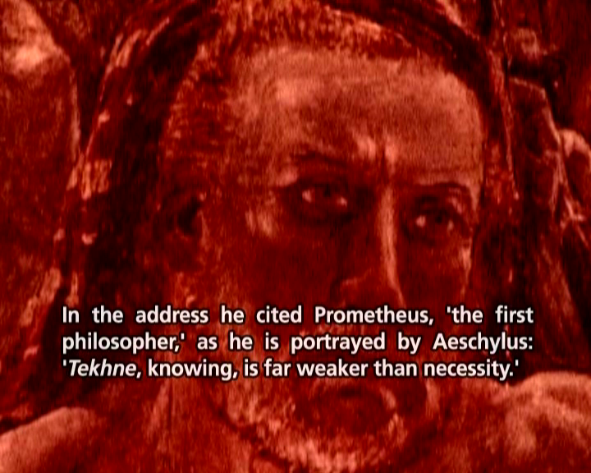

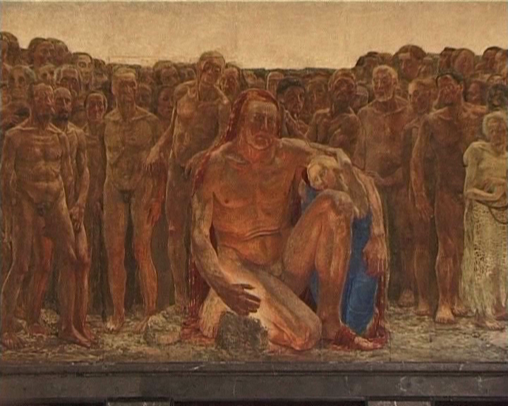

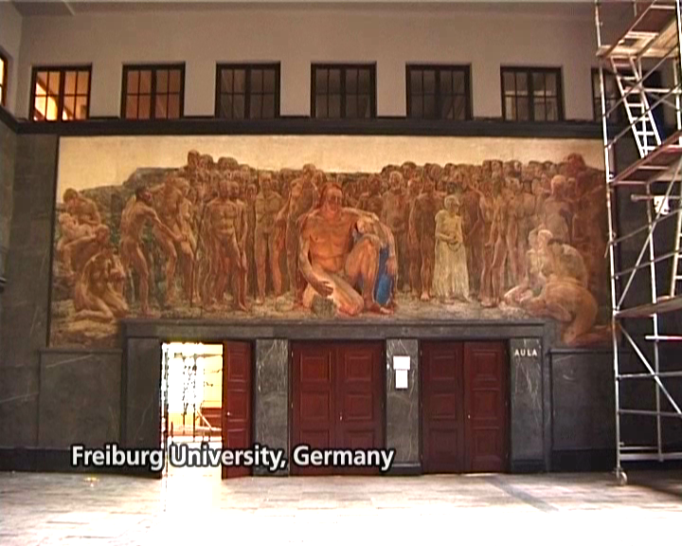

Figures 4 – 6 summarise the “slow reveal” of the source of this image of the mythical Titan who stole fire from Zeus so that humans would not die of their lack of “natural” qualities. The Prometheus graphic comes first to us in Part One, illustrating Stiegler’s recounting of the myth of the origin of mortals and of Tekhne. But when the source of this actual image of Prometheus is subsequently “located” as a mural on the wall in the Freiburg University hall where Heidegger stood delivering his 1933 Rectoral address, there is a powerful refocussing of attention on this image. It now speaks less of ancient Greek myth known generally in the Western cultural treasury, but of a highly specific image, historically situated as a factical support of a politically extreme, ultra-nationalist mobilisation of that factical “already there.”

This colouring of perception according to both its past reception and the alteration to consciousness in between encounters is made explicit and irreducible in the case of mechanically “exact” recordings exactly repeated. Same phenomenon, different phenomena. For Stiegler the key to understanding this change is to understand conscious, intentional perception as always already a mixture of retentions and the protentions they project in anticipation of the perceived. This necessarily temporal, anticipatory-recollective structure, changes permanently with the arrival of each new perception. The continuity of consciousness as metastable consistency is underwritten by the tertiary memory forms of facticity in relation to which the interior processes of consciousness are articulated (Technics and Time 3 43). As my insurance metaphor suggests, this underwriting is never an objectless, neutral grounding, but a projective impetus and commitment of capital setting out to limit the course of eventuality. The factical does hold within itself undeployed capital potential, but this must be drawn out in reinventions of this impetus of the cultural program stored in technicity. From this perspective, The Ister is a film structured to promote an explicit reflection on this historical, conceptual, material complexity of perception, thought and meaning-making.

Conclusion
“The ear,” claims Stiegler, against Husserl’s account of the hearing of a melody, “is originarily musical” (Technics and Time 2 242). Which also means it is originarily cultural, programmed in “the bath of local rhythms” (276). This is the nub of Stiegler’s critique of Husserl’s effort to preserve for phenomenological endeavour the living present moment of intentional conscious attention to the phenomenon, keeping it separate from the imaginative colourings of past perceptions. For Stiegler what Husserl neglects in this gesture is the tertiary memory function of the technical milieu, one which is no less constitutive for consciousness. This exterior memory makes possible the running of the cultural program on the basis of which the individual consciousness relates to the collective in a process of mutual individuation. Stiegler draws on Gilbert Simondon to characterise this as a “transductive” process which plays out on the plane of the technical. This prosthetic plane of human becoming is, however not merely the pure medium or instrumental dimension of the human dynamic, but com-poses the individual and the collective in and through an irreducible exteriority. This is why the ear, and the rhythms which move it, are never simply a question of what (be)comes naturally. Com-posing with the technics that bear the cultural program is always critical to creating new rhythms.

The film proposes (with Stiegler) the advance of technological modernity as the undermining of the possibility of the local, of home (along with the foreign). Stiegler identifies this in his work with the potential of the global rhythming of the program industries to alter and replace the local (Technics and Time 2 277). The idiosyncratic adoption of these global rhythmings remains possible, for now, as The Ister demonstrates in conjugating conventional and unconventional forms, the philosophical, poetic and the cinematic.

Endnotes
1. I have excluded complications to this sketch of editing processes by avoiding discussion of the editing of image and sound tracks. For instance, one documentary filmmaker I spoke with defined an insert edit as one where the image track was overwritten (with, for example, a “cutaway”) while the soundtrack was unaltered, preserving the original temporal structure of the cut through the audio track. This is a contemporary usage of “insert edit” recalling the linear, analog editing tradition rather than as the name of the nondestructive technical procedure in programs like Final Cut.

2. This is perhaps also true for Deleuze; the “time-image” is best understood arguably as emerging from the unworking of the movement image’s indirect image. The relation between the formulations of Stiegler and Deleuze on the cinema, the machine and technics deserves a much fuller treatment in another context.

3. Tarkovsky’s films seem from this perspective to be profound meditations on this pressure at a critical phase in Russian and world history; the pressure of European (universalising) notions of art, culture, history, in apocalyptic conflict with the fatal coupling of Cold War geopolitics.

4. Other examples include the shots from the carnival at Regensberg, from the May Day festivities in Stalintown in Budapest, the images of Prometheus from the Rectory at Freiburg University, and shots of the Greek temple folly built by Ludwig I in Bavaria.

5. See my review of Technics and Time 3 in Film-Philosophy for a more detailed commentary on Stiegler’s account of cinema (Crogan, “Essential Viewing”).

Works Cited
Crogan, Patrick. Essential Viewing. Film-Philosophy 10:2 (September 2006). http://www.film-philosophy.com/archive/vol10-2006/

Deleuze, Gilles. Cinema 1: The Movement-Image. Trans. Hugh Tomlinson and Barbara Habberjam. Minneapolis: University of Minnesota Press, 1986.

Eisenstein, Sergei. Film Form: Essays in Film Theory. Trans. Jay Leyda. San Diego: Harvest Press, 1977.

Leroi-Gourhan, André, Gesture and Speech. Trans. Anna Bostock Berger. Cambridge, MA: The MIT Press, 1993.

Murch, Walter. In the Blink of an Eye: A Perspective on Film Editing. LA: Silman-James, 1995.

Pearlman, Karen. Cutting Rhythms: Shaping the Film Edit. Forthcoming Boston: Focal Press, 2009.

Stiegler, Bernard. Technics and Time 1: The Fault of Epimetheus. Trans. Richard Beardsworth and George Collins. Stanford: Stanford University Press, 1998.

Stiegler, Bernard. Technics and Time 2: Disorientation. Trans. Stephen Barker. Stanford: Stanford University Press, 2009.

Stiegler, Bernard. La technique et le temps 3: Le temps du cinéma et la question du mal-être [Technics and Time 3: The Time of Cinema and the Question of Ill-being] (Paris: Editions Galilee, 2001).

Tarkovsky, Andrey. Sculpting in Time: Reflections on the Cinema. Trans. Kitty Hunter-Blair. London: Bodley Head, 1986.

